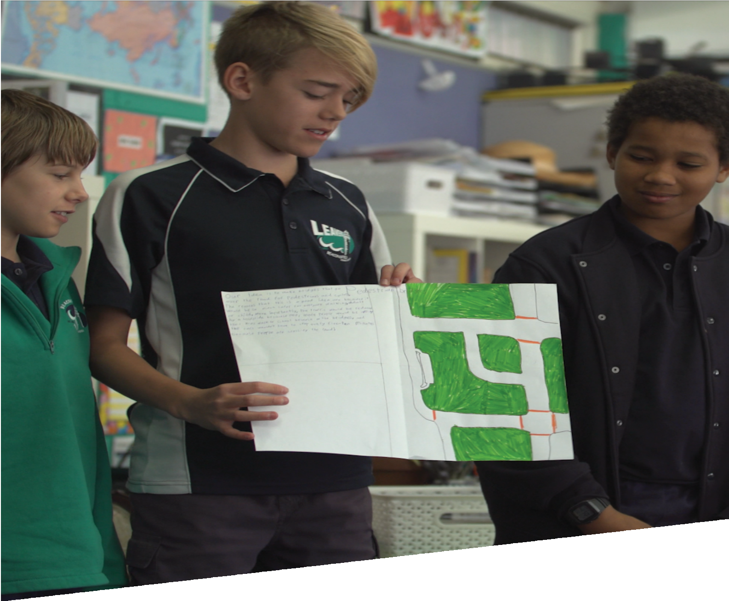

CURRICULUM RESOURCE MODULE
Travel choices
YEAR 6

Acknowledgements
The STEM Learning Project respectfully acknowledges the Traditional Custodians of the lands upon which our students and teachers live, learn and educate.

The STEM Learning Project is funded by the Western Australian Department of Education (the Department) and implemented by a consortium in STEM education comprising the Educational Computing Association of WA, the Mathematical Association of WA, the Science Teachers Association of WA and Scitech. We acknowledge and thank the teachers and schools who are the co-creators of these resources.
Copyright and intellectual property
The copyright and intellectual property of this module remain the property of the Department.

Any Western Australian Curriculum content in this resource is used with the permission of the School Curriculum and Standards Authority (the Authority); this permission does not constitute Authority endorsement of the resource. The Authority accepts no liability for any errors or damages arising from reliance on its content.

The Western Australian Curriculum content may be freely copied, or communicated on an intranet, for non-commercial purposes in educational institutions, provided that the Authority is acknowledged as the copyright owner. Copying or communication for any other purpose can be done only within the terms of the Copyright Act 1968 or with prior written permission of the Authority. Any Australian Curriculum content in the Western Australian Curriculum is used by the Authority under the terms of the Creative Commons Attribution-NonCommercial 3.0 Australia licence.

Any content on the www.scsa.wa.edu.au domain that has been derived from the Australian Curriculum may be used under the terms of Creative Commons Attribution-NonCommercial 3.0 Australia licence.

Appendix 2: General capabilities continuums is adapted from ACARA, © Australian Curriculum, Assessment and Reporting Authority (ACARA) 2009 to present, unless otherwise indicated. This material was downloaded from the ACARA website (www.acara.edu.au) (accessed December 2015) and was not modified. The material is licensed under CC BY 4.0 (https://creativecommons.org/licenses/by/4.0/). ACARA does not endorse any product that uses ACARA material or make any representations as to the quality of such products. Any product that uses material published on this website should not be taken to be affiliated with ACARA or have the sponsorship or approval of ACARA. It is up to each person to make their own assessment of the product.

This resource includes references and examples of iOS, Android and other apps. The Department does not endorse or recommend any commercial products and simply provides these as examples for teachers.

The Department is committed to providing quality information to its customers. Whilst every effort has been made to ensure accuracy, currency and reliability of the information within these documents, the Department accepts no responsibility for errors, omissions or amendments made since the time of publishing. Confirmation of information may be sought from the Department or the originating bodies providing the information. The Department has no control over the content of material published on websites to which users are referred in this resource. It is the responsibility of the internet user to make their own decision as to the relevancy, accuracy, currency and reliability of information found on those sites.

This resource contains various images from iStock used under license.
Attributions: Kidblog, Weebly, Evernote, eBook, Pages, Keynote, Microsoft Excel, Microsoft PowerPoint, Survey Monkey, iMovie, Seesaw, Class Dojo.

Table of contents

The STEM Learning Project 2
Overview 3
Activity sequence and purpose 6
Background 7
Activity 1: Modes of travel 10
Activity 2: Travelling to school 16
Activity 3: A better way to go 31
Activity 4: Educating the community 37
Appendix 1: Links to the Western Australian Curriculum 41
Appendix 1B: Mathematics proficiency strands 43
Appendix 2: General capabilities continuums 44
Appendix 3: Materials list 47
Appendix 4: Design process guide 48
Appendix 5: Student journal 49
Appendix 6: Student activity sheet 1.0: Journal checklist 50
Appendix 7: Teacher resource sheet 1.1: Cooperative learning – Roles 51
Appendix 8: Teacher resource sheet 1.2: Cooperative learning – Jigsaw 52
Appendix 9: Teacher resource sheet 1.3: Cooperative learning – Placemat 53
Appendix 10: Teacher resource sheet 1.4: Cooperative learning – Think, Pair, Share 54
Appendix 11: Student activity sheet 3.1: Design brief 55
Appendix 12: Student activity sheet 4.1: Presentation review 56
Appendix 13: Teacher resource sheet 4.2: Evaluation 57

The STEM Learning Project
The aim of the STEM Learning Project is to generate students’ interest, enjoyment and engagement with STEM (Science, Technology, Engineering and Mathematics) and to encourage their ongoing participation in STEM both at school and in subsequent careers. The curriculum resources will support teachers to implement and extend the Western Australian Curriculum across Kindergarten to Year 12 and develop the general capabilities.
Why STEM?
A quality STEM education will develop the knowledge and intellectual skills to drive the innovation required to address global economic, social and environmental challenges.
STEM capability is the key to navigating the employment landscape changed by globalisation and digital disruption. Routine manual and cognitive jobs are in decline whilst non-routine cognitive jobs are growing strongly in Australia. Seventy-five per cent of the jobs in the emerging economy will require critical and creative thinking and problem solving, supported by skills of collaboration, teamwork and literacy in mathematics, science and technology. This is what we call STEM capability. The vision is to respond to the challenges of today and tomorrow by preparing students for a world that requires multidisciplinary STEM thinking and capability.
The approach
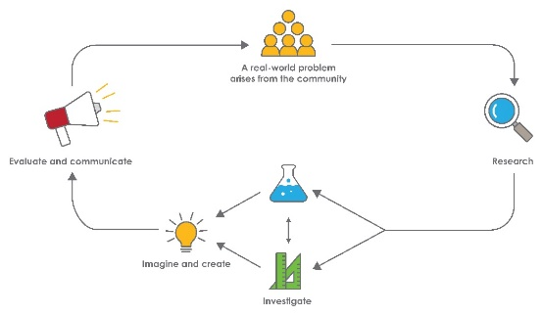
STEM capabilities are developed when students are challenged to solve open-ended, real-world problems that engage students in the processes of the STEM disciplines.

Year 6 – Travel choices
STEM Consortium

Overview
Governments and business organisations seek to influence the behaviour of individuals and other organisations to deliver economic, social and community benefits. This is done in a variety of ways, including establishing policies informed by detailed analysis of data. In this module, students will collect data about various modes of travel to and from school and assess the impact on people’s health, wellbeing and the environment.
Evidence from science and mathematics investigations are important for solving problems faced by communities. This module promotes community activism and responsibility by engaging students in analysing data related to modes of travel and its various effects on individuals and the community. Students develop solutions for a chosen problem around transport to school and present this at a learning symposium for the school community.
What is the context?
There are several issues a school might face involving traffic, including environmental considerations, congestion and vehicle security. There are also more general community issues associated with local travel habits that relate to health, safety, public transport availability and local government planning. Evidence from research and community awareness-raising can assist in identifying and addressing challenges that can arise from the travel choices people make.
What is the problem?
How can we engage the school community in good travel choices?
How does this module support the integration of the STEM disciplines?
Science
Students use scientific knowledge to solve problems and inform personal and community decisions (ACSHE100). They construct and use a range of data representations to reveal and communicate patterns in data (ACSIS107). When refining their survey questions, they have the opportunity to reflect on and suggest improvements to scientific investigations (ACSIS108), and compare their data with their predictions to use as evidence when developing explanations (ACSIS221).
Technology
Students design, represent and communicate alternative solutions to current travel choices (WATPPS35). Collaboratively, they develop criteria to evaluate and justify their solutions (WATPPS37) and develop an understanding of how people address competing considerations, including sustainability, when designing and evaluating solutions (ACTDEK019). Students work collaboratively to plan, develop and communicate their solutions to improving travel choices at their school (WATPPS38). They have the opportunity to use digital technologies to collect, sort, interpret and visually present different types of data using software to manipulate data for a range of purposes (ACTDIP016).
The Design process guide is included as a resource to help teachers understand the complete design process as developed in the Technologies curriculum.
Mathematics
Students interpret and compare a range of data displays, including pie graphs and side-by-side column graphs for two categorical variables (ACMSP147). When summarising and comparing their data in tables and graphs, students make connections between equivalent fractions, decimals and percentages (ACMNA131). During their research and investigations, they interpret secondary data presented in digital media and elsewhere (ACMSP148).
When measuring their travel distance to school and comparing speed, distance and time taken for different modes of travel, they will select and apply efficient mental and written strategies and appropriate digital technologies to solve problems involving all four operations with whole numbers (ACMNA123) and decimals (ACMNA128, ACMNA129). During this process, they will have opportunities to connect decimal representations to the metric system (ACMMG135).
This module also provides opportunities to develop the Mathematics proficiency strands of fluency when processing their numerical data and making calculations to compare different modes of travel, and of reasoning when students interpret their data and use their conclusions to develop and justify travel choices.
General capabilities
There are opportunities for the development of the general capabilities and cross-curriculum priorities as students engage with Travel choices. In this module, students:
- Develop problem-solving skills as they research the problem and its context (Activity 1); investigate parameters impacting on the problem (Activity 2); imagine and develop solutions (Activity 3); and evaluate and communicate their solutions to an audience (Activity 4).
- Utilise creative thinking as they generate possible design solutions; and critical thinking, numeracy skills and ethical understanding as they choose between alternative approaches to solving the traffic congestion problem.
- Utilise personal and social capability as they develop socially cohesive and effective working teams; collaborate in generating solutions; adopt group roles; and reflect on their group work capabilities through self and peer evaluation.
- Utilise a range of literacies and information and communication technology (ICT) capability as they collate records of their work in a journal and present and communicate their solution to an audience in Activity 4.
- Communicate and, using evidence, justify their group’s design to a community member either face-to-face, by letter or email.
What are the pedagogical principles of the STEM learning modules?
The STEM Learning Project modules develop STEM capabilities by challenging students to solve real-world problems set in authentic contexts. The problems engage students in the STEM disciplines and provide opportunities for developing higher order thinking and reasoning, and the general capabilities of creativity, critical thinking, communication and collaboration.
The design of the modules is based on four pedagogical principles:
- Problem-based learning
All modules are designed around students solving an open-ended, real-world problem. Learning is supported through a four-phase instructional model: research the problem and its context; investigate the parameters impacting on the problem; design and develop solutions to the problem; and evaluate and communicate solutions to an authentic audience.
- Developing higher order thinking
Opportunities are created for higher order thinking and reasoning through questioning and discourse that elicits students' thinking, prompts and scaffolds explanations, and requires students to justify their claims. Opportunities for making reasoning visible through discourse are highlighted in the modules with the icon shown here.
- Collaborative learning
This provides opportunities for students to develop teamwork and leadership skills, challenge each other’s ideas, and co-construct explanations and solutions. Information that can support teachers with aspects of collaborative learning is included in the resource sheets.
- Reflective practice
Recording observations, ideas and one’s reflections on the learning experiences in some form of journal fosters deeper engagement and metacognitive awareness of what is being learnt. Information that can support teachers with journaling is included in the resource sheets.
These pedagogical principles can be explored further in the STEM Learning Project online professional learning modules located in Connect.

Activity sequence and purpose
Modes of travel
Students brainstorm types of ground transportation available to them. Working in groups, they research the benefits and problems associated with their chosen mode of transport. They share their data with the other groups.
Travelling to school
Students investigate how the school population travels to school and any issues arising from these choices. They also investigate possible alternative travel opportunities.
A better way to go
Students use their data to devise solutions to any travel problems they have identified. They develop a design brief that outlines key messages and travel recommendations and use it to encourage families to make good choices about the ways their children travel to school.
Educating the community
Students conduct a learning symposium, sharing their data and recommendations through various media. They analyse the effectiveness of their presentations in improving the travel choices of their community.

Background
Expected learning | At the completion of this module students will be able to:  - Recognise how scientific knowledge can solve problems and inform personal and community decisions.  - Establish the purpose and questions for surveys and investigations, and plan and conduct surveys and investigation.  - Collate, organise, tabulate and graph data and interpret their meaning.  - Use their data as evidence when developing explanations.  - Interpret secondary data obtained from digital sources.  - Work collaboratively to design, represent and communicate alternative solutions.  - Consider how competing personal and community choices impact on sustainability and health.  - Read and interpret maps to calculate distances and travel times.  - Use appropriate mathematical operations to solve problems involving relationships between speed, time and distance.  - Recognise why percentages should be used to compare data from different sized study groups.  - Create a design plan to propose improved choices justified by their research data.  - Use information and communication technology (ICT) to organise and present information to an audience.
Vocabulary | This module uses subject-specific terminology. The following vocabulary list contains terms that need to be understood before the module commences or developed as they are used:  Congestion, estimate, graph, kilometres per hour, landmark, landscape, means of transport, pedestrian, route, speed, survey, sustainable, timetable, traffic, zone.
Timing | There is no prescribed duration for this module. The module is designed to be flexible enough for teachers to adapt. Activities do not equate to lessons; one activity may require more than one lesson to implement.
Consumable material | A Materials list is provided for this module. The list outlines materials outside of normal classroom equipment that will be needed to complete the activities.
Safety notes | There are potential hazards inherent in these activities and with the equipment being used, and a plan to mitigate any risks will be required.  Potential hazards specific to this module include but are not limited to:  - Possible exposure to cyberbullying, privacy violations and uninvited solicitations when using the internet.
Enterprise skills | The Travel choices module focuses on higher order skills with significant emphasis on expected learning from the general capabilities and consideration of what are enterprise skills.  Enterprise skills include problem-solving, communication skills, digital literacy, teamwork, critical thinking and presentation skills.  More information is available from the Foundation for Young Australians in the New Work Order six-report series at www.fya.org.au/our-research-2/#series.
Assessment | The STEM modules have been developed to provide students with learning experiences to solve authentic real-world problems using science, technology, engineering and mathematics capabilities. While working through the module, the following assessment opportunities will arise:  - Work samples from mathematics investigations as students calculate distances from a scale map and calculate time from speed and distance  - Journal reflections  - Observations and recordings from the symposium as students deliver their presentations in Activity 4.  Appendix 1 indicates how the activities are linked to the Western Australian Curriculum.  Evidence of learning from journaling, presentations and anecdotal notes from this module can contribute towards the larger body of evidence gathered throughout a teaching period and can be used to make on-balance judgements about the quality of learning demonstrated by the students in the science, technologies and mathematics learning areas.  Students can further develop the general capabilities of Information and communication technology capability, Critical and creative thinking and Personal and social capability. Continuums for these are included in the General capabilities continuums but are not intended to be for assessment purposes.

Activity 1: Modes of travel
Activity focus | Students brainstorm types of ground transportation available to them. Working in groups, they research the benefits and problems associated with their chosen mode of transport. They share their data with the other groups.
Background information | The transport of people and goods is a significant component of the economy and one which raises several sustainability issues. As populations increase, traffic congestion increases, resulting in lost productivity. It also causes threats to the environment and health through the generation of air pollutants, including greenhouse gases. Walking and cycling are encouraged as healthy and sustainable transport alternatives. Trains, trams and buses have a lower environmental impact per passenger than cars.  A few countries have legislated to ban the use of diesel and petrol-powered cars in city centres to encourage the uptake of electric cars, bikes and public transport. The following article contains several examples:  13 cities that are starting to ban cars (Business Insider Australia, 2017)  www.businessinsider.com.au/cities-going-car-free-ban-2017-8?r=US&IR=T  Encouraging people to walk or ride to school helps ease traffic congestion around schools and is good for students’ health. Reduction in car use can also be achieved through carpooling and combining car travel part-way and walking the rest.
Instructional procedures | It is recommended that students work in small groups for all activities. Mixed ability groups encourage peer tutoring and collaboration in problem-solving. Collaboration is an important STEM capability.  Refer to the teacher resources sheets for Cooperative Learning (1.3, 1.4, 1.5) for information on the Placemat and Think, Pair, Share strategies students will use in this activity.
Expected learning | Students will be able to:  - Recognise that scientific knowledge can inform personal and community decisions (Science).  - Consider how competing personal and community choices impact on sustainability and health (Technologies).  - Interpret secondary data obtained from digital sources (Mathematics).
Equipment required | For the class:  Interactive whiteboard  Sticky notes for small group brainstorming (if used)
For the students:
Access to computers or iPad connected to the internet for research (or library access)
Preparation | Arrange a visit from a local government planning officer who can present information about roads, footpaths and cycle tracks in the school’s area, including how decisions are made for future constructions and competing considerations.
Activity parts | Part 1: Travel modes  Begin with a brainstorm in response to the question:  How do people get from one place to another within a town or city?  Teachers choose a way to generate a list from the activity. Encourage a wide range of modes including scooters, skateboards, horseback, walking and running as well as the obvious choices.  A collaborative method is to have students in small groups come up with their own list, writing each different mode of travel on a sticky note. Students then place their sticky notes on the whiteboard, placing identical modes of travel on top of one another.  Once the list is generated, groups choose one or two modes of travel and carry out research through the internet or the school library to better understand the features, history and impact of their chosen modes.  Ensure all modes of travel are covered by the groups. Use the questions below to stimulate curiosity. Support students’ research with videos from the Digital resources section.  - When, where and why did this mode of travel develop?  - What innovations has modern technology had on this mode of travel?  - What powers this mode of travel?  - What effect does that travel choice have on the environment?  - What effect does that travel choice have on people’s health and wellbeing?  - How will this mode of travel change in the future?  Use a think-pair-share activity (see Teacher resource sheet 1.4: Cooperative learning – Think, Pair, Share)to enable groups to share their research with the rest of the class. They may use their journals to record some of what they have learnt about their favourite mode of travel.  Students will use their research to inform Part 2 of this activity.
Part 2: The environment
Tell students that people create roads, paths or tracks to make particular modes of travel possible or easier.
Have students in their small groups list the one or more ways the environment has been changed to accommodate their mode of travel.
Students may not be aware of the different government bodies that are responsible for roads, paths, train lines and stations, or bus routes.
If possible, invite a planning officer from the local council to talk to students about the planning process and which roads and pathways are the responsibility of local government, and which are the responsibility of state and federal governments.
Students could ask the visiting speaker questions such as:
- What aspects are considered when planning roads and footpaths?
- How is travel by walking balanced with travel by vehicles?
- What planning is needed to help keep cyclists and pedestrians safe?
- Who decides where footpaths, bike paths and pedestrian crossings are located?
- Who decides bus routes and where train lines will go?
- How are these decisions made?
Students can use their journals to record what they have learnt from the speaker and list any issues with the way the environment has been changed to accommodate particular modes of travel.
The Digital resources section contains some clips that may be useful to demonstrate how some local governments are trying to reduce the use of cars in their cities.
Part 3: Problems with modes of travel
It is likely that through the previous parts, issues such as pollution, road congestion, accidents or health issues through lack of exercise may have been raised.
In this activity, part of the general effects of different modern modes of travel on an individual’s health and wellbeing can be directly addressed.
Refer students to their posters and have them identify which of the negatives they had listed could impact on human health and wellbeing.
Students can stay in their groups and create a list for the modes of travel their group explored in Part 1. A placemat strategy could be used in the groups to share the task. (See Teacher resource sheet 1.3: Cooperative learning – Placemat).
A list for travel by car might look like this:
carbon monoxide pollution
vehicle noise
congestion – traffic jams
car accidents
getting knocked down
not enough exercise
expensive – to buy and run
Discuss with students the differences they found in the number of negative effects listed for each mode of travel and why people might choose one or the other, even though there are negative effects.
Prompt questions could include:
- Why do you think so many people drive cars, when they seem to have the most negative effects?
- If walking or using bicycles have fewer negative effects, why do you think more people don’t travel that way?
- What do you think makes people choose to travel on trains or buses, rather than drive?
When students have provided some opinions, suggest that we could guess what people are thinking when they choose different modes of transport, but if we want some scientific evidence then we need to carry out some investigations in our local community to find out what is happening and when and why people choose particular modes of transport.
Tell students that is what they will be doing in the next activity with a focus on how their school community travels to school.
Introduce students to the problem that they will be asked to address in Activity 3:
How can we engage the school community in making good travel choices?
As a way to raise awareness that some children in the world have very difficult journeys to school each day, and don’t have parents with vehicles to drive them to school, show one or more clips from the Digital resources section under the heading of World’s most dangerous journeys to school.
Part 4: Reflection
Students record their thinking and responses to the questions below in their individual reflective journals or blogs. See Student journal for elaboration.
- What are your thoughts on the positive and negative effects of some modes of travel?
- What effect do you think government decisions might have on people’s choice of travel?
- What do you think makes people choose one form of travel over another?
- Why might the answers to these questions be important to our community?
Responses to these questions can be represented as a mind map that can be further developed while working through the module.
Resource sheets | Student journal  Teacher resource sheet 1.3: Cooperative learning – Placemat  Teacher resource sheet 1.4: Cooperative learning – Think, Pair, Share
Digital resources | Mind mapping | Teaching strategies #3 (Teachings in Education, 2017)  youtu.be/xCyjFipytRE
 | The Foundation for Young Australians: The New Work Order Series (Reports on 21st Century workplace skills) https://www.fya.org.au/our-research-2/
World’s most dangerous journeys to school
6 most dangerous ways kids get to school (World List, 2017)
youtu.be/zzpT_MFcWU0
Zipline commute: Columbia kids cross canyon to reach school (Learning World: S1E04, part 1/3) (WISE channel, 2011)
youtu.be/Wh0o2zNOx8Y
Is This the Most Dangerous School Run in The World? (Barcroft TV, 2016)
youtu.be/sRNNRahOumU
Utrecht: Planning for People & Bikes, Not for Cars (Streetfilms, 2019)
youtu.be/Boi0XEm9-4E
Oslo: The Journey to Car-free (Streetfilms, 2019)
youtu.be/SuboGpL3de4
13 cities that are starting to ban cars (Leanna Garfield, Business Insider Australia, 2017)
www.businessinsider.com.au/cities-going-car-free-ban-2017-8?r=US&IR=T

Activity 2: Travelling to school
Activity focus  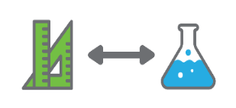 | Students use their data to devise solutions to any travel problems they have identified. They develop a design brief that outlines key messages and travel recommendations and use it to encourage families to make good choices about the ways their children travel to school.
Background information | There are many things influencing how children travel to school. For students to address the problem and design solutions, they need to know how students travel to school and understand the range of reasons for those travel choices.  Families cannot change their travel distance to school; however, their travel time is adjustable depending on the mode of transport they choose. In Activity 3, students will be involved in considering all aspects of the problem before attempting to formulate solutions that will encourage good travel choices.
Instructional procedures | Continue to promote small group collaborative problem-solving throughout the investigations. Begin by collating travel information from the class, using it to engage in some explicit teaching about using numerical data to produce a pie graph and other graphs that may be needed. Student groups then construct their own survey questions, trialling them with classmates to refine them, before conducting a whole school survey.  As distance from school is likely to be an important factor in choices, engage students in using mathematics to compare their travel time by car, cycle or walking (regardless of how they usually travel to school). Help students to conduct a mini investigation to obtain extra information about their choice that may assist with developing their design solution later in Activity 3.
Expected learning | Students will be able to:  - Establish the purpose and questions for a survey about the ways students get to school, and contribute to planning and conducting the survey (Mathematics).  - Collate, tabulate and graph the survey data and interpret the findings of the survey (Mathematics and Science).  - Read and interpret a scale on maps to calculate distances and travel times and apply appropriate mathematical operations to solve problems involving speed, time and distance (Mathematics).  - Recognise why percentages are used to compare data from different sized study groups (Mathematics).  - Plan and undertake a small-scale investigation of their own choosing and interpret the results (Mathematics and Technologies).
Equipment required | For the class:  Interactive whiteboard
For the students:
Devices with internet access
Prepared map(s) of the school’s local area (digital and printed as required)
Compass and ruler for measuring distances on a map
Preparation | Source a road map of the school and its surrounding intake area so that each student can find their home and the school on the same sheet. For large school areas the map may need to be split into sections. Maps should be to scale with the appropriate scale ratio clearly shown.  It is advised that prior to this activity students have had some experience interpreting scale on maps.
Activity parts | Part 1: Asking our class  As a class, discuss who determines how they usually travel to school and why they choose that method.  The following prompt questions could be used:  - Who decides how you travel to school?  - What factors influence these choices?  - What alternative choices could be made?  - How might the local environment influence your choice of travel?  After the information has been gathered for the whole class, work together to display the data. Brainstorm how the results might be categorised and model creating graphs using a program such as Microsoft Excel.  A pie graph could be introduced as a means of displaying the number of students in the class who usually travel to school by each method. Show students how a pie graph is used to illustrate a complete set of data where there is one piece of data for each person or object.  Students can be helped to understand how a pie graph works using their class data, but without needing to calculate percentages at this stage.  Provide a wooden bead to each student, using a different colour to represent the way each usually travels to school. For example, bike riders get a blue bead each, walkers get a purple bead each and so on. Each student then adds their coloured bead to a string adjacent to others with same coloured beads. The completed ‘necklace’ of beads is tied into a tight circle. The teacher demonstrates laying the circle of beads onto a sheet of paper, making sure it is circular, then drawing around the circle, marking where each colour changes and the centre of the circle. Lines are then drawn from where each colour changes to the centre to complete the pie graph. Each section can be labelled with the ratio of students and the category, as shown below.  9/32  bike  11/32  car  3/32  scooter  4/32  bus  5/32  walk  A frequency bar graph could be used to display the range of reasons for students’ travel choice. Draw attention to why a pie graph would not be appropriate for this data because students could select more than one reason for choosing a particular travel method.  A side-by-side bar graph could be used to show comparative data. For example, boys’ and girls’ methods of travel to school, in response to the question, ‘Do more boys than girls ride their bikes?’  This small-scale class data collection provides students with experience in organising, summarising and displaying data in different ways to prepare them for having more choice in the ways they process the whole school data in Part 2 of this activity.  When the class data has been displayed, stimulate a discussion about whether or not students believe their data would be representative of the whole school community.  Questions could include:  - How do you think a Year 1 student’s mode of travel might differ from a Year 6 student?  - What might be the reasons for that?  - What other considerations are there when thinking about travel to school for very young children?  Challenge students to work in their small groups to think about the questions they would need to put in a written survey to obtain data from the whole school about modes of travel to school and reasons for choosing that mode.  Discuss the differences between being able to ask the questions orally with the opportunity for further questions and the challenges of formulating unambiguous questions in a written survey.  Students may reflect in their journals some of the ideas they discussed in their groups.
Part 2: Surveying the whole school
Building on ideas from Part 1, students work in their groups to formulate a survey to obtain information from the whole school population about the modes of travel they use to get to and from school and the reasons for those choices.
Explain to students that scientific knowledge is used to solve problems and inform community decisions in the real world. By creating and administering this survey, students will be engaging in the same work as scientists.
Use the following questions to stimulate thought and decision-making:
- How would the way your group wants to analyse data affect the questions we include?
- Why is it important to think about and plan your intended analysis before the questions are formulated?
- What are the advantages and disadvantages of providing a list from which respondents choose their mode of travel and reasons?
- How might the data differ if we make the questions open-ended?
- Would it help to put the questions into categories?
- Do we want students to choose just one main travel mode, or do we want to know the different ways the same student might travel to school?
- Why might it be useful to ask ‘why’ questions so that we find out some reasons for travel choices?
- What other data about the student would we want to collect to assist in data analysis? (eg age, sex, perhaps their street address so we can calculate the distance to school)
- Do we want the students or the parents to complete the survey, and what difference might that make to the information we get?
- If your survey is designed for students, how will you adjust this to the different literacy levels of students according to age – will some need to be interviewed?
Students formulate draft questions for their group’s survey. Ask students to test their draft questions with other groups. They should reflect on the usefulness of the questions and revise questions as necessary.
Ask students:
- How well did your questions provide the information you wanted?
- Was there any information you weren’t expecting to get?
- Were any of your questions misinterpreted?
- How could you change your question to make sure you get the information you want?
Display each group’s set of questions and, as a class, select at least one or two of each group’s questions to compile into a single survey that be used to obtain data from either parents or students or both.
In compiling the survey, provide identifying codes for the questions contributed by each group so they may analyse the data from their particular questions, along with a set of agreed demographic data, such as sex, age-group and distance from the school to be included in the final survey.
If possible, provide the survey electronically through email, Survey Monkey or other means, and consider whether interviews may be necessary if young students are to be surveyed.
Part 3: Conducting, summarising, analysing
Depending on the chosen survey method and targeted recipients, distribute the survey.
For large schools, a sample rather than the whole population could be considered. If a sample of students or their parents is desired, discuss with students how they might obtain a fair sample. For example, they might choose ten students from each class by surveying every third student on each class roll.
If the aim is to survey the whole school population, consider how the survey can be promoted to maximise the number of responses. Students set a closing date for responding to the survey. Data collation and analysis can commence after the closing date.
When the responses are obtained, and depending on the the methods used to obtain the data, each group should receive back the demographic data together with the responses to their particular questions for analysis.
Groups should use what they learnt in Part 1 when the data from their class was collated and displayed, to process and categorise the data, discuss what they think it is saying and decide how best to display their particular data set.
Initially, groups can be encouraged to write fractions that show how many in each category gave particular answers out of the total number of respondents in those categories.
Discuss with the class how they can compare some of their fractions when the group sizes are different. Introduce the idea of using percentages to make fair comparisons to answer questions like, ‘Do more boys than girls ride their bikes to school?’
Ask students:
- How can we compare our data for boys and girls if there are more girls than boys who responded to the survey?
- Why might it be misleading to just compare the number of girls who ride their bikes with the number of boys who ride their bikes and say which is more?
To help students begin to understand proportional comparison, provide an extreme example to show that we need to consider the total number of girls and boys in the survey, not just how many rode bikes, and that percentages can help.
For example, if there were 200 girls and 100 boys who answered the question, and 75 girls and 50 boys said they rode their bikes, would it make sense to say more girls than boys ride their bikes to school? Not all students will understand proportional comparison at this age, but they may make some sense if it is pointed out that 50 out of 100 is 50% of boys rode their bikes. Then ask, if the same percentage of girls rode their bikes, how many girls would that be? Assist students to see that 50% of 200 would be 100. So, if only 75 girls rode their bikes, that’s less than 100, so it has to be less than 50%, and we could say, ‘proportionally’ more boys than girls ride their bikes to school.
Then working out 75/200 as a percentage can be demonstrated. While a procedure for calculating simple percentages may have been taught, a ‘sharing’ context can be used to help students make sense of the calculation needed to convert a fraction to a percentage.
Tell students that we can share 100 percentage points among all the girls to find out how many or how much of a percentage points we can assign to each girl. We can do this by working out 100 ÷ 200, so each girl’s share of 100 percentage points is 0.5% in this case. So, if 75 of those girls rode their bikes we can work out how many percentage points the bike riders get by multiplying 75 by each girl’s share, so 75 x 0.5% = 37.5% which is the same as 75/200 as a percentage.
Not all Year 6 students will understand proportion, but this two-step method of calculating a percentage from a fraction using a ‘sharing’ idea provides a level of concrete ‘sense’ to the operations involved, and can help students achieve the curriculum requirement that they recognise the connections between equivalent fractions and percentages.
If students have been taught a procedure for converting a fraction to a percentage, assist students to see connections to the ‘sharing’ method. It may also help them to understand why the operations needed to calculate a percentage discount works in reverse of the above.
To further emphasise the connection between fractions and percentages, return to the whole class pie graph and, as a class, calculate the percentages of the class in each category using the above-described method. Round each to a whole number percentage and use 100 coloured beads to construct a pie graph as before, using the same colours for each travel category, with each bead representing 1%.
When complete, the circle will be larger, but students can compare the ‘wedges’ from both pie graphs and, depending on their accuracy, the angles at the centre point of each pair of ‘wedges should match – both pie graphs represent the same proportion of the class in each category of travel. Even though the circle is larger, the proportion of the total for each mode of travel is the same for both circles.
After making their calculations and deciding on the important aspects to compare and share, students display their particular pieces of data in tables or graphs. Students should be encouraged to consider what they have learnt about graph types to choose the most appropriate displays for their data.
Groups share their parts of the data and their particular findings with the whole class. After their sharing, discuss the survey results as a whole, asking some challenging questions such as:
- Did anyone’s data help us understand why so many students travel to school by car?
- Did anyone find out whether distance was a factor in people’s travel to school?
- Were there any concerns about bike safety on the way to school and at school? (eg lack of cycle paths, bikes getting stolen, dangerous when arriving at school with too many cars)
- Is there anything about the street layout, the footpaths and cycle tracks, public transport availability, congestion around the school that impacted on people’s choices?
Draw out from the discussion that there are many factors that can affect travel to school that might not have been identified through the survey.
Remind students of the reason for their investigations and the problem they will design solutions to in Activity 3: How can we engage the school community in making good travel choices?
Tell students that now they know how students travel to school, they might be able to investigate other factors that will help them encourage families to make healthier and/or more environmentally friendly choices about their children’s travel to school.
Tell students that in the following activity parts they will look at the relationship between distance and types of travel, and then have the opportunity to conduct individual or small group investigations into some of these other factors to help them create their design solutions.
Part 4: Speed, distance and time
Assist students to relate speed and distance to time by making comparisons between driving, cycling or walking to school from each student’s home. Let students know that while this may not be the actual method of travel they use. The purpose of the activity is to compare the different methods.
Obtain a birds-eye view map of the school intake area showing the position of the school and street names. Maps should be to scale, with the scale shown on the map. Each student will be given a map on which they can find and mark the position of their home. Depending on the size of the school’s intake area, several different maps may need to be copied so that each student can see the position of their home and the school on the same page.
Students draw the route they would take to get to school in three different ways - by car, by bike or walking. They use a different colour for each. Remind students to think about the different routes they would actually take and how it would be different for different modes of travel, depending on the footpaths, cycle paths and main roads. There may, for example, be a local park that they would walk across but would need to drive around. There may be major roads that can only be crossed at an intersection.
Encourage discussion between students to share information about features along the routes with which not all students will be familiar. Ask students to draw the routes they would use for each travel method.
When their routes are drawn, show students how to carefully use a compass to accurately measure the distance between two points, which they then transfer to their ruler to get the precise distance on the map for each section of the route. Students record the distance they would need to travel for each travel type. Assist students to use the scale on the map to accurately calculate the actual distance in kilometres and parts of a kilometre.
After all students have the distances in kilometres (expressed as a decimal number) for each of the three travel types, ask and discuss:
- How long do you think it would take you to get to school, using each method of travel?
- What else would we need to know to work that out?
- How can we find out what would be an average speed for each method of travel?
Support students to understand that if we know how fast something travels, we can use that rate to work out how long it will take to travel a particular distance.
Spend some time establishing the average rate of speed that is reasonable for each method of travel. Students can use the internet, or some other means to decide the notional speed to be used. The teacher may engage the class in using a stopwatch and a measured distance at the school to determine an average walking and cycling rate that the whole class can use. Convert the measures to kilometres per hour.
Students calculate, with assistance as needed, the time it would take them to walk, cycle and drive to school. Establish the calculation strategy and formula by using a simple example. Tell students that a car’s average speed is 40 kph and ask the questions below to ensure they understand the relationship between time and distance that is represented in a given rate of speed.
- How far would it travel in an hour?
- How far would it travel in 2 hours?
- How far would it travel in 5 hours?
- How would you represent this as a number sentence to solve on your calculator? (40 x 5 = 200 km)
- Can you write that as a formula for any speed and time? (speed (kph) x time (hrs) = distance (km))
- How long would it take to travel 40 km?
- How long would it take to travel 80 km?
- How long would it take to travel 100 km?
- How would you represent this as a number sentence using what you know (40 x = 100)
- How would you rewrite this to solve on your calculator (100 ÷ 40 = 2.5 hours)
- Can you write that as a formula for any speed and distance? (distance (km)÷ speed (kph) = time (hrs)
Note: Students need to understand that the units of time and distance must be consistent. For example, if the speed is given as metres per second, then the distance must be in metres, and the time must be in seconds.
Although students are not expected to work flexibly with rates and formula until well into secondary schooling, students at this level can be assisted to use the relationship between multiplication and division to consider how the one formula for this everyday rate can be rewritten to calculate whichever part is unknown, providing a foundation for later learning. For example:
If we know that speed x time = distance, we can write the same formula with an ‘empty box’ to show what we need to find out.
speed x time =
speed x = distance
x time = distance
What do we need to do to re-write the formula with the answer (empty box) after the equals sign for the second and third formula? Tell students that the relationships are exactly the same for any multiplication equation such as 3 x 2 = 6, and assist them write the equivalent number sentences.
What do you need to do to find the missing number in each of these?
3 x 2 =
x 2 = 6
3 x = 6
What new number sentence can you write for the second and third unknown so that the empty box is after the equals sign and the answer will be true?
When students sufficiently understand why division is needed to calculate the time it would take them to get to school using each method of travel, have them attempt their calculations, using an agreed whole class average speed for each of walking, cycling and driving.
Warn students that the time they calculate will be in hours and typically result in a decimal number which represents part of an hour. Many students have misconceptions about decimals and metric units and believe the decimal point separates any two types of units, for example, metres and centimetres, Litres and millilitres AND hours and minutes. They don’t connect decimal fractions to a generalised understanding of decimal place value. They may believe, for example, that 1.25 hours means 1 hour and 25 minutes.
This activity is an ideal context in which to challenge this misconception. Rather than teach them a conversion procedure, it is more useful at this stage to work through the decimal relationship to hours and minutes using information they already know. For example, most students will know that 1.5 means ‘one and a half’ so 1.5 hours must mean one hour and thirty minutes, not ‘one hour and five minutes’ or ‘one hour and fifty minutes’. From this, they can derive further conversions, for example:
- 0.5 hrs = 30 mins,
so 15 mins must be 0.25 hrs,
and 45 minutes must be 0.75 hrs.
- How many minutes must be in 0.1 hrs? (0.1 is 1/10 or 1 divided by ten, so divide 60 by 10 to work it out.)
- If 0.1 hrs = 6 mins, and 0.2 hrs = 12 mins,
Then, 0.15 hrs must equal 9 mins (ie 0.15 is halfway between 0.1 and 0.2, so find halfway between 6 and 12 to work it out).
From this information, students can construct a table to show most of the decimal to minutes equivalences to assist them to convert their final travel times to hours and minutes, or just minutes as their travel times are likely to be less than an hour. Challenge students to use a spreadsheet and derive a formula to set up a table.
Note: Introducing mathematical concepts in this way helps students to develop a deeper level understanding of decimal conversions than teaching them a procedure.
Students display and compare their maps and their calculations. Ask them, ‘How would consideration of time affect decisions about how to travel to school?’
Teachers may choose to show students how the relationship between distance and time for each rate of speed can be plotted on a graph, illustrating why joining the plot points in this case makes sense. The x-axis shows time and the y-axis distance. Students will notice that the greater the speed, the greater the slope of the line. For example:
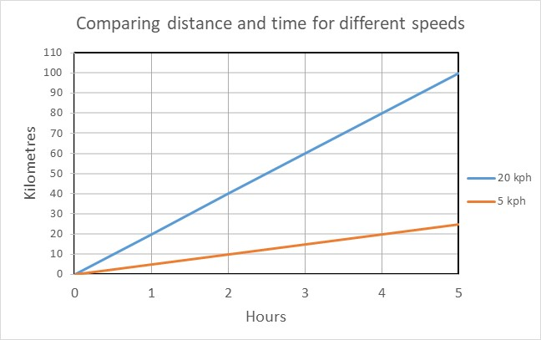
When the results have been shared, stimulate a whole class discussion, asking questions such as:
- What would need to change in your lifestyle if you walked to school, for example, instead of being driven? (eg need to get up earlier)
- How does distance from school realistically affect travel choice? (eg 20 km is too far to walk)
- Has making these calculations made any of you re-think how you travel to school?
Tell students they will have the opportunity to conduct any small group or individual investigation they choose to gather more data to help them devise solutions to the problem:
How can we engage the school community in making good travel choices?
Part 5: Investigating other factors
Provide students with the opportunity to use any method they choose (observation, surveys, analysis of online data) to conduct an individual, pair, or small group mini scientific investigation. They should investigate some aspect of travel to school that they don’t already have sufficient data about and that will help in some way to devise solutions to the problem:
How can we engage the school community in making good travel choices?
Aspects of travel that could be investigated might include:
- Cost of running a car
- Availability of public transport in the area
- Cycle tracks in the community
- Congestion of cars and bikes before and after school
- Health benefits of cycling or walking
- Carpooling or sharing
- Incentives to cycle or walk.
Provide time and support as needed for all students to become engaged and productive.
Give students the opportunity to display or present the results of their investigation to the rest of the class.
Part 7: Reflection and journaling
Encourage students to reflect on the research and investigations and their learning about travel choices.
- What are the main reasons students travel to school as they do?
- Of the information we have collected, which could help families enable their children walk rather than drive?
- What strategies could we use to make it easier or safer for students to cycle or walk to school?
- What are the benefits to health and the environment of walking or cycling?
- What kinds of incentives could we suggest that might stimulate families to change habits?
- How could you make use, as examples, of students who already walk or cycle to school?
Students are reminded to refer to their journal reflections, their data and displays to assist them in the next activity.
There are also some video clips in the Digital resources that may be helpful to show students at this stage to further stimulate their thinking.
Digital resources | Transperth journey planner (Transperth)  www.transperth.wa.gov.au/Journey-Planner
The journey to school (Regional Rail Link, 2011)
youtu.be/uZx5raF8O4U
Children’s active travel (NSW Heart Foundation, n.d)
www.healthykids.nsw.gov.au/campaigns-programs/childrens-active-travel
Stepping It Up: How to Get Active on the Trip to School Through School Travel Planning (Smart Commute, 2011)
youtu.be/7XUyslpUCb4

Activity 3: A better way to go
Activity focus | Students use their data to devise solutions to any travel problems they have identified. They develop a design brief that outlines key messages and travel recommendations and use it to encourage families to make good choices about the ways their children travel to school.
Background information | Many effective campaigns have positively influenced public behaviour. These campaigns all follow consistent guidelines such as having a clear and memorable message, communicating the most important information concisely and presenting information in eye-catching ways. More information is included in Digital resources.  Infographics can be very powerful ways to communicate information and students can be encouraged to investigate and apply this approach. The app Canva has information on how to create infographics.  Another guideline is choosing effective targets for the campaign. For instance, some families may live in locations for which driving is the only viable option, so the messages to those families may be different (eg carpooling, public transport options) than to families who live within reasonable walking or cycling distances.  Negotiation, critical thinking and reasoning skills will be required by students as they work on their designs. Problem-solving in collaborative situations is a STEM capability that students need to exercise. Allowing students to negotiate amongst themselves will encourage the development of this skill.
Instructional procedures | To inform their design solution, students use their conceptual knowledge and understanding, and information gathered from their research in Activity 1 and their surveys and investigations in Activity 2.  As they design their solution students will need to engage with the design process. See Design process guide for elaboration. Students should be encouraged to persevere and embrace the design process. The steps of ideation, development and production are followed in this activity.  A design brief proforma is provided to assist students to focus their thinking (see Student activity sheet 3.1: Design brief).  The teacher should act as a facilitator during this activity, encouraging students to collaboratively develop their design brief. This gives students ownership of the creative process and encourages their creativity.  Presentations should be prepared in groups. To scaffold cooperative group work, each member of the group could have a role and responsibility. For example, one could be the Content Director, one the Media Director and a Presentation Director. All students in the group would contribute to deciding on the content, preparing the media and giving the presentation whilst one student has overall responsibility for managing that phase of the task. (See Teacher resource sheet 1.1: Cooperative learning – Roles for more information.)  Students may use a portfolio to track their progress and processes during the development of their solution. See Student journal for digital portfolio ideas.
Expected learning | Students will be able to:  - Create a design brief, justified by their research data, to propose improved choices (Science).  - Use their data as evidence when developing explanations (Science).  - Use information and communication technology (ICT) to organise a presentation (Technologies).  - Collate, organise, tabulate and graph data and interpret their meaning for a purpose (Mathematics).  - Work collaboratively to design, represent and communicate alternative solutions (Technologies).
Equipment required | For the students:  Access to ICT and a range of software (see Digital resources)  Student activity sheet 3.1: Design brief
Preparation | Digital options for presentations include creating a comic strip, eBook or poster in Pages, Keynote or PowerPoint or iMovie (or similar). Photographs or videos may be taken during the design process to be used in their digital presentations.  Time may need to be dedicated to ensure students have sufficient skill and experience in using the various apps they are expected to use in their presentations (See Digital resources).
Activity parts | Part 1: Designing solutions  Tell students that their class will be conducting a symposium to publicise the solutions their solutions and convince families to re-consider their choices about travel to school, with health and environmental considerations in mind.  So students understand what a symposium might look like, discuss the features of a symposium and what sorts of activities and products would be on show. This will also assist them to focus their planning process with the final products in mind.  This definition could be shared with students:  A symposium is an organised public meeting for the discussion of some subject, especially a meeting at which experts present papers and discuss a topic or issue and make recommendations for a certain course of action in front of an audience.  Brainstorm some presentation ideas for students to consider as they formulate their solutions. They could produce a PowerPoint presentation, a poster, a comic book, an infographic, a video or case studies.  Explain that only after they have clarified their key messages and their audiences, should they decide on the best way to communicate their messages.  Continuing to work in their small groups, students decide which aspects of travel choices should be their group’s main focus. They discuss the key messages they want to draw out and the specific changes they hope families will make as a result of the information they have provided. Students review the data they’ve collected and displayed and choose which will have the most impact. They should consider what will be most persuasive in convincing families to change their travel habits.
Part 2: Refining their solutions
After students have had some time in their groups to discuss and agree on the particular aspects of the problem they wish to pursue, have them develop a design brief (Student activity sheet 3.1: Design brief) to help them focus in on the particular area of the problem and the solutions they will propose.
Students discuss their ideas, and review their data and collected information to complete each section of the design brief.
Scaffold student thinking with questions like:
- Is your focus area manageable or are you trying to include too much?
- What are the particular issues associated with your focus area that you feel strongly about?
- Are your supporting facts and data directly linked to your focus area and the issues you’ve raised?
- Who will your key messages be targeting and why?
- How do the facts and data you will include support your key messages and recommendations?
- Are the specific actions you want people to take clear in your key messages?
- Have you provided convincing reasons for suggested changes?
- How will you get people’s attention in your mode of delivery?
- How will your key messages be conveyed – visually, by photos or a video, by a talk with supporting slideshow, by infographics?
- Have you considered presenting ‘case study’ examples demonstrating successful change? For example, students A & B both live in the same street but are too young to walk to school on their own. They suggested that their parents take turns to drive both to school and drop them at the end of the school street to allow them to safely walk together part of the way to school.
When the group and the teacher are satisfied that the group’s design brief is clear and comprehensive, students may begin creating their presentations and/or displays.
Part 3: Creating the presentations
Support students to create their presentations and/or displays in preparation for the symposium. They may require software support for a digital presentation, opportunity to take photos, time to create a script and act out a video production that highlights their messages. Others may wish to create posters or physical displays, or combinations of technology and hard copy. See Digital resources for ideas and examples to assist.
Provide students with time and encouragement to explore options and try out different ways to deliver their messages, seeking feedback from the teacher and from other groups.
Part 4: Reflection and journaling
At different times during the designing phase, have students evaluate their progress and use their journals to record their personal reflections about their group’s planning processes.
Prompt student reflections with:
- How have you shared out the responsibilities in your group?
- Have you made use of individual group member’s particular strengths?
- Is what you had planned in your design brief manageable? If not, how have you adapted it?
- What new ideas have you incorporated as you implemented your design brief?
- How have you managed your time so that you will be ready for the symposium date?
- Are you satisfied that your solution is successful in addressing your design brief? Why or why not?
Ensure that students have sufficient time to fully develop their solution and presentations for the symposium. Begin to plan the symposium only when the students are well into creating their presentations.
Resource sheets | Student journal  Teacher resource sheet 1.1: Cooperative learning – Roles  Student activity sheet 3.1: Design brief
Digital resources | Information on how to create infographics (Canva, n.d)  www.canva.com/learn/create-infographics
Behaviour change campaigns (World Health Organization, n.d)
www.who.int/communicating-for-health/principles/actionable/behaviour-change/en
29 Effective Examples of Public Relations Campaigns and Tactics to Inspire Your Strategy (CoSchedule, n.d)
coschedule.com/blog/public-relations-examples
The Road Less Travelled: The 2015 Active Healthy Kids Australia Progress Report Card on Active Transport for Children and Young People (Active Healthy Kids Australia, 2015)
www.activehealthykidsaustralia.com.au/siteassets/documents/ahka_reportcard_2015_web.pdf
Active school travel program (Brisbane City Council, 2019)
www.brisbane.qld.gov.au/traffic-and-transport/public-transport/school-transport/active-school-travel-program
Comic Life
apps.apple.com/us/app/comic-life/id432537882?ign-mpt=uo%3D4%20Paid%20app
iBooks Author
www.apple.com/au/ibooks-author
Book Creator
itunes.apple.com/au/app/book-creator-for-ipad-create/id442378070?mt=8
iMovie
itunes.apple.com/au/app/imovie/id377298193?mt=8
Pages
itunes.apple.com/au/app/pages/id361309726?mt=8
Keynote
itunes.apple.com/au/app/keynote/id361285480?mt=8

Activity 4: Educating the community
Activity focus | Students conduct a learning symposium, sharing their data and recommendations through various media. They analyse the effectiveness of their presentations in improving the travel choices of their community.
Instructional procedures | The presentations provide a rich opportunity for assessing the students' understanding of science, mathematics and technology, as well as literacies associated with speaking and listening. Inviting parents and visitors with an interest in sustainability, design or civil engineering will increase students’ engagement and learning from the task.  After the symposium, students should be given time to reflect on the feedback received from the audience. They may need assistance to receive feedback positively.  Further opportunity for communication with parents who were not able to attend the symposium may be achieved using a platform such as Connect, Seesaw or Class Dojo. If this option is chosen, students may be able to refine their presentations based on feedback from the symposium.  In this activity, there is the opportunity to monitor and reflect on students’ development of the general capability of Personal and social capability using Teacher resource sheet 4.2: Evaluation.
Expected learning | Students will be able to:  - Use information and communication technology (ICT) to organise and present information to an audience (Technologies).  - Work collaboratively to communicate alternative solutions (Technologies).  - Consider how personal and community choices impact on sustainability and personal wellbeing (Technologies).  - Recognise how scientific knowledge can solve problems and inform personal and community decisions (Science).
Equipment required | For the class:  Devices with appropriate apps for showing their presentations.
For the students:
Student activity sheet 1.0: Journal checklist
Student activity sheet 4.1: Presentation review
Teacher resource sheet 4.2: Evaluation
Preparation | A great deal of teacher input is likely to be needed to plan and deliver a successful symposium. To maximise the learning opportunity for students, it is suggested that they are involved in all decisions with teacher guidance.  Ensure students have time to practise their presentations before delivery at the symposium.
Activity parts | Part 1: Planning the symposium  As a class lead a discussion in which the details of the symposium can be planned. Questions to be resolved as part of this process include:  - When will it be held, and for how long should it last?  - Where will it be held? How many do we expect to come? How much space will we need? How many different displays will there be?  - Should we send invitations or just advertise it? If so, how will we advertise it?  - How will we organise the space? Will we need tables and chairs? What technology will we need on the day?  - Will we provide any refreshments, and if so, how will we pay for them?  - Do we need to have a ‘keynote speaker’ to set the scene for the day? Who could that be and what would we want them to talk about?  With student input, create a timeline and tasks that need to be completed leading up to the symposium. Also, as a class, create a task sheet for the day to ensure it runs smoothly.  Engage students at every stage of the planning, accepting their suggestions as appropriate.
Part 2: Planning for evaluation
Discuss with the class how they can find out whether or not the symposium was successful in stimulating healthier travel habits that are more environmentally friendly.
Students are asked to design a simple feedback questionnaire that visitors to the symposium can complete on the day to provide students with data on how likely it is that at least some families will change travel habits for the better. Questions could include:
- Did you learn anything new from the presentations?
- If yes, what was one thing you learnt?
- How do you (your children) travel to school now?
- If travelling by car, how likely are you (or your child) to begin walking at least part of the way to school?
- How likely are you (or your child) to begin cycling to school? (scales from ‘very likely’ to ‘not at all likely’)
- If the answers to the above questions are ‘not at all likely’ please say why.
Consider having ‘roving reporters’ recording short interviews with visitors, asking similar questions.
Part 3: The symposium
Provide an opportunity for groups to practise their presentations prior to the symposium and have other groups provide constructive feedback to assist them to improve their presentations.
Ensure that the digital equipment is charged and loaded with apps as needed and tested prior to the day.
Conduct the symposium
Hand out the feedback sheets, providing pencils and a table to make it easy for visitors to complete the feedback sheet. Provide a box with a slit for feedback sheets.
Arrange for photos and/or a video to be taken on the day to be reviewed back in class.
Remind students to thank visitors for attending.
Part 4: Reviewing the day
Following the symposium students watch the video and/or photos from the event and review the feedback sheets, collating the data. Assist students to interpret the data and celebrate their successes.
As a class, produce a report on the symposium to go into the school newsletter, on the school noticeboard, or in the local paper – including summary data from the feedback sheets.
To consolidate their learning experiences, conduct a class discussion to scaffold students’ reflections on how their investigations provided the evidence to formulate a solution to a community problem, how their thinking evolved, and the ways their design changed over time. Ask students to consider how they would improve their presentations if they were to repeat the symposium.
Prompt student reflections with the following questions:
- How were your suggestions for good travel choices informed by your research and investigations?
- How important were science and mathematics for helping visitors understand the issue?
- In what ways did your thinking change about travel choices through the research and design processes? What specifically made your thinking change?
- How effective do you think your presentation was?
- How could you strengthen and improve your presentation if repeated?
If time is available, students could improve their presentations in response to feedback from the symposium and their review process. Students could deliver it digitally to parents who were unable to attend the symposium through a platform like Connect, Seesaw or Class Dojo (see Digital resources).
Students complete Student resource sheet 4.1: Presentation review. This is also a good opportunity to complete Teacher resource sheet 4.2: Evaluation.
Students complete Student activity sheet 1.0: Journal checklist.
Resource sheets | Student activity sheet 1.0: Journal checklist  Teacher resource sheet 1.1: Cooperative learning – Roles  Student activity sheet 4.1: Presentation review  Teacher resource sheet 4.2: Evaluation
Digital resources | Seesaw Digital Portfolio  web.seesaw.me
Class Dojo
www.classdojo.com

Appendix 1: Links to the Western Australian Curriculum
The Travel choices module provides opportunities for developing students’ knowledge and understandings in science, technologies and mathematics. The table below shows how this module aligns to the content of the Western Australian Curriculum and can be used by teachers for planning and monitoring.
TRAVEL CHOICES | ACTIVITY
 | 1 | 2 | 3 | 4
SCIENCE
SCIENCE AS A HUMAN ENDEAVOUR
Use and influence of science: Scientific knowledge is used to solve problems and inform personal and community decisions (ACSHE100) |  |  |  | ●
SCIENCE INQUIRY SKILLS
Processing and analysing: Construct and use a range of representations, including tables and graphs, to represent and describe observations, patterns or relationships in data using digital technologies as appropriate (ACSIS107) |  | ●
Evaluating: Reflect on and suggest improvements to scientific investigations (ACSIS108) |  | ●
Processing and analysing: Compare data with predictions and use as evidence in developing explanations (ACSIS221) |  |  | ●
DESIGN TECHNOLOGIES
KNOWLEDGE AND UNDERSTANDING
Technologies and society: How people address competing considerations, including sustainability when designing products, services and environments for current and future use (ACTDEK019) |  | ● | ●
PROCESSES AND PRODUCTION SKILLS
Designing: Design, modify, follow and represent both diagrammatically, and in written text, alternative solutions using a range of techniques, appropriate technical terms and technology (WATPPS35) |  |  | ●
Evaluating: Develop collaborative criteria to evaluate and justify design processes and solutions (WATPPS37) |  |  |  | ●
Collaborating and managing: Work independently, or collaboratively when required, considering resources, to plan, develop and communicate ideas and information for solutions (WATPPS38) | ● | ● | ● | ●
DIGITAL TECHNOLOGIES
PROCESSES AND PRODUCTION SKILLS
Collecting, managing and analysing data: Collect, sort, interpret and visually present different types of data using software to manipulate data for a range of purposes (ACTDIP016) |  | ● | ●
MATHEMATICS
NUMBER AND ALGEBRA
Number and place value: Select and apply efficient mental and written strategies and appropriate digital technologies to solve problems involving all four operations with whole numbers (ACMNA123) |  | ●
Fractions and decimals: Add and subtract decimals, with and without digital technologies, and use estimation and rounding to check the reasonableness of answers (ACMNA128) |  | ●
Fractions and decimals: Multiply decimals by whole numbers and perform divisions by non-zero whole numbers where the results are terminating decimals, with and without digital technologies (ACMNA129) |  | ●
Fractions and decimals: Make connections between equivalent fractions, decimals and percentages (ACMNA131) |  | ●
MEASUREMENT AND GEOMETRY
Using units of measurement: Connect decimal representations to the metric system (ACMMG135) |  | ●
STATISTICS AND PROBABILITY
Data representation and interpretation: Interpret and compare a range of data displays, including side-by-side column graphs for two categorical variables (ACMSP147) |  | ●
Data representation and interpretation: Interpret secondary data presented in digital media and elsewhere (ACMSP148) | ● | ● | ●
Further information about assessment and reporting in the Western Australian Curriculum can be found at: k10outline.scsa.wa.edu.au/home.

Appendix 1B: Mathematics proficiency strands
Key ideas
In Mathematics, the key ideas are the proficiency strands of understanding, fluency, problem-solving and reasoning. The proficiency strands describe the actions in which students can engage when learning and using the content. While not all proficiency strands apply to every content description, they indicate the breadth of mathematical actions that teachers can emphasise.
Understanding
Students build a robust knowledge of adaptable and transferable mathematical concepts. They make connections between related concepts and progressively apply the familiar to develop new ideas. They develop an understanding of the relationship between the ‘why’ and the ‘how’ of mathematics. Students build understanding when they connect related ideas, when they represent concepts in different ways, when they identify commonalities and differences between aspects of content, when they describe their thinking mathematically and when they interpret mathematical information.
Fluency
Students develop skills in choosing appropriate procedures; carrying out procedures flexibly, accurately, efficiently and appropriately; and recalling factual knowledge and concepts readily. Students are fluent when they calculate answers efficiently, when they recognise robust ways of answering questions, when they choose appropriate methods and approximations, when they recall definitions and regularly use facts, and when they can manipulate expressions and equations to find solutions.
Problem-solving
Students develop the ability to make choices, interpret, formulate, model and investigate problem situations, and communicate solutions effectively. Students formulate and solve problems when they use mathematics to represent unfamiliar or meaningful situations, when they design investigations and plan their approaches, when they apply their existing strategies to seek solutions, and when they verify that their answers are reasonable.
Reasoning
Students develop an increasingly sophisticated capacity for logical thought and actions, such as analysing, proving, evaluating, explaining, inferring, justifying and generalising. Students are reasoning mathematically when they explain their thinking, when they deduce and justify strategies used and conclusions reached, when they adapt the known to the unknown, when they transfer learning from one context to another, when they prove that something is true or false, and when they compare and contrast related ideas and explain their choices.
Source: ACARA - www.australiancurriculum.edu.au/f-10-curriculum/mathematics/key-ideas/?searchTerm=key+ideas#dimension-content

Appendix 2: General capabilities continuums
The general capabilities continuums shown here are designed to enable teachers to understand the progression students should make with reference to each of the elements. There is no intention for them to be used for assessment.
Information and communication technology (ICT) capability learning continuum
Sub-element | Typically by the end of Year 4 | Typically by the end of Year 6 | Typically by the end of Year 8
Create with ICT  Generate ideas, plans and processes | use ICT to generate ideas and plan solutions | use ICT effectively to record ideas, represent thinking and plan solutions | use appropriate ICT to collaboratively generate ideas and develop plans
Create with ICT  Generate solutions to challenges and learning area tasks | create and modify simple digital solutions, creative outputs or data representation/ transformation for particular purposes | independently or collaboratively create and modify digital solutions, creative outputs or data representation/ transformation for particular audiences and purposes | design and modify simple digital solutions, or multimodal creative outputs or data transformations for particular audiences and purposes following recognised conventions
Communicating with ICT  Collaborate, share and exchange | use appropriate ICT tools safely to share and exchange information with appropriate known audiences | select and use appropriate ICT tools safely to share and exchange information and to safely collaborate with others | select and use appropriate ICT tools safely to lead groups in sharing and exchanging information, and taking part in online projects or active collaborations with appropriate global audiences

Critical and creative thinking learning continuum
Sub-element | Typically by the end of Year 4 | Typically by the end of Year 6 | Typically by the end of Year 8
Inquiring – identifying, exploring and organising information and ideas  Organise and process information | collect, compare and categorise facts and opinions found in a widening range of sources | design, condense and combine relevant information from multiple sources | critically analyse information and evidence according to criteria such as validity and relevance
Generating ideas, possibilities and actions  Imagine possibilities and connect ideas | expand on known ideas to create new and imaginative combinations | combine ideas in a variety of ways and from a range of sources to create new possibilities | draw parallels between known and new ideas to create new ways of achieving goals
Generating ideas, possibilities and actions  Seek solutions and put ideas into action | experiment with a range of options when seeking solutions and putting ideas into action | assess and test options to identify the most effective solution and to put ideas into action | predict possibilities, and identify and test consequences when seeking solutions and putting ideas into action
Reflecting on thinking and processes  Transfer knowledge into new contexts | transfer and apply information in one setting to enrich another | apply knowledge gained from one context to another unrelated context and identify new meaning | justify reasons for decisions when transferring information to similar and different contexts

Personal and social capability learning continuum
Sub-element | Typically by the end of Year 4 | Typically by the end of Year 6 | Typically by the end of Year 8
Social management  Work collaboratively | describe characteristics of cooperative behaviour and identify evidence of these in group activities | contribute to groups and teams, suggesting improvements in methods used for group investigations and projects | assess the extent to which individual roles and responsibilities enhance group cohesion and the achievement of personal and group objectives
Social management  Negotiate and resolve conflict | identify a range of conflict resolution strategies to negotiate positive outcomes to problems | identify causes and effects of conflict, and practise different strategies to diffuse or resolve conflict situations | assess the appropriateness of various conflict resolution strategies in a range of social and work-related situations
Social management  Develop leadership skills | discuss the concept of leadership and identify situations where it is appropriate to adopt this role | initiate or help to organise group activities that address a common need | plan school and community projects, applying effective problem-solving and team-building strategies, and making the most of available resources to achieve goals
Further information about general capabilities is available at:
k10outline.scsa.wa.edu.au/home/p-10-curriculum/general-capabilities-over/general-capabilities-overview/general-capabilities-in-the-australian-curriculum

Appendix 3: Materials list
The following materials are required to complete this module:
- Student devices with internet access
- Classroom interactive whiteboard
- Prepared map(s) of the school’s local area (digital and printed as required)
- Graph paper or a graphing application on student devices
- Compasses
- Rulers
- Protractors.

Appendix 4: Design process guide
Safe production of the final design or multiple copies of the final design.
Fine tuning the production process, such as division of labour for batch or mass production.
Use of intended materials and appropriate tools to safely make the solution to the design problem.
Reflection on the process taken and the success of the design.
Evaluation can lead to further development or improvement of the design and can be a final stage of the design process before a conclusion is reached.
Could be formal or informal and verbal or written.
Ideation
Development
Development of the design ideas. Improvements, refinements, adding detail, making it better.
Activities such as detailed drawings, modelling, prototyping, market research, gaining feedback from intended user, further research – if needed – to solve an issue with the design, testing different tools or equipment, trialling production processes, measuring or working out dimensions, testing of prototypes and further refinement.
Idea generation – turning ideas into tangible forms so they can be organised, ordered and communicated to others.
Activities such as brainstorming, mind mapping, sketching, drawing diagrams and plans, collecting colour samples and/or material samples and talking through these ideas can help to generate more creative ideas.
Using the SCAMPER model can assist with this: www.mindtools.com/pages/article/newCT_02.htm
www.designorate.com/a-guide-to-the-scamper-technique-for- creative-thinking
Analysis
Finding useful and helpful information about the design problem.
Gathering information, conducting surveys, finding examples of existing solutions, testing properties of materials, practical testing.
Understanding the meaning of the research findings.
Analysing what the information means, summarising the surveys, judging the value of existing solutions, understanding test results.
Research
Production
Evaluation

Appendix 5: Student journal
When students reflect on learning and analyse their ideas and feelings, they self-evaluate, thereby improving their metacognitive skills.
These modules encourage students to self-reflect and record the stages of their learning in a journal. This journal may take the form of a written journal, a portfolio or a digital portfolio.
istockphoto.com
Using digital portfolios can help develop students’ information and communication technology (ICT) capability.
Reflective practice and recording can be supported in classrooms by creating opportunities for students to think about and record their learning through notes, drawings or pictures. Teachers should encourage students to revisit earlier journal entries to help them observe the progress of their thoughts and understanding.
Journals are a useful tool that gives teachers additional insight into how students value their own learning and progress, as well as demonstrating their individual achievements.
The following links provide background information and useful apps for journaling.
Reflective journal (University of Technology Sydney)
www.uts.edu.au/sites/default/files/reflective_journal.pdf
Reflective thinking (Association of Independent Schools of South Australia, 2013)
www.ais.sa.edu.au/__files/f/173001/AISSA%20Reflective%20Thinking.pdf
Balancing the two faces of ePortfolios (Helen Barrett, 2009)
electronicportfolios.org/balance/Balancing.jpg
Digital portfolios for students (Cool tools for school)
cooltoolsforschool.wordpress.com/digital-student-portfolios
Kidblog – digital portfolios and blogging
kidblog.org/home
Evernote (a digital portfolio app)
evernote.com
Weebly for education (a drag and drop website builder)
education.weebly.com
Connect – the Department of Education’s integrated, online environment connect.det.wa.edu.au

Appendix 6: Student activity sheet 1.0: Journal checklist
As an ongoing part of this module, you have been keeping a journal of your work.
Before submitting your journal to your teacher please ensure you have included the following information.
- Tick each box once complete and included.
- Write N/A for items that were not required in this module.
istockphoto.com

Your name and group member's names or photographs
An explanation of the problem you are solving
Your notes from Activity 1
Your notes from Activity 2
Your notes from Activity 3
Your notes from Activity 4
Student activity sheet 3.1: Design brief
Student activity sheet 4.1: Presentation review
Student activity sheet 1.0: Journal checklist

Appendix 7: Teacher resource sheet 1.1: Cooperative learning – Roles
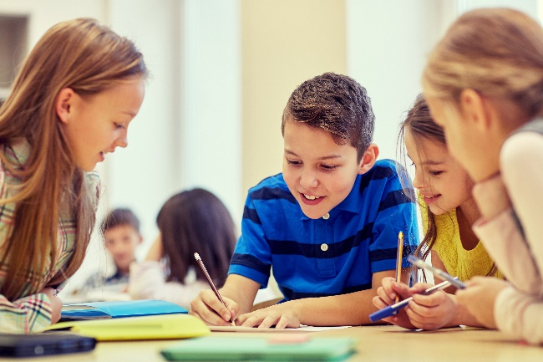
Cooperative learning frameworks create opportunities for groups of students to work together, generally to a single purpose.
istockphoto.com
As well as having the potential to increase learning for all students involved, using these frameworks can help students develop personal and social capability.
When students are working in groups, positive interdependence can be fostered by assigning roles to group members.
These roles could include:
- Working roles such as Reader, Writer, Summariser, Time-keeper
- Social roles such as Encourager, Observer, Noise monitor, Energiser.
Teachers using the Primary Connections roles of Director, Manager and Speaker for their science teaching may find it effective to also use these roles for STEM learning.
Further to this, specific roles can be delineated for specific activities that the group is completing.
It can help students if some background to the purpose of group roles is made clear to them before they start, but at no time should the roles get in the way of the learning. Teachers should decide when or where roles are appropriate to given tasks.
istockphoto.com

Appendix 8: Teacher resource sheet 1.2: Cooperative learning – Jigsaw
Cooperative learning frameworks create opportunities for groups of students to work together, generally for a single purpose.
As well as having the potential to increase learning for all students involved, using these frameworks can help students develop personal and social capability.
The jigsaw strategy typically has each member of the group becoming an 'expert' on one or two aspects of a topic or question being investigated. Students start in their cooperative groups, then break away to form 'expert’ groups to investigate and learn about a specific aspect of a topic. After developing a sound level of understanding, the students return to their cooperative groups and teach each other what they have learnt.
Within each expert group, issues such as how to teach the information to their group members are considered.

Step 1 | Cooperative groups  (of four students) | 1 2 3 4 |  | 1 2 3 4
Step 2 | Expert groups  (size equal to the number of groups) | 1 1 | 2 2 | 3 3 | 4 4
Step 3 | Cooperative groups  (of four students) | 1 2 3 4 |  | 1 2 3 4

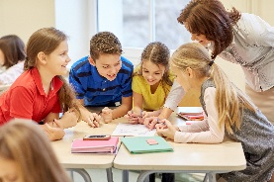
Appendix 9: Teacher resource sheet 1.3: Cooperative learning – Placemat
Cooperative learning frameworks create opportunities for groups of students to work together, generally for a single purpose.
istockphoto.com
As well as having the potential to increase learning for all students involved, using these frameworks can help students develop personal and social capability.
The placemat strategy involves students working collaboratively to record prior knowledge about a common topic and brainstorm ideas. It also allows teachers to readily see the contribution of each student. The diagram below shows a typical placemat template.

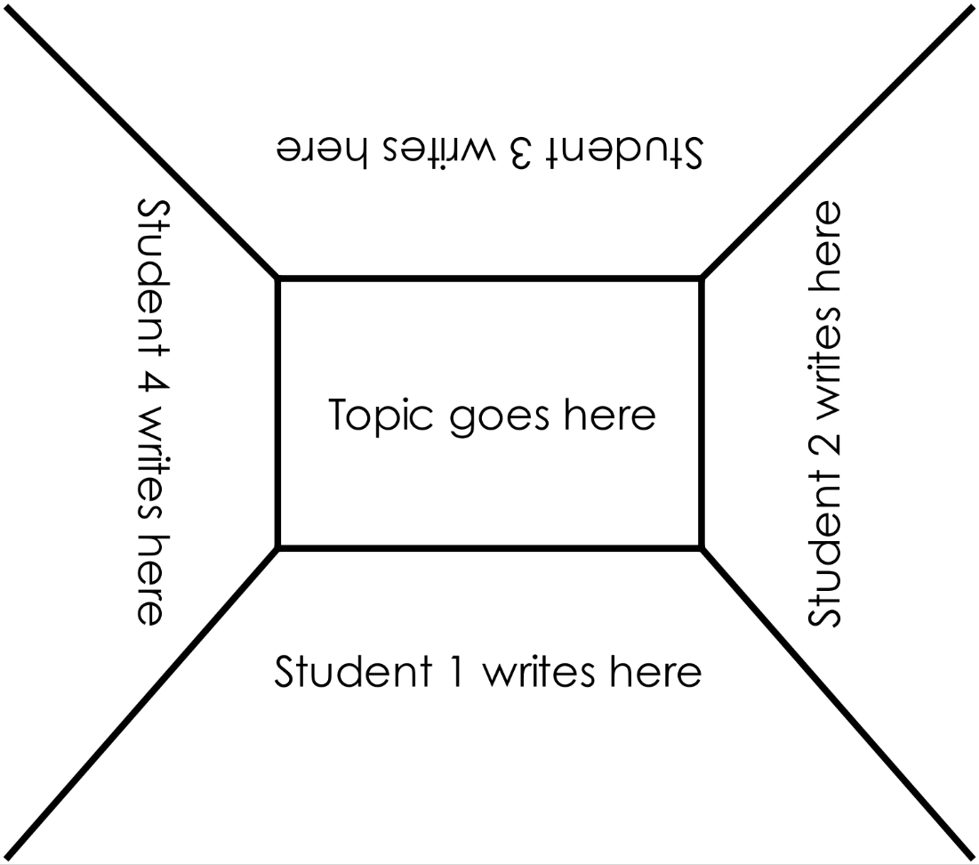

STEM Consortium

Appendix 10: Teacher resource sheet 1.4: Cooperative learning – Think, Pair, Share
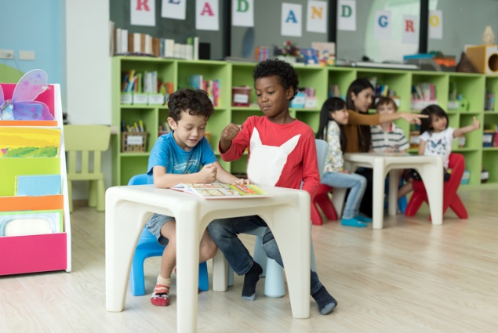
Cooperative learning frameworks create opportunities for groups of students to work together, generally to a single purpose.
istockphoto.com
As well as having the potential to increase learning for all students involved, using these frameworks can help students develop personal and social capability.
In the 'think' stage, each student thinks silently about a question asked by the teacher.
In the 'pair' stage, students discuss their thoughts and answers to the question in pairs.
In the 'share' stage, the students share their answer, their partner’s answer or what they decided together. This sharing may be with other pairs or with the whole class. It is important also to let students 'pass'. This is a key element of making the strategy safe for students.
Think–pair–share increases student participation and provides an environment for higher levels of thinking and questioning.
istockphoto.com

Appendix 11: Student activity sheet 3.1: Design brief
Group members ________________________________________________________________________________________________________________
Problem | How can we engage the school community in making better travel choices?
Our focus
area
Issues
addressed
Supporting facts and data
Audience
Key
messages
Mode of
delivery

Appendix 12: Student activity sheet 4.1: Presentation review
Photographs or drawing

Things I would keep the same ________________________________________________________________________________________________________________________________________________________________________________________________________________________________
Things I would change
________________________________________________________________________________________________________________________________________________________________________________________________________________________________________________________
Extra things I could do
____________________________________________________________________________________________________________________________________________________________________________________________________________________________________________________________

Appendix 13: Teacher resource sheet 4.2: Evaluation
Key:  - Sometimes  - Often  - Always | Student name
Remains focused on tasks presented
Completes set tasks to best of their ability
Works independently without disrupting others
Manages time effectively
Cooperates effectively within the group
Contributes to group discussions
Shows respect and consideration for others
Uses appropriate conflict resolution skills
Actively seeks and uses feedback

Notes
________________________________________________________________________________________________________________________________________________________________________________________________________________________________________________________________________________________________________________________________________________________________________________________________________________________________________________________________________________________________________________________________________________________________________________________________________________________________________________________________________________________________________________________________________________________________________________________________________________________________________________________________________________________________________________________________________________________________________________________________________________________________________________________________________________________________________________________________________________________________________________________________________________________________________________________________________________________________________________________________________________________________________________________________________________________________________________________________________________________________________________________________________________________________________

