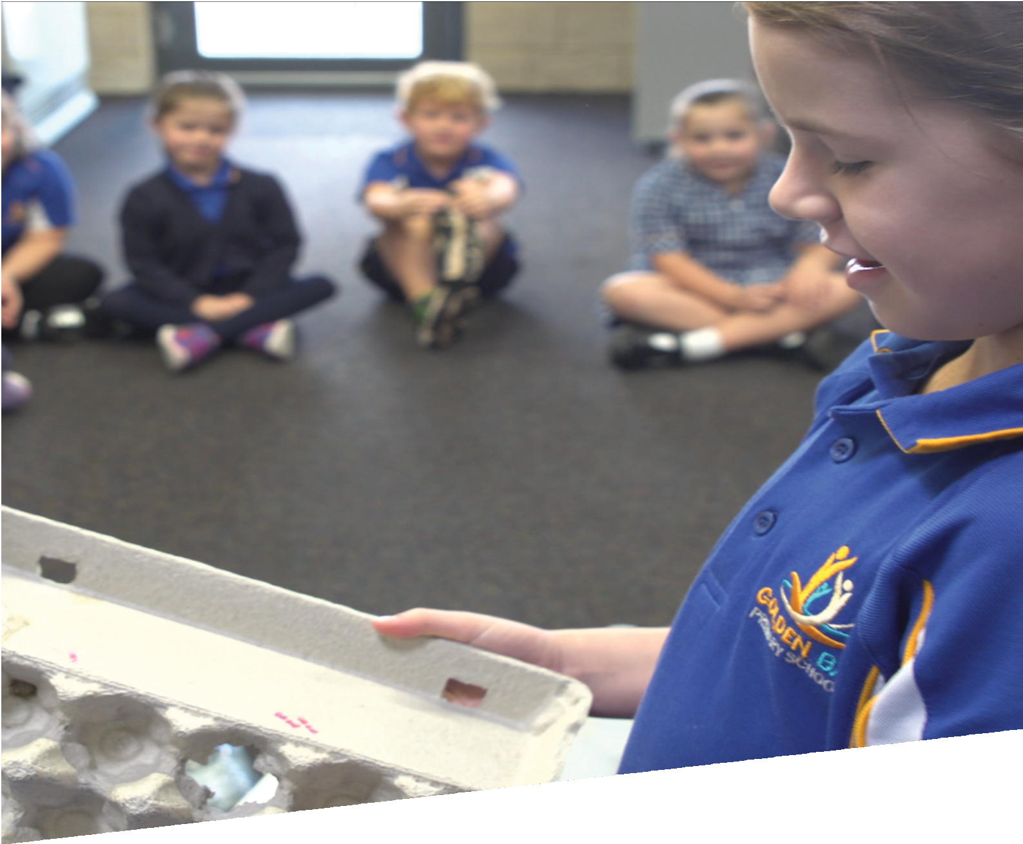
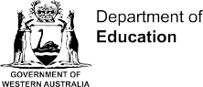

CURRICULUM RESOURCE MODULE
Waste warriors
YEAR 2
Acknowledgements
We acknowledge and thank the teachers and schools who are the co-creators of these resources.

The STEM Learning Project is funded by the Western Australian Department of Education (the Department) and implemented by a consortium in STEM education comprising the Educational Computing Association of WA, the Mathematical Association of WA, the Science Teachers Association of WA and Scitech. The STEM Learning Project respectfully acknowledges the Traditional Custodians of the lands upon which our students and teachers live, learn and educate.
Copyright and intellectual property
The copyright and intellectual property of this module remain the property of the Department.

Any Western Australian Curriculum content in this resource is used with the permission of the School Curriculum and Standards Authority (the Authority); this permission does not constitute Authority endorsement of the resource. The Authority accepts no liability for any errors or damages arising from reliance on its content.

The Western Australian Curriculum content may be freely copied, or communicated on an intranet, for non-commercial purposes in educational institutions, provided that the Authority is acknowledged as the copyright owner. Copying or communication for any other purpose can be done only within the terms of the Copyright Act 1968 or with prior written permission of the Authority. Any Australian Curriculum content in the Western Australian Curriculum is used by the Authority under the terms of the Creative Commons Attribution NonCommercial 3.0 Australia licence. Any content on the www.scsa.wa.edu.au domain that has been derived from the Australian Curriculum may be used under the terms of Creative Commons Attribution-NonCommercial 3.0 Australia licence.

Appendix 2: General capabilities continuums is adapted from ACARA, © Australian Curriculum, Assessment and Reporting Authority (ACARA) 2009 to present, unless otherwise indicated. This material was downloaded from the ACARA website (www.acara.edu.au) (accessed December 2015) and was not modified. The material is licensed under CC BY 4.0 (https://creativecommons.org/licenses/by/4.0/). ACARA does not endorse any product that uses ACARA material or make any representations as to the quality of such products. Any product that uses material published on this website should not be taken to be affiliated with ACARA or have the sponsorship or approval of ACARA. It is up to each person to make their own assessment of the product.

This resource includes references and examples of iOS, Android and other apps. The Department does not endorse or recommend any commercial products and simply provides these as examples for teachers.

The Department is committed to providing quality information to its customers. Whilst every effort has been made to ensure accuracy, currency and reliability of the information within these documents, the Department accepts no responsibility for errors, omissions or amendments made since the time of publishing. Confirmation of information may be sought from the Department or the originating bodies providing the information. The Department has no control over the content of material published on websites to which users are referred in this resource. It is the responsibility of the internet user to make their own decision as to the relevancy, accuracy, currency and reliability of information found on those sites.

Attributions: iMovie, MS Excel, Class Dojo, Explain everything, Connect, Seesaw.

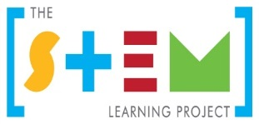
Table of contents

The STEM Learning Project 2
Overview 3
Activity sequence and purpose 7
Background 8
Activity 1: Why so much waste? 11
Activity 2: What does our school waste? 20
Activity 3: Reducing waste at our school 34
Activity 4: Learning symposium 38
Appendix 1: Links to the Western Australian Curriculum 44
Appendix 1B: Mathematics proficiency strands 47
Appendix 2: General capabilities continuums 48
Appendix 3: Materials list 50
Appendix 4: Design process guide 51
Appendix 5: Reflective journal 52
Appendix 6: Student activity sheet 1.1: Journal checklist 53
Appendix 7: Teacher resource sheet 1.2: Cooperative learning – Roles 54
Appendix 8: Teacher resource sheet 1.3: Cooperative learning – Think, Pair, Share 55
Appendix 9a: Teacher resource sheet 1.4: Waste images 1 56
Appendix 9b: Teacher resource sheet 1.4: Waste images 2 57
Appendix 10: Student activity sheet 1.5: I see, I think, I wonder 58
Appendix 11: Student activity sheet 1.6: KWL Chart 59
Appendix 12: Teacher resource sheet 1.7: Sample parent letter 60
Appendix 13: Teacher resource sheet 3.1: Construction skills 61
Appendix 14: Student activity sheet 3.2: Prototype troubleshooting 65

The STEM Learning Project
The aim of the STEM Learning Project is to generate students’ interest, enjoyment and engagement with STEM (Science, Technology, Engineering and Mathematics) and to encourage their ongoing participation in STEM both at school and in subsequent careers. The curriculum resources will support teachers to implement and extend the Western Australian Curriculum and develop the general capabilities across Kindergarten to Year 12.
Why STEM?
A quality STEM education will develop the knowledge and intellectual skills to drive the innovation required to address global economic, social and environmental challenges.
STEM capability is the key to navigating the employment landscape changed by globalisation and digital disruption. Routine manual and cognitive jobs are in decline whilst non-routine cognitive jobs are growing strongly in Australia. Seventy-five per cent of the jobs in the emerging economy will require critical and creative thinking and problem solving, supported by skills of collaboration, teamwork and literacy in mathematics, science and technology. This is what we call STEM capability. The vision is to respond to the challenges of today and tomorrow by preparing students for a world that requires multidisciplinary STEM thinking and capability.
The approach
STEM capabilities are developed when students are challenged to solve open-ended, real-world problems that engage students in the processes of the STEM disciplines.
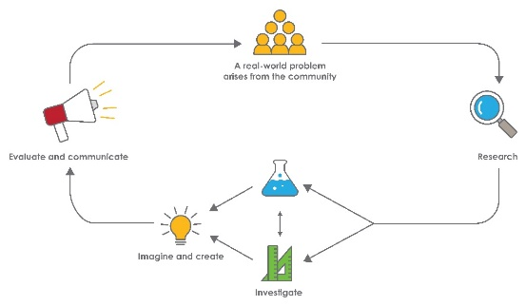
Year 2 – Waste warriors

Overview
This module focuses on developing knowledge, skills, and values about waste as students consider the impact of lifestyle choices on the environment and how they can contribute to more sustainable patterns of living.
What is the context?
People can strive for a more sustainable future by reducing waste and conserving the Earth’s natural resources.
As a nation, Australians are buying more products, and using them less before throwing them away, adding to the fast-growing mountain of unnecessary landfill.
Processed food and manufactured goods are often excessively packaged, producing more waste before they are ever used.
Plastic bags are a practical replacement for the cloth or paper bags that were used to carry many goods in the pre-plastic era, but unlike paper, plastics do not break down quickly or completely when discarded. Single use plastic bags are used for an average of 12 minutes, but often end up littering the streets, polluting our natural environment like bushlands, waterways, and oceans and harming the health of our wildlife for hundreds of years. Efforts are being made to reduce the use of single-use plastic bags. For example, the Western Australian government has banned them, and retailers and consumers have been challenged to find sustainable alternatives.
While this is a step in the right direction, the competition to attract consumers through convenient and attractive pre-packaging of goods continues to add to the excessive production of waste materials that are typically thrown away rather than reused. Even when placed in recycling bins, the overall volume of discarded recyclable materials such as textiles, paper, cardboard, wood, glass, metals, hard plastics, electronic waste, and rubber exceeds manufacturers’ ability to process most of these materials and they often still end up in landfill.

What is the problem?
How can we reduce waste at our school?

How does this module support integration of the STEM disciplines?
Science
Students begin to understand the importance of using science to predict possible effects of human activity and developing management plans or alternative technologies that minimise these effects. In particular, when interviewing seniors and investigating waste around the school, students learn that the Earth’s resources are used in a variety of ways (ACSSU032: Understand Earth’s resources are used in a variety of ways) and that science involves observing, asking questions about, and describing changes in, objects and events (ACSHE034: Science involves observing, asking questions about, and describing changes in, objects and events). They question, predict, investigate, explore and compare observations about the waste being generated and discarded at school and in society in general (ACSIS037: Pose and respond to questions, and make predictions about familiar objects and events, ACSIS038: Participate in guided investigations to explore and answer questions, ACSIS039: Use informal measurements to collect and record observations, using digital technologies as appropriate, and ACSIS040: Use a range of methods to sort information, including drawings and provided tables and through discussion, compare observations with predictions). They engage in representing and communicating their observations and ideas in a variety of ways when planning for and presenting their ideas at a learning symposium (ACSIS042: Represent and communicate observations and ideas in a variety of ways).
Technology
Students engage with design processes from the Technologies syllabus as they create ways to reduce waste in their school community (ACTDEK001: People design and produce familiar products, services and environments to meet local and community needs, WATPPS11: Explore design to meet needs or opportunities), use materials and equipment safely (WATPPS13: Use components and given equipment to safely make solutions) and work collaboratively (WATPPS15: Work independently, or collaboratively when required, to organise information and ideas to safely create and share sequenced steps for solutions). Students use Information communication technology (ICT) to communicate their design ideas, describing or drawing their construction process and modelling the sequence of steps (WATPPS12: Develop, communicate and discuss design ideas through describing, drawing, modelling and/or a sequence of steps).
The Design process guide is included as a resource to assist teachers in understanding the complete design process as developed in the Technologies curriculum.

Mathematics
When collecting and sorting waste items students are given the opportunity to group, partition and rearrange collections in tens and ones to facilitate more efficient counting (ACMNA028: Group, partition and rearrange collections up to 1000 in hundreds, tens and ones to facilitate more efficient counting) and to represent collections as repeated equal groups, in arrays, and as repeated addition to develop the concept of multiplication (ACMNA031: Recognise and represent multiplication as repeated addition, groups and arrays). Students use balance scales and uniform, informal units to compare the mass (ACMMG038: Compare masses of objects using balance scales) and the volume (ACMMG037: Compare and order several shapes and objects based on length, area, volume and capacity using appropriate uniform informal units) of different types of waste materials. They collect, check and classify data about waste (ACMSP049: Collect, check and classify data) and begin to see how data can be usefully displayed using lists, tables and graphs (ACMSP050: Create displays of data using lists, table and picture graphs and interpret them).
General capabilities
There are opportunities for the development of general capabilities and cross-curriculum priorities as students engage with this module, students:
- Develop problem solving skills as they research the problem and its context (Activity 1); investigate parameters impacting on the problem (Activity 2); imagine and develop solutions (Activity 3); and evaluate and communicate their solutions to an audience (Activity 4).
- Utilise creative thinking as they generate possible design solutions; and critical thinking, numeracy skills and ethical understanding as they choose between alternative approaches to solving the problem.
- Utilise personal and social capability as they develop socially cohesive and effective working teams; collaborate in generating solutions; adopt group roles; and reflect on their group work capabilities.
- Utilise a range of literacies and Information and communication technologies (ICT) capabilities as they collate records of work completed throughout the module in a journal; represent and communicate their solutions to an audience using digital technologies in Activity 4.
- Communicate and, using evidence, justify their design to an authentic audience.
- Learn to value sustainable use of materials through extending their life and use, therefore reducing waste.

What are the pedagogical principles of the STEM learning modules?
The STEM Learning Project modules develop STEM capabilities by challenging students to solve real-world problems set in authentic contexts. The problems engage students in the STEM disciplines and provide opportunities for developing higher-order thinking and reasoning, and the general capabilities of creativity, critical thinking, communication, and collaboration.
The design of the modules is based on four pedagogical principles:
- Problem-based learning
All modules are designed around students solving an open-ended, real-world problem. Learning is supported through a four-phase instructional model: research the problem and its context; investigate the parameters impacting on the problem; design and develop solutions to the problem; and evaluate and communicate solutions to an authentic audience.
- Developing higher order thinking
Opportunities are created for higher order thinking and reasoning through questioning and discourse that elicits students' thinking, prompts and scaffolds explanations, and requires students to justify their claims. Opportunities for making reasoning visible through discourse are highlighted in the modules with the icon shown here.
- Collaborative learning
This provides opportunities for students to develop teamwork and leadership skills, challenge each other’s ideas, and co-construct explanations and solutions. Information that can support teachers with aspects of collaborative learning is included in the resource sheets.
- Reflective practice
Recording observations, ideas and one’s reflections on the learning experiences in some form of journal fosters deeper engagement and metacognitive awareness of what is being learned. Information that can support teachers with journaling is included in the resource sheets.
These pedagogical principles can be explored further in the STEM Learning Project online professional learning modules located in Connect Resources.

Activity sequence and purpose
Why so much waste?
Students engage with the problem of waste by researching consumer behaviour. They learn about the packaging and distribution of goods and identify the natural resources from which products are made. They appreciate that the earth’s resources are finite.
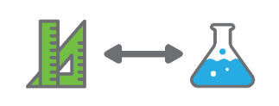 | What does our school waste?  Students investigate how items are packaged, delivered and used and consider the potential waste generated. They produce and analyse data about the materials that are discarded and the ways these could be reduced, reused or recycled. They focus on the content of their own lunch box and suggest sustainable alternatives.
Reducing waste at our school.
Students follow the technology design process as they imagine and create practical solutions to reducing waste in their school community based on their research in
Activity 1 and their investigations in Activity 2.
Learning symposium.
Students share their strategies for reducing waste with their peers and communicate their solutions to a community audience via a learning symposium using a chosen form of media.

Background
Expected learning | Students will be able to:  - Identify real-world problems related to the environment and sustainability  - Identify some ways that Earth’s resources are used  - Describe changes in objects and events  - Identify questions of interest, predict outcomes and gather data to answer the questions  - Produce, document and organise data  - Partition collections in tens and ones to facilitate efficient counting  - Create grid arrays to represent multiplication as repeated addition  - Compare and order objects and materials based on number, mass and volume, and measure using balance scales and appropriate uniform, informal units  - Develop, communicate and discuss design ideas through describing, drawing, modelling and/or sequencing steps  - Use a chosen form of information communication technology (ICT)to record the design process  - Work collaboratively, to organise information and ideas to safely create and share sequenced steps for solutions
Vocabulary | The following vocabulary list contains terms that need to be understood, either before the module commences or developed as they are used:  biodegradable, data, environment, manufactured material, natural, organic, plastic, recycle, reduce, repurpose, resources, reuse, single-use plastics, strength, survey, sustainable, tally, textiles, upcycle, useful, waste, waterways.
Timing | There is no prescribed duration for this module. The module is designed to be flexible enough for teachers to adapt. Activities do not equate to lessons; one activity may require more than one lesson to implement.
Consumable materials | A Materials list is provided for this module. The list outlines materials outside of normal classroom equipment that will be needed to complete the activities.
Safety notes | There are potential hazards inherent in these activities and with the equipment being used. A plan to mitigate any risks will be required.  Potential hazards specific to this module include but are not limited to:  - Possible exposure to cyber bullying, privacy violations and uninvited solicitations when using the internet.  - Hazards associated with being outdoors such as falls, insect bites and exposure to direct sunlight.  - Potential health hazards when handling waste materials.
Assessment | The STEM modules have been developed to provide students with learning experiences to solve authentic real-world problems using science, technology, engineering, and mathematics capabilities. While working through this module, assessment opportunities will arise as students:  - Plan and conduct interviews with seniors and school staff  - Collect, and interpret data  - Use science inquiry skills to investigate the generation of waste  - Sort and categorise waste items  - Count and measure different kinds of waste  - Develop and present solutions to reduce waste in the  school community.  Appendix 1 indicates how the activities are linked to the Western Australian Curriculum.  Evidence of learning from journaling, presentations and anecdotal notes from this module can contribute towards the larger body of evidence gathered throughout a teaching period and can be used to make on-balance judgments about the quality of learning demonstrated by the students in the science, technologies, and mathematics learning areas.  Students can further develop the general capabilities of Information and communication technology capability, Critical and creative thinking and Personal and social capability. Continuums for these are included in the General capabilities continuums but are not intended to be used for assessment purposes.
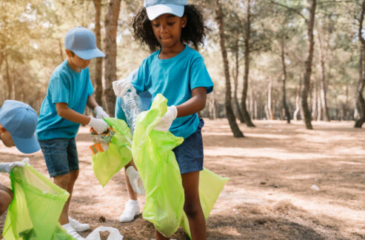
Getty images

Activity 1: Why so much waste?
Activity focus | Students engage with the problem of waste by researching consumer behaviour. They learn about the packaging and distribution of goods and identify the natural resources from which products are made. They appreciate that the earth’s resources are finite.
Background information | Australians generate approximately 67 million tonnes of waste a year. We can work together to reduce many types of household waste including paper, plastics, aluminum, steel, electronic waste, food and garden waste.  Single-use plastics such as shopping bags, straws, cups, water bottles, cutlery, and food wrappers save time and effort for businesses and consumers and have therefore replaced many of the reusable cloth, glass and metal containers and utensils in use before cheap plastic replacements became increasingly available in the 1960s and 1970s.  Packaging protects items from contamination and theft and entices consumers to purchase. The high level of efficiency and safety achieved by modern methods of manufacturing, packaging, and distribution of foodstuffs and other goods has resulted in a huge increase in waste with increased use of resources and environmental damage.  Plastic, in particular, has negatively impacted the environment and possibly human health through the pollution and ingestion of ‘micro-plastics’. These are the very tiny pieces of plastic that result from the breaking down of plastics, whether as part of a manufacturing process or when plastics products are discarded. They accumulate permanently in the food chain, cannot be digested and may be found to have long term detrimental effects on health.  The Earth’s natural resources are finite and there may not always be resources available to make the products we consume. It is estimated that Australian households throw away one tonne of plastic every minute (War on Waste, ABC). Government efforts to reduce this include the banning of single-use plastic bags.
Instructional procedures | It is recommended that students work in small groups of three to four for most activities. Mixed ability groups encourage peer tutoring and collaboration in problem-solving. Collaboration is an important STEM capability, see Teacher resource sheet 1.2: Cooperative learning – Roles.  Student ideas and learning should be recorded in a reflective journal. Depending on the needs of the class, this can be a collaborative process in one class journal, or students can work individually in their own journals. The journal can be either digital or physical. See Reflective journal for more support.  A KWL chart is suggested as a graphic organiser for several of the data producing activities. Support for using this strategy can be found at www.youtube.com/watch?v=L8ZhucZczxE.  During Activities 1and 2 plan the class displays carefully, incorporating the use to tables to collate the growing amount of data students will have produced. Students will need to refer to this information during Activity 3 to inform their design solutions. At this year level, their own journaling and recordings will not be as helpful as whole class carefully modelled data displays.  In Activity 4, students share their awareness of sustainable practices that could be implemented in their school community to reduce waste, before hosting a learning symposium for the wider community. The main objective of the symposium is to establish a common community language regarding sustainability, with a focus on the 12th sustainable development goal of the United Nations, responsible consumption, and production, and to build partnerships for sustainable education within the school community. Visit the sustainability development goals at https://sustainabledevelopment.un.org/sdg12.  A whole-school approach towards sustainability and waste reinforces what has been learned in classrooms and moves students and the school community from developing knowledge and skills towards providing motivation and opportunities to take action. Consideration for a whole school approach towards achieving this sustainable goal should begin from Activity 1.  Sustainable Schools WA is a whole-school planning framework for Education for Sustainability that has been developed 'by schools, for schools' to support the implementation of the Western Australian Curriculum.  http://det.wa.edu.au/curriculumsupport/sustainableschools/detcms/portal/  The twelve 'action learning areas' showcase school case studies and key resources that support additional learning and action for sustainability across school communities. Support resources about waste can be found at:  http://det.wa.edu.au/curriculumsupport/sustainableschools/detcms/navigation/action-learning-areas/waste/
Expected learning | Students will be able to:  - Identify real-world problems related to the waste of natural resources (Science).  - View images, make observations and compare them with others and draw inferences from observations (Science).  - Plan questions and conduct interviews to produce relevant data (Science).  - Describe a change in objects and events (Science).
Equipment required | For the class:  Interactive whiteboard or data projector with internet access  Whiteboard and markers
For the students:
Student activity sheet 1.5: I see, I think, I wonder
Student activity sheet 1.6: KWL Chart
Preparation | Prior to the activity, take photos of waste found in places with which students are familiar (eg beach, park, river), or use photos from Teacher resource sheet 1.4: Waste images.  Prepare and distribute a parent letter before the commencement of the module. See Teacher resource sheet 1.7: Sample parent letter.  Source seniors (in their 70s) from local retirement or aged care villages, clubs or students' relatives and friends willing to participate in activities.  Preview relevant videos and photo references to decide which to use during Activity 1. See links in the Digital resources section.
Activity parts | Part 1: What do we throw away?  Ask students to use the think-pair-share strategy (see Teacher resource sheet 1.3: Cooperative learning – Think, pair, share) to explore their prior knowledge of what is meant by ‘waste’. Use the following questions to prompt student thinking:  - What things get thrown away in your house?  - How does your family get rid of those things?  - What are those things made from? (e.g. plastic, paper, cardboard, glass, metal.)  - What packaging gets thrown away in your house?  - Which objects are ‘one-use’ (e.g. paper plate) and which are thrown away after many uses (e.g. ice-cream container, or broken items that are not repaired)?  As a class, summarise the information using a wall display. It may be set up as an explosion chart or a table that categorises the waste according to the information provided by the students. If permitted, students could take a tablet home and photograph various ‘throw-away’ items to add to the display – or other photos and/or children’s drawings can be used. The display can be a reference point during later investigations into the range of waste products produced in the school.
Part 2: Why worry about waste?
Display waste photos at stations around the room (Teacher resource sheet 1.4: Waste images). Students work in small groups at each station to complete Student activity sheet 1.5: I see, I think, I wonder. This is a thinking strategy that encourages students to make careful observations and thoughtful interpretations, stimulating curiosity and inquiry.
To relate the activity to Part 1, ask:
- What can you see in the photos that look like things your family might put in the rubbish?
- What do you think might happen to these waste items over time?
- What problems could be caused by these waste items if left where they are?
Have students share their thoughts with the class. If time is available, rotate students to another station.
Show students short video clips from the Digital resources or read from Literary resources to assist students to understand the problems that excessive waste has produced in modern societies, particularly from the plastic packaging and single-use products currently available. Emphasise that the invention of cheap ‘throw-away’ plastic products is relatively recent.
Revisit the last two questions,
- What do you think might happen to these waste items over time?
- What problems could be caused by these waste items when left where they are?
Brainstorm students’ answers on the whiteboard, and highlight that most plastics are made from non-renewable resources (ie oil, coal and natural gas).
With students’ assistance, add relevant information to the wall display, focusing on the adverse effects of generating excessive waste.
Students’ individual reflections at this stage could be recorded in their personal journals.
Part 3: What did people do in the past?
Students research how people purchased foods and goods, how they were packaged, how the food was stored and how they carried food and other goods in the past (50 or 60 years ago). Source seniors, about 70 years of age, for students to interview. They could be relatives of students and teachers, people residing in retirement villages or from seniors groups or clubs in the community.
Refer to the various ‘throw-away’ items listed on the display, and identify what might not have been available to people over 70 when they were children. As background, also show some photos of how shops looked before ‘self-service’ shopping became available. (See Digital resources).
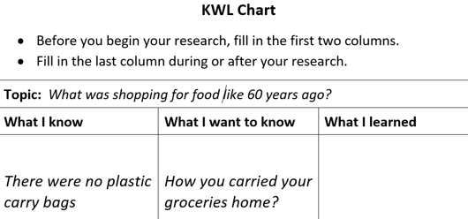
Use the KWL resource sheet (Student resource sheet 1.6: KWL Chart) to assist students to work in pairs and decide on a focus topic and a series of ‘Want to know’ questions for their interview. See example below:
Prompt with suggested questions if necessary. For example, for the topic ‘School lunches 60 years ago’ they might ask:
- What did you take to school for lunch?
- What sort of lunch box did you have?
- How was your lunch wrapped?
- Was there a canteen and what did it sell?
When the interviews are complete, use two columns, ‘then’ and ‘now’, to compare what the students have learned with their own experience.
Use focus questions to assist students’ thinking and to emphasise that ways of wrapping, packaging and carrying food can affect the quantity of waste produced:
- How did people wrap food before plastic wrap?
- What kinds of snacks did people have before the little snack packs we have now?
- How did people carry food and other goods home from the shops?
- What did people use to store leftover food?
- How were shops different?
- What kinds of food were kept in big bags or containers in shops and only measured into paper bags as purchased?
- What do we now throw away, that people used to keep and re-use?
Help students review the information in the table and consider how much more waste material is generated now compared to 50-60 years ago.

Introduce students to the problem:
- How can we reduce waste at our school?
Explain that in the next activity they will be investigating the different foods and materials used at school, the ways they are packaged and used, and suggest ways the level of waste can be reduced. Lastly, they will communicate their suggestions to the school community.
Part 4: Reflection and journaling
Students write or draw what they have learned in their reflective journal (individual or class) in response to these focus questions:
- Why do we have so much more waste now than before there were supermarkets and plastic packaging?
- What items and materials might we be throwing away at our school?
Resource sheets | Teacher resource sheet 1.2: Cooperative learning – Roles  Teacher resource sheet 1.3: Cooperative learning – Think, pair, share  Teacher resource sheet 1.4: Waste images 1 & 2  Student activity sheet 1.5: I see, I think, I wonder  Student activity sheet 1.6: KWL Chart  Teacher resource sheet 1.7:Sample parent letter
Digital resources | Shopping for Food and goods  Photo history of food in Australia in each decade  https://australianfoodtimeline.com.au/  Wide range of photos of old-fashioned grocery shops, shopping bags, signs and markets to use as stimulus (the site allows 1-month free access and 10 free images)  https://www.shutterstock.com/search/old-fashioned+grocery+shops?image_type=photo  Video of old-style hardware shop with commentary explaining personal service – refers to change in the 1960s.  https://youtu.be/QOaTUxeJjII  Video of an American corner store – needs to be previewed with only short clips shown to students to see examples of ‘over the counter’ personal service.  https://youtu.be/wJRiI_pI1jY  60 photos of historic shopping – ranging from very early to first supermarkets – select photos of ‘over the counter’ images to show students.  https://youtu.be/Kca3vJ7sbXA  A photo history of the plastic bag https://www.unenvironment.org/news-and-stories/story/birth-ban-history-plastic-shopping-bag
Earth’s resources used to make plastic
How Plastic is Made (Green Living Science, 2017)
youtu.be/w4VG-7ZFvDM
Single-use plastics and their impact on our environment
Ocean confetti (MinuteEarth, 2014)
youtu.be/qVoFeELi_vQ
Can you live plastic-free for 31 days? (Cleanaway, 2018)
www.cleanaway.com.au/about-us/sustainable-future/plastic-free-living-2018/
War on Waste, Chapter 4: Plastics in our oceans - Part 1 (ABC Education, 2017)
education.abc.net.au/home#!/digibook/2597026/war-on-waste
War on Waste, Chapter 4: Plastics in our oceans – Part 2 (ABC Education, 2017)
education.abc.net.au/home#!/digibook/2597026/war-on-waste
Plastic Bags (ABC Behind The News, 2008)
www.abc.net.au/btn/story/s2227446.htm
Dolphin dies after becoming entangled in fishing line in the Swan River (The West Australian, 2018)
thewest.com.au/news/animals/swan-river-dolphin-found-dead-with-tackle-wrapped-around-its-fin-ng-b88935416z
How much plastic does it take to kill a turtle? (CSIRO News-release, 2018)
www.csiro.au/en/News/News-releases/2018/How-much-plastic-does-it-take-to-kill-a-turtle
Literary resources | Duffy’s lucky escape by Eleanor Jackson (Author),  Liz Oldmeadow (Illustrator)  A bag and a bird by Pamela Allen  All the way to the ocean by Joel Harper  Lelani and the plastic kingdom by Robb N. Johnston

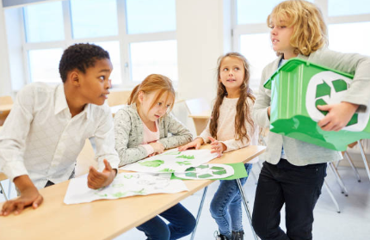
Getty images

Activity 2: What does our school waste?
Activity focus  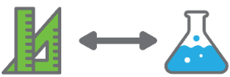 | Students investigate how items are packaged, delivered and used and consider the potential waste generated. They produce and analyse data about the materials that are discarded and the ways these could be reduced, reused or recycled. They focus on the content of their lunch box and suggest sustainable alternatives.
Background information | Many household products are used without much thought about their origin. For example:  - metals are made from minerals mined from the Earth  - plastics are mostly made from oil  - paper products are often made from wood fibres, but can also be made from cotton, silk, and reeds  - textiles can be made from animal hair or fur (eg wool), plant fibres (eg cotton) and plastics made from oil and coal (eg polyester).  Manufacturers transform and combine natural resources into a new state to create products with properties different from the raw materials. Some manufactured materials can be recycled but this often doesn’t happen. Good sustainable design looks for solutions that use materials already available before buying more. Textiles are materials which are often wasted when they could be repurposed, for example, in just one-hour Australians throw away 36 tonnes of clothes, or 6 tonnes every 10 minutes (War on Waste, ABC).
Instructional procedures | The following activities provide students with opportunities to develop mathematical skills when counting and measuring rubbish collected at the school. Students compare the weight and volume of collected waste materials and challenge the common misconception that ‘bigger things’ weigh more than ‘smaller things’. They need to learn that this is only true in some circumstances. There is an opportunity to challenge These misconceptions using balance scales to demonstrate the different weights of the same volume of different kinds of materials.  In this activity, the production of tables and graphs is modelled by the teacher to help students develop proficiency in deciding when and how to display and interpret data. Students participate in discussions to understand that classification underlies the organisation of data and that there are differences between data and their interpretations. When classifying and reading data, students compare the categories, calculating totals and differences.  Provide students with enough time and support to interpret the data displays so they can be confident in the conclusions they draw. The main science skill to be developed is interpreting data.  Students develop both mathematical and scientific understandings as they pose questions to guide the collection of data and question the data produced. They learn that their questions must be precise and this may need to be modelled by the teacher with students being prompted to elaborate on simple questions. Students should experience the processes involved in posing questions for themselves and refine and reframe the questions to make them useful.  Assist students to distinguish between questions that could be answered by collecting data and questions that are vague or ambiguous.
Expected learning | Students will be able to:  - Collect, sort and group objects into categories (Mathematics and Science).  - Identify a question of interest and gather data that can be grouped (Mathematics and Science).  - Compare different ways of categorising and measuring data (Mathematics and Science).  - Group, partition and rearrange collections, including in tens and ones, to facilitate more efficient counting (Mathematics).  - Represent collections using a grid array and repeated addition as an introduction to multiplication (Mathematics).  - Measure and compare mass using balance scales and volume using regular informal units of different types of waste materials. (Mathematics).  - Identify common types of materials from their observable properties (Technologies and Science).  - Explain that common materials are made from the Earth’s resources (Science).  - Pose and respond to questions, and make predictions about familiar objects and events (Science).  - Participate in guided investigations to explore and answer questions (Science).
Equipment required | For the class:  Contents of bins from different areas of the school  Identical containers to use as informal, uniform units of volume  A litre carton filled with water and sealed to use for informal mass unit  Balance scales  Interactive whiteboard  Disposable gloves and tongs  Large tarpaulin or plastic groundsheet
For the students:
1 cm grid paper
KWL Charts (Student resource materials 1:3 KWL Chart)
Rubber bands to bundle discarded straws and pop sticks
Disposable gloves and tongs
Preparation | Decide in advance whether it will be appropriate to collect all rubbish bins or just a selection. This will depend on the size of the school and the time available for the sorting activity.  Consider the time of the activity, such as after lunch, by which time most of the waste has been produced and discarded  If there is more than one collection method suggested by students, it may be useful to engage different groups in different methods. For example, some students could watch other students at lunchtime and record items that are discarded, while others could empty a classroom bin and sort, count or measure the contents.  Advise other staff of the activity, particularly if the sorting will occur in a shared area of the school.  Plan how to safely dispose of food waste. Extra care should be taken with decomposing food items. Ensure there are enough disposable gloves and tongs available. Any child whose parents wish them to be excluded should be provided with suitable alternative activities, such as an observation checklist to record results or a device with which to take photos.
Part 1: Which products result in waste at our school?
Students conduct interviews with school personnel to find out what products are used, how they are packaged and what is likely to be discarded. For example, groups or pairs of students can interview:
- Canteen workers
- Office staff
- Teachers
- Students
- Cleaners
- Library staff
Encourage students to photograph the various products mentioned during the interviews to focus the following discussion.
Collate the photos and brainstorm the potential waste involved for each type of product. Ask:
- Which products are likely to result in waste?
- Which parts of the products would be wasted?
- What are the waste parts made of?
- Where will it be discarded?
Discuss with students, how they might measure the waste produced:
- Which types of material do you think are wasted the most in our school?
- How did our interviews help us think about that?
- What else could we do to find out which kinds of materials are discarded at the school?
- What else could we do to find out how much of each kind of material is wasted?
- Can we use numbers to help us record how much of each kind of material is wasted?
Part 2: Collecting the waste
It is suggested that an investigation of the content of rubbish bins take place after lunch, by which time the majority of waste has been produced and discarded.
How the data is produced should take into account students’ responses to the final questions in Part 1.
The collection of data could be managed in different ways, depending on the size of the school. In small schools, the contents of all bins could be examined, while in a large school a sampling of bins might be more suitable. Students at this level will not have the proportional reasoning required to engage with formal or even intuitive sampling methodology, but they would be able to understand that a bin from the lunch area, a bin from the office, and a bin from the classroom would produce a ‘fairer’ range of school waste than say, three classrooms bins. Students might also decide to use only the waste produced by their class as another way of obtaining a sample of the school.
Some waste will be easily counted, for example, the number of straws, pop sticks or paper or plastic cups discarded, while other types of waste might be better measured, such as the mass of plastic wrap. Bear in mind that at year two, students are not yet using formal units or standard measuring instruments. The teacher may, however, like to demonstrate the use of a formal measurement such as mass on digital scales to expose students to concepts they will learn in future years.
A suggested approach is described below but should be adapted to accommodate local conditions and students’ ideas and levels of development.
Organise students into small groups and plan which bins will be collected, how the waste will be sorted and what will be photographed. Students may choose to sort and measure the contents of one bin at a time or put the contents together. Choose as appropriate for the class and school size.
In a protected open area, spread the collected waste items onto a tarpaulin or plastic sheet. Ask students to think about what they see. Photos can be taken for later reference. Ask focus questions such as:
- What kinds of waste items do you see?
- Is this what you expected to see? (Compared to information from the interviews.)
- Which pieces of waste are whole items, and which are packages or wrappings?
- What looks to be the most common type of waste material?
- How can we best sort the waste into categories to help us answer our questions about how much of each type of waste we produce?

Ask students how they could collect data about the categories of waste.
- Which types of waste would be best counted to find out how many? Why? (e.g. whole items that are the same type and size, such as straws, pop sticks, plastic cups, fruit drink cartons, drink cans.)
- How could you record how many? (Tally marks, numbers, drawings.)
- Which types of waste would be best put together and measured in some way? Why? (e.g. same kind of material that is in different sizes and/or screwed-up, such as plastic wrap, snack packaging, paper bags, foodstuffs.)
- What kinds of measurements would tell us ‘how much’ we have of these different kinds of materials?
  - Students may need to be prompted to distinguish between volume, ‘how big’, and mass, ‘how heavy’. While area could also be considered, it is difficult for this age group to provide a sensible informal unit and may confuse rather than assist their understanding of the attribute.
Discarded food can be weighed by measuring the mass of a suitable closed container and personally disposing of or closely supervising the disposal of all food and drink scraps into that container during the sorting activities. The container can then be weighed following the activity and the mass of the food it contains determined by subtracting the mass of the container from the total. This can then be a topic of conversation:
- Why are we wasting so much food?
- What are the implications of this kind of waste?
Once the data collection methods have been decided, coordinate the sorting of the materials so they are placed in designated areas or large, labelled containers. When all items have been sorted, ask students to examine the remaining waste and discuss what to do with any unsorted materials. Ask:
- Are there any categories of discarded items that we forgot about?
- Can we categorise what is left?
- Do we need to include an ‘other category’ for mixed items, or are there enough of the same types of material to add a new category?

Part 3: Producing the data
Some thought needs to be given to the counting and measuring of the collected rubbish so that the mathematical concepts that can be developed and/or practised are appropriately matched to the quantities involved and the intended purpose for the data. The following are some suggestions for making the most of this opportunity.
Number concepts:
If there are more than around 30 items to count, introduce early place value understandings, drawing attention to the significance of groupings by tens.
Begin by suggesting that we could count by ones to find out how many items but it would be hard to keep track and not lose count and have to start over again. Ask:
- Is there an easier way?
Students may suggest grouping items and skip counting. Ask how many would be a good number to put in each group. Groups of four may be good as students will find it easy to make groups without having to count. Invite students to think about whether that will make it easier to count. Write the following list on the white-board and encourage students to count by fours.
1 group = 4
2 groups = 8
3 groups = 12
4 groups = 16
And so on.
Keep adding groups until students struggle to find the next total.
Ask students to suggest other numbers and settle on trying ten. Demonstrate how you can get ten items without counting, ie. taking three and two to make five and then another three and two to make ten. Invite students to suggest other ways, for example, three and three and three to make nine and one more to make ten, or two and two to make four, and another four, and two more to make ten.
List the groups of ten next to the fours as shown:
1 group = 4 1 group = 10
2 groups = 8 2 groups = 20
3 groups = 12 3 groups = 30
4 groups = 16 4 groups = 40
Typically students will find counting by tens easier and will quickly find the next number for each subsequent group (though be aware that they may not yet fully connect counting by tens to counting by ones – ie that they must result in the same quantity).
Continue the list into the hundreds and ask students if they can see anything interesting about the number of groups and the tens numerals. Draw attention to the continuation of the pattern in the numeral for the number of groups and the total amount.
Have students group the discarded straws into tens using elastic bands. Use the pattern in the number of groups to write the total without needing to count by tens, and then count by tens to show that the numbers match, not forgetting to add on any extra items each time. Ask:
- How many would there be if we counted them all by ones?
Reinforce that the number must be the same no matter how the of items are counted. It is of value to count how many by ones with the class to develop trust that skip counting by tens tells you the same ‘how many’ as counting by ones.
For fewer than about 30 items, have students arrange items in an array in rows to match the skip counting strategy the students wish to use. Represent on grid paper and then as repeated addition, not forgetting to add on the extra items. Below is an example of the three representations for a quantity of 22 cans.
STEM Consortium
The language of multiplication can be introduced if students are ready. Explain there are 4 rows and there are 5 items in each row, so we are adding 4 groups of 5 items which makes 20 items altogether. We can also write that as 4 x 5 = 20 which is the same as 5 + 5 + 5 + 5 = 20.
Only some students in year two will make sense of the idea that you can count how many of other ‘numbers’ and understand the meaning of ‘four fives’ without seeing or visualising four groups of five objects. Ensure students have visual representations to help them interpret these early multiplication concepts and the associated language.
Students should be invited to arrange their smaller collections in various ways, trying different ways to use skip counting to find the totals, emphasising that no matter how the collection is arranged or counted the total must be the same. When comparing strategies for counting, the focus should be on which is the most efficient for a particular collection. By exploring different arrays for their collections, they can also discover which groupings for which numbers make a neat array without leftovers and so be informally working with factors and multiples.
Graphing concepts
After all counting methods have been exhausted, record the totals in a display ready for later reflections.
- Can you easily see how many items are wasted at school each day? Is there a way to make this easier?
This part creates opportunities for students to transfer concrete information (ie different types of items) to abstract information (ie numbers).
Using a selection of items from each waste group, model the creation of a pictograph on the board. Ask students to draw a picture of an item from the selection of items on a square of paper. Arrange the squares of paper in the column corresponding to the label, creating the graph together.
Once finished, ask students to mark the top of the highest square piece of paper in each column. Then remove all the square pieces of paper and, using different colours, colour each column.
Prompt students to think about the information the graph represents:
- Can you use the graph to tell us which item is the most common without counting each picture? How?
- Would this data be the same tomorrow?
- Would our data be more accurate if we took samples over multiple days?
- Can you see any interesting trends?
- Does the representation help us to see at a glance what waste types of are most common?
- Which item has the tallest column? The smallest column?
- What does this tell us?
Clarify misconceptions regarding quantity, mass and and size.
Measurement concepts:
Measurement involves quantifying continuous quantities. In this context it means measuring the total amount of each type of material even though it is made up of items of different sizes and shapes. For example, the hard plastics will be made up of various drink bottles, yoghurt containers, snack containers etc.
It is suggested that volume and mass are used to measure the amount of each type of waste.
Volume – Students can use informal, uniform units to measure the volume of the different types of material, for example, equal sized containers or buckets to fill with the material they have collected and record how many buckets they can fill. Use a container size that relates to the overall quantity ensuring they would need to fill it at least three or four times to measure the total amount.
Explain that to make accurate comparisons, students have to squeeze as many of the items in the containers as possible, but no more.
- Why should we be careful to fill the container just level with the top and not have the materials bulging over the edge?
Demonstrate how to shake the container to ensure there are no air pockets, fitting shapes together with no gaps or overlaps.
Question the students:
- Are gaps and overlaps are a problem? Why?
- Which objects created containers with the least gaps?
- Which objects had the biggest gaps? Could more items fit? How much more does it need? What could we do to make it fit exactly? Does it make a difference if you pack the items in the containers very carefully?
- How could you pack it again so that there are not so many gaps? What makes a good fit?
- Why are some items easier to pack than others?
- If you squash them into the container have you changed the size of your item? How do you know?
Over time, students should see that to get reliable results they need to ensure that the item size remains constant throughout and that they fit in as many as possible, but no more.
Students will need help to quantify part units, using language like ‘nearly four buckets full’, ‘about three and a half’, ‘just over four’, for example.
Mass – Students can use balance scales to compare the mass of the different materials to an informal, uniform unit. While any suitable unit could be used, it makes sense to use a litre carton filled with water as the unit, which happens to approximate a kilogram. Students put the sealed litre of water on one side of the balance scales and add the pieces of the material until it balances, ie the mass of the material is the same as the mass of the water. They record how many times they can do that before the material is used.
Record the mass and volume for each type of materials.
Draw attention to any differences to help students understand that mass and volume are quite different attributes. For example, the paper wrappings may be lighter overall than the plastic but may have more volume. If there are discarded metal cans, they can be crushed and matched by volume to the same volume of waste plastic wrap, and then compared using the balance scale to show that the metal is much heavier than the same volume of plastic.
Students photograph or draw a basic diagram to represent the result of this comparison, showing the slope of the beam.

plastic metal
eg

Record the total measurements on the class display for later reflection.

Part 4: What kinds of waste can be reduced?
Students review the results of their research and investigations as shown in the class display and consider the overall problem of how to reduce waste at school. Ask focus questions such as:
- Which items are most often discarded at school?
Likely to be straws and disposable food and drink containers.
- What kinds of materials are thrown away?
If classroom and office rubbish is included, the amount of paper thrown away could be raised as a concern.
- What kind of material is most often discarded?
Likely to be plastic packaging and wrapping materials.
- What are these items and materials used for?
Likely to be for wrapping or holding food and drink.
- Which of these items or materials could be replaced by other non-disposable products to reduce the waste?
Remind students to think back to their interviews with the seniors and refer to the table displaying the results of their interviews.
Additional learning opportunity
To focus students thinking, suggest they do an ‘audit’ of their lunch box (or purchased lunch). Have them take a before and after photo, laying out the items they will discard. Display the photos after lunch and collaboratively problem solve how these waste items can be reduced in their lunches. It would be expected that there will be variation among students so sensitivity is required to avoid making judgments and embarrassing students. If there is concern about this, students can focus only on their lunch box and use their journals to records ways they can reduce their waste.
- Discuss the methods students with less rubbish use.
- How do the items in your lunchbox contribute towards the larger collection of school waste?
Part 5: Reduce
Remind students of the previous discussion about ways to reduce waste by using non-disposable alternatives, particularly after getting some ideas from our interviews with seniors.
View videos listed in the digital resources section about reducing, reusing and recycling waste materials. Compare the merits of reducing waste production vs reusing or recycling waste and conclude that reducing waste is the best option.
Explain that in the next activity students will be creating solutions to reduce waste, that they will then communicate their solutions to the school community through a planned ‘learning symposium’ (Activity 4).
Part 6: Reflection and journaling
Students use drawings and writing reflect on their learning from their investigations and the videos. Provide the following suggestions:
- Choose one item of waste and show/describe how it could be replaced with something you don’t need to throw away.
- Choose a different item of waste and say how it could be re-used or recycled.
- Write down at least one suggestion for the canteen that would help to reduce waste at recess and lunch.
- Decide which type of material you would try most to reduce and say why?
- How did the audit develop your understandings about waste at our school?
- How did you use numbers to help you measure how much waste is produced?
- Did your graph help to see the types of waste produced?

Digital Resources | Single-use plastic bags  War on Waste, Chapter 3: Plastic bags (ABC Education, 2017)  education.abc.net.au/home#!/digibook/2597026/war-on-waste  Plastic bag ban (ABC Behind The News, 2017)  www.abc.net.au/btn/story/s4704469.htm  Straw no more  www.strawnomore.org/
Plastic-free ideas
Plastic free ideas, calendar (Cleanaway, 2018)
www.cleanaway.com.au/about-us/sustainable-future/plastic-free-living-2018/
Straw no more
www.strawnomore.org/
City of Kwinana initiative nets impressive results (The West Australian, 2018)
thewest.com.au/news/sound-southern-telegraph/city-of-kwinana-initiative-nets-impressive-results-ng-b88919325z
Solutions
Australia found a simple and helpful way to save water from plastic pollution (Thinking Humanity, 2018)
www.thinkinghumanity.com/2018/12/australia-found-a-simple-and-helpful-way-to-save-water-from-plastic-pollution.html
4Ocean is a global movement actively removing trash from the ocean and coastlines while inspiring individuals to work together for cleaner oceans
4ocean.com/?gclid=EAIaIQobChMI1f2f9ZWz4AIVjTUrCh0Ykw4pEAAYASAAEgLQSfD_BwE
Seabins officially switched on in an effort to clean up Mandurah’s waterways (Mandurah Mail, 2019)
www.mandurahmail.com.au/story/5894525/seabins-officially-switched-on-in-an-effort-to-clean-up-mandurahs-waterways/
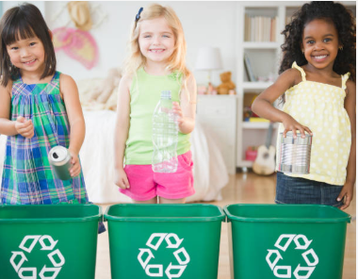
Envision is an Australian company making prosthetics (particularly for children) from bottle caps.
http://www.envision.org.au/media-packs/
Getty images

Activity 3: Reducing waste at our school
Activity focus | Students follow the technology design process as they imagine and create practical solutions to reducing waste in their school community based on their research in  Activity 1 and their investigations in Activity 2.
Background information | The choices we make, for example replacing single-use plastics with non-disposable alternatives, repurposing and recycling, can help to reduce waste, create change and contribute to a healthier and more sustainable environment.  Students assess the current school practices and consider alternatives that could reduce school waste.
Instructional procedures | As students engage in the design thinking process they will be asked to  - Develop empathy and understand the needs of the people for whom they are designing solutions.  - Define the problem and opportunity for designing solutions.  - Generate and visualise creative ideas.  - Develop approaches and strategies to reduce waste.  - Test solutions and seek feedback.  By developing design thinking in our students, we increase their confidence in their abilities to adapt and respond to new challenges, develop innovative solutions to problems and develop as optimistic, empathetic and active members of society who can contribute to solving the complex challenges the world faces into the future. See Appendix 4: Design process guide.
Expected learning | Students will be able to:  - Identify a community problem and explore design ideas to address the problem (Technologies).  - Develop, communicate and discuss design ideas through describing, drawing, modelling and/or sequenced steps (Technologies).  - Work independently and collaboratively as required to develop a solution to a problem (Technologies)
Equipment required | For the class:  Construction tools and materials, see Materials list  Digital camera
Preparation | Prepare time and space for construction activities.
Activity parts | Part 1: Creating solutions  Students work in small groups on practical solutions to the problem:  - How can we reduce waste at our school?  Students may draw on ideas from things they have seen at home or in the media. Encourage investigation through class discussion and using the internet. Revisit digital resources accessed during Part 2 to prompt students.  Possible ideas include:  - Promote a ‘no-waste’ lunch box program with instructions for parents.  - Suggest to the Art Teacher that they include a ‘paper making’ project using discarded photocopying and other scrap paper to make art paper.  - Make paper mache objects from discarded wrapping paper and paper bags.  - Encourage teachers to print less and use technology more.  - Set printer defaults to 2-sided.  - Host a book, clothing, sporting goods, toy or garden swap event.  - Design shopping or library bags from old cloth articles that parents with sewing machines can be asked to make.  - Recycle food scraps in a school worm farm or compost heap.  - Find out from the local council if the school can use a multi-bin system (if not already installed).  - Advocating for change in the school canteen (eg biodegradable or re-usable cutlery, pasta straws, etc).  - Plan and build an edible garden or chicken coop.  - Collect discarded cloth products, cut or tear in strips and use to make plaited mats.  - Make reusable waterproof wrap from old cloth sheeting and beeswax to replace plastic wrap for storing food.  - Encourage teachers to make greater use of ICT for students’ writing in lessons to save paper.  Encourage and accept students’ ideas. Suggest they talk to their older siblings and parents for ideas they may not have thought about.
Part 2: Ideation
Student groups choose and start planning their waste reduction solution. Students work together to draw or write about their idea and then pitch their idea to the teacher. The teacher will need to guide students to understand and use the design process (outlined in Design process guide). Students’ designs may involve a strategy, a product, or a process that provides one solution to the problem of how to reduce waste at the school. It may include a scientific diagram that is labelled to show details as well as the materials required and how the strategy or item will reduce waste or, it may provide a sequential list of actions to be undertaken to achieve an outcome.
Discuss with students how they might present their design by asking:
- What is your solution?
- What should your drawing/description include?
- What type of drawing or description will work best to show the features of your solution? (eg top view, front view, explosion chart, step by step diagram, numbered actions).
- How will the person looking at your drawing/description understand its purpose?
- How will we label our diagrams in the same way scientists do?
Part 3: Development
Students construct a prototype or other visual representation to use when pitching their solution on waste during the Learning symposium in Activity 4. If constructing a prototype or model, students consider and source types of materials and appropriate tools. Adult assistance will likely be required throughout this process. See Teacher resource sheet: 3.1 Construction skills and
1.7: Sample parent letter.
If their design plan is a strategy, assist them to think about how they can best convey their plan to an audience; will they produce a video, a PowerPoint presentation or a series of annotated photos or diagrams?
Question students about their work during the process:
- What are you making/describing?
- What is its purpose?
- Are you able to follow your plan or did you have to make changes? Why did you need to change your plan?
- What problems have you had with your design?
- How can you improve your prototype or strategy?
Support students in documenting the process by capturing digital images. Provide an opportunity for students to present and obtain feedback from the class before the symposium, to enable revisions and improvements.
Part 4: Reflection and journaling
Conduct a review of the process. Students write their reflections in the class journal or their journal.
Additional learning opportunity: Upcycling
Introduce the idea of ‘upcycling’ waste. Ask students to consider how they might repurpose waste items to be of use or more value. For example, they may like to make a library, sport or shopping bag or cushion cover, handbag, purse, mat/rug, potholder, coat hanger cover, juggling balls or dog toy from discarded fabrics or yarn. They could use a range of discarded materials to create art objects. This activity provides students with time to stimulate their ideas and learn important construction skills.
During construction, ask students:
- Why is it a good idea to upcycle unwanted materials to create useful or valued items?
- How would upcycling contribute to reducing waste?
Resource sheets | Teacher resource sheet 1.3: Cooperative learning – Think, Pair, Share  Teacher resource sheet 3.1: Construction skills  Student activity sheet 3.2: Prototype troubleshooting

Activity 4: Learning symposium
Activity focus | Students share their strategies for reducing waste with their peers and communicate their solutions to a community audience via a learning symposium using a chosen form of media.
Instructional procedures | In this activity, students attempt to build the capacity of their audience for thinking and acting in ways that contribute to a waste-free, sustainable future. They seek to develop reflective thinking processes and empower design action that will lead to a more equitable, respectful and sustainable school and community.  Students are likely to require scaffolding to prepare their presentations. To scaffold cooperative group work, each member of the group could have a role and responsibility. For example, one could be the Content Director, one the Media Director and a third the Presentation Director. While one student has overall responsibility for managing an aspect of the task all students contribute to each of the three phases of deciding on the content; preparing the media; and presenting.  Ensure every group member has a role in the presentation.  Students can be given a choice of creating a range of presentation types, including digital (eg iMovie or Explain everything), which could then be shared through a digital portfolio platform such as Connect, Seesaw or Class Dojo. Students may require explicit instruction in using these apps.  To enable the completion of the design process, students should be given time to make improvements to their work based on feedback. This could be in groups or as a private reflection written in journals. Time should be taken to discuss how to give constructive feedback and how to take feedback positively.
Expected learning | Students will be able to:  - Use a chosen form of information communication technology to record a reflection of the design process (Technologies).  - Explain that the Earth’s resources are used in a variety of ways (Science).  - Describe how changes in behaviour can reduce waste (Science).  - Record and represent observations and communicate ideas in a variety of ways, using data to justify their ideas. (Science and Mathematics).  - Work independently, or collaboratively, to organise information and ideas to safely create and share sequenced steps for solutions (Technologies).
Equipment required | For the class:  Digital devices with appropriate apps  Information communication technology (ICT)
For the students:
Sticky notes in two different colours
Preparation | Ensure devices are charged and loaded with appropriate apps.  Locate an appropriate venue for the leaning symposium. With input from students, decide on an audience and invite participants or advertise the event.  A great deal of teacher input will be needed to plan and deliver a successful Learning Symposium. To maximize learning opportunities for students, it is suggested that they are involved in decisions with teacher guidance. It may also be possible to buddy with a Year 6 class who can provide suggestions and guidance to individual students during this process.  Ensure students have time to practice their presentations before delivery.
Activity parts | Part 1: Gallery walk  Students participate in a gallery walk to view and share their design solutions for reducing waste from Activity 3. Provide students with sticky notes in two colours. Identify the colour that will be used to identify a strength about a solution and the other colour to give feedback. Encourage students to work in their small groups offering an idea for improvement for up to three solutions.  Allocate time for students to consider the feedback and make any revisions needed. This can be a continuation of Parts 5 & 6 from Activity 3.
Part 2: Complete their presentations
Student groups are provided with time and support to fully complete their presentations and practise until they feel confident to proceed to a more public display and presentation.
Only after students are at that stage should the final date be set for the Learning Symposium to ensure its success.
Part 3: Planning the Learning Symposium
With teacher support, students identify where they want to hold the Learning Symposium and how they plan to set up their space.
As a class, lead a discussion in which the details of the Symposium can be planned. Questions to be resolved as part of this process include:
- When will it be held, and for how long should it last?
- How many different displays/presentations will there be? How much space will we need for our displays?
- Where will we hold it? How big is the venue? How many people can it hold?
- Should we send invitations or just advertise? What different could that make?
- How will we organise the space? Will we need tables and chairs? What technology will we need on the day?
- Will we provide any refreshments, and if so, how will we pay for them?
- Do we need to have a ‘keynote speaker’ to set the scene for the day? Who could that be and what would we want them to talk about?
With student input, create a timeline and tasks that need to be completed leading up to the Symposium. Also, as a class, create a task sheet for the day to ensure it runs smoothly.
Develop promotional material or invitations.
Encourage students to be creative. Promotional materials or invitations can be designed using graphic design software such as Canva, Microsoft Word or Pages.
Engage students at every stage of the planning, accepting their suggestions as appropriate.
Part 4: Planning for evaluation
Discuss with the class how they could find out whether the Symposium was successful and what ‘successful’ means. Does it mean that everyone had an enjoyable day, or does it mean, will people change their ‘waste’ habits as a result of seeing and hearing the presentations?
Students are asked to design a simple feedback questionnaire that visitors to the symposium can complete on the day to obtain data that tells them how likely it is that at least some families will change waste habits for the better. Questions could include:
- Did you learn anything new from the presentations?
- If yes, what was one thing you learned?
- How likely are you to change your behavior?
- If the answers to the above question is ‘not at all likely’ please say why?
Consider having ‘roving reporters’ recording short interviews with visitors, asking similar questions. Consider how the feedback questionnaire will be administered, a poll everywhere app could be a digital option.
Part 5 Conducting the Symposium
Ensure digital equipment is charged and loaded with appropriate apps as needed, and tested before the day. Arrange displays using parent help if required.
Arrange for photos and/or a video to be taken on the day to be reviewed back in class.
Students make their presentations to the audience. Following the presentations, participants are encouraged to engage students with questions about their findings and suggestions. Polling apps such as Poll Everywhere, Mentimeter and Ask the room provide quick and easy feedback from presentation audiences.
Following the Symposium, students may like to share their presentations more broadly using a chosen forum (eg Connect, Seesaw, Class Dojo, a class blog, etc).
Part 6: Reflection and journaling
Students self-evaluate and reflect on the benefits of the Learning Symposium and their personal experiences in presenting to the audience. Assist students to collate the participants’ feedback sheets and consider whether or not they can consider the Symposium successful, based on that feedback.
Encourage students to reflect the total experience by asking:
- Three things you have learned
- Two things that challenged you
- A question you are still wondering about
- How your understanding and commitment to sustainability have changed as you have worked through this STEM module.
Students complete Student activity sheet 1.0: Journal checklist.
Part 7 – Enacting solutions
Following the reflective process, engage students in thinking about which of all the solutions presented, they could, as a class develop and implement at the school.
The overall effectiveness of the module in raising student and community awareness of waste issues could be greatly improved by the implementation of students' ideas where practically possible.
This could engage students in additional STEM-related learning opportunities. Enacting proposed strategies could also involve students from a range of year groups as well as the Parents and Citizens Association, teachers and other schools staff or community groups.
An important real-life skill for students would be in the development of criteria that can be used to measure how well the intended outcome of the particular strategy has been met. Well-planned success criteria can tell students how effective their strategies have been in reducing waste in the school community.

Resource sheets | Student activity sheet 1.0: Journal checklist
Digital resources | Keynote  itunes.apple.com/au/app/keynote/id361285480?mt=8
Comic Maker HD
itunes.apple.com/au/app/comic-maker-hd/id649271605?mt=8
iBooks Author
www.apple.com/au/ibooks-author
Book Creator
itunes.apple.com/au/app/book-creator-for-ipad-create/id442378070?mt=8
Comic Life
itunes.apple.com/us/app/comic-life/id432537882?mt=8&ign-mpt=uo%3D4
iMovie
itunes.apple.com/au/app/imovie/id377298193?mt=8
Pages
itunes.apple.com/au/app/pages/id361309726?mt=8
Seesaw Digital Portfolio
web.seesaw.me
Class Dojo
www.classdojo.com
Explain Everything
explaineverything.com
Getty images

Appendix 1: Links to the Western Australian Curriculum
The Waste warriors? module provides opportunities for developing students’ knowledge and understandings in science, technologies, and mathematics. The table below shows how this module aligns with the content of the Western Australian Curriculum and can be used by teachers for planning and monitoring.

Waste warriors  Links to the Western Australian Curriculum | ACTIVITY
 | 1 | 2 | 3 | 4
SCIENCE
SCIENCE UNDERSTANDING
Earth and space sciences: Understand Earth’s resources are used in a variety of ways (ACSSU032) | ● | ●
SCIENCE AS A HUMAN ENDEAVOUR
Nature and development of science: Science involves observing, asking questions about, and describing changes in, objects and events (ACSHE034) | ● | ●
SCIENCE INQUIRY SKILLS
Questioning and predicting: Pose and respond to questions, and make predictions about familiar objects and events (ACSIS037) | ● | ●
Planning and conducting: Participate in guided investigations to explore and answer questions (ACSIS038) | ● | ●
Planning and conducting: Use informal measurements to collect and record observations, using digital technologies as appropriate (ACSIS039) |  | ●
Processing and analysing data and information: Use a range of methods to sort information, including drawings and provided tables and through discussion, compare observations with predictions (ACSIS040) |  | ●
Waste warriors  Links to the Western Australian Curriculum | ACTIVITY
 | 1 | 2 | 3 | 4
DESIGN AND TECHNOLOGIES
KNOWLEDGE AND UNDERSTANDING
Technologies and society: People design and produce familiar products, services and environments to meet local and community needs (ACTDEK001) |  |  | ● | ●
Materials and technologies specialisations: Characteristics and properties of materials and individual components that are used to produce design solutions (ACTDEK004) |  |  | ● | ●
PROCESSES AND PRODUCTION SKILLS
Investigating and defining: Explore design to meet needs or opportunities (WATPPS11) |  |  | ● | ●
Designing: Develop, communicate and discuss design ideas through describing, drawing, modelling and/or a sequence of steps (WATPPS12) |  |  | ● | ●
Producing and implementing: Use components and given equipment to safely make solutions (WATPPS13) |  |  | ●
Collaborating and managing: Work independently, or collaboratively when required, to organise information and ideas to safely create and share sequenced steps for solutions (WATPPS15) |  |  |  | ●
Waste warriors  Links to the Western Australian Curriculum | ACTIVITY
 | 1 | 2 | 3 | 4
MATHEMATICS
NUMBER AND ALGEBRA
Number and place value: Recognise and represent multiplication as repeated addition, groups and arrays (ACMNA031) |  | ●
Number and place value: Group, partition and rearrange collections up to 1000 in hundreds, tens and ones to facilitate more efficient counting (ACMNA028) |  | ●
MEASUREMENT AND GEOMETRY
Using units of measurement: Compare and order several shapes and objects based on length, area, volume and capacity using appropriate uniform informal units (ACMMG037) |  | ●
Using units of measurement: Compare masses of objects using balance scales (ACMMG038) |  | ●
STATISTICS AND PROBABILITY
Data representation and interpretation: Collect, check and classify data (ACMSP049) |  | ●
Data representation and interpretation: Create displays of data using lists, table and picture graphs and interpret them (ACMSP050) | ● | ● | ●
Further information about assessment and reporting in the Western Australian Curriculum can be found at: k10outline.scsa.wa.edu.au/home.

Appendix 1B: Mathematics proficiency strands
Key ideas
In Mathematics, the key ideas are the proficiency strands of understanding, fluency, problem-solving and reasoning. The proficiency strands describe the actions in which students can engage when learning and using the content. While not all proficiency strands apply to every content description, they indicate the breadth of mathematical actions that teachers can emphasise.
Understanding
Students build a robust knowledge of adaptable and transferable mathematical concepts. They make connections between related concepts and progressively apply the familiar to develop new ideas. They develop an understanding of the relationship between the ‘why’ and the ‘how’ of mathematics. Students build understanding when they connect related ideas, when they represent concepts in different ways, when they identify commonalities and differences between aspects of content, when they describe their thinking mathematically and when they interpret mathematical information.
Fluency
Students develop skills in choosing appropriate procedures; carrying out procedures flexibly, accurately, efficiently and appropriately; and recalling factual knowledge and concepts readily. Students are fluent when they calculate answers efficiently, when they recognise robust ways of answering questions, when they choose appropriate methods and approximations, when they recall definitions and regularly use facts, and when they can manipulate expressions and equations to find solutions.
Problem-solving
Students develop the ability to make choices, interpret, formulate, model and investigate problem situations, and communicate solutions effectively. Students formulate and solve problems when they use mathematics to represent unfamiliar or meaningful situations, when they design investigations and plan their approaches, when they apply their existing strategies to seek solutions, and when they verify that their answers are reasonable.
Reasoning
Students develop an increasingly sophisticated capacity for logical thought and actions, such as analysing, proving, evaluating, explaining, inferring, justifying and generalising. Students are reasoning mathematically when they explain their thinking, when they deduce and justify strategies used and conclusions reached, when they adapt the known to the unknown, when they transfer learning from one context to another, when they prove that something is true or false, and when they compare and contrast related ideas and explain their choices.
Source: ACARA - www.australiancurriculum.edu.au/f-10-curriculum/mathematics/key-ideas/?searchTerm=key+ideas#dimension-content

Appendix 2: General capabilities continuums
The general capabilities continuums shown here are designed to enable teachers to understand the progression students should make with reference to each of the elements. There is no intention for them to be used for assessment.
Information and communication technology (ICT) capability learning continuum
Sub-element | Typically by the end of Year 2 | Typically by the end of Year 4 | Typically by the end of Year 6
Communicating with ICT  Collaborate, share and exchange | use purposefully selected ICT tools safely to share and exchange information with appropriate local audiences | use appropriate ICT tools safely to share and exchange information with appropriate known audiences | select and use appropriate ICT tools safely to share and exchange information and to safely collaborate with others
Personal and social capability learning continuum
Sub-element | Typically by the end of Year 2 | Typically by the end of Year 4 | Typically by the end of Year 6
Social management  Work collaboratively | identify cooperative behaviours in a range of group activities | describe characteristics of cooperative behaviour and identify evidence of these in group activities | contribute to groups and teams, suggesting improvements in methods used for group investigations and projects

Critical and creative thinking learning continuum
Sub-element | Typically by the end of Year 2 | Typically by the end of Year 4 | Typically by the end of Year 6
Inquiring – identifying, exploring and organising information and ideas  Organise and process information | organise information based on similar or relevant ideas from several sources | collect, compare and categorise facts and opinions found in a widening range of sources | analyse, condense and combine relevant information from multiple sources
Generating ideas, possibilities and actions  Imagine possibilities and connect ideas | build on what they know to create ideas and possibilities in ways that are new to them | expand on known ideas to create new and imaginative combinations | combine ideas in a variety of ways and from a range of sources to create new possibilities
Generating ideas, possibilities and actions  Seek solutions and put ideas into action | investigate options and predict possible outcomes when putting ideas into action | experiment with a range of options when seeking solutions and putting ideas into action | assess and test options to identify the most effective solution and to put ideas into action
Reflecting on thinking and processes  Transfer knowledge into new contexts | use information from a previous experience to inform a new idea | transfer and apply information in one setting to enrich another | apply knowledge gained from one context to another unrelated context and identify new meaning
Further information about general capabilities is available at:
k10outline.scsa.wa.edu.au/home/p-10-curriculum/general-capabilities-over/general-capabilities-overview/general-capabilities-in-the-australian-curriculum

Appendix 3: Materials list

The following materials are required to complete this module.
Disposable gloves
Tongs
Large plastic sheet or tarpaulin
Equipment for testing materials:
- Balance scales
- Identical containers to use as informal units of volume
- Milk carton filled with water and sealed to use as informal unit of mass
Supplies for construction:
- Assorted construction tools and materials (i.e. glue, scissors, split pins, clamps, cable ties, pins, string, sticky tape, glue guns, staplers, hook and loop fasteners).
- Additional /reusable type materials to complement what is found around the school in Activity 1(including paper, plastic, textile and metals).

Appendix 4: Design process guide
Safe production of the final design or multiple copies of the final design.
Fine tuning the production process, such as division of labour for batch or mass production.
Use of intended materials and appropriate tools to safely make the solution to the design problem.
Reflection on the process taken and the success of the design.
Evaluation can lead to further development or improvement of the design and can be a final stage of the design process before a conclusion is reached.
Could be formal or informal and verbal or written.
Ideation
Development
Development of the design ideas. Improvements, refinements, adding detail, making it better.
Activities such as detailed drawings, modelling, prototyping, market research, gaining feedback from intended user, further research – if needed – to solve an issue with the design, testing different tools or equipment, trialling production processes, measuring or working out dimensions, testing of prototypes and further refinement.
Idea generation – turning ideas into tangible forms so they can be organised, ordered and communicated to others.
Activities such as brainstorming, mind mapping, sketching, drawing diagrams and plans, collecting colour samples and/or material samples and talking through these ideas can help to generate fu creative ideas.
Using the SCAMPER model can assist with this: www.mindtools.com/pages/article/newCT_02.htm
www.designorate.com/a-guide-to-the-scamper-technique-for- creative-thinking
Analysis
Finding useful and helpful information about the design problem.
Gathering information, conducting surveys, finding examples of existing solutions, testing properties of materials, practical testing.
Understanding the meaning of the research findings.
Analysing what the information means, summarising the surveys, judging the value of existing solutions, understanding test results.
Research
Production
Evaluation

Appendix 5: Reflective journal
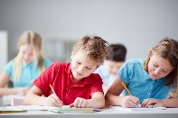
When students reflect on learning and analyse their own ideas and feelings, they self-evaluate, thereby improving their metacognitive skills. When students self-monitor or reflect, the most powerful learning happens.
Journaling may take the form of a written or digital journal, a portfolio or a digital portfolio. Early childhood classrooms may use a class reflective floor book with pictures of the learning experience and scribed conversations.
Source: istock
Teachers can model the journaling process by thinking aloud and showing students how they can express learning and thoughts in a variety of ways including diagrams, pictures and writing.
Journals are a useful tool that gives teachers additional insight into how students value their own learning and progress, as well as demonstrating their individual achievements.
The following links provide background information and useful apps for journaling.
Kidblog – digital portfolios and blogging
kidblog.org/home
Edmodo – for consolidating and storing class notes and learning materials
www.edmodo.com/
Explain Everything™ – a screen casting, video and presentation tool all in one
explaineverything.com
Popplet – allows you to jot down your ideas and then sort them visually
popplet.com
Seesaw – for capturing work completed by students in class, using a device’s camera function
web.seesaw.me
Connect – the Department of Education’s integrated, online environment
connect.det.wa.edu.au
Evernote (a digital portfolio app)
evernote.com
Digital portfolios for students (Cool tools for school)
cooltoolsforschool.wordpress.com/digital-student-portfolios

Appendix 6: Student activity sheet 1.1: Journal checklist
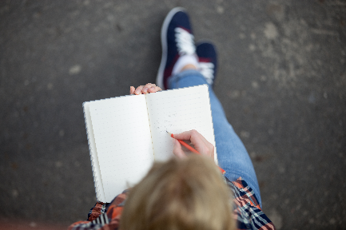
As an ongoing part of this module, you have been keeping a journal of your work.
Before submitting your journal to your teacher please ensure you have included the following information.
- Tick each box once complete and included.
Source: istock
- Write N/A for items that were not required in this module.

Your name and group member's names or photographs
An explanation of the problem you are solving
Your notes from Activity 1
Your notes from Activity 2
Your notes from Activity 3
Your notes from Activity 4
Student activity sheet 1.5: I see, I think, I wonder
Student activity sheet 3.2: Prototype troubleshooting
Student activity sheet 1.1: Journal checklist

Appendix 7: Teacher resource sheet 1.2: Cooperative learning – Roles
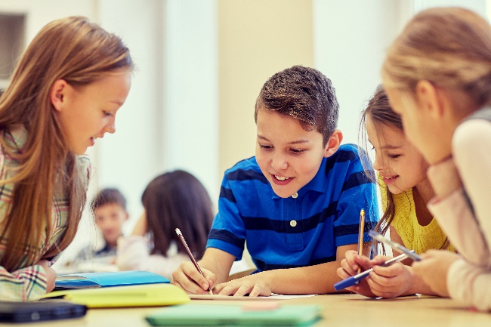
Cooperative learning frameworks create opportunities for groups of students to work together, generally to a single purpose.
As well as having the potential to increase learning for all students involved, using these frameworks can help students develop personal and social capability.
When students are working in groups, positive interdependence can be fostered by assigning roles to group members.
Source: istock
These roles could include:
- Working roles such as Reader, Writer, Summariser, Time-keeper
- Social roles such as Encourager, Observer, Noise monitor, Energiser.
Teachers using the Primary Connections roles of Director, Manager and Speaker for their science teaching may find it effective to also use these roles for STEM learning.
Further to this, specific roles can be delineated for specific activities that the group is completing.
It can help students if some background to the purpose of group roles is made clear to them before they start, but at no time should the roles get in the way of the learning. Teachers should decide when or where roles are appropriate to given tasks.
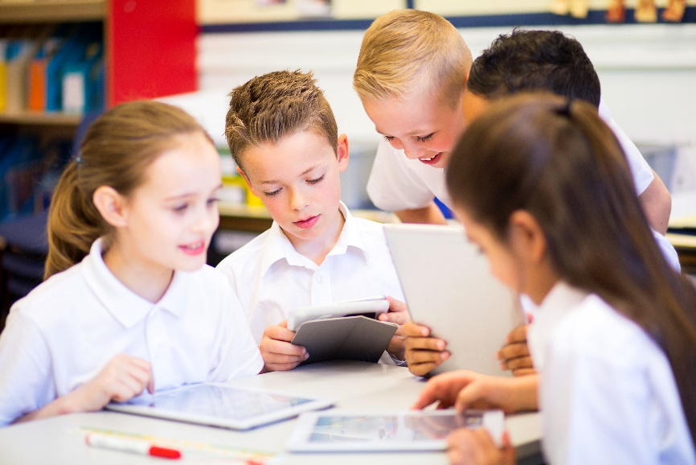
Source: istock

Appendix 8: Teacher resource sheet 1.3: Cooperative learning – Think, Pair, Share
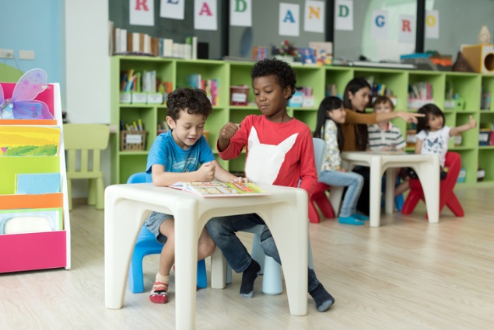
This resource sheet provides a brief outline of a cooperative learning strategy known as 'think – pair – share'.
Cooperative learning frameworks create opportunities for groups of students to work together, generally to a single purpose.
As well as having the potential to increase learning for all students involved, using these frameworks can help students develop personal and social capability.
Source: istock
In the 'think' stage, each student thinks silently about a question asked by the teacher.
In the 'pair' stage, students discuss their thoughts and answers to the question in pairs.
In the 'share' stage, the students share their answer, their partners answer or what they decided together. This sharing may be with other pairs or with the whole class. It is important also to let students 'pass'. This is a key element of making the strategy safe for students.
Think – pair – share increases student participation and provides an environment for higher levels of thinking and questioning.
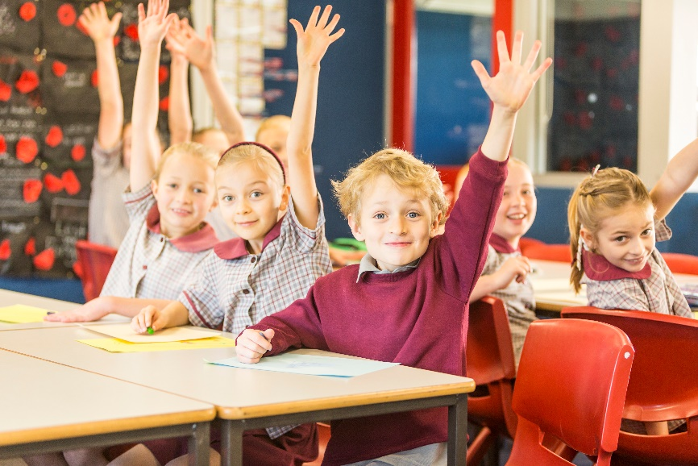
Source: istock

Appendix 9a: Teacher resource sheet 1.4: Waste images 1
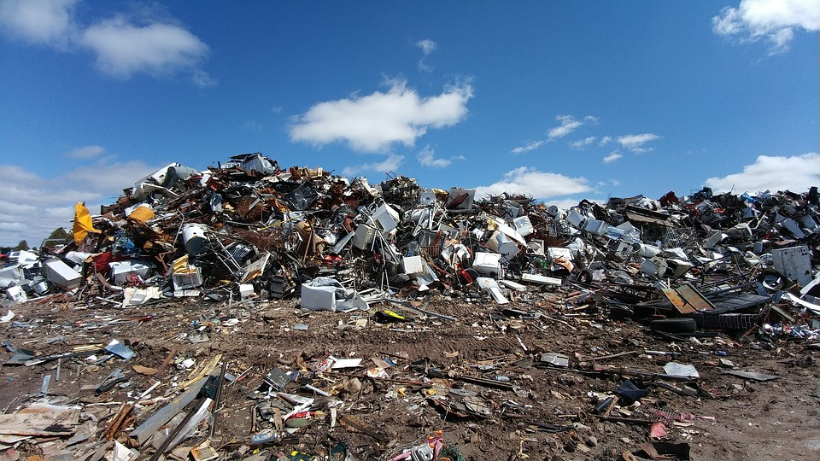
Source: Pixabay
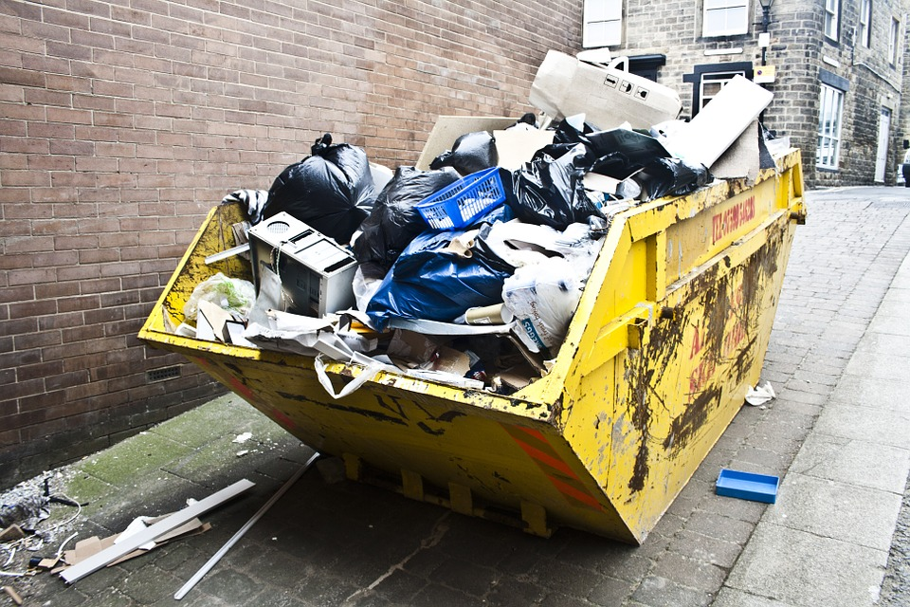

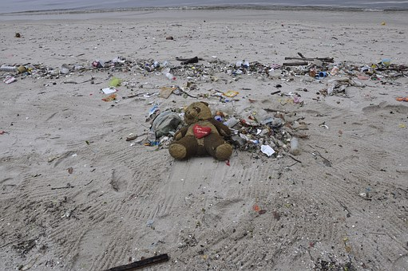
Appendix 9b: Teacher resource sheet 1.4: Waste images 2
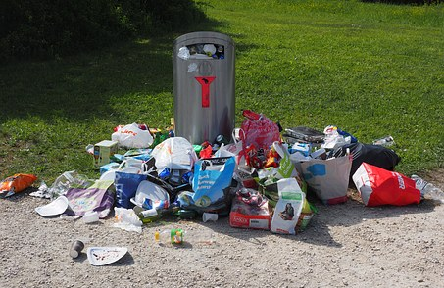
Source: Pixabay

Appendix 10: Student activity sheet 1.5: I see, I think, I wonder

What do you see when you look at this image?
What are you thinking about as you look at this image?
What are your wonderings (questions)?

Appendix 11: Student activity sheet 1.6: KWL Chart
- Before you begin your research, fill in the first two columns.
- Fill in the last column during or after your research.
Topic:
What I know: | What I want to know: | What I learned:

Appendix 12: Teacher resource sheet 1.7: Sample parent letter
(School details and letterhead)
(Date)

Dear parents and caregivers,

RE: Waste Warriors STEM Project

This term, our class is undertaking a STEM (Science, Technology, Engineering and Mathematics) project called Waste Warriors. Its purpose is to raise students’ awareness of the increasing amount of waste generated by modern living and the impact on world resources and the environment.
Students will interview seniors to discover what was used for wrapping and carrying food and goods in the days before supermarkets and cheap plastics were available. If you have a relative or friend in their 70s please ask them if they would be willing to answer questions about their childhood memories of food and grocery shopping, school lunches etc from a group of two or three students. Alternatively, they may like to talk to your child at home, that would also be helpful.
Students will be engaged in examining, sorting and measuring items discarded in school bins. Disposable gloves and tongs will be provided and all care will be taken to ensure students understand the level of hygiene needed to avoid health risks during this activity. If your child has health issues that may be impacted by these activities or you have any concerns, please contact me to discuss.
Please complete the slip below and return to me as soon as possible.
Thank you in advance,
(Classroom teacher)
----------------------------------------------------------------------------------------------------------------------------------------------
REPLY SLIP
Student’s Name ___________________________________________Please circle YES or NO for each question
- YES NO I have a friend or relative who could come to school to talk to a small group of students.
- YES NO I have a friend or relative who could answer questions from my child at home.
- YES NO I have health concerns about my child sorting rubbish as noted below.
Health concerns ____________________________________________________________________________
__________________________________________________________________________________________
Other _____________________________________________________________________________________
Parent/Carer Name ________________________________ Signature ________________________________

Appendix 13: Teacher resource sheet 3.1: Construction skills
Construction skills help students to generate and produce solutions for real-world problems.
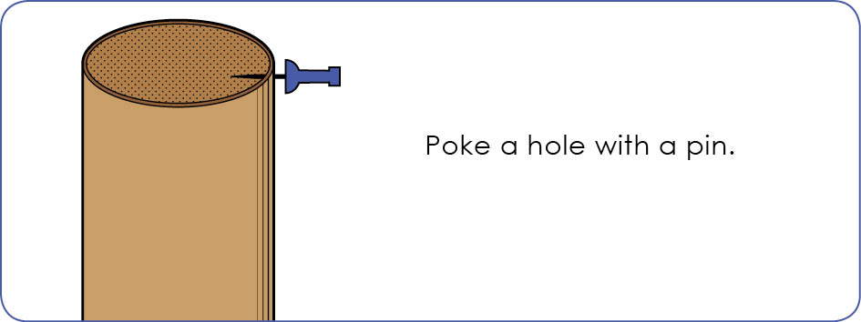
This resource can be used as a visual stimulus to prompt students to develop solutions to design problems. The cards can be printed to create stations.

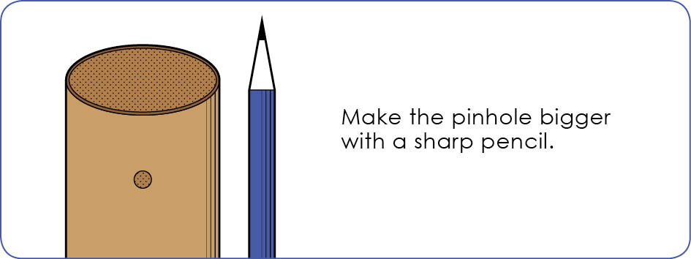
Poke a hole with a pin.
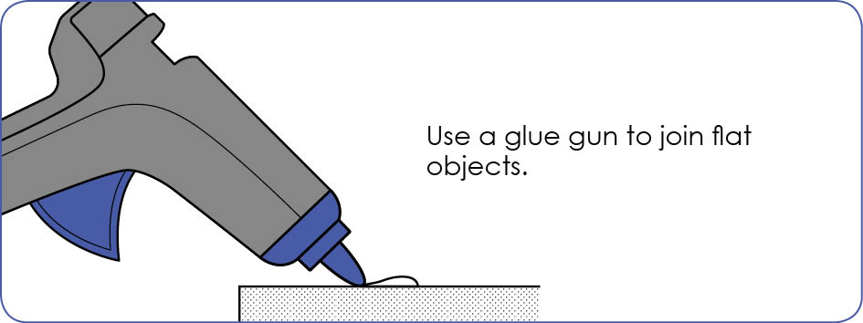
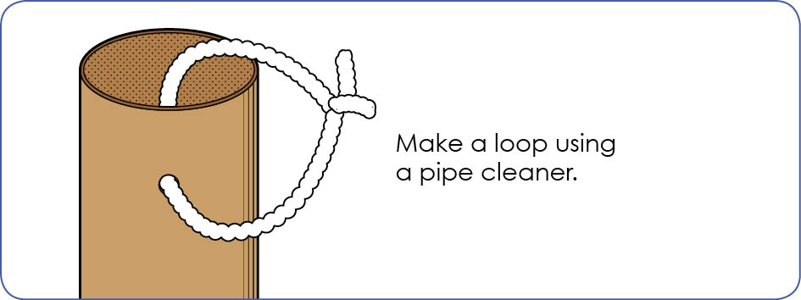

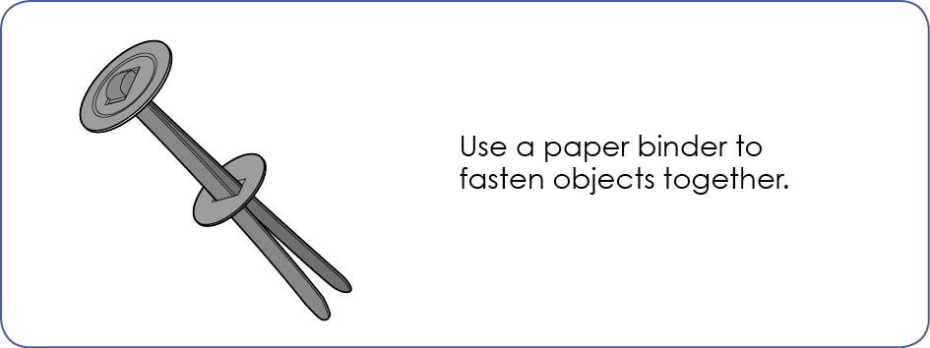

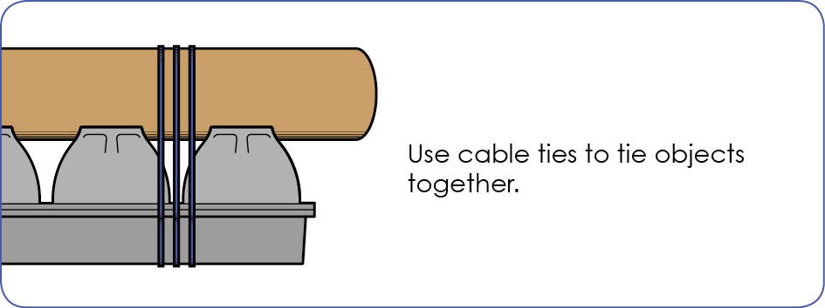
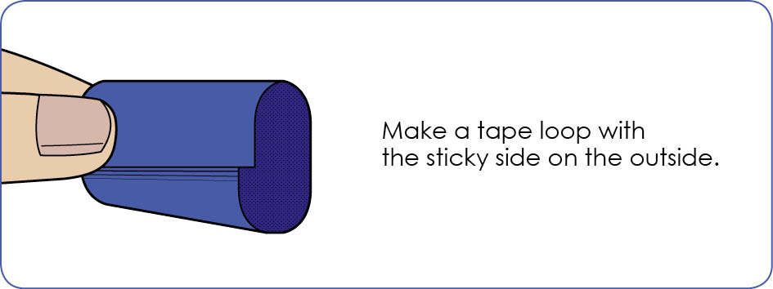

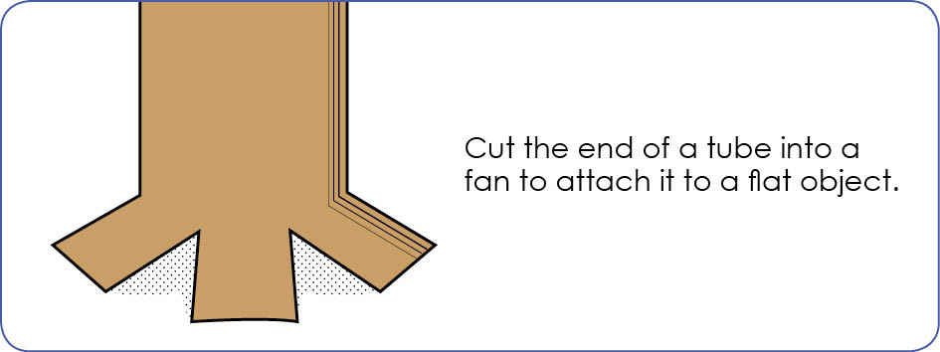

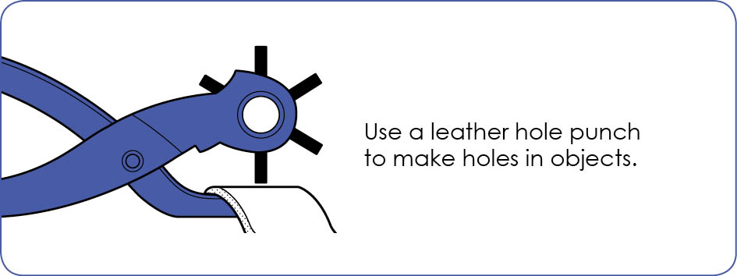

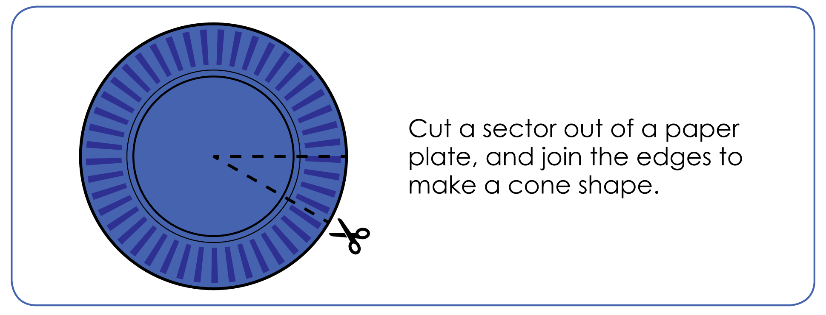

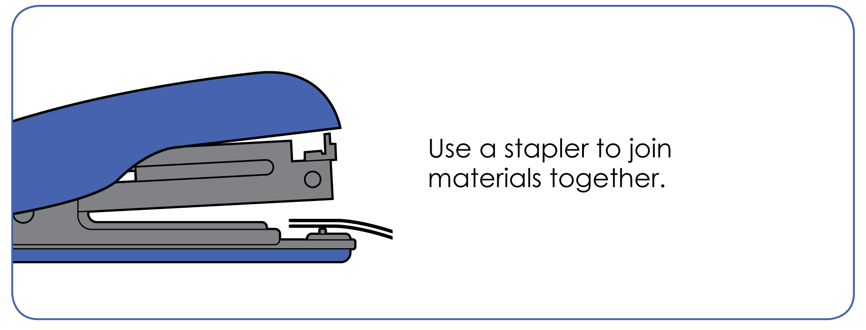

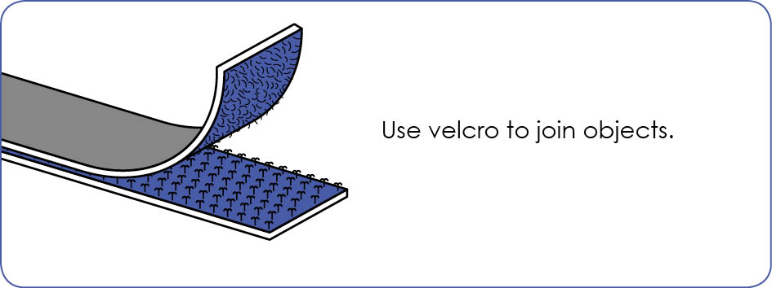

Appendix 14: Student activity sheet 3.2: Prototype troubleshooting
Problem | Reason for the problem | Possible changes to your design to solve the problem

Notes
________________________________________________________________________________________________________________________________________________________________________________________________________________________________________________________________________________________________________________________________________________________________________________________________________________________________________________________________________________________________________________________________________________________________________________________________________________________________________________________________________________________________________________________________________________________________________________________________________________________________________________________________________________________________________________________________________________________________________________________________________________________________________________________________________________________________________________________________________________________________________________________________________________________________________________________________________________________________________________________________________________________________________________________________________________________________________________________________________________________________________________________________________________________________________________________________________________________________

Notes
________________________________________________________________________________________________________________________________________________________________________________________________________________________________________________________________________________________________________________________________________________________________________________________________________________________________________________________________________________________________________________________________________________________________________________________________________________________________________________________________________________________________________________________________________________________________________________________________________________________________________________________________________________________________________________________________________________________________________________________________________________________________________________________________________________________________________________________________________________________________________________________________________________________________________________________________________________________________________________________________________________________________________________________________________________________________________________________________________________________________________________________________________________________________________________________________________________________________

Notes
________________________________________________________________________________________________________________________________________________________________________________________________________________________________________________________________________________________________________________________________________________________________________________________________________________________________________________________________________________________________________________________________________________________________________________________________________________________________________________________________________________________________________________________________________________________________________________________________________________________________________________________________________________________________________________________________________________________________________________________________________________________________________________________________________________________________________________________________________________________________________________________________________________________________________________________________________________________________________________________________________________________________________________________________________________________________________________________________________________________________________________________________________________________________________________________________________________________________

