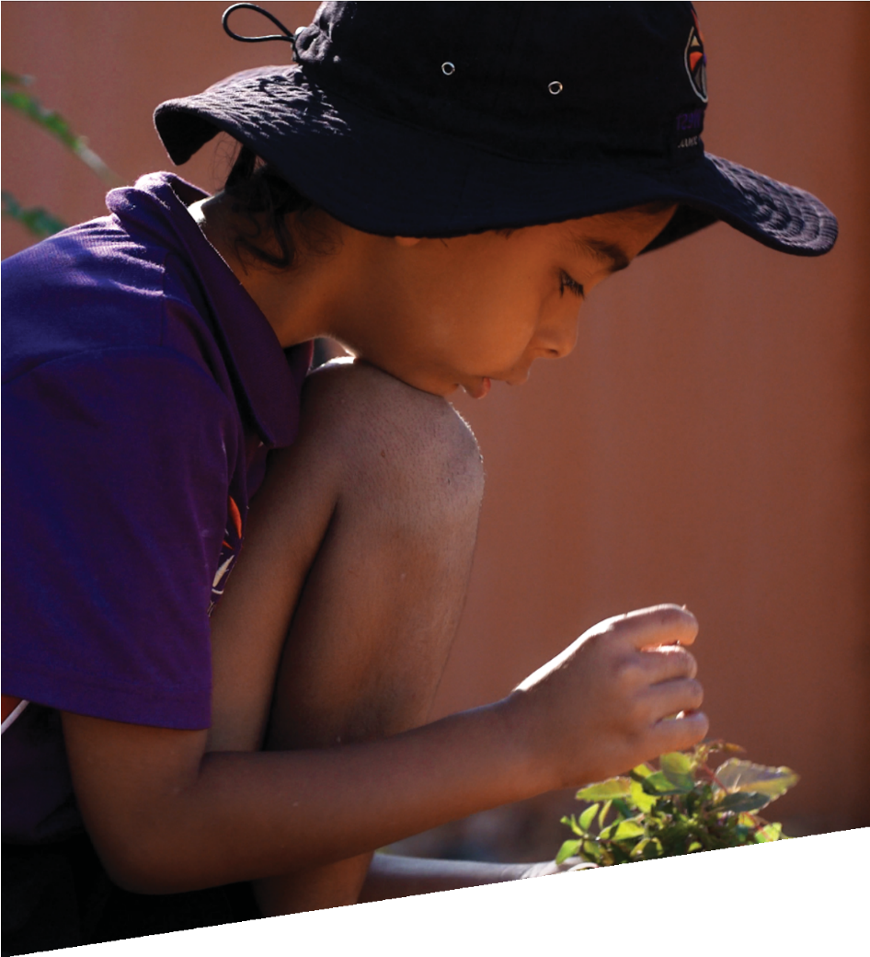

CURRICULUM RESOURCE MODULE
Caring for country
YEAR 6
Acknowledgements
The STEM Learning Project respectfully acknowledges the Traditional Custodians of the lands upon which our students and teachers live, learn and educate.

The STEM Learning Project is funded by the Western Australian Department of Education (the Department) and implemented by a consortium in STEM education comprising the Educational Computing Association of WA, the Mathematical Association of WA, the Science Teachers Association of WA and Scitech. We acknowledge and thank the teachers and schools who are the co-creators of these resources.

Copyright and intellectual property
The copyright and intellectual property of this module remain the property of the Department.
Any Western Australian Curriculum (WAC) content in this resource is used with the permission of the School Curriculum and Standards Authority (the Authority); this permission does not constitute Authority endorsement of the resource. The Authority accepts no liability for any errors or damages arising from reliance on its content.

The WAC content may be freely copied, or communicated on an intranet, for non-commercial purposes in educational institutions, provided that the Authority is acknowledged as the copyright owner. Copying or communication for any other purpose can be done only within the terms of the Copyright Act 1968 or with prior written permission of the Authority. Any Australian Curriculum content in the Western Australian Curriculum is used by the Authority under the terms of the Creative Commons Attribution-NonCommercial 3.0 Australia licence.

Any content on the www.scsa.wa.edu.au domain that has been derived from the Australian Curriculum may be used under the terms of Creative Commons Attribution-NonCommercial 3.0 Australia licence.

Appendix 2: General capabilities continuums is adapted from ACARA, © Australian Curriculum, Assessment and Reporting Authority (ACARA) 2009 to present, unless otherwise indicated. This material was downloaded from the ACARA website (www.acara.edu.au) (accessed December 2015) and was not modified. The material is licensed under CC BY 4.0 (https://creativecommons.org/licenses/by/4.0/). ACARA does not endorse any product that uses ACARA material or make any representations as to the quality of such products. Any product that uses material published on this website should not be taken to be affiliated with ACARA or have the sponsorship or approval of ACARA. It is up to each person to make their own assessment of the product.

This resource includes references and examples of iOS, Android and other apps. The Department does not endorse or recommend any commercial products and simply provides these as examples for teachers.

The Department is committed to providing quality information to its customers. Whilst every effort has been made to ensure accuracy, currency and reliability of the information within these documents, the Department accepts no responsibility for errors, omissions or amendments made since the time of publishing. Confirmation of information may be sought from the Department or the originating bodies providing the information. The Department has no control over the content of material published on websites to which users are referred in this resource. It is the responsibility of the internet user to make their own decision as to the relevancy, accuracy, currency and reliability of information found on those sites.

The Department acknowledges the unique culture and heritage of our Aboriginal peoples and the contributions Aboriginal peoples have made and continue to make to Western Australian society. In this module, the term ‘Aboriginal’ is intended to encompass the diverse cultures and identities of the First Peoples of Western Australia and also recognises those of Torres Strait Islander descent who call Western Australia home.

Various images from Gondwana Link and iStock are been used with permission or under license.

Attributions: Google maps and docs, Microsoft Office 365, PowerPoint, Excel and Word, Keynote, Pages, Sway, eBook, iMovie, Seesaw, Class Dojo, Padlet, OneNote, Get app, Kidblog, Edmodo, Explain Everything, Popplet, Evernote, Cool tools for school, Tinkercad, Sketch Up, Autodesk.

Table of contents

The STEM Learning Project 2
Overview 3
Activity sequence and purpose 8
Background 9
Activity 1: Local degradation 12
Activity 2: Environmental detective 22
Activity 3: Restoration plan 33
Activity 4: Advocating for restoration 38
Appendix 1: Links to the Western Australian Curriculum 45
Appendix 1B: Mathematics proficiency strands 48
Appendix 2: General capabilities continuums 49
Appendix 3: Materials list 52
Appendix 4: Design process guide 53
Appendix 4B: Drawing in the design process 54
Appendix 5: Reflective journal 55
Appendix 6: Student activity sheet 1.0: Journal checklist 56
Appendix 7: Teacher resource sheet 1.1: Cooperative learning – Roles 57
Appendix 8: Teacher resource sheet 1.2: Cooperative learning – Jigsaw 58
Appendix 9: Teacher resource sheet 1.3: Cooperative learning – Placemat 59
Appendix 10: Teacher resource sheet 1.4: Cooperative learning – Think, Pair, Share 60
Appendix 11: Student activity sheet 2.1: Cartesian coordinates 61
Appendix 12: Teacher resource sheet 3.1: Flowcharting symbols 62
Appendix 13: Teacher resource sheet 3.2: Flowchart example 63
Appendix 14: Student activity sheet 3.3: Prototype troubleshooting 64
Appendix 15: Teacher resource sheet 4.1: Progress photographs 65
Appendix 16: Student activity sheet 4.2: Self-evaluation 66
Appendix 17: Teacher resource sheet 4.3: Peer and visitor feedback 67

The STEM Learning Project
The aim of the STEM Learning Project is to generate students’ interest, enjoyment and engagement with STEM (Science, Technology, Engineering and Mathematics) and to encourage their ongoing participation in STEM both at school and in subsequent careers. The curriculum resources will support teachers to implement and extend the Western Australian Curriculum across Kindergarten to Year 12 and develop the general capabilities.
Why STEM?
A quality STEM education will develop the knowledge and intellectual skills to drive the innovation required to address global economic, social and environmental challenges.
STEM capability is the key to navigating the employment landscape changed by globalisation and digital disruption. Routine manual and cognitive jobs are in decline whilst non-routine cognitive jobs are growing strongly in Australia. Seventy-five per cent of the jobs in the emerging economy will require critical and creative thinking and problem-solving, supported by skills of collaboration, teamwork and literacy in mathematics, science and technology. This is what we call STEM capability. The vision is to respond to the challenges of today and tomorrow by preparing students for a world that requires multidisciplinary STEM thinking and capability.
The approach
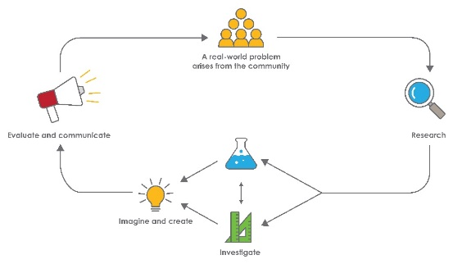
STEM capabilities are developed when students are challenged to solve open-ended, real-world problems that engage students in the processes of the STEM disciplines.
STEM Consortium

Year 6 – Caring for country: Restoring native vegetation

Overview
Erosion by wind, waves and water impacts plant communities and landforms that support natural landscapes. There are also many competing uses for our land which result in natural ecosystems and their native vegetation being damaged by urban development, recreational uses, agriculture and mining.
Restoring natural ecosystems contributes to sustainability by maintaining a diversity of habitats, species and most importantly the genetic legacy of those species. Australia has many endangered species and a poor record of extinction of the many plants and animals which are unique to our country. Western Australia is rich in biodiversity that unfortunately is under threat. Consequently, we all have a responsibility to care for our unique natural heritage.
Aboriginal people have lived in harmony with the natural environment for more than 60 000 years and have a significant connection to country from which we can all learn. ‘Caring for country’ centres on the relationships between Indigenous peoples and their country, which includes their lands, waters, plants, animals, heritage, culture, ancestors, laws, religions and more (Rose 1992, 1996). This involves more than the physical management of a geographical area but also the resources, stories and cultural obligations associated with that area, as well as the associated processes of spiritual renewal, connecting with ancestors, food provision and maintaining kin relationships.
Reference: Nourishing terrains : Australian Aboriginal views of landscape and wilderness / Deborah Bird Rose 1996
The Western Australian Government has made significant changes to legislation relating to the involvement of Aboriginal people on land and water managed by the Department of Parks and Wildlife. These changes recognise Aboriginal custodianship and, as a result, many organisations researching the plant communities of natural ecosystems now work in partnership with Elders from local communities, drawing on Aboriginal knowledge of the land.
What is the context?
We all live close to areas of land that have been changed by extreme or repeated weather events as well as human activity. The most visible impacts are to topography, soil and native vegetation. The less obvious changes are to the number of soil microbes, insects, reptiles and birds that are supported by the reduced vegetation cover.
This module explores the changes made to natural ecosystems through weather events or human activity and encourages students to develop strategies to restore plant communities of local provenance at one of these sites to increase the diversity of species that can be supported.

What is the problem?
How can we restore native vegetation disturbed by natural events or human activity?
How does this module support integration of the STEM disciplines?
Science
Students learn that the survival of living things is influenced by their environment and by changes in the environment (ACSSU094, ACSSU096). Students plan and conduct fieldwork investigations to gather evidence and consider Aboriginal and Torres Strait Islander historical and cultural perspectives (ACSHE098) to inform land revegetation plans (ACSIS103). Students use scientific representations to support them in advocating for land revegetation (ACSIS110).
Refer to ACARA’s Science elaborations addressing the Aboriginal and Torres Strait Islander Histories and Cultures cross-curriculum priority at www.australiancurriculum.edu.au/f-10-curriculum/cross-curriculum-priorities/aboriginal-and-torres-strait-islander-histories-and-cultures for elaborations and background information relevant to this module.
Technology
Students construct and use quadrats as a tool for sampling plant populations and distributions (ACTDIP016, WATPPS36). They consider plant species of local provenance and the need for biodiversity when designing their plans for revegetation (ACTDEK019). Students develop sequenced steps as part of their designs (WATPPS33), modify solutions based on feedback and incorporate a range of techniques using appropriate technologies (WATPPS35). Students create and collaborate online to publish their plans (ACTDIP022).
The Design process guide is included as a resource to help teachers understand the complete design process as developed in the Technologies curriculum.
Mathematics
Students use the Cartesian coordinate system to map plant locations and distributions (ACMMG143) and compare lengths and areas using appropriate units (ACMMG137). When plotting and recording ordered pairs on their grid coordinates they connect decimal representations to the metric system (ACMMG135) and convert between metric units of length (ACMMG136). They analyse and compare the frequency and area of ground coverage of a plant species using fractions and percentages (ACMNA131). Students create and interpret data representations (ACMSP147).
General capabilities
There are opportunities for the development of general capabilities and cross-curriculum priorities as students engage with native plant revegetation. In this module, students:

- Develop problem-solving skills as they research the problem and its context (Activity 1); investigate parameters impacting on the problem (Activity 2); imagine and develop solutions (Activity 3); and evaluate and communicate their solutions to an audience (Activity 4).
- Utilise creative thinking as they generate possible design solutions; and critical thinking, numeracy skills and ethical understanding as they choose between alternative approaches to solving the problem of restoring native vegetation disturbed by natural events or human activity.
- Utilise personal and social capability as they develop socially cohesive and effective working teams; collaborate in generating solutions; adopt group roles; and reflect on their group work capabilities through self and peer evaluation.
- Utilise a range of literacies and information and communication technologies (ICT) capabilities as they collate records of work completed throughout the module in a journal; and represent and communicate their solutions to an audience using digital technologies in Activity 4.
- Advocate protecting natural ecosystems to a local government councillor or community member.
Additional learning opportunities
Students could:
- Create a classroom herbarium to showcase to younger years the variety of local native flora. Note: All flora that is native to Western Australia is protected under the Wildlife Conservation Act 1950. A licence from the Department of Biodiversity, Conservation and Attractions is required to take flora from Crown land. Further details are available at www.dpaw.wa.gov.au/plants-and-animals/licences-and-permits.
- Investigate the involvement of Aboriginal people in the management of land and water administered by the Department of Parks and Wildlife at www.dpaw.wa.gov.au/parks/aboriginal-involvement.
- Capitalise on opportunities for students to recognise the importance of Aboriginal and Torres Strait Islander peoples’ knowledge in developing a richer understanding of the Australian environment; the cultural significance of landscape, plants and animals; and the spiritual significance of country.
- Investigate a specific landscape and create a presentation on the native flora and fauna including a food web.
- Plan for native plants to be planted within the school grounds and present to the school’s P&C or school board about the importance of using local native species.
Excursions and incursions
Check with your local government for links to natural resource management (NRM) groups and connections to local Elders. Some examples of these groups in the Perth metro area are:
- WA Herbarium – Department of Biodiversity, Conservation and Attractions, Keiran McNamara Conservation Science Centre, Kensington
www.dpaw.wa.gov.au/plants-and-animals/wa-herbarium
- Kings Park and Botanic Gardens
www.bgpa.wa.gov.au/kings-park/events/walks-and-tours/aboriginal-cultural-experiences
- Draw on the expertise of local Aboriginal Elders (eg Neville Collard, Noel Nannup, Indigenous Tours WA)
- Tucker Bush
tuckerbush.com.au/schools-program/
- South East Regional Centre for Urban Landcare
www.sercul.org.au/for-educators/incursions-and-excursions
- Canning River Eco Education Centre
www.canning.wa.gov.au/places-and-events/places-to-learn/canning-river-eco-education-centre/schools/excursions-and-events/excursions
- Edith Cowan University, Old Ways New Ways Program
www.ecu.edu.au/centres/kurongkurl-katitjin/old-ways-new-ways
NRM groups are in many regional areas across Western Australia:
- Natural Resource Management Program
www.nrm.wa.gov.au/nrm-in-wa/western-australian-regional-nrm-groups.aspx

What are the pedagogical principles of the STEM learning modules?
The STEM Learning Project modules develop STEM capabilities by challenging students to solve real-world problems set in authentic contexts. The problems engage students in the STEM disciplines and provide opportunities for developing higher order thinking and reasoning, and the general capabilities of creativity, critical thinking, communication and collaboration.
The design of the modules is based on four pedagogical principles:
- Problem-based learning
This is an underlying part of all modules with every module based around solving an initial problem. It is supported through a four-phase instructional model: research the problem and its context; investigate the parameters impacting on the problem; design and develop solutions to the problem; and evaluate and communicate solutions to an authentic audience.
- Developing higher order thinking
Opportunities are created for higher order thinking and reasoning through questioning and discourse that elicits students' thinking, prompts and scaffolds explanations, and requires students to justify their claims. Opportunities for making reasoning visible through discourse are highlighted in the modules with the icon shown here.
- Collaborative learning
This provides opportunities for students to develop teamwork and leadership skills, challenge each other’s ideas, and co-construct explanations and solutions. Information that can support teachers with aspects of collaborative learning is included in the resource sheets.
- Reflective practice
Recording observations, ideas and one’s reflections on the learning experiences in some form of journal fosters deeper engagement and metacognitive awareness of what is being learnt. Information that can support teachers with journaling is included in the resource sheets.
These pedagogical principles can be explored further in the STEM Learning Project online professional learning modules located in Connect Resources.

Activity sequence and purpose
Local degradation | Students research the causes of degradation of native plant communities in their locality and develop an understanding of the significance of native plants within ecosystems and to Aboriginal cultures.
Environmental detective | Students investigate the topography and vegetation at two sites, using fractional numbers to analyse vegetation ground cover. They identify differences in the distribution of species and hypothesise to explain variances in distribution.
Restoration plan | Using algorithmic thinking, students develop restoration plans based on their findings. They share designs, give and receive feedback, and apply feedback to improve their design.
Advocating for restoration | Students create and share a presentation to educate the wider community about protecting natural ecosystems and the importance of restoration projects. Students reflect on and evaluate the project.

Background
Expected learning | Students will be able to:  - Describe environmental factors that affect the growth and survival of native plants.  - Explain the importance of maintaining species diversity.  - Describe traditional Aboriginal uses of plants and the meaning of the phrase ‘caring for country’.  - Investigate changes to topography, soils and vegetation in an area affected by human activity or a severe weather event.  - Use a Cartesian plane to describe locations using coordinates.  - Communicate fractions using percentage, decimals and equivalent fractions.  - Build a Cartesian plane to use in fieldwork.  - Imagine, plan and develop a process flowchart for restoring the native vegetation in a degraded area.  - Use evidence-based arguments to advocate for the preservation and restoration of native vegetation.
Vocabulary | The following vocabulary list contains terms that need to be understood, either before the module commences or developed as they are used:  Aboriginal, advocate, biodiversity, caring for country, Cartesian plane, climate, data, degradation, ecosystem, endemic, environment, fauna, flora, habitat, Indigenous, local environment, native, provenance, quadrant, quadrat, rehabilitation, revegetation, species, sustainable, topography.
Timing | There is no prescribed duration for this module. The module is designed to be flexible enough for teachers to adapt. Activities do not equate to lessons; one activity may require more than one lesson to implement.
Consumable materials | A Materials list is provided for this module. The list outlines materials outside of normal classroom equipment that will be needed to complete the activities.
Safety notes  . | There are potential hazards inherent in these activities and with the equipment being used, and a plan to mitigate any risks will be required.  Potential hazards specific to this module include but are not limited to:  - Possible exposure to cyber bullying, privacy violations and uninvited solicitations when using the internet  - Hazards associated with being outdoors and in bushland.
Enterprise skills | The Caring for country: Restoring native vegetation module focuses on higher order skills with significant emphasis on expected learning from the general capabilities and enterprise skills.  Enterprise skills include problem-solving, communication skills, digital literacy, teamwork, critical thinking and presentation skills.  Further background is available from the Foundation for Young Australians in the New Work Order six-report series at www.fya.org.au/our-research-2/#series.
Assessment | The STEM modules have been developed to provide students with learning experiences to solve authentic real-world problems using science, technology, engineering, and mathematics capabilities.  While working through the module, the following assessment opportunities will arise:  - Reflections from students’ learning journals  - Anecdotal notes from observations and work samples as students engage in the quadrat and Cartesian plane activities  - Work samples from science investigations  - Work samples of flowcharts representing a plan for provenance restoration  - Observations as students present their recommendations in Activity 4.  Appendix 1 indicates how the activities are linked to the Western Australian Curriculum.  Evidence of learning from journaling, presentations and anecdotal notes from this module can contribute towards the larger body of evidence gathered throughout a teaching period and can be used to make on-balance judgments about the quality of learning demonstrated by the students in the science, technologies, and mathematics learning areas.  Students can further develop the general capabilities of Information and communication technology (ICT) capability, Critical and creative thinking, and Personal and social capability. Continuums for these are included in the General capabilities continuums but are not intended to be for assessment purposes.

Activity 1: Local degradation
Activity focus | Students research the causes of degradation of local, native plant communities and develop an understanding of the significance of native plants within ecosystems and to Aboriginal people.
Background information | A sustainable ecosystem is one that sustains the life of all its inhabitants over an extended period; however, the population of individual plant and animal species may vary naturally over time. If a species becomes extinct, then it could be said that the relationship to its ecosystem was unsustainable.  Many native plants occur across a broad geographic range. However, within that range, different populations of a species may change slightly to become specifically adapted to local conditions and individual habitats. Populations containing local genetic variations are called provenances. It is important to preserve these as each provenance is unique. Locally collected seed is the best way to maintain local provenance.  The causes of ecosystem destruction can be small or large, slow or sudden, direct or indirect. Examples include:  - Introduction of species which become predators of native species (eg numbats threatened by foxes and cats in the South West region of WA), contribute to overgrazing (eg donkeys in the Pilbara region) or compete with native species for food sources (eg rabbits). Rabbits are selective feeders that search out tiny seedlings and remove them before they can grow and reproduce. Once mature trees die, the species is lost as there are no younger plants to replace them.  - Removal of the apex predator (eg dingos) which enables other species to increase in numbers and destabilise ecosystems.  - Bushfire events which can kill entire populations of animals and plants and destroy ground cover, resulting in erosion (eg 2016 Yarloop bushfire).  - Clearing native plants for agriculture such as cattle stations in the Midwest region and the cultivation of wheat in Western Australia’s Wheatbelt.  - Changes to coastal ecosystems caused by storm damage to sand dunes resulting in loss of habitat for dune plants in areas such as Mettam’s Pool, Perth in 2018 or the growth and movement of sand dunes such as the Yeagarup mobile sand dunes in the South West.  - Suburban development with gardens growing non-native plants, reducing habitat space for native flora and fauna and introducing a range of potential weed species.  - Runoff from farms and gardens containing fertilisers and pesticides entering the ecosystem and encouraging overgrowth of some species (eg algal blooms) and undergrowth of others.  Successful restoration of the local native vegetation can contribute to environmental health and sustainability. The key to success is planting native species that suit the local soil type. Collaboration should be sought with local Aboriginal communities so their knowledge about plants and ecosystems can inform restoration strategies.  A guide setting out the Western Australian Department of Environment Regulation’s recommended approach to preparing a restoration plan can be found at  www.der.wa.gov.au/images/documents/our-work/consultation/Revegetation-plan/Consultation_Draft__Reveg_Guide_v0-3.pdf.  The growth and survival of living things are affected by the physical conditions in the environment. Western Australia has some of the most at-risk flora and fauna in the world, with the South West region recognised internationally as a biodiversity hotspot. Some examples of at-risk species in this area include:  - The white-bellied frog - it is the only species of frog in Western Australia to be listed as critically endangered due to habitat loss and ongoing degradation of existing habitat. It can be found in the very dense swamp vegetation bordering streams in the extreme south-west of Western Australia. The Perth Zoo has a breeding program for this species and there is also a recovery program to protect the remaining habitat and individuals. See perthzoo.wa.gov.au/saving-wildlife/breeding-conservation/frog-breeding-programs.  - Known by its Noongar name, the woylie is a small nocturnal marsupial that once had a broad habitat range across Australia, but whose range has now become restricted to small areas of Western Australia. The woylie’s diet of fungi is extremely important for the health of the ecosystems because they help to spread fungal spores and seeds which create homes and environments for plants and other wildlife. Extensive land clearing for agriculture has contributed to the steep decline in the population of woylies. They are also under threat by introduced predators, including foxes and feral cats.  - Foote’s grevillea is a spreading, flat-topped shrub that grows up to one-metre-tall and is native to Dandaragan in Western Australia. It grows mainly in sandy soils under prickly bark and marri. The species is threatened by habitat loss, invasive weeds, herbicide overspray, frequent fire, grazing animals and dieback.  The Martu Living Deserts Project combines modern science with Indigenous ecological knowledge to prevent native flora and fauna disappearing from Martu country in the Western Desert. Teams are in the field controlling feral animals, rehabilitating water holes and protecting threatened species:  The project assists Martu to continue their remarkable connection to country, combining modern scientific land management with Indigenous ecological knowledge. The project’s partners are working together to ensure effective conservation while balancing Martu aspirations to look after their country, culture and harness economic development. Management by Martu of their country is central to the ongoing survival of this vast and important arid landscape. For Martu, healthy lands are achieved through a process that begins with yaninpa ngurrarakarti (going to country), continues with ngurraku ninti (knowledge of country) and completes the cycle with kanyirninpa ngurrara (holding/caring for country).  For more information see www.bhp.com/-/media/bhp/documents/investors/annual-reports/2016/160921_martulivingdesertproject.pdf?la=en
Expected learning | Students will be able to:  - Explain the concept of sustainability and that the physical conditions of the environment affect the growth and survival of plants and animals (Science).  - Describe the impacts of natural events and human activity on natural ecosystems (Science).  - Describe the importance of connection to country in Aboriginal culture (Science).
Equipment required | For the class:  Projector or interactive whiteboard
For the students:
Digital device with internet access - one per student (or one per pair of students)
Preparation | Locate an area close to the school and appropriate for fieldwork; one that includes an area of degraded natural vegetation.
Activity parts | Part 1: Plants and their relationships  The South West region of Western Australia is a very biodiverse location. The reason for this great diversity of flora and fauna is the environment (geology, soils and climate) in which these communities have evolved. Plants have many important roles such as sources of food, shelter and nesting sites for animals, they help to maintain the biosphere and are used for scientific and medicinal purposes by humans. Plants may also be an important part of the stories and cultural obligations associated with an area. The videos suggested for this activity show the important relationships between Aboriginal peoples and country, the ethos of caring for country, and the relationships between plants, animals and the natural environment.  Explain to the students that they will be working in small groups to watch a range of videos about Australia’s native plant species, the important role plants play in the community and the ethos of caring for country. Encourage students to develop their way of recording information in their groups. They may choose to use a mind map, brainstorm or an application such as Padlet or OneNote.  If students work in groups, a placemat or jigsaw strategy may be useful. See Teacher resource sheet 1.2: Cooperative learning - Jigsaw and Teacher resource sheet 1.3: Cooperative learning - Placemat.  Focus questions have been provided for each video and maybe useful prompts for students. Select from the range of resources below to suit the needs of the class.  Australia’s biodiversity of Indigenous perspectives (CSIRO, 2014)  youtu.be/_vL9WZ9xYUg  Prompt student discussion with the following questions:  - How are Aboriginal peoples connected to 'country' and to 'biodiversity'?  - How do Aboriginal and Torres Strait Islander peoples monitor and manage biodiversity?  Backburning, Caring for Country (Behind the News, 2017)  youtu.be/iHg9vgGQFSE  Prompt student discussion with the following questions:  - What is backburning and why is it carried out?  - How does backburning provide for the needs of Aboriginal peoples?  Native bee buzz ep 16 2019 (Gardening Australia, 2019)  youtu.be/ZVF67dn6mhI  Prompt student discussion with the following questions:  - What are the differences between European honeybees and native bees?  - What is the special relationship between native bees and native wildflowers?  - Why are native bees important to maintaining biodiversity?  - How can we maintain populations of native bees?  Young Dark Emu by Bruce Pascoe  www.magabala.com/young-dark-emu.html  Prompt student discussion with the following questions:  - How might Aboriginal and Torres Strait Islander traditional knowledge about native plants and animals help them?  - What knowledge can we take from Aboriginal and Torres Strait Islander peoples about native plants and animals which will assist in the future protection of plant and animal species, particularly endangered ones?  - How does knowing whether animals hunt at night or day, what or where they eat, and when they have their young help protect a species?  Bush Tucker Garden - Behind the News  youtube.com/watch?v=WQ8NiPKTavQ  Prompt student discussion with the following questions:  - Why were the students growing the garden? What types of plants were they growing?  - How were the students going to use the plants?  - Is it important the students knew how to cook the plants? Why?  - How did indigenous knowledge help the students grow and cook their plants?  A real history of Aboriginal Australians, the first agriculturalists | Bruce Pascoe | TEDxSydney (TEDx Talks, 2018)  youtu.be/fqgrSSz7Htw  Prompt student discussion with the following questions:  - How would you explain food production and consumption among Indigenous Australians prior to European settlement?  - What tools and technology were used?  Bush tucker fact sheets (South East Regional Centre for Urban Landcare)  www.sercul.org.au/our-projects/bushtucker/  Prompt student discussion with the following questions:  - What are the Aboriginal uses for some of these plants?  - How could this information be useful in informing local provenance?  Bring the class together to share what they have learnt from the videos. Ask students:  - How could we use ICT to collaborate and share our information?  - What have you learnt about the relationships between Aboriginal peoples and country?  - What do we mean by biodiversity?  - How have Aboriginal peoples maintained Australia’s biodiversity for over 60 000 years?  - In what ways are plants, animals and the environment dependent on each other?  - How can we contribute to sustaining biodiversity in our locality?
Part 2: Plant life destruction
Building on the discussion in Part 1, ask students to brainstorm possible causes of degradation of local native vegetation. Divide the class into small groups to brainstorm and record ideas. Remind students to keep their ideas local to their area. At two or three-minute intervals, rotate the papers around the groups, encouraging students to read their peers' ideas, make comments and record new ideas.
Once students have their original brainstorm paper back, ask them to try to categorise the information. Prompt student thinking by asking:
- How can you group the ideas?
- Can you re-group them in another way?
Draw connections between the brainstorms and introduce ideas that the students may not have considered including:
- Clearing for horticulture and agriculture (Midwest, South West, Wheatbelt)
- Coastal erosion (limestone cliff collapse at Gracetown, Mettam’s Pool, Port Beach)
- Fire (Yarloop)
- Flooding (Swan Valley, Marble Bar and Moora)
- Forestry (South West forests)
- Four-wheel driving (Lancelin dunes)
- Introduced weed species (eg bull rushes in Perth wetlands, gamba grass in the Kimberley)
- Mining (Alcoa in Pinjarra and Pilbara Minerals in Pilbara)
- Moving sand dunes (Yeagarup dunes in Pemberton)
- Pastoralism (Goldfields, Kimberley, Pilbara, Midwest)
- Roads (statewide)
- Solar and wind farms (statewide)
- Sports grounds and other recreational activities
- Urbanisation (Perth metropolitan area, other towns and cities)
- Water catchment (Canning Dam, Lake Argyle).
Part 3: Satellite photo data
Display the photo below by searching ‘Lancelin’ on Google Maps.
Draw attention to the circled South Mimegarra Nature Reserve and the colour of this area compared to other ground nearby.
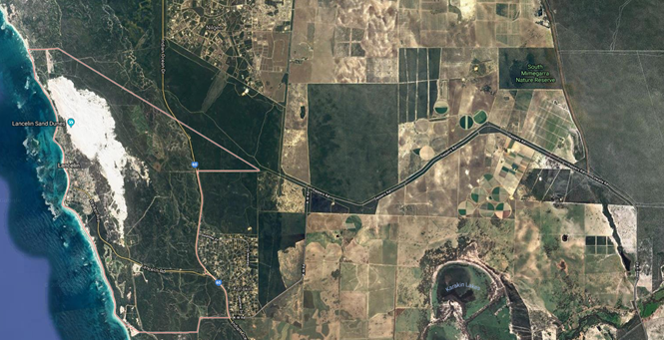
The image is taken above Lancelin, WA. Sourced from Google Maps, Imagery ©2019 CNES Airbus, DigitalGlobe, Data SIO, NOAA, U.S. Navy, NGA, GEBCO, Map data ©2019 Google.
Ask students why they think there is a difference in the land colour of this area and its surroundings. What could be the cause of this?
Examine the areas beyond the yellow circle and identify land degradation examples from the list in Part 2 (eg sand dunes, roads and urban areas, agriculture, possible coastal erosion from waves).
Working in pairs or small groups, ask students to use a web-based mapping program (eg Google Maps) to locate a town of their choice in Western Australia. Use the zoom-out function to view surrounding areas of the town.
Ask students to copy an image of the map showing the town and surrounding areas (ie using screenshot/screen-print/snipping tool) to a presentation program or app (eg Microsoft PowerPoint, Keynote). Using an edit function, students label examples of land degradation.
Part 4: Revegetation
Given the dependence of plants on their physical environment and other organisms, once an ecosystem has been degraded the remaining organisms are at risk. If ecosystems are restored, they can improve the survival rate of local species and maintain the sustainability of the ecosystem.
Explain to students that areas of vegetation around the school may have been damaged in the past. These areas could look different now; they may have been restored, or could be areas that look ‘natural’ but may not have local provenance (ie it has been restored with native or introduced vegetation that is not local to the site).
Explain that provenance refers to a characteristic of a plant population containing a local genetic variation. Local provenance plants are grown from seed collected from plants that are endemic to the local area. Local provenance is key to successful revegetation and will drive student restoration plans.
The problem for students to consider is: How can we restore native vegetation disturbed by natural events or human activity?
Explain to students that they are going to work as a class, using Google Maps or similar, to locate the closest area of degraded natural vegetation to their school. Where possible, students should visit and observe the identified area and be encouraged to take photos of large areas of vegetation as well as close-up photos of a variety of plants to identify back in the classroom. Working in small groups, students use the information collected from the site to inform further research in Activity 2.
Additional learning opportunity
Students may wish to research areas beyond their school, including wetlands and reserves that may combine natural vegetation and recreational areas.
The Ramsar Convention is an international treaty on the conservation of important wetlands. Western Australia has 12 Ramsar wetlands, see the Department of Biodiversity, Conservation and Attractions for more information at www.dpaw.wa.gov.au/management/wetlands/wetlands-of-national-and-international-importance.
Students could explore why treaties such as this are developed and why the conservation of wetlands is of national importance.
Part 5: Reflection and journaling
Encourage students to reflect on their learning. The following questions could be used as prompts. Students decide how they record their responses and if they work together or individually.
- How are plants dependent on their physical environment?
- How are plants and animals dependent on each other?
- How are humans dependent on plants and animals?
- List some examples of how plants are significant to and used by Aboriginal peoples?
- What does it mean to say that an ecosystem is sustainable?
- Why is it important to revegetate areas where land degradation has occurred?
- What is local provenance? Why should we revegetate an area with local plants?
Resource sheets | Teacher resource sheet 1.1: Cooperative learning – Roles  Teacher resource sheet 1.2: Cooperative learning – Jigsaw  Teacher resource sheet 1.3: Cooperative learning - Placemat
Digital resources | Why poor places are more diverse (MinuteEarth, 2015)  youtu.be/mWVATekt4ZA
Rise from the ashes (dvkojkrdk, 2009)
youtu.be/Z4Ur8ky-Q2I
Bush Tucker Garden - Behind the News
youtube.com/watch?v=WQ8NiPKTavQ
Biodiversity
What is a biodiversity hotspot? (California Academy of Sciences, 2014)
youtu.be/RaQBaVeEbW8
Healthy Urban Microbiome Initiative
https://www.humiglobal.org/
Local provenance
Genetic Provenance (Australian Plants online, 2003)
anpsa.org.au/APOL32/dec03-5.html

Activity 2: Environmental detective
Activity focus | Students investigate the topography and vegetation at two sites, using fractional numbers to analyse vegetation ground cover. They identify differences in the distribution of species and hypothesise to explain variances in distribution.
Background information | Topography, soils and climate determine which flora and fauna are successful in an ecosystem. When restoring an area, the spatial positioning of the planting pattern is important. Using the positive quadrant of a Cartesian plane to represent the spread of individual plants in an area can help in planning a restoration project. Practical fieldwork is a great way to let students solve problems and see for themselves how ecosystems work, leading to a better understanding of the interdependence of plants, animals and the physical environment.  In fieldwork, it is usually not possible to record the distribution of all plants over an entire area of interest, therefore data is collected from samples areas. Some plants are of greater interest than others when considering the sustainability of an area of native vegetation. For example, some native plants are critical for the survival of animals that depend on them for nesting sites and some introduced species may be invasive and threaten the sustainability of the ecosystem.  Quadrats (a square frame often 1 m²) are commonly used as a tool to sample vegetation. The quadrat is placed at random locations or placed along a transect within the area of interest. The number of plants or the area covered by a plant species within the quadrat can be recorded. A Cartesian plane is a useful tool for representing the distribution of the plants.  The use of the positive quadrant of the Cartesian plane is a useful introduction to the notation associated with Cartesian planes, i.e. (x,y). Students develop an understanding that the axes on a Cartesian coordinate system are number lines that enable ordered pairs to identify specific points in a quadrant (e.g. point (2,1)) rather than locating a square within a grid reference system in which the rows and columns are labelled alphanumerically, for example, square A1. This activity provides opportunity to compare a grid refererence and a grid coordinate system.  The construction of the quadrat frames will require materials with properties suited to the intended purpose, and methods of cutting and joining using suitable tools in a safe manner. As students progress through schooling, they need opportunities to explore as many different materials as possible. Understanding how materials behave in different conditions will help students understand the world around them and why objects are made of specific materials.
Instructional procedures | The degradation of native vegetation is best understood when an area in relatively pristine condition is compared with a degraded area. Two areas of 10 m x 10 m, each giving a total area of 100 m², would be a suitable size. Each square metre in the 10 m x 10 m grid can be identified using an alphanumeric grid reference system, while precise positions within each of the metre squares can be defined using the positive quadrant of the Cartesian plane. Students can set up the coordinates by creating number lines on the (x,y) axes on their quadrat frames and labelling in decimetre increments, using decimals to record the coordinates of plant positions between the decimetre labels. The origin will be at the bottom left of each of the quadrat frames, defined by (0,0). Attention can be drawn to the different information that is provided by grid references and grid coordinates.  Students can take responsibility for marking out and labelling the 10 metre square areas of interest using grid references to identify each metre square. They can then be assigned specific alphanumeric squares within the grid, which they must locate, then use their quadrat as the positive quadrant of a Cartesian plane to plot and record plant positions, and can also record plant coverage using the same Student activity sheet (Appendix 11)
Expected learning | Students will be able to:  - Formulate a question, plan and conduct a fieldwork investigation and document observations (Science).  - Investigate changes to topography, soil and vegetation in an area affected by human activity or a severe weather event (Science).  - Represent data, analyse and interpret data (Science).  - Distinguish between a grid reference system and a Cartesian plane coordinate system and plot and record ordered pairs using decimals to identify the location of plants on the positive quadrant (Mathematics).  - Use fractions and percentages to compare the numbers of plants of different species and the area of plant cover (Mathematics).  - Use appropriate units of length and area and convert between metric units of length when setting up the coordinate system and recording plant locations and coverage (Mathematics).
Equipment required | For the class:  A field guide for identifying plants in the local area  Florabase, an online database of Western Australian flora may be useful, see florabase.dpaw.wa.gov.au  Picture this app enables identification of plants through a photograph – suitable for use on iphone or ipad  https://www.picturethisai.com/?gclid=EAIaIQobChMI_I6z_tah6gIVmXwrCh0CqQRmEAAYAiAAEgJ8YfD_BwE.
For the students (per group):
Materials to construct quadrants for fieldwork (eg PVC pipe, bamboo, 1 m rulers, wooden stakes, rope, string and pegs, measuring tape)
Small containers for soil samples, trowels, cameras, graph paper, marker, paper, scissors, sticky tape, pencil,
30 cm ruler
Magnifying glasses and trays
Student activity sheet 2.1 – Cartesian grid coordinates
Preparation | Identify two areas of native vegetation in or near the school that would be suitable for fieldwork. One that appears to be degraded, and another that is in good condition.  Gather a range of materials for students to use to design and make their quadrants.  Invite community members such as grandparents, local retirement village occupants or wildflower club members to assist students with the process. A member of the local Aboriginal community could collaborate with the students and their parents or families to further support student learning and engagement.  The Aboriginal Cultural Standards Framework would support this collaboration and can be accessed via Ikon for Department of Education teachers.  Develop a risk assessment for the outdoor activity and put in place any necessary control measures.
Activity parts | Part 1: Planning the fieldwork  Review the knowledge developed in Activity 1. Notably that a sustainable ecosystem is one that sustains the life of all its inhabitants. The population of individual plant and animal species may vary naturally over time. If a species becomes extinct, then it could be said that its relationship to its ecosystem was unsustainable.  Remind students of the problem: How can we restore native vegetation disturbed by natural events or human activity?  Explain to students they will investigate an area of native vegetation that has been degraded by human activity or extreme weather events, and a second site that appears to be relatively undisturbed, then use their findings to develop a plan for restoring the site.  Lead the class through a discussion to plan the investigation. Record student responses as the investigation plan is developed:  - How can we learn about the history of the site and how it has become degraded?  - How will we know what the site was like before it became degraded?  - How will we find out if the plant species we find are endemic to the area?  - Can we identify and record all the plants? (Introduce the idea of sampling using quadrats and the means chosen to identify plants)  - What information do we need to collect about the plants? (Types, positions, numbers and the area covered by the plants)  - What other information would we need to collect about the environment in which the plants live? (Soil, accumulated rubbish, associated plants)  It is useful to consider the act of surveying the area and how this may damage or change the environment surveyed.  Ask students to brainstorm points to consider in their fieldwork regarding the collection and representation of data (ie Will the sample provide an accurate representation of the wider area? How will large trees be captured? Does the size of the area covered by the plant species matter when considering the importance of a species? How can the location of plants be recorded?).  Creating quadrats for fieldwork  Encourage students to think about designs for a quadrat for use in the field. This activity provides an opportunity for a Design and Technologies investigation in the Materials context.  Introduce the idea that by placing number lines on each axis to create the positive quadrant of the Cartesian plane, precise positions within a quadrat can be plotted. It can be useful to consider relationships between the plant species to know exactly where, within each metre square, different species of plants and other features are located.  As the quadrats are1 metre square, suggest using decimetres to mark out the axes, and introduce the coordinate activity sheet, which is also labelled in decimetres (See Student activity sheet 2.1). Assist students to recognise that if the quadrat grid is marked in decimetres, precise points between the whole decimetre coordinates can be identified using decimals. Connect 1 dm to 10 cm which means each cm equals 0.1. (If students have not previously been introduced to the Cartesian plane and the process of plotting and recording x,y coordinates, more time and practice should be given to this section of the activity.)  Provide the class with a range of materials. Encourage students to discuss which materials might be best for making a quadrat and why. Use prompt questions such as:  - Are there several materials you have identified?  - What techniques and materials will be needed to join the materials to construct the quadrat?  - How will weather conditions, time or other factors affect the practicality and durability of your chosen materials?  - How will you clearly mark the number lines on your quadrat, starting at the lower left origin of (0,0)  Students work in pairs to design prototypes of their quadrats (either drawings or physical prototypes) and agree on testing methods to inform choices of materials for final quadrats. Decimetres lengths should be marked and numbered on all axes, so that lengths of string can be lined up between the opposite axes to determine and record the exact position of individual plants.
Part 2: Conducting the fieldwork
It is recommended that students work in small groups during the initial survey of the areas. Mixed ability groups encourage peer tutoring and collaboration in problem-solving. Students working in groups of three or four can each take a role in the site survey, see Teacher resource sheet 1.1: Cooperative learning – Roles.
One site should represent a relatively pristine ecosystem and the other a site that has been degraded. Mark out a 10 m x 10 m area at each site for data collection with the lower left corner at each site marked as the datum point.
Use ropes to lay out the area as a grid reference system. Place markers at each metre, and label the spaces between the metre marks alphanumerically, so that each metre square within the 10 m x 10 m area has a unique letter/number identity. Have students practise pacing out, or using measuring tapes or ropes to find the position of given metre squares within the grid.

Stand in the area to be surveyed and use a 10 by 10 grid reference plan of each area to note key features. Have students assist in finding the grid references for squares with large trees or rocks that would interfere with their quadrat investigations, and mark these on the relevant squares. Make note of any visible features in the vegetation, such as areas of flowering plants, worn grass or darker vegetation. Students practise identifying different plant species using the chosen method and note the diversity of species at the two sites.
Ask further questions such as:
- What plants species do you recognise?
- What plant species do you think are endemic to the area? Why? How could you find out?
- How are the plants important to animals and each other?
Science understandings can be developed by working with students to develop a vocabulary to describe plants such as:
- Key botanical features (eg leaf veins, sepals, flower cluster arrangements)
- Shapes of leaves, the patterns of attachment of leaves to stems
- The habit of the plant (eg ground cover, creeping, rosette).
Ask student groups to:
- Photograph the area
- Record evidence of animal life
- Record details of the nature of the landscape (eg flat, sloped, rocky, distance to water).
Back in the classroom, display the grid plan of the areas and discuss whether every single one of the 100 squares needs to be investigated, or could it make sense to randomly select only some of the squares. Take students’ lead for deciding how many out of the 100 squares at each site would provide sufficient representation of the whole area. Grid squares with major obstacles like trees or large rocks should be excluded.
Suggest a method to randomly decide which squares should be investigated. For example, number the squares 1to100 and use a computer random generator to select random numbers between one and 100. Alternatively, two ten-sided dice can be thrown, one to represent the first ten letters, thereby identifying a specific grid reference after each throw. Mark off each square until the required number of squares are recorded on the grid, ignoring repeats.
Allocate grid squares to pairs of students. The students are to find their grid square and place their quadrat carefully making sure it is oriented correctly to the grid reference system. Once in place, they use the number lines on their quadrats and two lengths of string to find the position of each plant, locate that point on their recording sheet and use decimals to record the x,y coordinates for each plant.
The stem of most plants will provide the point to be recorded. For some they may need to record a number of ordered-pairs to show the area covered by a plant. If possible have each pair of students take an overhead photo of their quadrat for later comparison to their recordings.
Repeat the observations and recordings at the second site.
Part 3: Representing the data
Students continue to work in pairs to label photographs (either printed or digital) from the sites, matching their Cartesian plane coordinates and plant species from their recording sheet.
Students consult their recording sheets and discuss:
- How could the number of different species of plants growing at each site be compared?
- How could the area of ground covered by plants be compared?
- How could the different species of plants be categorised to assist comparing the data?
- What other interesting aspects of plant growth could be compared?
Assist students to recognise how collating and aggregating their data and making some calculations can enable comparisons between the two 10 m x 10 m areas. Data may be processed in some or all of the following ways:
- Express as a fraction, the number of plants of each species type out of the total number of plants. (Write the number of plants of a particular species over the total number of plants – the fraction may be simplified)
- Express the number of plants of each species as a percentage of the total number of plants. (The number of plants of a particular species divided by the total number of plants, multiplied by 100)
- Find the average frequency of plants of a particular species per square metre at each site. (Add together the total number of plants of the species of interest and divide by the number of metre squares investigated.)
- Work out the area of each metre square that is covered by plants and find the percentage of the total area covered by plants. (Use the grid to work out the area of plants covering each metre square in square centimetres, convert to square decimetres by dividing by 100, and then add all the areas together, divide by 100 to convert to square metres. Work out the percentage covered: area covered by plants/total area of the squares investigated x 100)
- Categorise plant species as either introduced or native to Australia and comparing the relative percentages for each area. (Write the total number of Australian plants as a fraction of the total number of plants and express that as a percentage, i.e. Number of Australian Plants/total number of plants multiplied by 100)
- Look for patterns in the associated plants – are there some plant species that occur near to each other, and other species that are never found near each other
- Use ICT (spreadsheets such as MS Excel) to collate data and make calculations.
Discuss the summarised data and ask students:
- Could the aggregated data from the investigated metre squares, such as the percentage of plant coverage, be used to describe the whole 10 m x 10 m area, and the surrounding area? Why? Why not?
- Which data is the most useful to describe and compare the vegetation at each site? Why?
- What advantage is there in converting fractions to a percentage to make comparisons?
- Why is it important to collect this information? Who in our community might collect information like this? What do you think they would use it for?
- Would graphing the data help identify patterns in the data? Why? How?
- Would a graph help communicate the information to others? Why? How?
- If so, which type of graph might be most useful? Why?
Encourage students to determine, and justify, how they can best display the data. If students used Microsoft Excel to tabulate their data, with support they could use this application to create a graph to display the data. Having students develop and draw their representations will contribute towards developing mathematical proficiency skills.
Part 4: Analysing the data
Lead a discussion to facilitate student identification of patterns in the data. Prompt questions can include:
- What differences were there in the species found at the two sites?
- What differences were there in the average frequency of the observed plants species at the two sites?
- What differences were there in the percentage ground cover at the two sites?
- What factors might explain why the frequency and ground cover at the two sites differed?
- What differences were there in the percentage of native compared to introduced species at the two sites.
- How would you describe the impact of human activity or weather elements at the sites? Why?
Additional learning opportunity: Measuring abiotic factors in the environment, specifically soil
Abiotic factors can have a significant influence on living organisms and include water, sunlight, oxygen, soil and temperature.
Soil type is an important determinant of the composition of plant communities. Soil samples can be compared by shaking a soil sample in a tall jar with water and allowing the soil to settle. Larger soil particles tend to settle fastest, and some organic matter will float to the top. Soil samples can also be spread on paper and examined with a magnifying glass or microscope. Clay will be suspended in the water initially but will then settle to the bottom but may take time to do so. Soil acidity can be tested using a universal indicator.
A good flowchart for determining soil texture by feel is at:
Determining soil texture by feel (Ritchley, McGrath, Gehring, 2015) uknowledge.uky.edu/cgi/viewcontent.cgi?article=1139&context=anr_reports
Part 5: Reflection and journaling
Provide time for students to reflect on and review their investigation and draw conclusions. Discuss how this information could inform choices about how to restore local areas of native vegetation. Useful prompts might include:
- How good was our investigation?
- What might have worked better?
- What did we find out that might help us plan for the restoration of a local area of native vegetation?
- Why should we invest time and effort in restoring a local area of native vegetation?
- How can scientific and mathematical data help us improve our environment? How have scientists used data to inform choices about our environment? Can you think of some examples of where this has happened?
- How could we communicate our knowledge to the community?
Resource sheets | Teacher resource sheet 1.1: Cooperative learning – Roles  Student activity sheet 2.2: Cartesian Coordinates
Digital resources | Determining soil texture by feel (Ritchley, McGrath, Gehring, 2015)  uknowledge.uky.edu/cgi/viewcontent.cgi?article=1139&context=anr_reports
Picture this app enables identification of plants through a photograph – suitable for use on iphone or ipad
https://www.picturethisai.com/?gclid=EAIaIQobChMI_I6z_tah6gIVmXwrCh0CqQRmEAAYAiAAEgJ8YfD_BwE
FloraBase - WA Flora Database (Western Australian Herbarium, Biodiversity and Conservation Science; Department of Biodiversity, Conservation and Attractions)
florabase.dpaw.wa.gov.au

Activity 3: Restoration plan
Activity focus | Using algorithmic thinking, students develop restoration plans based on their findings. They share designs, give and receive feedback, and apply this to improve their design.
Background information | An algorithm is a sequence of steps that are followed to solve a problem. People use algorithms every day to solve problems and complete tasks, for example baking a cake or getting dressed. A flowchart is a diagrammatic representation of an algorithm and can take the form of a branching set of shapes with decision-making steps. The shapes used in a flowchart are shown in Teacher resource sheet 3.1: Flowcharting symbols and an example of a possible flowchart is shown in Teacher resource sheet 3.2: Flowchart example.  When students develop their flowchart, one of the first steps they can take is to isolate the data from the decision-making process. Flowcharts are not about expressing data as much as they are about expressing decisions. The specific data used to make a decision is not relevant in a flowchart, only the fact that data is used and where it is used.  In the example (see Teacher resource sheet 3.2: Flowchart example), all three data boxes (site selection criteria, site condition and vegetation selection criteria) share a set of common information, which can be represented separately and used in conjunction with the flowchart. Inputs students could consider for these data boxes may include climate, light and shade, heat, soil moisture, precipitation, water catchment and runoff, soil type, soil stability, cultural significance, safety and feasibility.  Similarly, the final steps in the flowchart example ‘Address reticulation and drainage needs’ and ‘Establish protective measures’ themselves comprise a series of options or step-by-step processes but have been left out for the sake of simplicity. For example, ‘Establish protective measures’ might include fencing, signage, stakes and supports, plant protection sleeves or netting.  Guide students to follow the steps of the design process including ideation, development and production (see Design process guide) to refine and enhance their restoration plan. Students are encouraged to build resilience as they embrace the design process.  Negotiation, critical thinking and reasoning skills will be required by students as they work on their designs. Problem-solving in collaborative situations is a STEM capability that students need to exercise. Enabling students to negotiate amongst themselves will encourage the development of this skill.  For examples of digital work sample portfolios, including flowcharting, go to the Years 5 and 6 section at www.australiancurriculum.edu.au/f-10-curriculum/technologies/digital-technologies and look for the work samples. This may also offer useful guidance regarding the level of detail students at this age are expected to provide.
Expected learning | Students will be able to:  - Explain the concept of a biodiversity hotspot and the interrelationships between living things and their physical environment (Science).  - Apply the findings from a fieldwork investigation to planning for the restoration of a degraded plant community (Science).  - Design, create, test and publish a digital flowchart to guide a restoration plan (Technologies).
Equipment required | For the students:  Paper and sticky notes  Student activity sheet 3.3: Prototype troubleshooting
Preparation | Become familiar with the structures and functions of flowcharts and decide how the flowcharts will be constructed (eg sticky notes can help draft the layout on paper, and boxes and arrows can be relocated easily when using ICT applications).
Activity parts | Part 1: What is a biodiversity hotspot?  As a class, view the following video:  What is biodiversity hotspot? (California Academy of Sciences, 2014) at youtu.be/RaQBaVeEbW8  After watching, discuss the words ‘unique’, ‘rare’ and ‘endemic’ as they were used in the video.  Ask students to consider biodiversity hotspots on a global perspective. Images showing this can be found by searching ‘biodiversity hotspot’.  Encourage students to make inferences about the locations of the hotspots by asking: Why do you think biodiversity hotspots exist?  Ask students to consider factors that contribute to the creation of biodiversity hotspots (such as pollution, exploitation of land, invasive species, introduced species, deforestation or climate change) and why it is important to restore land that has been degraded.  Students may also discuss ways degraded land can be restored and suggest ideas such as protection of water resources, soil formation and protection, nutrient storage and recycling, pollution breakdown and absorption, maintenance of ecosystems.
Part 2: What is the problem?
Now that students have considered the need to conserve and improve biodiversity, focus their attention on acting locally to support the global challenge of sustainability.
Review the problem being addressed: How can we restore native vegetation disturbed by natural events or human activity?
Review what has been learnt from the fieldwork and challenge students to consider how that could be applied to developing a restoration plan:
- What were your findings from the investigation?
- How did the sites differ?
- What needs to change to restore local vegetation?
- Is the site likely to be fenced and have signs erected?
- How can you minimise the impacts of human activity and weather events?
- What weed control might need to occur?
- What new plants need to be established?
- What soil types are needed for the selected plants?
- Where will those new plants come from? Where do we source plants with local provenance?
- How will you engage the community in the restoration?
- How will you know if the plan has been successful?
Part 3: Developing flowcharts
Continuing to work in small groups, students start preparing a flowchart that outlines the process of restoring local vegetation to the identified area. Sticky notes or mini whiteboards could be used when planning to allow for flexibility and iteration of ideas.
Review the process of producing a flowchart and encourage students to think of the audience, describe the need and understand the message.
As students work through the process of developing a flowchart, they will identify the restoration steps, apply the algorithm conventions (ie shapes and connections) and arrange and test these to provide an easy to follow sequence with branching and iteration identifying the if/then as well as and/or decisions. See Teacher resource sheet 3.1: Flowcharting symbols and Teacher resource sheet 3.2: Flowchart example.
Digital flowcharts can be made using programs or apps such as Keynote, PowerPoint or Pages or using the ‘insert shapes’ function in Word. Get app (www.getapp.com) has many flowcharts apps that may be useful.
Students could use an online collaborative tool to share their flowcharts. Examples of online software include Connect, Microsoft Office 365, OneNote, Sway, PowerPoint, Word.
Part 4: Testing flowcharts
Explain to students the process of providing feedback. This part engages students in the design process where they provide, receive and apply constructive feedback.
When providing feedback, students follow the lines of the flowchart, checking for accuracy and identifying opportunities for improvement. Ticking or crossing each arrow or connecting line will provide a way to check all parts of the flowchart. Provide students with the opportunity to review and apply feedback.
Part 5: Publish flowcharts
Students publish a final version of their flowchart considering the following elements:
- An informative title
- Clear and easy to follow arrows and shapes
- Correct spelling and grammar
- Aesthetics.
Students reflect on the process and record troubleshooting issues using Student activity sheet 3.3: Prototype troubleshooting. Students should justify actions proposed for their plans based on evidence from their investigation.
Resource sheets | Design process guide  Teacher resource sheet 3.1: Flowcharting symbols  Teacher resource sheet 3.2: Flowchart example  Student activity sheet 3.3: Prototype troubleshooting
Digital resources | FloraBase - Western Australian Flora Database (Western Australian Herbarium, Biodiversity and Conservation Science; Department of Biodiversity, Conservation and Attractions)  florabase.dpaw.wa.gov.au
What is a biodiversity hotspot? (California Academy of Sciences, 2014)
youtu.be/RaQBaVeEbW8

Activity 4: Advocating for restoration
Activity focus | Students create and share a presentation to educate the wider community about protecting natural ecosystems and the importance of revegetation projects. Students reflect on and evaluate the project.
Background information | 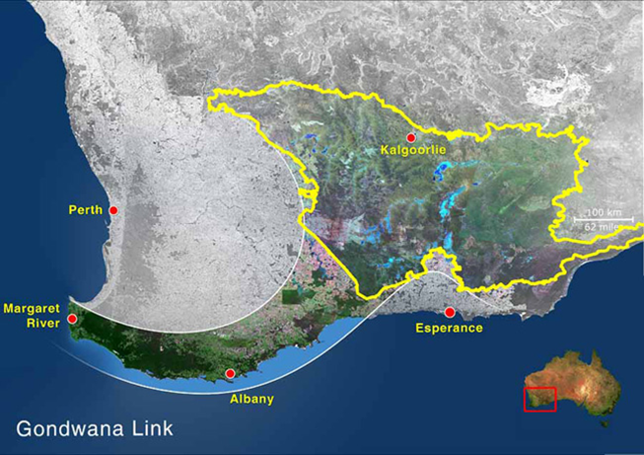  Advanced revegetation efforts can include creating ‘natural corridors’ (Gondwana Link 2018) which enable animals to move over larger distances. See Gondwana Link for an example of this at www.gondwanalink.org/aboutus/wherewework.aspx.  Gondwana Link  If many schools across the metropolitan area planted local native plants, a natural corridor could be created for flying animals (eg bees, birds). Schools from rural areas could contribute to natural corridors by investigating how nature reserves, remnant bushland or roadways can form these corridors. Further information about wildlife corridors is available from the Department of the Environment and Energy at www.environment.gov.au/topics/biodiversity/biodiversity-conservation/wildlife-corridors/what-are-wildlife-corridors.  The idea of natural corridors could be used to extend student understanding of how revegetation projects could have large-scale impacts.  Ideally, the external audience at the exhibition event would be representatives from a local council, Aboriginal community members or organisations that work in land management. An audience of local community members and parents may influence local residents to plant more native species in their gardens.
Instructional procedures | This activity provides an opportunity for cross-curriculum assessment with literacy, listening and speaking as well as assessing students’ understanding of science, mathematics and technologies content.  Presentation skills  Students may need information about effective presentation skills such as voice clarity, pace, projection, volume, pitch and tone. Time constraints should be set for presentations and all students should contribute to the presentation.  Students will need support and scaffolding to help prepare for the presentation. To scaffold cooperative group work, each member of the group could have a role and responsibility. See Teacher resource sheet 1.1: Cooperative learning – Roles for elaboration.  Depending on students’ prior knowledge or ability, time may need to be allocated to developing oral presentation skills.  Presentation options include creating a comic strip, eBook, poster in Pages, Sway, Keynote or PowerPoint or simple iMovie (or similar), which can then be shared through a digital platform such as Connect, Seesaw or Class Dojo, added to a class blog, or shared on the interactive whiteboard. Students may require explicit instruction when using apps.  To enable the completion of the design process, students should be given time to make improvements to their work based on feedback received regarding their presentations. Improvements could be made in their groups or as a private reflection in their learning journals.  There is the opportunity to evaluate students’ development of the general capability Personal and social capability using Teacher resource sheet 4.3: Peer and visitor feedback.
Expected learning | Students will be able to:  - Work collaboratively to develop and deliver a presentation (Technologies).  - Communicate flowchart design ideas to an authentic audience (Technologies).  - Evaluate the effectiveness of the design processes and solutions used, using an agreed set of criteria and personal reflection strategies (Technologies).  - Communicate ideas, explanations, and processes using scientific representations in a variety of ways, including multi-modal texts (Science).  - Use evidence from fieldwork to justify choices made in the steps of the restoration plan flowchart (Science).
Equipment required | For the class:  Presentation space
For the students:
Presentation equipment as required
Student activity sheet 4.2: Self-evaluation
Preparation | Students host an exhibition event which will be promoted throughout the school and, where possible, the local community. The event could be named ‘Caring for Country’.  Students will need support to prepare for the event. Some considerations may include:  Venue  - Where will the event be held? Is there enough space?  Invitations  - Who will be invited to attend? Which community members will you invite?  - How will you raise awareness of the event?  Digital infrastructure  - Is there access to wi-fi and a power supply?  - Will the technology be available and charged?  - How will the presentations be scheduled?  - What presentation equipment will be required?
Activity parts | Part 1: Inspect a well-restored site  Display the following images for the class, see Teacher resource sheet 4.1: Progress photographs. The land area in the photos was cleared for farming but has since become a revegetation project. Use the following questions to prompt discussion:  - How would you describe the land behind the car in each image?  - How do you think the land is used?  - What type of plants do you think were planted in the revegetation project?  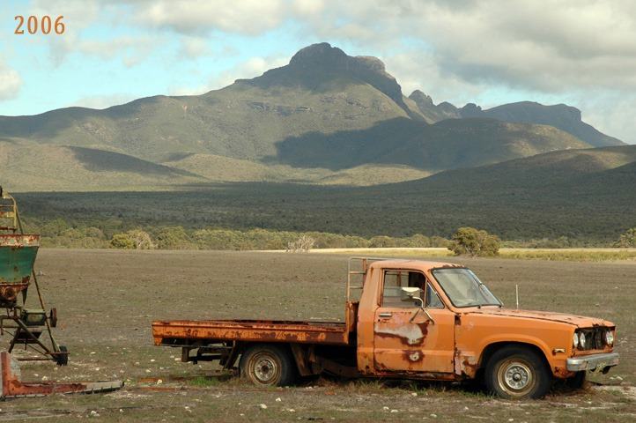  - We can see the changes in the plants, what else might have changed?  Gondwana Link  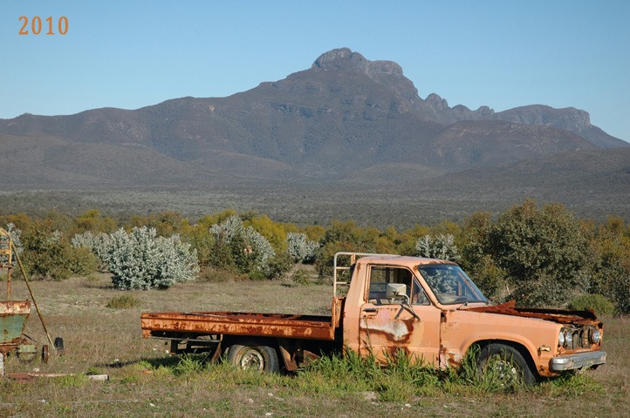  Gondwana Link  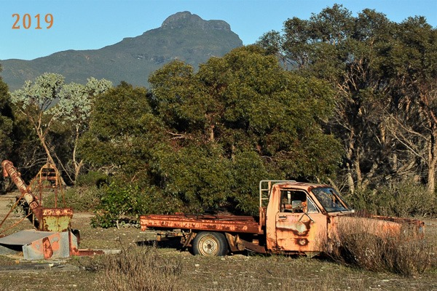  Gondwana Link
Part 2: Define advocating
Explain the three photos above are a form of advocacy; they show the positive results of somebody’s revegetation efforts. Ask students to find the meaning of ‘advocate’ and discuss the positives of advocating on a project such as:
- Are there spaces around your home or our school that could be revegetated to produce native plant communities?
- How could we find out more about Aboriginal culture and histories to develop a connection to country in our area?
Part 3: Prepare presentations
Explain to students they will be hosting an event to exhibit their learning to the wider community, and that by informing and educating others they are advocating for the protection of natural ecosystems and the restoration of degraded habitats.
Reinforce the power of learning and explain that if one person's understanding is developed as a result of the exhibition then it strengthens the commitment to a sustainable world.
Discuss with the students that Aboriginal and Torres Strait Islander communities maintain a connection to and responsibility for country. Emphasise that Aboriginal and Torres Strait Islander people have holistic belief systems and are spiritually and intellectually connected to land, sea, sky and waterways.
The exhibition aims to educate visitors about the importance of protecting Australia’s biodiversity and hopefully encourage people to use this information to develop their own revegetation projects. To encourage visitors to do so, students need to successfully communicate the value of revegetating degraded habitat.
Encourage students to decide on the content and style of their presentation and to include:
- Reasons for the degradation of local plant communities
- People’s relationship with the natural environment and competing uses for it (eg conservation, recreation, agriculture and mining)
- Aboriginal and Torres Strait Islander people’s relationship with the natural environment, including the significance of native plants and animals
- The interdependence of plants, animals and the physical environment
- Information from their fieldwork including the impact of human activity or weather events on plant communities
- Their flowchart plan for restoration.
Students will need enough time prior to the exhibition to develop and prepare their presentations.
Part 4: Exhibition preparation
Prior to the event, engage students in thinking about how the presentation area can be arranged to best accommodate the exhibition. Students will need to consider the space and furniture required as well as extra resources they may need such as tablecloths, book stands, laptops and other ICT tools. The timing of the exhibition and visitor numbers will also need to be considered.
Allow time for students to share and engage in their peers’ presentations. Develop ways for students to record feedback, see Teacher resource sheet 4.3: Peer and visitor feedback.
Part 5: Reflection
Students decide on the best way to collate the feedback from the exhibition by discussing:
- What tools will we use to do this?
- What information does this tell us?
- What changes would we make for subsequent exhibitions?
Discuss the impact of the exhibition on the community and ways to measure the success or spread of sharing their knowledge.
- Will some groups continue with this message after finishing this module?
- Will there be any long-term impact stories?
- How could these be tracked and shared?
- Should we implement a restoration plan? How could we do this? What would we need to consider? Who would we involve? Which flowchart would we follow? How could we decide this?
Students reflect on their work throughout the project using Student activity sheet 4.2: Self-evaluation.
Students complete Student activity sheet 1.0: Journal checklist.
Resource sheets | Student activity sheet 1.0: Journal checklist  Teacher resource sheet 1.1: Cooperative learning – Roles  Teacher resource sheet 4.1: Progress photographs  Student activity sheet 4.2: Self-evaluation  Teacher resource sheet 4.3: Peer and visitor feedback

Appendix 1: Links to the Western Australian Curriculum
The Caring for country: Restoring native vegetation module provides opportunities for developing students’ knowledge and understandings in science, technologies and mathematics. The table below shows how this module aligns to the content of the Western Australian Curriculum and can be used by teachers for planning and monitoring.
Caring for country: Restoring native vegetation | ACTIVITY
 | 1 |  | 2 |  | 3 |  | 4
SCIENCE
SCIENCE UNDERSTANDING
Biological sciences: The growth and survival of living things are affected by physical conditions of their environment (ACSSU094) | ●
SCIENCE INQUIRY SKILLS
Planning and conducting: Identify, plan and apply the elements of scientific investigations to answer questions and solve problems using equipment and materials safely and identifying potential risks (ACSIS103) |  | ●
Communicating: Communicate ideas, explanations and processes using scientific representations in a variety of ways, including multi-modal texts (ACSIS110) |  |  |  | ● |  | ●
DESIGN AND TECHNOLOGIES
PROCESS AND PRODUCTION SKILLS
Creating solutions by designing: Design, modify, follow and represent both diagrammatically, and in written text, alternative solutions using a range of techniques, appropriate technical terms and technology (WATPPS35) |  |  |  | ●

Caring for country: Restoring native vegetation | ACTIVITY
 | 1 |  | 2 |  | 3 |  | 4
DIGITAL TECHNOLOGIES
PROCESS AND PRODUCTION SKILLS
Collecting, managing and analysing data: Collect, sort, interpret and visually present different types of data using software to manipulate data for a range of purposes (ACTDIP016) |  | ●
Digital implementation: Manage the creation and communication of information, including online collaborative projects, using agreed social, ethical and technical protocols (ACTDIP022) |  |  |  | ● |  | ●
Investigating and defining: Define a problem, and a set of sequenced steps, with users making decisions to create a solution for a given task (WATPPS33) |  |  |  | ●
Producing and implementing: Select, and apply safe, procedures when using a variety of components and equipment to make solutions (WATPPS36) |  | ● |  | ●
MATHEMATICS
MEASUREMENT AND GEOMETRY
Using Units of Measurement: Connect decimal representations to the metric system (ACMMG135)  Using Units of Measurement: Convert between common metric units of length, mass and capacity (ACMMG136)  Using Units of Measurement: Solve problems involving the comparison of lengths and areas using appropriate units (ACMMG137)  Location and transformation: Introduce the Cartesian coordinate system using all four quadrants (ACMMG143) |  | ●      
NUMBER AND ALGEBRA
Fractions and decimals: Make connections between equivalent fractions, decimals and percentages (ACMNA131) |  | ●
STATISTICS AND PROBABILITY
Data representation and interpretation: Interpret and compare a range of data displays, including side-by-side column graphs for two categorical variables (ACMSP147) |  | ●
Further information about assessment and reporting in the Western Australian Curriculum can be found at k10outline.scsa.wa.edu.au/home.

Appendix 1B: Mathematics proficiency strands
Key ideas
In Mathematics, the key ideas are the proficiency strands of understanding, fluency, problem-solving and reasoning. The proficiency strands describe the actions in which students can engage when learning and using the content. While not all proficiency strands apply to every content description, they indicate the breadth of mathematical actions that teachers can emphasise.
Understanding
Students build a robust knowledge of adaptable and transferable mathematical concepts. They make connections between related concepts and progressively apply the familiar to develop new ideas. They develop an understanding of the relationship between the ‘why’ and the ‘how’ of mathematics. Students build understanding when they connect related ideas, when they represent concepts in different ways, when they identify commonalities and differences between aspects of content, when they describe their thinking mathematically and when they interpret mathematical information.
Fluency
Students develop skills in choosing appropriate procedures; carrying out procedures flexibly, accurately, efficiently and appropriately; and recalling factual knowledge and concepts readily. Students are fluent when they calculate answers efficiently, when they recognise robust ways of answering questions, when they choose appropriate methods and approximations, when they recall definitions and regularly use facts, and when they can manipulate expressions and equations to find solutions.
Problem-solving
Students develop the ability to make choices, interpret, formulate, model and investigate problem situations, and communicate solutions effectively. Students formulate and solve problems when they use mathematics to represent unfamiliar or meaningful situations, when they design investigations and plan their approaches, when they apply their existing strategies to seek solutions, and when they verify that their answers are reasonable.
Reasoning
Students develop an increasingly sophisticated capacity for logical thought and actions, such as analysing, proving, evaluating, explaining, inferring, justifying and generalising. Students are reasoning mathematically when they explain their thinking, when they deduce and justify strategies used and conclusions reached, when they adapt the known to the unknown, when they transfer learning from one context to another, when they prove that something is true or false, and when they compare and contrast related ideas and explain their choices.

Source: ACARA – www.australiancurriculum.edu.au/f-10-curriculum/mathematics/key-ideas/?searchTerm=key+ideas#dimension-content

Appendix 2: General capabilities continuums
The general capabilities continuums shown here are designed to enable teachers to understand the progression students should make with reference to each of the elements. There is no intention for them to be used for assessment.
Information and communication technology (ICT) capability learning continuum
Sub-element | Typically by the end of Year 4 | Typically by the end of Year 6 | Typically by the end of Year 8
Create with ICT  Generate ideas, plans and processes | use ICT to generate ideas and plan solutions | use ICT effectively to record ideas, represent thinking and plan solutions | use appropriate ICT to collaboratively generate ideas and develop plans
Create with ICT  Generate solutions to challenges and learning area tasks | create and modify simple digital solutions, creative outputs or data representation/ transformation for particular purposes | independently or collaboratively create and modify digital solutions, creative outputs or data representation/  transformation for particular audiences and purposes | design and modify simple digital solutions, or multimodal creative outputs or data transformations for particular audiences and purposes following recognised conventions
Communicating with ICT  Collaborate, share and exchange | use appropriate ICT tools safely to share and exchange information with appropriate known audiences | select and use appropriate ICT tools safely to share and exchange information and to safely collaborate with others | select and use appropriate ICT tools safely to lead groups in sharing and exchanging information, and taking part in online projects or active collaborations with appropriate global audiences

Critical and creative thinking learning continuum
Sub-element | Typically by the end of Year 4 | Typically by the end of Year 6 | Typically by the end of Year 8
Inquiring – identifying, exploring and organising information and ideas  Organise and process information | collect, compare and categorise facts and opinions found in a widening range of sources | analyse, condense and combine relevant information from multiple sources | critically analyse information and evidence according to criteria such as validity and relevance
Generating ideas, possibilities and actions  Imagine possibilities and connect ideas | expand on known ideas to create new and imaginative combinations | combine ideas in a variety of ways and from a range of sources to create new possibilities | draw parallels between known and new ideas to create new ways of achieving goals
Generating ideas, possibilities and actions  Seek solutions and put ideas into action | experiment with a range of options when seeking solutions and putting ideas into action | assess and test options to identify the most effective solution and to put ideas into action | predict possibilities, and identify and test consequences when seeking solutions and putting ideas into action
Reflecting on thinking and processes  Transfer knowledge into new contexts | transfer and apply information in one setting to enrich another | apply knowledge gained from one context to another unrelated context and identify new meaning | justify reasons for decisions when transferring information to similar and different contexts

Personal and social capability learning continuum
Sub-element | Typically by the end of Year 4 | Typically by the end of Year 6 | Typically by the end of Year 8
Social management  Work collaboratively | describe characteristics of cooperative behaviour and identify evidence of these in group activities | contribute to groups and teams, suggesting improvements in methods used for group investigations and projects | assess the extent to which individual roles and responsibilities enhance group cohesion and the achievement of personal and group objectives
Social management  Negotiate and resolve conflict | identify a range of conflict resolution strategies to negotiate positive outcomes to problems | identify causes and effects of conflict, and practise different strategies to diffuse or resolve conflict situations | assess the appropriateness of various conflict resolution strategies in a range of social and work-related situations
Social management  Develop leadership skills | discuss the concept of leadership and identify situations where it is appropriate to adopt this role | initiate or help to organise group activities that address a common need | plan school and community projects, applying effective problem-solving and team-building strategies, and making the most of available resources to achieve goals
Further information about general capabilities is available at:
k10outline.scsa.wa.edu.au/home/p-10-curriculum/general-capabilities-over/general-capabilities-overview/general-capabilities-in-the-australian-curriculum

Appendix 3: Materials list

The following materials are required to complete this module:
- Field guide for identifying plants in your local area (if possible)
- A quadrat in the form of a cartesian plane for fieldwork for each student group (possibly made from PVC pipe, bamboo, string and pegs, measuring tape) or one metre rulers and string
- Small containers for soil samples, trowels, cameras, graph paper, markers, paper, scissors, sticky tape, pencil, 30 cm ruler
- Magnifying glasses and trays
- Sticky notes.

Materials for optional or extension parts are identified within activities.

Appendix 4: Design process guide
Safe production of the final design or multiple copies of the final design.
Fine tuning the production process, such as division of labour for batch or mass production.
Use of intended materials and appropriate tools to safely make the solution to the design problem.
Reflection on the process taken and the success of the design.
Evaluation can lead to further development or improvement of the design and can be a final stage of the design process before a conclusion is reached.
Could be formal or informal and verbal or written.
Ideation
Development
Development of the design ideas. Improvements, refinements, adding detail, making it better.
Activities such as detailed drawings, modelling, prototyping, market research, gaining feedback from intended user, further research – if needed – to solve an issue with the design, testing different tools or equipment, trialling production processes, measuring or working out dimensions, testing of prototypes and further refinement.
Idea generation – turning ideas into tangible forms so they can be organised, ordered and communicated to others.
Activities such as brainstorming, mind mapping, sketching, drawing diagrams and plans, collecting colour samples and/or material samples and talking through these ideas can help to generate fu creative ideas.
Using the SCAMPER model can assist with this: www.mindtools.com/pages/article/newCT_02.htm
www.designorate.com/a-guide-to-the-scamper-technique-for- creative-thinking
Analysis
Finding useful and helpful information about the design problem.
Gathering information, conducting surveys, finding examples of existing solutions, testing properties of materials, practical testing.
Understanding the meaning of the research findings.
Analysing what the information means, summarising the surveys, judging the value of existing solutions, understanding test results.
Research
Production
Evaluation

Appendix 4B: Drawing in the design process
Incorporating the design process into the STEM modules will often result in the need for students to draw plans of their designs. This can be done at a simple level using hand-drawn sketches or at a more technical level using computer-aided design (CAD).
istockphoto.com.au
By developing skills using industry-standard software, students may be well-placed to explore future career pathways.
There are several CAD software options, two free examples are detailed below. Autodesk is a third package that is also free for educational use.
Tinkercad
- Format: Web-based app requiring internet access via a browser
- Purpose: A simple, online 3D design and 3D printing app
- Home: www.tinkercad.com
- Blog: blog.tinkercad.com
- Tutorials: www.tinkercad.com/learn
- Feature: Connects to 3D printing and laser cutting.
SketchUp
- Format: Can be downloaded and installed on devices, or used in a browser
- Purpose: Enables students to draw in 3D
- Home: www.sketchup.com 'Products' 'SketchUp for Schools'
- Help centre: help.sketchup.com/en
- Blog: blog.sketchup.com
- Tutorials: www.youtube.com/user/SketchUpVideo. From beginner tool tips to intermediate and advanced modelling techniques, the video tutorials help to build SketchUp skills.

Appendix 5: Reflective journal
When students reflect on learning and analyse their own ideas and feelings, they self-evaluate, thereby improving their metacognitive skills. When students self-monitor or reflect, the most powerful learning happens.
Journaling may take the form of a written or digital journal, a portfolio or a digital portfolio. Early childhood classrooms may use a class reflective floor book with pictures of the learning experience and scribed conversations.
istockphoto.com.au
Teachers can model the journaling process by thinking aloud and showing students how they can express learning and thoughts in a variety of ways including diagrams, pictures and writing.
Journals are a useful tool that gives teachers additional insight into how students value their own learning and progress, as well as demonstrating their individual achievements.
The following links provide background information and useful apps for journaling.
Kidblog – digital portfolios and blogging
kidblog.org/home
Edmodo – for consolidating and storing class notes and learning materials
www.edmodo.com/
Explain Everything™ – a screen casting, video and presentation tool all in one
explaineverything.com
Popplet – allows you to jot down your ideas and then sort them visually
Popplet.com
Seesaw – for capturing work completed by students in class, using a device’s camera function
web.seesaw.me
Connect – the Department of Education’s integrated, online environment
connect.det.wa.edu.au
Evernote (a digital portfolio app)
evernote.com
Digital portfolios for students (Cool tools for school)
cooltoolsforschool.wordpress.com/digital-student-portfolios

Appendix 6: Student activity sheet 1.0: Journal checklist
As an ongoing part of this module, you have been keeping a journal of your work.
Before submitting your journal to your teacher please ensure you have included the following information.
- Tick each box once complete and included.
- Write N/A for items that were not required in this module.
istockphoto.com.au

Your name and group member's names or photographs
An explanation of the problem you are solving
Your notes from Activity 1
Your notes from Activity 2
Your notes from Activity 3
Your notes from Activity 4
Student activity sheet 3.3: Prototype troubleshooting
Student activity sheet 4.2: Self-evaluation
Student activity sheet 4.3: Peer and visitor feedback
Student activity sheet 1.0: Journal checklist

Appendix 7: Teacher resource sheet 1.1: Cooperative learning – Roles
Cooperative learning frameworks create opportunities for groups of students to work together, generally to a single purpose.
As well as having the potential to increase learning for all students involved, using these frameworks can help students develop personal and social capability.
When students are working in groups, positive interdependence can be fostered by assigning roles to group members.
istockphoto.com.au
These roles could include:
- Working roles such as Reader, Writer, Summariser, Time-keeper
- Social roles such as Encourager, Observer, Noise monitor, Energiser.
Teachers using the Primary Connections roles of Director, Manager and Speaker for their science teaching may find it effective to also use these roles for STEM learning.
Further to this, specific roles can be delineated for specific activities that the group is completing.
It can help students if some background to the purpose of group roles is made clear to them before they start, but at no time should the roles get in the way of the learning. Teachers should decide when or where roles are appropriate to given tasks.
istockphoto.com.au

Appendix 8: Teacher resource sheet 1.2: Cooperative learning – Jigsaw
Cooperative learning frameworks create opportunities for groups of students to work together, generally for a single purpose.
As well as having the potential to increase learning for all students involved, using these frameworks can help students develop personal and social capability.
The jigsaw strategy typically has each member of the group becoming an 'expert' on one or two aspects of a topic or question being investigated. Students start in their cooperative groups, then break away to form 'expert’ groups to investigate and learn about a specific aspect of a topic. After developing a sound level of understanding, the students return to their cooperative groups and teach each other what they have learnt.
Within each expert group, issues such as how to teach the information to their group members are considered.

Step 1 | Cooperative groups  (of four students) | 1 2 3 4 |  | 1 2 3 4
Step 2 | Expert groups  (size equal to the number of groups) | 1 1 | 2 2 | 3 3 | 4 4
Step 3 | Cooperative groups  (of four students) | 1 2 3 4 |  | 1 2 3 4

Appendix 9: Teacher resource sheet 1.3: Cooperative learning – Placemat
Cooperative learning frameworks create opportunities for groups of students to work together, generally for a single purpose.
As well as having the potential to increase learning for all students involved, using these frameworks can help students develop personal and social capability.
The placemat strategy involves students working collaboratively to record prior knowledge about a common topic and brainstorm ideas. It also allows teachers to readily see the contribution of each student. The diagram below shows a typical placemat template.
istockphoto.com.au

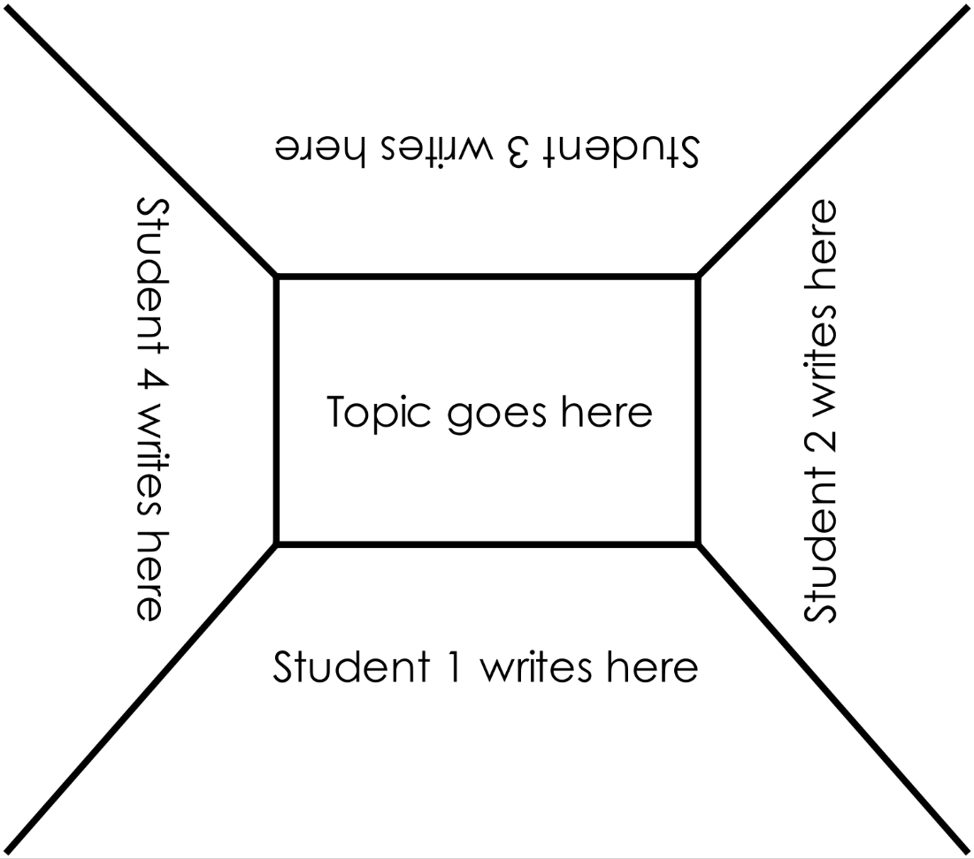
STEM Consortium

Appendix 10: Teacher resource sheet 1.4: Cooperative learning – Think, Pair, Share
Cooperative learning frameworks create opportunities for groups of students to work together, generally to a single purpose.
As well as having the potential to increase learning for all students involved, using these frameworks can help students develop personal and social capability.
In the 'think' stage, each student thinks silently about a question asked by the teacher.
istockphoto.com.au
In the 'pair' stage, students discuss their thoughts and answers to the question in pairs.
In the 'share' stage, the students share their answer, their partner’s answer or what they decided together. This sharing may be with other pairs or with the whole class. It is important also to let students 'pass'. This is a key element of making the strategy safe for students.
Think–pair–share increases student participation and provides an environment for higher levels of thinking and questioning.

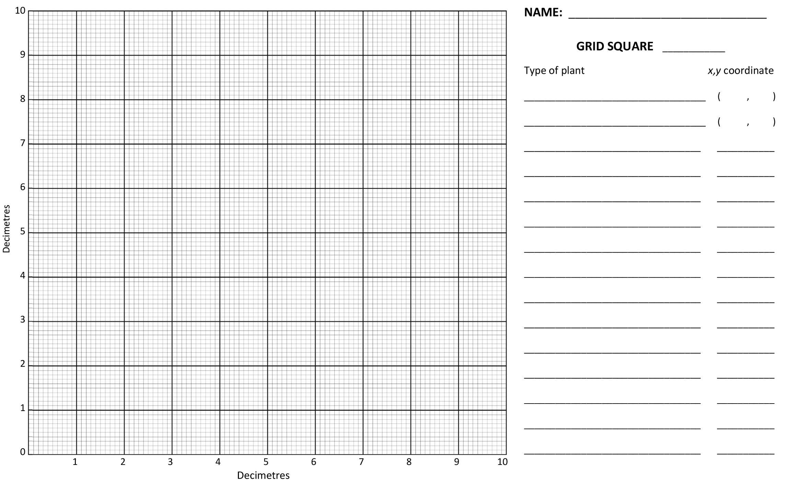
Appendix 11: Student activity sheet 2.1: Cartesian coordinates

Appendix 12: Teacher resource sheet 3.1: Flowcharting symbols
A flowchart is a diagrammatic representation of an algorithm. It can take the form of a branching set of shapes with decision-making steps. The shapes used in a flowchart are shown here with explanations of their purpose.

Terminator
This symbol is used to represent the start and end of a flowchart.
Process
This symbol is used to represent one or more instructions or things to do.
Data
This symbol is used to represent the input or output of any information.
Decision
This symbol is used to represent a point in the flowchart where a decision is made and from which two or more paths could be followed.
Flowline
This symbol is used to show the direction of the process or data flow.

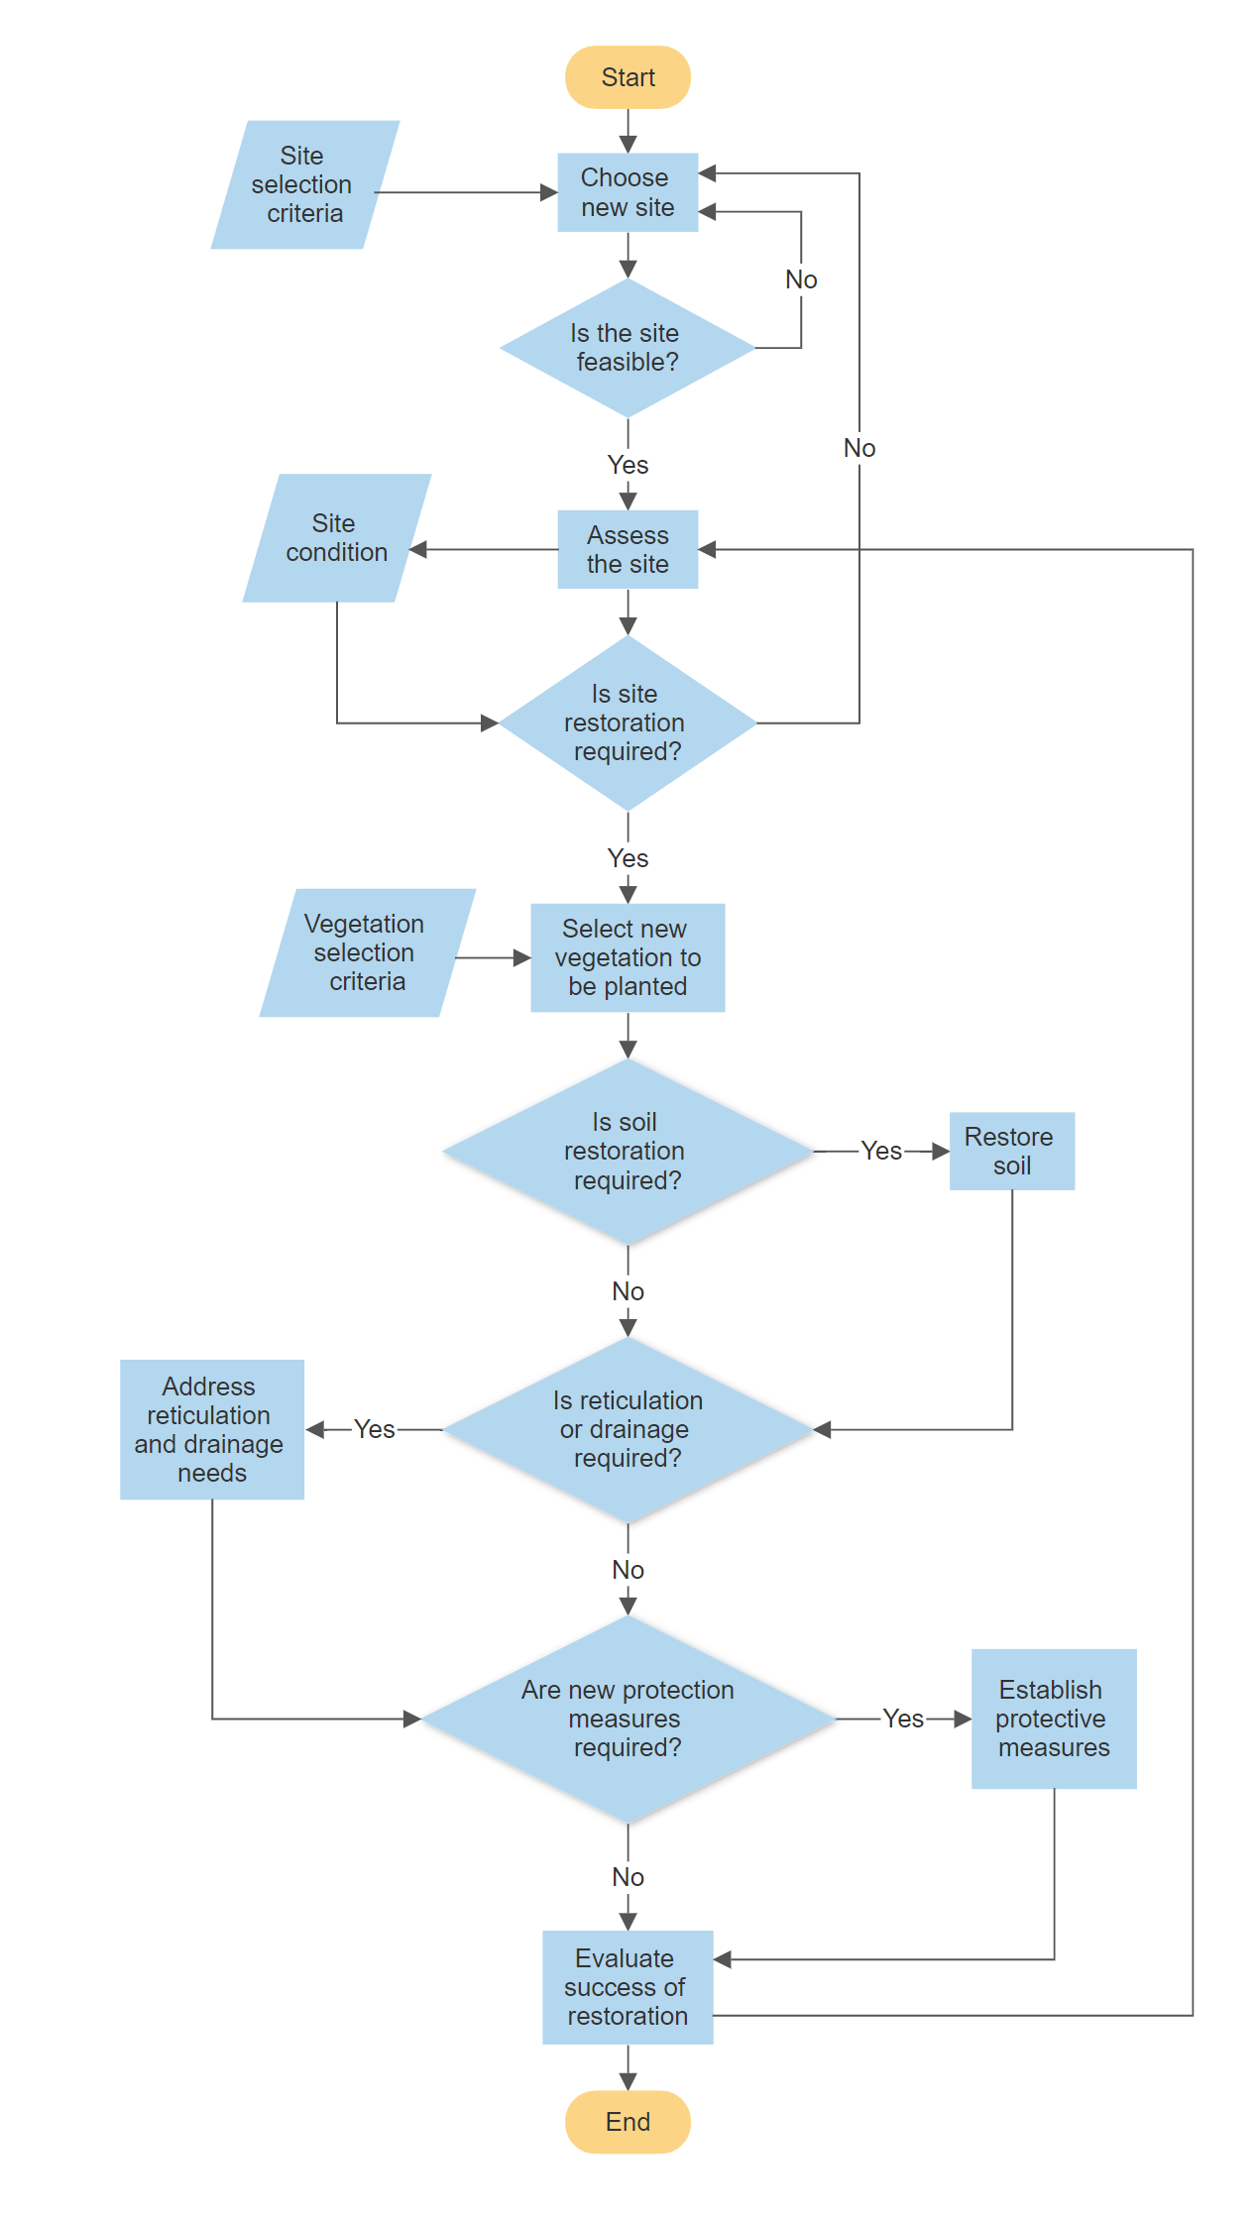
Appendix 13: Teacher resource sheet 3.2: Flowchart example
STEM Consortium

Appendix 14: Student activity sheet 3.3: Prototype troubleshooting
Problem | Reason for the problem | Possible changes to your design  to solve the problem

Appendix 15: Teacher resource sheet 4.1: Progress photographs
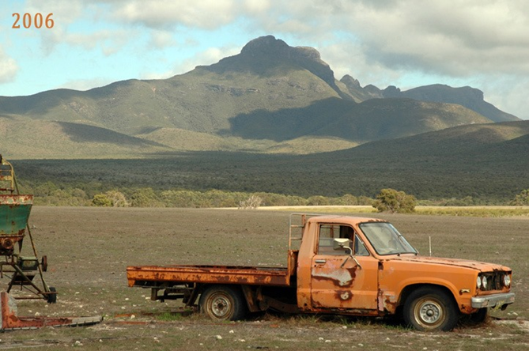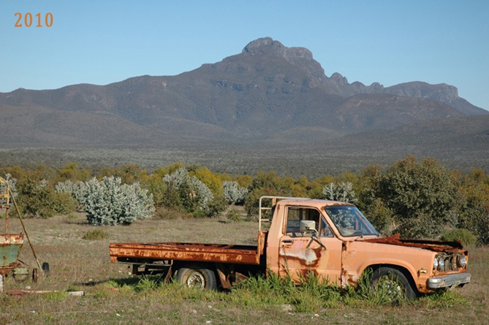
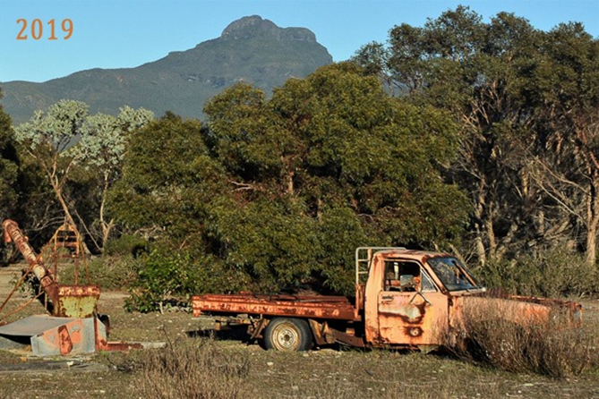
Gondwana Link

Appendix 16: Student activity sheet 4.2: Self-evaluation
 | Always | Usually | Sometimes | Rarely
Remains focused on tasks presented
Completes set tasks to best of their ability
Works independently without disrupting others
Uses time well
Cooperates effectively within the group
Contributes to group discussions
Shows respect and consideration for others
Uses appropriate conflict resolution skills
Actively seeks and uses feedback

Comments: __________________________________________________________________________________________________________________________________________________________________________________________________________________________________________________________________________________________________________________________________________________________

Appendix 17: Teacher resource sheet 4.3: Peer and visitor feedback
Please provide us with some feedback about our exhibition.
Did you have fun? What did you learn? What will you do with this new information?

Notes
________________________________________________________________________________________________________________________________________________________________________________________________________________________________________________________________________________________________________________________________________________________________________________________________________________________________________________________________________________________________________________________________________________________________________________________________________________________________________________________________________________________________________________________________________________________________________________________________________________________________________________________________________________________________________________________________________________________________________________________________________________________________________________________________________________________________________________________________________________________________________________________________________________________________________________________________________________________________________________________________________________________________________________________________________________________________________________________________________________________________________________________________________________________________________________________________________________________________

