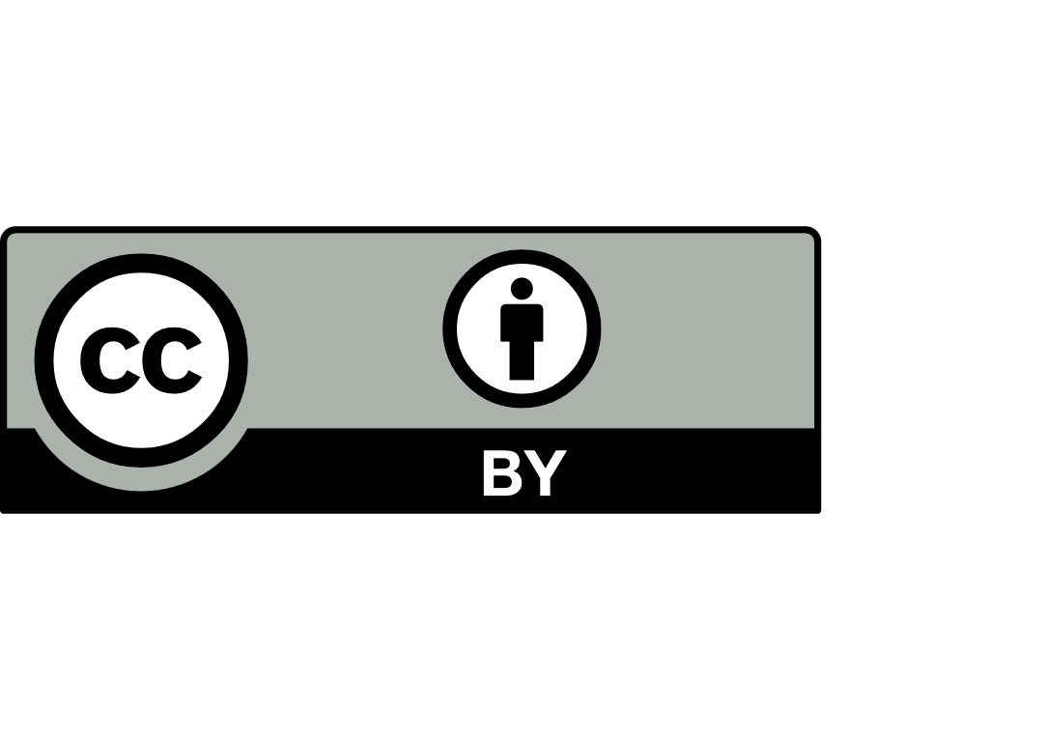
About this form
CRICOS course registration and variation schedule
Non-Government School Regulation

To add new courses to Commonwealth Register of Institutions and Courses for Overseas Students (CRICOS) or vary courses already registered on CRICOS you must complete the Course Registration and Variation Schedule (refer page 5 of this document).

To register a new course or courses you must complete all fields of the schedule (except column 2 in the case of new courses) in full. Should the documentation not be completed we may return documentation for competition.

You are not permitted to promote a course, offer a course or enrol international students into a course unless that course is registered on CRICOS.

Fee payment
Each application for the registration of a new course or courses is to be placed on the CRICOS within an institution's registration period will be subject to the following charges:
Institutions with a total international student population of 9 or less per calendar year $345
Institutions with a total international student population of 10 or more per calendar year $855
Deletion of a course or courses $21
Note: The above fees do not apply if courses are being registered as part of an initial registration or renewal of registration process.
We will issue an invoice to the applicant for the applicable fee on receipt of the application

Tuition Protection Service (TPS)
As required by section 26 of the Education Services for Overseas Students Act 2000 (ESOS Act) if you are seeking to add courses to Provider Registration and International Student Management System (PRISMS), complete this form and include evidence that additional coverage has been obtained from your TPS for those courses.

Course variations
For course variations select the course title, enter CRICOS course code and indicate on the schedule the new details for the course (only complete columns where details have changed). For example, if you wish to change the tuition fee for a course, complete the course title, CRICOS course code and fee values (columns 1,2,7,8 and 9 of the schedule).

Deleting courses
Should you wish to cancel a course, include the title of the course, course code and in the third column “action type” select “cancel”.
Collection notice for non-government school regulation
We collect personal information for the purpose of administering key clauses of the School Education Act 1999 (WA) and the School Education Regulations 2000 and make recommendations to the Director General about school registration and compliance.

We use the information to register, assess and monitor your application and ongoing responsibilities. Information may be shared with authorised Department staff and, where necessary, other agencies or parties as permitted or required by law. Your information will be stored securely within Australia with access restricted to authorised staff. Personal information is retained and disposed of following the Department’s Records Management policy and the State Records Act 2000.

If the information is not collected, we cannot assess your application. You may request access to, or correction of, your information. Email the Non-Government School Regulation directorate at (ngsregulation@education.wa.edu.au). For further information about how we handle personal information, refer to the Collection notice for non-government school regulation and our Privacy statement.

How to complete the schedule

Follow this process to complete the variation schedule.

Course title
Select the official course title, if ‘other’ selected, type the course title in cell.

CRICOS course code
Insert the CRICOS course code if the course is already registered and you are requesting to vary the registered details.

Action type
Select whether you wish to add a new course, vary a registered course or cancel an existing course. If you are seeking to relinquish your registration as an international education provider altogether rather than using this form the principal executive officer must submit the request and indicate the effective date of the requested action.

Course Level
Select course level from the drop down.

Level of Education
CRICOS requires the entry of a broad, narrow and detailed level of study in line with the Australian Standard Classification for Education (ASCED). For field 5 you must select the broad, narrow and detailed level by selecting the relevant classification codes according to the ASCED Guidelines available at the Australian Bureau of Statistics website at www.abs.gov.au. Mainstream school sector courses will typically be classified as 12 01 01, however in some cases, other classifications are appropriate.

Duration
Indicate the number of weeks the course is offered over (including breaks) in whole semesters with a one-year course recorded as 52 weeks.

Tuition fees
Tuition fees are fees received that are directly related to the provision of a course (defined in section 7 of the ESOS Act). Tuition fees are typically compulsory fees for the delivery of the enrolled course and include items such as:
- face-to-face instruction
- tutorials and tutoring sessions
- additional requisite training including practicums and practice hours
- ancillary costs for fieldwork, excursions or laboratories
- specialist materials that are mandatory and relate to the provision of the course
- any compulsory enrolment or administration fees that apply during the entire period of enrolment.

Non-tuition fees
Non-tuition fees cover other items not directly related to tuition and may be compulsory or discretionary. Non-tuition fees include fees such as:
- application fees
- boarding fees only if boarding is a mandatory requirement for enrolment
- book fees (where books are not supplied by the school)
- uniform fees (estimate over the duration of the course)
- endowment fees.

Total course cost
Indicate the estimated total course cost for the entire course. For example, if the Senior Secondary Certificate of Education Years 11 - 12 is a two-year course, indicate the total cost for the entire course. Course costs include tuition and non-tuition fees.

Arrangements with other providers
Indicate whether any other providers are involved in the delivery of the course. For example, will a registered Vocational Education and Training provider potentially be issuing a qualification to students.
Note: If yes, in line with Standard 11.1 of the National Code, provide a rationale for the delivery for the course, where and how the course will be delivered, information as to how you will ensure compliance with the National Code when the student is with the other provider and provide a copy of a signed agreement between the parties.

Course location sites
Indicate the site or sites where the course will be delivered. Where the school delivers at more than one site, indicate tag one site as ‘main’. Attach a separate page if space is insufficient to make nominations.

Mode of study
Percentage, if any, of the total course is delivered on-line or through distance education. Indicate by inserting percentage.

Submissions
Submit the completed the schedule including the signed authorisation declaration by email to NGSRegulation@education.wa.edu.au.

Enquiries:
Telephone: (08) 9441 1900
Email: NGSRegulation@education.wa.edu.au

CRICOS – Course registration and variation schedule

1 | 2 | 3 | 4 | 5 |  |  | 6 | 7 | 8 | 9 | 10 | 11 | 11
Course title | CRICOS course code  (if already registered) | Action type | Course  level | ASCED Level of education |  |  | Duration (weeks) | Tuition fees | Non-tuition fees | Total course cost | Arrangements  with other providers | Course location site or sites | Mode of online study (%)
 |  |  |  | Broad | Narrow | Detailed
Choose an item | Click or tap | Choose an item | Choose an item | Choose an item | Choose an item. | Choose an item | Click or tap | Click or tap | Click or tap | Click or tap | Choose an item. | Click or tap | Click or tap
Choose an item | Click or tap | Choose an item | Choose an item | Choose an item | Choose an item. | Choose an item | Click or tap | Click or tap | Click or tap | Click or tap | Choose an item. | Click or tap | Click or tap
Choose an item | Click or tap | Choose an item | Choose an item | Choose an item | Choose an item. | Choose an item | Click or tap | Click or tap | Click or tap | Click or tap | Choose an item. | Click or tap | Click or tap
Choose an item | Click or tap | Choose an item | Choose an item | Choose an item | Choose an item. | Choose an item | Click or tap | Click or tap | Click or tap | Click or tap | Choose an item. | Click or tap | Click or tap
Choose an item | Click or tap | Choose an item | Choose an item | Choose an item | Choose an item. | Choose an item | Click or tap | Click or tap | Click or tap | Click or tap | Choose an item. | Click or tap | Click or tap
Choose an item | Click or tap | Choose an item | Choose an item | Choose an item | Choose an item. | Choose an item | Click or tap | Click or tap | Click or tap | Click or tap | Choose an item. | Click or tap | Click or tap
Choose an item | Click or tap | Choose an item | Choose an item | Choose an item | Choose an item. | Choose an item | Click or tap | Click or tap | Click or tap | Click or tap | Choose an item. | Click or tap | Click or tap
Choose an item | Click or tap | Choose an item | Choose an item | Choose an item | Choose an item. | Choose an item | Click or tap | Click or tap | Click or tap | Click or tap | Choose an item. | Click or tap | Click or tap
Choose an item | Click or tap | Choose an item | Choose an item | Choose an item | Choose an item. | Choose an item | Click or tap | Click or tap | Click or tap | Click or tap | Choose an item. | Click or tap | Click or tap
Choose an item | Click or tap | Choose an item | Choose an item | Choose an item | Choose an item. | Choose an item | Click or tap | Click or tap | Click or tap | Click or tap | Choose an item. | Click or tap | Click or tap

Authorisation

Registered legal entity and school details
Registered legal entity | Click or tap here to enter text.
CRICOS provider code | Click or tap here to enter text.
School name | Click or tap here to enter text.

The schedule must be authorised by the Principal Executive Officer of the organisation or the Delegated Officer.

Courses meet the requirements of the National Code of Practice for Providers of Education and Training to Overseas Students 2018 and the ESOS Act 2000 with respect to provision for international students studying in Western Australia on student visas.

 |  | Click or tap to enter a date.
Signature |  | Date
Click or tap here to enter text.

Full name
Click or tap here to enter text.

Title

