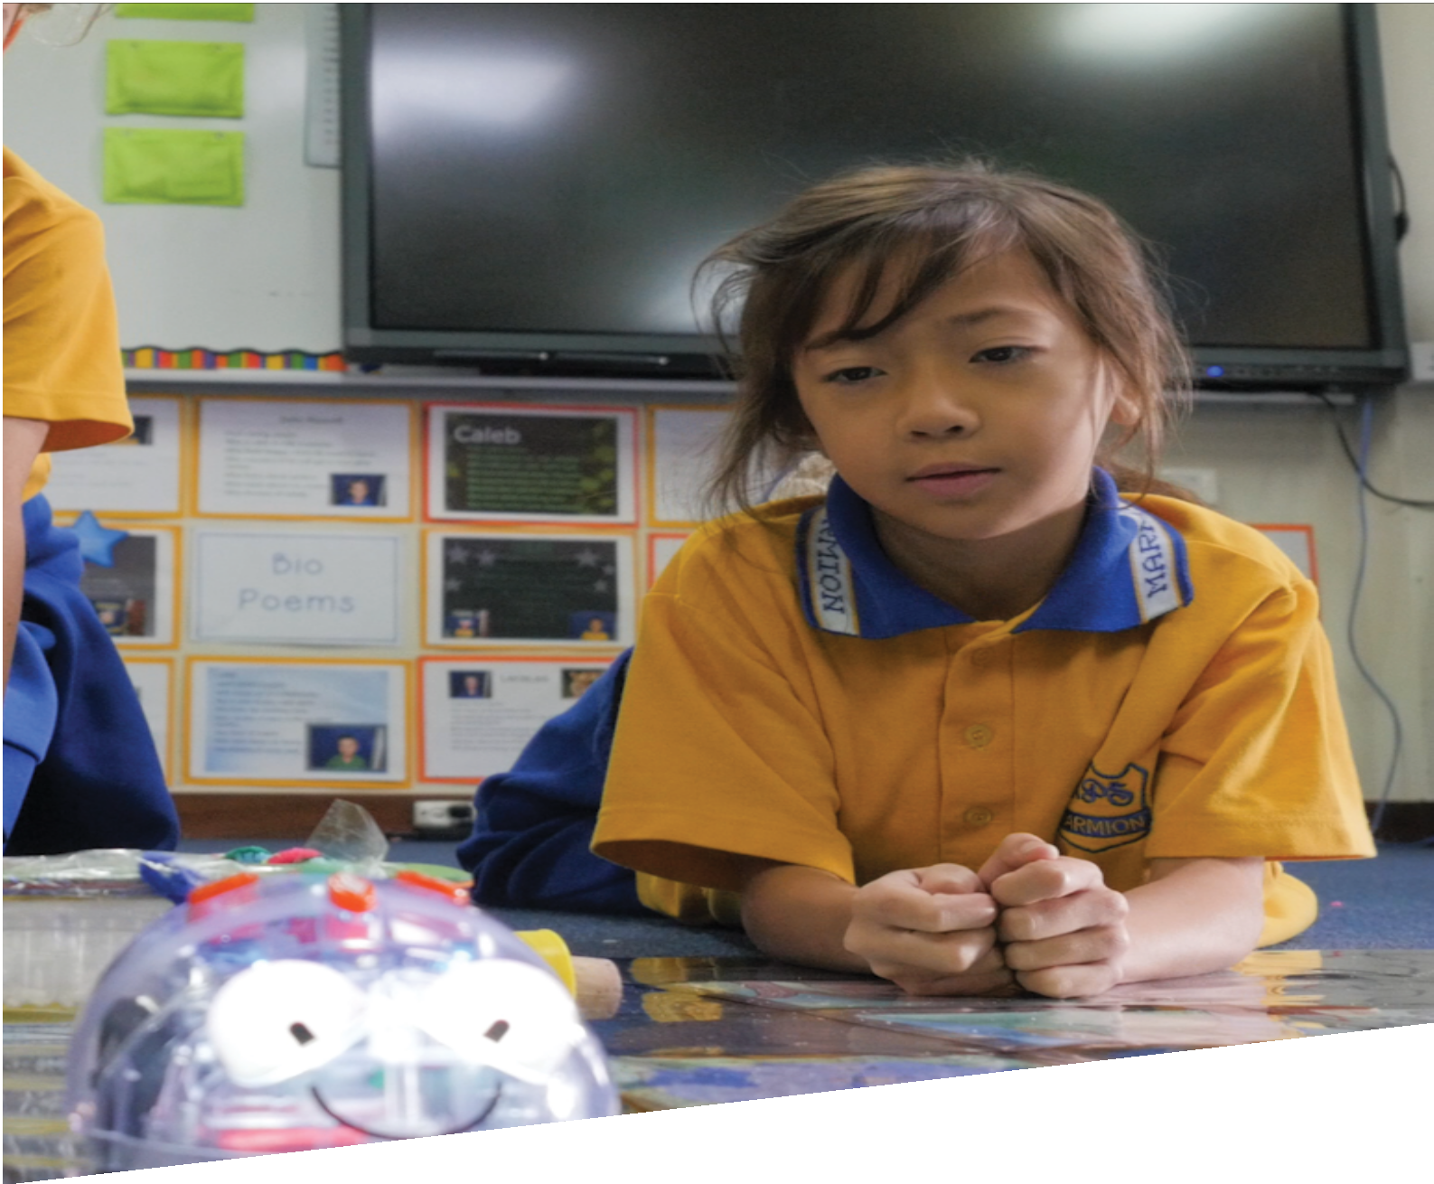

CURRICULUM RESOURCE MODULE
Little Red Hen’s robot friend
YEAR 2

Acknowledgements
The STEM Learning Project respectfully acknowledges the Traditional Custodians of the lands upon which our students and teachers live, learn and educate.

The STEM Learning Project is funded by the Western Australian Department of Education (the Department) and implemented by a consortium in STEM education comprising the Educational Computing Association of WA, the Mathematical Association of WA, the Science Teachers Association of WA and Scitech. We acknowledge and thank the teachers and schools who are the co-creators of these resources.

Copyright and intellectual property

The copyright and intellectual property of this module remain the property of the Department.

Any Western Australian Curriculum content in this resource is used with the permission of the School Curriculum and Standards Authority (the Authority); this permission does not constitute Authority endorsement of the resource. The Authority accepts no liability for any errors or damages arising from reliance on its content.

The Western Australian Curriculum content may be freely copied, or communicated on an intranet, for non-commercial purposes in educational institutions, provided that the Authority is acknowledged as the copyright owner. Copying or communication for any other purpose can be done only within the terms of the Copyright Act 1968 or with prior written permission of the Authority. Any Australian Curriculum content in the Western Australian Curriculum is used by the Authority under the terms of the Creative Commons Attribution-NonCommercial 3.0 Australia licence. Any content on the www.scsa.wa.edu.au domain that has been derived from the Australian Curriculum may be used under the terms of Creative Commons Attribution-NonCommercial 3.0 Australia licence.

Appendix 2: General capabilities continuums is adapted from ACARA, © Australian Curriculum, Assessment and Reporting Authority (ACARA) 2009 to present, unless otherwise indicated. This material was downloaded from the ACARA website (www.acara.edu.au) (Website) (accessed December 2015) and was not modified. The material is licensed under CC BY 4.0 (https://creativecommons.org/licenses/by/4.0/). ACARA does not endorse any product that uses ACARA material or make any representations as to the quality of such products. Any product that uses material published on this website should not be taken to be affiliated with ACARA or have the sponsorship or approval of ACARA. It is up to each person to make their own assessment of the product.

This resource includes references and examples of iOS, Android and other apps. The Department does not endorse or recommend any commercial products and simply provides these as examples for teachers.

The Department is committed to providing quality information to its customers. Whilst every effort has been made to ensure accuracy, currency and reliability of the information within these documents, the Department accepts no responsibility for errors, omissions or amendments made since the time of publishing. Confirmation of information may be sought from the Department or the originating bodies providing the information. The Department has no control over the content of material published on websites to which users are referred in this resource. It is the responsibility of the internet user to make their own decision as to the relevancy, accuracy, currency and reliability of information found on those sites.
This resource contains various images from iStock used under license.
Attributions: Kidblog, Weebly, Microsoft PowerPoint, iMovie, KeyNote, Sphero, Dash and Dot, Edison, Bee-Bot, YouTube, Padlet, Wordpress, Wix, Square Space, Adobe Spark, Microsoft Sway, Canva, Edmodo, Explain Everything, Popplet, Seesaw, Padlet, Class Dojo.

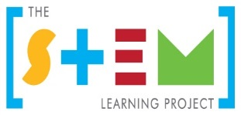
Table of contents

The STEM Learning Project 2
Overview 3
Activity sequence and purpose 8
Background 10
Activity 1: Robots 13
Activity 2: Forces and shapes 19
Activity 3: Prototyping 26
Activity 4: Share results 32
Appendix 1: Links to the Western Australian Curriculum 36
Appendix 1B: Mathematics proficiency strands 38
Appendix 2: General capabilities continuums 39
Appendix 3: Materials list 41
Appendix 4: Design process guide 42
Appendix 5: Reflective journal 43
Appendix 6: Teacher resource sheet 1.1: Cooperative learning – Roles 44
Appendix 7: Teacher resource sheet 1.2: Cooperative learning – Placemat 45
Appendix 8: Teacher resource sheet 1.3: Cooperative learning – Think, Pair, Share 46
Appendix 9: Student resource sheet 1.4: I see, I think, I wonder 47
Appendix 10: Teacher resource sheet 1.5: Sample parent letter 48
Appendix 11: Teacher resource sheet 3.1: Construction skills 49
Appendix 13: Student activity sheet 4.1: Design review 53

The STEM Learning Project
The aim of the STEM Learning Project is to generate students’ interest, enjoyment and engagement with STEM (Science, Technology, Engineering and Mathematics) and to encourage their ongoing participation in STEM both at school and in subsequent careers. The curriculum resources will support teachers to implement and extend the Western Australian Curriculum across Kindergarten to Year 12 and develop the general capabilities.
Why STEM?
A quality STEM education will develop the knowledge and intellectual skills to drive the innovation required to address global economic, social and environmental challenges.
STEM capability is the key to navigating the employment landscape changed by globalisation and digital disruption. Routine manual and cognitive jobs are in decline whilst non-routine cognitive jobs are growing strongly in Australia. Seventy-five per cent of the jobs in the emerging economy will require critical and creative thinking and problem solving, supported by skills of collaboration, teamwork and literacy in mathematics, science and technology. This is what we call STEM capability. The vision is to respond to the challenges of today and tomorrow by preparing students for a world that requires multidisciplinary STEM thinking and capability.
The approach
STEM capabilities are developed when students are challenged to solve open-ended, real-world problems that engage students in the processes of the STEM disciplines.
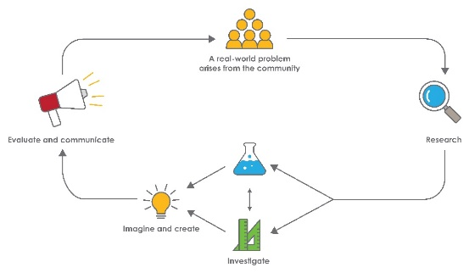
Year 2 – Little Red Hen’s robot friend

Overview
This module focuses on the impact of technology, particularly robots, on our everyday lives. Based on the folktale The Little Red Hen, students are encouraged to create their own automated solution to help the Little Red Hen carry her wheat.
What is the context?
Robots and machines help us in our everyday lives. They are useful for repetitive routine tasks, when a task requires super-human strength or great precision. Robots are also useful in situations that may be dangerous to humans such as underwater and in outer space. In this case, a robot can be used to transport goods over a predetermined route.
What is the problem?
How can a robot help the Little Red Hen transport her wheat to the mill and bring back her bag of flour?
How does this module support integration of the STEM disciplines?
In addition to providing a context in which students can develop outcomes for the Early Years Learning Framework, this module gives students the opportunity to develop skills in the STEM learning areas.
Science
Push and pull forces are explored through play-based investigations and design processes are followed as students create their solutions (ACSSU033: A push or a pull affects how an object moves or changes shape). Science conceptual understandings are developed as students redesign and refine their robot attachments. Students research and describe how robots are used to help people in their everyday lives (ACSHE035: People use science in their daily lives, including when caring for their environment and living things).
Technology
Students engage in the Technologies curriculum when programming their robots to follow a set route and describe how forces create movement in objects (ACTDEK002: Forces create movement in objects). Students design and create a solution to the given problem using materials provided (WATPPS13: Use components and given equipment to safely make solutions) working with a partner to communicate and discuss design ideas (WATPPS12: Develop, communicate and discuss design ideas through describing, drawing, modelling and/or a sequence of steps). They work independently and collaboratively to justify their solution and the steps needed to program their robot (WATPPS15: Work independently, or collaboratively when required, to organise information and ideas to safely create and share sequenced steps for solutions). They collect data to evaluate the success of their design (WATPPS14: Use simple criteria to evaluate the success of design processes and solutions) and communicate results through a choice of digital or non-digital formats (ACTDIP003 Present data using a variety of digital tools).
The Design process guide is included as a resource to aid teachers in understanding the complete design process as developed in the Technologies curriculum.
Mathematics
Mathematics is used when students begin to recognise the top view nature of a plan or map (ACMMG044: Interpret simple maps of familiar locations and identify the relative positions of key features) and use half and quarter turns when programming their robot (ACMMG046) Identify and describe half and quarter turns). When planning their robot attachment they draw two-dimensional figures (ACMMG042: Describe and draw two-dimensional shapes, with and without digital technologies) to represent the three-dimensional object they will plan and build (ACMMG043 Describe the features of three-dimensional objects). They measure and compare lengths when programming their robot and capacity when constructing the attachment that will carry the wheat (ACMMG03: Compare and order several shapes and objects based on length, area, volume and capacity using appropriate uniform informal units. They use balance scales to measure the mass of the bag of wheat their robot attachment will carry. (ACMMG038: Compare masses of objects using balance scales).
By the beginning of Year 2 it is assumed students have had some experience comparing and measuring length and capacity directly and indirectly using informal uniform units but are not yet expected to use standard units for any measuring tasks. They can compare mass by hefting to say which is heavier but may not have used balance scales with understanding. They will have some knowledge of two-dimensional figures and three-dimensional objects and give simple directions in familiar places. They are unlikely to understand maps or plans as top view representations and when asked to draw a plan of the classroom, for example, they will typically combine various eye-level views around the room.
During the module, these Measurement and Geometry understandings will be further developed. The relationship between two-dimensional figures and three-dimensional objects will be explored and students’ problem-solving skills will be exercised through the planning, drawing and construction of the three-dimensional attachment that will carry the wheat. Students will use balance scales to weigh and compare bags of wheat of equal mass, developing understanding and fluency in comparing mass. To program their robot to follow the route, they will develop the problem-solving skills needed to input distance and directional data using quarter and half turns as recognised by their robot. They will extend their locational understanding through an introduction to a ‘birds-eye’ or top view plan during construction of the physical model of the route from farm to the mill.
There is also opportunity in this module to expose students to standard mass units when filling and comparing the bags of wheat, and standard length units when programming the robot to follow the route. The language of ‘90 degrees’ and ‘right-angle’ turns can be incidentally modelled when planning and programing the route the robot will follow. Although these concepts are not formally introduced until year three, the informal use of the terminology and some exposure to standard length and mass units in meaningful contexts will support students’ future learning.

General capabilities
The following opportunities are presented for the development of the general capabilities and the cross-curriculum priorities as students work on Little Red Hen’s robot friend. Students:
- Develop critical thinking skills as they research the problem and its context (Activity 1); investigate parameters impacting on the problem (Activity 2); imagine and develop solutions (Activity 3); and evaluate and communicate their solutions to an audience (Activity 4).
- Utilise creative thinking as they generate possible design solutions; and critical thinking, numeracy skills and ethical understanding as they choose between alternative approaches to solving the problem.
- Utilise personal and social capability throughout the module as they develop socially cohesive and effective working teams; collaborate in generating solutions; adopt group roles; and reflect on their group work capabilities.
- Utilise a range of literacies and information and communication technology (ICT) capabilities as they collate records of work completed throughout the module in a journal and represent and communicate their solutions to an audience using digital technologies in Activity 4.
What are the pedagogical principles of the STEM learning modules?
The STEM Learning Project modules develop STEM capabilities by challenging students to solve real-world problems set in authentic contexts. The problems engage students in the STEM disciplines and provide opportunities for developing higher order thinking and reasoning, and the general capabilities of creativity, critical thinking, communication and collaboration.

The design of the modules is based on four pedagogical principles:
- Problem-based learning
All modules are designed around students solving an open-ended, real-world problem. Learning supported through a four-phase instructional model: research the problem and its context; investigate the parameters impacting on the problem; design and develop solutions to the problem; and evaluate and communicate solutions to an authentic audience.
- Developing higher order thinking
Opportunities are created for higher order thinking and reasoning through questioning and discourse that elicits students' thinking, prompts and scaffolds explanations, and requires students to justify their claims. Opportunities for making reasoning visible through discourse are highlighted in the modules with the icon shown here.
- Collaborative learning
This provides opportunities for students to develop teamwork and leadership skills, challenge each other’s ideas, and co-construct explanations and solutions. Information that can support teachers with aspects of collaborative learning is included in the resource sheets.
- Reflective practice
Recording observations, ideas and one’s reflections on the learning experiences in some form of journal fosters deeper engagement and metacognitive awareness of what is being learnt. Information that can support teachers with journaling is included in the resource sheets.
These pedagogical principles can be explored further in the STEM Learning Project online professional learning modules located in Connect Resources.

Activity sequence and purpose
Robots | Students’ interest in robots is captured through research about ways in which robots can help people.  Students are introduced to the story The Little Red Hen and brainstorm ideas about how robots could help the Little Red Hen get her wheat to the mill and the flour back to the farm.
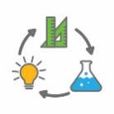  Forces, shapes and programming | Students create a physical representation of key landmarks in the story and program robots to follow the Little Red Hen’s journey to the mill and back to the farm.  Through play, students explore carrying toys that use push or pull mechanisms and compare ease of movement in various geometric objects. They are introduced to the range of building materials provided and consider what kinds of attachments to their robot are feasible.
Design an attachment | Students work collaboratively to design and build an attachment for the robot to help the Little Red Hen transport the wheat and flour, setting the criteria for success. They are guided through the design process of ideation, development and production.
Share results | Students evaluate the success of their robot attachment against an agreed set of criteria.  Students communicate their findings and justify their design choices to their peers and, where possible, a wider audience.

Background
Expected learning | Students will be able to:  - Describe how science is used in everyday life and how robots help people (Science).  - Begin to interpret a top down view of locations in plans (Mathematics).  - Begin to recognise and name two-dimensional figures and three-dimensional objects (Mathematics).  - Compare mass using balance scales (Mathematics).  - Provide sequential coding directions, compare lengths and Identify and describe half and quarter turns when programming a robot (Mathematics and Technology).  - Describe how push or pull forces affect how objects are moved over a distance (Science).  - Compare and consider capacity when designing and creating their attachment (Mathematics)  - Discuss how forces applied by the robot create movement in the attachment (Technology).  - Develop, communicate and discuss design ideas through describing, drawing or modelling (Technology).  - Work collaboratively to organise information and ideas.  - Use criteria to evaluate the success of design processes and solutions.  - Use digital technology to record a reflection of the design process (Technology).
Vocabulary | This module uses subject-specific terminology. The following list contains vocabulary that needs to be understood, either before the module commences or as the terminology is introduced.  balance scales, criteria, force, half, machine, mass, movement, program, pull, push, quarter, robot, route, sequence, three-dimensional, turn, two-dimensional
Timing | There is no prescribed duration for this module. The module is designed to be flexible enough for teachers to adapt. Activities do not equate to lessons; one activity may require more than one lesson to implement.
Consumable materials | A Materials list is provided for this module. The list outlines materials outside of normal classroom equipment that will be needed to complete the activities.
Safety notes | There are potential hazards inherent in these activities and with the equipment being used, and a plan to mitigate risks will be required.  Potential hazards specific to this module include, but are not limited to:  - Inadvertent exposure of personal details online and access to inappropriate content: Teachers must ensure that students are aware of online safety processes and digital citizenship. Students use of the internet should always be supervised and monitored to ensure compliance with department guidelines.  - Falling or tripping over objects: Teachers take care that objects are not left in walkways or doorways and that students are warned to take care when moving around among the robots, toys and other objects in use during the activities.
Assessment | The STEM modules have been developed to provide students with learning experiences to solve authentic real-world problems using science, technology, engineering and mathematics capabilities. While working through the module, the following assessment opportunities will arise:  - Anecdotal records of observations  - Justification of material choices and design aspects  - Records of conversations and activities demonstrating understanding of the following mathematical concepts, comparing lengths, using directional language and quarter and half turns, recognising top-down plan, comparing mass, drawing two-dimensional figures and naming and sorting three-dimensional objects.  - Student presentations in Activity 4 which have a cross curricular link to literacy, speaking and listening.  Evidence of learning from journaling, presentations and anecdotal notes from this module can contribute towards the larger body of evidence gathered throughout a teaching period and can be used to make on-balance judgements about the quality of learning demonstrated by the students in the Science, Technologies and Mathematics learning areas.  Students develop the general capabilities of Information and communication technology (ICT) capability, Critical and creative thinking and Personal and social capability. Continuums for these are included in the General capabilities continuums but are not intended to be for assessment purposes.

Activity 1: Robots
Activity focus | Students’ interest in robots is captured through showing students the ways by which robots can help people transport goods.  Students are introduced to the story The Little Red Hen and brainstorm how a robot could help the Little Red Hen carry her load of wheat to the mill.
Background information | A robot is a machine that can be programmed (told what to do). Some robots can work by themselves, other robots are controlled by people. Robots have sensors which enable them to detect and respond to changes (eg change in temperature, light levels or sound).  Robots can be used to do jobs humans can’t do (eg jobs that require super strength such as heavy lifting or jobs that are dangerous like investigating the depths of the ocean) or jobs humans prefer not to do (eg boring, repetitive jobs).  An example of this is Hadrianx, a robot that can lay bricks and build a house (www.fbr.com.au).  Robots can be programmed to travel set routes and transport goods from one place to another without human presence.
Instructional procedures | In this module robots are programmed to follow a route. Several robots from the technology kit provided by the Department of Education are suitable for this activity, for example, Dash from Dash and Dot, Edison or Bee-Bots. (Not Sphero because it is a sphere that rolls and so attachments are not possible.)  For further information on how to use and program these robots see:  Edison – meetedison.com/robotics-lesson-plans  Dash and Dot – teachers.makewonder.com  Bee-bots – https://www.bee-bot.us/bee-bot.html  I see, I think, I wonder is a thinking routine which is used in this activity and develops visual literacy. It encourages students to make careful observations and thoughtful interpretations, stimulating curiosity and inquiry. See Student resource sheet 1.4: I see, I think, I wonder.  Students work in pairs or small groups for the activities. Mixed ability groups encourage peer tutoring and collaboration in problem solving. At Year Two, working in pairs can be more productive than larger groups. Collaborative processes may be developed in Year Two through careful planning and specific teaching of roles and protocols. Collaboration is an important STEM capability. See Teacher resource sheet 1.1: Cooperative learning – Roles.
Expected learning | Students will be able to:  - Describe how science is used in everyday life, in particular, ways in which robots help people (Science).
Equipment required | For the class:  The Little Red Hen picture book or YouTube video (see Digital and Literary resources). Ensure the version chosen includes a journey to a mill and back (not all versions include this step).
For the students:
Devices for research
Example of Robot or robots to be used in Activity 2.
Preparation | Inform parents about the STEM project students will be undertaking and invite them into the classroom to assist. See Teacher resource sheet 1.5: Sample parent letter.  Prepare the necessary resource sheets for students.  Choose a variety of images of robots for the class to view, print these out and place them around the classroom. Information about robots can be found on the All On Robots website www.allonrobots.com/types-of-robots.html.
Activity parts | Part 1: Robot research  To stimulate and engage students in the topic, play a segment of a TV show or movie that includes robots or read a book about robots (see Digital and Literary resources).  Initiate a class discussion to activate prior knowledge about robots. Record student ideas as a class brainstorm and ensure this is kept somewhere visible throughout the STEM activities. Ask students:  - What are robots?  - What do we use robots for? Why?  Place printed pictures of robots around the room. There should be enough so no more than four students are using each picture at a time (there can be doubles of pictures). Distribute Student resource sheet 1.4: I see, I think, I wonder, one per pair. Ask students to move to the image of the robot that interests them most and work together to complete the resource sheet. Student thinking can be prompted with questioning:  - What do you see when you look at this image?  - What are you thinking about as you look at this image? Why?  - What are your wonderings about the image (questions)?  As a class, discuss student wonderings and predict possible answers. A think-pair-share activity (see Teacher resource sheet 1.3: Cooperative learning – Think, Pair, Share) prior to a class discussion may encourage a greater range of responses.
Part 2: Investigate robots
Students investigate the types and roles of robots using digital devices and books from the class library. See Digital resources for links which can be loaded into Connect for easy access by students.
Students work in groups of four to record and discuss findings using Teacher resource sheet 1.2: Cooperative learning – Placemat.
Facilitate a class discussion for students to share their learning and hang placemat worksheets in a place visible to all students.
Part 3: Robot definition
Watch the SciShow video Real-Life Robots (see Digital resources) or display a series of images to provide context for this activity part and to add to the students’ knowledge.
Create a class definition for the term robot. The way this is developed and recorded will be unique to the class; however, a consensus-forming strategy will need to be followed. For example, common ideas from the placemat activity in Part 2 could be used as a foundation for the definition. Or, a class brainstorm could be used to record ideas. It is a good idea to revisit the definition as it may evolve over the next few activities.
Digital options such as Padlet or an interactive whiteboard could be used to record class definitions.
Complete the introduction to robots by providing a simple demonstration (or reminder if students have previously used the robots) of the movement capabilities of the robot or robots they will use in further activities.
If students have never had any experience with robotics, it would be helpful to have a session where the students play with the robots. They can follow one of the introduction to block programming tuition sequences available so that students get ‘hands-on’ knowledge of what their particular robot can do as preparation for the rest of the module.

Part 4: How robots can help
Read the story The Little Red Hen to the class. Discuss how the Little Red Hen moved the wheat to the mill and how she took her flour home.
Refer again to the robot they will use and ask:
- How could our robot move the Little Red Hen’s load for her?
- What would we need to tell (program) our robot to do?
- What changes might we need to make to our robot to enable it to carry the Little Red Hen’s wheat and flour?
Brainstorm ideas using an app such as Padlet, a large sheet of paper or an interactive whiteboard.
In this discussion assist students to arrive at the need to create some kind of attachment to the robot that can carry a bag of wheat or flour.
Tell student that in the next activities they will teach the robot to travel to the mill and back and design and build their own attachments so that the robot can move the Little Red Hen’s wheat for her.
Part 5: Reflective journal
Using words or pictures, students record what they have learnt about robots. Students reflect about two things they have learnt and note one question they have about robots. See Reflective journal for elaborations on journaling.
Resource sheets | Teacher resource sheet 1.1: Cooperative learning – Roles  Teacher resource sheet 1.2: Cooperative learning – Placemat.  Teacher resource sheet 1.3: Cooperative learning – Think, Pair, Share  Student resource sheet 1.4: I see, I think, I wonder  Teacher resource sheet 1.5: Sample parent letter  Reflective journal
Digital resources | Following three versions all mention the trip to the mill.  https://www.youtube.com/watch?v=ZzCBY5bL7vo  https://www.youtube.com/watch?v=kWz1CvR9WLs  https://www.youtube.com/watch?v=JTCsL26vob4
Real-Life Robots (SciShow Kids,2015)
www.youtube.com/watch?v=8wHJjLMnikU
YouTube channels
Boston Dynamics (Boston Dynamics, 2018)
www.youtube.com/user/BostonDynamics
Series of videos of cutting-edge real-life robots developed by Boston Dynamics to carry equipment over rough terrain. Check out Big Dog and Atlas.
Movies
WALL-E (Pixar, 2008) Rating: G. The main character is a robot who cleans up Earth, which was left in ruin by humans.
https://www.youtube.com/watch?v=D7iqUEWEPOA
Big Hero 6 (Disney, 2014) Rating: PG. The main character builds a robot called Baymax who helps heal sick people.
disneyplus.com/movies/big-hero-6
Robots (Blue Sky Studios, 2005) Rating: G. All of the characters in this movie are robots
blueskystudios.com/films/robots/
 | Flubber (Disney, 1997) Rating: G. The main character’s assistant is a robot called Weebo.
Literary resources | The Little Red Hen – An Old Story (Margot Zemach, 1983)  The Little Red Hen is an old folk tale. The story teaches children the virtues of work ethic and personal initiative.
Robots Slither (Ryan Ann Hunter, 2004)
A picture book about what robots can do, where they are used in our lives and potential future uses.
Boy and Bot Ame Dyckman, 2012)
A picture book about the friendship between a boy and a robot that explains their different needs.
Clink (Kelly DiPucchio, 2011)
A picture book about an outdated robot looking for a home.
Oh No!: Or How My Science Project Destroyed the World (Mac Barnett, 2010)
A picture book about a robot gone wrong and one girl’s mission to stop her science project from destroying the city.
Nick and Tesla’s Robot Army Rampage: A Mystery with Hoverbots, Bristle bots, and Other Robots You Can Build Yourself (‘Science Bob’ Pflugfelder and Steve Hockensmith, 2014).
A chapter book including instructions for real robots you can build yourself from simple, easy-to-find equipment.
A Curious Robot on Mars (James Duffett-Smith, 2013)
A picture book story about the Curiosity rover on Mars.
Robot Zombie Frankenstein (Annette Simon, 2012)
Silly picture book about robots and 2D shapes.
ICT Professionals – Incursions | Scientists in Schools (CSIRO, 2018)  www.csiro.au/en/Education/Programs/STEM-Professionals-in-Schools  A free national program run by the CSIRO. You can register your school to build a relationship with a scientist, mathematician or ICT professional.

Activity 2: Forces and shapes
Activity focus | Students help create a physical ‘map’ of the route from the farm to the mill and program a robot to travel that route and back.  Students consider what kind of attachment to the robot could enable it to best carry a load. Through play, students investigate toys that use push or pull mechanisms. They experiment with three-dimensional objects, comparing the ease with which they can be moved by pushing or pulling.  They sort the collected items with a view to their use in Activity 3 design solution
Background information | Push and pull forces can change the motion of an object (ie start or stop an object moving or change the speed or direction of an object) or change the shape of an object (ie flatten or stretch the object). Push and pull forces are usually represented in diagrams as an arrow pointing in the direction in which the force is acting.  Heavy objects are often moved by sliding them across the floor or by rolling them. Movement of objects is opposed by the force of friction. Friction is far less when objects roll than when they slide; therefore, smaller forces can move a rolling object than a sliding object of the same mass. Round objects with smooth surfaces are easily moved by rolling.  In this activity students develop coding and debugging skills while developing directional language including ‘quarter turn’ and ‘half turn’ (to reverse direction).
Instructional procedures | - Have objects ready to represent the farm and the mill, and cardboard strips to create a route between the two that require one or two quarter turns and is wide enough for the robot to travel. A ‘bridge’ and ‘hills’ that involve a rise in the roadway would be a helpful addition.  - The teacher assists students to set up this route as a physical map in an open area.  - Teacher creates and models a plan of the set-up so that the physical map can be cleared and set up again for subsequent sessions, with assistance from students.
Expected learning | Students will be able to:  - Begin to recognise a top down view of a location (Mathematics).  - Use distance and directional language and coding needed to program a robot to travel a route using quarter turns for 90 degree corners and a half turn to reverse direction (Mathematics).  - Identify and name some standard 3-D objects (Mathematics).  - Describe the effect of a push or pull on the movement of objects (Science).  - Make, test and evaluate a prediction (Science).
Equipment required | For the class:  Robots and devices  Collected discarded materials, boxes containers lids etc  Firm card to create the roadway.
Preparation | Ensure robots and devices are charged.  Plan area which is to be set up as a physical map of route from farm to mill.  Ensure there is enough space for students to investigate the toys and when sorting and classifying shapes.  Organise parent help.

Activity parts | Part 1: Programming the robot  In this section, a physical map of the route is set up and students plan how to tell their robot to travel from farm to mill and then use block coding and trial and error to program the robot to follow the route.  Teachers can involve students in creating the representations of the farm and the mill (decorated boxes for example) or teachers could prepare these in advance. The mill should be placed several metres from the farm with a ‘road’ joining the two. It is suggested the road can be best made using cardboard strips about 20 cm wide taped together to create a route from the mill to the farm (This method means the road can be folded up for storage between uses). Include one or more 90 degree turns. It could also have hills and a bridge represented by using lego or similar to lift the road in places. (Students can experiment to decide how much slope can be transversed by the robot they are using.) This farm-mill route will be re-used in Activity 3 when the robot and the attachment carrying the wheat is tested.  As an introduction to the idea of a top view, ask students to imagine what the route would look like if they were a fly on the ceiling looking down. Copy the arrangement on a large sheet of paper or on a whiteboard that can be photographed, with students’ suggestions guiding the placement of the farm, the mill and the road. (With teacher assistance, this plan can then be used by students to guide the replacement of the physical route ready for Activity 3.)  With students sitting around the route, have a short discussion about what they would have to tell their robot to do to travel the route, section by section, emphasising the sequence, first … then ….  When demonstrating the meaning of a ‘quarter turn’, the teacher may include the use ’90 degree’ and ‘right angle’ terminology incidentally in that context.  In pairs, ask students to plan and write down the ‘instructions’ they will need to give their robot to travel the route, using their own language and numbering the sections e.g.  - Go to the first corner  - Turn right  - Go to the bridge  - Go over the bridge  - Turn left  - Go to the mill  Then allocate the robots and allow students time to explore and refine the coding needed to program the robot’s movements and directional turns. (If there are not enough robots for whole class to be engaged, then working with one smaller group at a time may be necessary.) The time needed for students to explore this step will vary according to the students’ previous experience with the robots. The teacher should support and facilitate, but not tell students exactly what to input. For example, students should be allowed to enter a ‘move’ with a guessed distance. They try it, then adjust it, and try it again. They can be encouraged to use string or informal uniform units to measure the distance of a length on the ‘road’, then mark that distance elsewhere to test and adjust their coding. (Note – they are not expected to measure lengths in standard units and do not need to do so in order to program the robot’s movement – they use trial and error to code the distances. However, the teacher may choose to model the use of a standard measuring tape and use centimetre and decimetre language in this section. Note that the Dash robot, for example, is programmed in 10 cm increments up to a metre, represented as an unlabelled bar, but labelled in cm on the ‘block’ that results from the student’s choice of bar length.)  As a class, have selected students demonstrate their robot’s ability to travel successfully from farm to mill, and then, on a signal, turn around and return to the farm. The successful coding should be saved for use when the attachment is built.
Part 2: Pushing, pulling, lifting or carrying
Explain to students that they have now found a way to program a robot to travel to the mill for the Little Red Hen, but there is nowhere to put the bag of wheat. Remind them that they are going to design and make an attachment from the collected items that will enable the robot to carry the wheat, but to help them with that, they are going to play with some different ‘carrying’ toys and think about what makes them move.
Engage students in play using different moving toys that can be pushed or pulled (eg trains, trucks, cars, wagons, wheel barrows, prams, sleds).
Students should participate in play activities that enable them to experience the effect of a range of different forces.
Forces applied to moving objects can cause changes to the speed and direction of the motion. The direction of a force applied to a toy will affect the direction of the motion of the toy. For example, if the students apply a push or a pull force to a stationary toy, the push or pull, if large enough, with cause the toy to move in the direction of the push or the pull.
If the toy is already in motion, and the students apply a push or a pull force in the same direction as the existing motion, the toy will continue to move in that direction, and if the force is large enough, the toy will move faster. If students apply a push or a pull force to a toy in a direction that is opposite to, or at an angle to, the existing motion of the toy, the push or pull force, if large enough, will change the direction of the toy’s motion and may also change the speed of the toy or stop its motion altogether.
Using a think-pair-share strategy (Teacher resource sheet 1.3: Cooperative learning Think, Pair, Share) review students’ experiences with the toys to develop their understanding of push and pull forces and directions of movement.
- How did the toys move?
- Why did the toys move?
- How could you make a toy move towards you?
- How could you move a toy away from you?
What would happen if…
- The size of the toy changed?
- The size of the push changed?
- The surface changed (rough, smooth, oily)?
- The wheels changed? Or, there were no wheels?

Part 3 Sorting shapes and objects
Select some standard geometric 3-D objects including various prisms, pyramids, cylinders and spheres and have students use the Question, Predict, Test, Observe, Evaluate (QPTOE) strategy, in the example below, to investigate how easily each shape can be moved. (Number the objects for identification by the students, but model the correct geometric terminology when referring to them):
Question: Which shape is the easiest to move?
Predict: Which shape will be the easiest to move?
Test: Push and pull each object.
Observe: Which shapes were easy to move?
Evaluate: Were our predictions correct? Which shape was easiest to move? Why?
Discuss with students what they have found out so far and how that might help them design their wheat-carrying attachment. Students are likely to arrive at the need for wheels or rollers on their attachment. They may also decide that having their robot pull something rather than push might be easier. Leave it open for students to put forward their own ideas.
Move on to the collected items. Working in small groups of three or four, students sort the collected items according to whether they think the item would be useful for building an attachment or not. They should justify their choices, and be encouraged to use everyday language as well as some standard geometric terminology for 2-D figures and 3-D objects. Teacher should continue to model the standard geometric language in their discussion with students.
Once students have a set of ‘useful items’ they can be asked to re-sort using their own criteria for the selection of categories.
- What makes this group of objects all the same?
- What make these two groups different?
- Are you sorting because of how the items look or what they are used for?
- What would be a useful way to sort for our purpose (i.e. making a wheat-carrying attachment for the robot.)
Have a class discussion about what they have learned about the push pull forces on objects and how that will help them design an attachment for their robot from the materials they have been sorting. Ask:
- Will you have your robot push or pull the load? Why?
- How would having the robot carry the load on top of it cause different forces than pushing or pulling the load?
- How might you join your attachment to the robot?
- How could you make your attachment move more easily?
Part 4: Reflection
In their reflective journals, students document what they have learnt about programming robots to follow a route and what they have learnt about different shapes and how they may be moved. Students record one question they are curious about.
Digital resources | 2D Shape Word Mat (Twinkl, 2018)  www.twinkl.co.uk/resource/t-n-105-2d-shape-word-mat
3D Shape Word Mat (Twinkl, 2018)
www.twinkl.co.uk/resource/t-n-106-3d-shape-word-mat
Little Red Hen printable resources (Twinkl, 2018)
www.twinkl.com.au/resources/early-years-on-the-farm-storybooks/early-years-little-red-hen-1/early-years-little-red-hen-1-activities

Activity 3: Prototyping
Activity focus | Establish the load of wheat to be transported and the design criteria.  Students work collaboratively to design and build an attachment for their robot to transport an established amount of wheat over the given route using push or pull forces. They follow the design process of ideation, development and production.
Background information | The design process is a series of steps to guide problem solving. There are many different versions, but the core ideas are the same. See Design process guide for elaboration. The key idea is to allow students to improve on their original design after testing.
Instructional procedures | Students may need support and scaffolding as they work through the design process. This process is cyclical, ensuring the final product is refined and demonstrates changes that reflect critical and creative thinking.  Students will need to explain and justify their reasoning in their reflective journals and final presentation.  Working in pairs will require students to negotiate with their partner to reach an agreed outcome. Collaborative group skills are a foundation of STEM processes and students are encouraged to develop these from an early age.
Expected learning | Students will be able to:  - Use balance scales to equalise mass (Mathematics).  - Describe how a push or a pull force affects how the robot attachment moves objects over a distance (Science).  - Identify that it is the force of the robot that enables the attachment to move (Technologies).  - Develop, communicate and discuss design ideas and a solution through describing, drawing and modelling (Technologies).  - Use some geometric terminology to describe their drawings and models (Mathematics).  - Work collaboratively to organise information and ideas (Technologies).
Equipment required | For the class:  Set of robots (eg Edison, Dash and Dot, Bee-Bot)  Camera  balance scales  Wheat  Plastic zip-lock sandwich size bags  Soup spoons or similar to scoop the wheat  2 cm wooden blocks
For the students:
Devices, computers if necessary
A range of recycled materials or craft supplies
Tools - scissors, sticky tape, poster putty, glue
Pens and pencils

Preparation | Prepare the necessary resource sheets for students.  Ensure robots are charged.
Activity parts | Part 1: What is the design process?  To engage students in the design process, view the Crash Course Kids video The Engineering Process, or another from Digital resources.  Discuss and outline the steps of the design process the students will follow as they create a solution to the problem. Explain the process is cyclical and encourage students to engage in the process more than once. This will ensure students are producing the best solution they can.
Part 2: Design criteria
Facilitate a discussion about how the performance of their attachments might be judged. Develop a suitable set of design criteria for the class.
Establish that we already know the route that the robot will travel and have a set of successful coding instructions ready – so the criteria should be focused on the success of the attachment for carrying the wheat over the distance.
Discuss with students how the attachments can be tested and compared in a fair way.
Prompt thinking through questioning:
- How will we know if our design solution was successful?
Possible answers: It stuck to the robot, it held the bag of wheat and didn’t let it fall off, it could follow the route.
- Does it matter if the design pushes, pulls, or carries the wheat?
- Will it matter how much wheat is carried?
Prompt students to recognise that we have not yet thought about how much wheat the attachment must carry. Tell them they will work that out next session.

Part 3: Creating the bags of wheat
With the whole class watching, begin to fill a zip-lock bag with wheat. Have the class suggest when to stop filling it. (Don’t over-fill.) Establish that this is the bag of wheat to be carried to the mill. But everyone will need to have one. (Teacher may plan this mass to equal a certain number of grams as a demonstration of standard units, but students will measure using informal uniform units, i.e. 2 cm wooden cubes.)
Demonstrate the use of balance scales to find the number of 2 cm wooden cubes that exactly equal the mass of the bag of wheat.
Provide containers of wheat, scoops, zip-lock bags and 2 cm wooden cubes and have students in pairs create their bag of wheat to use in planning their design solution.
To draw attention to the difference between mass and volume ask:
- Why don’t we just use the blocks to test our design if they weigh the same as the wheat?
- What’s different about the wheat and the blocks?
- Why would if be unfair is some used the bag of wheat and some used that number of blocks?
When the bags have been created, put the blocks away and ask students to compare each other’s bags using the balance scales, to ensure they all weigh the same. Adjust as needed. Make sure all bags are completely sealed. The bags may be taped shut as an extra precaution against spillage.

Part 4: Design and create the attachment
Working in pairs, students decide on a design and choose items from the collected material that they think they will use to construct their attachment to carry the bag of wheat.
Together they plan and draw a diagram of their chosen design, showing the materials they will use and how they will be put together and attached to the robot.
At this age they will need to have the items they plan to use in front of them to be able to draw their design, but they should not begin building until they have a basic drawing. Students will vary in both their developmental stages and their levels of spatial visualisation, so teachers will need to adapt their expectations to individual students.
It may be appropriate to have a sharing session with those students who have produced a plan, sharing it with the class to assist those having difficulties with the process.
Use the opportunity to model the language of 2-D shapes and 3-D objects. For example: “I can see you drew a rectangle to show the side view of your box. Can you see any squares in this prism?” (Hold up the box.)

Part 5: Building solutions
Allow students time to build their attachment. Don’t correct students’ mistakes at this stage in the process. The point of the design process is for students to test their solution and then alter it depending on how well it meets the success criteria. The success criteria could be made into a checklist for students to use as they develop their solutions.
Use questioning to develop higher order thinking:
- Why do you think that will work?
- Why have you designed your attachment that way?
See Teacher resource sheet 3.1: Construction skills for ways students can develop their cutting and joining skills.
If students are stuck, offer suggestions for how to overcome the problem but avoid offering solutions. For example:
- Why does it keep falling off?
- How could you stop this?
- Are there any other items that you can add to it?
- What makes it work when it is empty but stop when you put the wheat in?
- What makes your design fall over when the robot turns the corner? Does it matter how fast it is travelling?
Encourage students to look at what others are doing and collaborate to help each other with suggestions.
Part 6: Testing solutions
Allow students time to test their solutions.
Make the successful coding for the route available to all students so that it is the success of the design solution that is judged, not the basic coding.
Encourage students to reflect on their performance and learning by asking questions such as:
- What worked well?
- What did not work well?
- How could you improve your design?

Provide opportunities for students to improve their design and then retest. Provide an end date at which point students need to submit a final prototype,
Ask students to revise their original planning document and create a ‘blue-print’ from which someone else could build the same design. Have them think about what information they would need to provide in the ‘blue-print’. A photo of their design could be attached to the blue-print and displayed in Activity 4.
Part 8: Reflection
Students add to their reflective journals something that went well when working as a group and something they would do differently. Encourage them to reflect on their designs, justifying any improvements.
Resource sheets | Teacher resource sheet 1.2: Cooperative learning - Placemat  Teacher resource sheet 1.3: Cooperative learning Think-pair-share  Teacher resource sheet 3.1: Construction skills  Student activity sheet 3.2: Shapes or objects
Digital resources | Teach Engineering  www.teachengineering.org  Suite of in-depth resources for teaching engineering for K-12 from the University of Colorado.
ABC Splash resources
Thinking about the design process (ABC, 2015)
education.abc.net.au/home#!/media/2128865/thinking-about-the-design-process
Short video on the engineering design process
Thoughtful design (ABC, 2001)
education.abc.net.au/home#!/media/1662194/thoughtful-design
Short video on how a home is designed to accommodate someone in a wheelchair. Comparisons can be made to designing for robots.

Crash Course Kids videos
The Robot Challenge: Crash Course Kids #47.1
www.youtube.com/watch?v=0GMBJFqgHfc
The Engineering Process: Crash Course Kids #12.2
www.youtube.com/watch?v=fxJWin195kU
MIT K-12 Videos
Science, Engineering and Design! Video 2: Engineering Design Process (MIT K-12 Videos, 2013)
www.youtube.com/watch?v=5Dp2qHz8r2U
The Works – engineering museum
Engineering design process poster (The Works Museum, 2016)
theworks.org/educators-and-groups/elementary-engineering-resources/engineering-design-process/

Activity 4: Share results
Activity focus | Students evaluate the success of their robot attachment against a set of criteria. Students communicate their findings and justify design choices to their peers and, where possible, a wider audience.
Background information | Students create their presentation using a choice of media such as a comic strip, eBook, Pages, Keynote or PowerPoint or iMovie (or similar) presentation, which can then be shared through a digital platform such as Connect, Seesaw or Class Dojo, added to a class blog, or shared on an interactive whiteboard. Students may require explicit instruction in using these apps.  If digital technology is not accessible, students could share their project using a poster, recount or book.  There are many ways to safely share information online. A tool that involves sending information privately to individuals (eg via email) or uses passwords to protect the information (eg a password protected website, app that requires a log-in) is preferred. The tools listed in the Digital resources section are good examples. However, learn how to use the tool before using it in the classroom as sometimes the default setting may be ‘public’ and it should be changed to ‘private’.
Expected learning | Students will be able to:  - Use simple criteria to evaluate the success of design processes and solutions (Technologies).  - Use a chosen form of digital technology to record a reflection of the design process (Technologies).  - Use appropriate media to communicate the solution and justify design choices (Science and Technologies).
Equipment required | For the class:  Devices and technology necessary for presentations
For the students:
Two different coloured sticky notes per student
Device with appropriate software
Preparation | Prepare the necessary resource sheets for students.  Offer a choice of apps for students to create a digital refection on their designs (see Digital resources).  Ensure digital photos of their design solutions are available.
Activity parts | Part 1: Gallery walk  Students participate in a gallery walk and view the completed robot designs. Working in pairs, students will be given two different coloured sticky notes and encouraged to leave one note highlighting a strength of each design and another offering an idea for improvement.
Part 2: Self-reflection
Students self-evaluate and reflect on the feedback, thinking about changes they could make to improve their design. Students complete the Student activity sheet 4.1: Design review to continue the design process with a focus on the evaluation phase.
Evaluation: What works, what doesn’t, what could work better?
Students use the success criteria determined by the class in Activity 3 to evaluate their solution.
Part 3: Digital reflection creation
Students work collaboratively to communicate their design journey. Use questioning to stimulate reflection and discussion:
- What have you designed?
- Why did you choose that design?
- How will your design help the Little Red Hen?
- What did not work according to your plan? How did you change things to make it work?
- What would you do differently the next time? Why?
Students document their final solution. This can be done in several ways including (but not limited to):
- Photos
- Video
- Labelled diagram
- Poster

Suggested apps for use in the creation of presentations are listed in Digital resources.
Part 4: Sharing the design
Students communicate and share their presentations and learning with their school community, parents, class mates or an industry representative.
Using tools such as the school intranet, Connect, Seesaw, a class blog, Padlet, email newsletter (see Digital resources) will enable students to share their presentations with an audience beyond the classroom.
Part 5: Reflective Journal
Students reflect on their learning, using the following question prompts to guide their reflection on their STEM learning journey:
- What are three things I have learnt about how robots help people?
- What are two things I found difficult?
- What is a question I still wonder about?
Resource sheets | Student activity sheet 4.1: Design review
Digital resources | Keynote  tunes.apple.com/au/app/keynote/id361285480?mt=8
Comic Maker HD
itunes.apple.com/au/app/comic-maker-hd/id649271605?mt=8
iBooks Author
www.apple.com/au/ibooks-author
Book Creator
itunes.apple.com/au/app/book-creator-for-ipad-create/id442378070?mt=8
Comic Life
itunes.apple.com/us/app/comic-life/id432537882?mt=8&ign-mpt=uo%3D4

iMovie
itunes.apple.com/au/app/imovie/id377298193?mt=8
Pages
itunes.apple.com/au/app/pages/id361309726?mt=8
Seesaw Digital Portfolio
web.seesaw.me
Free online student digital portfolio tool. Private space for your class to share their work. Students and parents can only access the space through temporary passwords or by scanning a QR code. Works great with tablets.
Class Dojo
www.classdojo.com
Explain Everything
explaineverything.com
Padlet
www.padlet.com
Free online ‘pin-up’ board. Ability to make the ‘pin-up’ board collaborative so multiple students can post their work on it. It is also possible to set it to private, so only those with the link, or a set password can access the page.
Free website creators
Be aware of the privacy settings associated with the website you create. It may be ‘publicly’ available.
Weebly www.weebly.com
Wordpress www.wordpress.com
Wix www.wix.com
Square Space www.squarespace.com
Adobe Spark spark.adobe.com
Microsoft Sway sway.com
Canva www.canva.com

Appendix 1: Links to the Western Australian Curriculum
The Little Red Hen’s robot friend module provides opportunities for developing students’ knowledge and understandings in science, technologies and mathematics. The table below shows how this module aligns to the content of the Western Australian Curriculum and can be used by teachers for planning and monitoring.

LITTLE RED HEN’S ROBOT FRIEND  Links to the Western Australian Curriculum | ACTIVITY
 | 1 | 2 | 3 | 4
SCIENCE
SCIENCE UNDERSTANDING
Physical sciences: A push or a pull affects how an object moves or changes shape |  | ●
SCIENCE INQUIRY SKILLS
Planning and conducting: Participate in guided investigations to explore and answer questions |  | ●
DESIGN AND TECHNOLOGIES
KNOWLEDGE AND UNDERSTANDING
Engineering principles and systems: Forces create movement in objects |  | ● | ●
PROCESSES AND PRODUCTION SKILLS
Designing: Develop, communicate and discuss design ideas through describing, drawing, modelling and/or a sequence of steps |  |  | ●
Evaluating: Use simple criteria to evaluate the success of design processes and solutions |  |  | ●
Collaborating and managing: Work independently, or collaboratively when required, to organise information and ideas to create and safely share sequenced steps for solutions | ● | ● | ● | ●

MATHEMATICS
MEASUREMENT AND GEOMETRY
Using units of measurement: Compare and order several shapes and objects based on length, and capacity using appropriate uniform informal units.  Compare masses of objects using balance scales |  | ● | ●
Using units of measurement:  Identify and describe half and quarter turns. |  | ●
Shape: Describe the features of three-dimensional objects  Describe and draw two-dimensional shapes |  | ● | ●
Location and transformation: Interpret simple maps of familiar locations and identify the relative positions of key features |  | ●

Appendix 1B: Mathematics proficiency strands
Key ideas
In Mathematics, the key ideas are the proficiency strands of understanding, fluency, problem-solving and reasoning. The proficiency strands describe the actions in which students can engage when learning and using the content. While not all proficiency strands apply to every content description, they indicate the breadth of mathematical actions that teachers can emphasise.
Understanding
Students build a robust knowledge of adaptable and transferable mathematical concepts. They make connections between related concepts and progressively apply the familiar to develop new ideas. They develop an understanding of the relationship between the ‘why’ and the ‘how’ of mathematics. Students build understanding when they connect related ideas, when they represent concepts in different ways, when they identify commonalities and differences between aspects of content, when they describe their thinking mathematically and when they interpret mathematical information.
Fluency
Students develop skills in choosing appropriate procedures; carrying out procedures flexibly, accurately, efficiently and appropriately; and recalling factual knowledge and concepts readily. Students are fluent when they calculate answers efficiently, when they recognise robust ways of answering questions, when they choose appropriate methods and approximations, when they recall definitions and regularly use facts, and when they can manipulate expressions and equations to find solutions.
Problem-solving
Students develop the ability to make choices, interpret, formulate, model and investigate problem situations, and communicate solutions effectively. Students formulate and solve problems when they use mathematics to represent unfamiliar or meaningful situations, when they design investigations and plan their approaches, when they apply their existing strategies to seek solutions, and when they verify that their answers are reasonable.
Reasoning
Students develop an increasingly sophisticated capacity for logical thought and actions, such as analysing, proving, evaluating, explaining, inferring, justifying and generalising. Students are reasoning mathematically when they explain their thinking, when they deduce and justify strategies used and conclusions reached, when they adapt the known to the unknown, when they transfer learning from one context to another, when they prove that something is true or false, and when they compare and contrast related ideas and explain their choices.
Source: www.australiancurriculum.edu.au/f-10-curriculum/mathematics/key-ideas/?searchTerm=key+ideas#dimension-content

Appendix 2: General capabilities continuums
The general capabilities continuums shown here are designed to enable teachers to understand the progression students should make with reference to each of the elements. There is no intention for them to be used for assessment.
Information and communication technology (ICT) capability learning continuum
Typically by the end of Year 2 | Typically by the end of Year 4 | Typically by the end of Year 6
use ICT to prepare simple plans to find solutions or answers to questions | use ICT to generate ideas and plan solutions | use ICT effectively to record ideas, represent thinking and plan solutions
experiment with ICT as a creative tool to generate simple solutions, modifications or data representations for particular audiences or purposes | create and modify simple digital solutions, creative outputs or data representation/ transformation for particular purposes | independently or collaboratively create and modify digital solutions, creative outputs or data representation/ transformation for particular audiences and purposes
use purposefully selected ICT tools safely to share and exchange information with appropriate local audiences | use appropriate ICT tools safely to share and exchange information with appropriate known audiences | select and use appropriate ICT tools safely to share and exchange information and to safely collaborate with others

Personal and social capability learning continuum
Typically by the end of Year 2 | Typically by the end of Year 4 | Typically by the end of Year 6
identify cooperative behaviours in a range of group activities | describe characteristics of cooperative behaviour and identify evidence of these in group activities | contribute to groups and teams, suggesting improvements in methods used for group investigations and projects
practise solving simple interpersonal problems, recognising there are many ways to solve conflict | identify a range of conflict resolution strategies to negotiate positive outcomes to problems | identify causes and effects of conflict, and practise different strategies to diffuse or resolve conflict situations
discuss ways in which they can take responsibility for their own actions | discuss the concept of leadership and identify situations where it is appropriate to adopt this note | initiate or help to organise group activities that address a common need

Critical and creative thinking learning continuum
Typically by the end of Year 2 | Typically by the end of Year 4 | Typically by the end of Year 6
organise information based on similar or relevant ideas from several sources | collect, compare and categorise facts and opinions found in a widening range of sources | analyse, condense and combine relevant information from multiple sources
build on what they know to create ideas and possibilities in ways that are new to them | expand on known ideas to create new and imaginative combinations | combine ideas in a variety of ways and from a range of sources to create new possibilities
investigate options and predict possible outcomes when putting ideas into action | experiment with a range of options when seeking solutions and putting ideas into action | assess and test options to identify the most effective solution and to put ideas into action
use information from a previous experience to inform a new idea | transfer and apply information in one setting to enrich another | apply knowledge gained from one context to another unrelated context and identify new meaning
Further information about general capabilities is available at:
k10outline.scsa.wa.edu.au/home/p-10-curriculum/general-capabilities-over/general-capabilities-overview/general-capabilities-in-the-australian-curriculum

Appendix 3: Materials list
The following materials are required to complete this module.
A range of recyclable items, including:
- newspaper
- cans
- plastic bottles
- ice-cream containers
- yoghurt containers
- shoe boxes
- plastic wrapping
- boxes
- foil
- fabric scraps
- egg cartons
- bottle caps

A selection of cutting and construction tools such as:
- tape
- scissors
- cutting mats
- glue sticks
- PVA glue
- paint brushes
- hot glue guns (used by adults)
- tacks
- cable ties
- string

Other equipment and supplies:
- Suitable robot and tablet containing block programming software.
- Balance scales
- 2 cm Wooden Blocks
- Wheat and scoop
- Ziplock bags
- Standard set of geometric objects
- Range of push/pull toys

Appendix 4: Design process guide
Safe production of the final design or multiple copies of the final design.
Fine tuning the production process, such as division of labour for batch or mass production.
Use of intended materials and appropriate tools to safely make the solution to the design problem.
Reflection on the process taken and the success of the design.
Evaluation can lead to further development or improvement of the design and can be a final stage of the design process before a conclusion is reached.
Could be formal or informal and verbal or written.
Ideation
Development
Development of the design ideas. Improvements, refinements, adding detail, making it better.
Activities such as detailed drawings, modelling, prototyping, market research, gaining feedback from intended user, further research – if needed – to solve an issue with the design, testing different tools or equipment, trialling production processes, measuring or working out dimensions, testing of prototypes and further refinement.
Idea generation – turning ideas into tangible forms so they can be organised, ordered and communicated to others.
Activities such as brainstorming, mind mapping, sketching, drawing diagrams and plans, collecting colour samples and/or material samples and talking through these ideas can help to generate more creative ideas.
Using the SCAMPER model can assist with this: www.mindtools.com/pages/article/newCT_02.htm
www.designorate.com/a-guide-to-the-scamper-technique-for- creative-thinking
Analysis
Finding useful and helpful information about the design problem.
Gathering information, conducting surveys, finding examples of existing solutions, testing properties of materials, practical testing.
Understanding the meaning of the research findings.
Analysing what the information means, summarising the surveys, judging the value of existing solutions, understanding test results.
Research
Production
Evaluation

Appendix 5: Reflective journal
When students reflect on learning and analyse their own ideas and feelings, they self-evaluate, thereby improving their metacognitive skills. When students self-monitor or reflect, the most powerful learning happens.
Journaling may take the form of a written or digital journal, a portfolio or a digital portfolio. Early childhood classrooms may use a class reflective floor book with pictures of the learning experience and scribed conversations.
Teachers can model the journaling process by thinking aloud and showing students how they can express learning and thoughts in a variety of ways including diagrams, pictures and writing.
Journals are a useful tool that gives teachers additional insight into how students value their own learning and progress, as well as demonstrating their individual achievements.
The following links provide background information and useful apps for journaling.
Kidblog – digital portfolios and blogging
kidblog.org/home
Edmodo – for consolidating and storing class notes and learning materials
www.edmodo.com
Explain Everything™ – a screen casting, video and presentation tool all in one
Explaineverything.com
Popplet – allows you to jot down your ideas and then sort them visually
Popplet.com
Seesaw – for capturing work completed by students in class, using a device’s camera function
Web.seesaw.me
Connect – the DoE portal for teachers
connect.det.wa.edu.au
Evernote (a digital portfolio app)
evernote.com
Digital portfolios for students (Cool tools for school)
cooltoolsforschool.wordpress.com/digital-student-portfolios

Appendix 6: Teacher resource sheet 1.1: Cooperative learning – Roles
Cooperative learning frameworks create opportunities for groups of students to work together, generally to a single purpose.
As well as having the potential to increase learning for all students involved, using these frameworks can help students develop personal and social capability.
When students are working in groups, positive interdependence can be fostered by assigning roles to group members.
These roles could include:
- working roles such as Reader, Writer, Summariser, Time-keeper.
- social roles such as Encourager, Observer, Noise monitor, Energiser.
Teachers using the Primary Connections roles of Director, Manager and Speaker for their science teaching may find it effective to also use these roles for STEM learning.
Further to this, specific roles can be delineated for specific activities that the group is completing.
It can help students if some background to the purpose of group roles is made clear to them before they start, but at no time should the roles get in the way of the learning. Teachers should decide when or where roles are appropriate to given tasks.

Appendix 7: Teacher resource sheet 1.2: Cooperative learning – Placemat
This resource sheet provides a brief outline of a cooperative learning strategy known as 'placemat'.
Cooperative learning frameworks create opportunities for groups of students to work together, generally for a single purpose.
As well as having the potential to increase learning for all students involved, using these frameworks can help students develop personal and social capability.
The placemat strategy involves students working collaboratively to record prior knowledge about a common topic and brainstorm ideas. It also allows teachers to readily see the contribution of each student. The diagram below shows a typical placemat template.

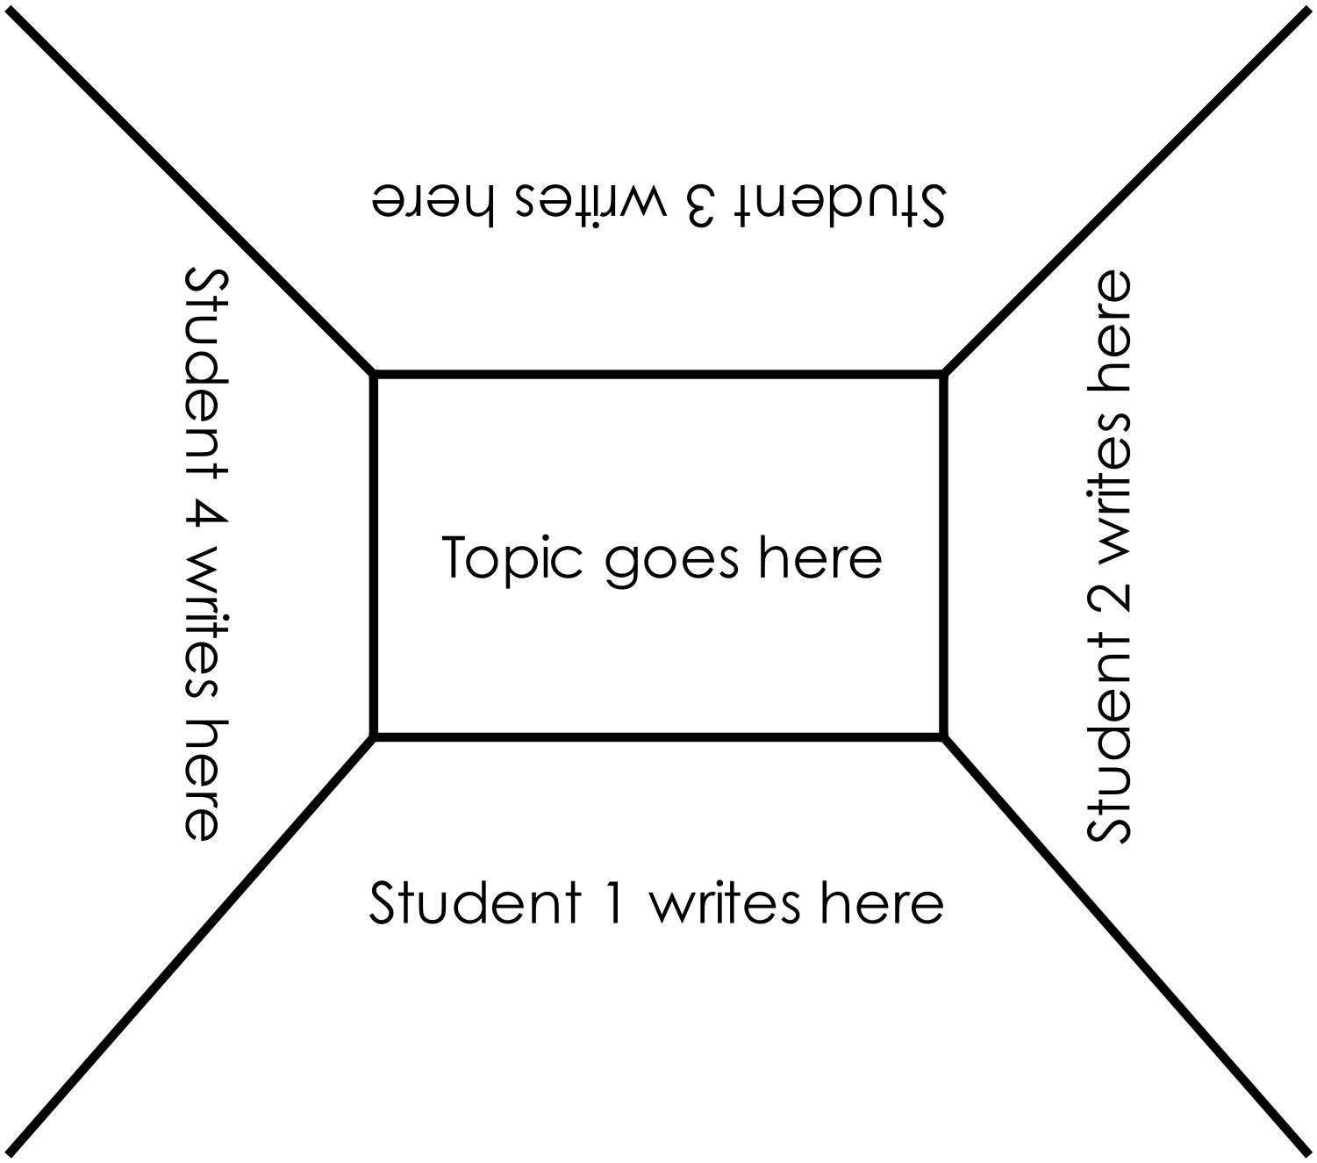

Appendix 8: Teacher resource sheet 1.3: Cooperative learning – Think, Pair, Share
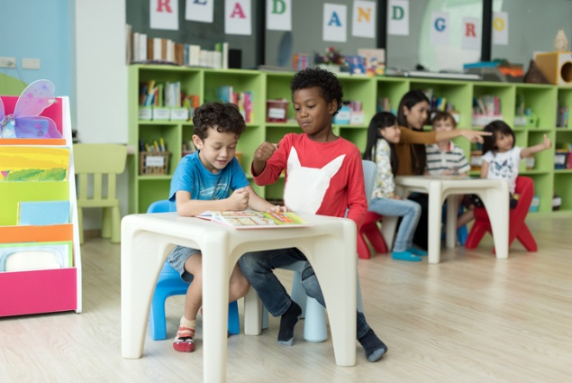
This resource sheet provides a brief outline of a cooperative learning strategy known as 'think – pair – share'.
Cooperative learning frameworks create opportunities for groups of students to work together, generally to a single purpose.
As well as having the potential to increase learning for all students involved, using these frameworks can help students develop personal and social capability.
In the 'think' stage, each student thinks silently about a question asked by the teacher.
In the 'pair' stage, students discuss their thoughts and answers to the question in pairs.
In the 'share' stage, the students share their answer, their partners answer or what they decided together. This sharing may be with other pairs or with the whole class. It is important also to let students 'pass'. This is a key element of making the strategy safe for students.
Think – pair – share increases student participation and provides an environment for higher levels of thinking and questioning.

What do you see when you look at this image?

What are you thinking about as you look at this image?
What are your wonderings (questions)?

Appendix 9: Student resource sheet 1.4: I see, I think, I wonder

Appendix 10: Teacher resource sheet 1.5: Sample parent letter
(School details and letterhead)
(Date)

Dear parents/caregivers,

RE: REUSABLE ITEMS COLLECTION FOR LITTLE RED HEN’S ROBOT FRIEND STEM PROJECT

This term our class is undertaking a STEM (Science, Technology, Engineering and Mathematics) project called Little Red Hen’s robot friend. Based on the picture book The Little Red Hen by Margot Zemach, this project will involve students repurposing items to create an attachment for a robot to help the Little Red Hen take her wheat to the mill and the flour to her home.
This project focuses on repurposing items to give students opportunities to consider sustainability and the impact of our lifestyles on our environment, while developing their ability to design, create and problem-solve.
To enable us to create our design solutions, we would appreciate if you could please collect clean reusable items from your house. Please do not include any alcoholic containers or toilet rolls. We would like the items to be delivered to the classroom before (date).
We will be collecting data on the shape and material properties of the items before using them to create a solution.
We may require adult assistance during the construction phase so please let me know if you are available to help.

Thank you in advance,

(Classroom teacher)

Appendix 11: Teacher resource sheet 3.1: Construction skills
Construction skills help students to generate and produce solutions for real-world problems. This resource develops students' skills in design and technologies.
This resource can be used as a visual stimulus to prompt students to develop solutions to design problems. The cards can be printed out to create stations.

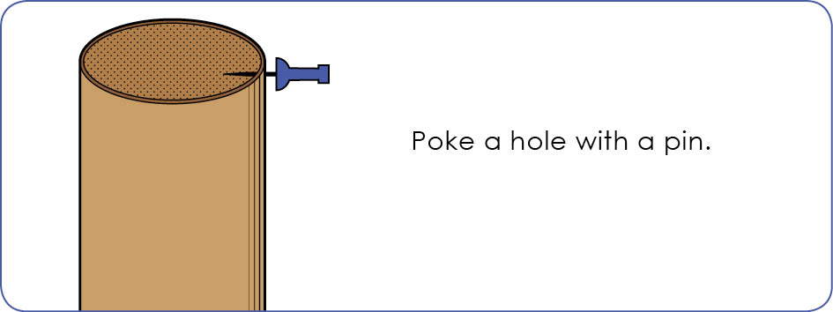

Poke a hole with a pin.
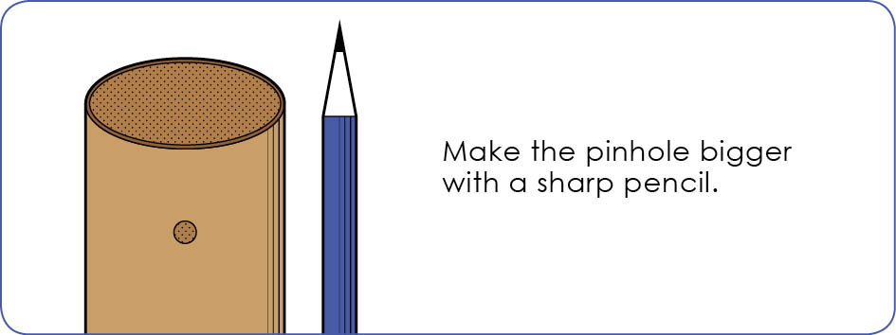

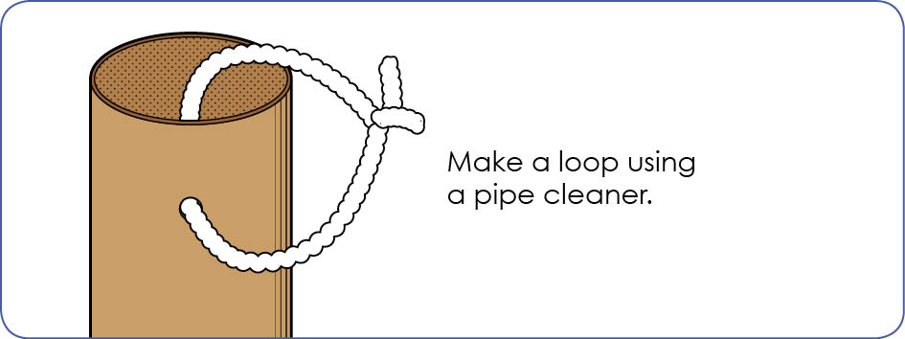

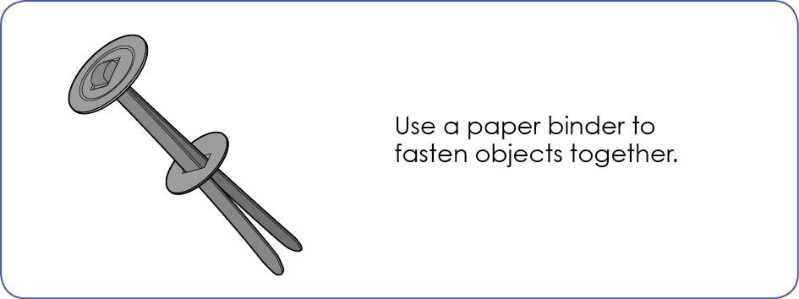

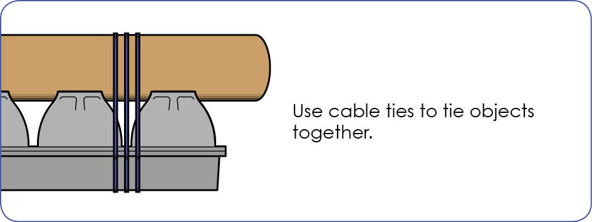
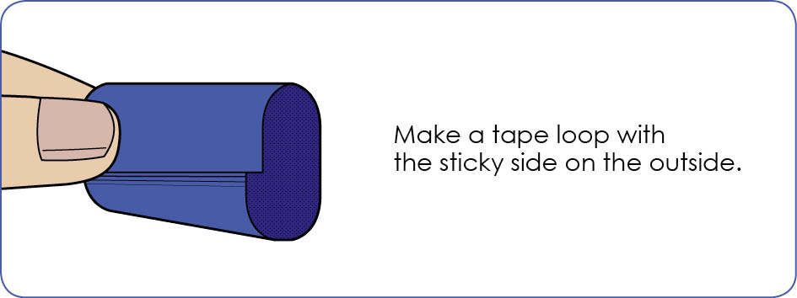

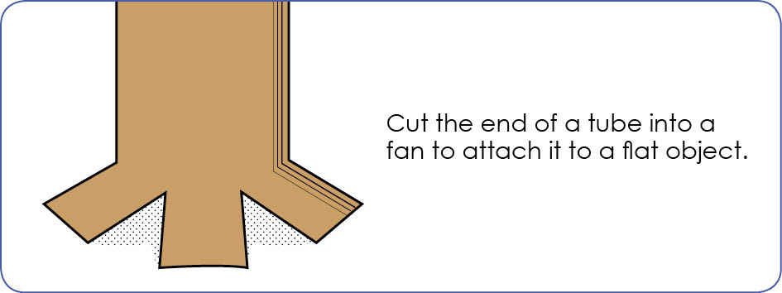

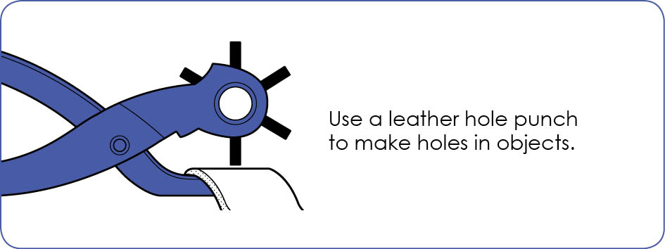
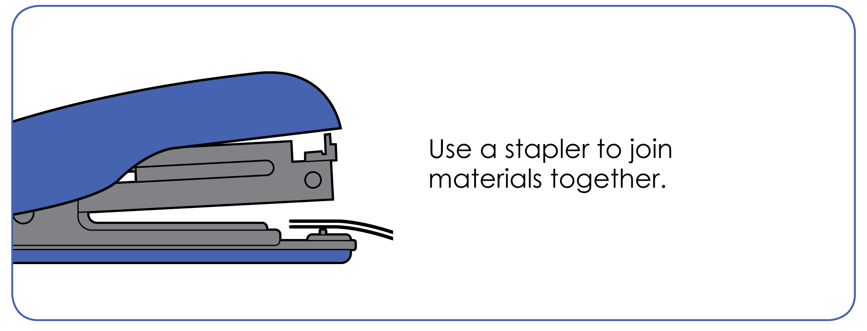

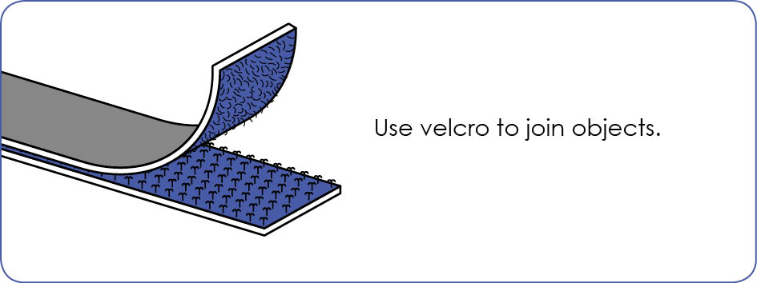

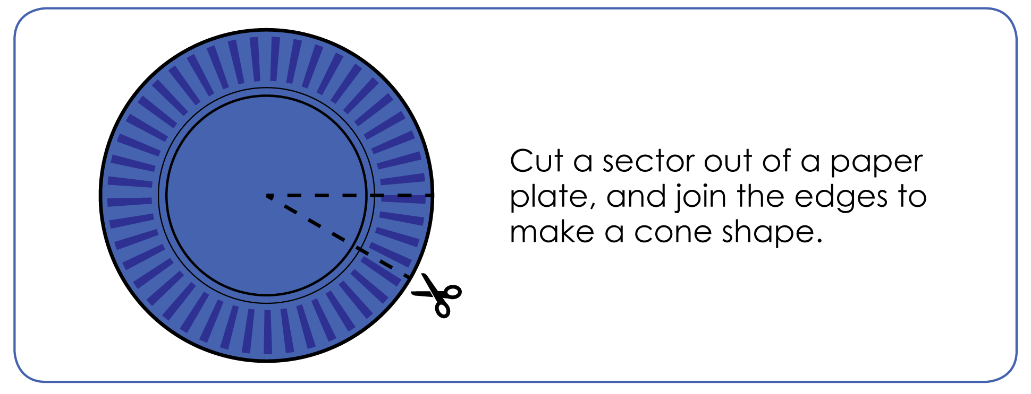

Appendix 13: Student activity sheet 4.1: Design review
Site location: ______________________

I like our attachment because …

We could improve our attachment by …

Did you have a problem while building your attachment?

How did you solve the problem?

What did you learn from doing this project?
Photograph or drawing

Notes
________________________________________________________________________________________________________________________________________________________________________________________________________________________________________________________________________________________________________________________________________________________________________________________________________________________________________________________________________________________________________________________________________________________________________________________________________________________________________________________________________________________________________________________________________________________________________________________________________________________________________________________________________________________________________________________________________________________________________________________________________________________________________________________________________________________________________________________________________________________________________________________________________________________________________________________________________________________________________________________________________________________________________________________________________________________________________________________________________________________________________________________________________________________________________________________________________________________________

