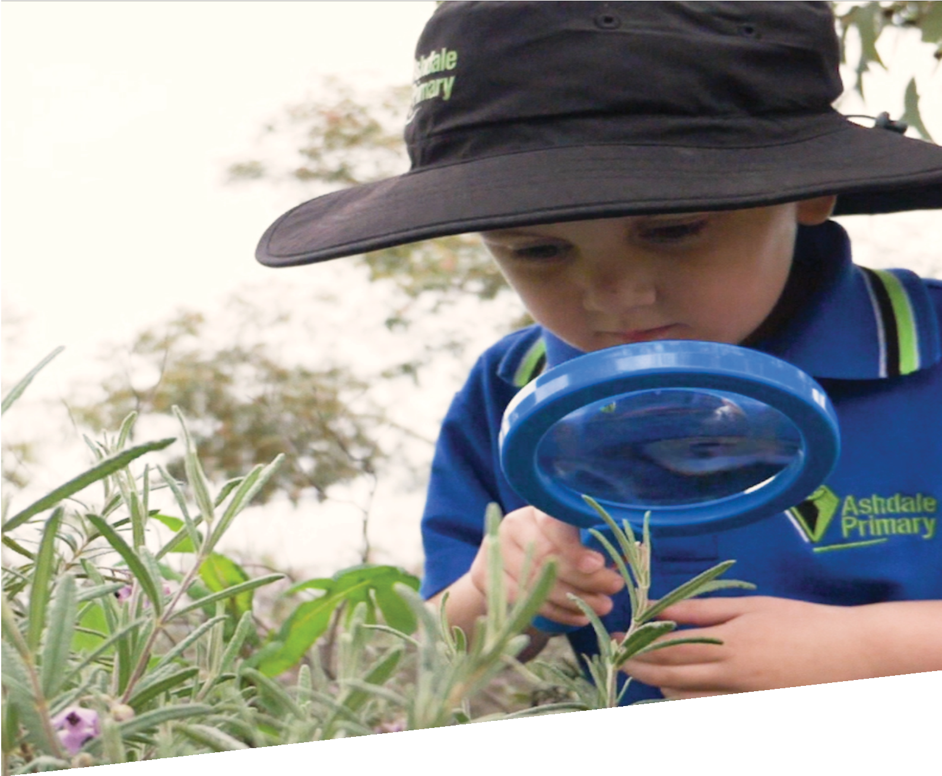

CURRICULUM RESOURCE MODULE
Creepy crawly castle
KINDERGARTEN
Acknowledgements
The STEM Learning Project respectfully acknowledges the Traditional Custodians of the lands upon which our students and teachers live, learn and educate.
The STEM Learning Project is funded by the Western Australian Department of Education (the Department) and implemented by a consortium in STEM education comprising the Educational Computing Association of WA, the Mathematical Association of WA, the Science Teachers Association of WA and Scitech. We acknowledge and thank the teachers and schools who are the co-creators of these resources.

Copyright and intellectual property
The copyright and intellectual property of this module remain the property of the Department.
Any Western Australian Curriculum content in this resource is used with the permission of the School Curriculum and Standards Authority (the Authority); this permission does not constitute Authority endorsement of the resource. The Authority accepts no liability for any errors or damages arising from reliance on its content.
The Western Australian Curriculum content may be freely copied, or communicated on an intranet, for non-commercial purposes in educational institutions, provided that the Authority is acknowledged as the copyright owner. Copying or communication for any other purpose can be done only within the terms of the Copyright Act 1968 or with prior written permission of the Authority. Any Australian Curriculum content in the Western Australian Curriculum is used by the Authority under the terms of the Creative Commons Attribution-NonCommercial 3.0 Australia licence.
Any content on the www.scsa.wa.edu.au domain that has been derived from the Australian Curriculum may be used under the terms of Creative Commons Attribution-NonCommercial 3.0 Australia licence.
This resource includes references and examples of iOS, Android and other apps. The Department does not endorse or recommend any commercial products and simply provides these as examples for teachers.
The Department is committed to providing quality information to its customers. Whilst every effort has been made to ensure accuracy, currency and reliability of the information within these documents, the Department accepts no responsibility for errors, omissions or amendments made since the time of publishing. Confirmation of information may be sought from the Department or the originating bodies providing the information. The Department has no control over the content of material published on websites to which users are referred in this resource. It is the responsibility of the internet user to make their own decision as to the relevancy, accuracy, currency and reliability of information found on those sites.
Attributions: Padlet, Popplet, Chatterpix, Seesaw, Explain Everything, Kidblog, Edmodo, Evernote, Connect, eBook, Pages, Keynote, PowerPoint, iMovie, Class Dojo.

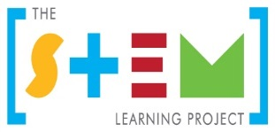
Table of contents

The STEM Learning Project 2
Overview 4
Activity sequence and purpose 7
Background 8
Activity 1: Creepy crawly hunt 11
Activity 2: Creepy crawly profiles 23
Activity 3: Building our creepy crawly castle 29
Activity 4: Creepy crawly stories 33
Appendix 1: Links to the Kindergarten Curriculum Guidelines 36
Appendix 2: Materials list 42
Appendix 3: Design process guide 43
Appendix 4: Reflective journal 44
Appendix 5: Teacher resource sheet: Cooperative learning – Think-Pair-Share 45
Appendix 6: Student activity sheet: Where do invertebrates live? matching activity 46
Appendix 7: Student activity sheet: Where do invertebrates live? drawing activity 47
Appendix 8: Student activity sheet: Design review 48
Appendix 9 Teacher resource sheet: 3-2-1 Reflection 49

The STEM Learning Project
The aim of the STEM Learning Project is to generate students’ interest, enjoyment and engagement with STEM (Science, Technology, Engineering and Mathematics) and to encourage their ongoing participation in STEM both at school and in subsequent careers. The curriculum resources will support teachers to implement and extend the Kindergarten Curriculum Guidelines and the Western Australian Curriculum and develop the general capabilities across Kindergarten to Year 12.
Why STEM?
A quality STEM education will develop the knowledge and intellectual skills to drive the innovation required to address global economic, social and environmental challenges.
STEM capability is the key to navigating the employment landscape changed by globalisation and digital disruption. Routine manual and cognitive jobs are in decline whilst non-routine cognitive jobs are growing strongly in Australia. Seventy-five per cent of the jobs in the emerging economy will require critical and creative thinking and problem solving, supported by skills of collaboration, teamwork and literacy in mathematics, science and technology. This is what we call STEM capability. The vision is to respond to the challenges of today and tomorrow by preparing students for a world that requires multidisciplinary STEM thinking and capability.
The approach
STEM capabilities are developed when students are challenged to solve open-ended, real-world problems that engage students in the processes of the STEM disciplines.
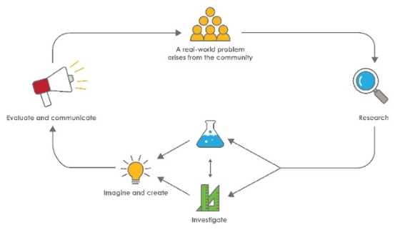

STEM in the early years
STEM is about children exploring the world around them and asking questions about how or why something works. Whether it is playing with water, building towers with blocks, talking about changes in the weather, or planting seeds, children demonstrate from an early age their readiness to engage in STEM.
When children come to school, they bring with them all the things they have learned. As their partners in learning, you can build on these skills, interests and knowledge using play-based learning alongside intentional teaching experiences. This balanced approach can help to keep every child productive and engaged in STEM.
Play is an essential and fun part of every child’s learning and development and helps them to build their knowledge, skills and attitudes. When children are playing, they are learning to talk and interact with other children and adults. They observe and copy others and discover new ways of doing things, have the freedom to explore their own interests, test solutions, problem solve and answer questions for themselves. By encouraging children to play, explore and investigate, teachers are helping children become active participants in their own learning.
The inquiry question posed in this module allows children to pursue knowledge and increase understanding of related content across the five learning and development areas of the Kindergarten Curriculum Guidelines which are based on the five outcomes of the Early Years Learning Framework (EYLF) (DEEWR, 2009). The EYLF recognises inquiry as a central component in effective learning, not only in childhood but also throughout life,
This module focuses on this kind of learning which addresses the National Quality Standard (NQS), Quality Area 1 – Educational Program and Practice. The module also focuses on Quality Area 5 – Relationships with Children.
STEM exploration and discovery can be embedded in the daily practices of your early learning setting and can also build students’ competence within the seven general capabilities.

Kindergarten – Creepy crawly castle

Overview
Encouraging students to study very small animals in nature contributes to conservation and is an educational and enjoyable pursuit. While stimulating curiosity and inquiry it brings a wider understanding to young learners of how the living world works. In this module, students investigate animals without a backbone or internal skeleton known as invertebrates. Students explore the diversity of invertebrates and where and how they live, and then design a structure that will encourage more invertebrates to live in the school gardens.
What is the context?
The development of school buildings and grounds may disrupt the natural environment and change the habitats in which many small animals and invertebrates live. Invertebrates play important roles within ecosystems; for example, they are part of a food chain, some aerate the soil or act as pollinators, while others decompose leaf litter and other decaying matter.
What is the problem?
How can we encourage invertebrates to visit and live at our school?
How does this module support integration of the STEM disciplines?
Science
As students study this module they have opportunities to ‘release’ an invertebrate from a block of ice and investigate the diversity of small animals in the local environment, their features and need for shelter, moisture and food.
Technology
Students draw on their understandings of an invertebrate’s need for shelter, moisture and food to design and build a creepy crawly castle that will attract more invertebrates into the school garden. Students use digital technologies to capture data and tell stories about their invertebrates.
The Design process guide is included as a resource to help teachers to understand the complete design process as developed in the Technologies curriculum.
Mathematics
Students develop their use of positional language when participating in the invertebrate hunt, understanding of numbers when counting invertebrate body parts, and names of familiar shapes when making their invertebrates and creepy crawly castles.
What are the pedagogical principles of the STEM learning modules?
The STEM Learning Project modules develop STEM capabilities by challenging students to solve real-world problems set in authentic contexts. The problems engage students in the STEM disciplines and provide opportunities for developing higher order thinking and reasoning, and the general capabilities of creativity, critical thinking, communication and collaboration.
The design of the modules is based on four pedagogical principles:
- Problem-based learning
This is an underlying part of all modules with every module based around solving an initial problem. It is supported through a four-phase instructional model: research the problem and its context; investigate the parameters impacting on the problem; design and develop solutions to the problem; and evaluate and communicate solutions to an authentic audience.
- Developing higher order thinking
Opportunities are created for higher order thinking and reasoning through questioning and discourse that elicits students' thinking, prompts and scaffolds explanations, and requires students to justify their claims. Opportunities for making reasoning visible through discourse are highlighted in the modules with the icon shown here.
- Collaborative learning
This provides opportunities for students to develop teamwork and leadership skills, challenge each other’s ideas, and co-construct explanations and solutions. Information that can support teachers with aspects of collaborative learning is included in the resource sheets.
- Reflective practice
Recording observations, ideas and one’s reflections on the learning experiences in some form of journal fosters deeper engagement and metacognitive awareness of what is being learnt. Information that can support teachers with journaling is included in the resource sheets.
These pedagogical principles can be explored further in the STEM Learning Project online professional learning modules located in Connect Discover.
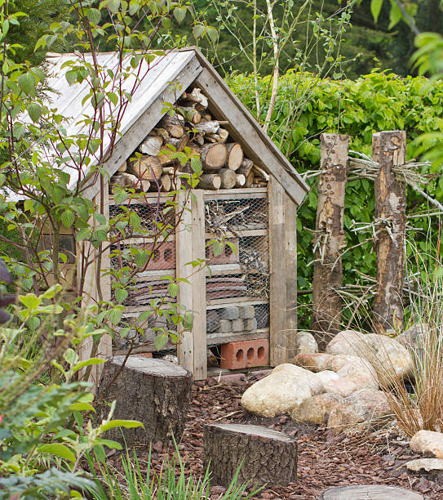
An example of a creepy crawly castle

Activity sequence and purpose
Creepy crawly hunt
Working collaboratively, students participate in a hunt for frozen invertebrate figurines hidden in their school garden. They investigate the features of invertebrates and sort invertebrates and non-invertebrates.
Creepy crawly profiles
Students work collaboratively to investigate the habitat and diet of different invertebrates. Using this information, they design a creepy crawly castle.
Building creepy crawly castles
Students work with members of the community to build a creepy crawly castle in their school garden.
Students design and build their own invertebrate using natural materials and digitally record them in the creepy crawly castle.
Creepy crawly stories
Students create digital stories about their invertebrates and creepy crawly castle. They share their story with an authentic audience and the wider community via a digital platform.

Background
Learning focus | This will be evident when students make progress towards being able to:  - Show initiative by asking questions, negotiating and sharing.  - Listen to others’ opinions and points of view, share own ideas and take turns in small group situations.  - Share observations with others as they explore their immediate world using their five senses.  - Participate with others to solve problems.  - Describe both verbally and non-verbally what they see, hear, touch, feel and taste.  - Use simple and safe tools to explore and investigate the environment.  - Describe some of the simple natural and built elements and materials in their environment.  - Contribute their ideas in discussion about experiences in the natural and constructed environment.  - Investigate places where invertebrates live and describe the basic needs of invertebrates.  - Use positional language such as on, under, behind, between and simple language of measurement to describe, compare and sort the observations made when exploring.  - Sort and classify invertebrates according to attributes, for example colour, size, shape, legs, wings.  - Represent findings and communicate simple information for a purpose using a range of tools, resources and technologies safely and appropriately.  - Engage with ICT for fun and to promote thinking and learning, and use simple skills with assistance, to collection information and communicate it simply.
Vocabulary | The following vocabulary list contains terms that need to be introduced before the module commences or developed as they are used. The words in brackets are for teacher reference only. Wherever possible, and especially for children who demonstrate interest, or an established vocabulary related to invertebrates, use the scientific word.  Antenna, backbone, beetle, camouflage, carnivore, centipede, crustacean, decomposer, diagram, earwig, exoskeleton, habitat, herbivore, insect, invertebrate, larvae, metamorphosis, millipede, omnivore, segments, skeleton, slater, snail (mollusc), spider (arachnid), vegetation, woodlouse, worms (annelid).  Movement vocabulary: Crawls, flies, hops, jumps, quickly, ripple, runs, slithers, slowly, walks, wriggles.  Habitat vocabulary: Cold, dark, dry, grassy, leafy, light, moist, muddy, rocky, sandy, slimy, stony, underground, warm, wet  Students will also need to count to ten and recognise and name some colours.
Timing | There is no prescribed duration for this module. The module is designed to be flexible enough for teachers to adapt. Activities do not equate to lessons; one activity may require more than one lesson to implement.
Consumable materials | A Materials list is provided for this module. The list outlines materials outside of normal classroom equipment that will be needed to complete the activities. Plan ahead to order materials from a supplier.
Safety notes | There are potential hazards inherent in these activities and with the equipment being used, and a plan to mitigate any risks will be required.  Potential hazards specific to this module include but are not limited to:  - Activities outside the classroom  - Biting or stinging invertebrates  - Sun exposure  - Sharp tools and heavy items  - Possible exposure to cyber bullying, privacy violations and uninvited solicitations if using the internet.  When planning for the delivery of this topic it is important to consider the backgrounds and experiences of students in the class as the activities may be of concern for those who have allergies to pollens or plants.
Assessment | The STEM modules have been developed to provide students with learning experiences to solve authentic real-world problems using science, technology, engineering and mathematics. While working through the module, the following assessment opportunities will arise:  - Anecdotal records of:  - Group and class discussions  - Science inquiry skills used throughout the activities  - Collaborative skills.  - Following a key to identify small animals  - Applying knowledge to design and create a creepy crawly castle  - Applying knowledge to design and create an invertebrate  - Communicating observations and reflections  Mapping to the Kindergarten Curriculum Guidelines is provided in Appendix 1.

Activity 1: Creepy crawly hunt
Activity focus | Working collaboratively, students participate in an invertebrate hunt in one area of their school. They investigate the features of invertebrates and use a simple dichotomous key to classify them.
Background information | Invertebrates are animals without a vertebrate or bony skeleton. These include but are not limited to snails, worms, ants, butterflies, bees, flies and spiders. Invertebrates have structures to support and protect them, such as shells on snails or an exoskeleton.  Some invertebrates can only detect shadows while others are able to see colours, including ultra-violet light. Many small animals have compound eyes composed of hundreds of lenses.  The bodies of invertebrates are sensitive to touch. Antennae are used to detect odours and touch. Flies taste with their feet. Invertebrates do not have ears, but some are able to detect sounds. Mosquitoes detect sounds through their antennae, crickets through their forelegs, cicadas use their thorax, and grasshoppers have a sound receptor on their abdomen.  Although invertebrates are small, they play important roles in ecosystems. Worms tunnel through the soil helping air and water to penetrate the soil and keep it healthy. Ants, moths, wasps, beetles, butterflies and bees pollinate flowers so that they can form fruit that other animals feed on and set seeds. Many invertebrates help decompose decaying plant and animal matter, releasing nutrients into the soil for plant growth. They are also a very important source of food for other animals such as birds, mammals, amphibians and reptiles, making them an important part of the ecosystem in which they live.  When school buildings and grounds are established there may be a loss of natural habitats and the homes of invertebrates destroyed. As gardens are developed, new habitats are formed, and some invertebrates return. Healthy and sustainable environments need invertebrates to support a rich diversity of plant and animal life.
Instructional procedures | Student ideas and conversations from the lesson could be recorded using digital versions as annotations in a class reflective journal, along with copies of photos that have been taken. This could be digital or physical, see Reflective journal for elaboration.  It is recommended that students work in small groups for the activities. Mixed groups encourage peer tutoring and collaboration in problem solving. Collaboration is an important STEM capability. There are many creative solutions to this problem and negotiation is encouraged. Refer to Teacher resource sheet: Cooperative learning – Think-Pair-Share.  In the following activities, Bloom’s question stems could be used to scaffold questioning and encourage higher order thinking and reasoning.  Remember /knowledge What is…? How would you show…? Where did you…? Which one…? What happened when…?  Understand / comprehend How would you explain…? How are these alike? Different? Which does not belong? What do you mean by…?  Apply / application What might happen if…? Why does …? Using what you have learnt, how could you…?  Analyse / analysis Why do you think that happened? What are the (good) positive and interesting things …? Explain why it is not possible for…? How would you …?  Evaluate What is one thing you could do to improve…?  Create /synthesise How would you design an X to do Y?  Museum in a box is a resource which can be hired from the Australian Museum to support learning in this module:  The Minibeasts box is a resource designed specifically for Early Childhood. The topic was chosen to complement children's fascination with creatures that they find in their environment. It includes a great variety of 'treasures' - real insects and spiders embedded in resin, a large model ant, insect finger puppets, handmade silk butterfly wings, a specially created wooden ladybug puzzle, posters and books.  More information and delivery costs are available at australianmuseum.net.au/museum-in-a-box-minibeast  Purchase minibeast slides and viewers to enhance student learning and experiences. Contact your local secondary school as they may have invertebrate resources available for loan.  Magnifying attachments enable students to photograph what they are viewing on an iPad or Android device and can be purchased from local department stores. It may be beneficial to use these in place of magnifying glasses for this activity.  Keeping live invertebrates such as moths, butterflies and stick insects in the classroom encourages students to observe, discuss and record changes that occur in their growth. Care should be taken and policies adhered to, when considering keeping invertebrates in the classroom.  It is not a requirement for schools to apply to the School Animal Ethics Committee (SAEC) for permission to use them or to keep records of their use (refer to http://det.wa.edu.au/curriculumsupport/animalethics/detcms/portal/). The SAEC website does however offer some advice on their use and care in Species Specific Information. Teachers are encouraged to consider the ethical issues relating to using invertebrates and to discuss these with the class.  Hands-on experiences of animals in the early years assists students to begin to develop understandings about animals and responsible, empathetic attitudes about animal welfare. It is not a requirement for schools to apply to the School Animal Ethics Committee (SAEC) for permission to use them or to keep records of their use (refer to http://det.wa.edu.au/curriculumsupport/animalethics/detcms/portal/). The SAEC website offers some advice on their use and care in Species Specific Information.
Expected learning | Students will be able to:  - Show initiative by asking questions, negotiating and sharing (English, Science).  - Take turns in small group situations.  - Share observations with others as they explore their immediate world using their five senses (Science).  - Describe both verbally and non-verbally what they see, hear, touch, feel and taste (English, Science).  - Use ICT with assistance to collect information and communicate it simply (English).  - Create and use simple representations to organise, record and communicate mathematical and scientific ideas and concepts (Mathematics, Science).  - Use positional language such as on, under, behind, between (Mathematics).  - Count objects by using one to one correspondence.  - Sort, classify and match objects according to attributes, for example colour, size and shape (Mathematics).
Equipment required | For the class:  Images of invertebrates (see Digital resources)  Small plastic invertebrates  Containers for collecting plastic and real invertebrates  Pop sticks for moving plant debris or moving invertebrates into containers  Interactive whiteboard
For the students:
Digital devices
Magnifying glasses or magnifying device attachments
Invertebrate classification charts or photos

Preparation | Hide a range of realistic plastic invertebrates in places in one area of the school. Where possible, try to include invertebrates that would be found in the local area and other areas.  Source magnifying glasses or magnifying attachments for digital devices. Ensure students know how to use these.  Charge digital devices.  Notify parents of the STEM activity in which the students will participate. Inform them of times when parent help will be needed and of the types of reusable and natural materials needed for creating the invertebrate and the creepy crawly castle in Activity 3. If necessary, request donations of materials. A suggestion could be to take a family nature walk over a weekend to collect items such as leaves, twigs, honky nuts and pinecones.
Activity parts | Part 1: Engage  Show the class several images of invertebrates (see Digital resources). Conduct a brainstorm to engage students and determine what they know about invertebrates ie how they live and survive. A teacher guided think-pair-share strategy could be used prior to the brainstorm to encourage development of ideas among students, see Teacher resource sheet: Cooperative learning – Think-Pair-Share.  Ask students:  - Tell me about the invertebrates you have seen before?  - Where did you see them?  - Which ones did you see?  Record student responses as a mind map either on the whiteboard or using an app such as Padlet or Popplet. The mind map can be elaborated as students’ ideas develop over the module.  To engage students in the topic, read a story or watch an episode of Minibeast heroes (see Digital resources and Literacy resources). Add names or pictures of invertebrates to the mind map.  Through the discussions ensure that students understand that invertebrates are animals without a backbone or bony skeleton eg snails, worms, ants, butterflies, bees, flies, spiders and many others.  Note: If reading The Very Hungry Caterpillar, as suggested in Literary resources, a discussion will need to take place to clarify a caterpillar’s diet. Students need to understand that the foods eaten by the caterpillar in the story are not factual.
Part 2: Invertebrate hunt
Working in pairs, students participate in an invertebrate hunt in one area of the school. Explain to students that a scientist who studies animals including invertebrates is called a biologist. They are going to be biologists, looking for invertebrates living in their natural environment around the school.
Ask students:
- Do biologists take anything with them when they go looking for invertebrates? What should we take?
- What should we do if we see an invertebrate and think it is dangerous?
- Where do you think invertebrates might be living in our garden? Use positional vocabulary – under, in, on, near, on top of etc.
Explain to the students that many invertebrates use camouflage to protect themselves; this means they try to look like part of their habitat (the place where they live). Encourage students to look in different types of habitat including in soil, under bark, in grass, trees and bushes, in garden beds, under rocks and logs, on plants, in water and in the air.
Ask students to answer the following questions as they explore the garden, raising awareness of four of their five senses.
- What can you see?
- What can you hear?
- What do you feel?
- What can you smell?
- Should we taste anything when we’re in the garden? Why?
Ask students the following questions when they have found real and plastic invertebrates.
- Tell me which invertebrates you found.
- How many did you find?
- Are they big or small?
- Where did you find your invertebrate? Encourage the use of positional language (ie on a leaf, under a log, in a tree, behind a rock).
- If you were an invertebrate how would you feel if you were removed from your home? What do you think could happen to you?
Photos of the students participating in the activity can be taken and used for discussion in future science lessons.
Part 3: Magnifying invertebrates
This is an inquiry activity where students are encouraged to make, investigate and discuss observations. The responses do not need to be recorded. The photos students have taken along with the plastic invertebrates will be used in Part 4 when students use a simple dichotomous key to classify their invertebrates.
Students use a magnifying glass or magnifying attachment on a device to investigate the features of the plastic and live invertebrates. Encourage students to take photos and discuss what they see. Questions to stimulate conversation include:
- Do any of your invertebrates have legs? How many legs can you count?
- Do any of your invertebrates have a hard shell? I wonder why it has a hard shell.
- Do any of your invertebrates have wings? How many can you see?
- What colours can you see on your invertebrate? Would this colour help the invertebrate help it hide from other animals? This question is only for the live invertebrates as plastic models may not be the correct colour.
- What else did you discover about invertebrates?
Note: If students have discovered live invertebrates in the garden and have collected those for observation, caution will need to be exercised when handling these and when using magnifying glasses, especially on days with high temperatures. The ability to answer some questions will depend on the plastic model (ie number of wings, colour and hard shell) and the live invertebrates found on the hunt.
After students have finished looking at their invertebrates, facilitate a class discussion to observe all the invertebrates found and encourage students to observe:
- Does your invertebrate have body parts? How many?
- Does your invertebrate have legs? How many? Do all invertebrates have legs?
- Does your invertebrate have wings? How many? Do all invertebrates’ wings look the same? I wonder if all invertebrates have wings.
- Does your invertebrate have antenna? How many? I wonder what they are for. How many?
- Does your invertebrate have a sting? Where is it? I wonder why some invertebrates have a sting and others don’t.
The Atlas of Living Australia website may assist with identifying invertebrates: www.ala.org.au.
Part 4: Classifying invertebrates
Students should spend time sorting and resorting their invertebrates based on simple characteristics eg legs and no legs, wings and no wings.
Students work in pairs to identify their invertebrates from diagrams and develop grouping skills.
The Backyard Buddies website may be useful in providing images and information about Australian invertebrates: www.backyardbuddies.org.au/explore/bugs-and-insects
Part 5: Drawing invertebrates
Students use the information they have gained about invertebrates to draw a scientific diagram. This activity can be individual, or group based. Encourage the drawings to be as accurate as possible.
Scribe for students the various parts of the invertebrate they have drawn.
After students have drawn an invertebrate, they can use an app such as Chatterpix to record a voice-over describing the features.

Part 6: Additional learning opportunities
Mancala snail game
This game is based on the ancient African game of strategy, with the goal being to collect more snails than your opponent. The game provides an opportunity for students to develop counting skills. Alternatively, students could design and create their own mancala games. Digital versions can be found in Digital resources.
To incorporate literacy in this activity, a story such as The Very Hungry Caterpillar by Eric Carle or Caterpillar and Butterfly by Ambelin Kwaymullina could be read as a stimulus (see Library resources). Life cycles could be discussed, and the life cycle stages could provide choice for the game pieces as an alternative to snails.
This game also provides an opportunity to link with Aboriginal culture where invertebrates from a traditional diet could be used as game pieces. Information about invertebrates used for food sources can be found on the Aboriginal Culture website, see Digital resources.
Links to design technologies
From observations and photographs:
- Make monoprints, press prints or string prints of invertebrates.
- Make invertebrate blot paintings.
- Paint an invertebrate in a camouflaged habitat.
- Make clay models of invertebrates for display in a museum. Scribe a caption using scientific language for museum visitors.
- Make a stitched design of an invertebrate.
Creating compost
Start a classroom compost pile using food scraps collected from students’ lunchboxes. This activity encourages students to be involved in recycling and to become aware of the importance of rotting material in the life cycles of many invertebrates.
It may be useful to visit local council websites for additional information on composting.
Part 7: Reflection
Student thinking from the lesson can be recorded in the class journal along with copies of photos taken during the activity parts. Keep the journal in a place easily accessible to parents to further involve them in their children’s learning journey.
Digital resources | Support resources
Minibeast education resource (Young People’s Trust for the Environment, 2005)
dnk4skl3hw8rq.cloudfront.net/assets/db4dd1fb1f9e25abe1f6206f456bb04bfcd32013/11._Minibeasts_-_Conservation_Education_-_YPTE.original.pdf?1411671011
Australian minibeast resource pack (Twinkl, 2018)
www.twinkl.com.au/resource/au-t-867--australia---minibeasts-resource-pack
Minibeast slides and viewers (Modern teaching aids, 2018)
www.teaching.com.au/catalogue?catalogue=MTA&category=MTA-SCIENCE-INSECTS-AND-SPIDERS&_escaped_fragment
Museum in a box – Minibeast (Australian Museum, 2018)
australianmuseum.net.au/museum-in-a-box-minibeast
Minibeasts in my city (Western Australian Museum, 2018)
museum.wa.gov.au/museums/offsite/mini-beasts-my-city
Critique and feedback – the story of Austin’s Butterfly – Ron Berger (Tali Lerner, 2012)
www.youtube.com/watch?v=hqh1MRWZjms
Australian iconic species – Invertebrates (Atlas of living Australia, 2018)
lists.ala.org.au/iconic-species?fq=kvp%20group:Invertebrates
Engagement videos
Insects (BBC, 2014)
www.bbc.co.uk/nature/life/Insect/by/rank/all
Minibeasts (BBC, 2018)
www.bbc.com/education/clips/z44g9j6
Minibeast heroes (ABCiview, 2018)
iview.abc.net.au/show/minibeast-heroes
Minibeast information resource
Bugs and insects (Backyard Buddies, 2018)
www.backyardbuddies.org.au/explore/bugs-and-insects
Activity links
Minibeast identification (science-resources.co.uk, 2012)
www.science-resources.co.uk/KS2/Habitats/Minibeast_identification.html
 | Aboriginal Culture (David M Welch, 2017) www.aboriginalculture.com.au/bush_foods2.html
Garden detective (Education Services Australia, 2016)
www.scootle.edu.au/ec/viewing/L1118/L1118/index.html#
Mancala snails (Lil’ games, 2018)
www.lilgames.com/mancala_snails.shtml
Mancala Simplified for Preschoolers (Evergreen Montessori House, 2012)
evergreenmontessorihouse.blogspot.com/2012/10/mancala-simplified-for-preschoolers.html
Literary resources | Caterpillar and Butterfly by Ambelin Kwaymullina  www.fremantlepress.com.au/products/caterpillar-and-butterfly
 | The Very Hungry Caterpillar by Eric Carle
What’s that? The Australian Minibeasts
dominie.com.au/products/ER-1089A
Minibeast booklist (Twinkl, 2018)
www.twinkl.com.au/book-list/minibeasts-primary-book
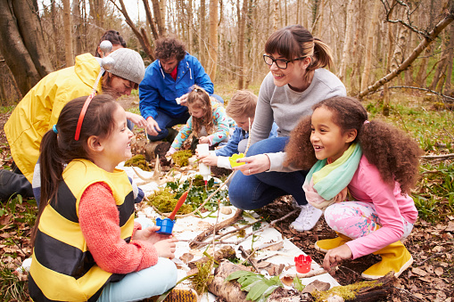
Students participating in an invertebrate hunt

Activity 2: Creepy crawly profiles
Activity focus | Students work collaboratively to investigate the habitat and diet of invertebrates. Using this information, they draw a design for their ‘creepy crawly castle’.
Background information | Invertebrates can be found in almost every part of the world. They can survive in the most extreme ecosystems.  A habitat is the type of place in which it is natural for an invertebrate to live and grow, where it can find food, shelter and protection.  Most invertebrates live on land (terrestrial, in the sea (marine) and in water bodies such as lakes and rivers (freshwater). Some species such as dragonflies live both on land and in the water, depending on their life stage.  Many invertebrates are herbivores and only eat plants. Most eat a wide range of plant food.  Invertebrates take in air through spiracles, holes along the side of their bodies and have a variety of structures to help them eat. Ants have strong jaws, butterflies have a long-coiled tube, mosquitoes can pierce skin to suck blood, a praying mantis uses large front legs to catch and manipulate food, molluscs such as slugs and snails, have an radula which they use to tear up plant food. Grasshoppers and caterpillars have a mandible with very sharp edges for cutting into grass and leaves.  Some invertebrates have a strong sense of smell. They use their antennae to detect odours in the air to locate food sources or other individuals of their own species.  Drawing on an understanding of the places where invertebrates live and their needs, students design a creepy crawly castle to encourage more invertebrates to live in the school grounds.  The Design process is a series of steps that guides the development of a solution to a problem. These steps are:  - Define the problem: What is the need?  - Research and gather information.  - Analysis: Imagine: Brainstorm ideas.  - Ideation: Plan: Pick the best idea, how will it work? Draw a diagram, identify materials or tools required?  - Development/ production: Create: Build the solution and test it.  - Evaluation: Improve: What works, what doesn’t, what could work better? Repeat the cycle.  Refer to the Design process guide for further information on design in the Technologies curriculum.  Negotiation, critical thinking and reasoning skills will be used by the students as they work on their designs, as will problem solving in collaborative situations. Allowing students to negotiate amongst themselves will encourage the development of problem solving. These are all STEM capabilities that students need to develop and practise.
Instructional procedures | Students will need support when providing feedback using the Two stars and a wish strategy. Support and scaffolding will need to be provided about how to give and receive feedback constructively, how to listen to others and acknowledge differences of opinion.
Expected learning | Students will be able to:  - Listen to others and share ideas (English).  - Share observations with others as they explore their immediate world using their five senses (Science).  - Plan and carry out a few simple sequenced steps when exploring and investigating (Science, Technologies).  - Use simple language of measurement to describe, compare, order or sort the observations made when exploring (Mathematics, Science).  - Contribute their ideas in discussion about experiences in the natural and constructed environment.  - Use play to investigate, project and explore new ideas (Science).  - Describe the basic needs of people, plants and animals, and places where they live (Science).  - Investigate places where people, plants and animals live (Science).
Equipment required | For the class:  White tray  White sheet
For the students:
Student activity sheet: Where do invertebrates live? matching activity
Student activity sheet: Where do invertebrates live? drawing activity
Student activity sheet: Design review
Preparation | Research plants in your local environment and source examples to show to students. These will be used in the creation of the creepy crawly castle in Activity 3.  The Atlas of Living Australia website could assist with finding suitable species: www.ala.org.au.  Prepare copies of the activity sheets.  Students can work individually or in pairs.
Activity parts | Part 1: Investigate habitat  The videos in the Digital resources section can be used to trigger students’ interest in invertebrate habitats before the class move outside and investigate habitats in the school grounds.  Allow students to explore and investigate places around the school where they think Invertebrates may live. Encourage students to look in different types of habitats including in soil, grass, water and the air, under bark, rocks and logs, and on bushes, trees and other plants. Remind students that many invertebrates use camouflage to protect themselves, this means they try to look like part of and blend it with their habitat (the place where they live).  To assist in the hunt:  - Take some surface soil and leaf litter and spread this out in a white tray so that students can see small animals moving against the white background.  - Take a white bed sheet and lay it under a bush then shake the bush vigorously so that any invertebrates that fall off can be seen.  - If there is a compost heap close by, turn over some of the compost at the bottom of the heap to reveal the invertebrates that help to break down the compost.  Back in the classroom, discuss the different types of habitats found around the school and explain that habitats similar to these can be found in many other areas.  See if students can use their knowledge to match the invertebrates to their habitat. Photos taken during Activity 1 can be printed and displayed to facilitate a matching game where students stick the plastic invertebrates onto the photos of the habitat.  Discuss and negotiate these choices as a class, allowing students to explain and justify their choices.  Student activity sheet: Where do invertebrates live? matching activity and Student activity sheet 2.2: Where do invertebrates live? drawing activity can be used to help students connect invertebrates to their habitats and may be useful during group rotation activities.
Part 2: Investigating diet
Explain to students that some invertebrates eat plants (eg caterpillars, snails), some eat other animals (eg spiders, crickets) and others eat decaying plants and animals (eg cockroaches).
Have students place different food sources in with the live invertebrates collected in Activity 1 and observe.
Part 3: Creepy crawly castles
Explain that invertebrates are important to our environment and we need to attract more to the school gardens. Ask students to identify the habitats invertebrates need:
- Where did we find invertebrates?
- I wonder why they like to live there. Talk about all animals needing shelter.
- Where do they find food?
- Do they need water?

The students’ ideas could be added to the mind map started in Activity 1 and used to guide the design of their creepy crawly castles.

Working individually or in small groups, students design and draw a creepy crawly castle for their invertebrates. They could use an app such as Explain Everything to take a photo of their design and record a voice-over, explaining their design ideas. Questions to stimulate discussion can include:
- What materials will you need to build your creepy crawly castle?
- Where will you build your creepy crawly castle?
- Is your creepy crawly castle going to be big or small?
- What invertebrates will like to live in your creepy crawly castle? Why?
- How will they get in your creepy crawly castle?
- What will they eat in your creepy crawly castle?
- Will there be places for them to hide in your creepy crawly castle?
- Will you need to wear anything special when you’re building your creepy crawly castle? What?

Part 4: Share designs
Students share their creepy crawly castle designs with one another and the parent community using a platform such as Connect or Seesaw.
This is a good opportunity to develop reflective practice through peer and self-reflection and can be modelled through good classroom discourse. An example of how this can be facilitated is Austin’s Butterfly (see Digital resources).
The two stars and a wish strategy will work well with this age group where the class comments on two things they like about each castle design and one thing they might change, do differently or ask a question about.
After receiving this feedback students can complete Student activity sheet: Design review with the help of a teacher or other adult. The purpose is for students to identify whether they would make any changes to their creepy crawly castle based on feedback, providing opportunity to further engage in the Design process guide.
As a class, talk about the materials needed to build a creepy crawly castle in the school garden, and write a list of these. Source the materials or ask for parent donations ready to use in Activity 3.
Part 5: Reflection
Student thinking and conversations from the lesson can be scribed in the class journal along with copies of photos taken during the activity parts. Keep this in a place easily accessible to parents to further involve them in their children’s learning journey.
Resource sheets | Student activity sheet: Where do invertebrates live? matching activity  Student activity sheet: Where do invertebrates live? drawing activity  Student activity sheet: Design review
Digital resources | Stimulus video  Insect Habitats (Paige Birthisel, 2014)  www.youtube.com/watch?v=tmR30EnrUiY
Support resource
Critique and feedback – the story of Austin’s Butterfly – Ron Berger (Tali Lerner, 2012)
www.youtube.com/watch?v=hqh1MRWZjms
Minibeast adventure videos
Minibeast Adventures with Jess – Crazy Critters | Bugs for Kids (Wizz, 2017)
www.youtube.com/watch?v=JuHg5oWF_mo
Minibeast Adventures with Jess – Bugs in the Garden | TV Shows for Kids (Wizz, 2018)
www.youtube.com/watch?v=a8xgh2H5dGw

Activity 3: Building our creepy crawly castle
Activity focus | Students work together, along with members of the community, to build a creepy crawly castle in their school garden.  Students design and build an invertebrate using natural materials and photograph them inside the creepy crawly castle.
Background information | Gardens are ideal for invertebrates, often full of microhabitats such as ponds, compost heaps, rockeries, flower borders and shrubberies that mimic good examples of natural habitats.  Invertebrates are found under the soil surface and above ground. Leaf litter and soil provide homes for many invertebrates, while others live in and under rotting logs, stones, bushes, grass and trees.  Freshwater invertebrates are an important part of the freshwater ecosystem and food chain. Freshwater invertebrates are invertebrates that spend at least part of their lifecycle in freshwater such as rivers, streams, ditches, springs, ponds and lakes.
Instructional procedures | Students may need assistance with cutting and joining skills when making their invertebrate. Parent help or buddy class support will need to be arranged prior to the lesson.
Expected learning | This will be evident when students:  - Name simple natural and built elements in their environment (Science).  - Use simple and safe tools to explore and investigate the environment (Technologies).  - Describe some of the simple aspects of materials and places in their environment (Technologies).  - Use a range of tools, technologies and resources safely and appropriately (Technologies).
Equipment required | For the class:  A range of reusable and natural materials  Construction materials as outlined in the Materials list
For the students:
Sun smart and protective clothing (eg gloves) when outside in the garden
Pop sticks and paint brushes to move soil and leaf litter when outside in the garden
Digital devices
Preparation | This activity provides an opportunity to develop community partnerships. An Aboriginal person with local knowledge or a representative from the parent community, the P&C or local garden or hardware centre, would help contribute towards the authenticity of the task.  Source or collect parent donations of a range of natural materials such as twigs, grasses, honky nuts, pinecones or small pebbles that students can use to make their invertebrates.
Activity parts | Part 1: Building the creepy crawly castle  Students work together with members of the community to build a creepy crawly castle in the school garden.  Have students use their knowledge of habitats that invertebrates like to live when choosing a suitable area to build the castle. It’s recommended that the area is level and on firm ground. Different invertebrates will visit depending on where the castle is built. A strong, stable framework no more than one metre high will need to be established. Old wooden pallets are a good option, as they are sturdy and come with good sized gaps. Start by layering some bricks on the corners, leaving spaces between them. Once the structure has been established, the gaps can start to be filled. Use dry leaves, sticks and straw to attract invertebrates. Use dead wood and bark to attract centipedes and spiders. Bamboo, reeds and dry logs can make attractive homes for bees. Cool areas created with stones can attract frogs. The remainder can be packed with dry leaves to replicate the habitat of a natural forest or bushland floor.  While building the creepy crawly castle, encourage students to talk about elements of the design, identify and solve prolbems and make decisions. Ask students:  - What would make it easy for all invertebrates to get in our creepy castle?  - Is there enough shelter for them?  - Where will we put the food?  - How will we stop other animals getting in the creepy crawly castle?  - Is there anything else our creepy crawly castle needs to have? Why?  Additional creepy crawly castle resources that would enhance this activity can be found in Digital resources.
Part 2: My invertebrate
Students design and make a model of an invertebrate using natural materials such as twigs, grasses, honky nuts, pinecones, leaves or small pebbles.
Encourage students to take photos of their invertebrate in its natural habitat or the creepy crawly castle. Use these when students create their digital story in Activity 4.
For a digital alternative, there are website links to create creepy crawlies in Digital resources.
The What am I? minibeast describing game can be found in Digital resources and provides an opportunity for students to apply their knowledge about invertebrates. It is best played as a class with this age group.
Part 3: Reflection
Student observations and discussions from the lesson can be scribed in the class journal along with copies of photos taken during the activity parts. Keep this in a place easily accessible to parents to further involve them in their children’s learning journey.
Digital resources | Make your own minibeast hotel outdoor activity (Twinkl, 2018)  www.twinkl.com.au/resource/t-t-27093-make-your-own-minibeast-hotel-outdoor-activity?sign_in=1
Minibeast maker (ICT games, 2017)
www.ictgames.com/minibeasts.html
Create your own Super Bug (My Learning, 2018)
www.mylearning.org/resources/create-your--own-super-bug
What am I? A minibeast describing game (PowerShow.com, 2018)
www.powershow.com/view4/593ad9-ZDAzO/A_describing_minibeasts_game_powerpoint_ppt_presentation
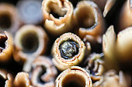
Bees in the creepy crawly castle habitat

Activity 4: Creepy crawly stories
Activity focus | In this activity, students collaborate to create digital stories about their invertebrate and creepy crawly castle. They share their story with an authentic audience and the wider community via a digital platform.
Background information | Digital options for the stories include creating a comic strip, eBook, poster in Pages, Keynote or PowerPoint or simple iMovie (or similar). The stories are can be shared through a digital portfolio platform such as Connect, Seesaw or Class Dojo, added to a class blog or shared on an interactive whiteboard. Students will require explicit instruction in using these apps.  If digital technology is not accessible, students could share their story by creating a book or poster.
Instructional procedures | Students may need support and scaffolding to help them create a digital story. Parent help or a buddy class will need to be organised.  Photographs taken of the invertebrate models and, where appropriate the investigation process, should be used in the digital stories and reflection.  The presentations provide a rich opportunity for assessing the students' understanding of the science and technology principles and processes, as well as the literacies associated with speaking and listening.
Expected learning | This is evident when students:  - Develop inquiry and communication skills as they represent findings and communicate ideas in a variety of ways (Arts, English).  - Respond to others appropriately as they listen to others’ opinions and points of view (English).  - Express ideas and feelings and make meaning using creative arts, such as drawing, painting, sculpture, drama, dance movement, music and storytelling.  - Create simple information for a purpose using tools, resources and technologies.  - Develop simple skills to use information and communication technologies.  - Engage with information and communication technologies for fun and to promote thinking and learning.
Equipment required | For the class:  Digital devices  Interactive whiteboard
For the students:
Their invertebrate model and access to the creepy crawly castle
Photos of their invertebrate model and creepy crawly castle
Preparation | Prepare necessary resources for presentations.  Ensure photos of the invertebrates and creepy crawly castle taken in Activity 3 are accessible.  Organise a buddy class or parent help.
Activity parts | Part 1: Creating stories  Ask students:  - How could we share what we know about invertebrates and where they live with other students in the school?  Students may suggest creating books, posters, puppet shows or multimodal presentations.  Students work with a parent helper or buddy to create a story about their invertebrate using media of choice. It is suggested students record a voice-over for their story to enable them to be able to listen to one another’s stories without the need for adult assistance. Questions to help stimulate thinking could include:  - What is your invertebrate’s name?  - How many legs/wings/antenna/body parts does it have?  - Where does it live?  - What does it eat?  - Is there anything very special about your invertebrate?
Part 2: Sharing stories
Students share their stories with each other. Encourage students to take turns and listen.
Part 3: Reflection
Using a digital device, record students explaining their learning journey, the importance of attracting invertebrates into gardens and how they worked together to do this at their school.
The recordings can be uploaded to a digital platform such as Connect, Seesaw or Explain Everything. Students could listen to themselves and their friends and share their learning experience with the parent community.
Student reflections can be recorded using Teacher resource sheet: 3-2-1 Reflection.
Resource sheets | Teacher resource sheet: 3-2-1 Reflection
Digital resources | iBooks Author  www.apple.com/au/ibooks-author/
Book Creator
itunes.apple.com/au/app/book-creator-for-ipad-create/id442378070?mt=8 ($7.99)
iMovie
itunes.apple.com/au/app/imovie/id377298193?mt=8
Pages
itunes.apple.com/au/app/pages/id361309726?mt=8
Keynote
itunes.apple.com/au/app/keynote/id361285480?mt=8
Connect – the Department of Education’s integrated, online environment
connect.det.wa.edu.au
Seesaw Digital Portfolio
web.seesaw.me
Class Dojo
www.classdojo.com

Appendix 1: Links to the Kindergarten Curriculum Guidelines
The five areas of learning and development in the Kindergarten Curriculum Guidelines are based on the five outcomes of the Early Years Learning Framework. They are:
- Identity
- Connecting and Contributing
- Wellbeing
- Learning and Thinking
- Communicating
The table below maps the Creepy, crawly castle module to the content of the Kindergarten Curriculum Guidelines, and can be used by teachers for planning and monitoring.
CREEPY CRAWLY CASTLE  AREAS OF LEARNING AND DEVELOPMENT | ACTIVITY
 | 1 | 2 | 3 | 4
IDENTITY
Children in the Kindergarten year have a strong sense of identity when they:
Feel safe, secure, accepted and supported
Build a sense of stability and trust – initiate interactions and conversations with peers, teachers and other adults in a range of contexts; initiate and join in play with enjoyment and satisfaction | ● | ● | ● | ●
Build a sense of belonging – describe places they live in and belong to, such as their family, community and kindergarten community; join in group activities, such as singing and dancing to songs; approach new situations with a positive attitude | ● | ● | ● | ●
Act with increasing autonomy, interdependence, resilience and sense of agency
Show resilience – persevere with tasks when faced with challenges; make new discoveries and celebrate their own efforts and achievements and those of others |  | ● | ● | ●
Make choices and decisions (by themselves and with others) – show initiative by asking questions, negotiating and sharing (S); make decisions and choices and describe options | ● | ● | ● | ●
Manage routines, organise self and belongings – take increasing responsibility for their own actions and learning; respond to ideas and suggestions from others | ● | ● | ● | ●
Build knowledgeable and confident self-identities
Show confidence in own learning and capabilities – show increasing confidence in their abilities, achievements and ideas as learners; show curiosity, engagement and purpose for learning; participate in dramatic play, role play and learning experiences that explore aspects of identity and points of view; celebrate achievement and share contributions with others | ● | ● | ● | ●
Display a positive image of self, their family and culture – build an understanding that there are other social and cultural heritages different from their own; engage with elders and cultural community members to explore their social and cultural heritage | ● |  | ●
Interact with others with care, empathy and respect
Participate positively as part of a group – participate appropriately in a social context; take turns in small group situations; cooperate and contribute to play and small group experiences | ● | ● | ● | ●
Respond to others appropriately – listen to others’ opinions and points of view; show respect for others, their views and property; reflect on their actions and consider consequences | ● | ● | ● | ●
CONNECTING AND CONTRIBUTING
Children in the Kindergarten year are connected with and contribute to their world when they:
Work with others to develop skills for communication and inquiry about themselves and their world
Develop skills for working with others - listen to others and share own ideas; share observations with others as they explore their immediate world using their five senses(S); participate with others to solve problems (M) | ● | ● | ●
Develop inquiry and communication skills – participate and carry out a few simple sequenced steps when exploring and investigating (S, T); use simple language of measurement to describe, compare, order or sort the observations made when exploring (M,S); describe both verbally and non-verbally what they see, hear, touch, feel and taste (S); use ICT with assistance to collect information and communicate it simply; represent findings and communicate ideas in a variety of ways. | ● | ● | ● | ●
Explore diversity and respond with respect
Explore the diversity of culture, heritage, background and tradition – name who is in their family and recognise not all family structures are the same
Respond respectfully to diversity
Show respect for the environment
Explore natural and constructed environments – use simple and safe tools to explore and investigate the environment (T); contribute their ideas in discussion about experiences in the natural and constructed environment | ● | ● | ●
Respect, care for and sustain the environment – observe, reflect and ask questions about their environment | ● | ● | ●
Investigate the interactions between the environment and its people – describe the basic needs of people, plants and animals, and places where they live; investigate places where people, plants and animals live; describe the relationships that are living and non-living things; develop an awareness of the impact of human activity on environments and the interdependence of living things | ● | ● | ● | ●
WELLBEING
Children in the Kindergarten year have a strong sense of wellbeing when they:
Become strong in their social and emotional wellbeing
Interact positively to form relationships and friendships – negotiate friendships and build and maintain respectful, trusting relationships with other children and teachers; demonstrate increasing awareness of the needs and rights of others; describe their contributions to shared projects and experiences; acknowledge and accept affirmation | ● | ● | ● | ●
Recognise simple emotions and build self-regulation - make choices, accept challenges and take considered risks |  | ●
Take increasing responsibility for their own health and physical wellbeing
Build knowledge, skills and positive attitudes to physical movement – move to the tempo of the music and develop motor movements to the rhythm of music such as trot or gallop; move around the environment safely demonstrating spatial awareness; use small muscles to use implements such as pencils, scissors and paintbrushes with some control and coordination; demonstrate a willingness to participate in energetic physical activity including dance, drama, movement and games; respond through movement to traditional and contemporary music, dance and storytelling |  | ● | ● | ●
Explore ways to promote own and others health and safety – suggest ways to keep themselves, others and their surroundings safe; engage in experiences, conversations and routines that promote healthy lifestyles, good nutrition, safety and personal hygiene practices |  | ●
LEARNING AND THINKING
Children in the Kindergarten year are confident and involved learners when they:
Develop positive dispositions for learning
Build enthusiasm, confidence, cooperation, commitment, persistence – express curiosity and wonder about events, experiences and interest in their environments (S); persist even when a task is difficult and experience satisfaction of achievement | ● | ● | ● | ●
Develop curiosity, resourcefulness and reflexivity – explore the properties of familiar objects (S); build concentration and ability to focus on important aspects of learning experiences; actively engage in learning experiences, conversations and play experiences; ask questions about people, events, objects and the environment | ● | ● | ● | ●
Develop a range of skills and processes for learning and thinking
Develop problem solving, investigation and inquiry strategies – ask questions, develop own simple theories and test own theories (S); inquire, investigate, attempt to solve problems (S);create and use simple representation to organise, record and communicate mathematical and scientific ideas and concepts (M, S) |  | ● | ● | ●
Reflect on thinking and learning and transfer and adapt what they have learned – use skills of prediction, hypothesising, testing, experimenting and evaluating in play experiences (S); respond to ideas and suggestions from others; use reflective thinking to consider why things happen and what can be learnt from these experiences; apply a range of thinking strategies to engage with situations and solve problems and adapt these strategies to new situations | ● | ● | ● | ●
Make choices and organise self for learning – make simple plans and carry them out to complete a task; organise self and simple resources to carry out a task or participate in an activity | ● | ● | ● | ●
Engage in creative and inventive ways of thinking and doing
Use imagination and innovation – explore and experiment with form, shape, colour, line, texture, contrast, patters in art works; explore different ways of creating models and doing things | ● | ● | ● | ●
Represent ideas, feelings and experiences in creative ways – engage in dramatic, fantasy and role play; use simple tools and materials to investigate, take apart, invent, construct, change and represent ideas (S, T) |  |  | ● | ●
Engage in and extend numeracy in personally meaningful ways
Develop knowledge of number and algebra – count objects by using one to one correspondence (M); name the last number in the count that represents how many in the set (cardinal value); count objects by using one to one correspondence; know that numbers always happen in a conventional order (stable order; recite number names in order, initially to 5, then to 10 consistently | ●
Develop knowledge of measurement and geometry – use positional language such as on, under, behind, between (M); use language words to describe duration and relative duration, such as quick, slow, fast, it takes a long time | ● | ● | ●
Develop knowledge of statistics and probability – sort, classify and match objects according to attributes, for example colours, sizes and shapes (M); | ●
COMMUNICATING
Children in the Kindergarten year are effective communicators when they:
Interact verbally and non-verbally with others for a range of purposes
Build aural and oral language – listen to others; act upon simple instructions and statements; modulate voice appropriate to the situation; use simple sentences when speaking; use turn-taking in conversations | ● | ● | ● | ●
Develop phonological awareness skills
Convey and construct messages for a range of purposes in a variety of contexts – verbalise ideas and simple concepts and ask questions to clarify concepts; retell a simple story; engage in discussion about narratives and informational texts | ● | ●
Engage in and extend literacy practices in personally meaningful ways
Develop understanding of purpose and meanings of a range of texts – share a range of texts for enjoyment; explore the language presented in fiction and non-fiction texts; identify keys ideas from simple texts | ●
Engage in reading, writing and viewing behaviours – show an awareness that print holds meaning | ● |  |  | ●
Understand how symbols and pattern systems work
Develop concepts of print – describe how the illustrations connect to the text; build an understanding of book features, such as the title, author, illustrator
Investigate symbols and pattern systems
Express ideas and make meaning using a range of media
View and create with media – express ideas and feelings and make meaning using creative arts, such as drawing, painting, sculpture, drama, dance movement, music and storytelling | ● | ● | ● | ●
Investigate the properties of a range of media |  |  | ● | ●
Explore resources, tools and information communication technologies to represent ideas and their thinking
Use tools, resources and technologies in play, thinking and learning – create simple information for a purpose using tools, resources and technologies (T) |  | ● | ● | ●
Develop simple ICT skills – develop simple skills to use information and communication technologies (T); engage with information communication technologies for fun and to promote thinking and learning (T) | ● | ● | ● | ●
Further information about the Kindergarten Curriculum Guidelines can be found at: k10outline.scsa.wa.edu.au/media/documents/outline_downloads/Western-Australian-Kindergarten-Curriculum-Guidelines-pdf.pdf

Appendix 2: Materials list

- One journal
- Interactive whiteboard and digital devices
- Copies of invertebrate classification charts
- A collection of books on invertebrates as suggested in Activity 1.
- Plastic invertebrates
- Containers for collecting invertebrates
- Pop sticks and small paintbrushes
- A range of natural and reusable resources to build the creepy crawly castle and invertebrates such as:
  - A large wooden pallet
  - Bricks
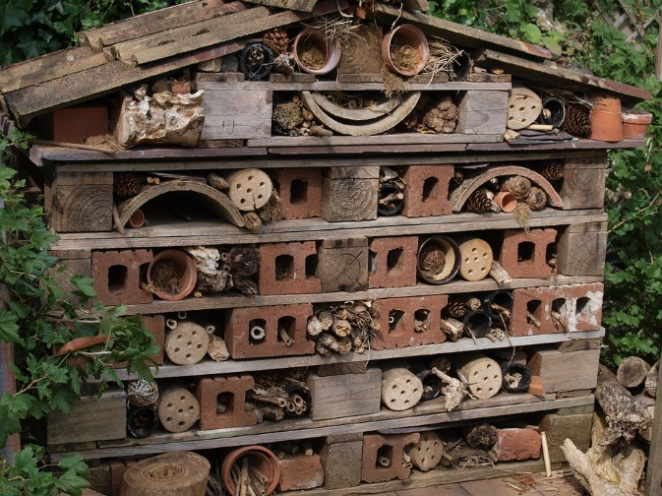
  - Various sized stones
  - Roof tiles
  - Tubes
  - Logs and sticks
  - Ceramic pot plants
  - Compost/soil
  - Twigs
  - Dry leaves
  - Bark
  - Honky nuts
  - Pinecones
  - Straw
  - Twigs
  - A variety of plants to attract insects such as thyme, lavender, grasses etc.
- Tools to cut wood or logs if necessary.

Appendix 3: Design process guide
Safe production of the final design or multiple copies of the final design.
Fine tuning the production process, such as division of labour for batch or mass production.
Use of intended materials and appropriate tools to safely make the solution to the design problem.
Reflection on the process taken and the success of the design.
Evaluation can lead to further development or improvement of the design and can be a final stage of the design process before a conclusion is reached.
Could be formal or informal and verbal or written.
Ideation
Development
Development of the design ideas. Improvements, refinements, adding detail, making it better.
Activities such as detailed drawings, modelling, prototyping, market research, gaining feedback from intended user, further research – if needed – to solve an issue with the design, testing different tools or equipment, trialling production processes, measuring or working out dimensions, testing of prototypes and further refinement.
Idea generation – turning ideas into tangible forms so they can be organised, ordered and communicated to others.
Activities such as brainstorming, mind mapping, sketching, drawing diagrams and plans, collecting colour samples and/or material samples and talking through these ideas can help to generate fu creative ideas.
Using the SCAMPER model can assist with this: www.mindtools.com/pages/article/newCT_02.htm
www.designorate.com/a-guide-to-the-scamper-technique-for- creative-thinking
Analysis
Finding useful and helpful information about the design problem.
Gathering information, conducting surveys, finding examples of existing solutions, testing properties of materials, practical testing.
Understanding the meaning of the research findings.
Analysing what the information means, summarising the surveys, judging the value of existing solutions, understanding test results.
Research
Production
Evaluation

Appendix 4: Reflective journal
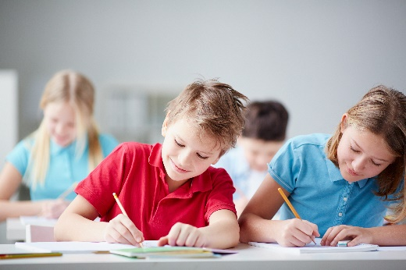
When students reflect on learning and analyse their own ideas and feelings, they self-evaluate, thereby improving their metacognitive skills. When students’ self-monitor or reflect, the most powerful learning happens.
Journaling may take the form of a written or digital journal, a portfolio or a digital portfolio. Early childhood classrooms may use a class journal or student journals that include photos of the learning experiences and scribed conversations demonstrating students’ reflections.
Teachers can model the journaling process by thinking aloud and showing students how they can express learning and thoughts in a variety of ways including diagrams, pictures and writing.
Journals are a useful tool that gives teachers additional insight into how students value their own learning and progress, as well as demonstrating their individual achievements.
The following links provide background information and useful apps for journaling.
Kidblog – digital portfolios and blogging
kidblog.org/home
Edmodo – for consolidating and storing class notes and learning materials
www.edmodo.com/
Explain Everything™ – a screen casting, video and presentation tool all in one
explaineverything.com
Popplet – allows you to jot down your ideas and then sort them visually
Popplet.com
Seesaw – for capturing work completed by students in class, using a device’s camera function
web.seesaw.me
Connect – the Department of Education’s integrated, online environment
connect.det.wa.edu.au
Evernote (a digital portfolio app)
evernote.com
Digital portfolios for students (Cool tools for school)
cooltoolsforschool.wordpress.com/digital-student-portfolios

Appendix 5: Teacher resource sheet: Cooperative learning – Think-Pair-Share
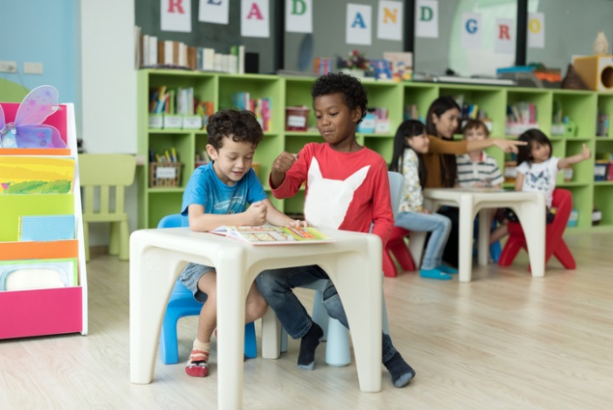
This resource sheet provides a brief outline of a cooperative learning strategy known as 'think-pair-share’.
Cooperative learning strategies create opportunities for students to work together, generally to a single purpose.
Think-pair-share increases student participation and provides an environment for higher levels of thinking and questioning.
As well as having the potential to increase learning for all students involved, using these strategies can help students develop personal and social capabilities.
In the 'think' stage, each student thinks silently about a question asked by the teacher.
In the 'pair' stage, students discuss their thoughts and answers to the question with a partner.
In the 'share' stage, the students talk about their answer and their partner’s answer or what they decided with other pairs or with the whole class. It is important to give students the option to 'pass' in the sharing step.

Appendix 6: Student activity sheet: Where do invertebrates live? matching activity
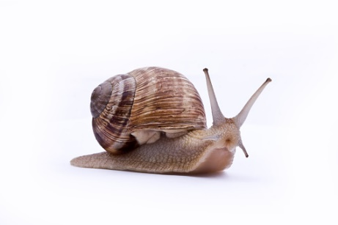
Which habitat do these invertebrates live in? There might be more than one living in each habitat.
in webs 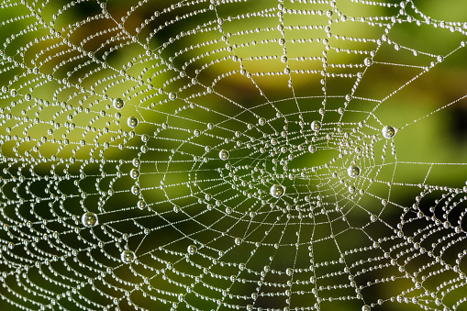
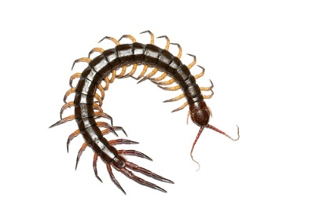
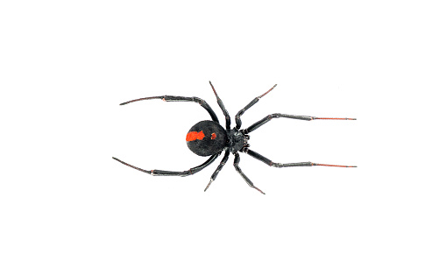
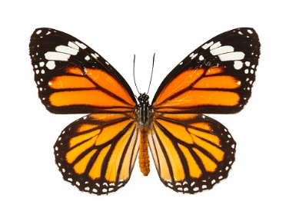
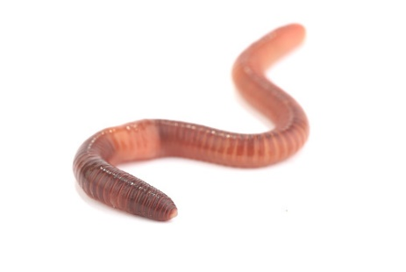
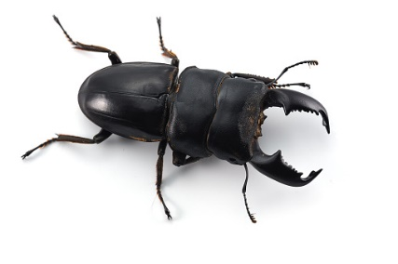
damp places
(under leaves) 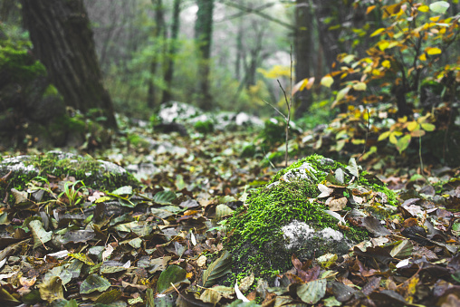
on plants, trees, bushes, flowers… 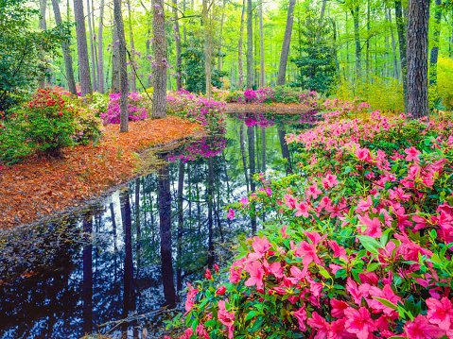
on flowering plants
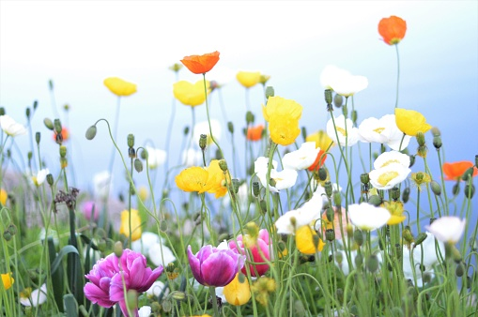
under logs
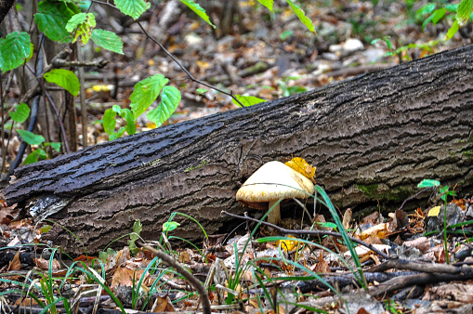
in the soil
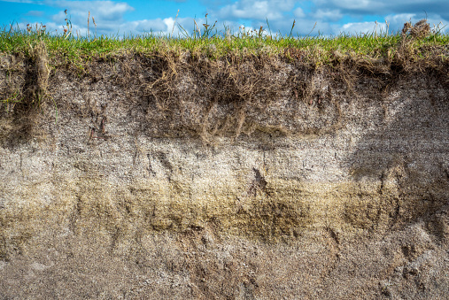

Appendix 7: Student activity sheet: Where do invertebrates live? drawing activity
Draw an invertebrate that you might find in these habitats.

In the soil
Under a log
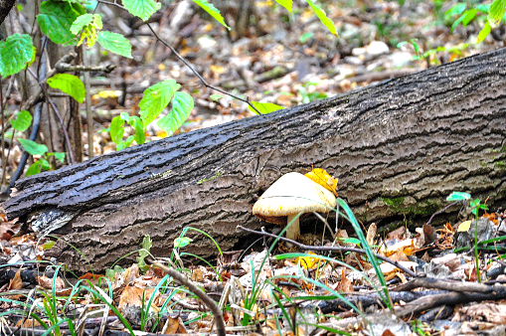
In the air
On a plant
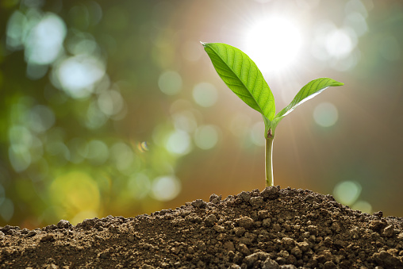

Appendix 8: Student activity sheet: Design review
My creepy crawly castle design

Things I would change

Things I would keep the same

Appendix 9 Teacher resource sheet: 3-2-1 Reflection
3-2-1 Reflection
Name | 3 things I learnt | 2 things I found interesting | 1 thing I found difficult

