Appendix C. TEMPLATE RISK ASSESSMENT

College:
Name of leisure activity:
Where:
(include Traditional place name where possible)
Date of leisure activity:
(if known)
Those considered in this risk assessment: | Students ☐ | Staff ☐
 | Parents ☐ | Public ☐
Risk assessment completed by:
Signed:
Date:

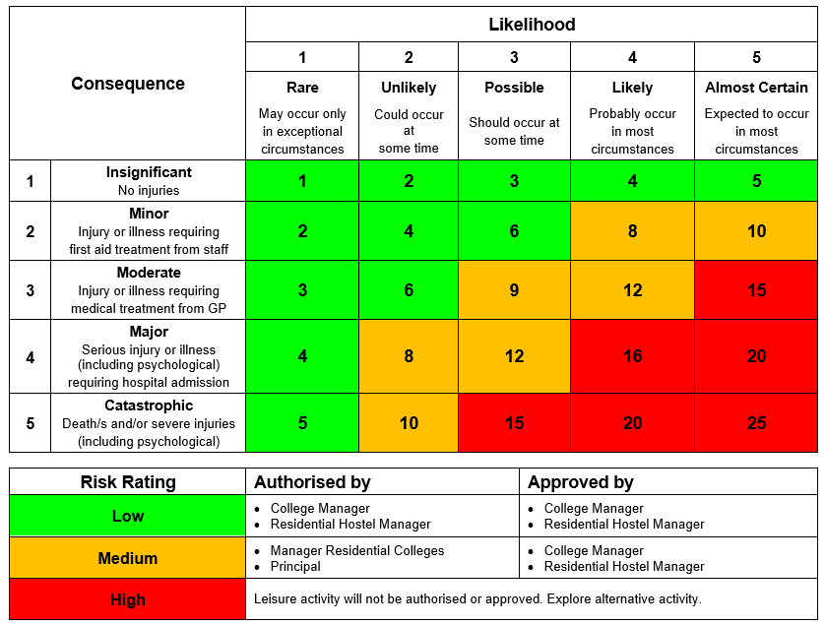

Consider likelihood on a ‘per activity’ basis. For example, a student riding a bicycle is at risk of injury from a fall. The likelihood of a fall during one ride might be assessed as rare, even though over the course of the year with a high number of rides undertaken it could increase to possible or even likely.

Similarly, a group bicycle ride as a single event might be assessed as a moderate likelihood of a fall given the greater number of participants, even though regular group rides would almost certainly experience a fall at some stage. The key is to assess each leisure activity on its own merits on each occasion.

When assessing risk, consider the capacity of the most vulnerable student. For example, when assessing swimming at the beach, your assessment should reflect the weakest swimmer of the group.

Consequences and likelihood should also be assessed taking into account the controls which are in place to minimise risk. Using the same example of a bike ride, it might be reasonable to assess the likelihood of ‘being hit by a car’ as rare if a key control was to forbid students to ride on roads and remain only on cycle paths. Similarly, the consequence rating of an accident may also be reduced by enforcing the wearing of helmets.

These risk examples are provided as a guide only on how to complete a risk assessment. The example controls are not mandatory and are not intended to be an exhaustive list.

Risk | Controls | Rating of risk
 |  | C – consequence L – Likelihood
 |  | C | L | Rating
Traffic accident | - Staff are licenced with PTD authorisation.  - Two or more drivers to share long distance driving.  - Buses in satisfactory condition due to regular inspections.  - Head lights on.  - Vehicle driving policy practiced re safe speeds and defensive driving practices.  - Seat belts enforced. | 4 | 1 | 4
Student goes missing | - Students to carry their mobile phone and staff to have all student mobile numbers.  - Provide students with the college mobile contact number.  - Students to be advised before leaving bus of the boundaries while at the designated activity.  - Muster point clearly defined and obvious.  - Students must be in pairs or more when out and about.  - No student can be on their own (to stay with staff if needed)  - Students instructed on actions to take if they are lost or unable to meet on time.  - Staff present and visible within the activity area. | 3 | 1 | 3
Student is ill or injured during the outing | - Students to be advised before leaving bus of behavioural expectations while at the designated activity.  - Students instructed to contact staff if illness or injury occurs  - Students must be in pairs or more  - Location of and directions to closest medical facility are known if treatment is required. | 3 | 2 | 6
Vehicle breaks down | - Buses serviced and inspected annually.  - Bus checked prior to departure – tyres / water / oil checked regularly during term.  - Buses driven safely and as intended.  - Local breakdown service available if needed. | 1 | 2 | 2
 | Insert more rows as required

I endorse this risk assessment as accurate and complete.
Based on this risk assessment and in line with the Leisure Activities in Residential Facilities Procedures I deem this leisure activity to be:

☐ Low risk – may be authorised by me as the College manager/Residential manager
☐ Medium risk – may be authorised only by the Manager Residential Colleges or principal
☐ High risk and is not authorised
Name of College manager /  Residential manager: | __________________________________________
Signed: | __________________________________________
Date: | __________________________________________

