D23/0703407

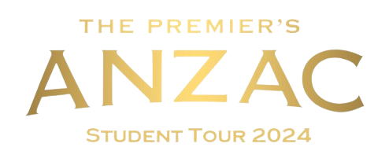

Teacher Supervisor
Expression of Interest
2024

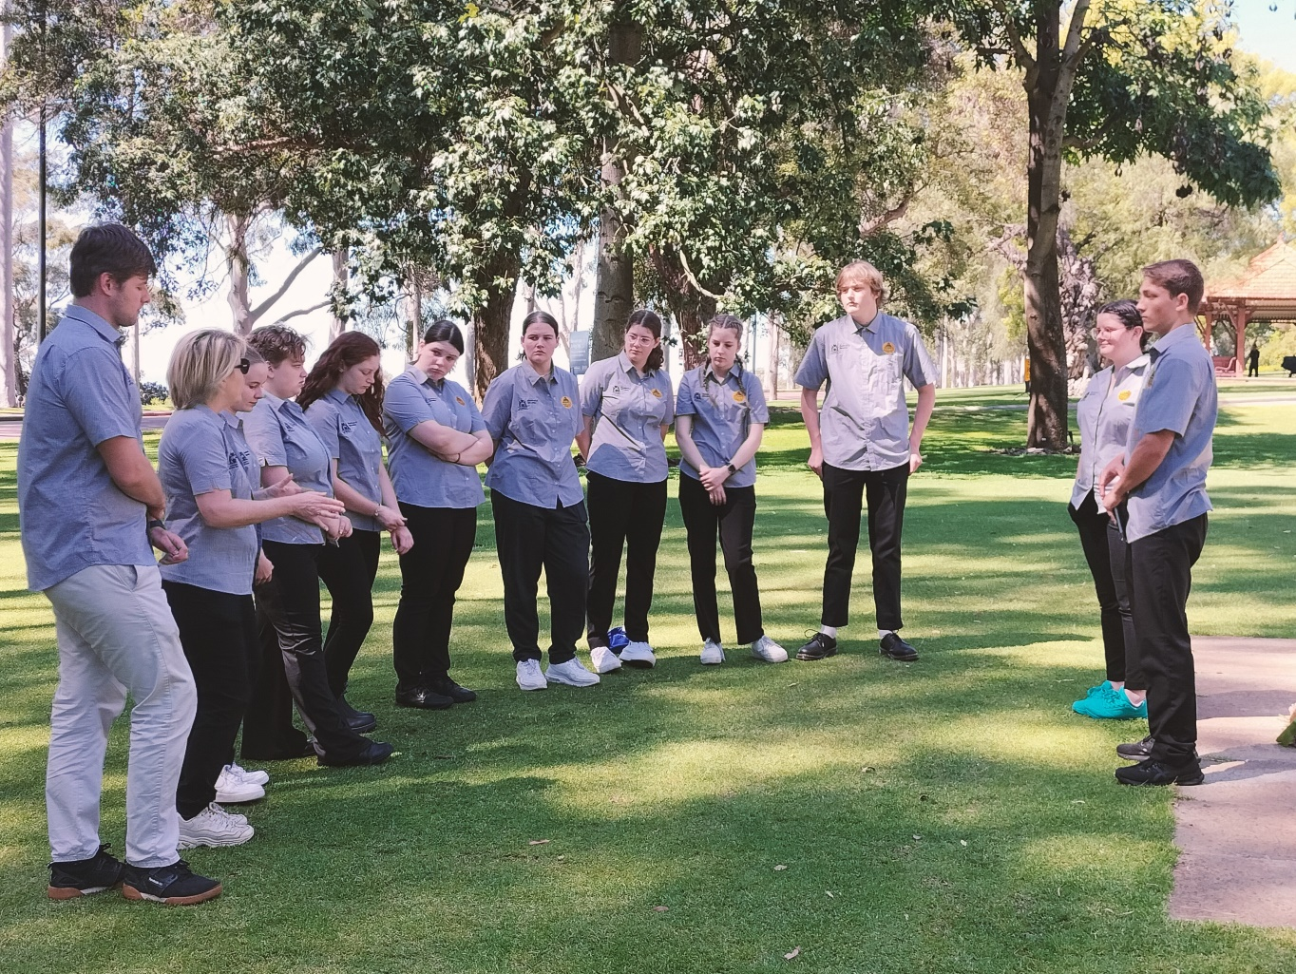
Image: https://freesvg.org/australian-world-war-1-soldiers-silhouette
The 2024 Premier’s Anzac Student Tour

The Premier’s Anzac Student tour invites secondary school students to become ambassadors and represent Western Australia on a commemorative overseas study tour.
In 2024, the Premier’s Anzac Student tour will travel to Singapore to commemorate the 82nd anniversary of the fall of Singapore and 106 years since the signing of the Armistice.
Over 993 000 Australians served in the armed forces during World War II. Of those, 27 073 were killed in action or died, 23 477 were wounded, and 30 560 were taken as prisoners of war by other nations. Of those taken prisoner, 8 296 died while in captivity.
The tour will visit important historical sites including Changi Chapel and Museum, Kranji War Cemetery and Fort Canning.
There is an opportunity for two teacher supervisors to join the tour to:
- chaperone 10 students (in accordance with the Department of Education’s Excursions Policy)
- provide support in developing and delivering the history education program
- assist with organising the tour.
Applications close 5.00 pm on Friday, 18 August 2023. To apply, you must meet the selection process and criteria.

Selection process
Teachers with students submitting entries for the 2024 Premier’s Anzac Student Tour competition are eligible to apply. All applicants must be registered with the Teacher Registration Board of Western Australia and hold a current Working with Children Check. Applications must also be endorsed by the school principal.
Costs for the tour, except for personal expenses, are met by the Department of Education.

Selection criteria
Please address each criterion in the context of your contribution at a school and system/sector level.
- Demonstrated innovative teaching practice to engage students.
- Demonstrated interest in the Australian war experience and participation in Anzac related commemoration activities.
- Demonstrated experience in conducting extended excursions involving secondary students, including the ability to develop and implement tour education activities, work collaboratively in a team and maintain effective working relationships.

Application process
Please complete the application form. Type, print, sign, scan and submit your endorsed application by 5.00 pm on Friday, 18 August 2023 by email anzactour@education.wa.edu.au. Late applications will not be accepted.
Interviews, if required, will be conducted in September 2023. The outcome of the selection process will be advised by the beginning of Term 4.
For more information and a copy of the Department’s Excursions Policy, contact:
Ms Karen Lamond
T: 9402 6123
E: anzactour@education.wa.edu.au
W:https://www.education.wa.edu.au/premiers-anzac-student-tour

Please type your responses

Personal details
First Name
Last name
Title
Preferred pronouns | ☐ he/him ☐ she/her ☐ they/them
Aboriginal or Torres Strait Islander | ☐ yes ☐ no
Home address
Suburb/town |  | Postcode
Home phone number
Mobile phone number
Personal email

Employment details
Name of school
School address
Suburb/town |  |  |  | Postcode
Work email
E Number
TRBWA number |  | Expiry date
WWCC number |  | Expiry date

Qualifications and experience
Tertiary qualifications
Summary of teaching experience (including current role): Applicants are advised to confine responses to the space provided.
List your membership in professional associations and relevant committee or representational roles undertaken in the previous five years Applicants are advised to confine responses to the space provided.
List your participation in previous school-based extended excursions. Please include the year and duration of the extended excursions Applicants are advised to confine responses to the space provided.
Addressing the selection criteria
The 2024 Premier’s Anzac Student Tour promotes understanding of the Anzac legacy. Western Australian secondary school students visit commemorative sites of significance to Australians.
The role of the accompanying teacher supervisors is to support the tour coordinator in:
- chaperoning 10 students (in accordance with Department of Education's Excursions Policy)
- providing support in developing and delivering the history education program
- assisting with organising the tour.
Please state how you meet each of the three selection criteria in the space provided below.
Demonstrated innovative teaching practice to engage students.
Applicants are advised to confine responses to the space provided.
Demonstrated interest in the Australian war experience and participation in Anzac related commemoration activities. Applicants are advised to confine responses to the space provided.
Demonstrated experience in conducting extended excursions involving secondary students, including the ability to develop and implement tour education activities, work collaboratively in a team and maintain effective working relationships. Applicants are advised to confine responses to the space provided.
Other relevant qualifications and expertise
Describe any additional qualifications and/or expertise that may be of interest to the selection panel. For example, first aid qualifications, previous travel, photographic and/or applied ICT skills, Bronze Medallion. Applicants are advised to confine responses to the space provided.
Reasons for application
Describe your reasons for applying to become a Teacher Supervisor on the 2024 Premier’s Anzac Student Tour. Applicants are advised to confine responses to the space provided.

Referee details
Referee 1: A person other than your school principal who can confirm your suitability
Title |  |  | First name |  |  |  |  | Last name
Position
School
Phone number | Work |  |  |  |  | Mobile
Email
Referee 2: A person other than your school principal who can confirm your suitability
Title |  |  | First name |  |  |  |  | Last name
Position
School
Phone number | Work |  |  |  |  | Mobile
Email
Endorsement by principal
The following endorsement requires verification by your school principal.
- I confirm that the applicant named on this application form is a teacher at the school specified.
- I confirm that the applicant named on this application has actively promoted the 2024 Premier’s Anzac Student Tour within this school and has supported students to participate.
- I endorse this application and the candidate's suitability to assume the role of teacher supervisor.
- I endorse and support the applicant as a suitable ambassador for the Premier of Western Australia and the State of Western Australia.
- Should the applicant be selected to join the 2024 Premier’s Anzac Student Tour as a teacher supervisor, I understand that there will be program commitments that require the individual to be absent from work on occasion, and that the Department of Education will meet teacher relief costs.
Name
Signature
School
Phone number
Email
Date
Declaration by applicant
I declare that the information supplied is complete and correct. I authorise the Department of Education to obtain from other education institutions and relevant authorities, at any time, details of my work experience and qualifications. I consent for these details and any information contained in this application form to be made available to the Department and the selection panel. I confirm that I will comply with the requirements of the position of teacher supervisor for the 2024 Premier’s Anzac Student Tour.
Name
Signature
Date
Number of students participating in the 2024 Premier’s Anzac Student Tour competition at your school. |  |  |  | Total participants |  |  | Number of entries submitted for judging

Privacy notice
The personal information collected on this application may be used for assessing and verifying the details provided, conducting referee checks, Working with Children Check and publicising and administering the 2024 Premier’s Anzac Student Tour. The information may be accessed and used by various Western Australian Government Departments and others that provide assistance to the program. The applicant consents to all such use by signing this application form.
Application submission
Completed and endorsed teacher applications must be received by the Tour Coordinator by 5.00 pm Friday, 18 August 2023. Late applications will not be accepted.
Interviews, if required, will be conducted during September and the outcome of the selection process known to all applicants by the beginning of Term 4.

For more information and a copy of the Department’s Excursions Policy, contact Karen Lamond
T: 9402 6123
E: anzactour@education.wa.edu.au

Premier’s Anzac Student Tour Coordinator
Secondary Schools, District High Schools & Post-School Pathways
Statewide Services 33 Giles Avenue
PADBURY WA 6025

