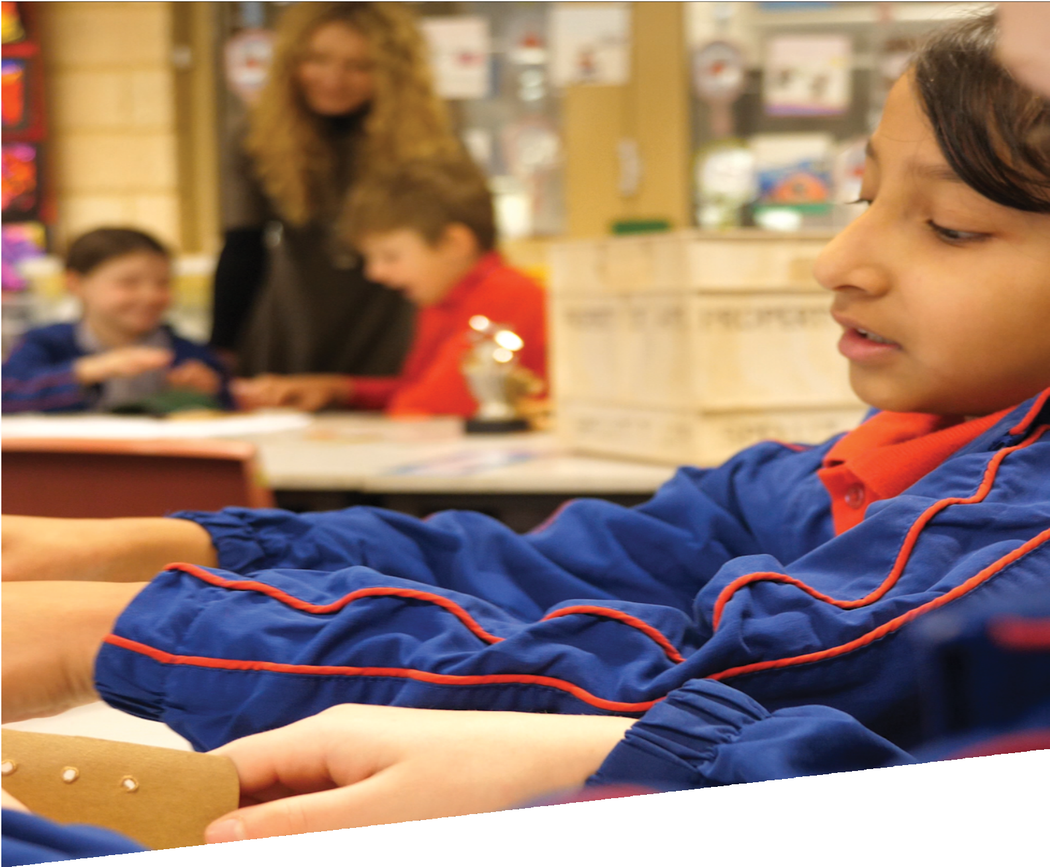

CURRICULUM RESOURCE MODULE
Plastic pollution
YEAR 3

Acknowledgements

The STEM Learning Project respectfully acknowledges the Traditional Custodians of the lands upon which our students and teachers live, learn and educate.

The STEM Learning Project is funded by the Western Australian Department of Education (the Department) and implemented by a consortium in STEM education comprising the Educational Computing Association of WA, the Mathematical Association of WA, the Science Teachers Association of WA and Scitech. We acknowledge and thank the teachers and schools who are the co-creators of these resources.

Copyright and intellectual property

The copyright and intellectual property of this module remain the property of the Department.

Any Western Australian Curriculum content in this resource is used with the permission of the School Curriculum and Standards Authority (the Authority); this permission does not constitute Authority endorsement of the resource. The Authority accepts no liability for any errors or damages arising from reliance on its content.

The Western Australian Curriculum content may be freely copied, or communicated on an intranet, for non-commercial purposes in educational institutions, provided that the Authority is acknowledged as the copyright owner. Copying or communication for any other purpose can be done only within the terms of the Copyright Act 1968 or with prior written permission of the Authority. Any Australian Curriculum content in the Western Australian Curriculum is used by the Authority under the terms of the Creative Commons Attribution-NonCommercial 3.0 Australia licence. Any content on the www.scsa.wa.edu.au domain that has been derived from the Australian Curriculum may be used under the terms of Creative Commons Attribution-NonCommercial 3.0 Australia licence.

Appendix 2: General capabilities continuums is adapted from ACARA, © Australian Curriculum, Assessment and Reporting Authority (ACARA) 2009 to present, unless otherwise indicated. This material was downloaded from the ACARA website (www.acara.edu.au) (Website) (accessed December 2015) and was not modified. The material is licensed under CC BY 4.0 (https://creativecommons.org/licenses/by/4.0/). ACARA does not endorse any product that uses ACARA material or make any representations as to the quality of such products. Any product that uses material published on this website should not be taken to be affiliated with ACARA or have the sponsorship or approval of ACARA. It is up to each person to make their own assessment of the product.

This resource includes references and examples of iOS, Android and other apps. The Department does not endorse or recommend any commercial products and simply provides these as examples for teachers.

The Department is committed to providing quality information to its customers. Whilst every effort has been made to ensure accuracy, currency and reliability of the information within these documents, the Department accepts no responsibility for errors, omissions or amendments made since the time of publishing. Confirmation of information may be sought from the Department or the originating bodies providing the information. The Department has no control over the content of material published on websites to which users are referred in this resource. It is the responsibility of the internet user to make their own decision as to the relevancy, accuracy, currency and reliability of information found on those sites.

This resource contains various images from iStock used under license.

Attributions: Google Slides, Google Docs, Microsoft Office 365, Microsoft Excel, PowerPoint, Sharepoint and OneDrive, Kidblog, Weebly, Evernote, Autodesk, Tinkercad, SketchUp.

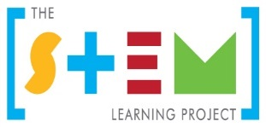
Table of contents
The STEM Learning Project 2
Year 3 – Plastic pollution 3
Overview 3
Activity sequence and purpose 7
Background 8
Activity 1: Pollution by plastics 11
Activity 2: Reducing pollution by plastics 26
Activity 3: Creating educational plans 37
Activity 4: Presenting and reflecting 43
Appendix 1: Links to the Western Australian Curriculum: 47
Appendix 1B: Mathematics proficiency strands 49
Appendix 2: General capabilities continuums 50
Appendix 3: Glossary 53
Appendix 4: Materials list 54
Appendix 5: Design process guide 55
Appendix 5B: Drawing in the design process 56
Appendix 6: Reflective journal 57
Appendix 7: Student activity sheet 1.0: Journal checklist 58
Appendix 8: Teacher resource sheet 1.1: Cooperative learning – Roles 59
Appendix 9: Teacher resource sheet 1.2: Cooperative learning – Placemat 60
Appendix 10: Teacher resource sheet 1.3: Cooperative learning – Think-pair-share 61
Appendix 11: Teacher resource sheet 1.4: Cooperative learning – Pass it on 62
Appendix 12: Teacher resource sheet 1.5: Picture stimulus - Pollution 63
Appendix 13: Student activity sheet 1.6: I see, I think, I wonder 65
Appendix 14: Student activity sheet 1.7: Hundreds grid 66
Appendix 15: Student activity sheet 1.8: Plastics flowchart 67
Appendix 16: Teacher resource sheet 2.1: Recycling HDPE plastic 68
Appendix 17: Teacher resource sheet 2.2: Sample parent letter 70
Appendix 18: Student activity sheet 3.1: Concept brief 71
Appendix 19: Student activity sheet 3.2: Action plan 72
Appendix 20: Teacher resource sheet 3.3: Construction skills 73
Appendix 21: Student activity sheet 4.1: Self-evaluation 78
Appendix 22: Teacher resource sheet 4.2: Student evaluation 79

The STEM Learning Project
The STEM Learning Project aims to generate students’ interest, enjoyment and engagement with STEM (Science, Technology, Engineering and Mathematics) and to encourage their ongoing participation in STEM both at school and in subsequent careers. The curriculum resources will support teachers to implement and extend the Western Australian Curriculum across Kindergarten to Year 12 and develop the general capabilities.
Why STEM?
A quality STEM education will develop the knowledge and intellectual skills to drive the innovation required to address global economic, social and environmental challenges.
STEM capability is the key to navigating the employment landscape changed by globalisation and digital disruption. Routine manual and cognitive jobs are in decline whilst non-routine cognitive jobs are growing strongly in Australia. Seventy-five per cent of the jobs in the emerging economy will require critical and creative thinking and problem-solving, supported by skills of collaboration, teamwork and literacy in mathematics, science and technology. This is what we call STEM capability. The vision is to respond to the challenges of today and tomorrow by preparing students for a world that requires multidisciplinary STEM thinking and capability.
The approach
STEM capabilities are developed when students are challenged to solve open-ended, real-world problems that engage students in the processes of the STEM disciplines.
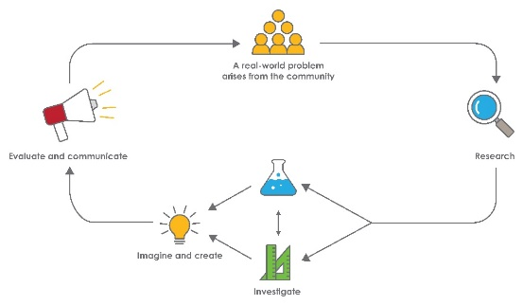
STEM Consortium

Year 3 – Plastic pollution

Overview
Plastic is a flexible, durable, inexpensive and versatile material which is used in countless applications in our everyday lives. From plastic utensils, food and drink packaging, electronics and medical supplies, to the carpet and furniture in our homes and even the clothing we wear. However, it has become increasingly clear that the excessive volume of one-use plastic production, combined with plastic’s durability, has created unprecedented environmental pollution. The oceans, in particular, have become the recipients of large amounts of discarded plastics with devastating effects on its habitats and animal life.
The ocean is comprised of complex, interconnected ecosystems and is home to a diverse range of marine life, including bacteria, plants and animals. The ocean plays a vital role in removing carbon from the atmosphere and producing oxygen. The ocean is also directly involved in regulating the Earth’s weather by its currents and through its role in the water cycle and resulting rainfall.
The durability of plastic means it can remain a pollutant in the ocean for hundreds of years, causing injury and death to marine life in its original forms. Over time, many plastics break down into increasingly smaller pieces, commonly called microplastics. These toxic microplastics are ingested by a diverse range of marine and birdlife, resulting in starvation and disrupted food chains.
By 2050 it is estimated there will be more plastic than fish by weight in the world’s oceans. As such, plastic pollution is a major environmental concern impacting on the health of marine ecosystems worldwide. https://www.unenvironment.org/news-and-stories/video/plastic-pollution-how-humans-are-turning-world-plastic
This module aims to educate young learners about the problem of plastic pollution and how local actions help reduce the amount of discarded plastics in the environment.
What is the context?
Current levels of discarded plastic products are negatively impacting ecosystems in the oceans and surrounding environments. This level of plastic pollution has led to the creation of a major environmental issue that is difficult to solve.
What is the problem?
What can we do to reduce the pollution caused by plastics?

How does this module support integration of the STEM disciplines?
Plastic pollution aims to educate students about the polluting effects of plastic and the kinds of actions that can reduce the amount of discarded plastics that end up in the ocean and surrounding environments.
Science
While working through the module students, with guidance, plan and conduct a scientific investigation to answer questions about the effects of sunlight and seawater on plastics compared to other materials (ACSIS054). They consider the elements of fair tests and accurately make and record observations (ACSIS055) and compare results with their predictions, suggesting possible reasons for their findings (ACSIS215). Through science investigations, students recognise how science knowledge helps people to understand the effect of their actions (ACSHE051).
Students experience changes of state between solid and liquid caused by adding or removing heat (ACSSU046) when they make their beeswax wraps and recycle the HDPE discarded plastic.
Technology
When creating their beeswax wraps, string bags and recycled plastic objects, students engage with safe practices when using materials, tools and equipment (ACTDEK013) and select and safely use appropriate components with given equipment to make a solution (WATPPS18).
When planning for their presentations, students develop and communicate ideas using labelled drawings and appropriate technical terms (WATPPS17).
Students work independently, or collaboratively when required, to plan, safely create and communicate sequenced steps (WATPPS19, WATPPS20). When planning their presentations, students create and communicate ideas and information safely (ACTDIP013).
The Design process guide is included to help teachers understand the complete design process as developed in the Technologies curriculum under Processes and Production Skills.
Mathematics
When counting the discarded items brought in from home, student have opportunity to model, represent and order numbers (ACMNA052) and use place value to partition and .rearrange numbers to solve problems (ACMNA053). When comparing the number of plastic to non-plastic items they recognise and explain the connection between addition and subtraction (ACMNA054). They can also recognise numbers to at least 10,000 when learning about the quantities of discarded plastics and time taken to decompose (ACMNA052, ACMNA053).

Students collect data in the form of observations and create displays using lists and tables when collecting and processing data in their seawater experiment and considering alternatives to plastic items (ACMSP069).
General capabilities
There are opportunities for the development of general capabilities and cross-curriculum priorities as students engage with Plastic pollution. In this module, students:
- Develop critical and creative thinking skills as they research the problem and its context (Activity 1); investigate parameters impacting on the problem (Activity 2); imagine and develop solutions (Activity 3); and evaluate and communicate their solutions to an audience (Activity 4).
- Utilise creative thinking as they generate possible design solutions; and critical thinking, numeracy skills and ethical understanding as they choose between alternative approaches to solving the problem of how can we reduce the amount of plastic polluting the environment?
- Utilise personal and social capability as they develop socially cohesive and effective working teams; collaborate in generating solutions; adopt group roles; and reflect on their group work capabilities through self and peer evaluation.
- Utilise a range of literacies and information and communication technology (ICT) capabilities as they collate records of work completed throughout the module in a journal; represent and communicate their solutions to an audience using digital technologies in Activity 4.
- Communicate and justify their group’s design solutions to a community audience.
What are the pedagogical principles of the STEM learning modules?
The STEM Learning Project modules develop STEM capabilities by challenging students to solve real-world problems set in authentic contexts. The problems engage students in the STEM disciplines and provide opportunities for developing higher order thinking and reasoning, and the general capabilities of creativity, critical thinking, communication and collaboration.
The design of the modules is based on four pedagogical principles:
- Problem-based learning
All modules are designed around students solving an open-ended, real-world problem. Learning is supported through a four-phase instructional model: research the problem and its context; investigate the parameters impacting on the problem; design and develop solutions to the problem; and evaluate and communicate solutions to an authentic audience.

- Developing higher order thinking
Opportunities are created for higher order thinking and reasoning through questioning and discourse that elicits students' thinking, prompts and scaffolds explanations, and requires students to justify their claims. Opportunities for making reasoning visible through discourse are highlighted in the modules with the icon shown here.
- Collaborative learning
This provides opportunities for students to develop teamwork and leadership skills, challenge each other’s ideas, and co-construct explanations and solutions. Information that can support teachers with aspects of collaborative learning is included in the resource sheets.
- Reflective practice
Recording observations, ideas and one’s reflections on the learning experiences in some form of journal fosters deeper engagement and metacognitive awareness of what is being learnt. Information that can support teachers with journaling is included in the resource sheets.
These pedagogical principles can be explored further in the STEM Learning Project online professional learning modules located in Connect Resources.
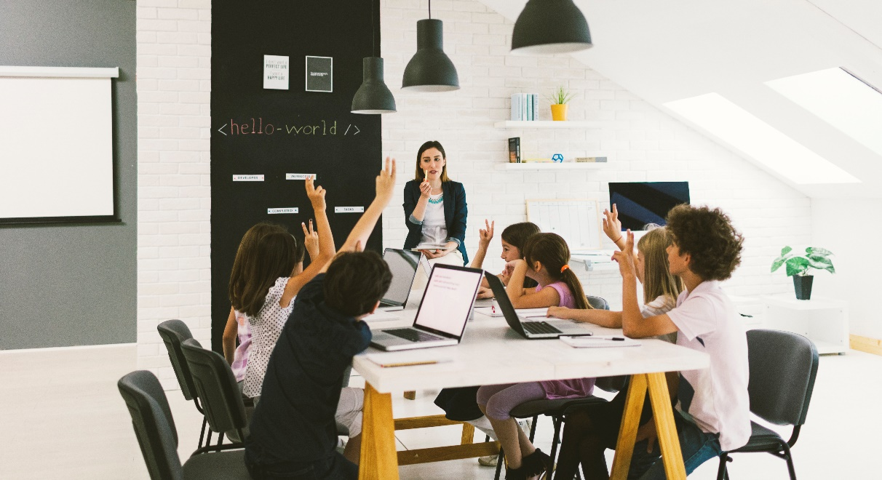
istockphoto.com

Activity sequence and purpose
Pollution by plastics
Students consider the polluting effects of the excessive amount of plastics that humans are discarding. They learn how and why plastics are produced and compare the rate at which some plastics and other materials decompose. Students learn about the impacts on ocean ecology and surrounding environments.
Reducing pollution by plastics
Students investigate some ways that plastic pollution can be reduced by using sustainable alternatives. They also learn about the current and future processing possibilities of recycling discarded plastics.
Creating educational plans
Students use the knowledge gained in Activities 1 and 2 to design educational presentations or communications aimed at raising community awareness of plastic pollution in the ocean and surrounding environments. They suggest ways their target audience can help to reduce the volume of plastics that end up in the ocean.

Presenting and reflecting
Students present their educational programs to their target community audiences. They reflect on their experiences and the success of their presentations/communications.

Background
Expected learning | Students will be able to:  - Recognise links between pollution by man-made products and environmental damage.  - Identify everyday products that are made from plastic and describe how plastic is produced.  - Contribute to the design of a science experiment into the decomposition of plastic and other materials in simulated seawater.  - Collate and tabulate observational data from their experiment and interpret the findings of their experiment.  - Describe the impact of plastic pollution on marine life.  - Recognise the connection between addition and subtraction and use place value to partition and rearrange large quantities.  - Recognise the change of state between liquid and solid when heat is applied to various materials.  - Work safely with a range of materials and equipment while experimenting and creating alternatives to plastics.  - Recognise how and why plastics should be recycled.  - Work collaboratively to create a concept brief and action plan, including a timeline, and develop a presentation for a purpose.  - Evaluate the effectiveness of their presentation, using personal reflection strategies.
Vocabulary | This module uses subject-specific terminology, some of which is shown in the Glossary. The list contains terms that need to be understood before the module commences or developed as they are used.
Timing | There is no prescribed duration for this module. However, the experiment involving the breakdown of various materials needs to be set up over time. It is suggested that Activity 1 be undertaken early in Term 1 and the remainder of the module undertaken in Term 2 when the experiment has been completed.  The module is designed to be flexible enough for teachers to adapt. Activities do not equate to lessons; one activity may require more than one lesson to implement.
Consumable materials | A Materials list is provided for this module. The list outlines materials outside of normal classroom equipment that will be needed to complete the activities.
Safety notes | There are potential hazards inherent in these activities and with the equipment being used, and a plan to mitigate any risks will be required.  Potential hazards specific to this module include but are not limited to:  - Possible exposure to cyber bullying, privacy violations and uninvited solicitations when using the internet.  - Hazards associated with being outdoors such as falls, insect bites and exposure to direct sunlight.  - Burns while heating and melting plastic – care should be taken to carefully supervise students.  - Risk of breaking glass jars – place jars in cardboard cartons and at floor level to minimise the risk of breakage.  - Health risks from discarded plastic brought to school by students – care taken that they have been thoroughly cleaned.
Enterprise skills | The Plastic pollution module focuses on higher order skills with significant emphasis on expected learning from the general capabilities and consideration of enterprise skills.  Enterprise skills include problem-solving, communication skills, digital literacy, teamwork, financial literacy, creativity, critical thinking and presentation skills.  Further background on this is available from the Foundation for Young Australians in their New Work Order Series of reports at www.fya.org.au/our-research-2/#series.
Assessment | The STEM modules have been developed to provide students with learning experiences to solve authentic real-world problems using science, technology, engineering and mathematics capabilities.  While working through this module, assessment opportunities will arise as students:  - Sort, bundle and count collected discarded items  - Contribute to the design and observe the results of an investigation into the decomposition of materials in seawater  - Use tables to record the uses and alternatives to plastic items  - Observe the effects of heat when creating beeswax wraps and melting recycled plastics  - Reflect in their journals  - Produce and present their educational presentations about plastic pollution.  Links to the Western Australian Curriculum indicates the expected learning students will engage in as they work through the module.  Evidence of learning from journaling, presentations and anecdotal notes from this module can contribute towards the larger body of evidence gathered throughout a teaching period and can be used to make on-balance judgements about the quality of learning demonstrated by the students in the science, technologies and mathematics learning areas.  Students can further develop the general capabilities of Information and communication technology (ICT) capability, Critical and creative thinking, and Personal and social capability. Continuums for these are included in the General capabilities continuums but are not intended to be for assessment purposes.

Activity 1: Pollution by plastics
Activity focus | Students consider the polluting effects of the excessive amount of plastics that humans are discarding. They learn how and why plastics are produced and compare the rate at which some plastics and other materials decompose. Students learn about the impacts on ocean ecology and surrounding environments.
Background information | The first synthetic plastic polymer was invented in 1869 by John Wesley Hyatt as a substitute for ivory. He produced a kind of plastic that could imitate natural substances like tortoiseshell, horn and ivory to prevent the exploitation of endangered animals. It is the prolific production of these single-use plastic items that cause so much pollution and are a threat to the environment.  How are modern plastics produced?  Natural gas and oil are refined into ethane and propane. Ethane and propane are treated with high heat, in a process known as ‘cracking’ and converted into monomers such as ethylene and propylene. The monomers ethylene and propylene are combined with a catalyst to create a polymer ‘fluff’, which looks like powdered laundry detergent. The polymer is fed into an extruder, where it is melted to form a long tube as it cools. The tube is cut into small pellets and shipped to factories when it is melted and moulded into water bottles, food packaging, auto parts, medical devices and much more. The Plastics Industry Association website has more information, see Digital resources.  Properties of plastics  The term ‘plastic’ is derived from the Greek word ‘plastikos’, meaning moldable. As a material, plastic has many positive characteristics including strength, durability, flexibility, lightweight and versatility.  It is also inexpensive, water and heat resistant, and can be made in any colour. Plastic containers can be made to safely store alcohol, soap, water, acid or petrol without the substance dissolving the container.  Problem with plastic  However, the same properties which have made plastic such a versatile and durable material, are now contributing to serious environmental damage, particularly in the oceans. Single-use plastics such as shopping bags, straws, cups, water bottles, cutlery and food wrappers make their way into the oceans when litter and loose landfill is carried to the sea by waterways and rivers. Carried by ocean currents and ocean gyres, the plastic eventually makes its way to one of several garbage zones in the ocean, such as the Great Pacific Garbage Patch. Some researchers suggest that by 2050 there could be more plastic than fish in the oceans by weight. See the article More plastic than fish in the sea by 2050, says Ellen MacArthur in the Digital resources section.  There are several ways that marine life is negatively impacted by plastic pollution:  - Ingestion: Some marine species, such as sea turtles, whales, fish and birds mistake the plastic as food. Once ingested, the plastic gives the animals a false sense of fullness. This often leads to starvation as the animals are not receiving the nutrients that they require to stay alive.  - Suffocation: When plastic is ingested it also has the potential to create an obstruction which may lead to suffocation.  - Entanglement: Animals become entangled in plastic fishing line, nets and rope. Because they are unable to untangle themselves, they may die from starvation or become vulnerable to predators. Being entangled in plastic waste may also create open wounds which become infected and reduce the animal’s ability to swim or fly.  - Microplastics and microbeads: Most plastic that ends up in the ocean breaks up into very small particles less than 5 mm called microplastics. Other tiny particles of plastics, called microbeads, are intentionally manufactured and used in many health and beauty products. Microbeads travel along waterways into the oceans where, along with microplastics, marine life and birds mistake them for food. They are undigestible and so accumulate and pass along the food chain. Research is underway but health effects are still unknown. The use of microbeads was banned in 2015 in the US, but microplastic pollution in the oceans is still a serious problem. For more information, see What are microplastics? in the Digital resources.
Instructional procedures | Stimulus pictures have been provided to assist with initiating classroom conversation see Teacher resource sheet 1.5: Picture stimulus - Pollution.  It is recommended that students work in small groups of three to four for all activities. Mixed ability groups encourage peer tutoring and collaboration in problem-solving. Collaboration is an important STEM capability.  Student ideas and learning should be recorded in a reflective journal. Depending on the needs of the class, this can be a collaborative process in one class journal, or students can work individually on their reflective journals. The journal can be either digital or physical. See Reflective journal for more support.
Expected learning | Students will be able to:  - Compare the number of plastic and non-plastic discarded items using place value partitions and addition and subtraction (Mathematics).  - Explain how and why plastic is made (Science).  - Create a flowchart showing the main steps in producing a plastic item (Technologies).  - Contribute to planning a fair experiment into the decomposition of plastic and other materials, make predictions based on prior knowledge and tabulate observations (Science and Mathematics).  - Recognise the environmental damage caused by excessive amounts of discarded plastic in the ocean (Science).
Equipment required | For the class:  Interactive whiteboard  Small clear glass jars  Labels  ‘Sea’ water (35 g or approximately 7 teaspoons salt to 1-litre water)  See Materials list
For the students:
Digital devices or laptops
Popplet, Keynote, Pages, Word
Student activity sheet 1.6: I see, I think, I wonder
Student activity sheet 1.7: Hundreds grid
Student activity sheet 1.8: Plastics flowchart
Preparation | Display the stimulus pictures from Teacher resource sheet 1.5: Picture stimulus - Pollution.  Source A2 card to list discarded materials.  Create a table on the A2 card for students to record their observations during the decomposition experiment.  View the suggested videos in Digital resources, download where possible, exclude advertising, and plan where to pause for discussion.  Review and select excerpts from the videos listed in Part 3.
Activity parts | Part 1: Pollution  Read the book or view an online reading or animation of The Lorax by Dr Seuss (see Digital resources).  Use the story to introduce students to the idea of pollution in general. Discuss the reasons for the pollution and environmental damage in the story and relate it to more generalised pollution problems in the modern (throw away) society. Cutting down trees is still an issue but other problems have arisen though the number of manufactured items that humans now throw away.  Display the stimulus images in Teacher resource sheet 1.5: Picture stimulus - Pollution for the class.  Ask students to think about the kinds of things that get thrown away. In pairs, students complete Student activity sheet 1.6: I see, I think, I wonder.  Hold a class brainstorm about all of the non-food items and materials that students think are discarded. List these on the interactive whiteboard.  Ask students to observe their family’s rubbish disposal at home over several days and bring in all their cleaned ‘throw-aways’ (ie all of the items or containers that get discarded both in the ordinary bins and their recycling bins than can be washed or cleaned). The range should include different types of plastic and paper bags, plastic bottles and containers, plastic wrap, plastic and paper straws, cardboard packaging, egg cartons, pop sticks and jars etc. As items are brought in, tick off on the class list or add if items were overlooked in the brainstorm.  Students review the class list of throw-away items and label each as plastic or non-plastic. Tell students they will be sorting the items brought from home into plastics and non-plastics. (Ideally, collect several hundred of each type.)  Explain that we are going to compare the number of plastic discarded items to the number of non-plastic discarded items, to find out which is more. Suggest that it might be easier to bundle the items in some way, to make the counting easier.  - Why might it be a good idea to organise the items in groups?  - What size groups should we use?  - Why might groups of ten make it easier to count how many altogether?  Assist students to understand why bundling in tens provides an efficient way to determine how many. Demonstrate so they connect the groups of ten to the numerals, for example produce, or have students produce, lists such as these.  1 bundle of 10 = 10 2 bundles of 10 = 20 3 bundles of 10 = 30 4 bundles of 10 = 40 5 bundles of 10 = 50 6 bundles of 10 = 60 7 bundles of 10 = 70 8 bundles of 10 = 80 9 bundles of 10 = 90 10 bundles of 10 = 100 11 bundles of 10 = 110 12 bundles of 10 = 120 13 bundles of 10 = 130 1 bundle of 4 = 4 2 bundles of 4 = 8 3 bundles of 4 = 12 4 bundles of 4 = 14 5 bundles of 4 = 20 6 bundles of 4 = 24 7 bundles of 4 = 26 8 bundles of 4 = 32 9 bundles of 4 = 36 10 bundles of 4 = 40 11 bundles of 4 = 44 12 bundles of 4 = 48 13 bundles of 4 = 52  Ask student to look at the numbers in the lists:  - Can you see a connection between the number of bundles of ten and the total number that doesn’t happen when bundling in groups of four?  - Could you predict the total number if you had 18 bundles?  - What would the total be if you had 27 bundles?  Suggest that we group our discarded items in bundles of 10 so we will be able to count them by tens to check our predictions.  Have students sort the discarded items into plastics and non-plastics, grouping each category into bundles of ten. Decide on a range of methods for bundling, depending on the types of items – they could use string, elastic bands, and discarded plastic bags for larger plastic items and and paper bags or cardboard boxes for non-plastics. Containers can be crushed to make bundling easier.  As numbers become larger, students can check their predictions, counting the bundles by tens to prove for themselves that 18 bundles of ten do contain 180 items. Some student may still wish to count by ones to check that counting by tens provides the same total as counting by ones.  Students can discover (or remember) that 10 bundles of ten contain 100 items, so that by re-bundling 10 bundles of ten, then count count the hundreds.  When the collecting, bundling and counting of each category has been completed, the total quantities can be examined and rearrange, representing the quantities in standard and non-standard arrangements.  For example, 287 item can be lined up in hundreds, tens, and ones to show that 200 + 80 + 7 = 247. The bundles can be rearranged to show that 80 + 200 + 7 must also equal 247. To show nonstandard partitions, the bundles can be separated and represented in various ways, such as, 100 + 180 + 7, or 250 + 17, or 100 + 100 + 17 + 50.  Ask students to write their own non-standard number sentence, and then, as a class attempt to rearrange the bundles to match each suggestion.  The numbers of items can be represented on grid paper that has the hundreds emphasised (see Student activity sheet 1.1 – Hundreds grid) to connect the numbers and bundles to hundreds, tens, and ones.  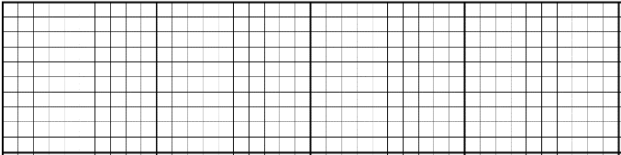  100  60  7  100  Once the two collections have been quantified, ask students to say which is greater – the number of plastic or non-plastic discarded items.  Typically, substantially more plastic items are discarded than cardboard or other materials, which should link to the research.  Ask students to think about ‘how many more’ plastic than non-plastic items they have collected. The numbers should be relatively large, so follow up by asking:  - How can we find out how many more plastic items than non-plastic items we have in our collection?  Year 3 students typically see a ‘how many more’ comparison problem as needing a ‘counting on’ strategy and so think of it logically as addition. When the two quantities have been identified, write an open addition number sentence that matches that way of thinking:  Number of non-plastic items + = Number of plastic items.  Challenge students to use their grid representations of the numbers to try and calculate how many more plastic than non-plastic items had been collected.  Ask students to think about how they use a calculator to find out ‘how many more’. Assist students to recognise that the open addition number sentence could be rewritten as an ‘equivalent’ subtraction number sentence so that the missing number is after the equals sign, and so could be entered into a calculator.  Clarify that subtracting the number of non-plastic items from the number of plastic items will answer the ‘how many more’ question as well as the ‘how many less or fewer’ question, and will tell us the ‘difference’ between the two quantities. This relationship can be demonstrated using a part-part-whole diagram which may help students see the relationship between addition and subtraction in this context:  Number of non-plastic items  Number of plastic items  HM more or HM less?  Relate the problem to similar small number ‘compare’ and ‘equalise’ problem types the students will be learning to solve in mathematics lessons. For more information refer to First Steps in Mathematics Book 2, Page 89, Background notes on problem types (see Digital resources).  Carry out the calculation and ask students to describe and record the comparative information using ‘more than’, ‘less than’ ‘fewer’ and ‘difference’ in the sentences they construct.  This process normally results in a larger quantity of plastic than all the rest of the materials, which matches what the world data suggests. If, by chance, the opposite occurs, discuss with students why that could be so.
Part 2: Where does plastic come from?
Show students the video How is plastic made? which explains the short history and process of making plastics (see Digital resources).
Refer students back to The Lorax story and connect the ideas in the story to the history of plastic.
The Lorax story: Originally good things were made from the trees – but then too many things were made and trees were used up and pollution damaged the environment.
How is plastic made?: Originally good because it saved animals from being killed for ivory and tortoiseshell, but too many plastics are being made, using up oil and gas (also natural resources like trees, but ones that cannot be replaced in our lifetime) and then causing too much pollution, particularly in the ocean.
Show students the videos From oil to plastic and How plastic is made, which show the process from oil to plastic products (see Digital resources).
Ask students to draw a flowchart for one of their discarded plastic items. The flowchart should outline the key stages in the life of their chosen item, based on what they saw on the video. If students have had experience with a flowchart, they can use blank paper. If not provide them with the framework in Student activity sheet 1.8: Plastics flowchart.

Boxes in the flowchart should include:
- Extraction (oil or gas)
- Processing (making into plastic pellets)
- Manufacturing (Moulding/filling)
- Distribution (to public and businesses)
- Use (in households, schools, businesses).
Leave the boxes following the ‘throw-away’ and ‘put in recycle bin’ blank so they can be completed during Activity 2.
Instruct students to share their flowcharts and display in the classroom.
Encourage students to think about the ‘what happens next’ to a lot of the plastics we use by asking:
- Why is discarded plastic so damaging to the environment when there are lots of other materials like cardboard and paper that are also discarded?
Students may already have some ideas to contribute. Use a think-pair-share activity (see Teacher resource sheet 1.3: Cooperative learning – Think-pair-share) or their ideas can be recorded in their journal.
Let students know they will be looking more closely at this in the next activity.
Part 3: The effects of plastic pollution
Discuss with students the idea of organic materials like food scraps, fallen leaves decomposing naturally, as in composting.
To find out how plastics and other discarded materials break down in the ocean compared to some natural organic materials, suggest to students they could set up a science experiment. Tell students that they could put pieces of the different materials into jars of water and watch what happens over a long time.
Use the opportunity to elicit from students what is involved in planning a science experiment and, in particular, what needs to be considered to make it a ‘fair’ experiment.
Hold a class discussion, using the following prompt questions:

- What are we trying to find out?
- How can we make the water in the jars more like the ocean?
- What do we need to keep the same?
- Why do we need to keep those things the same?
- What will we be watching for?
- How will we keep a record of what we will observe?
- What do we think will happen? What is our prediction?
- How long should we keep the experiment going?
With students’ help, set up the jars with simulated seawater (35 g or approximately 7 teaspoons salt to 1 litre water, or use real seawater if available). Students should put one type of material in each jar to make observations easier. Variables not considered by the students should be raised by the teacher. These could include:
- The same amount of ‘seawater’ should be put in each jar.
- The pieces of the different materials being compared should be the same shape and size.
- Jars should be carefully labelled.
- The water in the jars should be agitated at regular times each day to simulate the waves and currents in the ocean.
- The jars should be placed in the sun each day to simulate the warmth and light that falls on the ocean.
- Observations need to be made in the same way and recorded and dated at regular times.
Create a class table on an A2 card so students can record their observations over time. List the different materials in the first column, and add dated columns to record the observed changes at regular intervals during the experiment. Assist students to recognise how a column and a row intersect to identify a particular cell in the table. Throughout the experiment, progressively discuss their observations and the implications.

Prompt student thinking by asking:
- Have any of materials decomposed yet? If so, were they natural or manufactured materials?
- Which materials broke up but left some remains in the bottom of the jar?
- Which materials seemed to dissolve but made the water cloudy or unclear?
- Which materials decomposed the slowest?
- Which materials did not decompose at all?
- Which materials do you think would accumulate as waste in the ocean? Why?
Discuss the implications for the ocean of what they have observed in conjunction with showing a selection of the videos listed below (see Digital resources for links):
- Plastic Pollution: How Humans are Turning the World into Plastic
- Powerful Video: Why We Need to Stop Plastic Pollution in Our Oceans For Good
- What Are Microplastics And How Are They Harming Our Oceans? Plastic Pollution
- Plastic Ocean
- Plastic Oceans: What is the impact of pollution in the sea
- Kids Take Action Against Ocean Plastic – Short Film Showcase
- What Have We Done! Shocking Images Show Earth Drowning in Plastic Pollution (Before the Flood)
Review and select excerpts from the videos – not all need to be shown, but excerpts could be spread out over the term during the experiment to maintain interest.
Students view the clips to find facts relating to discarded plastics and the effect it has on the oceans, the wildlife and surrounding environments.
After showing the range of videos over time students use a pass it on activity(see Teacher resource sheet 1.4: Cooperative learning – Pass it on) to reflect on what they have learnt about plastic pollution and its damaging effect. Their reflections can contribute to a class explosion chart on the ways plastics do and do not break down and the level of environmental damage resulting from that pollution.

Display the chart and discuss as a class. Where appropriate, relate the students’ research findings to their observations of the way materials decomposed in their experiment.
To complete their research, show students the video Plastic Pollution PSA – Earth Day 2019 which shows snapshots of environmental damage made by plastics (see Digital resources).
Introduce the question that is the focus of this module and will be followed up in the next activities:
What can we do to reduce the pollution caused by plastics?
Part 4: Reflection and journaling
Students reflect on the following questions in their journals:
- What is plastic?
- What is plastic pollution?
- Why is plastic pollution worse than other kinds of rubbish?
- How does plastic pollution impact upon the ocean?
Resource sheets | Reflective journal  Teacher resource sheet 1.3: Cooperative learning – Think-pair-share  Teacher resource sheet 1.4: Cooperative learning – Pass it on  Teacher resource sheet 1.5: Picture stimulus - Pollution  Student activity sheet 1.6: I see, I think, I wonder  Student activity sheet 1.7: Hundreds grid  Student activity sheet 1.8: Plastics flowchart  Teacher resource sheet 2.2: Sample parent letter
Digital resources | The Lorax - Read Aloud Picture Book | Brightly Storytime (Brightly Storytime, 2018)  youtu.be/EdWesdMfyd4
The Lorax (original) (jefronty, 2013)
youtu.be/8V06ZOQuo0k
First Steps in Mathematics Book 2, Chapter 3, Understand Operations, Background Notes (Department of Education, 2013)
det.wa.edu.au/stepsresources/detcms/navigation/first-steps-mathematics/
How are plastics made? (Plastics Industry Association, n.d)
www.thisisplastics.com/plastics-101/how-are-plastics-made/
More plastic than fish in the sea by 2050, says Ellen MacArthur (The Guardian, 2016)
www.theguardian.com/business/2016/jan/19/more-plastic-than-fish-in-the-sea-by-2050-warns-ellen-macarthur
How is Plastic Made? (Mystery Doug, 2019)
youtu.be/6PgjA3HISmw
From Oil To Plastic (Nate Ivy, 2013)
youtu.be/IwdUwffecsM
Show first 4.5 minutes only for this activity – rest of video is about recycling which is used in Activity 2.
How Plastic is Made (Green Living Science, 2015)
youtu.be/w4VG-7ZFvDM
Show first 1 minute 45 seconds – last minute is also about recycling.
Plastic Pollution: How Humans are Turning the World into Plastic (Kurzgesagt – In a Nutshell, 2018)
youtu.be/RS7IzU2VJIQ
Cartoon uses King Midas fable to introduce dangers of plastic pollution – first 5 minutes only are suitable.
Powerful Video: Why We Need to Stop Plastic Pollution in Our Oceans For Good (Oceana, 2019)
youtu.be/Yomf5pBN8dY
Powerful 4.5-minute video about the damaging effects of plastics.
What are microplastics? (National Ocean Service, 2020)
oceanservice.noaa.gov/facts/microplastics.html
What Are Microplastics And How Are They Harming Our Oceans? Plastic Pollution (Behind the News, 2016)
youtu.be/tG4AYagBz9Q
3.5-minute video explaining microplastics.
Plastic Ocean (United Nations, 2018)
youtu.be/ju_2NuK5O-E
7-minute video - shows contents of sea birds stomachs full of plastic.
Plastic Oceans: What is the impact of pollution in the sea (ABC Science, 2012)
youtu.be/cwTDvqaqPlM
12-minute Australian video - birds eating plastic – some overlap with previous clip.
Kids Take Action Against Ocean Plastic – Short Film Showcase (National Geographic, 2017)
youtu.be/hKFV9IquMXA
Children talking about Styrofoam and the ocean.
What Have We Done! Shocking Images Show Earth Drowning in Plastic Pollution (Before the Flood) (Minute Made, 2018)
youtu.be/Tcr6gX1DHYI
Series of photo images of the effects of plastic pollution.
Plastic Pollution PSA – Earth Day 2019 (Contend, 2019)
youtu.be/XD-k_Tkw3lY
Padlet
padlet.com
Google Classroom
play.google.com/store/apps/details?id=com.google.android.apps.classroom&hl=en
Keynote
apps.apple.com/au/app/keynote/id361285480
All the way to the ocean (Freedom Three Publishing, 2017)
youtu.be/sZW2ByM623g
A brief history of plastics (Sky News, 2017)
youtu.be/QW3OGMZ1bWc
The story of plastic (TRT World, 2019)
youtu.be/O-5nTIk8H6k
The Great Pacific Garbage Patch Is Not What You Think It Is | The Swim (Seeker, 2018)
youtu.be/6HBtl4sHTqU
What really happens to the plastic you throw away - Emma Bryce (TED-Ed, 2015)
youtu.be/_6xlNyWPpB8
Kill Plastic not Wildlife (The Australian Research Institute for Environment and Sustainability, 2012)
aries.mq.edu.au/videos/kill-plastic-not-wildlife/
For decades, scientists puzzled over the plastic ‘missing’ from our oceans – but now it’s been found (Jennifer Lavers, The Conversation, 2020)
theconversation.com/for-decades-scientists-puzzled-over-the-plastic-missing-from-our-oceans-but-now-its-been-found-133434
How much plastic is inside you? (TRT World, 2018)
youtu.be/LFDPYBNB7bs
Literary resources | Harry Saves The Ocean!: Teaching children about plastic pollution and recycling by NGK
 | One Plastic Bag: Isatou Ceesay and the Recycling Women of Gambia by Miranda Paul

Activity 2: Reducing pollution by plastics
Activity focus | Students investigate some ways that plastic pollution can be reduced through using sustainable alternatives. They also learn about the current and future processing possibilities of recycling discarded plastics.
Background information | Many young people are so accustomed to the widespread use of disposable plastic products it can be difficult for them to consider alternatives. A useful reference for background information is the article 10 Plastic Pollution Facts That Show Why We Need To Do More (see Digital resources).  To reduce the amount of plastic pollution reaching the oceans, communities can employ the 3 R strategy of Reduce, Reuse and Recycle.  Least Preferred  Most Preferred  STEM Consortium  - Reduce (A focus in Activity 2: Finding ways to use fewer single-use plastic products. Replace some everyday plastic items with non-plastic alternatives.  - Reuse (Not a focus in this module): Using plastic products for other purposes once they have been used for their original purpose instead of discarding them.  - Recycle (A focus in Activity 2): Discarded plastic is collected and sorted into like plastic types so that the material can be processed into other plastic products.  Recycling plastic  As a general rule, the majority of recycling programs in Australia accept numbers 1 (PETE or PET) and 2 (HDPE). However, not all councils collect the same recyclable items so it is essential to check to see what items they accept. The website Recycling near you at recyclingnearyou.com.au can assist residents with information to ensure they are putting the right things into their recycling bin.  Soft plastics, such as plastic bags and packaging, are often not able to be recycled by council recycling services. However, REDcycle, a recycling organisation, works in partnership with some of Australia’s largest supermarkets to provide ways in which soft plastic can be recycled. See the REDcycle website at www.redcycle.net.au for more information.  Consumer plastics can fall into different categories depending on the type of plastic the item is made of. These plastics are given a ‘Plastic identification Number’ and can be found on the plastic packaging. These examples are not exhaustive and most of these have multiple overlapping uses.  Symbol Name Examples  Polyethylene Terephthalate (PET) Soft drink bottles; clear plastic food packaging; polyester fabrics  High-Density Polyethylene (HDPE) Milk bottles; shampoo and other bottles; plastic lids; pipes, car parts  Polyvinyl Chloride (V) Electrical conduit; garden hoses; construction; car parts; medical equipment  Low-Density Polyethylene (LDPE) Plastic bags; plastic film; plastic bottles; tubing; computer parts  Polypropylene (PP) Toys; furniture; bags; many consumer goods  Polystyrene (PS) Packaging; meat trays; plastic foam  Other Medical Parts  STEM Consortium
Instructional procedures | Students will engage in several activities that focus on two aspects of reducing the amount of discarded plastic that finds its way into the oceans and surrounds. Parent and/or other adult assistance will be needed for these activities.  The first is to consider ways to reduce the number of plastic products that are needed by replacing them with other environmentally friendly reusable products.  The second is a focus on recycling – reprocessing plastics to make new products, so reducing the amount of new plastic production from oil and gas. Students will engage in melting and reshaping High-Density Polyethylene (HDPE) plastic into new products to mimic commercial recycling of plastic.
Expected learning | Students will be able to:  - Use heat to bring about a change of state between a solid and a liquid (Science).  - Work safely with a range of materials and equipment while creating alternatives to plastics (Technologies).  - Recognise the impact reduce and recycle strategies can have in reducing the impact of plastic pollution (Science).  - Use a table to record information (Mathematics).
Equipment required | For the class:  Iron and a safe surface  Access to an oven  See Materials list
For the students:
Student activity sheet 1.7: Plastics flowchart (to complete)
Preparation | Try out the melting of HDPE plastic first so that the timing can be more carefully planned. See Teacher resource sheet 2.1: Recycling HDPE Plastic.  View the suggested videos in Digital resources, download where possible, exclude advertising, and plan where to pause for discussion.
Activity parts | Part 1: Why use plastic?  Following the completion of the experiment with different types of materials and their research into the damage done by discarded plastic, ask students to conduct a think-pair-share (see Teacher resource sheet 1.3: Cooperative learning – Think-pair-share) on the following question:  - If we know that discarded plastic causes damage to the ocean environment, then why do we use so much of it?  Discuss with the students that plastic is a very versatile, cost-efficient and durable product. As a result, it is used widely in our everyday lives.  Refer back to the original list of discarded plastics and draw out the purpose for some of those items. In small groups students create their tables to record the purposes, adding a column for alternatives, for example:  Plastic items Used for: Alternative?  Ice cream, yoghurt, margarine tubs Holding foods  Cool drink, detergent, shampoo bottles Holding liquids  Plastic wrap Wrap or cover leftover foods  Plastic carry bags Carry groceries and other things you buy  Ask the following stimulus question and ask students to complete the table:  - What could you use for these purposes if all plastics disappeared?  Students may need help in imagining a world without plastic where glass, clay, metal, wood, stone, natural fibres and paper products covered all these human needs.  Show excerpts from the video Life without plastic – DW Documentary, which shows a Bavarian family trying to live ‘plastic-free’ – and how difficult that can be (see Digital resources).  Let students know that some of these alternatives are becoming popular again as people are more conscious of the need to reduce plastic pollution.  Tell students they will be making an alternative to plastic wrap and plastic carry bags.
Part 2: Reduce – creating alternatives
Engage students in manufacturing two products that can be used as alternatives to ‘throw-away’ plastic products:
- Reusable beeswax wraps instead of cling film plastic wrap
- String bags instead of plastic carry bags.
Beeswax wraps
Explain to students that instead of using plastic wrap for covering of wrapping food, they can create reusable wraps that use cotton fabric and melted beeswax.
To make the wraps, beeswax is melted into the cotton fabric to create a malleable waterproof cloth that can be tightly wrapped around food, sticking to itself something like cling wrap.
Show the last five minutes only of the video How to make beeswax cotton food wrap with either an iron or oven, which demonstrates a simple way to create the wraps using an electric iron.
Students can cut their fabric and prepare the beeswax themselves but will need one-on-one supervision during the heating process. Parent help may be required to assist. The iron on method using one or more electric irons under adult supervision is preferable as the students can be more directly involved in the heating process. They can observe how the solid wax melts under the heat and soaks into the cloth and then solidifies and stiffens the cloth as the heat is removed and the wax cools (Science understanding).
String bags
Students can make scaled-down string bags at school to learn the technique.
This small bag was made from two curtain rings and 12 x 1 m lengths of cotton kitchen string (the kind usually used to tie meat for roasting).
The number of knots needed is within the skill level of Year 3 students, although some may need adult assistance.

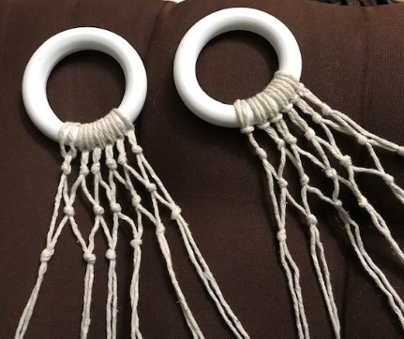
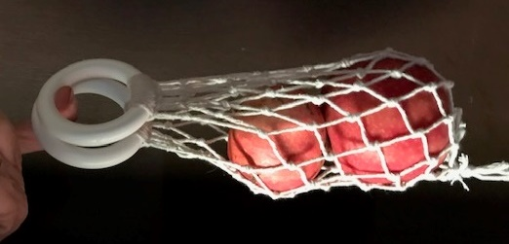
Lengths of string are doubled and looped over the rings. Adjacent pairs of string are knotted alternately.
STEM Consortium
Once three rows of knots have been completed, join at the sides and continue knotting alternate pairs of strings around the bag.
When a few centimetres of string ‘tails’ are left, knot together to close the bottom of the bag.
For a detailed set of instructions for making a similar but full-sized string bag watch the How to make a NET bag (knotted) video (see Digital resources).
Once students have constructed their wraps and bags, engage them in a discussion about what other ways they could reduce the need to use throw-away plastic products. They may have ideas of their own and search the internet for further possibilities.
To complete this section, show the Plastic packaging – Behind The News video (see Digital resources).
As a class, discuss the video and the students’ experiences in the module so far. Prompt discussion with the following questions:
- What ways of reducing plastic usage were mentioned in the video?
- Do you have ideas not mentioned in the video?
- Could beeswax wraps be used to keep your sandwiches fresh?
- What would you need to do differently if you stopped using throw-away packaging and wraps? (You would need to clean and take care of alternative products.)
Part 3: Recycle your plastics
Show students the TED Ed animation What really happens to the plastic you throw away - Emma Bryce, which describes the life cycle of plastic bottles (see Digital resources).
The video concludes with a short explanation of what happens to plastics that go into the recycling bin and will help students review what they learnt about plastics in Activity 1.
Ask students to complete the final boxes in Student activity sheet 1.7: Plastics flowchart.
The following videos may be shown to students to provide more information about the range of current recycling (see Digital resources for links):
- How plastic bags are recycled
- Scotland’s ‘most advanced’ recycling facility set opens in Aberdeen today
- An environmentally friendly process: plastics recycling at mtm plastics
In their groups, students use a placemat activity (Teacher resource sheet 1.2: Cooperative learning – Placemat) to record what they have learnt about the topic of recycling.
Draw out that most recycling plants are engaged in sorting and organising waste materials. Plastics are put together in various ways and sent to manufacturers – sometimes to the same companies who manufacture items from new plastics produced from oil and gas.
Show the video How plastic bottles are turned into polyester clothing (see Digital resources). This video goes through the full recycling process and shows where the plastic bottles are sent for processing into polyester clothing. Tell students they will be recycling some plastic waste into a new product. Begin by returning to the plastic waste that was brought in at the beginning of the module (or bring more from home, if necessary).
Draw students’ attention to the recycling codes on plastics. Show the video What numbers of plastic are recyclable? (see Digital resources) which goes through the full list of recycling codes. Students can examine some of their collected plastics to find and read the codes.
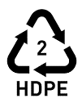
Ask students to sort out the plastics that are coded ‘2’ in the recycle triangle with lettering HDPE, which stands for High Density Polyethylene. This plastic is commonly used in milk and other opaque plastic bottles and lids. Let students know that this particular type of plastic will melt at the same heat that it takes to bake a cake (180° Celsius) and does not emit any fumes at that heat.
With assistance from adult helpers, students select and prepare a quantity of the waste High Density Polyethylene ready for recycling by removing labels, separating lids and cutting up the larger bottles.
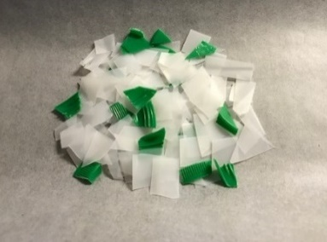
Explain to students that in this activity they will be observing how states of matter can be changed by either adding or removing heat. Students will observe that heat is required to melt the plastic so that it softens and changes shape. When the heat is removed, the plastic cools down and hardens again very quickly. Under supervision, they melt their plastic in an oven and then mix, press and shape it as it cools.
STEM Consortium
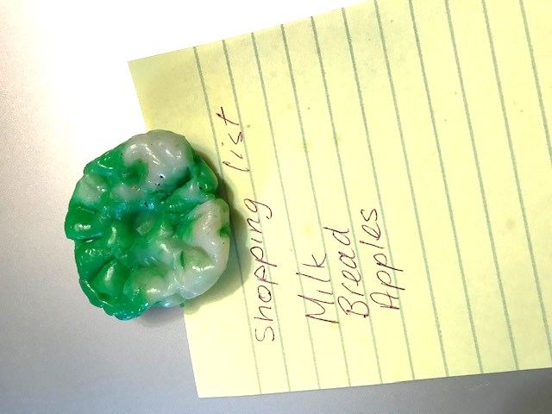
This plastic hardens very quickly and will need to be re-melted several times to achieve the final result. It takes five to ten minutes to melt and only a few minutes to harden after removal from the oven. With planning, several students can be cycled through the melting and shaping process, taking turns to do their shaping using implements and padded cotton oven mitts, then returning it to the oven to re-melt. Refer to Teacher resource sheet 2.1: Recycling HDPE plastic for full instructions.
Warn students that heating any plastic to a higher temperature than 180° Celsius can cause dangerous fumes. Tell them they must only ever try to melt recyclable plastics labelled Number 2, and always with adult supervision at no more than the temperature needed to bake a cake.
Ask students:
- How is this process the same as what happened when heat was applied to the beeswax on the cotton cloth?
- How is it different?
Assist students to understand that different materials behave differently when heat is applied. Low heat turns some materials into liquid, others need higher heat. Some materials do not become liquid at all and burn when high heat is applied. (These ideas can be further explored and developed in other lessons.)
Complete the recycling section by showing the video Have Australian scientists discovered a recycling solution to our plastic problem? The video shows that scientists have found a way to turn waste plastics back into oil, similar to the oil that plastics were made from to begin with. This can give students a taste of what recycling could lead to in the future.
Discuss with students the possibility that in the future, all plastics could be fully recycled, thus preventing the need to create any more plastic in the world.
Hold a class discussion to draw out that if you must use any ‘single-use’ plastic items, make sure that all are recycled. But best of all, avoid using ‘throw-away’ plastics and find sustainable substitutes instead.
Part 4: Reflection and journaling
Students reflect on the following questions in their journals:
- What are the advantages of reducing discarded plastics by using alternative products?
- What are the advantages of recycling plastics?
- What might the future of plastics be?
- Could it be possible to ban the creation of any more ‘new’ plastic made from oil and gas?
Resource sheets | Reflective journal  Teacher resource sheet 1.2: Cooperative learning – Placemat  Teacher resource sheet 1.3: Cooperative learning – Think-pair-share  Student activity sheet 1.7: Plastics flowchart  Teacher resource sheet 2.1: Recycling HDPE plastic  Teacher resource sheet 2.2: Sample parent letter
Digital resources | 10 Plastic Pollution Facts That Show Why We Need To Do More (Seneo Mwamba, Global Citizen, 2018)  www.globalcitizen.org/en/content/plastic-pollution-facts/
Life without plastic – DW Documentary (DW Documentary, 2017)
youtu.be/jeFHnYw0-pA
How to make beeswax cotton food wrap with either an iron or oven (Aannsha Jones creates) (Aannsha Jones, 2017)
youtu.be/wkRoh1pQoks
How to make a NET bag (knotted)(Anna Nik, 2017)
youtu.be/mMhgxWqiJj0
Plastic packaging – Behind the News (Behind the News, 2016)
youtu.be/e4z7GKGBVYk
What Numbers of Plastic are Recyclable? (Quality Logo Products, 2017)
youtu.be/jJlqyTb-oy0
What really happens to the plastic you throw away - Emma Bryce (TED-Ed, 2015)
youtu.be/_6xlNyWPpB8
How plastic bags are recycled (Earth911TV, 2011)
youtu.be/Q6hzhKmw4EY
Scotland’s ‘most advanced’ recycling facility set opens in Aberdeen today (Evening Express, 2017)
youtu.be/9oA_yONzHtA
An environmentally friendly process: plastics recycling at mtm plastics (mtm plastics, 2014)
youtu.be/x9rXCPlRF78
Have Australian scientists discovered a recycling solution to our plastic problem? (ABC News (Australia), 2019)
youtu.be/MTgentcfzgg
How Plastic Bottles Are Recycled Into Polyester (Triwood1973, 2009)
youtu.be/zyF9MxlcItw
Greenbatch Recycling Program (Greenbatch, 2020)
www.greenbatch.com/
The family turning bottle caps into prosthetic limbs for children in need (Liam Taylor, Planet Ark, 2019)
www.recyclingnearyou.com.au/news/display/2760
How bottle caps can help change lives
7news.com.au/the-daily-edition/envision-hands-turns-bottle-caps-into-prosthetic-limbs-for-kids-in-need-c-200981
War on Waste: What plastics can be recycled? (ABC, 2017)
www.abc.net.au/news/2017-05-24/what-plastics-can-i-recycle-war-on-waste/8548658?pfmredir=sm
A brief history of how plastic has changed our world (National Geographic, 2018)
youtu.be/jQdBag_p6kE
Recycling Mythbusters | Not all plastics are made equal (Planet Ark, 2019)
youtu.be/7winIW2iJnQ
The Australasian Recycling Label (Planet Ark, 2019)
youtu.be/oYVfA8mGJYg
Life of a Plastic Bottle (PepsiCo Recycling, 2017)
youtu.be/erGnf7ws20E
Sorting your recycling – shortened version (Planet Ark, 2013)
youtu.be/uEr8Ot5p_Fo
Recycling Near You (Planet Ark, 2020)
recyclingnearyou.com.au
How Plastic Recycling Actually Works (Reactions, 2018)
youtu.be/zO3jFKiqmHo

Activity 3: Creating educational plans
Activity focus | Students use the knowledge gained in Activities 1 and 2 to design educational presentations or communications aimed at raising community awareness of plastic pollution in the ocean and surrounding environments. They suggest ways their target audience can help to reduce the number of plastics that end up in the ocean.
Background information | The focus of the students’ presentations will be the environmental impact of discarded plastics and the sustainability practices individuals can employ to reduce the problem.  Students should be encouraged to take a multimedia approach and be supported to use technologies to assist in making their message more powerful.  Students may choose to utilise peripheral devices and coding software to enhance their presentations. Examples of peripheral devices include Hummingbird Robotic Kits, Little Bits or Micro:bit.  This may mean having to immerse the students in coding and computational thinking activities. An example of coding software is Scratch, there is an instructional video link to this in the Digital resources section.  Video tutorials or online instructions would be beneficial to students. Allow students who are unfamiliar with the technology to immerse themselves in it before the planning.
Instructional procedures | Students will need to be supported to collaboratively develop a concept brief followed by an action plan. Teacher facilitation and advice is important, but students should maintain ownership of the creative process and fulfil design process requirements. See Design process guide for elaboration.  Teacher resource sheet 3.3: Construction skills can assist students who choose to construct physical models as part of their presentation. Students may need access to construction tools that are best used with adult supervision.
Expected learning | Students will be able to:  - Develop and communicate their concept brief and action plans for a specific purpose (Technologies).  - Use a calendar to plan a timeline for their action plan (Mathematics).  - Produce an educational presentation using digital technology (Technologies).
Equipment required | For the class:  Whiteboard or interactive whiteboard  Digital camera or device
For the students:
Devices or laptops
Student activity sheet 3.1: Concept brief
Student activity sheet 3.2: Action plan
See Materials list
Preparation | View the suggested videos in Digital resources, download where possible, exclude advertising, and plan where to pause for discussion.  Ensure students have access to the resource sheets.
Activity parts | Part 1: The plan  Show students the following videos which explain what some individuals have done to reduce the amount of plastic pollution the ocean (see Digital resources for links):  - Wipe Out Waste school program - Behind the News  - Rookie Report: Molly's Straw No More Campaign - Behind the News  - One Month Without Single-Use Plastics | One Small Step  Remind students that in the previous activities they learnt about some ways that plastic use can be reduced and how plastics can be recycled.  Explain to students that, according to research, only a small amount of plastic that could be recycled is recycled. People are still using a lot of ‘throw-away’ plastic products and packaging that could be replaced with sustainable products.  Prompt student thinking by asking:  - What have you learnt about ways to reduce the use of throw away plastic products?  - What have you learnt about the importance of recycling plastics, rather than throwing them in the garbage?  - Who would benefit from knowing more about what you have learnt?  - What are some ways that information can be passed on to those people?  Using a pass it on strategy (see Teacher resource sheet 1.4: Cooperative learning – Pass it on), students work in small groups and write down their ideas about what and how they could educate others about plastics in our modern world and what can be done to reduce their damaging effects. Display the completed sheets for students to reflect on as they develop their ideas.  Remind students of the problem: What can we do to reduce the pollution caused by plastics?  Tell students they will work in pairs or small groups to produce an educational presentation to teach others what they have learnt and to motivate them with the question: What can YOU do to reduce pollution caused by plastics?  Let students know that each pair or group can take a different approach if they choose. They can take a wider view, or a more specific focus on just one idea or product. Students consider what kinds of educational materials they could produce and how to present them to a wider audience.  Assist students to include the following decision making in their group discussions:  - Who will be their target audience? (eg other children, older, younger, parents, wider community, politicians)  - What background information is needed? (eg history, research findings, statistics)  - What are the most important current messages? (eg damage to environment, wildlife, humans, future)  - What media will be used? (eg print, photographic, a model, video clip, digital games, mixed media)  - How will it be distributed/conveyed (eg face-to-face, digital, printed materials)  - What is the best format/program/platform to use? (depends on previous decisions)  Students should be encouraged to create their own ways of communicating the information and choose who they intend to educate. Assist them to expand on their ideas and open up possibilities, but students should ‘own’ their plans.
Part 2: Concept brief
Once students have an informal plan about what they want to convey and to whom, engage them in creating a concept brief.
Students can use Student activity sheet 3.1: Concept brief to pull together their ideas and develop their plan in more detail.
Provide students with the opportunity to explain their concept brief to their peers and ask for feedback. They may adjust their concept brief until they are satisfied and ready to move on to their action plan – which sets out how they are going to complete their presentation within the timeframe.
Part 3: Action plan
Students use their concept brief to collaboratively complete Student activity sheet 3.2: Action plan. The action plan will include:
- Educational focus – summary of their main focus
- Team member and roles
- Actions – decide on a series of steps needed to develop their presentation
- Timeline – plan when each step will realistically be completed, final date in consultation with the teacher
- Feedback – see Part 4
Provide an opportunity for groups to convey their plan to other groups and invite critical input and suggestions that can lead to a review of the concept brief and/or their action plan.
Part 4: Feedback plan
Discuss with students:
- How will you know if your educational presentation has been successful?
- Who will give you the information?
- How will you obtain the information/feedback?
- What questions could you ask?
- What kinds of answers (criteria) would count as ‘success’?
- How could you build feedback into your plan?
Students complete the feedback strategy section of Student activity sheet 3.2: Action plan with details about how they will obtain feedback. Assist students to create appropriate feedback questionnaires or response sheets that relate to their particular presentation.
Part 5: Whole class reflection
Discuss the planning process with the whole class and provide an opportunity to compare progress between groups.
List the different modes of communication and decide if there are consistencies that can be addressed as a class.
For example, if most of the group wish to provide a face-to-face demonstration and/or a digital or other display, then it a joint plan could be put in place for an ‘Exhibition’ or ‘Seminar’, which will require negotiation and planning for a suitable date and venue that fits with the rest of the school’s timetable.
If most choose to use an electronic method for communicating their educational presentation, it may be possible to set up a website that can be accessed by password or use Connect or another acceptable online platform for their presentations.
Students need to take the lead after being provided with sufficient background information to draw on in planning their design briefs and action plans.
The teacher’s role is to facilitate and respond to the students’ needs and assist them to enact their visions.
Resource sheets | Design process guide  Teacher resource sheet 1.4: Cooperative learning – Pass it on  Student activity sheet 3.1: Concept brief  Student activity sheet 3.2: Action plan  Teacher resource sheet 3.3: Construction skills
Digital resources | Wipe Out Waste school program - Behind the News (Behind the News, 2017)  youtu.be/UJcLPZ0raVc
Rookie Report: Molly's Straw No More Campaign - Behind the News (Behind the News, 2018)
youtu.be/rtCRNH3yWRk
One Month Without Single-Use Plastics | One Small Step (NowThis Future, 2019)
youtu.be/-sj3BT_LLH8
Scratch: Instructional Videos
scratch.mit.edu/help/videos/
Scratch: Programming for Hummingbird
www.hummingbirdkit.com/learning/scratch
Welcome to littleBits (littleBits Electronics, 2014)
youtu.be/YUUsJSDa7PEE
How to build a automata toy (GeonPa, 2018)
youtu.be/POjj7yokWXU
How to make your first Automaton (J.E. Johnson, 2016)
youtu.be/QU2CzClTtjk
How to use SketchUp (Tim Slavin, Beanz, 2014)
www.kidscodecs.com/3d-sketchup-for-beginners/
Micro:bit
microbit.org

Activity 4: Presenting and reflecting
Activity focus | Students present their educational programs to their target community audiences. They reflect on their experiences and the success of their presentations/communications.
Background information | There is a wide range of possible presentations that students may wish to conduct. As far as is realistic, facilitate what will be needed to achieve success.
Instructional procedures | As the adult facilitator, the instructional procedure will need to respond to the ideas and visions of the students as they plan and develop their presentations.  Students will need support and scaffolding to help them prepare. To scaffold cooperative group work, each member of the group could have a role and responsibility. For example, one could be the content director, one the media director and a third the presentation director. Teacher resource sheet 1.1: Cooperative learning – Roles.  Depending on students’ prior knowledge or ability, time may need to be dedicated to developing oral presentation skills such as voice clarity, projection, volume, pitch and tone.  To enable the completion of the design process, students should be given time to make improvements to their work based on feedback received from the presentations.  This could be in groups or as a private reflection in learning journals. Time should be taken to discuss how to give constructive feedback and how to take feedback positively.
Expected learning | Students will be able to:  - Work collaboratively to develop and deliver an educational presentation (Technologies).  - Develop and communicate design ideas (Technologies).  - Evaluate the effectiveness of their design processes and solutions, using an agreed set of criteria and personal reflection strategies (Technologies).
Equipment required | For the class:  Media for presentations
For the students:
Digital photos
Digital devices or laptops
Appropriate digital apps
Student activity sheet 1.0: Journal checklist
Student activity sheet 4.1: Self-evaluation
Preparation | Ensure appropriate technology is available and students have the required skills.  View the suggested videos in Digital resources, download where possible, exclude advertising, and plan where to pause for discussion.  Information on developing presentation skills and teacher resources for scaffolding student learning can be sourced from the TED-Ed talks and other presentation ideas in the Digital resources section. Preparation required will depend on the planned presentations.  Ensure students have access to the resource sheets.
Activity parts | Part 1: Following their action plans  Students work through their action plans with the teacher and parent support as needed. Provide classroom and individual support in response to the challenges Year 3 students will face as they carry out plans. It is likely some of their plans and timelines may be unrealistic due to their inexperience, and some teacher counselling can assist them to avoid serious pitfalls. However, students must be given the time and the opportunity to make mistakes, to re-adjust plans and make their judgements, without having an adult take over or do it for them.  A wall chart should be set up displaying the stages and timeline for each group’s action plan. Groups can ‘tick off’ their progress and adjust the timeline if needed. This process models a systematic visual way of tracking their progress and ensures no groups are overlooked by the teacher.  Provide a process by which groups can signal if and when teacher assistance is required.
Part 2: Promotion
Groups may need to develop promotional material to advertise face-to-face presentations, displays, or online sites or webpages that need to be visited digitally.
Prompt student thinking by asking:
- What information needs to be conveyed?
- How will it be delivered?
- Will it be open/available to the public or only by invitation?
If a joint presentation or exhibition is to be organised, whole class decisions may need to be made and more teacher input required.
Promotional materials can be distributed around the school, newsletters and on the school website. Promotional materials can be created in a variety of different ways using a variety of different tools or software such as Canva, Microsoft Word, PowerPoint or Pages.
Students should be directly involved in all decisions.
Part 3: Carry out presentations
A timeframe should be planned to ensure all groups present their educational experiences to their audiences in a fair and equitable way.
Adult supervision during presentations, whether face-to-face or online, is essential to ensure comfort and safety for all students.
Ensure that students have had the opportunity to obtain feedback from the audience in whatever form they had chosen.
Part 4: Feedback and evaluation
Review and collate the feedback methods each group chose and implemented as part of their plan and presentation. Assist students to interpret audience feedback positively.
The teacher may use this opportunity to complete the Teacher resource sheet 4.2: Student evaluation.
Ask students to work in their groups and use the Six Thinking Hat structures to reflect on their experiences in carrying out this module. Refer to Student activity sheet 4.1: Self-evaluation.
These include the following types of reflection:
- Yellow: Positive reflections about the experience
- Black: Negative aspects that have been identified
- Red: Feelings about the experience
- Green: Recommendations for next time
Part 5: Journaling
Provide an opportunity for students to individually reflect in their journals and provide their personal feelings about the experience.
Ask students the following to prompt reflection:
- What was the best part of your presentation?
- What would you do differently if you could do it again?
- What was the most important thing you learned about plastic pollution?
- What changes might you make to reduce plastic pollution?
Ask students to complete Student activity sheet 1.0: Journal checklist.
Resource sheets | Student activity sheet 1.0: Journal checklist  Teacher resource sheet 1.1: Cooperative learning – Roles  Student activity sheet 4.1: Self-evaluation  Teacher resource sheet 4.2: Student evaluation
Digital resources | TED-Ed talks (Phys.org, 2014)  phys.org/news/2014-01-kids-pitch-world-changing-ideas.html
How to host a pop up museum (Santa Cruz Museum of Art & History, n.d.)
www.popupmuseum.org/pop-up-museum-how-to-kit/
Not another Powerpoint: Ten Creative Presentation Tools (Jane Clary and Karen Hill, James F. Byrnes High School Media Center, 2012)
www.spart5.net/cms/lib/SC01000802/Centricity/Domain/804/NotAnotherPowerpointHandout.pdf
17 Killer Presentation Tips for Students (Powtoon, 2017)
www.powtoon.com/blog/17-killer-presentations-tips-students-stand/

Appendix 1: Links to the Western Australian Curriculum:
The Plastic pollution module provides opportunities for developing students’ knowledge and understandings in science, technologies and mathematics. The table below shows how this module aligns to the content of the Western Australian Curriculum and can be used by teachers for planning and monitoring.
Plastic pollution  Links to the Western Australian Curriculum | ACTIVITY
 | 1 | 2 | 3 | 4
SCIENCE
SCIENCE UNDERSTANDING
Chemical sciences: A change of state between solid and liquid can be caused by adding or removing heat (ACSSU046) |  | ●
SCIENCE AS A HUMAN ENDEAVOUR
Use and Influence of science: Science knowledge helps people to understand the effect of their actions (ACSHE051) | ● | ●
SCIENCE INQUIRY SKILLS
Planning and conducting: With guidance, plan and conduct scientific investigations to find answers to questions, considering the safe use of appropriate materials and equipment (ACSIS054) | ●
Planning and Conducting: Consider the elements of fair tests and use formal measurements and digital technologies as appropriate, to make and record observations accurately (ACSIS055) | ●
Processing and Analysing Data and Information: Compare results with predictions, suggesting possible reasons for findings (ACSIS215) | ●
DESIGN AND TECHNOLOGIES
KNOWLEDGE AND UNDERSTANDING
Materials and technologies specialisations: Suitability and safe practice when using materials, tools and equipment for a range of purposes (ACTDEK013) | ● | ● | ● | ●
Plastic pollution  Links to the Western Australian Curriculum | ACTIVITY
 | 1 | 2 | 3 | 4
PROCESSES AND PRODUCTION SKILLS
Designing: Develop and communicate ideas using labelled drawings and appropriate technical terms (WATPPS17) |  |  | ● | ●
Producing and implementing: Select, and safely use, appropriate components with given equipment to make a solution (WATPPS18) |  | ●
Evaluating: Use criteria to evaluate design processes and solutions developed (WATPPS19) |  |  |  | ●
Collaborating and managing: Work independently, or collaboratively when required, to plan, safely create and communicate sequenced steps (WATPPS20) |  |  | ● | ●
DIGITAL TECHNOLOGIES
PROCESSES AND PRODUCTION SKILLS
Digital Implementation: Create and communicate ideas and information safely (ACTDIP013) |  |  | ● | ●
MATHEMATICS
NUMBER AND ALGEBRA
Number and place value: Recognise, model, represent and order numbers to at least 10 000 (ACMNA052) | ●
Number and place value: Apply place value to partition, rearrange and regroup numbers to at least 10 000 to assist calculations and solve problems (ACMNA053) | ●
Number and place value: Recognise and explain the connection between addition and subtraction (ACMNA054) | ●
STATISTICS AND PROBABILITY
Data representation and interpretation: Collect data, organise into categories and create displays using lists, tables, picture graphs and simple column graphs, with and without the use of digital technologies (ACMSP069) | ● | ●
Further information about assessment and reporting in the Western Australian Curriculum can be found at: k10outline.scsa.wa.edu.au/home.

Appendix 1B: Mathematics proficiency strands
Key ideas
In Mathematics, the key ideas are the proficiency strands of understanding, fluency, problem-solving and reasoning. The proficiency strands describe the actions in which students can engage when learning and using the content. While not all proficiency strands apply to every content description, they indicate the breadth of mathematical actions that teachers can emphasise.
Understanding
Students build a robust knowledge of adaptable and transferable mathematical concepts. They make connections between related concepts and progressively apply the familiar to develop new ideas. They develop an understanding of the relationship between the ‘why’ and the ‘how’ of mathematics. Students build understanding when they connect related ideas, when they represent concepts in different ways, when they identify commonalities and differences between aspects of content, when they describe their thinking mathematically and when they interpret mathematical information.
Fluency
Students develop skills in choosing appropriate procedures; carrying out procedures flexibly, accurately, efficiently and appropriately; and recalling factual knowledge and concepts readily. Students are fluent when they calculate answers efficiently, when they recognise robust ways of answering questions, when they choose appropriate methods and approximations, when they recall definitions and regularly use facts, and when they can manipulate expressions and equations to find solutions.
Problem-solving
Students develop the ability to make choices, interpret, formulate, model and investigate problem situations, and communicate solutions effectively. Students formulate and solve problems when they use mathematics to represent unfamiliar or meaningful situations, when they design investigations and plan their approaches, when they apply their existing strategies to seek solutions, and when they verify that their answers are reasonable.
Reasoning
Students develop an increasingly sophisticated capacity for logical thought and actions, such as analysing, proving, evaluating, explaining, inferring, justifying and generalising. Students are reasoning mathematically when they explain their thinking, when they deduce and justify strategies used and conclusions reached, when they adapt the known to the unknown, when they transfer learning from one context to another, when they prove that something is true or false, and when they compare and contrast related ideas and explain their choices.

Source: ACARA - www.australiancurriculum.edu.au/f-10-curriculum/mathematics/key-ideas/?searchTerm=key+ideas#dimension-content

Appendix 2: General capabilities continuums
The general capabilities continuums shown here are designed to enable teachers to understand the progression students should make with reference to each of the elements. There is no intention for them to be used for assessment.
Information and communication technology (ICT) capability learning continuum
Sub-element | Typically by the end of Year 2 | Typically by the end of Year 4
Create with ICT  Generate ideas, plans and processes | use ICT to prepare simple plans to find solutions or answers to questions | use ICT to generate ideas and plan solutions
Create with ICT  Generate solutions to challenges and learning area tasks | experiment with ICT as a creative tool to generate simple solutions, modifications or data representations for particular audiences or purposes | create and modify simple digital solutions, creative outputs or data representation/ transformation for particular purposes
Communicating with ICT  Collaborate, share and exchange | use purposefully selected ICT tools safely to share and exchange information with appropriate local audiences | use appropriate ICT tools safely to share and exchange information with appropriate known audiences

Critical and creative thinking learning continuum
Sub-element | Typically by the end of Year 2 | Typically by the end of Year 4
Inquiring – identifying, exploring and organising information and ideas  Organise and process information | organise information based on similar or relevant ideas from several sources | collect, compare and categorise facts and opinions found in a widening range of sources
Generating ideas, possibilities and actions  Imagine possibilities and connect ideas | build on what they know to create ideas and possibilities in ways that are new to them | expand on known ideas to create new and imaginative combinations
Generating ideas, possibilities and actions  Seek solutions and put ideas into action | investigate options and predict possible outcomes when putting ideas into action | experiment with a range of options when seeking solutions and putting ideas into action
Reflecting on thinking and processes  Transfer knowledge into new contexts | use information from a previous experience to inform a new idea | transfer and apply information in one setting to enrich another

Personal and social capability learning continuum
Sub-element | Typically by the end of Year 2 | Typically by the end of Year 4
Social management  Work collaboratively | identify cooperative behaviours in a range of group activities | describe characteristics of cooperative behaviour and identify evidence of these in group activities
Social management  Negotiate and resolve conflict | practise solving simple interpersonal problems, recognising there are many ways to solve conflict | identify a range of conflict resolution strategies to negotiate positive outcomes to problems
Social management  Develop leadership skills | discuss ways in which they can take responsibility for their own actions | discuss the concept of leadership and identify situations where it is appropriate to adopt this role
Further information about general capabilities is available at:
k10outline.scsa.wa.edu.au/home/p-10-curriculum/general-capabilities-over/general-capabilities-overview/general-capabilities-in-the-australian-curriculum

Appendix 3: Glossary
Biodegradable | To decay and become absorbed by the environment.
Conservation | The act of conserving; prevention of injury, decay, waste, or loss; preservation.
Current | A flowing; flow, as of a river.
Disposable | Designed for or capable of being thrown away after being used or used up.
Entanglement | To make tangled; ensnarl; intertwines.
Environment | The air, water, minerals, organisms, and all other external factors surrounding and affecting a given organism at any time.
Gyre | A ring-like system of ocean currents rotating clockwise in the Northern Hemisphere and counterclockwise in the Southern Hemisphere.
Ingestion | To take, as food, into the body.
Landfill | A low area of land that is built up from deposits of solid refuse in layers covered by soil.
Marine | Relating to anything found in the sea.
Microbeads | Very small plastic beads created for use in many cosmetics and skin cleansers.
Microplastic | Extremely small pieces of plastic debris in the environment resulting from the disposal and breakdown of consumer products and industrial waste.
Ocean | The vast body of salt water that covers almost three-fourths of the earth's surface.
Plastic | A group of synthetic or natural organic materials that may be shaped when soft and then hardened.
Pollution | The introduction of harmful substances or products into the environment.
Polymer | A substance with very large molecules - plastics are special kinds of polymers.
Recycling | The process of converting waste materials into new materials and objects.
Reduce | In the context of plastics it means to use less plastic by replacing it with other sustainable materials.
Single-use | Refers to manufactured objects designed to be used once and then discarded.

Appendix 4: Materials list
The following materials are required to complete this module.
Activity 1
- Small jars with tight closing lids
- Salt to make seawater
- Labels
- A2 card
Activity 2
- Beeswax
- Thin cotton recycled cloth
- Curtain rings
- Cotton kitchen string
- Baking paper
- HDPE discarded plastic (code 2)
- Padded cotton oven mitts
- Wooden spoon
Activity 3
- Collected waste materials if required

Appendix 5: Design process guide
Safe production of the final design or multiple copies of the final design.
Fine tuning the production process, such as division of labour for batch or mass production.
Use of intended materials and appropriate tools to safely make the solution to the design problem.
Reflection on the process taken and the success of the design.
Evaluation can lead to further development or improvement of the design and can be a final stage of the design process before a conclusion is reached.
Could be formal or informal and verbal or written.
Ideation
Development
Development of the design ideas. Improvements, refinements, adding detail, making it better.
Activities such as detailed drawings, modelling, prototyping, market research, gaining feedback from intended user, further research – if needed – to solve an issue with the design, testing different tools or equipment, trialling production processes, measuring or working out dimensions, testing of prototypes and further refinement.
Idea generation – turning ideas into tangible forms so they can be organised, ordered and communicated to others.
Activities such as brainstorming, mind mapping, sketching, drawing diagrams and plans, collecting colour samples and/or material samples and talking through these ideas can help to generate fu creative ideas.
Using the SCAMPER model can assist with this: www.mindtools.com/pages/article/newCT_02.htm
www.designorate.com/a-guide-to-the-scamper-technique-for- creative-thinking
Analysis
Finding useful and helpful information about the design problem.
Gathering information, conducting surveys, finding examples of existing solutions, testing properties of materials, practical testing.
Understanding the meaning of the research findings.
Analysing what the information means, summarising the surveys, judging the value of existing solutions, understanding test results.
Research
Production
Evaluation

Appendix 5B: Drawing in the design process
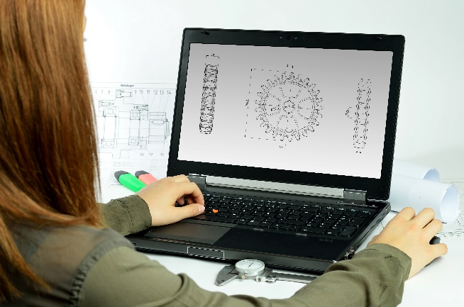
Incorporating the design process into the STEM modules will often result in the need for students to draw plans of their designs. This can be done at a simple level using hand-drawn sketches or at a more technical level using computer-aided design (CAD).
istockphoto.com
By developing skills using industry-standard software, students may be well-placed to explore future career pathways.
There are several CAD software options; two free examples are detailed below. Autodesk is a third package that is also free for educational use.
Tinkercad
- Format: Web-based app requiring internet access via a browser
- Purpose: A simple, online 3D design and 3D printing app
- Home: www.tinkercad.com
- Blog: blog.tinkercad.com
- Tutorials: www.tinkercad.com/learn
- Feature: Connects to 3D printing and laser cutting.
SketchUp
- Format: Can be downloaded and installed on devices, or used in a browser
- Purpose: Enables students to draw in 3D
- Home: www.sketchup.com 'Products' 'SketchUp for Schools'
- Help centre: help.sketchup.com/en
- Blog: blog.sketchup.com
- Tutorials: www.youtube.com/user/SketchUpVideo. From beginner tool tips to intermediate and advanced modelling techniques, the video tutorials help to build SketchUp skills.

Appendix 6: Reflective journal
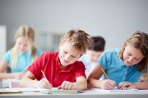
When students reflect on learning and analyse their own ideas and feelings, they self-evaluate, thereby improving their metacognitive skills. When students self-monitor or reflect, the most powerful learning happens.
istockphoto.com
Journaling may take the form of a written or digital journal, a portfolio or a digital portfolio. Early childhood classrooms may use a class reflective floor book with pictures of the learning experience and scribed conversations.
Teachers can model the journaling process by thinking aloud and showing students how they can express learning and thoughts in a variety of ways including diagrams, pictures and writing.
A journal is a useful tool that gives teachers additional insight into how students value their own learning and progress, as well as demonstrating their individual achievements.
The following links provide background information and useful apps for journaling.
Kidblog – digital portfolios and blogging
kidblog.org/home
Edmodo – for consolidating and storing class notes and learning materials
www.edmodo.com/
Explain Everything™ – a screen casting, video and presentation tool all in one
explaineverything.com
Popplet – allows you to jot down your ideas and then sort them visually
Popplet.com
Seesaw – for capturing work completed by students in class, using a device’s camera function
web.seesaw.me
Connect – the Department of Education’s integrated, online environment
connect.det.wa.edu.au
Evernote (a digital portfolio app)
evernote.com
Digital portfolios for students (Cool tools for school)
cooltoolsforschool.wordpress.com/digital-student-portfolios

Appendix 7: Student activity sheet 1.0: Journal checklist
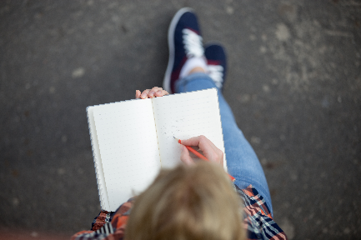
As an ongoing part of this module, you have been keeping a journal of your work.
Before submitting your journal to your teacher please ensure you have included the following information.
- Tick each box once complete and included.
- Write N/A for items that were not required in this module.
istockphoto.com

Your name and group member's names or photographs
An explanation of the problem you are solving
Your notes from Activity 1
Your notes from Activity 2
Your notes from Activity 3
Your notes from Activity 4
Student activity sheet 1.6: I see, I think, I wonder
Student activity sheet 1.7: Plastics flowchart
Student activity sheet 3.1: Concept brief
Student activity sheet 3.2: Action plan
Student activity sheet 4.1: Self-evaluation
Student activity sheet 1.0: Journal checklist

Appendix 8: Teacher resource sheet 1.1: Cooperative learning – Roles
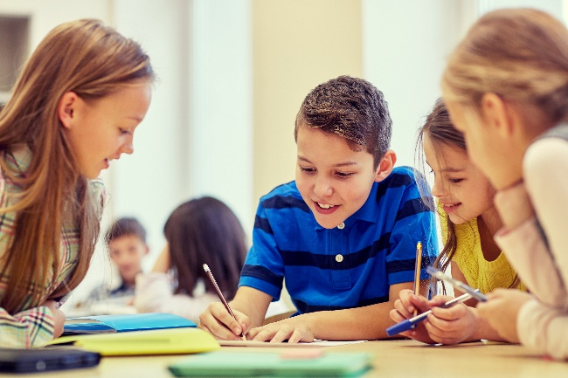
Cooperative learning frameworks create opportunities for groups of students to work together, generally to a single purpose.
istockphoto.com
As well as having the potential to increase learning for all students involved, using these frameworks can help students develop personal and social capability.
When students are working in groups, positive interdependence can be fostered by assigning roles to group members.
These roles could include:
- Working roles such as Reader, Writer, Summariser, Timekeeper
- Social roles such as Encourager, Observer, Noise monitor, Energiser.
Teachers using the Primary Connections roles of Director, Manager and Speaker for their science teaching may find it effective to also use these roles for STEM learning.
Further to this, specific roles can be delineated for specific activities that the group is completing.
It can help students if some background to the purpose of group roles is made clear to them before they start, but at no time should the roles get in the way of the learning. Teachers should decide when or where roles are appropriate to given tasks.
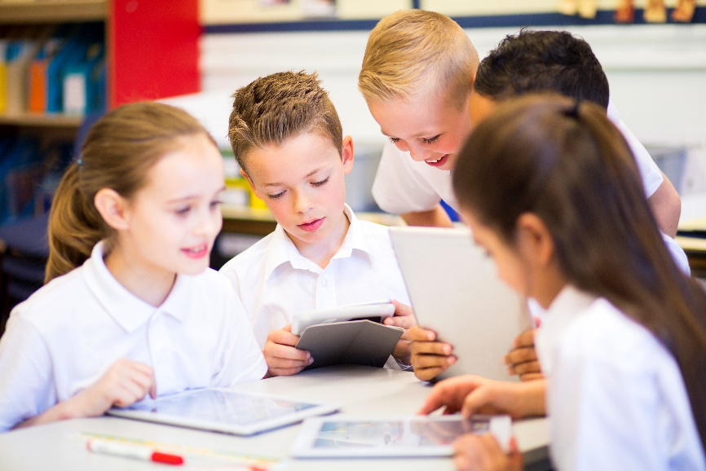
istockphoto.com

Appendix 9: Teacher resource sheet 1.2: Cooperative learning – Placemat
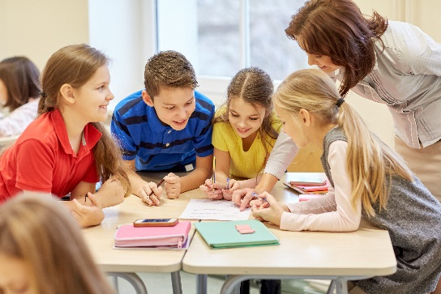
Cooperative learning frameworks create opportunities for groups of students to work together, generally for a single purpose.
As well as having the potential to increase learning for all students involved, using these frameworks can help students develop personal and social capability.
The placemat strategy involves students working collaboratively to record prior knowledge about a common topic and brainstorm ideas. It also allows teachers to readily see the contribution of each student. The diagram below shows a typical placemat template.
istockphoto.com

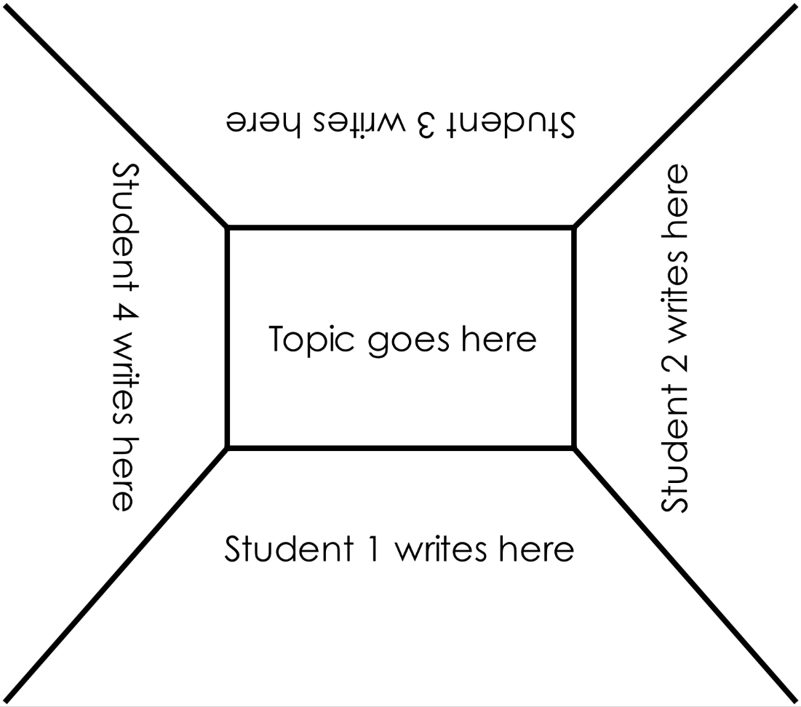
STEM Consortium

Appendix 10: Teacher resource sheet 1.3: Cooperative learning – Think-pair-share
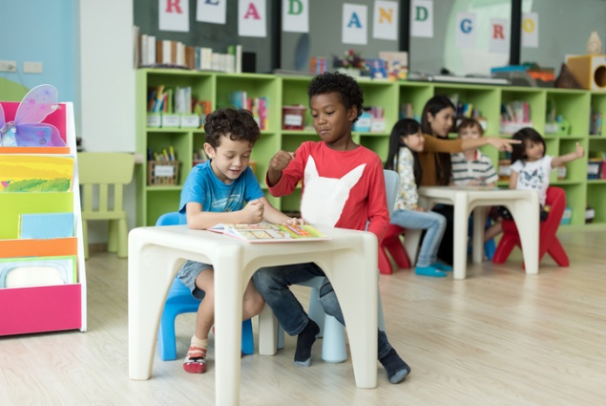
Cooperative learning frameworks create opportunities for groups of students to work together, generally to a single purpose.
istockphoto.com
As well as having the potential to increase learning for all students involved, using these frameworks can help students develop personal and social capability.
The think-pair-share strategy increases student participation and provides an environment for higher levels of thinking and questioning.
In the 'think' stage, each student thinks silently about a question asked by the teacher.
In the 'pair' stage, students discuss their thoughts and answers to the question in pairs.
In the 'share' stage, students share their answer, their partner's answer or what they decided together. This sharing may be with other pairs or with the whole class. It is important also to let students 'pass'. This is a key element of making the strategy safe for students.
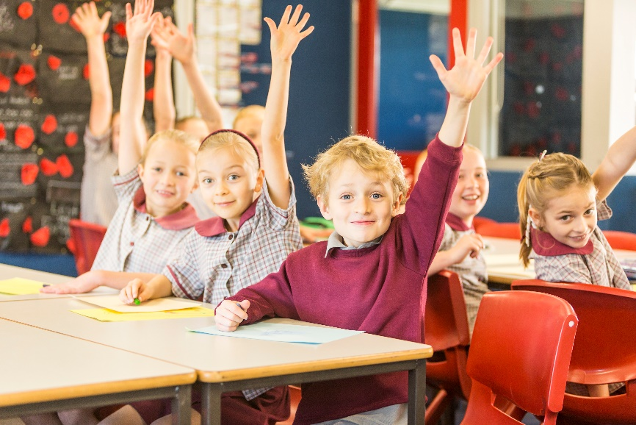
istockphoto.com

Appendix 11: Teacher resource sheet 1.4: Cooperative learning – Pass it on
Cooperative learning allows students to exchange ideas, thoughts or responses with each other, rather than with the teacher. It can generate new avenues of learning and multiple interactions with others can amplify student learning.
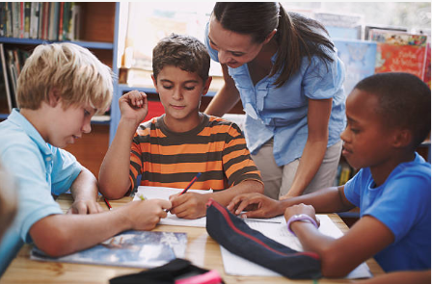
‘Pass it on’ is a brainstorming activity that starts with groups of four students, or however many can fit around a large sheet of paper and record ideas.
gettyimages.com
The groups are spread around the room in a circular shape. Each group has a large sheet of paper on which a nominated group leader writes the brainstorm topic or phrase in the middle.
The students have one minute to start recording ideas about the topic or phrase. When the minute has passed, each group leader takes their sheet to the neighbouring group, working in a clockwise direction.
Student groups, now with a new brainstorm paper, have 30 seconds to read it followed by 30 seconds to add something new, as exposure to new ideas can inspire more new ideas.
When that minute has passed, group leaders again must take their sheet to the neighbouring group to their left. Once again, students have 30 seconds to read, followed by 30 seconds to write.
Students continue this pattern until the sheets have completed a rotation to every group, or the sheets have no more space.
Following the activity, the teacher facilitates a class discussion by asking:
- What were the favourite ideas you read?
- What were the favourite ideas you recorded?
- What are the ideas you came up with after reading others’ ideas?
- Why do you think new ideas generate more new ideas?
The activity works well when students are motivated by the time limits; however, when conducting it for the first time, students may benefit with longer than one minute to learn the activity.

Appendix 12: Teacher resource sheet 1.5: Picture stimulus - Pollution
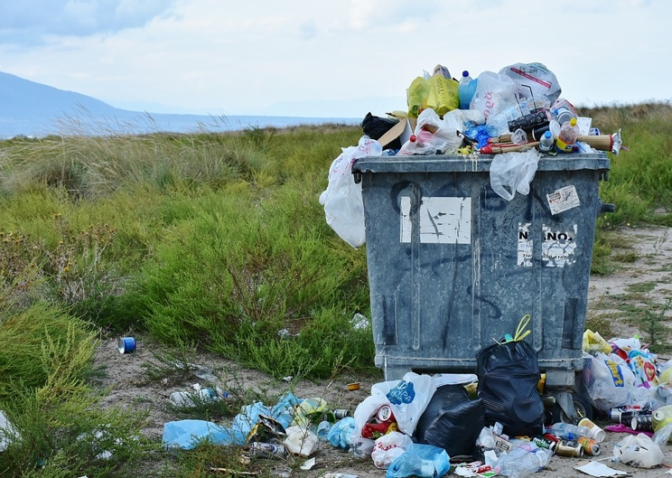
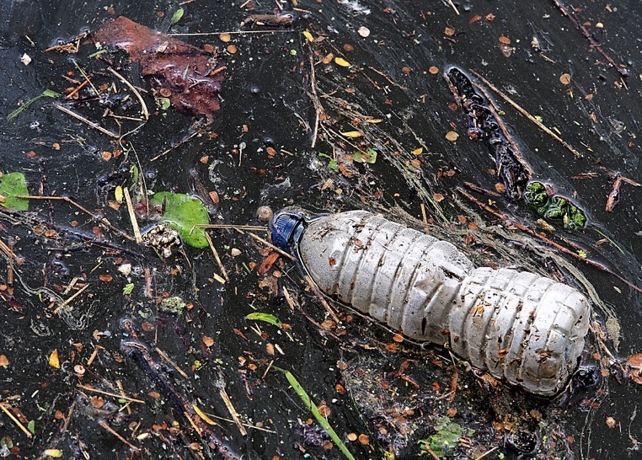
Pixabay.com
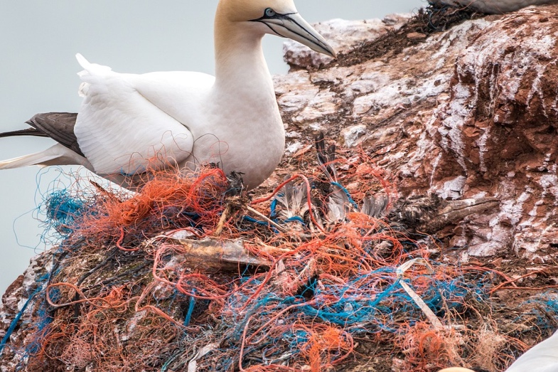
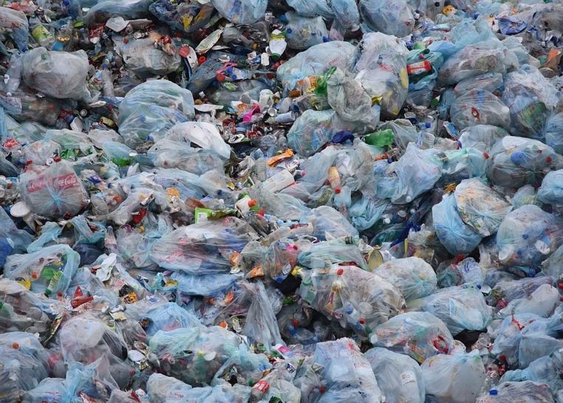

Appendix 13: Student activity sheet 1.6: I see, I think, I wonder

What do you see when you look at this image?
pixabay.com
What are you thinking about as you look at this image?
pixabay.com
What are your wonderings (questions)?
pixabay.com
Information about the I see, I think, I wonder cooperative strategy can be found at pz.harvard.edu/resources/see-think-wonder-at

Appendix 14: Student activity sheet 1.7: Hundreds grid

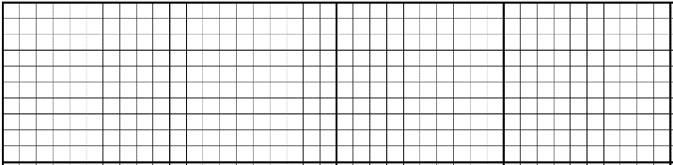

Appendix 15: Student activity sheet 1.8: Plastics flowchart
Put in recycle bins
Throw in rubbish
Oil and gas production
Item not wanted
What happens next?

Appendix 16: Teacher resource sheet 2.1: Recycling HDPE plastic
How to recycle High Density Polyethylene

General notes:
Many liquid containers and lids are made from HDPE.
HDPE melts into a pliable, sticky mass at 180° C without fumes.
HDPE cools quickly into hard plastic when removed from heat.
Use an oven set at 180° C or a flat sandwich toaster (max heat is180° C).
Protect the oven tray or toaster with sheets of oven bake paper.
The melted plastic does not stick to cotton oven mitts or wooden tools.
Any labels must be removed, and large containers need to be cut into small pieces.
Lids can be melted whole.

CAUTION:
Do not heat beyond 180° C or dangerous fumes can be emitted.
Only melt containers or lids that are labelled with the symbol ‘2’ – don’t guess.
Do not touch hot plastic without padded mitts – will stick and burn on bare skin.
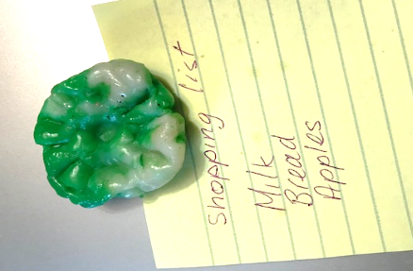
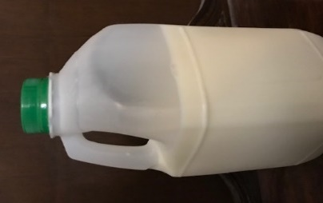
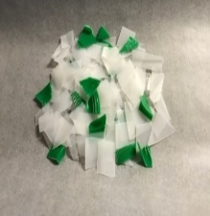
Instructions for making a fridge magnet
from a milk bottle and lid
- Cut up the milk bottle and lid, removing label.
Pre-heat oven to 180° C
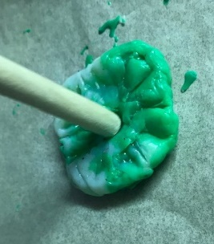
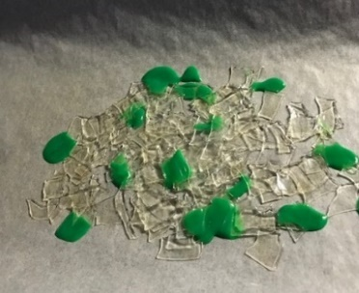

2. Place on baking paper on a tray in oven until melted – about 10 minutes

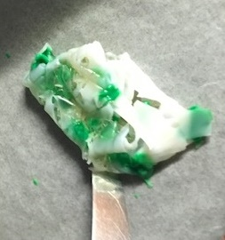

- Remove and mix with round ended knife while cooling

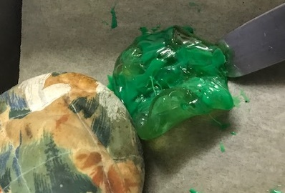

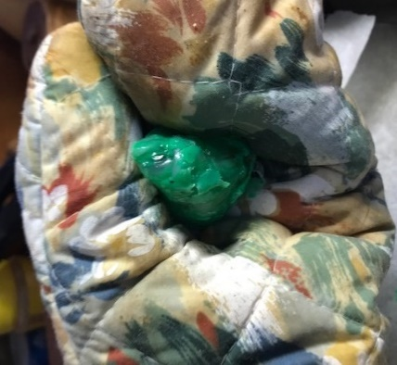
- Re-melt, remove and shape using oven mitts

- Re-melt, and reshape as desired using wooden spoon handle
- When cold, glue on a magnet

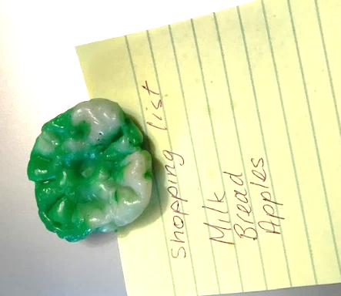

Appendix 17: Teacher resource sheet 2.2: Sample parent letter
(School details and letterhead)
(Date)

Dear Parents/Caregivers,
RE: ITEM COLLECTION FOR SCHOOL PROJECT
This term, our class is undertaking a STEM (Science, Technology, Engineering and Mathematics) project called Plastic pollution. This project will involve students investigating the detrimental effects that the excessive amounts of discarded plastics have on marine life.
Students will be asked to bring to school your clean discarded plastic and non-plastic items, from both normal rubbish and your recycle bin. Please ensure the items are thoroughly cleaned before sending to school.
Students will engage in solving the problem of how the use of plastics can be reduced and recycling increased. The project develops students’ ability to design, create and problem-solve.
They will also make beeswax wraps, string bags and recycle some discarded plastic by melting and reshaping into new items. For these activities, extra adult hands will be helpful. Please indicate below if you could be available during school hours on any particular weekday to assist. Help for this part of the project will begin on _______________.
At the culmination of the project, students will prepare presentations for an audience to increase awareness of the damage caused by plastics in the environment and ocean and to suggest solutions.
Thank you in advance,

(Classroom teacher)

Name __________________________________

I could be available to assist in the classroom on the following weekdays:

Monday Tuesday Wednesday Thursday Friday

Appendix 18: Student activity sheet 3.1: Concept brief
Group members:
Focus:
Considerations | Decisions
Audience
Background Information
Important message
How?
What with (media)?
Where?

Appendix 19: Student activity sheet 3.2: Action plan
Educational message – What do you want your audience to learn?
Team members and roles | Actions | Timeline
1.________________________________________________________________________
2.________________________________________________________________________
3. ________________________________________________________________________
4. ________________________________________________________________________
5. ________________________________________________________________________
6. ________________________________________________________________________
Feedback strategy

Appendix 20: Teacher resource sheet 3.3: Construction skills
Construction skills help students to generate and produce solutions for real-world problems.
This resource can be used as a visual stimulus to prompt students to develop solutions to design problems. The cards can be printed to create stations.
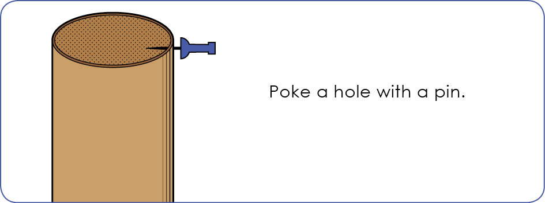
STEM Consortium
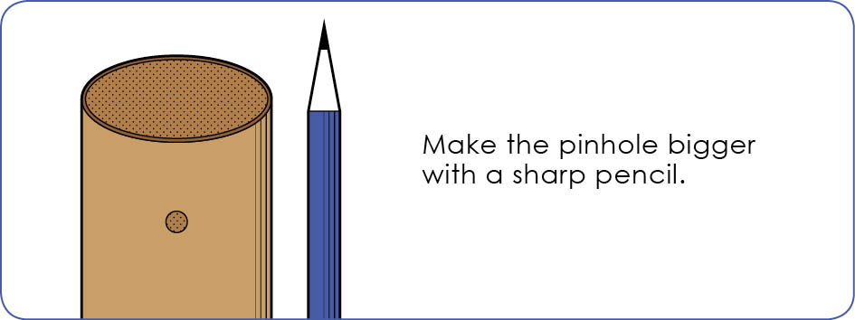
STEM Consortium
Poke a hole with a pin.

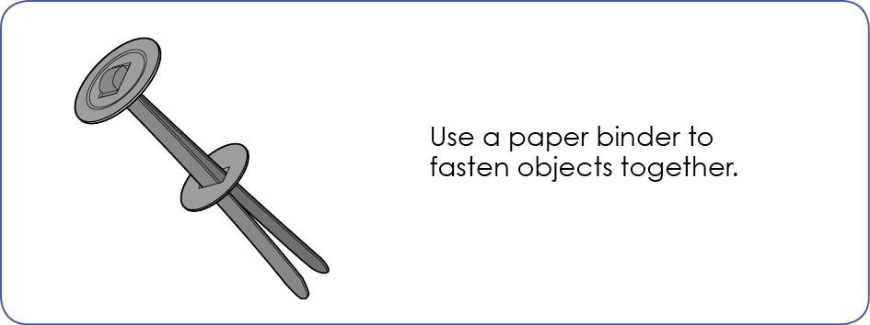
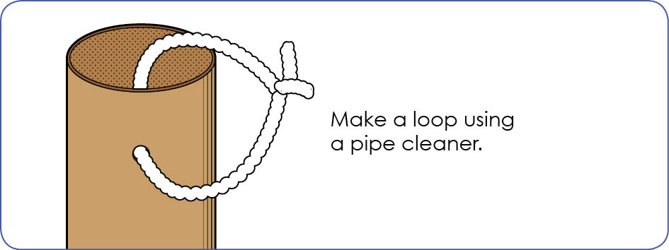
STEM Consortium
STEM Consortium
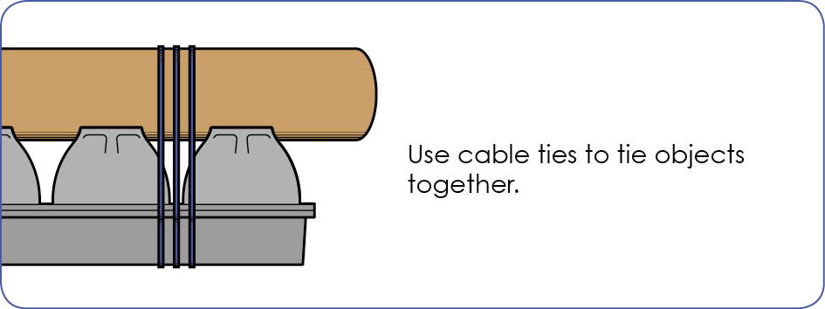
STEM Consortium

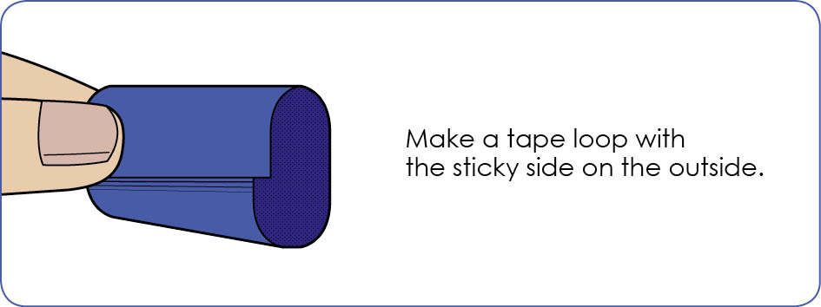
STEM Consortium

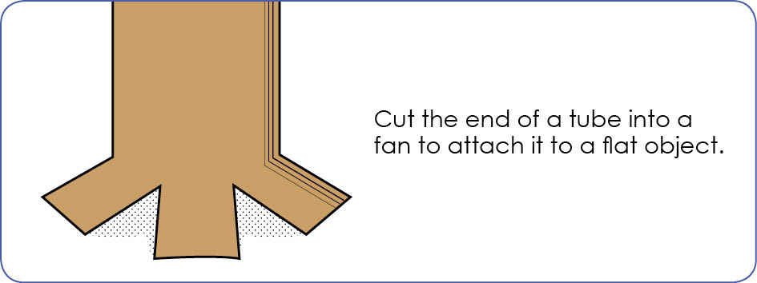
STEM Consortium
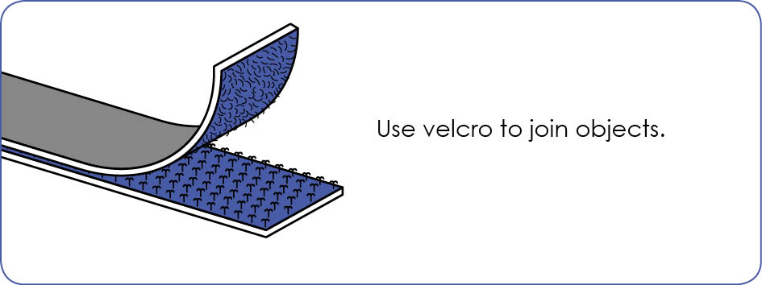
STEM Consortium

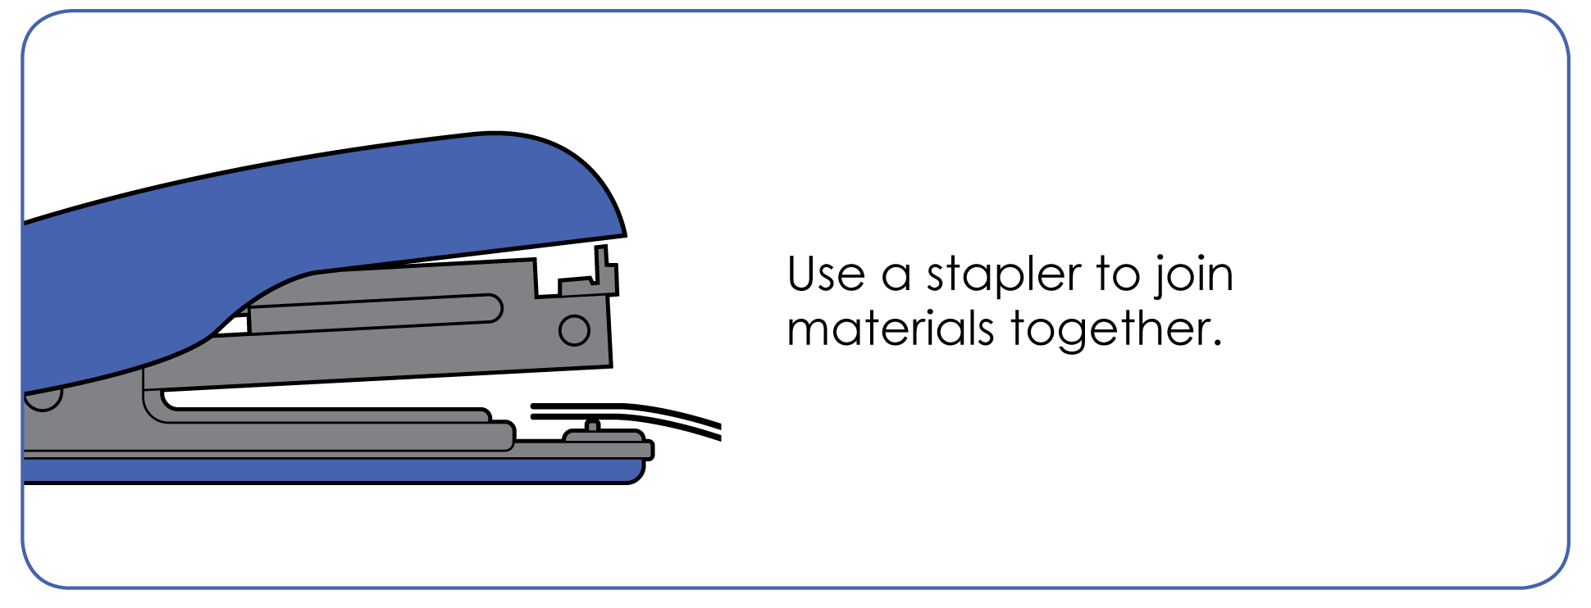
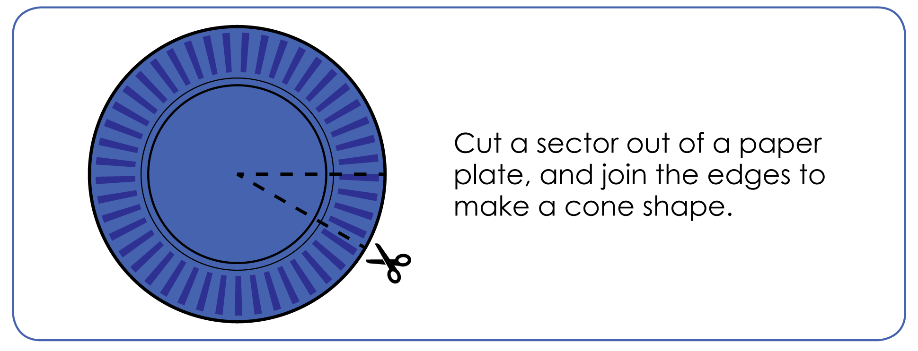
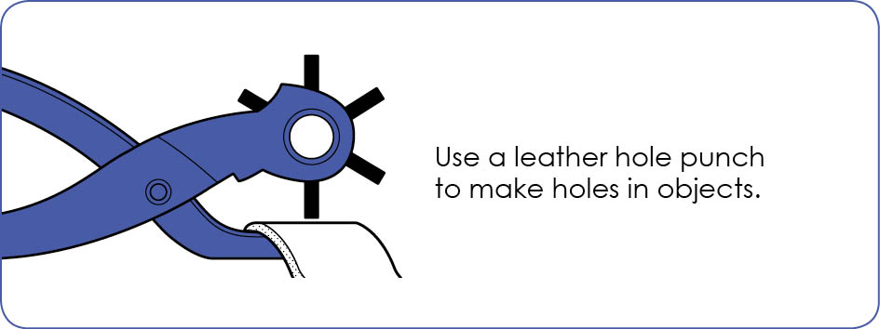
STEM Consortium
STEM Consortium
STEM Consortium

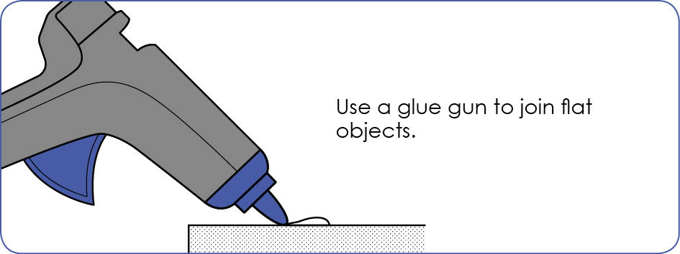
STEM Consortium

Appendix 21: Student activity sheet 4.1: Self-evaluation

Plastic pollution: Educative presentation
Photograph or drawing
What was your presentation? | How do you feel about your presentation?
 | pixabay.com
What do you like about your presentation | What could you have done better?
pixabay.com | pixabay.com
What would you do differently?

pixabay.com

Appendix 22: Teacher resource sheet 4.2: Student evaluation
Key:  - Sometimes  - Consistently  - Independently and consistently | Student name
Remains focused on tasks presented
Completes set tasks to best of their ability
Works independently without disrupting others
Manages time effectively
Cooperates effectively within the group
Contributes to group discussions
Shows respect and consideration for others
Uses appropriate conflict resolution skills
Actively seeks and uses feedback
Comments: ____________________________________________________________________________________________________________________________________________________________________________________________________________________________________________________________

