How to submit my work preferences and apply for relief work in WAIVS

Submit my preferences:
In order to submit your work preferences in WAIVS:
- Log into WAIVS using your employee ID and password.

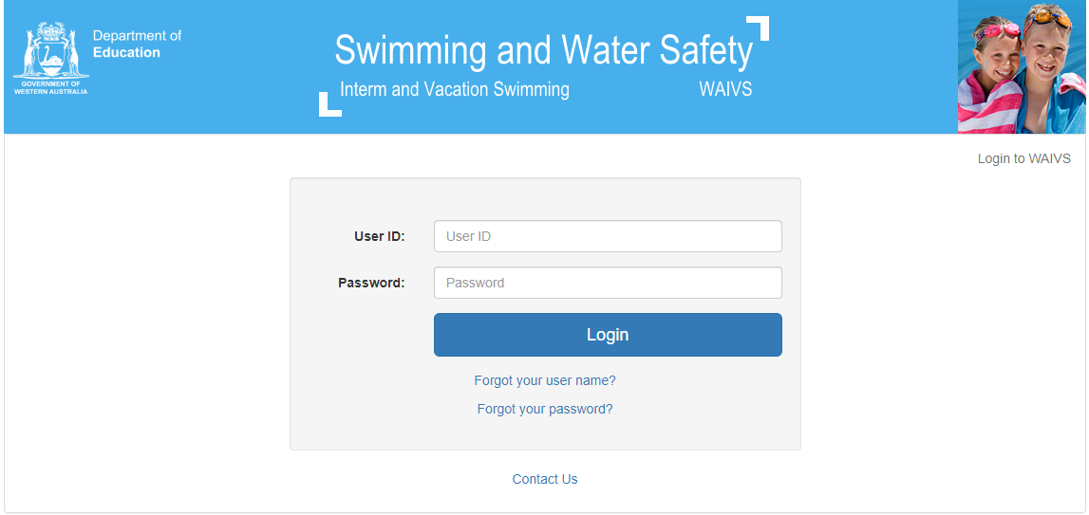

- Click on ‘Apply for Programs’ on the left hand side

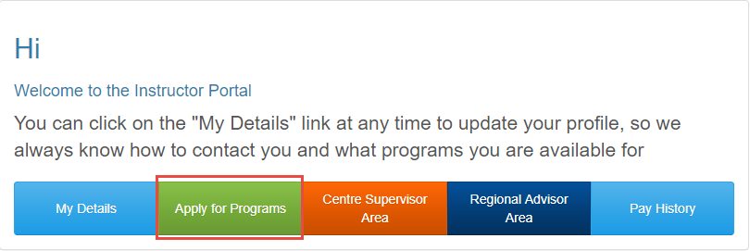

- Under ‘Apply for New Programs’ you will be able to click on the box to the left to select the program you would like to work and then click ‘apply’ at the bottom left of the screen.

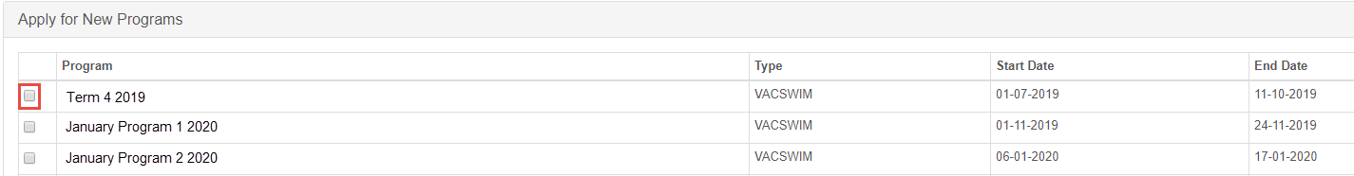

- Select the position/s you would like to apply for

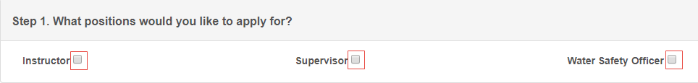

- The dates of the program will automatically populate in the ‘Avail from’ and ‘Avail to’ fields. If you are not available for the entire program, then edit the dates.

- Select if you are available for AM or PM or if you are available for Both

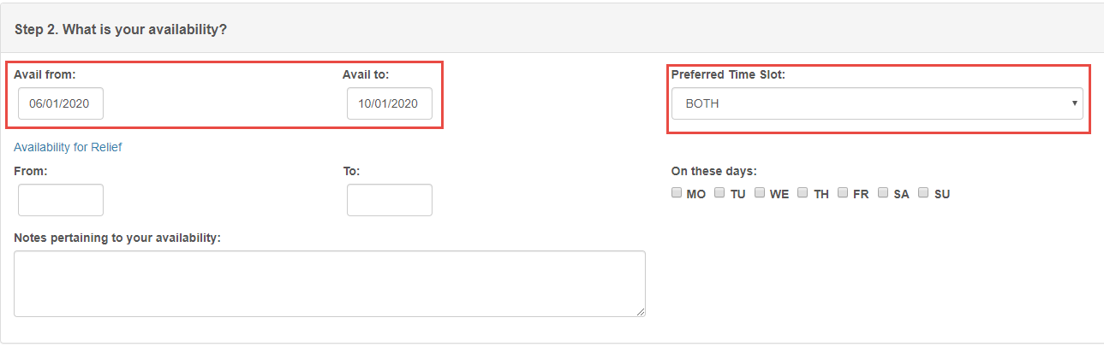

- Select the venues you would prefer to work at from the drop down. To select more than one venue click ‘add venue preference’ button

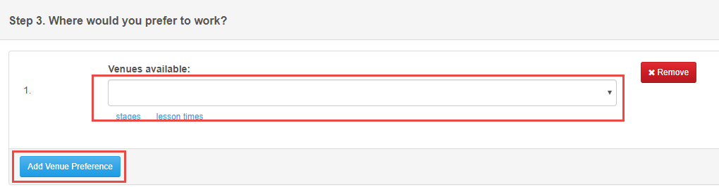

Note: it is recommended to have more than one venue selected in the metropolitan area.

- Click ‘Submit’ at the bottom left of the page.

Apply for relief work:

In order to submit your work preferences in WAIVS:
- Log into WAIVS using your employee ID and password.

- Click on ‘Apply for Programs’ on the left hand side

- Under ‘Apply for New Programs’ you will be able to click on the box to the left to select the program you would like to work and then click ‘apply’ at the bottom left of the screen.

- Select the position/s you would like to apply for

- The dates of the program will automatically populate in the ‘Avail from’ and ‘Avail to’ fields. If you are only available for relief then change ‘Avail from’ and ‘Avail to’ dates to be the same.

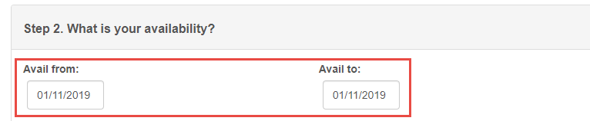

- Availability for relief ‘From’ and ‘To’ add the dates you are available for. Add ‘relief only’ to the Notes pertaining to your availability. If you are available for certain days, select the days you can work under on these days

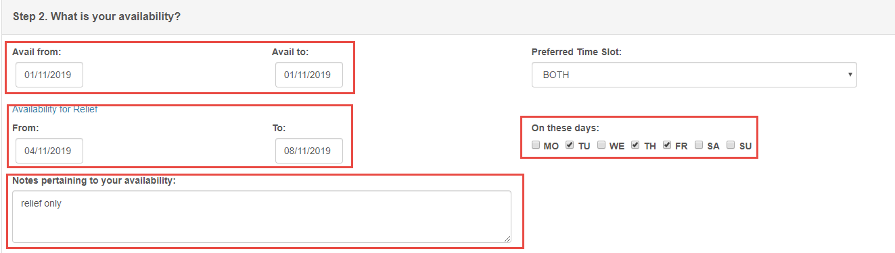

- Select the venues you would prefer to work at from the drop down. To select more than one venue click ‘add venue preference’ button

Note: it is recommended to have more than one venue selected in the metropolitan area.

- Click ‘Submit’ at the bottom left of the page.

