
D25/0322075

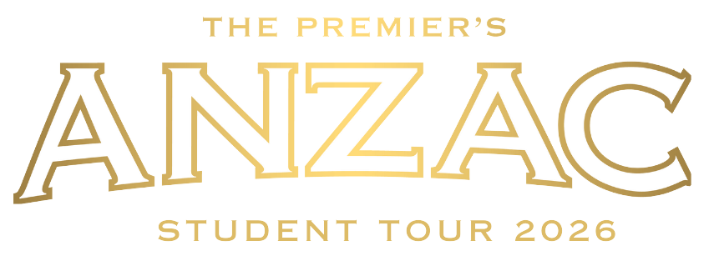

Student Application Package

2026
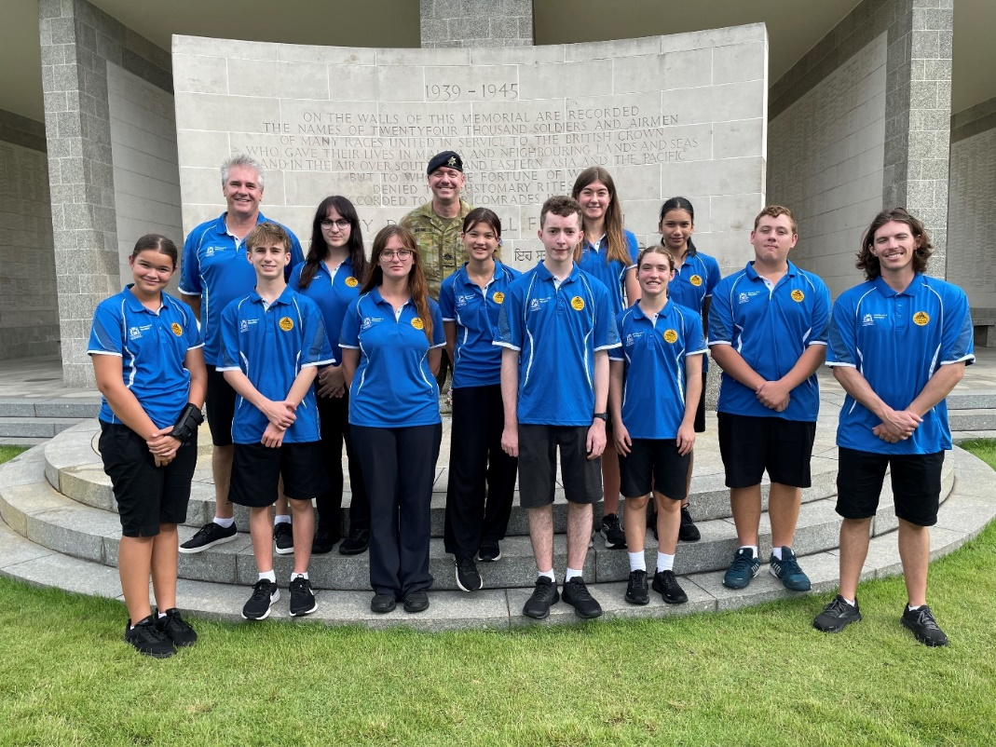

Image: https://freesvg.org/australian-world-war-1-soldiers-silhouette
The 2026 Premier’s Anzac Student Tour
The Premier’s Anzac Student Tour invites you to become an ambassador and represent Western Australia on a commemorative overseas study tour.
In 2026, the Premier’s Anzac Student tour will travel to Darwin and Singapore to acknowledge the 81st anniversary of the end of the Second World War, and the 84th anniversary of the bombing of Darwin and the fall of Singapore.
Over 993,000 Australians served in the armed forces during World War II. Of those, 27,073 were killed in action or died, 23,477 were wounded, and 30,560 were taken as prisoners of war by other nations. Of those taken prisoner, 8,296 died while in captivity. Remembrance, in the broader context, acknowledges men and women of the Commonwealth forces who died in all wars.
The tour will visit important historical sites including Darwin Military Museum, Adelaide River War Cemetery, World War II Oil Storage Tunnels, Stokes Hill, Kranji Cemetery and the Former Ford Factory. Applications close at 4:00 pm on Wednesday 30 July 2025.

Tour details
Ten students will be selected to participate in this historical commemorative study tour to Darwin and Singapore in the Term 1 School holidays 2026. Selected students will be accompanied by
3 adult supervisors.
The Western Australian Government will meet the cost of airfares, official clothing, accommodation, and the group’s meals when travelling. Parents will be responsible for meeting passport and visa expenses, travel insurance, immunisations and personal expenses.

Eligibility
To be eligible you must be a Western Australian student currently enrolled in Years 8 to 11 and display:
- a genuine interest in the Anzac experience
- an appreciation of the study of history
- excellent interpersonal skills and self-confidence
- a willingness to share your experiences (if selected) in your school and local community.
You will demonstrate an understanding of some of the positive values exhibited in times of war, the lessons of war for the current generation, and the importance of international peacekeeping processes and non-violent means of resolving conflict.

Competition process
Students may prepare individual responses as a class assessment task or as a personal project outside any assessment schedule.
To be eligible, all entrants require a nominating teacher and principal endorsement to attest to their suitability to represent their schools, communities and the state as youth ambassadors on the 2026 Premier’s Anzac Student Tour.
Schools may conduct their own selection process and can nominate up to 3 students in each of the 2 categories: Years 8 and 9, Years 10 and 11. All entries should be received no later than 4:00pm on Wednesday 30 July 2025.
Shortlisted applicants will progress to a state final where they will discuss their understanding of the Anzac legacy, and their capacity to act as youth ambassadors for Western Australia. Ten students will be selected to participate in the tour.

How to apply
There are 2 parts to the application:
PART 1: Written response
PART 2: Completion of application form
PART 1: Written response
Prepare and submit a written response of no more than 1000 words to the following:

Examine the actions of a Western Australian individual, or specific group within the Australian Defence Force, who have protected or currently protect Australians, and explain why commemorating their service continues to be important.

Please note
Entries should:
- be presented in a suitable form, or combination of forms, such as an article, essay, letter, speech, or short story of no more than 1000 words (excluding the bibliography)
- demonstrate historical understanding
- be clearly related to the 2026 topic
- be clearly expressed and logically structured
- include an accurate bibliography acknowledging references made (ensuring a variety of resource types are used – not just those found online)
- be original and not use the words or ideas of other people without acknowledgement
- use Arial 11 font
- be saved as a PDF
- be submitted no later than 4:00pm on Wednesday 30 July 2025 by email to anzactour@education.wa.edu.au

Possible topics (NOTE: You are not restricted to these topics)

- The Special Air Service Regiment (SASR)
- 10th Light Horse Regiment
- A family member
- Cyber systems, Intelligence, Communications
- The Royal Australian Navy
- The Royal Australian Air Force
- The Australian Army
- Humanitarian and peacekeeping operations
- Victoria Cross recipients

To assist with your written response, please refer to the 2026 competition rubric provided on page 7.

PART 2: Completion of application form
Complete all sections of the form.
To assist with the completion of part 2, you may refer to the 2026 application form rubric provided on page 7

Student application form

Please type all sections, then print, sign, scan and email to: anzactour@education.wa.edu.au

Personal details
First name
Last name
Preferred pronouns | ☐ he/him ☐ she/her ☐ they/them
Aboriginal or Torres Strait Islander | ☐ yes ☐ no
Home address
Suburb/town |  | Postcode
Home phone number
Mobile phone number
Email
Year group in 2025 | ☐ Year 8 ☐ Year 9 ☐ Year 10 ☐ Year 11
Citizenship | ☐ Australian citizen ☐ permanent resident ☐ temporary visa
Current passport | ☐ yes ☐ no  NOTE: Students selected for 2026 Premier’s Anzac Student Tour who do not currently hold a valid passport will need to submit a passport application.

School details
School you attend in 2025
School you will attend in 2026
Current school address
Suburb/Town |  | Postcode
Telephone
Nominating teacher
Email
Nominating principal
Email

Write a short statement that accurately describes you to the selection panel.
Applicants are advised to confine responses to the space provided.
Why should you be selected to join the 2026 Premier’s Anzac Student Tour?
Applicants are advised to confine responses to the space provided.
Have you previously travelled or studied away from home within the past 5 years? If yes, please indicate where, when, for how long, and any lessons learned.
Applicants are advised to confine responses to the space provided.

Student declaration
I declare that the information provided is a true and accurate account and my written entry is my original work with no more than general guidance provided by others.
Full name
Signature
Date

Principal declaration
I support the entry of the above-named student as a suitable nominee for the 2026 Premier’s Anzac Student Tour as an ambassador for Western Australia.
Full name
Position
Signature
Date

Family/Caregiver declaration
I give permission for my child ___________________________to participate in the 2026 Premier’s Anzac Student Tour competition and, if selected, to travel on an interstate and overseas study tour in April 2026.
Full name
Relationship to student
Signature
Date

2026 Competition rubric

Part A  Written response | Excellent  achievement | High  achievement | Satisfactory  achievement
Historical knowledge and understanding demonstrated in response to the 2026 topic | Excellent use of relevant historical knowledge and understanding in response to the 2026 topic. Clearly examines the actions of a Western Australian individual, or specific group within the Australian Defence Force, who have protected or currently protect Australians, and explain why commemorating their service continues to be important. | Good use of some relevant historical knowledge and understanding in response to the 2026 topic. Includes detailed discussion of the actions of a Western Australian individual, or specific group within the Australian Defence Force, who have protected or currently protect Australians, and explain why commemorating their service continues to be important. | Some examples of historical knowledge and understanding are evident in response to the 2026 topic. Includes a discussion of the actions of a Western Australian individual, or specific group within the Australian Defence Force, who have protected or currently protect Australians, and explain why commemorating their service continues to be important.
 | Complex development of ideas and researched detail of a WA example. | Well-developed ideas with researched detail of a WA example. | Includes researched detail of a WA example.
Use of written communication form  (article, essay, letter, short story, speech) | Sophisticated use of subject specific vocabulary throughout. Language conventions, spelling and grammar are accurate and applies conventions of selected form. | Subject specific vocabulary used throughout. Language conventions, spelling and grammar are mostly accurate and applies conventions of selected form. | Some subject specific vocabulary used throughout. Language conventions, spelling and grammar are sometimes accurate and appropriate to the form chosen.
Use of primary and secondary sources | Evidence of a wide range of primary and secondary sources used to explore the 2026 topic. | Evidence of primary and secondary sources used to explore the 2026 topic. | Evidence of primary and secondary sources used in response to the 2026 topic.
Bibliography  Acknowledgement of references | Accurate bibliography and references throughout. | Accurate bibliography and references acknowledged. | Bibliography included and references acknowledged.

Part B  Application form | Excellent  achievement | High  achievement | Satisfactory  achievement
Genuine interest in the Anzac experience | Strong examples that demonstrate a genuine interest in the Anzac experience. | Suitable examples that show genuine interest in the Anzac experience. | Some examples showing interest in the Anzac experience.
Capacity to act as youth ambassador | High awareness of own skills and attributes. | Awareness of own skills and attributes. | Includes some awareness of skills and attributes.

Application submission
All entries should be received by the Tour Coordinator no later than
4:00pm Wednesday 30 July 2025.
Late applications will not be accepted. E: anzactour@education.wa.edu.au

Important dates

- 30 July 2025 Applications close
- 11 - 25 August 2025 Selection panels shortlist state finalists
- 10 September 2025 State finalists announced
- 10 October 2025 State final group discussion
- November 2025 Announcement of the 10 successful students
- March 2026 Pre-tour briefing
- April holidays 2026 2026 Tour

Enquiries and information

Karen Lamond
E: anzactour@education.wa.edu.au
W: https://www.education.wa.edu.au/premiers-anzac-student-tour
T: 9402 6123

Premier’s Anzac Student Tour Coordinator
Secondary Schools, District Hight Schools & Post-School Pathways
Statewide Services Centre
33 Giles Avenue
PADBURY WA 6025

