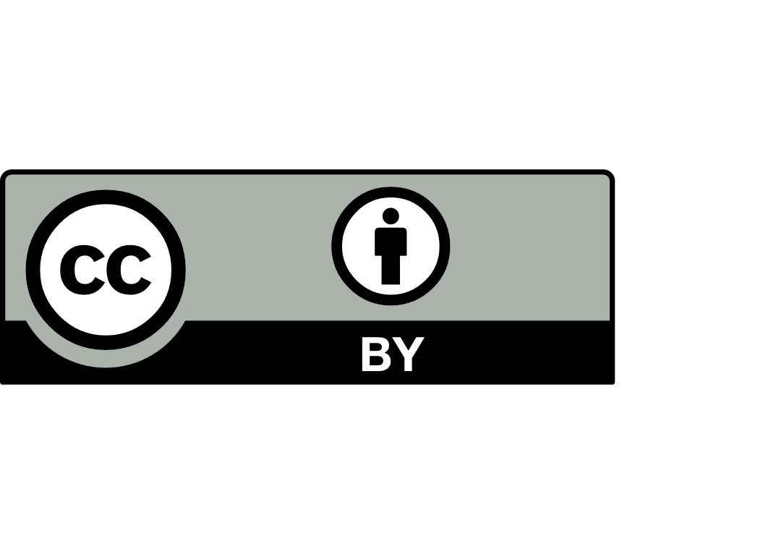
Application for exemption from compulsory school enrolment
Non-Government School Regulation

Relevant legislation
- Under section 11 of the School Education Act 1999 (WA) the Minister may exempt a child from compulsory education if the Minister is satisfied it is in the best interest of the child.
- Under section 11(6) of the Act, the Minister has delegated power to exempt children enrolled at
non-government schools to the Director General of the Department of Education.
- An exemption may be granted subject to conditions specified in the exemption approval letter and the exemption may be revoked at any time.

Collection notice for non-government school regulation
We collect personal information for the purpose of administering key clauses of the Act and the School Education Regulations 2000 and make recommendations to the Director General about school registration, compliance and exemption of students enrolled at non-government schools.

We use the information to register, assess and monitor your application and ongoing responsibilities. Information may be shared with authorised Department staff and, where necessary, other agencies or parties as permitted or required by law. Your information will be stored securely within Australia with access restricted to authorised staff. Personal information is retained and disposed of following the Department’s Records Management Policy and the State Records Act 2000.

If the information is not collected, we cannot assess your application. You may request access to, or correction of, your information. Email the Non-Government School Regulation directorate at NGSRegulation@education.wa.edu.au. For further information about how we handle personal information, refer to the Collection notice for non-government school regulation and our Privacy Statement.

Submission
Email the completed form and relevant attachments to NGSRegulation@education.wa.edu.au.

Enquiries
Telephone: (08) 9441 1900
Email: NGSRegulation@education.wa.edu.au

Applicant details
Relationship to child (for example parent or guardian) |  | Click or tap to enter text
Full Name | Click or tap to enter text
Address | Click or tap to enter text
Suburb | Click or tap to enter text |  | State | Click or tap | Postcode | Click or tap
Email | Click or tap to enter text |  | Mobile | Click or tap to enter text
I hereby apply for the child, whose details are given below, to be exempt from compulsory education under section 11 of the Act and agree to advise the Department of Education should these details change.
Signature |  | Date |  | Click or tap to enter date

Student details
Full name | Click or tap to enter text
Date of birth | Click to select date
Address | Click or tap to enter text
Suburb | Click or tap |  | State | Click or tap | Postcode |  | Click or tap
Email | Click or tap |  |  | Mobile |  | Click or tap
Current school |  | Click or tap to enter current school name
Current year level |  | Click or tap to enter current year level
Year level to be exempt |  | Click or tap to enter text

Reason for seeking exemption from school
Undertaking a full-time course at a TAFE. Attach a copy of enrolment confirmation and information on course duration, start and end dates. | ☐
Undertaking a full-time apprenticeship or traineeship. Complete section 5 and attach a copy of completed apprenticeship contract, training contract or letter of acceptance and information on course duration including start and end dates. | ☐
Undertaking a full-time course at a private Registered Training Organisation, University, higher education institution or Community Based Course. Attach a copy of enrolment confirmation and information on course duration including start and end dates. | ☐
Undertaking full-time employment. Complete section 6 and attach a copy of the employment contract and information on hours of work per week including start and end dates. | ☐
Undertaking a combination of approved options (detail below). Attached copies of supporting documentation and/or complete section 6, if applicable. | ☐

Proposed commencement date for exemption
Click or tap to enter date

Proposed exemption end date*
Click or tap to enter date
*Exemptions may only be considered for the period up to the end of Year 10.

6. Employer details (if applicable)
Business name or employer name and Australian Business Number (ABN) |  | Click or tap to enter text
Address |  | Click or tap to enter text
Suburb |  | Click or tap to enter text | State | Click or tap | Postcode | Click or tap
Contact person  name and role |  | Click or tap to enter text
Email | Click or tap |  | Mobile |  | Click or tap
Occupation of child (role/title) | Click or tap to enter text |  | Days and hours per week the child is to be employed |  | Click or tap to enter text
Signature of employer |  |  |  | Date | Click or tap to enter date

7. School recommendation and comments (must be completed by school principal)
Consider the following when preparing your response:
- What is your understanding of the reason for an exemption?
- What measures did the school put in place to re-engage the student?
- Why do you believe that an exemption from schooling would be in this student's best interests?

Click or tap to enter text
Name of principal | Click or tap to enter text
Signature of principal |  | Date | Click or tap to enter date

