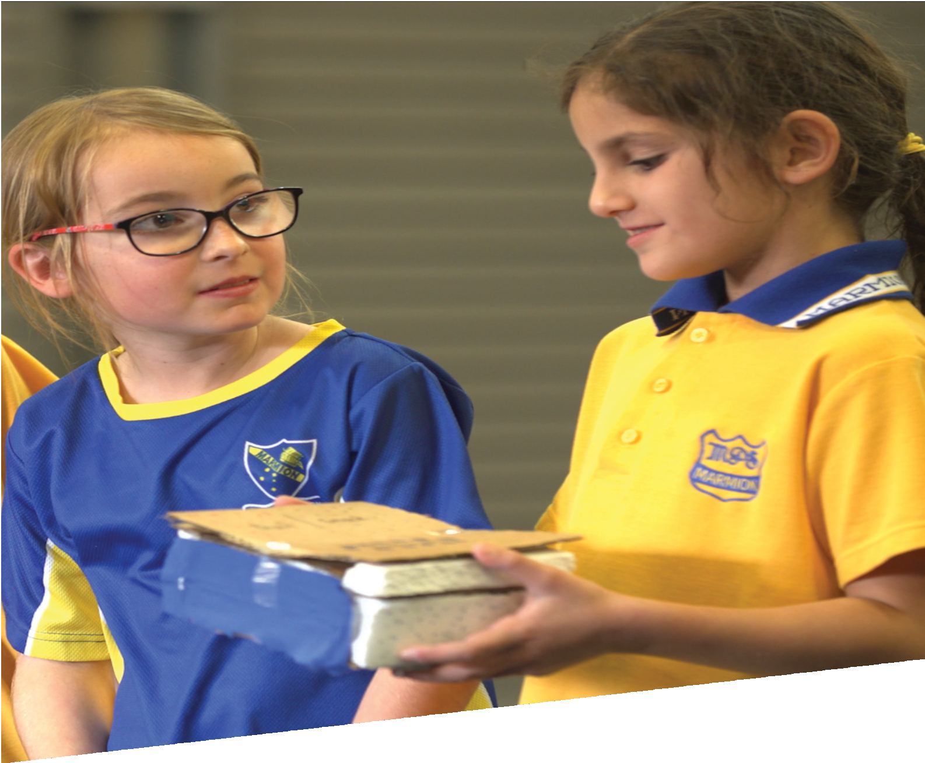

CURRICULUM RESOURCE MODULE
Cool lunch
YEAR 3

Acknowledgements
The STEM Learning Project respectfully acknowledges the Traditional Custodians of the lands upon which our students and teachers live, learn and educate.

The STEM Learning Project is funded by the Western Australian Department of Education (the Department) and implemented by a consortium in STEM education comprising the Educational Computing Association of WA, the Mathematical Association of WA, the Science Teachers Association of WA and Scitech. We acknowledge and thank the teachers and schools who are the co-creators of these resources.
Copyright and intellectual property
The copyright and intellectual property of this module remain the property of the Department.

Any Western Australian Curriculum content in this resource is used with the permission of the School Curriculum and Standards Authority (the Authority); this permission does not constitute Authority endorsement of the resource. The Authority accepts no liability for any errors or damages arising from reliance on its content.

The Western Australian Curriculum content may be freely copied, or communicated on an intranet, for non-commercial purposes in educational institutions, provided that the Authority is acknowledged as the copyright owner. Copying or communication for any other purpose can be done only within the terms of the Copyright Act 1968 or with prior written permission of the Authority. Any Australian Curriculum content in the Western Australian Curriculum is used by the Authority under the terms of the Creative Commons Attribution-NonCommercial 3.0 Australia licence.

Any content on the www.scsa.wa.edu.au domain that has been derived from the Australian Curriculum may be used under the terms of Creative Commons Attribution-NonCommercial 3.0 Australia licence.

Appendix 2: General capabilities continuums is adapted from ACARA, © Australian Curriculum, Assessment and Reporting Authority (ACARA) 2009 to present, unless otherwise indicated. This material was downloaded from the ACARA website (www.acara.edu.au) (accessed December 2015) and was not modified. The material is licensed under CC BY 4.0 (https://creativecommons.org/licenses/by/4.0/). ACARA does not endorse any product that uses ACARA material or make any representations as to the quality of such products. Any product that uses material published on this website should not be taken to be affiliated with ACARA or have the sponsorship or approval of ACARA. It is up to each person to make their own assessment of the product.

This resource includes references and examples of iOS, Android and other apps. The Department does not endorse or recommend any commercial products and simply provides these as examples for teachers.

The Department is committed to providing quality information to its customers. Whilst every effort has been made to ensure accuracy, currency and reliability of the information within these documents, the Department accepts no responsibility for errors, omissions or amendments made since the time of publishing. Confirmation of information may be sought from the Department or the originating bodies providing the information. The Department has no control over the content of material published on websites to which users are referred in this resource. It is the responsibility of the internet user to make their own decision as to the relevancy, accuracy, currency and reliability of information found on those sites.

This resource contains various images from iStock used under license.

Attributions: iMovie, Seesaw, Class Dojo, Padlet, Skype, Explain Everything, Kidblog, Evernote, Edmodo, Cool tools for school, QR codes.

Table of contents

The STEM Learning Project 2
Overview 3
Activity sequence and purpose 7
Background 8
Activity 1: Hot weather and spoilt food 10
Activity 2: Heat energy transfer 16
Activity 3: Design, create, test and modify 24
Activity 4: Share and evaluate 29
Appendix 1: Links to the Western Australian Curriculum 33
Appendix 1B: Mathematics proficiency strands 35
Appendix 2: General capabilities continuums 36
Appendix 3: Materials list 39
Appendix 4: Design process guide 40
Appendix 4B: Drawing in the design process 41
Appendix 5: Reflective journal 42
Appendix 6: Student activity sheet 1.0: Journal checklist 43
Appendix 7: Teacher resource sheet 1.1: Cooperative learning – Roles 44
Appendix 8: Teacher resource sheet 1.2: Cooperative learning – Jigsaw 45
Appendix 9: Teacher resource sheet 1.3: Cooperative learning – Placemat 46
Appendix 10: Teacher resource sheet 1.4: Cooperative learning – Think, Pair, Share 47
Appendix 11: Teacher resource sheet 2.1: Glossary 48
Appendix 12: Student activity sheet 2.2: Water cups experiment 50
Appendix 13: Student activity sheet 2.3: Lunch container temperatures investigation 51
Appendix 14: Teacher resource sheet 3.1: Construction skills 53
Appendix 15: Student activity sheet 3.2: Prototype troubleshooting 57
Appendix 16: Student activity sheet 3.3: Design review 58
Appendix 17: Teacher resource sheet 4.1: Student evaluation 59
Appendix 18: Student activity sheet 4.2: 3 – 2 – 1 Reflection 60

The STEM Learning Project
The aim of the STEM Learning Project is to generate students’ interest, enjoyment and engagement with STEM (Science, Technology, Engineering and Mathematics) and to encourage their ongoing participation in STEM both at school and in subsequent careers. The curriculum resources will support teachers to implement and extend the Western Australian Curriculum across Kindergarten to Year 12 and develop the general capabilities.
Why STEM?
A quality STEM education will develop the knowledge and intellectual skills to drive the innovation required to address global economic, social and environmental challenges.
STEM capability is the key to navigating the employment landscape changed by globalisation and digital disruption. Routine manual and cognitive jobs are in decline whilst non-routine cognitive jobs are growing strongly in Australia. Seventy-five per cent of the jobs in the emerging economy will require critical and creative thinking and problem-solving, supported by skills of collaboration, teamwork and literacy in mathematics, science and technology. This is what we call STEM capability. The vision is to respond to the challenges of today and tomorrow by preparing students for a world that requires multidisciplinary STEM thinking and capability.
The approach
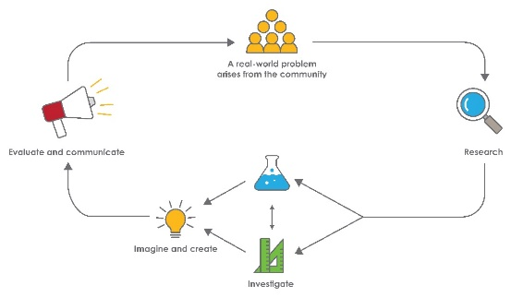
STEM capabilities are developed when students are challenged to solve open-ended, real-world problems that engage students in the processes of the STEM disciplines.

Year 3 – Cool lunch
STEM Consortium

Overview
In Australia, school students take food to eat for recess and lunch in a variety of containers. The lunch containers can remain outdoors in school bags, which are sometimes exposed to extreme weather conditions. Consequently, lunch containers may be subject to high temperatures for several hours before the food is consumed.
In some types of lunch foods, temperatures between 4°C to 60°C can cause bacteria and other pathogens to grow rapidly and cause illness.
In this module, students investigate how heat energy from the Sun transfers across a variety of materials, affecting the internal temperature of lunch containers. They conduct experiments to identify materials that absorb or reflect heat and draw on their findings to create, test and justify designs for effective lunch containers.
What is the context?
Heat energy, from the Sun or from the air on a hot day can heat lunch containers causing the inside temperature to increase and impact on the safety of the food.
What is the problem?
How can we design a lunch container that will help protect food from being spoilt?

How does this module support integration of the STEM disciplines?
Science
In Year 2, students will have been introduced to the idea that Science involves observing, asking questions about, and describing changes in objects and events and will have engaged in simple science inquiry skills that are almost fully teacher-directed.
New science contexts can be introduced in this module when students describe the transfer of heat from the Sun to a variety of materials (ACSSU049: Heat can be produced in many ways and can move from one object to another). Students can also investigate changes of state between solids and liquids caused by adding or removing heat (ACSSU046: A change of state between solid and liquid can be caused by adding or removing heat). Students will be assisted to identify questions about heat energy transfer and food spoilage, making predictions based on prior knowledge (ACSIS053: With guidance, identify questions in familiar contexts that can be investigated scientifically and make predictions based on prior knowledge).
Working collaboratively, students conduct a fair test of the temperatures of a range of lunch containers over a set period, accurately recording data and observations. They plan and conduct similar tests on materials used for their lunch container solution (ACSIS055: Consider the elements of fair tests and use formal measurements and digital technologies as appropriate, to make and record observations accurately).
Technology
Technology skills are developed when students represent designs for a lunch container solution as labelled drawings, select appropriate tools for use during the construction of their solution and practise safety skills (ACTDEK013: Suitability and safe practice when using materials, tools and equipment for a range of purposes). Students work collaboratively to design, create, test the product, record the process and use digital technologies to organise and communicate information. They evaluate the effectiveness of their designed item, using oral group feedback and personal reflection strategies (WATPPS17: Develop and communicate ideas using labelled drawings and appropriate technical terms, WATPPS19: Use criteria to evaluate design processes and solutions developed, and WATPPS20: Works independently, or collaboratively when required, to plan, create and communicate sequenced steps).
The Design process guide is included as a resource to help teachers understand the complete design process as developed in the Technologies curriculum.

Mathematics
Students collect, organise and record data to answer their questions about heat energy. They work in groups to plan their experiments and consider how they will collect their data. Students choose and use diagrams, tables or graphs suited to their data and its purpose, and can explain reasons for their choices about the methods of data collection and representation.
Students participate in discussions to understand that classification underlies the organisation of data and there are differences between data and their interpretations. When reading their data students compare the results, calculating totals and differences and draw conclusions based on their interpretations (ACMSP068: Identify questions or issues for categorical variables. Identify data sources and plan methods of data collection and recording; ACMSP069: Collect data, organise into categories and create displays using lists, tables, picture graphs and simple column graphs, with and without the use of digital technologies, and ACMSP070: Interpret and compare data displays). In their investigations they will use a digital thermometer and be introduced to the use of formal units to measure temperature, supporting their future learning needs.
General capabilities
There are opportunities for the development of general capabilities and cross-curriculum priorities as students engage with Cool lunch. In this module, students:
- Develop problem-solving skills as they research the problem and its context (Activity 1); investigate parameters impacting on the problem (Activity 2); imagine and develop solutions (Activity 3); and evaluate and communicate their solutions to an audience (Activity 4).
- Utilise creative thinking as they generate possible design solutions; and critical thinking, numeracy skills and ethical understanding as they choose between alternative approaches to solving the problem.
- Utilise personal and social capability as they develop socially cohesive and effective working teams; collaborate in generating solutions; adopt group roles; and reflect on their group work capabilities through self and peer evaluation.
- Utilise a range of literacies and information and communication technologies (ICT) capabilities as they collate records of work completed throughout the module in a journal, and represent and communicate their solutions to an audience using digital technologies in Activity 4.

What are the pedagogical principles of the STEM learning modules?
The STEM Learning Project modules develop STEM capabilities by challenging students to solve real-world problems set in authentic contexts. The problems engage students in the STEM disciplines and provide opportunities for developing higher order thinking and reasoning, and the general capabilities of creativity, critical thinking, communication and collaboration.
The design of the modules is based on four pedagogical principles:
- Problem-based learning
This is an underlying part of all modules with every module based around solving an initial problem. It is supported through a four-phase instructional model: research the problem and its context; investigate the parameters impacting on the problem; design and develop solutions to the problem; and evaluate and communicate solutions to an authentic audience.
- Developing higher order thinking
Opportunities are created for higher order thinking and reasoning through questioning and discourse that elicits students' thinking, prompts and scaffolds explanations, and requires students to justify their claims. Opportunities for making reasoning visible through discourse are highlighted in the modules with the icon shown here.
- Collaborative learning
This provides opportunities for students to develop teamwork and leadership skills, challenge each other’s ideas, and co-construct explanations and solutions. Information that can support teachers with aspects of collaborative learning is included in the resource sheets.
- Reflective practice
Recording observations, ideas and one’s reflections on the learning experiences in some form of journal fosters deeper engagement and metacognitive awareness of what is being learnt. Information that can support teachers with journaling is included in the resource sheets.
These pedagogical principles can be explored further in the STEM Learning Project online professional learning modules located in Connect Resources.

Activity sequence and purpose
Hot weather and spoilt food
Students’ interest is captured by engaging them with the problem of hot weather affecting perishable foods. Students make connections between heat energy from the Sun, food temperatures and food spoilage.
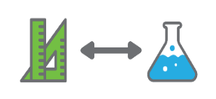 | Heat energy transfer  Students investigate how heat energy from the Sun is transferred in different ways across different materials.
Design, create, test and modify
Students collaborate to design and create a model of a lunch container to reduce the transfer of heat from the Sun to the food. Students test their models, record data and make modifications as necessary.
Share and evaluate
Groups present their lunch container models, justifying design choices to the class and, where possible, to an audience beyond the classroom. Students evaluate the design process.

Background
Expected learning | Students will be able to:  - Describe variations in the extent to which heat is transferred by different materials.  - Explain that when the temperature of an object falls it is losing heat and when the temperature of an object increases it is gaining heat.  - Be guided to identify questions and make predictions based on prior knowledge.  - Be guided to conduct a fair test, and collect and record observations and measurements.  - Follow the design process to create and describe key features of their design using labelled drawings and appropriate language.  - Select and safely use appropriate tools for constructing their prototype.  - Represent collected data using tables and graphs, and identify patterns and relationships in the data.  - Interpret data, compare it to their predictions and suggest possible reasons for the results.  - Work collaboratively to design, create and evaluate their design.  - Use digital technologies to organise and present information about their design as well as the design process.
Vocabulary | This module uses subject-specific terminology, which is shown in Teacher resource sheet 2.1: Glossary.
Timing | There is no prescribed duration for this module. The module is designed to be flexible enough for teachers to adapt. Activities do not equate to lessons; one activity may require more than one lesson to implement.
Consumable materials | A Materials list is provided for this module. The list outlines materials outside of normal classroom equipment that will be needed to complete the activities.
Safety notes | There are potential hazards inherent in these activities and with the equipment being used, and a plan to mitigate any risks will be required.  Potential hazards specific to this module include but are not limited to:  - Possible exposure to cyber bullying, privacy violations and uninvited solicitations when using the internet.  - Exposure to contaminated food.
Assessment | The STEM modules have been developed to provide students with learning experiences to solve authentic real-world problems using science, technology, engineering, and mathematics capabilities. While working through the module, the following assessment opportunities will arise:  - Formative assessment opportunities in the form of observations and anecdotal notes  - Summative assessment in the form of student worksheets, presentations and reflections.  Appendix 1 indicates how the activities are linked to the Western Australian Curriculum.  Evidence of learning from journaling, presentations and anecdotal notes from this module can contribute towards the larger body of evidence gathered throughout a teaching period and can be used to make on-balance judgments about the quality of learning demonstrated by the students in the science, technologies, and mathematics learning areas.  Students can further develop the general capabilities of Information and communication technology (ICT) capability, Critical and creative thinking and Personal and social capability. Continuums for these are included in the General capabilities continuums but are not intended to be for assessment purposes.

Activity 1: Hot weather and spoilt food
Activity focus | To capture students’ interest and engage them with the problem, students are exposed to the effects of hot weather on perishable foods. Students make connections between heat energy from the Sun, food temperatures and food spoilage.
Background information | For more information on food poisoning, bacteria and unsafe temperatures refer to the Digital resources section.  Most foods are exposed to the air which contains suspended bacteria, viruses and fungal spores. Small numbers of micro-organisms do not normally cause illness; however, at warm temperatures, they rapidly multiply and, in certain types of food, can cause food poisoning. Food poisoning bacteria only multiply at temperatures between 5°C and 60°C, which is referred to as the ‘temperature danger zone’. They multiply most rapidly at temperatures close to that of the human body (ie between 36°C and 38°C). Above 60°C nearly all food poisoning germs are killed and below 5°C the germs stay alive, but they tend not to multiply.
Instructional procedures | This activity involves preparing moist bread and peeled banana in sealed plastic bags. Keep the bags over a period of time and take photos at time intervals to show the growth of micro-organisms, mainly moulds. Students must not open these bags because of the infection risk. Use thick ziplock bags and tape them closed.  Students should work in small groups of two, three or four for all activities in this module. Mixed ability groups encourage peer tutoring and diversification in problem-solving skills. Collaboration is an important STEM capability which students will have the opportunity to develop. See Teacher resource sheet 1.1: Cooperative learning – Roles for further explanation.
Expected learning | Students will be able to:  - State that heat can be transferred by conduction, convection and radiation and can be absorbed or reflected differently by different materials (Science).  - State that when the temperature of an object falls it is losing heat and when the temperature of an object increases it is gaining heat (Science).
Equipment required | For the class:  Ziplock bag containing moistened peeled banana and bread, one per group  Ziplock bag containing a dry cracker biscuit, one per group  Ziplock bag containing an ice cube, one per group  Interactive whiteboard  Devices loaded with the Padlet app (optional)  Sticky notes
For the students:
Student journals – paper or digital – to individually record processes and reflections (see Reflective journal)
Two identical containers per group to contain ice blocks
Preparation | For each group, prepare a sealed ziplock bag containing moistened banana and bread, and a separate bag containing a dry cracker biscuit. Prepare these up a few days in advance so some mould will have developed. Use thick ziplock style bags and tape them closed to reduce infection risks.  Prepare ziplock bags containing one ice cube each, one per group.  Download the Foodborne Illness Demo video and any other videos (see Digital resources) before the lesson to avoid streaming issues.
Activity parts | Part 1: The hook  Organise the class into small groups and provide each group with the three types of bags: banana and bread, dry cracker biscuit and ice block.  Express concern about the bags containing food and explain how they were accidentally left out of the refrigerator and allowed to get warm.  Prompt students to make observations about each of the three bags by asking:  - What do you see in each bag? (collate observations on the interactive whiteboard)  - How are the packages different?  - What can you see in one package that you can‘t see in the other?  - How can you tell if food is safe to eat? What can each of your senses tell you?  - What might make food unsafe to eat?  - What else might you need to think about other than what the food looks like?  - Do you think the cracker is safe to eat? Why?  - Why has the cracker not gone mouldy?  - Which types of food are likely to become unsafe in lunch containers left in the heat of the Sun? Why? … because…  - Is the ice block changing? What can you see?  - Why is the ice melting? … because…  - Where does the heat come from to melt the ice and to increase the temperature of the food?  Through discussion, make it clear that dangerous bacteria growth in food does not always make it look bad. For example, a chicken sandwich left in a plastic lunch container for several hours in direct sunlight won’t have produced mould or any noticeable visual clues to the fact that it may be dangerous to eat.  Ensure students do not just focus on the horrible looking mould on the banana and bread and discuss that some foods can be dangerous without looking bad.  Use ‘why’ and ‘because’ to prompt deeper thinking and to elicit reasons for answers. Practise increased wait time to allow students to think and reflect on answers.  Record answers as a brainstorm on the board or digitally using an app such as Padlet.
Part 2: Making connections and wondering
As a class, watch the video Foodborne Illness Demo (see Digital resources).
Encourage students to use information from the video to explain what is happening to the food in the plastic bags. Explain that bacteria and moulds are two types of micro-organisms that can spoil food.
Use questioning to prompt discussion:
- Why do you think the mould has grown on the food?
- Do you think our food samples have entered the danger zone? Why or why not?
- How did the food get warm?
- Where did the heat energy come from?
Discuss the relationships between heat energy from the Sun, air temperature and the plastic bag of food left outdoors.
Demonstrate the effect of heat energy from the Sun using an ice block melting experiment. This will lead to the idea that containers in direct sunlight will receive more heat energy than containers not in direct sunlight.
Explain that the freezer removes heat from the water and it turns into ice (changes state from liquid to solid). If an ice block is taken out of the fridge and left on the sink it will melt (changes state from solid to liquid) because it warms up (gains heat from the air).
Explain to students that they will set up an experiment to find out what difference direct sunlight will make to the melting speed. Each group of students will have two identical ice blocks and place one in direct sunlight and the other in a shaded situation of their choosing.
A fair experiment would require the ice blocks to be placed in two identical containers and on similar surfaces, so the only difference is whether the ice block is exposed to direct sunlight or is in the shade (or inside). Students can use a device or stopwatch to time how long each block takes to melt completely.
This activity introduces aspects of planning a fair investigation, which students can bring to Activity 2.
Different aspects of planning are emphasised in each experiment in this module, setting students up to be able to independently plan and implement an investigation in Activity 3 when they are constructing their lunch containers.
Part 3: Wonder wall – Record the different thinking and wonderings
Create a class wonder wall – students transfer their ideas from Part 2 on to sticky notes, attach them to the wonder wall and group similar ideas together.
Guide students to identify a common thread and establish the problem they will investigate:
- How can we design a lunch container that will help protect food from being spoilt?
Part 4: Reflection and journaling
Students reflect on what they have learnt about food spoilage. They write the following questions in their learning journals and record their ideas based on their prior knowledge.
- Why does food go bad when it’s left out of the refrigerator?
- Why do some foods spoil more quickly than others?
- Where does the heat come from to make food warm?
- What question will we investigate to solve the problem of lunches getting warm?
- What might make a good lunch container?
Resource sheets | Reflective journal  Teacher resource sheet 1.1: Cooperative learning – Roles
Digital resources | Protecting food from contamination (Department of Health, 2010)  www.health.gov.au/internet/publications/publishing.nsf/Content/ohp-enhealth-manual-atsi-cnt-l~ohp-enhealth-manual-atsi-cnt-l-ch3~ohp-enhealth-manual-atsi-cnt-l-ch3.9
Foodborne Illness Demo (Blair Wood, 2016)
youtu.be/6MafnN-9p0M
Food Temperature (OnSolution Pty Ltd, 2016)
youtu.be/Zvlygja_1_0
Some Like It Hot, Some Like It Cold – Either Way, Here’s How to Keep Home-made School Lunches Safe and Tasty (Ethel Tiersky, 2018)
shelflifeadvice.com/content/some-it-hot-some-it-cold%E2%80%94either-way-here%E2%80%99s-how-keep-home-made-school-lunches-safe-and-tasty
Top Ten Tips for Packing School Lunches (Ethel Tiersky, 2013)
shelflifeadvice.com/content/top-ten-tips-packing-school-lunches
Temperature Danger Zone (Food Safety Information Council)
foodsafety.asn.au/topic/temperature-danger-zone/
How fast bacteria grow at room temperature: The danger zone - 40F° – 140F° (University of Missouri)
extension.missouri.edu/fnep/bacterialgrowth.pdf
Padlet
www.padlet.com

Activity 2: Heat energy transfer
Activity focus | In this activity, students measure temperature changes in cups of hot and cold water to explore the transfer of heat energy. They investigate changes in the temperature inside different lunch containers and draw conclusions about lunch container materials and design.
Background information | Heat is a form of energy that can be transferred from one place to another. Temperature is a measure of the intensity of the heat.  Heat energy can be transferred by conduction, convection and radiation.  Radiation from the Sun warms the air and objects, such as lunch containers, that sunlight falls on.  When air is warmed, the air expands and rises, causing convection currents, and carries heat energy to objects that the air comes into contact with. This may happen in the air around the lunch container as well as the air inside the lunch container.  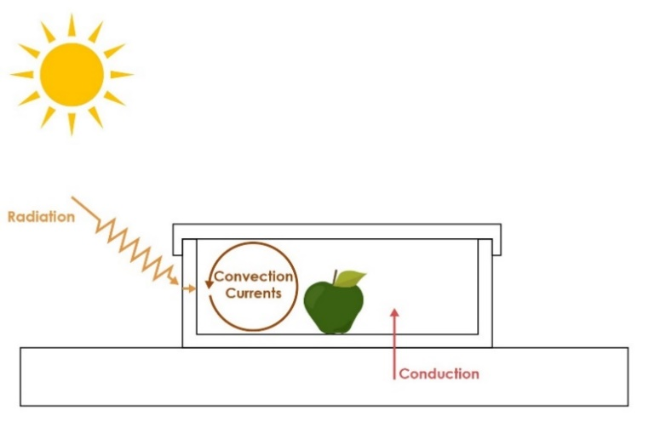  When objects are in physical contact, heat can be transferred by conduction. This can happen where a lunch container is in contact with a warm surface or where a warm food item is in contact with the lunch container.  STEM Consortium  When discussing ‘fair’ in science, students are likely to have an understanding of ‘fair’ in the context of a ‘fair share’, usually meaning each getting an equal amount of something. Students will need support to translate their understandings to a science context. A ‘fair test’ is about being sure that the experiment will answer the question being asked by controlling variables in the experiment. In a fair test, the independent variable is changed, the dependent variable is measured and all other variables are kept the same.  Students at this age will require examples to develop the ability to identify a fair test. For example, in the ice block experiment, if one container was placed on grass and the other on concrete, how could they be sure that the differences in melting rates come from the Sun’s radiation and not from the temperature difference between the warmer concrete and cooler grass?  Activity 2 provides students with the opportunity to develop mathematical skills focusing on recording, interpreting and analysing data. Students should be guided to create their own tables and graphs to collect and display data, as this provides students with opportunities to build mathematical reasoning. While this usually takes more time than using templates, it enables students to struggle with the concepts and develop a deeper understanding.
Instructional procedures | A word wall with subject-specific vocabulary is created in this activity (see Teacher resource sheet 2.1: Glossary).  Students may need close guidance in the investigation to ensure accurate readings, competent use of the thermometer and correct recording methods.  Choose a day to conduct the investigation when temperatures are predicted to be high. Commence the investigation as early in the school day as possible.  It is recommended that in Year 3 digital thermometers are used to record temperatures. This is to avoid the challenge of reading intricate scales and the potential hazards associated with using glass thermometers.  For the experiment, the cold water will get warmer as it gains heat and the hot water will cool as it loses heat. This activity provides students with the opportunity to practise science skills such as working with a thermometer and recording data using tables. It develops an understanding that heat moves from hot places to cooler places, temperature falls when heat moves away, and temperature rises when heat moves in.
Expected learning | Students will be able to:  - Be guided to identify questions and make predictions based on prior knowledge (Science).  - Be guided to conduct a fair test, and collect and record observations and measurements (Science).  - Represent collected data using tables and identify patterns and relationships in the data (Mathematics).  - Interpret data, compare it to their predictions and suggest possible reasons for the results (Science, Mathematics).
Equipment required | For the class:  Digital thermometers (one per group)  Two identical plastic cups per group  A half-filled bucket of warm water (about 45°C)  A half-filled bucket of cold water  A variety of lunch containers such as brown paper bag, plastic lunch containers of different colours, fabric bag, plastic lunch container with an ice pack, thermos, wax material wraps.
For the students:
Student activity sheet 2.2: Water cups experiment
Student activity sheet 2.3: Lunch container temperatures investigation
Preparation | Ensure students have access to resource sheets.  Bookmark video clips from the Digital resources and download before the lesson to avoid streaming issues.  Fill the buckets with different temperature water.  Gather a variety of lunch containers.
Activity parts | Part 1: Using thermometers  Discuss students’ prior knowledge about thermometers.  Explain to students the purpose of this activity is to practise using a thermometer, record temperatures accurately and look for patterns in the results.  Demonstrate how to take the temperature of water by immersing the sensor of the thermometer in the water until the temperature reading becomes stable. Read the temperature on the thermometer while it is immersed in the water. Explain to students they should not take the thermometer out of the water to read the dial or the reading will be of air temperature rather than the water temperature.  Explain that they will be working in small groups to record the temperature change of water over time in two different cups.  Planning  Challenge students to write a question to investigate in this experiment. Prompt student to identify the variables by asking:  - What are we going to measure?  - How do the cups of water differ?  Encourage students to predict what will happen to the temperature of the water in the cups by asking:  - What will happen to the temperature of the cold water? Why? …because…  - What will happen to the temperature of the hot water? Why? …because…  This is a good opportunity for students to apply and develop mathematical understandings about collecting and recording data. Explain that questions about heat energy can be answered by taking measurements and recording the numbers. The numbers are the data we will use to answer the question.  Encourage students to work in small groups to discuss ways of collecting and recording data. Ask students:  - What methods of recording data do you know?  - What do you think will work best for this investigation? Why?  If students have had previous experience constructing tables, students may decide to record their data that way and should be encouraged to design their own. In not, this activity provides opportunity for explicit teaching of the structure of tables.  Prompt students to identify the data to be recorded, for example:  - What are you measuring? What will you record?  - How often will you take measurements? What will you record?  - How will you tell the time?  - How will you organise your table?  - What units of measurement will be used?  - What are the key words that should be included in the title of the table?  - Do you think it will be useful to record the temperature of the air in the room? Why?  A template showing an example of how students can record information about the temperature of the water in the two cups at ten-minute intervals for an hour is provided in Student activity sheet 2.2: Water cups experiment.  Conducting  Distribute the thermometers and two plastic cups to each group. Students label one cup Cold and the other Hot.  Students fill their cups from the buckets of water containing cold water and hot water (about 45°C which will be safe from scalding).  Monitor students as they measure and record time and temperature and provide guidance as required.  Analysing  Encourage students to discuss the results, identifying patterns, and possible reasons for these by asking the following prompt questions:  - What were the initial temperatures of the hot water, cold water and the air in the room?  - What happened to the temperature of the hot water?  - What happened to the temperature of the cold water?  - How did the hot water become colder? …because…  - How did the cold water get hotter? …because…  - Were your predictions supported by your observations?  - What did you observe about the final temperature of the water in the two cups and the room temperature?  - Using your results, how would you answer your investigation question?  Evaluating  - How accurate do you think your measurements were? If you did the measurements again, would they be the same? Why?  - What could we do differently next time to get more accurate results?
Part 2: Investigating lunch container temperatures
Ask students:
- Can you think of situations when you might want to stop something from heating up?
- Are there times when you want something to heat up or cool down slowly?
Explain to students they will investigate what happens to the temperature inside lunch containers to better understand how materials can affect the internal temperature.
Ask students:
- How could we find out what happens to the temperature inside different types of lunch containers during the day?
Build on students’ understandings from the cup investigation and the ice block experiment. Encourage students to consider what makes a fair test. Reiterate the terms ‘variable’ and ‘fair test’ and create a word wall to display new vocabulary in a place that is visible and accessible to students. Additional vocabulary used in the module can be added to the word wall, see Teacher resource sheet 2.1: Glossary.
Support students to design their own investigation question and prediction (hypothesis). Remind students about the data collection method they used in the cup investigation and support them to create tools to record data for this investigation. Student activity sheet 2.3: Lunch container temperatures investigation can be used as a guide and shows an example of the process. Explain that it may be useful to know what the outside temperature is so that it can be used as a measure against the internal lunch container temperatures. Discuss where the best place would be to set up a thermometer to take the outside temperature and how often it should be recorded.
Note: Opening the lunch container often may affect its internal temperature. If possible, insert the sensor of the digital thermometer into the lunch container and close the lid over it to keep air out. Temperatures can then be read without opening the container again. An additional thermometer will be needed to record the temperature outside of the lunch container.

Part 3: Results
Students discuss the results in their groups and answer the questions on Student activity sheet 2.3: Lunch container temperatures investigation.
Prompt class discussion by asking:
- What happened to the outside temperature throughout the experiment?
- What happened to the inside temperature (of each lunch container) throughout the experiment? Why?
- What differences were there in the inside temperatures of different lunch containers? Can you explain this?
- What happened to the temperature inside the lunch container? Why did it increase?
- Did any of the inside temperatures reach the danger zone?
- Did your results support your prediction?
- How do you know if the tests on the different types of lunch containers were fair? …because…
- What have you learnt about the best lunch container designs and materials for keeping food at a safe temperature?
- Do you think this is the best way to represent data? What other ways could be used?
Students should be encouraged to undertake additional investigations of other factors that might effect the internal lunch container temperature (eg location).
Part 4: Reflection and journaling
Students need time and support to evaluate their data so they can be confident in the conclusions they draw. Students reflect on their learning and record their thinking in their learning journals.
Prompt questions could include:
- Why do we need to keep food cool?
- What materials or features of a lunch container might help to keep food cool? Why?
- What have you learnt about the movement of heat from one place to another?

Resource sheets | Teacher resource sheet 2.1: Glossary  Student activity sheet 2.2: Water cups experiment  Student activity sheet 2.3: Lunch container temperatures investigation
Digital resources | Reading a thermometer, Math lesson for 1st, 2nd, 3rd grade kids (Kisi KidsMathTV, 2013)  youtu.be/gvujzYWO5qg
Keep your child’s lunchbox safe (Healthy Kids Association, 2014)
healthy-kids.com.au/keeping-school-lunches-safe/
Lunch boxes (NSW Food Authority, 2015)
foodauthority.nsw.gov.au/aboutus/science/science-in-focus/lunch-boxes
Food temperature control – The 2 hour/4 hour guide (Department of Health WA)
ww2.health.wa.gov.au/Articles/F_I/Food-temperature-control

Activity 3: Design, create, test and modify
Activity focus | Students collaborate to design and create a model of a lunch container that will reduce the transfer of heat to the food. Students test their models, record data and make modifications as necessary.
Instructional procedures | Students will need support and scaffolding with the design process and to be positively encouraged to work through the process at least once. This will ensure their final product is a refined version, demonstrating improvements that reflect critical and creative thinking. Students will need to explain their thinking and reasoning in their learning journal (see Reflective journal) and final presentation.  Students working in groups will need to negotiate with their peers to reach an agreed outcome. Collaborative group skills are a foundation of the STEM process and students are encouraged to develop these from an early age.  The design process is a series of steps to guide problem-solving. There are many different versions, but the core ideas are the same:  - What is the problem?  - Research and analysis: Brainstorm ideas, research and understand the problem and its context. (Activities 1 and 2 should have provided direct experience that students can bring to the task.)  - Ideation: Choose the best idea – how will it work? Draw a diagram – what materials or tools will you need?  - Development and production: Build your solution and test it out. (Activity 2 should provide some tools students can use to test their product in a fair way.)  - Evaluation: What works, what doesn’t, what could work better? Repeat the cycle. (The key idea is to allow students to improve on their original design after testing.)  See Design process guide for elaboration.  To develop digital technology skills and ICT capability students could use computer-aided design (CAD) to develop their ideas (see Drawing in the design process).  Students may need support in building their model, see Teacher resource sheet 3.1: Construction skills for useful techniques.
Expected learning | Students will be able to:  - Follow the design process to create and describe key features of their design through labelled drawings and appropriate technical language (Technologies).  - Select and safely use appropriate tools for constructing their prototype lunch container (Technologies).  - Represent collected data using tables and identify patterns and relationships in the data (Mathematics).  - Interpret data, compare it to their predictions and suggest possible reasons for the results (Mathematics).
Equipment required | For the class:  A variety of materials and a range of construction tools including fabric, foil, plastic, rope, twine, staples, glue gun, tape, felt, wool, cardboard, leather (see Materials list)
For the students:
Digital cameras or devices to take photos
Student activity sheet 3.2: Prototype troubleshooting
Student activity sheet 3.3: Design review
Preparation | Ensure digital cameras or devices are fully charged.  Ensure students have access to resource sheets.  Ensure the school’s digital policy is followed.  Adult assistance may be required.
Activity parts | Part 1: Design the lunch container  As a class, review the problem: How can we design a lunch container that will help protect food from being spoilt?  Review learning from Activities 1 and 2 to help inform the students’ design of a better lunch container.  Prompt questions might include:  - What problem are we trying to solve?  - Why is that important?  - What have we learnt so far about the features of lunch containers?  Working in the same groups, students examine the construction materials available and share thinking about the best choices for their lunch container design.  Use questioning to prompt thinking:  - How will you keep the internal temperature down?  - What materials will absorb or reflect heat?  - How can we make sure the food is cool when it goes into the lunch container?  - How will we know if our design is successful?  As a class develop a common set of success criteria to enable students to evaluate the effectiveness of their lunch container in keeping food safe.  Encourage students to brainstorm lunch container design ideas in their groups and decide on a process to select the best idea. Explain that their designs must be documented as a labelled drawing with annotations that justify the features of their design.  Ask students:  - How will we know which idea is the best?  - What do we mean by the best idea?  - How could we agree on a design if there are two designs we like and that meet our criteria?  Discuss with students how they might draw their design by asking:  - What should your drawing include?  - What type of drawing will work best to show the features? (eg top view, front view, cross-section)  - How will the person looking at your drawing know what the parts are?  - How will we label our diagrams in the same way scientists do?  Once complete, share the groups’ drawings with the class. Encourage students to discuss the designs and which design features or materials they predict will make the lunch container more effective and why. Time should be taken to discuss how to give constructive feedback and how to receive feedback positively.
Part 2: Create the lunch container
Students follow their design plan from Part 1 to begin constructing their lunch container.
Prompt students to think about the options and best ways of folding and joining their chosen materials. Assist with construction techniques as required (see Teacher resource sheet 3.1: Construction skills).
Encourage students to compare their design to their construction, highlighting any differences. Prompt students to reflect on any modifications they are making to the design and to document these on their design plan, explaining why the changes were made.
Students take digital photos of the design process for their presentation in Activity 4. Once complete, students take photos of their lunch container from the top, front, back, side and internal views.
Part 3: Test and modify
Students repeat the investigation from Activity 2, Part 2, this time using their lunch container model and comparing it to a lunch container made by another group. With guidance, students plan and conduct the investigation, starting by discussing and recording their hypothesis.
Ask students:
- What do you predict might happen?
Ask students to consider their results or data:
- What question will you ask?
- How will you collect your data? What would you measure? What would you observe? How would you use your existing data?
- How will you organise your data?
- How will you make sure your data collection is accurate?
Encourage students to work together in their groups and take ownership of the way they run their investigation and record their data.
After the investigation, prompt students to review their findings and reflect on their design:
- Can you use science ideas to explain why some lunch containers are more effective than others?
- Can you use numbers to explain which lunch container was most effective?
Part 4: Reflection and journaling
Students reflect on the activity, recording their learning and thinking in their individual journals. Students complete Student activity sheet 3.2: Prototype troubleshooting and Student activity sheet 3.3: Design review and include them as part of their reflection.
Resource sheets | Design process guide  Drawing in the design process  Teacher resource sheet 3.1: Construction skills  Student activity sheet 3.2: Prototype troubleshooting  Student activity sheet 3.3: Design review

Activity 4: Share and evaluate
Activity focus | Groups present their lunch container models, justifying design choices to the class and, where possible, to an audience beyond the classroom. They evaluate and reflect on the process.
Instructional procedures | Students will need support and scaffolding to help them prepare for their presentation and to deliver it. To scaffold cooperative group work, each member of the group could have a role and responsibility. For example, one could be the Content Director, one the Media Director and a third the Presentation Director. All students should contribute to the three phases of deciding on the content, preparing the media and giving the presentation while one student has the overall responsibility for managing that phase of the task.  Decide on a time restriction for the presentation. For example, two minutes is a good length for a speech, with two minutes for questions and two minutes swap over between groups.  Ensure every group member has a role in the presentation. One person might introduce the presentation, another gives the presentation, and a third answers any questions.  The presentations provide a rich opportunity for assessing students’ understanding of the science, mathematics and technology principles and processes, as well as the literacies associated with speaking and listening.  Photographs taken throughout the design process should be used in presentations.  Students can be given a choice of creating a range of presentation types (eg iMovie or Explain Everything), which can then be shared through a digital portfolio platform such as Connect, Seesaw or Class Dojo, or shared on the interactive whiteboard. Students may require explicit instruction in using apps.  If ICT is not accessible, students could share their project using a traditional poster, a recount or make a book.
Expected learning | Students will be able to:  - Work collaboratively to design, create and evaluate their solution (Technologies).  - Use digital technologies to organise and present information about the lunch container design and the design process (Technologies).  - Explain and justify design choices using science, mathematics and technologies principles (Science, Mathematics, Technologies).  - Evaluate the effectiveness of their design, using oral group feedback and personal reflection strategies (Technologies).
Equipment required | For the students:  Device with an appropriate app for creating a digital presentation (see Digital resources section for suggestions)  Labelled lunch container designs  Photos from Activity 3
Preparation | Ensure devices are charged and loaded with appropriate apps.  Schedule time for presentations considering the venue, necessary technology and how the presentations could be shared with an audience beyond the classroom.
Activity parts | Part 1: Deciding on content for presentation  In their groups, students decide on the content of their presentation.  Presentations should focus on the students’ choice of materials as outlined in their design plan, changes to the design with justifications, as well as the effectiveness of the design with reference to their testing results and the success criteria.  Students analyse their completed model, identify the materials used and compare this to their initial design plan. Questions to prompt student thinking can include:  - What materials did you use and why?  - What didn’t you use? Why?  - How does your lunch container match your design plan?  - Did you change your design plan? Why?
Part 2: Create the presentation
In their groups, students use a chosen form of digital media to create a presentation to communicate their design process. See Digital resources for suggestions.
Part 3: Delivering the presentation
Students share their digital presentations with the class and give and receive feedback using Student activity sheet 4.2: 3 – 2 – 1 Reflection.
To create an authentic learning experience, students may pitch their design (either in person, by email or Skype) to an industry professional.
Alternatively, the lunch container and design drawings could be displayed in the school for parents to view using an interactive medium such as QR codes.
The teacher may use this opportunity to complete Teacher resource sheet 4.1: Student evaluation.
Students complete the Student activity sheet 1.0: Journal checklist.
Resource sheets | Student activity sheet 1.0: Journal checklist  Teacher resource sheet 4.1: Student evaluation  Student activity sheet 4.2: 3 – 2 – 1 Reflection
Digital resources | Comic Life  itunes.apple.com/us/app/comic-life/id432537882?mt=8&ign-mpt=uo%3D4
Comic Maker HD
https://itunes.apple.com/au/app/superhero-comic-book-maker-hd/id547117153?mt=8&ign-mpt=uo%3D4
iBooks Author
www.apple.com/au/ibooks-author
Book Creator
itunes.apple.com/au/app/book-creator-for-ipad-create/id442378070?mt=8
iMovie
itunes.apple.com/au/app/imovie/id377298193?mt=8
Pages
itunes.apple.com/au/app/pages/id361309726?mt=8
Keynote
itunes.apple.com/au/app/keynote/id361285480?mt=8
Seesaw Digital Portfolio
web.seesaw.me
Class Dojo
www.classdojo.com
QR Code Generator
www.qrstuff.com

Appendix 1: Links to the Western Australian Curriculum
The Cool lunch module provides opportunities for developing students’ knowledge and understandings in science, technologies and mathematics. The table below shows how this module aligns to the content of the Western Australian Curriculum and can be used by teachers for planning and monitoring.

COOL LUNCH  Links to the Western Australian Curriculum | ACTIVITY
 | 1 | 2 | 3 | 4
SCIENCE
SCIENCE UNDERSTANDING
Physical sciences: Heat can be produced in many ways and can move from one object to another (ACSSU049) | ● | ● | ● | ●
Chemical sciences: A change of state between solid and liquid can be caused by adding or removing heat (ACSSU046) |  | ● | ●
SCIENCE INQUIRY SKILLS
Questioning and predicting: With guidance, identify questions in familiar contexts that can be investigated scientifically and make predictions based on prior knowledge (ACSIS053) |  | ● | ●
Planning and conducting: Consider the elements of fair tests and use formal measurements and digital technologies as appropriate, to make and record observations accurately (ACSIS055) |  | ● | ●

COOL LUNCH  Links to the Western Australian Curriculum | ACTIVITY
 | 1 | 2 | 3 | 4
DESIGN AND TECHNOLOGIES
KNOWLEDGE AND UNDERSTANDING
Materials and technologies specialisations: Suitability and safe practices when using materials, tools and equipment for a range of purposes (ACTDEK013) |  |  | ●
PROCESSES AND PRODUCTION SKILLS
Designing: Develop and communicate ideas using labelled drawings and appropriate technical terms (WATPPS17) |  |  | ●
Evaluating: Use criteria to evaluate design processes and solutions developed (WATPPS19) |  |  |  | ●
Collaborating and managing: Works independently, or collaboratively when required, to plan, create and communicate sequenced steps (WATPPS20) |  | ● | ● | ●
MATHEMATICS
STATISTICS AND PROBABILITY
Data representation and interpretation: Identify questions or issues for categorical variables. Identify data sources and plan methods of data collection and recording (ACMSP068) |  | ● | ●
Data representation and interpretation: Collect data, organise into categories and create displays using lists, tables, picture graphs and simple column graphs, with and without the use of digital technologies (ACMSP069) |  | ● | ●
Data representation and interpretation: Interpret and compare data displays (ACMSP0700) |  | ● | ●
Further information about assessment and reporting in the Western Australian Curriculum can be found at k10outline.scsa.wa.edu.au/home.

Appendix 1B: Mathematics proficiency strands
Key ideas
In Mathematics, the key ideas are the proficiency strands of understanding, fluency, problem-solving and reasoning. The proficiency strands describe the actions in which students can engage when learning and using the content. While not all proficiency strands apply to every content description, they indicate the breadth of mathematical actions that teachers can emphasise.
Understanding
Students build a robust knowledge of adaptable and transferable mathematical concepts. They make connections between related concepts and progressively apply the familiar to develop new ideas. They develop an understanding of the relationship between the ‘why’ and the ‘how’ of mathematics. Students build understanding when they connect related ideas, when they represent concepts in different ways, when they identify commonalities and differences between aspects of content, when they describe their thinking mathematically and when they interpret mathematical information.
Fluency
Students develop skills in choosing appropriate procedures; carrying out procedures flexibly, accurately, efficiently and appropriately; and recalling factual knowledge and concepts readily. Students are fluent when they calculate answers efficiently, when they recognise robust ways of answering questions, when they choose appropriate methods and approximations, when they recall definitions and regularly use facts, and when they can manipulate expressions and equations to find solutions.
Problem-solving
Students develop the ability to make choices, interpret, formulate, model and investigate problem situations, and communicate solutions effectively. Students formulate and solve problems when they use mathematics to represent unfamiliar or meaningful situations, when they design investigations and plan their approaches, when they apply their existing strategies to seek solutions, and when they verify that their answers are reasonable.
Reasoning
Students develop an increasingly sophisticated capacity for logical thought and actions, such as analysing, proving, evaluating, explaining, inferring, justifying and generalising. Students are reasoning mathematically when they explain their thinking, when they deduce and justify strategies used and conclusions reached, when they adapt the known to the unknown, when they transfer learning from one context to another, when they prove that something is true or false, and when they compare and contrast related ideas and explain their choices.
Source: ACARA - www.australiancurriculum.edu.au/f-10-curriculum/mathematics/key-ideas/?searchTerm=key+ideas#dimension-content

Appendix 2: General capabilities continuums
The general capabilities continuums shown here are designed to enable teachers to understand the progression students should make with reference to each of the elements. There is no intention for them to be used for assessment.
Information and communication technology (ICT) capability learning continuum
Sub-element | Typically by the end of Year 2 | Typically by the end of Year 4 | Typically by the end of Year 6
Create with ICT  Generate ideas, plans and processes | use ICT to prepare simple plans to find solutions or answers to questions | use ICT to generate ideas and plan solutions | use ICT effectively to record ideas, represent thinking and plan solutions
Create with ICT  Generate solutions to challenges and learning area tasks | experiment with ICT as a creative tool to generate simple solutions, modifications or data representations for particular audiences or purposes | create and modify simple digital solutions, creative outputs or data representation/transformation for particular purposes | independently or collaboratively create and modify digital solutions, creative outputs or data representation/transformation for particular audiences and purposes
Communicating with ICT  Collaborate, share and exchange | use purposefully selected ICT tools safely to share and exchange information with appropriate local audiences | use appropriate ICT tools safely to share and exchange information with appropriate known audiences | select and use appropriate ICT tools safely to share and exchange information and to safely collaborate with others

Critical and creative thinking learning continuum
Sub-element | Typically by the end of Year 2 | Typically by the end of Year 4 | Typically by the end of Year 6
Inquiring – identifying, exploring and organising information and ideas  Organise and process information | organise information based on similar or relevant ideas from several sources | collect, compare and categorise facts and opinions found in a widening range of sources | analyse, condense and combine relevant information from multiple sources
Generating ideas, possibilities and actions  Imagine possibilities and connect ideas | build on what they know to create ideas and possibilities in ways that are new to them | expand on known ideas to create new and imaginative combinations | combine ideas in a variety of ways and from a range of sources to create new possibilities
Generating ideas, possibilities and actions  Seek solutions and put ideas into action | investigate options and predict possible outcomes when putting ideas into action | experiment with a range of options when seeking solutions and putting ideas into action | assess and test options to identify the most effective solution and to put ideas into action
Reflecting on thinking and processes  Transfer knowledge into new contexts | use information from a previous experience to inform a new idea | transfer and apply information in one setting to enrich another | apply knowledge gained from one context to another unrelated context and identify new meaning

Personal and social capability learning continuum
Sub-element | Typically by the end of Year 2 | Typically by the end of Year 4 | Typically by the end of Year 6
Social management  Work collaboratively | identify cooperative behaviours in a range of group activities | describe characteristics of cooperative behaviour and identify evidence of these in group activities | contribute to groups and teams, suggesting improvements in methods used for group investigations and projects
Social management  Negotiate and resolve conflict | practise solving simple interpersonal problems, recognising there are many ways to solve conflict | identify a range of conflict resolution strategies to negotiate positive outcomes to problems | identify causes and effects of conflict, and practise different strategies to diffuse or resolve conflict situations
Social management  Develop leadership skills | discuss ways in which they can take responsibility for their own actions | discuss the concept of leadership and identify situations where it is appropriate to adopt this role | initiate or help to organise group activities that address a common need
Further information about general capabilities is available at:
k10outline.scsa.wa.edu.au/home/p-10-curriculum/general-capabilities-over/general-capabilities-overview/general-capabilities-in-the-australian-curriculum

Appendix 3: Materials list
You will need the following materials to complete this module.
- Spoilt lunch food – for example, squashed banana and bread in a sealable plastic bag (needs to have been left out in the hot sun for hours before presenting to class)
- Digital thermometers (one per group)
- Wide variety of materials for constructing lunch containers such as:
  - Hook and loop fastners
  - Electrical tape
  - Fabric remnants
  - Hessian
  - Sponge
  - Masking tape
  - Sticky tape
  - Stapler and staples
  - Plastic (different thicknesses and colours)
  - Cardboard
  - Sewing needles
  - Paper or magazines
  - Brown paper
  - Cotton thread
  - Aluminium foil
  - Hot glue gun and glue sticks
  - Hammer
  - Wool
  - Felt
  - Tacks
  - Lamb’s wool
  - PVA glue
  - Nails.

Appendix 4: Design process guide
STEM Consortium
Safe production of the final design or multiple copies of the final design.
Fine tuning the production process, such as division of labour for batch or mass production.
Use of intended materials and appropriate tools to safely make the solution to the design problem.
Reflection on the process taken and the success of the design.
Evaluation can lead to further development or improvement of the design and can be a final stage of the design process before a conclusion is reached.
Could be formal or informal and verbal or written.
Ideation
Development
Development of the design ideas. Improvements, refinements, adding detail, making it better.
Activities such as detailed drawings, modelling, prototyping, market research, gaining feedback from intended user, further research – if needed – to solve an issue with the design, testing different tools or equipment, trialling production processes, measuring or working out dimensions, testing of prototypes and further refinement.
Idea generation – turning ideas into tangible forms so they can be organised, ordered and communicated to others.
Activities such as brainstorming, mind mapping, sketching, drawing diagrams and plans, collecting colour samples and/or material samples and talking through these ideas can help to generate more creative ideas.
Using the SCAMPER model can assist with this: www.mindtools.com/pages/article/newCT_02.htm
www.designorate.com/a-guide-to-the-scamper-technique-for- creative-thinking
Analysis
Finding useful and helpful information about the design problem.
Gathering information, conducting surveys, finding examples of existing solutions, testing properties of materials, practical testing.
Understanding the meaning of the research findings.
Analysing what the information means, summarising the surveys, judging the value of existing solutions, understanding test results.
Research
Production
Evaluation

Appendix 4B: Drawing in the design process
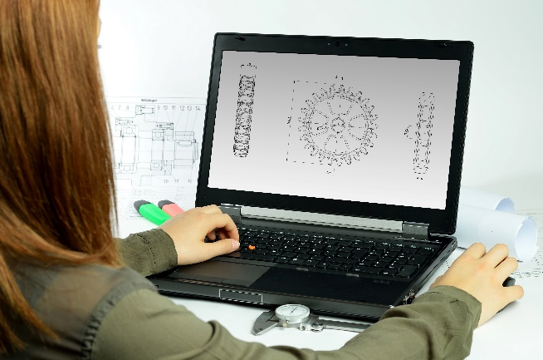
Incorporating the design process into the STEM modules will often result in the need for students to draw plans of their designs. This can be done at a simple level using hand-drawn sketches or at a more technical level using computer-aided design (CAD).
By developing skills using industry-standard software, students may be well-placed to explore future career pathways.
istockphoto.com

There are several CAD software options, two free examples are detailed below. Autodesk is a third package that is also free for educational use.
Tinkercad
- Format: Web-based app requiring internet access via a browser
- Purpose: A simple, online 3D design and 3D printing app
- Home: www.tinkercad.com
- Blog: blog.tinkercad.com
- Tutorials: www.tinkercad.com/learn
- Feature: Connects to 3D printing and laser cutting.
SketchUp
- Format: Can be downloaded and installed on devices, or used in a browser
- Purpose: Enables students to draw in 3D
- Home: www.sketchup.com 'Products' 'SketchUp Make'
- Help centre: help.sketchup.com/en
- Blog: blog.sketchup.com
- Tutorials: www.youtube.com/user/SketchUpVideo. From beginner tool tips to intermediate and advanced modelling techniques, the video tutorials help to build SketchUp skills.

Appendix 5: Reflective journal
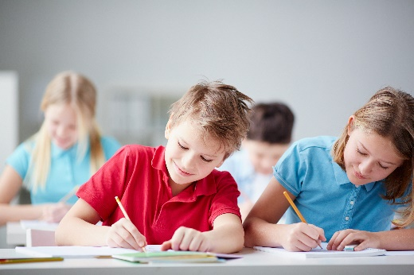
When students reflect on learning and analyse their own ideas and feelings, they self-evaluate, thereby improving their metacognitive skills. When students self-monitor or reflect, the most powerful learning happens.
Journaling may take the form of a written or digital journal, a portfolio or a digital portfolio. Early childhood classrooms may use a class reflective floor book with pictures of the learning experience and scribed conversations.
istockphoto.com

Teachers can model the journaling process by thinking aloud and showing students how they can express learning and thoughts in a variety of ways including diagrams, pictures and writing.
Journals are a useful tool that gives teachers additional insight into how students value their own learning and progress, as well as demonstrating their individual achievements.
The following links provide background information and useful apps for journaling.
Kidblog – digital portfolios and blogging
kidblog.org/home
Edmodo – for consolidating and storing class notes and learning materials
www.edmodo.com
Explain Everything™ – a screen casting, video and presentation tool all in one
explaineverything.com
Popplet – allows you to jot down your ideas and then sort them visually
Popplet.com
Seesaw – for capturing work completed by students in class, using a device’s camera function
web.seesaw.me
Connect – the Department of Education’s integrated, online environment
connect.det.wa.edu.au
Evernote (a digital portfolio app)
evernote.com
Digital portfolios for students (Cool tools for school)
cooltoolsforschool.wordpress.com/digital-student-portfolios

Appendix 6: Student activity sheet 1.0: Journal checklist
As an ongoing part of this module, you have been keeping a journal of your work.
Before submitting your journal to your teacher please ensure you have included the following information.
- Tick each container once complete and included.
- Write N/A for items that were not required in this module.
istockphoto.com

Your name and group member's names or photographs
An explanation of the problem you are solving
Your notes from Activity 1
Your notes from Activity 2
Your notes from Activity 3
Your notes from Activity 4
Student activity sheet 2.1: Water cups experiment
Student activity sheet 2.2: Lunch container temperatures investigation
Student activity sheet 3.2: Prototype troubleshooting
Student activity sheet 3.3: Design review
Student activity sheet 4.2: 3 – 2 – 1 Reflection

Student activity sheet 1.0: Journal checklist

Appendix 7: Teacher resource sheet 1.1: Cooperative learning – Roles
Cooperative learning frameworks create opportunities for groups of students to work together, generally to a single purpose.
As well as having the potential to increase learning for all students involved, using these frameworks can help students develop personal and social capability.
When students are working in groups, positive interdependence can be fostered by assigning roles to group members.
istockphoto.com

These roles could include:
- Working roles such as Reader, Writer, Summariser, Time-keeper
- Social roles such as Encourager, Observer, Noise monitor, Energiser.
Teachers using the Primary Connections roles of Director, Manager and Speaker for their science teaching may find it effective to also use these roles for STEM learning.
Further to this, specific roles can be delineated for specific activities that the group is completing.
It can help students if some background to the purpose of group roles is made clear to them before they start, but at no time should the roles get in the way of the learning. Teachers should decide when or where roles are appropriate to given tasks.
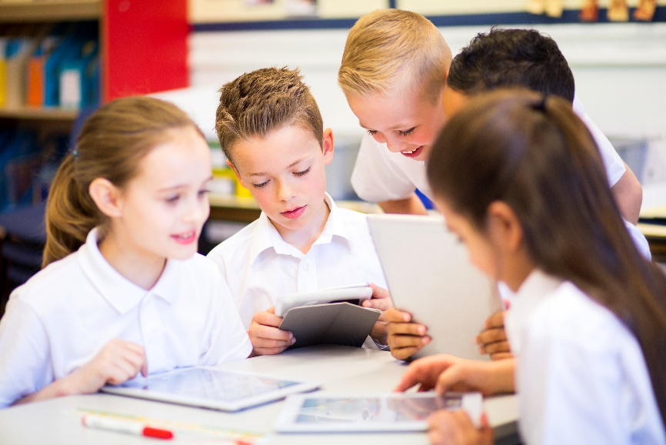
istockphoto.com
s

Appendix 8: Teacher resource sheet 1.2: Cooperative learning – Jigsaw
Cooperative learning frameworks create opportunities for groups of students to work together, generally for a single purpose.
As well as having the potential to increase learning for all students involved, using these frameworks can help students develop personal and social capability.
The jigsaw strategy typically has each member of the group becoming an 'expert' on one or two aspects of a topic or question being investigated. Students start in their cooperative groups, then break away to form 'expert’ groups to investigate and learn about a specific aspect of a topic. After developing a sound level of understanding, the students return to their cooperative groups and teach each other what they have learnt.
Within each expert group, issues such as how to teach the information to their group members are considered.

Step 1 | Cooperative groups  (of four students) | 1 2 3 4 |  | 1 2 3 4
Step 2 | Expert groups  (size equal to the number of groups) | 1 1 | 2 2 | 3 3 | 4 4
Step 3 | Cooperative groups  (of four students) | 1 2 3 4 |  | 1 2 3 4

Appendix 9: Teacher resource sheet 1.3: Cooperative learning – Placemat
Cooperative learning frameworks create opportunities for groups of students to work together, generally for a single purpose.
As well as having the potential to increase learning for all students involved, using these frameworks can help students develop personal and social capability.
The placemat strategy involves students working collaboratively to record prior knowledge about a common topic and brainstorm ideas. It also allows teachers to readily see the contribution of each student. The diagram below shows a typical placemat template.

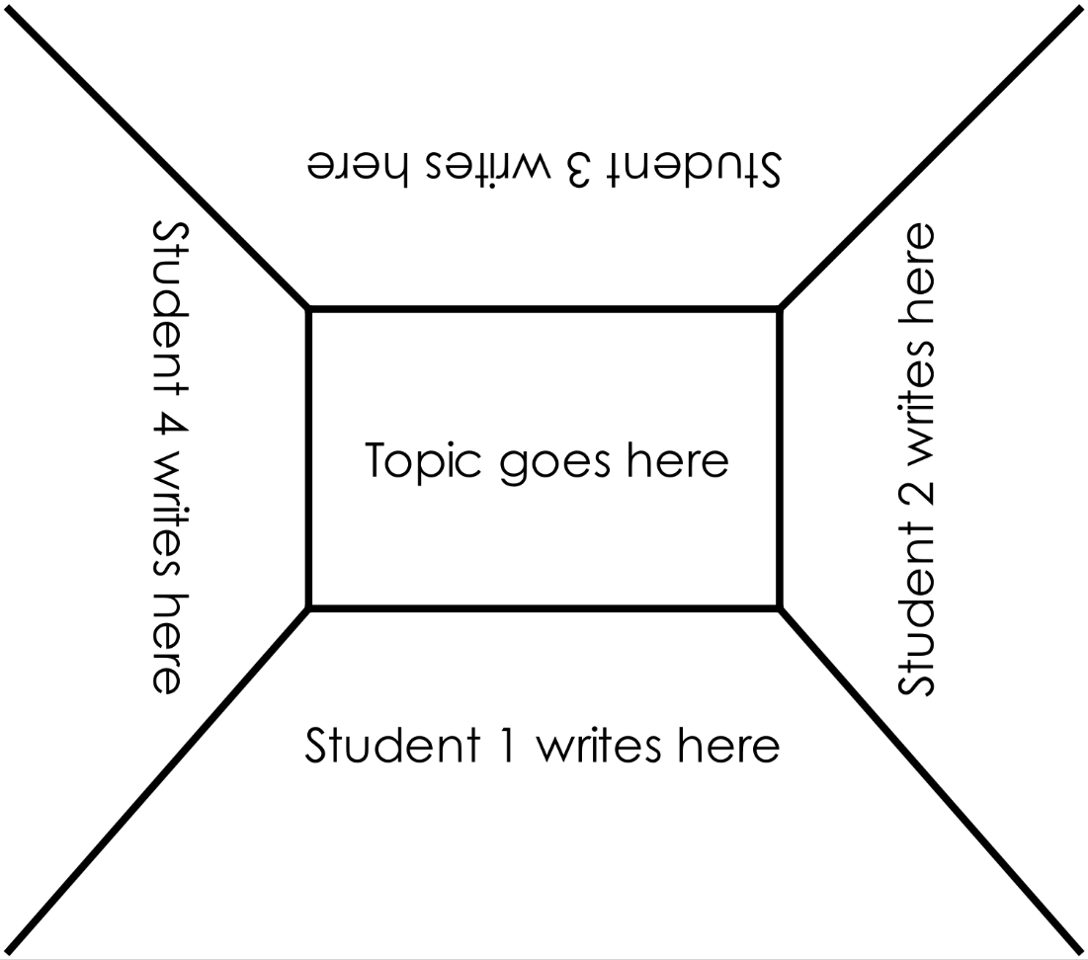

STEM Consortium

Appendix 10: Teacher resource sheet 1.4: Cooperative learning – Think, Pair, Share
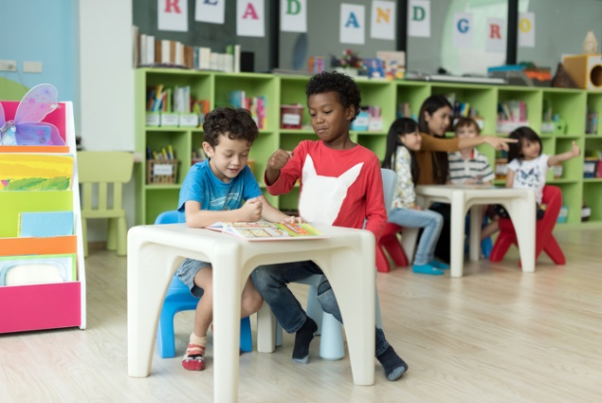
Cooperative learning frameworks create opportunities for groups of students to work together, generally to a single purpose.
As well as having the potential to increase learning for all students involved, using these frameworks can help students develop personal and social capability.
In the 'think' stage, each student thinks silently about a question asked by the teacher.
istockphoto.com

In the 'pair' stage, students discuss their thoughts and answers to the question in pairs.
In the 'share' stage, the students share their answer, their partner’s answer or what they decided together. This sharing may be with other pairs or with the whole class. It is important also to let students 'pass'. This is a key element of making the strategy safe for students.
Think-pair-share increases student participation and provides an environment for higher levels of thinking and questioning.
istockphoto.com

Appendix 11: Teacher resource sheet 2.1: Glossary
Vocabulary relating to heat energy
Conduction – the transfer of heat energy between objects that are in physical contact. Some materials conduct heat better than others. Metals are good conductors of heat energy.
Energy – energy is the ability to do work. Energy exists in different forms (eg light energy, heat energy and electrical energy).
Heat – a type of energy. When heat energy is given to something it usually gets hotter. If heat energy is taken away it will become colder.
Insulate – to cover and surround a material or substance to stop heat, sound or electricity from escaping or entering.
Radiant heat – all objects transfer thermal energy by infrared radiation. Radiation is how we feel the heat of the Sun.
Temperature – a measure telling us how hot or cold something is according to a defined scale.
Vocabulary relating to a thermometer
Thermometer – an instrument used to measure the temperature of something.
Degrees – the unit of measurement for temperature.
Celsius – modern system of measuring temperature. The freezing point of water is 0 degrees Celsius and the boiling point is 100 degrees Celsius.
Range – number of degrees from the lowest to highest number of degrees.
Vocabulary related to food safety
Bacteria – a type of microorganism that can be found in soil, on animals, on people and on the things people touch and use. If food becomes contaminated by bacteria it can cause food poisoning if eaten. Consumption of food contaminated by bacteria is the most common cause of food poisoning.
Danger zone – the temperature range at which bacteria multiply rapidly.
Food poisoning – an illness caused by eating contaminated food. The most common cause of food poisoning is from eating food contaminated by harmful bacteria. The most common symptoms of food poisoning include diarrhoea, stomach cramps, nausea, vomiting and fever. Food poisoning can be very serious and can even cause death.
Microorganism – a very small living organism that can only be seen under a microscope. Examples include bacteria, viruses and some fungi.
Perishable food – food that rapidly deteriorates if not kept covered and at a cool temperature below the ‘danger zone’.
Toxin – a poisonous substance produced by living organisms, for example, toxins can be produced by some bacteria. If bacteria present in food release toxins, the food can become unsafe to eat.
Unsafe – food is said to be unsafe when it causes harm after consumption.
Vocabulary related to experimentation and data collection
Category – a group used in a system of classification.
Fair test – a fair test occurs when only one factor is changed (variable) and all other conditions are kept the same.
Variable – something that can be kept the same, changed or measured in an experiment.

Appendix 12: Student activity sheet 2.2: Water cups experiment
Reading time | Temperature of water (⁰C)
 | Hot water | Cold water
1
2
3
4
5
6

Can you use your science knowledge to explain what happened to the cold water?

Can you use your science knowledge to explain what happened to the hot water?

Appendix 13: Student activity sheet 2.3: Lunch container temperatures investigation
What is the question we will investigate?

What is our prediction?

Temperatures inside and outside lunch containers recorded over four hours
Reading time | Temperatures inside and outside of lunch containers (ºC) |  | Calculate the difference between the inside and the outside temperature at each measurement.
 | Outside | Inside
1
2
3
4
5
6
7
8

What was the temperature inside the lunch container at the start of the experiment?

What was the temperature inside the lunch container at the end of the experiment?

By how many degrees did the temperature change?

Was your prediction supported by your results? Explain why.

Why did the inside of the lunch container get hotter?

Appendix 14: Teacher resource sheet 3.1: Construction skills
Construction skills help students to generate and produce solutions for real-world problems.
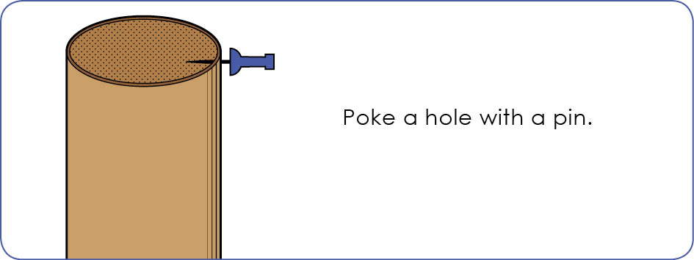
This resource can be used as a visual stimulus to prompt students to develop solutions to design problems. The cards can be printed to create stations.

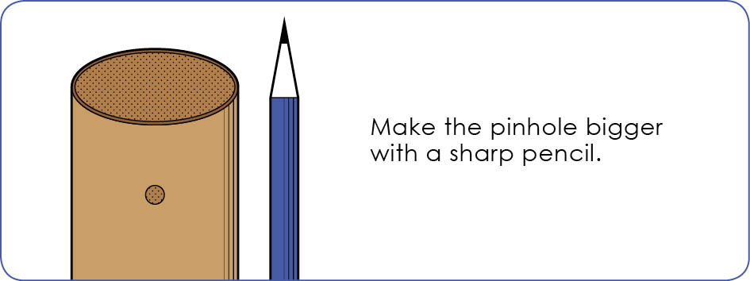
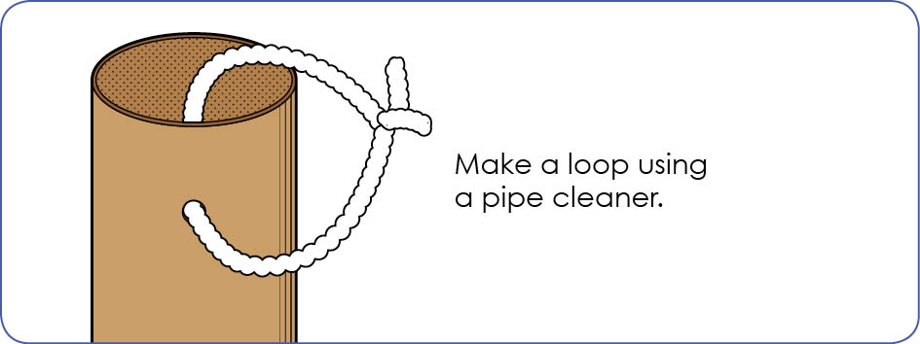
Poke a hole with a pin.

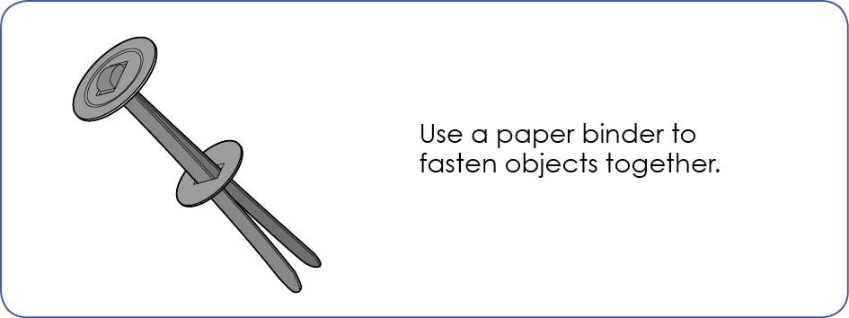

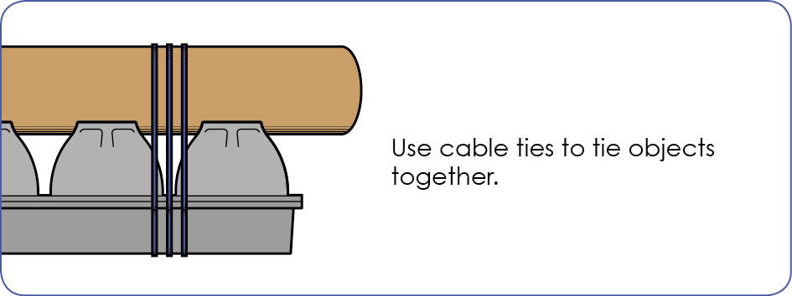

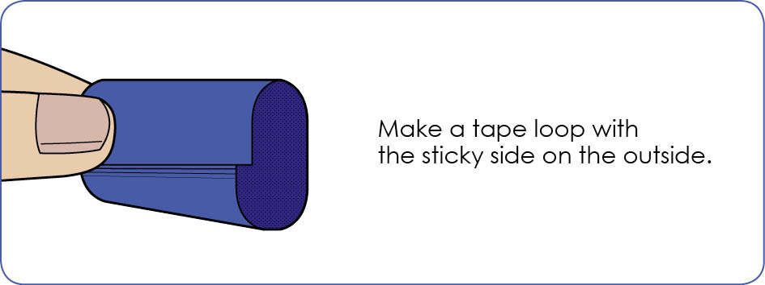

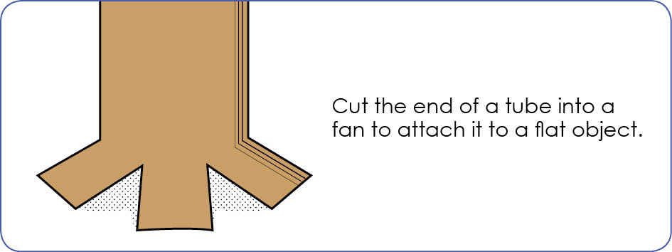

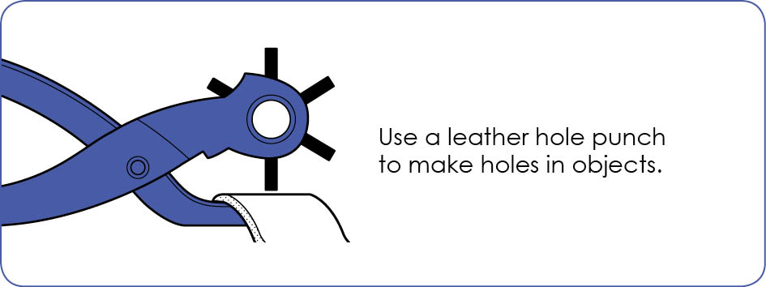

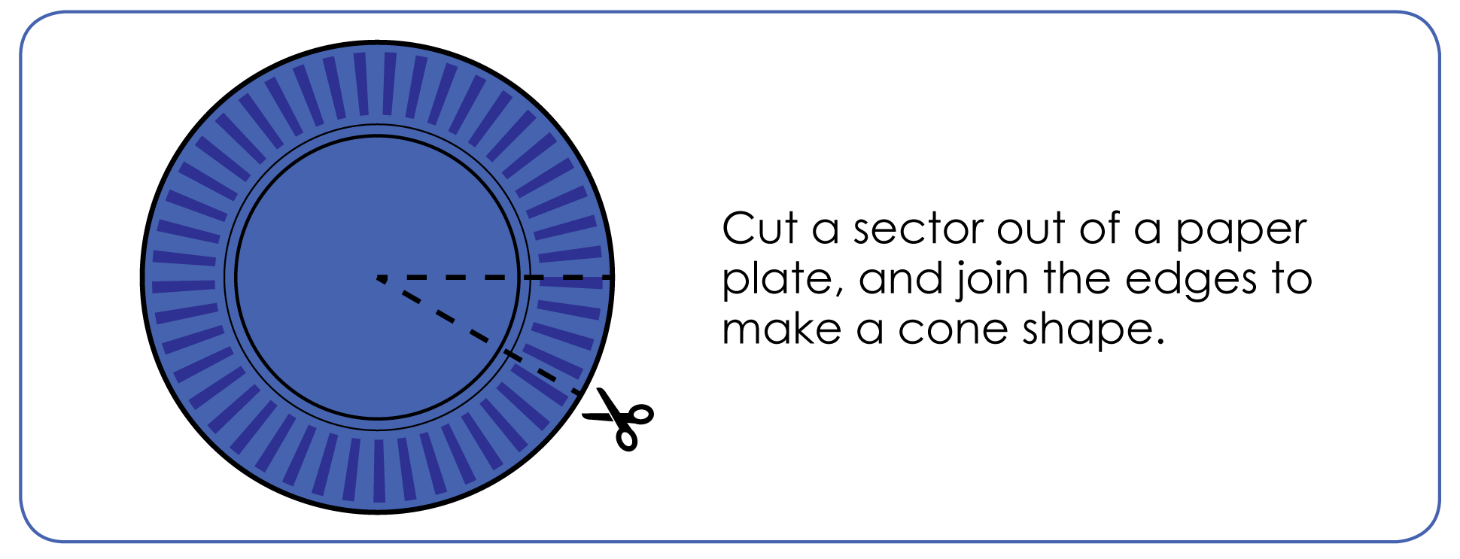

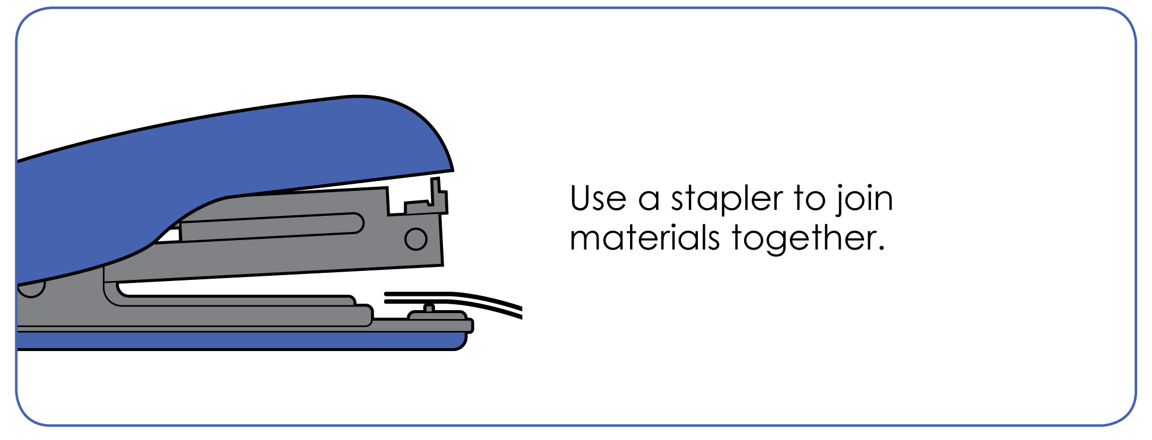

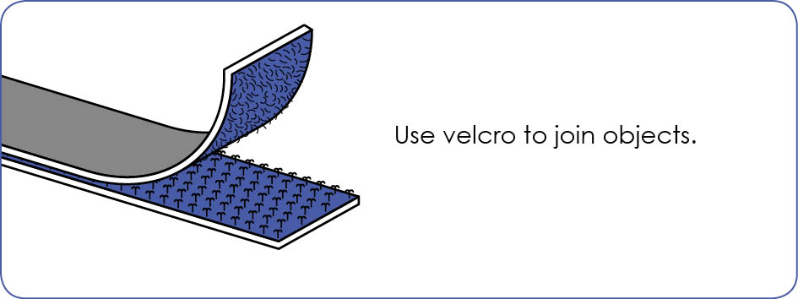

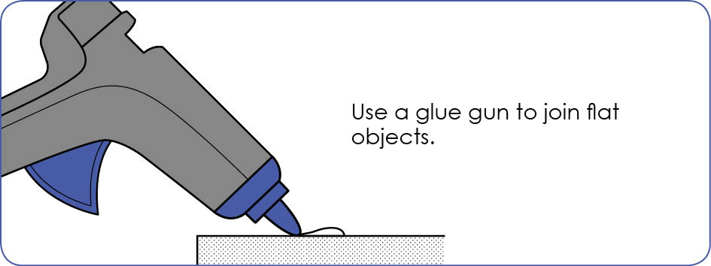
STEM Consortium

Appendix 15: Student activity sheet 3.2: Prototype troubleshooting
Problem | Reason for the problem | Possible changes to your design to solve the problem

Appendix 16: Student activity sheet 3.3: Design review
Things I would keep the same _________________________________________________________________________________________________________________________________________________________________________________________________________________________
Things I would change
________________________________________________________________________________________________________________________________________________________________________________________________________________________________________________________
Photograph or drawing

Appendix 17: Teacher resource sheet 4.1: Student evaluation
Key:  1 Needs attention/ Sometimes  2 Satisfactory/ Usually  3 Excellent/ Independently and consistently | Student name
Remains focused on tasks presented
Completes set tasks to best of their ability
Works independently without disrupting others
Manages time effectively
Cooperates effectively within the group
Contributes to group discussions
Shows respect and consideration for others
Uses appropriate conflict resolution skills
Actively seeks and uses feedback

Appendix 18: Student activity sheet 4.2: 3 – 2 – 1 Reflection
3 – 2 – 1 Reflections
Name | 3 things I learnt | 2 things I found interesting | 1 thing I found difficult

Notes
________________________________________________________________________________________________________________________________________________________________________________________________________________________________________________________________________________________________________________________________________________________________________________________________________________________________________________________________________________________________________________________________________________________________________________________________________________________________________________________________________________________________________________________________________________________________________________________________________________________________________________________________________________________________________________________________________________________________________________________________________________________________________________________________________________________________________________________________________________________________________________________________________________________________________________________________________________________________________________________________________________________________________________________________________________________________________________________________________________________________________________________________________________________________________________________________________________________________

