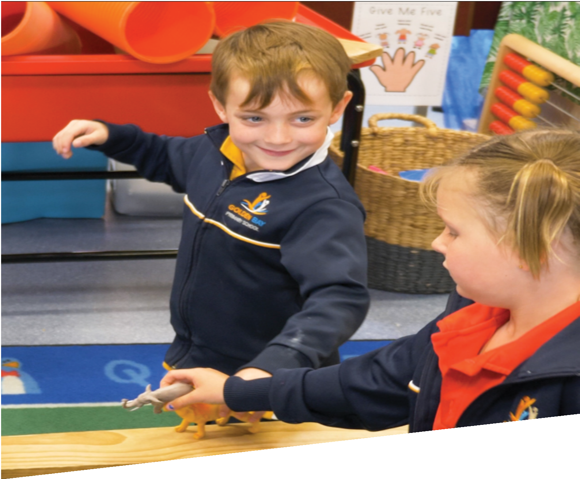
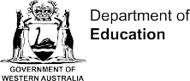

CURRICULUM RESOURCE MODULE
Animal rescue
PRE-PRIMARY
Acknowledgements
The STEM Learning Project is funded by the Western Australian Department of Education (the Department) and implemented by a consortium in STEM education comprising the Educational Computing Association of Western Australia, the Mathematical Association of Western Australia, the Science Teachers Association of Western Australia and Scitech.

We acknowledge and thank the teachers and schools who are the co-creators of these resources.

Copyright and intellectual property
The copyright and intellectual property of this module remain the property of the Department.

Any Western Australian Curriculum content in this resource is used with the permission of the School Curriculum and Standards Authority (the Authority); this permission does not constitute Authority endorsement of the resource. The Authority accepts no liability for any errors or damages arising from reliance on its content.

The Western Australian Curriculum content may be freely copied, or communicated on an intranet, for non-commercial purposes in educational institutions, provided that the Authority is acknowledged as the copyright owner. Copying or communication for any other purpose can be done only within the terms of the Copyright Act 1968 or with prior written permission of the Authority. Any Australian Curriculum content in the Western Australian Curriculum is used by the Authority under the terms of the Creative Commons Attribution NonCommercial 3.0 Australia licence.

Any content on the www.scsa.wa.edu.au domain that has been derived from the Australian Curriculum may be used under the terms of Creative Commons Attribution-NonCommercial 3.0 Australia licence.

Appendix 2: General capabilities continuums are adapted from ACARA, © Australian Curriculum, Assessment and Reporting Authority (ACARA) 2009 to present, unless otherwise indicated. This material was downloaded from the ACARA website (www.acara.edu.au) (accessed December 2015) and was not modified. The material is licensed under CC BY 4.0 (https://creativecommons.org/licenses/by/4.0/). ACARA does not endorse any product that uses ACARA material or make any representations as to the quality of such products. Any product that uses material published on this website should not be taken to be affiliated with ACARA or have the sponsorship or approval of ACARA. It is up to each person to make their own assessment of the product.

This resource includes references and examples of iOS, Android and other apps. The Department does not endorse or recommend any commercial products and simply provides these as examples for teachers.

The Department is committed to providing quality information to its customers. Whilst every effort has been made to ensure accuracy, currency and reliability of the information within these documents, the Department accepts no responsibility for errors, omissions or amendments made since the time of publishing. Confirmation of information may be sought from the Department or the originating bodies providing the information. The Department has no control over the content of material published on websites to which users are referred in this resource. It is the responsibility of the internet user to make their own decision as to the relevancy, accuracy, currency and reliability of information found on those sites.

Attributions: Microsoft Word, Google, Google Earth

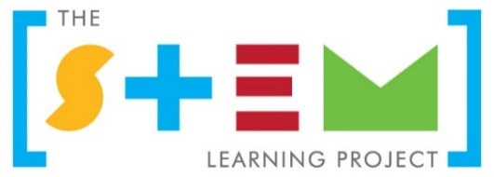
Table of contents

The STEM Learning Project 2
Overview 3
Activity sequence and purpose 6
Background 7
Activity 1: Creating a safe passage 9
Activity 2: Investigating structures 14
Activity 3: Improving initial designs 20
Activity 4: Sharing our journey 24
Appendix 1: Links to the Western Australian Curriculum 26
Appendix 1: Mathematics proficiency strands 27
Appendix 2: General capabilities continuum 28
Appendix 3: Materials list 30
Appendix 4: Design process guide 31
Appendix 5: Reflective journal 32
Appendix 6: Teacher resource sheet 1.4: Cooperative learning – Think, Pair, Share 33
Appendix 7: Teacher resource sheet 2.1: Prototype troubleshooting 34
Appendix 8: Teacher resource sheet 2.2: Recording grid for discussion language 35
Appendix 9: Teacher resource sheet 3.1: Recording grid for materials and processes 36
Appendix 10: Student activity sheet 4.1: Student model development and reflection 37

The STEM Learning Project
The STEM Learning Project’s aim is to generate students’ interest, enjoyment and engagement with STEM (Science, Technology, Engineering and Mathematics) and to encourage their ongoing participation in STEM while learning and in subsequent careers. The curriculum resources will support teachers to implement and extend the Western Australian Curriculum and develop the general capabilities across Kindergarten to Year 12.
Why STEM?
STEM education will develop the knowledge and intellectual skills to drive the innovation required to address global economic, social and environmental challenges.
STEM capability is the key to navigating the employment landscape changed by globalisation and digital disruption. Routine manual and cognitive jobs are in decline whilst non-routine cognitive jobs are growing strongly in Australia. Seventy-five per cent of the jobs in the emerging economy will require creative and critical thinking and problem solving, supported with skills of collaboration, teamwork and literacy in mathematics, science and technology. This is what we call STEM capability. The vision is to respond to the challenges of today and tomorrow by preparing students for a world that requires multidisciplinary STEM thinking and capability.
The approach
STEM capabilities are developed when students are challenged to solve open-ended, real-world problems that engage students in the processes of the STEM disciplines.
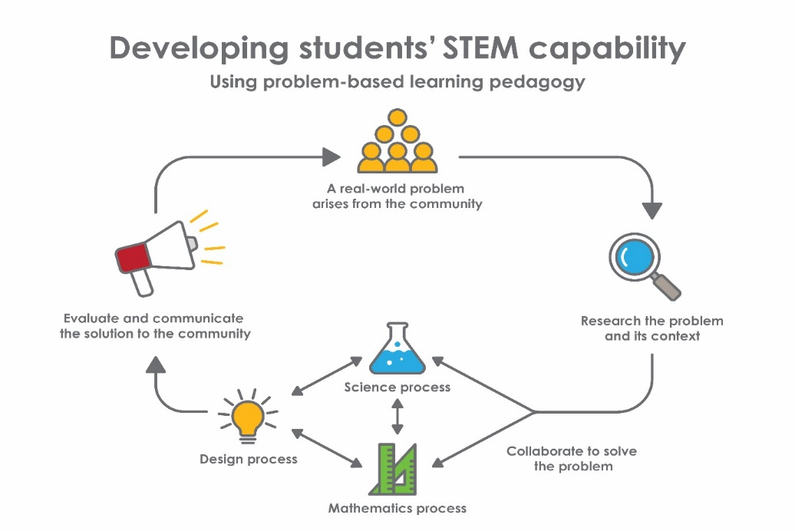
Pre-primary – Animal rescue

Overview
What is the context?
Roads often separate natural landscapes. A variety of animals in urban and rural settings need to cross roads to access resources such as food, water, breeding sites or mates. This is often hazardous for both animals and people in the vehicle. Unfortunately many animals and some people are injured or killed when vehicles collide with animals.
Where animal movements occur regularly with seasonal changes as new food sources become available or for breeding, the local council may build a structure to enable animals to cross the roads safely.
The design of these wildlife crossings varies depending on what type of animal is using them. They include overpasses, underpasses, green bridges, rope ladders, small mammal tunnels and wildlife viaducts.
What is the problem?
How can we design and make a model of a structure that animals can use to cross a road safely?
How does this module support integration of the STEM disciplines?
Using science, technology and mathematics to address a real-world problem, students draw on prior knowledge and learn new principles to collaboratively produce a solution.
Science
Students consider why animals cross roads to move to new places (ACSSU002 – Living things have basic needs, including food and water). They identify materials that are suitable for building their bridge (ACSSU003 – Objects are made of materials that have observable properties) and describe the relevant properties of these materials.
Students are guided to investigate the strength and stability of their bridge and make observations about the mass it can support (ACSIS011 – Participate in guided investigations and make observations using the senses). They share their observations about the strength of their bridge as well as their ideas about what made it strong or weak (ACSIS012 – Share observations and ideas).

Technology
Students consider the needs of local animals and explore the suitability of various materials as they design, construct, test and evaluate a bridge (ACTDEK001 – People produce familiar products to meet personal and community needs)
The Design process guide is included as a resource to help teachers understand the complete design process as developed in the Technologies syllabus.
Mathematics
Students will use the names of two-dimensional shapes and three-dimensional objects as they build and test their bridge (ACMMG009 – Sort, describe and name familiar two-dimensional shapes and three-dimensional objects in the environment). They will test and compare the strength of their bridge and use everyday language to describe and explain which bridge supports the heavier load (ACMMG006 – Use direct and indirect comparisons to decide which is longer, heavier or holds more, and explain reasoning in everyday language). They will use everyday language to describe the positions and movements of animals in relation to the bridge (ACMMG010 – Describe position and movement).
General capabilities
Students build on their Personal and social capability through cooperative learning activities (see General capabilities continuum).
What are the pedagogical principles of the STEM learning modules?
The STEM Learning Project modules develop STEM capabilities by challenging students to solve real-world problems set in authentic contexts. The problems engage students in the STEM disciplines and provide opportunities for developing higher order thinking and reasoning, and the general capabilities of creativity, critical thinking, communication and collaboration.
The design of the modules is based on four pedagogical principles:
- Problem-based learning
This is an underlying part of all modules with every module based around solving an initial problem. It is supported through a four-phase instructional model: research the problem and its context; investigate the parameters impacting on the problem; design and develop solutions to the problem; and evaluate and communicate solutions to an authentic audience.
- Developing higher order thinking
Opportunities are created for higher order thinking and reasoning through questioning and discourse that elicits students' thinking, prompts and scaffolds explanations and requires students to justify their claims. Opportunities for making reasoning visible through discourse are highlighted in the modules with the icon shown here.
- Collaborative learning
This provides opportunities for students to develop teamwork and leadership skills, challenge each other’s ideas, and co-construct explanations and solutions. Information that can support teachers with aspects of collaborative learning is included in the resource sheets.
- Reflective practice
Recording observations, ideas and one’s reflections on the learning experiences in some form of journal fosters deeper engagement and metacognitive awareness of what is being learned. Information that can support teachers with journaling is included in the resource sheets.
These pedagogical principles can be explored further in the STEM Learning Project online professional learning modules located in Connect Resources.

Activity sequence and purpose
Creating a safe passage | Students' interest is captured when they view video clips of animals needing help to cross busy roads safely.  Students consider situations where animals need to cross roads and brainstorm solutions, sharing their ideas through drawings. As a class, they critique their solutions to select the best approach.
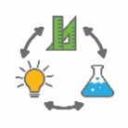  Investigating structures | Students experiment with a variety of materials to create models of sound structures. Through the design cycle they construct and refine their solutions.  They compare the strength of structures and infer why a design may be stronger or weaker than others.
Improving initial designs | Students are introduced to different types of structures through videos and photographs.  Students apply this new knowledge in a second attempt at building a structure.  Students are introduced to fair testing to measure the strength of their structure and evaluate their designs.
Sharing our journey | Students present their designs from Activities 2 and 3 to an audience beyond the classroom.  They explain the design features and justify why their ideas changed as they learnt and overcame problems.

Background
Expected learning | At the completion of this module, students will be able to:  - Explain why animals need to cross roads and say why this is dangerous.  - Design and construct a model of a structure that can carry animals safely over a road.  - Identify materials, and describe the properties of materials used to build a structure.  - Investigate the strength of structures and observe how much weight structures can carry.  - Share their observations from testing the strength of structures and ideas about what made them strong or weak.  - Test and compare the strength of structures and use everyday language to describe differences.  - Use everyday language to describe positions and movements in relation to the structure.  - Analyse digital images to identify features and, with assistance, annotate images to communicate information.
Vocabulary | There are opportunities in this module to develop subject-specific terminology relating to the design of bridges, such as:  Arch, beam, cable, cable-stayed, cantilever, deck, heavy, length, light, pier, strength, suspension, truss, weight, width.  Everyday language is also developed to describe position (eg above, below, at the side) and movement (eg crossing over, towards and away from).
Timing | There is no prescribed duration for this module. The module is designed to be flexible enough for teachers to adapt. Activities do not equate to lessons; one activity may require more than one lesson to implement.
Consumable materials | A Materials list is provided for this module. The list outlines materials outside of normal classroom equipment that will be needed to complete the activities.
Safety notes | There are potential hazards inherent in these activities and with the equipment being used, and a plan to mitigate any risks will be required.  Potential hazards specific to this module include, but are not limited to:  - Digital safety and digital citizenship.  - Construction tools and equipment.
Assessment | The STEM modules have been developed to provide students with learning experiences to solve authentic real-world problems using science, technology, engineering and mathematics capabilities. Appendix 1 indicates how the activities are linked to the Western Australian Curriculum.  While working through the module, the following assessment opportunities will arise:  - Students can be assessed on their discussion of possible solutions, what changes they would make and their reasons for creating their structures. Their reasoning should make some reference to science, mathematics and engineering principles.  - Shared learning journeys can be recorded in a class reflective journal to make thinking visible, showing the progression of learning.  Evidence of learning from journaling, presentations and anecdotal notes from this module can contribute towards the larger body of evidence gathered throughout a teaching period, and can be used to make on-balance judgements about the quality of learning demonstrated by the students in the science, technologies and mathematics learning areas.  Students will have opportunities to further develop their Personal and social capability. A continuum for this is included in the General capabilities continuum but is not intended for assessment purposes.

Activity 1: Creating a safe passage
Activity focus | This activity is designed to capture students’ interest in the problem of animals needing a safe way to cross busy roads.  Students watch video clips of animals crossing roads, brainstorm solutions and share their ideas through drawings. As a class, they critique their solutions to select the best approach.
Background information | With urban development, roads often cut through wildlife habitat. All over the world animals need to cross roads to access resources such as food, water, mates or breeding sites. This is often hazardous for animals and road users.  Many animal movements occur regularly with seasonal changes. During the breeding season, many animals need to cross roads to find their mate. Amphibians may move from dry areas to wet areas when it is time to lay their eggs. Some waterfowl may breed in one part of a lake and move their young to another part with abundant food.  To keep animals off roads, people have constructed animal friendly access ways often known as wildlife crossings or ecoducts. Designs vary depending on the type of animal is using them, but the animal bridge is the most common type of wildlife crossing. Animal bridges are found all over the world, with the majority in North America and Europe.  These highway overpasses and underpasses operate like the ones built for humans and vehicles. Many wildlife crossings have fencing to guide animals to them and natural vegetation to make them safer and more appealing to animals.  The following article shows examples of purpose-built structures that help many types of animals cross busy roads, including a bridge on Christmas Island which helps crabs reach their laying grounds.  A bridge for crabs and a penguin underpass: The amazing purpose-built crossings that help animals bypass roads safely (Daily Mail Australia, 2017)  www.dailymail.co.uk/travel/travel_news/article-4248826/Purpose-built-crossings-help-animals-pass-roads-safely.html  It is important to have an understanding of the difference between mass and weight prior to teaching this module. Mass is a measurement of the amount of matter an object contains whereas weight is the measurement of the pull of gravity on an object.
Instructional procedures | In this activity, students think of a diverse range of ideas to solve the problem. Open problem-solving is encouraged and students may decide to build a bridge, a tunnel or another structure or method.  Students could be prompted to further solve the challenge of channelling animals towards the structure.
Expected learning | Students will be able to:  - Explain that animals need to cross roads to satisfy basic needs and say why this is dangerous (Science).
Equipment required | For the class:  Interactive whiteboard or data projector with internet access  Whiteboard and markers
For the students:
Paper and pencils
Preparation | Preview videos from the Digital resources section to select those most relevant to your local surroundings.
Activity parts | Part 1: Set the scene  Set the context by observing a few short video clips of animals crossing roads. There is a variety to choose from in the Digital resources section including kangaroos, emus, swans and ducklings. These animals were fortunate enough to have people to guide them across the road.  After viewing, ask students:  - Why do you think these animals want to cross the road?  - Is crossing a road safe? Why?
Part 2: Class brainstorm
Engage the class in a short brainstorm based around helping these animals cross the road safely. Encourage diverse ideas to promote creative thinking.
Individually, students record their ideas or solutions through drawing. Help students to annotate and label designs as needed. As students finish, arrange them into small groups to share their designs with their peers.
Part 3: Solutions
When the class has finished their designs, guide a class discussion to share ideas and determine what might be an effective solution. Encourage students to make positive comments about each other’s ideas.
Part 4: Develop ideas
Discuss how different structures could help a larger variety of animals cross a busy road. Ask students:
- How could animals be guided to use a structure to cross a road?
- What would encourage animals to use it?
- How would you know if your idea worked?
Watch the Wildlife crossings around the world 2017 video to inspire, arouse curiosity and build enthusiasm for Activity 2.
Digital resources | Teacher background:  A bridge for crabs and a penguin underpass: The amazing purpose-built crossings that help animals bypass roads safely (Daily Mail Australia, 2017)  www.dailymail.co.uk/travel/travel_news/article-4248826/Purpose-built-crossings-help-animals-pass-roads-safely.html
Wild animals can safely cross the eco bridge (Ashleigh Elson, 2012)
www.youtube.com/watch?v=1dPbaF_T9zc
Five crazy bridges for animals (MinuteEarth, 2014)
www.youtube.com/watch?v=VjCJvn__N5c&t=1s
Skyway highway crossing for endangered possums in Busselton and Bunbury
http://www.abc.net.au/local/stories/2014/10/13/4105896.htm

Fauna bridge over the Tonkin Highway https://www.watoday.com.au/national/western-australia/no-humans-allowed-main-roads-building-wa-s-first-animal-bridge-20180726-p4ztre.html
Student viewing:
Black swans stop traffic in Perth to cross road (Claire Alexander, 2014)
www.youtube.com/watch?v=UlM0a_EiE7k
CNN Distraction: Family of ducks tries to cross highway (CNN, 2012)
www.youtube.com/watch?v=mGMzGxeO1wQ
Koala needs help crossing the road (Koalification, 2014)
www.youtube.com/watch?v=XG2G0HhNp0E
Echidna crossing the road on Kangaroo Island (James Wehrman, 2010)
www.youtube.com/watch?v=JcTOJsEvV0U
Goslings risk dangerous crossing at Humboldt (WillCFish Fishing Tips and Tricks, 2015)
www.youtube.com/watch?v=Czdlv-2LUl4
Wildlife crossings around the world 2017 (V-Talk, 2016)
www.youtube.com/watch?v=2q_XzNz9v44
Beware! Emu crossing! (WWF, 2012)
www.youtube.com/watch?v=bEsc409mD9o
Kangaroo owning the countryside road, only in Australia (Tony Milkail, 2015)
www.youtube.com/watch?v=2OJCkmFpqhk

A student work sample
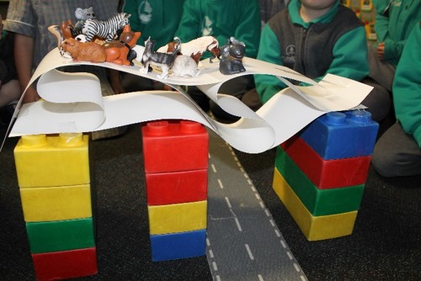

Activity 2: Investigating structures
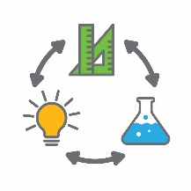  Activity focus | In this activity, students experiment with a variety of materials to create sound structures. Through the design process they construct and refine their solutions, building their understanding. They compare the strength of their structures and infer why different designs may be stronger than others.
Background information | The strength of a structure will be determined by the choice of materials, types of joins and the shapes included in the design. Real bridges and tunnels are made from materials like concrete and steel which can withstand compression (squashing) forces and steel cables which can withstand tension (stretching) forces.  Shorter horizontal beams will withstand heavier loads than longer beams, so it is more demanding to engineer long bridges. Because arches are strong shapes, they are often included as supports under bridge decks. Truss bridges include many strong triangle shapes in the truss which sits above and supports the bridge deck.  When testing the strength of a bridge, engineers increase the load on a model bridge or components until it collapses. They use standard units of measurement such as tonnes and Newtons.  At pre-primary level, non-standard units of measurement can be used, such as cubes or glass pebbles that are uniform in mass. Using toy animals as masses would strengthen the connection for students in relation to the task, however, conversations around heavier and lighter would need to occur.
Instructional procedures | This activity will work best if carried out in small groups and guided by an adult. This ensures each student has an adult to provide feedback, record thinking and keep them motivated to work through difficulties.  Record student thinking as annotations in the class reflective journal throughout the lesson. See Reflective journal for elaboration.
Expected learning | Students will be able to:  - Design and construct a model of a structure that can carry animals safely past a road (Technologies).  - Identify materials and describe the properties of the materials used to build a structure (Science).  - Investigate the strength of their structure and observe how much mass they can carry (Science).
Equipment required | For the students:  Variety of construction materials and tools (eg card, cardboard tubes, pipe cleaners, masking tape, scissors)  Collection of masses (commonly called weights) that can be used to test the strength of the structures.  A base on which to build their structure so it can be moved.
Preparation | Materials need to be organised prior to the lesson and either separated into buckets for small groups to access or allocated to a dedicated work area.  Plan the adult help required.
Activity parts | Part 1: Recap  As a class, discuss the learning from the previous activity and the agreed solutions. Explain that in this activity, students will work in small groups to build a solution.  During the activity, student discussions can be recorded using anecdotal notes. A template has been provided as Teacher resource sheet 2.2: Recording grid for discussion language.
Part 2: Materials
Present the materials and tools available for students to construct their models. Before beginning construction, discuss what students could do to improve their model if it collapses during testing.
Explain that encountering problems, testing and trying again is a normal part of the design process. Explain that engineers make and test models to get their designs right before building.

Part 3: Construction
As students construct, ask them how they plan to make their structure and why they are building in certain ways. Provide feedback and highlight that there are many ways to build any structure.
If students are having difficulty with their structure collapsing, encourage them to reflect and create a plan to fix it.
A template to record student thinking during this process is provided as Teacher resource sheet 2.1: Prototype troubleshooting.
Scaffolding questions could include:
- What is not working?
- Why is it not working?
- How can we change that?
- How could you find the total mass you have loaded onto your bridge?
- Was it difficult to find a mass that was just right?
Part 4: Testing
This part creates an opportunity for teachers to develop student understanding of ‘heavier’ and ‘holds more’. Activities that require students to heft objects and make decisions about which are heavier or lighter; or use balance beams to identify or rank items by mass will help to develop these understandings. Questioning should guide students to explore, think about and explain the concepts of heavier and lighter using everyday language. Use ‘why’ and ‘because’ to encourage students explain their responses.
- Which object is heaviest/lightest? How do you know?
- Can you find an object that is heavier/lighter than a ……..?
- Can you make it balance? How?
- In response to unbalanced masses……How could you make it balance?
- How many cubes does it take to balance with an eraser?
- Are the bigger objects heavier or lighter than the smaller objects?
- How does a balance work? What does a balance tell you?
- Have you seen anything in the playground that is like a balance?
- Would it be fun to see-saw with an elephant?
Once their structures are built, ask students how they might test its strength. Follow their ideas even if they are not a fair test; fair testing will be introduced in the next activity.
Test the strength of the structures using ideas suggested by the students. Examples might include placing blocks, books or toys on top of the structures. Ask the students:
- What is the heaviest thing you can put on your structure without it collapsing? Encourage students to explain their decisions.
- How could you decide which item is heavier?
- Why is it hard to know which is heavier just by looking?
Testing can be recorded in the class reflective journal using photos of the structures accompanied by a table showing the load carried by different structures.
Keep photos for comparison purposes in Activity 4 as the structures may get damaged in the testing process in Activity 3.
Part 5: Reflection
Students should be developing understandings that making reasonable estimates is not about making lucky guesses. Instead, requiring them to reflect and develop a procedure to compare the mass to be estimated against the strength of their structure.
Ask student to think-pair-share to discuss what they need to do to make good estimates.
Resource sheets | Reflective journal  Teacher resource sheet 2.1: Prototype troubleshooting  Teacher resource sheet 2.2: Recording grid for discussion language

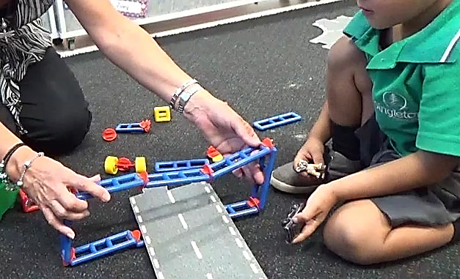
A student engaged in the design process
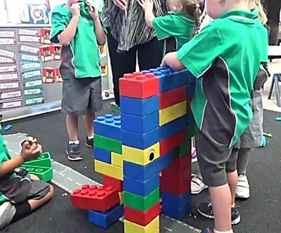

Students working collaboratively to solve the problem

A student design solution
Student “The turtles carry the rabbits on their backs over the road”
Teacher “What if there are no turtles, how will the rabbits cross?”
Student “They will get their mummies”

Activity 3: Improving initial designs
Activity focus | In this activity, students are introduced to different types of bridge designs by observing a video clip and viewing photographs. Students apply this new knowledge and have a second attempt at constructing their model bridge. They are introduced to fair testing to measure bridge strength and evaluate their designs.
Background information | There are four common designs for bridges: beam, arch, truss and suspension.  Beam bridges comprise a bridge deck that is supported at each end. Beam bridges work well over short distances; however, they are not as strong over long distances.  Arch bridges add one or more arches underneath the bridge deck which makes them stronger over long distances. More arches can be added to ensure the deck is supported along its full length.  Truss bridges use a complex steel frame which sits above and supports the bridge deck. The truss is made from many strong triangle shapes.  Suspension bridges use steel cables strung from pylons that support the bridge deck.  There are three broad categories of tunnels: mining, public works and transportation. Soft soil tunnels are those that are built through soil, instead of rock. These tunnels are the simplest to dig but they need a retaining structure to keep the soil in place so the tunnel doesn’t cave in.  View the 10-minute video on bridge design in the Digital resources section to learn more about the different types of bridges and tunnels.  Fair testing: To ensure the experiment is a fair test only one factor at a time can be changed, while keeping all other conditions the same. The factors in an experiment are called variables.
Instructional procedures | This activity engages students in an engineering design process to design, construct, test and evaluate a model of a structure that could be used by animals to cross a road.  The key principle that should inform design is that a structure needs to be structurally sound for it to support weight.  Continue to record student thinking throughout the activity as annotations in the class reflective journal.
Expected learning | Students will be able to:  - Test and compare the strength of structures and use everyday language to describe differences (Science and Mathematics).  - Investigate the strength of structures and observe how much mass they can carry (Science).  - Use everyday language to describe positions and movements in relation to a structure (Mathematics).  - Design and construct a model of a structure that can carry animals safely over a road (Technologies).
Equipment required | For the class:  Interactive whiteboard with internet access  Photographs (printed or digital) of different types of bridges
For the students:
The structures they made in Activity 2
Variety of construction materials and tools (eg card, cardboard tubes, pipe cleaners, masking tape, scissors, collection of ‘weights’)
A base for students’ structures.
Preparation | Gather materials and print out photos of structures.
Activity parts | Part 1: Investigating structures  As a class, view the short clip about beam, truss and suspension bridges, What makes bridges so strong? (see Digital resources).  Hand out pictures of different types of bridges for students to analyse and identify features. Talk about the features, introducing vocabulary such as piers, arches and decks.  Students build a second structure using their expanded knowledge about bridge design.  Anecdotal notes for this activity can be recorded on Teacher resource sheet 3.1: Recording grid for materials and processes
Part 2: Problem solving
As students complete their structure, ask them to explain their ideas. Encourage students to expand using ‘why’ and ‘because’ to justify their thinking.
- Why are you using these materials? Because…
- Can the way you use materials strengthen your structure? How?
- Does the shape you make from your materials change how strong your structure is? Why?
- What shapes are you including in your designs? Why?
- Why are you joining it this way? Because…
If a group is experiencing trouble with their structure collapsing, prompt them to locate where it is breaking and to create a plan to fix it.
- What’s not working?
- Why is that?
- How can you fix it?
- How did you improve your design?
Encourage teamwork and persistence.
Students decorate their structure so it is appealing for animals (eg covering the bridge in grass or sprinkling it with sand). Take a photo prior to decorating if this will alter the structural integrity of the structure.
Part 3: Fair testing
As students finish, discuss how they measured the strength of their bridge in Activity 2. Introduce the term ‘fair testing’, explaining that engineers test in a fair way to make sure comparisons between the strength of bridges are valid.
In this test, students will use the same masses arranged in the same places (eg across the bridge or piled in the middle). Guide students to test their second bridge in a fair manner using the same masses placed in similar positions.

After testing, encourage student reflection by asking:
- What makes a fair test? Was your testing fair? Why/why not?
- Which structure is the strongest? Why is it so strong?
- What shapes were used in the structure? Do certain shapes make the structure stronger?
- Does the size of the structure make a difference? What can you tell me about how changes in the height or length changes how strong the structure is?
- Do different materials make the structure stronger? Why?
Record students’ responses, encouraging the use of comparative language.
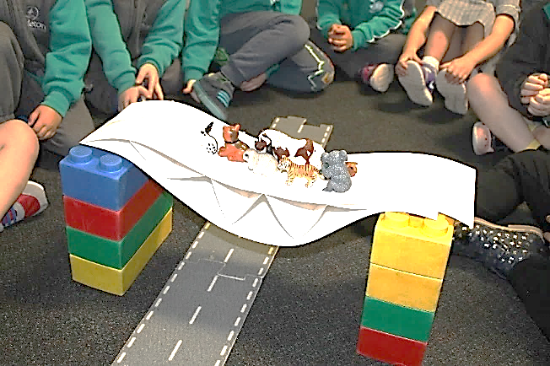
Students testing their design
Resource sheets | Teacher resource sheet 3.1: Recording grid for materials and processes
Digital resources | Teacher background:  Bridge design (and destruction!) (MITK12Videos, 2013)  Part 1: www.youtube.com/watch?v=lBP7739C83s  Part 2: www.youtube.com/watch?v=KBOGRxV49MQ  Tunnel design  www.youtube.com/watch?v=WnvZ_Eb0mhs
Student viewing:
What makes bridges so strong? (SciShow Kids, 2015)
www.youtube.com/watch?v=oVOnRPefcno&t=22s

Activity 4: Sharing our journey
Activity focus | Students present their two bridge designs from Activities 2 and 3 to an audience beyond the classroom. They explain their design features and choices, justifying why their ideas changed as they learnt about bridges and overcame problems.
Instructional procedures | Record students’ thinking using annotations on the photos of their bridge designs.  To strengthen the link to real-world concepts, photos of their bridge designs could be compared to real bridges on a display board or interactive whiteboard.
Expected learning | Students will be able to:  - Share their observations from testing the strength of bridges and ideas about what made them strong or weak (Science, Technologies).  - Analyse digital images to identify features and, with assistance, annotate images to communicate information (Technologies).
Equipment required | For the students:  Each student will need the two bridges (or photos) they created. This will assist them to reflect on and communicate how and why their ideas changed.
Preparation | An authentic audience needs to be sourced.  Organise bridge designs and photos around the room with space for people to view.
Activity parts | Part 1: Reflection  Conduct a class discussion for the reflective journal to highlight what students have learnt and enjoyed. Model how thinking has changed using the phrase:  - I used to think….. Now I think….  Some more examples of reflection starters are:  - The best part of learning about bridges was…  - A problem I ran into was…. I fixed it by…..  - I have learnt that….  Use Student activity sheet 4.1: Student model development and reflection for individual reflections.
Part 2: Presentation
Pair students with a buddy, parent or grandparent for presentations. Students should present their bridges to their partner and share what they have learnt.
Part 3: Gallery walk
As students finish presenting, they may walk with a ‘buddy’ around the room to view their peers’ designs.
Part 4: Build it together
Students co-construct a bridge with their audience (buddy, parent or grandparent) in an unstructured manner. This provides an opportunity to teach another person what they have learnt.
Resource sheets | Student activity sheet 4.1: Student model development and reflection

Appendix 1: Links to the Western Australian Curriculum
The Animal Rescue module provides opportunities for developing students’ knowledge and understandings in science, technologies and mathematics. The table below shows how this module aligns to the content of the Western Australian Curriculum and can be used by teachers for planning and monitoring.
ANIMAL RESCUE  Links to the Western Australian Curriculum | ACTIVITY
 | 1 | 2 | 3 | 4
SCIENCE
SCIENCE UNDERSTANDING
Chemical sciences: Objects are made of materials that have observable properties (ACSSU003) |  | ●
SCIENCE INQUIRY SKILLS
Planning and conducting: Participate in guided investigations and make observations using the senses (ACSIS011) |  | ● | ●
Communicating: Share observations and ideas (ACSIS012) |  |  |  | ●
DESIGN AND TECHNOLOGIES
KNOWLEDGE AND UNDERSTANDING
Technologies and society: People produce familiar products to meet personal and community needs (ACTDEK001) |  | ● | ●
MATHEMATICS
MEASUREMENT AND GEOMETRY
Using units of measurement: Use direct and indirect comparisons to decide which is longer, heavier or holds more, and explain reasoning in everyday language (ACMMG006) |  |  | ●
Location and transformation: Describe position and movement (ACMMG010) |  |  | ●
Further information about assessment and reporting in the Western Australian Curriculum can be found at: https://k10outline.scsa.wa.edu.au/home
curriculum-browser/technologies/technologies-overview/ways-of-assessing

Appendix 1: Mathematics proficiency strands
Key ideas
In Mathematics, the key ideas are the proficiency strands of understanding, fluency, problem-solving and reasoning. The proficiency strands describe the actions in which students can engage when learning and using the content. While not all proficiency strands apply to every content description, they indicate the breadth of mathematical actions that teachers can emphasise.
Understanding
Students build a robust knowledge of adaptable and transferable mathematical concepts. They make connections between related concepts and progressively apply the familiar to develop new ideas. They develop an understanding of the relationship between the ‘why’ and the ‘how’ of mathematics. Students build understanding when they connect related ideas, when they represent concepts in different ways, when they identify commonalities and differences between aspects of content, when they describe their thinking mathematically and when they interpret mathematical information.
Fluency
Students develop skills in choosing appropriate procedures; carrying out procedures flexibly, accurately, efficiently and appropriately; and recalling factual knowledge and concepts readily. Students are fluent when they calculate answers efficiently, when they recognise robust ways of answering questions, when they choose appropriate methods and approximations, when they recall definitions and regularly use facts, and when they can manipulate expressions and equations to find solutions.
Problem-solving
Students develop the ability to make choices, interpret, formulate, model and investigate problem situations, and communicate solutions effectively. Students formulate and solve problems when they use mathematics to represent unfamiliar or meaningful situations, when they design investigations and plan their approaches, when they apply their existing strategies to seek solutions, and when they verify that their answers are reasonable.
Reasoning
Students develop an increasingly sophisticated capacity for logical thought and actions, such as analysing, proving, evaluating, explaining, inferring, justifying and generalising. Students are reasoning mathematically when they explain their thinking, when they deduce and justify strategies used and conclusions reached, when they adapt the known to the unknown, when they transfer learning from one context to another, when they prove that something is true or false, and when they compare and contrast related ideas and explain their choices.
Source:
www.australiancurriculum.edu.au/f-10-curriculum/mathematics/key-ideas/?searchTerm=key+ideas#dimension-content

Appendix 2: General capabilities continuum
Personal and social capability continuum
Organising element | Level 1A Student | By the end of Foundation year students
Self-awareness element
Recognise emotions | Recognise and identify their own emotions | Identify a range of emotions and describe situations that may evoke these emotions
Recognise personal qualities and achievements | Express a personal preference | Identify their likes and dislikes, needs and wants, and explore what influences these
Understand themselves as learners | Select tasks they can do in different learning contexts | Identify their abilities, talents and interests as learners
Develop reflective practice | Recognise and identify participation in or completion of a task | Reflect on their feelings as learners and how their efforts affect skills and achievements
Self-management element
Express emotions appropriately | Recognise and identify how their emotions influence the way they feel and act | Express their emotions constructively in interactions with others
Develop self-discipline and set goals | Make a choice to participate in a class activity | Follow class routines to assist learning
Work independently and show initiative | Attempt tasks with support or prompting | Attempt tasks independently and identify when and from whom help can be sought
Become confident, resilient and adaptable | Identify people and situations with which they feel a sense of familiarity or belonging | Identify situations that feel safe or unsafe, approaching new situations with confidence
Social awareness element
Appreciate diverse perspectives | Show an awareness for the feelings, needs and interests of others | Acknowledge that people hold many points of view
Contribute to civil society |  | Describe ways they can help at home and school
Understand relationships |  | Explore relationships through play and group experiences
Communicate effectively | Respond to the feelings, needs and interests of others | Identify positive ways to initiate, join and interrupt conversations with adults and peers
Work collaboratively |  | Share experiences of cooperation in play and group activities
Make decisions |  | Identify options when making decisions to meet their needs and the needs of others
Negotiate and resolve conflict |  | Listen to others’ ideas, and recognise that others may see things differently from them
Further information about general capabilities is available at:
k10outline.scsa.wa.edu.au/home/p-10-curriculum/general-capabilities-over/general-capabilities-overview/general-capabilities-in-the-australian-curriculum

Appendix 3: Materials list

You will need the following materials to complete this module:
- a class reflective journal, see Reflective journal for further details
- interactive whiteboard or data projector with internet access
- a variety of construction materials and tools for bridge construction such as card, cardboard tubes, pipe cleaners, masking tape, scissors
- a collection of masses such as books, toys, blocks and some uniform masses having the same weight (eg marbles).

Appendix 4: Design process guide
Safe production of the final design or multiple copies of the final design.
Fine tuning the production process, such as division of labour for batch or mass production.
Use of intended materials and appropriate tools to safely make the solution to the design problem.
Reflection on the process taken and the success of the design.
Evaluation can lead to further development or improvement of the design and can be a final stage of the design process before a conclusion is reached.
Could be formal or informal and verbal or written.
Ideation
Development
Development of the design ideas. Improvements, refinements, adding detail, making it better.
Activities such as detailed drawings, modelling, prototyping, market research, gaining feedback from intended user, further research – if needed – to solve an issue with the design, testing different tools or equipment, trialling production processes, measuring or working out dimensions, testing of prototypes and further refinement.
Idea generation – turning ideas into tangible forms so they can be organised, ordered and communicated to others.
Activities such as brainstorming, mind mapping, sketching, drawing diagrams and plans, collecting colour samples and/or material samples and talking through these ideas can help to generate more creative ideas.
Using the SCAMPER model can assist with this: www.mindtools.com/pages/article/newCT_02.htm
www.designorate.com/a-guide-to-the-scamper-technique-for- creative-thinking
Analysis
Finding useful and helpful information about the design problem.
Gathering information, conducting surveys, finding examples of existing solutions, testing properties of materials, practical testing.
Understanding the meaning of the research findings.
Analysing what the information means, summarising the surveys, judging the value of existing solutions, understanding test results.
Research
Production
Evaluation

Appendix 5: Reflective journal
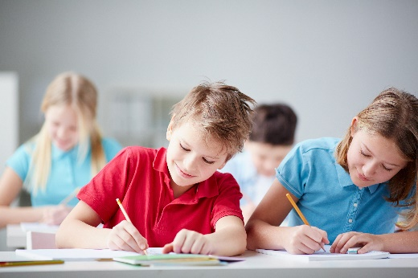
When students reflect on learning and analyse their own ideas and feelings, they self-evaluate, thereby improving their metacognitive skills. When students self-monitor or reflect, the most powerful learning happens.
Journaling may take the form of a written or digital journal, a portfolio or a digital portfolio. Early childhood classrooms may use a class reflective floor book with pictures of the learning experience and scribed conversations.
Teachers can model the journaling process by thinking aloud and showing students how they can express learning and thoughts in a variety of ways including diagrams, pictures and writing.
Journals are a useful tool that gives teachers additional insight into how students value their own learning and progress, as well as demonstrating their individual achievements.
The following links provide background information and useful apps for journaling.
Kidblog – digital portfolios and blogging
kidblog.org/home
Edmodo – for consolidating and storing class notes and learning materials
www.edmodo.com/
Explain Everything™ – a screen casting, video and presentation tool all in one
explaineverything.com
Popplet – allows you to jot down your ideas and then sort them visually
Popplet.com
Seesaw – for capturing work completed by students in class, using a device’s camera function
web.seesaw.me
Connect – the DoE portal for teachers
connect.det.wa.edu.au
Evernote (a digital portfolio app)
evernote.com
Digital portfolios for students (Cool tools for school)
cooltoolsforschool.wordpress.com/digital-student-portfolios

Appendix 6: Teacher resource sheet 1.4: Cooperative learning – Think, Pair, Share
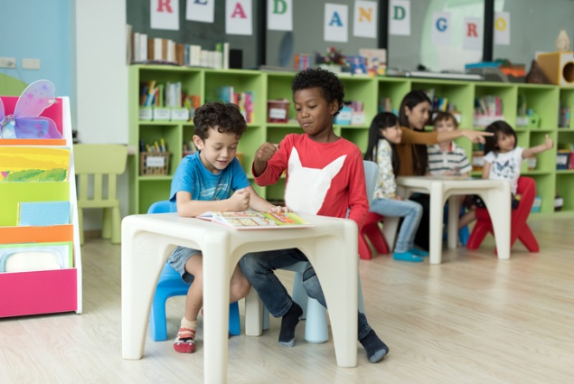
This resource sheet provides a brief outline of a cooperative learning strategy known as 'think – pair – share'.
Cooperative learning frameworks create opportunities for groups of students to work together, generally to a single purpose.
As well as having the potential to increase learning for all students involved, using these frameworks can help students develop personal and social capability.
In the 'think' stage, each student thinks silently about a question asked by the teacher.
In the 'pair' stage, students discuss their thoughts and answers to the question in pairs.
In the 'share' stage, the students share their answer, their partners answer or what they decided together. This sharing may be with other pairs or with the whole class. It is important also to let students 'pass'. This is a key element of making the strategy safe for students.
Think – pair – share increases student participation and provides an environment for higher levels of thinking and questioning.

Appendix 7: Teacher resource sheet 2.1: Prototype troubleshooting
Student | Problem | Reason student provided for the problem | Changes to the design suggested by the student

Student: | Student: | Student:
Student: | Student: | Student:
Student: | Student: | Student:

Appendix 8: Teacher resource sheet 2.2: Recording grid for discussion language
Highlight the language students’ use during discussions as they follow the Design process.

Appendix 9: Teacher resource sheet 3.1: Recording grid for materials and processes
Student:  Material and shape:  Reason and testing processes: | Student:  Material and shape:  Reason and testing processes: | Student:  Material and shape:  Reason and testing processes:
Student:  Material and shape:  Reason and processes: | Student:  Material and shape:  Reason and testing processes: | Student:  Material and shape:  Reason and testing processes:
Highlight the materials the student chose for building, and the reasons given, as they follow the Design process.

Appendix 10: Student activity sheet 4.1: Student model development and reflection
My model is made from

I used this because

My model will help animals cross the road safely by

__________________________________________________________________________________

__________________________________________________________________________________

Is my model strong?

Is my model stable?

This is a picture of my model:

