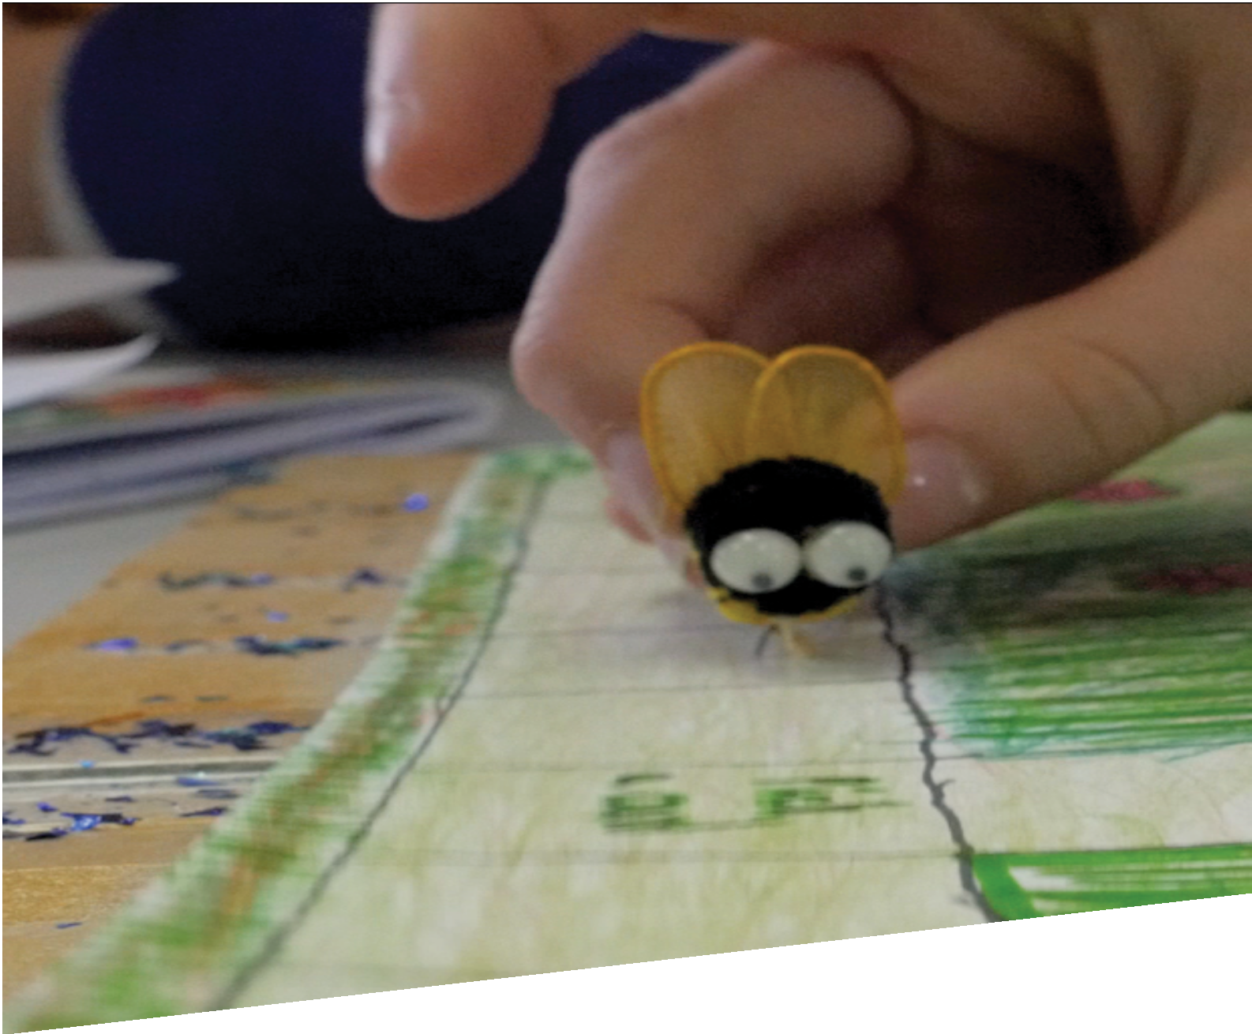

CURRICULUM RESOURCE MODULE
Honey bees
YEAR 4
Acknowledgements
The STEM Learning Project respectfully acknowledges the Traditional Custodians of the lands upon which our students and teachers live, learn and educate.

The STEM Learning Project is funded by the Western Australian Department of Education (the Department) and implemented by a consortium in STEM education comprising the Educational Computing Association of WA, the Mathematical Association of WA, the Science Teachers Association of WA and Scitech. We acknowledge and thank the teachers and schools who are the co-creators of these resources.

Copyright and intellectual property
The copyright and intellectual property of this module remain the property of the Department.

Any Western Australian Curriculum content in this resource is used with the permission of the School Curriculum and Standards Authority (the Authority); this permission does not constitute Authority endorsement of the resource. The Authority accepts no liability for any errors or damages arising from reliance on its content. The Western Australian Curriculum content may be freely copied, or communicated on an intranet, for non-commercial purposes in educational institutions, provided that the Authority is acknowledged as the copyright owner. Copying or communication for any other purpose can be done only within the terms of the Copyright Act 1968 or with prior written permission of the Authority. Any Australian Curriculum content in the Western Australian Curriculum is used by the Authority under the terms of the Creative Commons Attribution-NonCommercial 3.0 Australia licence.

Any content on the www.scsa.wa.edu.au domain that has been derived from the Australian Curriculum may be used under the terms of Creative Commons Attribution-NonCommercial 3.0 Australia licence.

Appendix 2: General capabilities continuums is adapted from ACARA, © Australian Curriculum, Assessment and Reporting Authority (ACARA) 2009 to present, unless otherwise indicated. This material was downloaded from the ACARA website (www.acara.edu.au) (accessed December 2015) and was not modified. The material is licensed under CC BY 4.0 (https://creativecommons.org/licenses/by/4.0/). ACARA does not endorse any product that uses ACARA material or make any representations as to the quality of such products. Any product that uses material published on this website should not be taken to be affiliated with ACARA or have the sponsorship or approval of ACARA. It is up to each person to make their own assessment of the product.

This resource includes references and examples of iOS, Android and other apps. The Department does not endorse or recommend any commercial products and simply provides these as examples for teachers.

The Department is committed to providing quality information to its customers. Whilst every effort has been made to ensure accuracy, currency and reliability of the information within these documents, the Department accepts no responsibility for errors, omissions or amendments made since the time of publishing. Confirmation of information may be sought from the Department or the originating bodies providing the information. The Department has no control over the content of material published on websites to which users are referred in this resource. It is the responsibility of the internet user to make their own decision as to the relevancy, accuracy, currency and reliability of information found on those sites.

Attributions: Google Drive and Google Docs, Microsoft Word, PowerPoint and OneNote, iMovie, Scratch, Scratch Jr, Tynker, Book Creator, Pages, Keynote, Seesaw, Sphero, Little Bits, Ozobot, Bee Bots, Makey Makey, Popplet, Piktochart, Canva, Numbers, Easy Chart, Dropbox, Dash and Dot, Edison, Green Screen, Lego EV3, Hopscotch, Qrafter, i-nigma, Aurasma, Puppet-Pals, SketchUp, Connect.

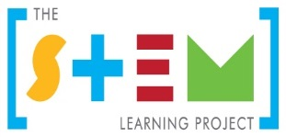
Table of contents
The STEM Learning Project 2
Overview 3
Activity sequence and purpose 7
Background 8
Activity 2: Identifying causes, finding solutions 18
Activity 3: Game workshop 31
Activity 4: The hive 35
Appendix 1A: Links to the Western Australian Curriculum 39
Appendix 1B: Mathematics proficiency strands 41
Appendix 2: General capabilities continuums 42
Appendix 3: Materials list 45
Appendix 4: Design process guide 46
Appendix 5: Reflective journal 47
Appendix 6: Student activity sheet 1.0: Journal checklist 48
Appendix 7: Teacher resource sheet 1.1: Cooperative learning – Roles 49
Appendix 8: Teacher resource sheet 1.2: Cooperative learning – Jigsaw 50
Appendix 9: Teacher resource sheet 1.3: Cooperative learning – Placemat 51
Appendix 10: Teacher resource sheet 1.4: Cooperative learning – Think, Pair, Share 52
Appendix 11: Teacher resource sheet 1.5: Picture stimuli 53
Appendix 12: Student activity sheet 1.6: Mind map 54
Appendix 13: Student activity sheet 1.7: I see, I think, I wonder 55
Appendix 14: Student activity sheet 1.8: Animation – Storyboarding 56
Appendix 15: Student activity sheet 1.9: Pollinated by honey bees 57
Appendix 16: Teacher resource sheet 1.10: Glossary 58
Appendix 17: Student activity sheet 2.1: Percentage grids 59
Appendix 18: Student activity sheet 2.2: Example design brief 60
Appendix 19: Student activity sheet 2.3: Infographic 61
Appendix 20: Student activity sheet 3.1: Action plan 63
Appendix 21: Student activity sheet 3.2: Prototype troubleshooting 64
Appendix 22: Teacher resource sheet 4.1: Question prompts 65
Appendix 23: Teacher resource sheet 4.2: Game tokens 66
Appendix 24: Teacher resource sheet 4.3: Example flyer 67
Appendix 25: Teacher resource sheet 4.4: Adopt a bee (seed envelope labels) 68
Appendix 26: Teacher resource sheet 4.5: Peer or parent feedback 69
Appendix 27: Student activity sheet 4.6: Self-evaluation 70
Appendix 28: Teacher resource sheet 4.7: Student evaluation 71
Appendix 29: Student activity sheet 4.8: Design review 72

The STEM Learning Project
The aim of the STEM Learning Project is to generate students’ interest, enjoyment and engagement with STEM (Science, Technology, Engineering and Mathematics) and to encourage their ongoing participation in STEM both at school and in subsequent careers. The curriculum resources will support teachers to implement and extend the Western Australian Curriculum and develop the general capabilities across Kindergarten to Year 12.
Why STEM?
A quality STEM education will develop the knowledge and intellectual skills to drive the innovation required to address global economic, social and environmental challenges.
STEM capability is the key to navigating the employment landscape changed by globalisation and digital disruption. Routine manual and cognitive jobs are in decline whilst non-routine cognitive jobs are growing strongly in Australia. Seventy-five per cent of the jobs in the emerging economy will require critical and creative thinking and problem solving, supported by skills of collaboration, teamwork and literacy in mathematics, science and technology. This is what we call STEM capability. The vision is to respond to the challenges of today and tomorrow by preparing students for a world that requires multidisciplinary STEM thinking and capability.
The approach
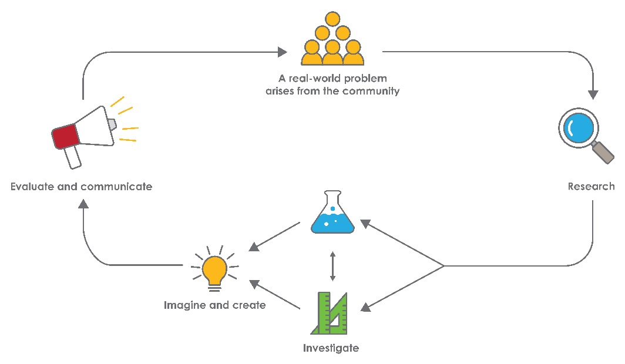
STEM capabilities are developed when students are challenged to solve open-ended, real-world problems that engage students in the processes of the STEM disciplines.
STEM Consortium
Year 4 – Honey bees

Overview
When we think of bees and how they contribute to our lives, the first thing that comes to mind is honey. However, bees play a much more important role. Bees contribute to one of the most important processes in horticulture and agriculture –pollination.
According to Barbara Baer, a researcher at the Centre of Integrative Bee Research, University of Western Australia, “Every third spoon of food we eat has been pollinated by a honey bee which makes them really important agricultural animals”.
Bees are responsible for the pollination of vegetables, fruits, nuts, spices, canola and countless plants.
In recent years, honey bee populations have been in decline. Some reasons for this include climate change, pesticide use, modern agricultural practices, viruses and bacteria. The parasitic Varroa mite has led to a huge drop in honey bee numbers.
Australia remains the only continent in the world to be free of Varroa mite. However, given the importance the honey bee plays in food production, the decline in populations around the world serves as a warning to Australia.
In this module, students explore the problem of declining honey bee populations.
What is the context?
Beekeepers around the world have observed a sudden decline in numbers of honey bees and honey bee colonies.
What is the problem?
How can we raise awareness about the importance and the plight of the honey bee?
How does this module support integration of the STEM disciplines?
Science
Students investigate the role honey bees play in pollination, agriculture and horticulture. This provides students with the opportunity to engage with an authentic and relevant ecological issue. Using a multidisciplinary approach, students apply content knowledge and processes to develop a greater understanding of the natural environment and develop advocacy for the conservation of the honey bee (ACSHE062: Science knowledge helps people to understand the effect of their actions).
Students engage in the biological sciences strand of the Science syllabus by researching the causes and solutions to the decline of honey bees and develop an understanding of how living things depend on each other and the environment to survive (ACSSU073: Living things depend on each other and the environment to survive). As important pollinators, bees play a key role in the plant life cycle (ACSSU072: Living things have life cycles) because many plants cannot produce seeds or fruit without cross-pollination.
Technology
This module allows students to engage in technology as they create solutions and design an engaging and informative game. Students investigate, design, produce, evaluate and collaborate effectively in developing their game (WATPPS26: Work independently, or collaboratively when required, to plan, create and communicate ideas and information for solutions, WATPPS23: Develop and communicate design ideas and decisions using annotated drawings and appropriate technical terms AND WATPPS25: Use criteria to evaluate and justify simple design processes and solutions).
Students engage in computational thinking when developing algorithms that use branching to develop their product (ACTDIP011: Use simple visual programming environments that include a sequence of steps (algorithm) involving decisions made by the user (branching)). There are opportunities for students to engage in coding using software and peripheral devices.
The Design process guide is included as a resource to aid teachers in understanding the complete design process as developed in the Technologies curriculum.
Mathematics
When developing a design brief for their game, students engage in mathematics as they collect, represent and analyse data (ACMSP095: Select and trial methods for data collection, including survey questions and recording sheets). They develop surveys and construct data displays that provide tabular and graphical representations of game features (ACMSP096: Construct suitable data displays, with and without the use of digital technologies, from given or collected data. Include tables, column graphs and picture graphs where one picture can represent many data values). When comparing their data from their investigations of plants and bee activity they will be exposed to equivalent fractions used in contexts (ACMNA077: Investigate equivalent fractions used in contexts). They will be introduced to the idea of using percentages to compare fractions as foundation for learning in later years.

General capabilities
There are opportunities for the development of general capabilities and cross-curriculum priorities as students engage with the honey bees module. In this module, students:
- Develop problem solving skills as they research the problem and its context (Activity 1); investigate parameters impacting on the problem (Activity 2); imagine and develop solutions (Activity 3); and evaluate and communicate their solutions to an audience (Activity 4).
- Utilise creative thinking as they generate possible design solutions; and critical thinking, numeracy skills and ethical understanding as they choose between alternative approaches to solving the problem of raising awareness about the importance and plight of the honey bee.
      - Utilise personal and social capability as they develop socially cohesive and effective working teams; collaborate in generating solutions; adopt group roles; and reflect on their group work capabilities through self and peer evaluation.
      - Utilise a range of literacies and information and communication technologies capabilities as they collate records of work completed throughout the module in a journal; and represent and communicate their solutions to an audience using digital technologies (Activity 4).
      - Communicate and, using evidence, justify their group’s design to an audience beyond the classroom.

What are the pedagogical principles of the STEM learning modules?
The STEM Learning Project modules develop STEM capabilities by challenging students to solve real-world problems set in authentic contexts. The problems engage students in the STEM disciplines and provide opportunities for developing higher order thinking and reasoning, and the general capabilities of creativity, critical thinking, communication and collaboration.
The design of the modules is based on four pedagogical principles:
- Problem-based learning
This is an underlying part of all modules with every module based around solving an initial problem. It is supported through a four-phase instructional model: research the problem and its context; investigate the parameters impacting on the problem; design and develop solutions to the problem; and evaluate and communicate solutions to an authentic audience.
- Developing higher order thinking
Opportunities are created for higher order thinking and reasoning through questioning and discourse that elicits students' thinking, prompts and scaffolds explanations, and requires students to justify their claims. Opportunities for making reasoning visible through discourse are highlighted in the modules with the icon shown here.
- Collaborative learning
This provides opportunities for students to develop teamwork and leadership skills, challenge each other’s ideas, and co-construct explanations and solutions. Information that can support teachers with aspects of collaborative learning is included in the resource sheets.
- Reflective practice
Recording observations, ideas and one’s reflections on the learning experiences in some form of journal fosters deeper engagement and metacognitive awareness of what is being learnt. Information that can support teachers with journaling is included in the resource sheets.
These pedagogical principles can be explored further in the STEM Learning Project online professional learning modules located in Connect Resources.

Activity sequence and purpose
Pollination animation
Students build on their prior knowledge of honey bees and the role of bees as pollinators. They represent what they currently know through storyboarding or by using visual programming (coding) software. Students identify the problem of honey bee population decline and understand the impact it has on ecosystems.
Identifying causes, finding solutions
Students investigate why honey bee populations are declining. They work collaboratively to research and document causes and identify potential solutions. Students present their findings as an infographic.

Game workshop
This activity requires students to engage with the design thinking process to develop a game that promotes awareness about honey bee decline and inspires advocacy.

The hive
Students present their game to the class and a wider audience such as other students, parents, carers, duty teachers, apiarists and scientists.

Background
Expected learning | At the completion of this module students will be able to:  - Describe the interdependence of bees, plants, humans and other animals.  - Describe the role played by bees as pollinators in the life cycle of flowering plants.  - Contribute to the planning and administering of a survey about the features of games and recognise the need to think in advance about how the data will be organised.  - Collate, tabulate, graph and interpret survey data.  - Identify a question for their investigation and make a prediction based on prior knowledge.  - Plan and conduct a scientific investigation.  - Use fractions to represent their data and, with teacher assistance, see why using percentages can help make fairer comparisons.  - Communicate the findings of their investigation in the form of an email message.  - Organise and display findings into an infographic.  - Use simple visual programming (coding) software to develop a game that simulates factors impacting on populations of honey bees, which meets the agreed design criteria.  - Develop a design brief and communicate designs using annotated drawings.  - Work collaboratively to build and present honey bee games.  - Evaluate the effectiveness of their design processes and solutions using an agreed set of criteria and personal reflection strategies.
Vocabulary | This module uses subject-specific terminology, some of which is listed in Teacher resource sheet 1.11: Glossary.  The list contains terms that students need to understand either before the module commences or developed as they are used.
Timing | There is no prescribed duration for this module. The module is designed to be flexible enough for teachers to adapt. Activities do not equate to lessons; one activity may require more than one lesson to implement.
Consumable materials | A Materials list is provided for this module. The list outlines materials outside of normal classroom equipment that will be needed to complete the activities.
Safety notes | There are potential hazards inherent in these activities and with the equipment being used, and a plan to mitigate any risks will be required.  Potential hazards specific to this module include but are not limited to:  - Exposure to bees by students who are allergic to bee stings  - Possible exposure to cyber bullying, privacy violations and uninvited solicitations when using the internet.
Assessment | The STEM modules have been developed to provide students with learning experiences to solve authentic real-world problems using science, technology, engineering and mathematics capabilities. While working through the module, the following assessment opportunities will arise:  - The mind map and infographic produced by students will provide helpful formative information to track students’ developing understandings.  - The game, student journals and anecdotal records from teacher observations and conversations with students will provide useful summative evaluation data.  Appendix 1 indicates how the activities are linked to the Western Australian Curriculum.  Evidence of learning from journaling, presentations and anecdotal notes from this module can contribute towards the larger body of evidence gathered throughout a teaching period and can be used to make on-balance judgements about the quality of learning demonstrated by the students in the science, technologies and mathematics learning areas.  Students can further develop the general capabilities of Information and communication technology (ICT) capability, Critical and creative thinking and Personal and social capability. Continuums for these are included in the General capabilities continuums but are not intended to be used for assessment purposes.
Activity 1: Pollination animation
Activity focus | Students build on their prior knowledge of honey bees and the role of bees as pollinators. They represent what they currently know through storyboarding or by using visual programming (coding) software.  Students identify the problem of honey bee population decline and understand the impact it has on ecosystems.
Background information | Many flowering plants rely on honey bees to assist in the process of pollination. As such, honey bees play an important role in horticulture and agriculture, with honey bees estimated to contribute to about 70% of Australian crop pollination.  Pollination is the transfer of pollen from the male part of a flower to the female part of the same or different flower. Plants are pollinated by various agents including, small mammals, bees, other insects, birds or by wind or water.  Pollen is produced in the male anther and it is transferred to the female stigma. Bees visit flowers to collect nectar and pollen. When they move from one flower to the next, some of the first flower’s pollen will be transferred to the next flower.  When pollen grains are deposited on the stigma of a flower, they absorb water and germinate (like seeds) and a pollen tube grows down to the ova (eggs) which are fertilised and develop into seeds enclosed in the developing fruit.  Without pollination, most plants could not produce seeds or set fruit. Honey bees are an important part of this process and are responsible for the pollination of many flowers including those of food crops. A diagram showing this process can be found using google images (or similar) by searching for plant fertilization.  Note:  - Some plants that children consider to be vegetables are in fact fruits (eg pumpkin, tomato and cucumber). Botanically they are fruits because they contain seeds. Sometimes the part of a plant we eat does not require pollination (eg carrots and celery), however, pollination is required for plants to produce seeds and continue the life cycle.  - Bananas are fruits; however, the common Cavendish banana does not produce seeds and they reproduce asexually. They have been bred this way to optimise commercial production.  - Grains such as wheat, barley and rice are wind pollinated.  The declining populations of honey bees have a major impact on the productivity of food plants that require assistance in pollination. This has consequences for agriculture and food supplies.  A review of long-term data by CSIRO scientist Saul Cunningham, and others showed that an absence of honey bee pollinators would cause a reduction of global food production of up to 8%. Further information can be found at www.csiro.au/en/News/News-releases/2015/Honey-Bee-Health  Given the growing global human population and a limit to agricultural expansion, the world cannot afford a reduction in the pollination services of honey bees.
Instructional procedures | Teachers will need to become acquainted with coding software such as Scratch or Tynker. These software platforms use block-based programming to code. The ability to code computer programs is an important part of digital literacy as it develops strategies for solving problems, designing projects and communicating ideas. In the Digital resources section, there are links to video tutorials explaining how to use the software.  This activity engages students in the process of computational thinking and block-based coding by having them create an animation using content they have learnt. If the animation is made using Scratch, it can be shared with a wider audience and even used in the games that the students produce in later activities.  Stimulus pictures have been provided to assist with initiating classroom conversation. Further images and a list of foods in which honey bees assist in pollination are listed in the Digital resources section.  Students produce a mind map representing what they currently know about honey bees and pollination. The map can be digital or paper-based. Links with information relating to mind mapping are listed in the Digital resources section.  It is recommended that students work in small groups of three to four for all activities. Mixed ability groups encourage peer tutoring and collaboration in problem solving. Collaboration is an important STEM capability. Refer to Teacher resource sheet 1.4: Cooperative learning – Think-Pair-Share for more information relating to the cooperative learning strategy students will use in this activity.
Expected learning | Students will be able to:  - Describe the interdependence of bees, plants, humans and other animals (Science).  - Describe the role played by bees as pollinators in the life cycle of flowering plants (Science).  - Predict the impact that declining populations would have on agriculture and humans (Science).  - Create visual representations of the role of bees in pollination (Science and Technologies).
Equipment required | For the class:  Whiteboard or interactive whiteboard  Teacher resource sheet 1.5: Picture stimuli
For the students:
Digital devices or laptops
Popplet, Scratch or Scratch Jnr apps
Student activity sheet 1.6: Mind map
Student activity sheet 1.7: I see, I think, I wonder
Student activity sheet 1.8: Animation – Storyboarding
Student activity sheet 1.9: Pollinated by honey bees
Preparation | Source a range of fruit and vegetables  Ensure students have access to the resource sheets
Activity parts | Part 1: Mind map  Show the students images of honey bees on Teacher resource sheet 1.5: Picture stimuli.  Using the pictures, conduct a think-pair-share activity to elicit students’ current knowledge about honey bees. Refer  to Teacher resource sheet 1.4: Cooperative learning Think-Pair-Share for more information on this learning strategy.  Students organise their ideas using a mind map on either Student activity sheet 1.6: Mind map or an app such as Popplet (see Digital resources).  Students research the focus questions and add their discoveries to their mind map.  Focus questions  - What do you know about honey bees?  - What do they look like?  - Where have you seen them?  - How do bees help plants and other animals?  (Note: Some students will have the misconception that as insects they are not animals).  - How do honey bees make honey? Why do they make honey?  - What is pollination?  The mind map will be a dynamic document that will be added to over the course of the module to help students track their own learning. It can also be used by teachers for formative and summative assessment.  Introduce the problem to the students – How can we raise awareness about the importance and plight of the honey bee?
Additional learning experience
An incursion from an apiarist relating to honey bees and pollination would be a valuable experience for students.
Before the incursion, students generate questions and wonderings for the presenter using Student activity sheet 1.7: I see, I think, I wonder.
Following the incursion, students update their mind maps with new information.
Students view Will Australia have the last bees on earth? Video (see Digital resources)
Part 2: Animation and storyboard
Using information from their mind maps, students create an animation using visual programming software such as
Scratch. This animation will show information relating to the life cycle of flowering plants, the process of cross-pollination and the role of bees in this process.
Storyboard
Students work in groups of three to four to storyboard their animation using Student activity sheet 1.8: Animation – Storyboarding. Together, they sketch out the backgrounds, sprites (graphics) and dialogue.
Animation – Scratch
Using the storyboard as a reference, students use Scratch or Scratch Jnr to create an animation showing the process of cross-pollination (see Digital resources).
The animation should include:
- The bees foraging through flowers looking for nectar
- Moving pollen from one flower to another
- A simple representation of fertilisation of the ovum.
The animation should include appropriate sprites, backgrounds, music and dialogue.
Part 3: Let’s go shopping
Present the following scenario to the class:
Mum and Dad have asked you to do the fruit and vegetable shopping for the week. Working in your groups, write down a list of fresh foods that your parents would usually buy from the shop.
Display a range of fresh fruit and vegetables for the students to observe. If possible, include some that students may not know e.g. star fruit. Revisit the idea of pollination and ask:
- Which foods require pollination by honey bees or bees in general?
Distribute a copy of Student activity sheet 1.9: Pollinated by honey bees to each group. Working together, students sort the list into two categories; those that require honey bees for pollination and those that don’t. They may wish to use a colour code to identify this.
Guide a class discussion around the idea that fruits we eat (eg apples, pears) only grow after the flower has been pollinated. The vegetables that we eat (eg carrots, celery) are not fruits, however, they do require pollination of their flowers to produce seeds for future crops. Explain how the parts of the plant we eat can disrupt the life cycle process and identify where honey bees (or bees in general) have an impact in the life cycle.
Students research the life cycle of flowering plants, adding a diagram explaining this to their mind maps. They identify the times when pollination takes place and predict the impact of eating parts of the fruit or vegetable prior to pollination.
Explain to students that much of the food we eat other than fruits and vegetables (eg oils, meat) as well as other products (eg cotton) are all dependent on bees at some point in the food production cycle.
Part 4: Class reflection
Pose the following questions for students to consider and discuss. Students reflect and record new learning on their mind maps.
- What is pollination? Why is it needed?
- What parts of plants that we eat only grow after pollination?
- Why do carrot flowers need to be pollinated?
- Can you think of some food plants that do not need insects or birds to pollinate them?
- What would happen to our food supply if honey bee populations drop?
Resource sheets | Teacher resource sheet: Cooperative learning – Think, Pair, Share  Teacher resource sheet 1.5: Picture stimuli  Student activity sheet 1.6: Mind map  Student activity sheet 1.7: I see, I think, I wonder  Student activity sheet 1.8: Animation – Storyboarding  Student activity sheet 1.9: Pollinated by honey bees
Digital resources | Will Australia have the last bees on earth? (ABC Science)  https://www.youtube.com/watch?v=uFg-UywBVD0
Beeaware
https://beeaware.org.au/
Getting the buzz on the value of bees (Australian Academy of Science)
https://www.science.org.au/curious/everything-else/bees
Honey Bees (ABC Catalyst, 2014)
www.abc.net.au/catalyst/stories/4094061.htm
Wheen Bee Foundation
https://www.wheenbeefoundation.org.au/about-bees-pollination/
Primezone
https://www.primezone.edu.au/resources/YR5-BIOSECURITY.html
 | Pollination https://australianmuseum.net.au/learn/animals/insects/pollination/
Honey bee image (National Geographic)
yourshot.nationalgeographic.com/u/ss/fQYSUbVfts-T7pS2VP2wnKyN8wxywmXtY0-Fwsgxpi9v94ONbJam_kPv35C6bZPMys1G9ToCKLtLcMdC1lBT
Working bees on honey cells (Raw Story, 2015)
www.rawstory.com/wp-content/uploads/2015/04/Working-bees-on-honey-cells-Shutterstock-800x430.jpg
Bee image (Beneficial bugs)
beneficialbugs.org/bugs/Honeybee/Honey_Bee4.jpg
How to Make a Concept Map (Lucidchart, 2017)
www.lucidchart.com/blog/how-to-make-a-concept-map
Popplet
itunes.apple.com/au/app/popplet/id374151636?mt=8
Popplet tutorial (Adam Bellow, 2011)
youtu.be/CxLDsWHsQ1g
Scratch Software
scratch.mit.edu
Plant Reproduction animation (kelly89, Scratch, 2010)
scratch.mit.edu/projects/900361
Scratch Jnr (iPads)
www.scratchjr.org
Scratch: Instructional videos (Scratch)
scratch.mit.edu/help/videos
Tynker Software
www.tynker.com
Tynker: Instructional videos (Tynker)
www.tynker.com/why-tynker
Meet the bees (Smokinhoney)
www.smokinhoney.com/meet-the-bees.html
Without the bees they’ll all be off the menu image (Genetic Literacy Project, 2015)
www.geneticliteracyproject.org/wp-content/uploads/2015/08/without_bees_they_d_all_be_off_the_menu.jpg
A picnic without bees infographic (Earthjustice, 2018)
earthjustice.org/sites/default/files/bee-infographic4_05-28d.jpg
New York Bee Sanctuary infographic (NBeeSanctuary)
s-media-cache-ak0.pinimg.com/564x/38/f8/14/38f81438f67bb65e541488b0f3eaeafb.jpg
We have bees to thank for these (Fix.com, 2018)
www.fix.com/assets/content/18934/we-have-bees-to-thank-002.jpg
Storyboarding (Khan Academy, 2018)
www.khanacademy.org/partner-content/pixar/storytelling/film-grammar/v/storyboarding-scene
Storyboard creator (Storyboardthat, 2018)
www.storyboardthat.com/storyboard-creator
How to storyboard a scene with Smurfs director Kelly Asbury | TIFF Kids 2017 (TIFF Originals, 2017)
www.youtube.com/watch?v=wJXKRFgbnHA

Activity 2: Identifying causes, finding solutions
Activity focus | Students investigate why honey bee populations are declining. They work collaboratively to research and document causes and identify potential solutions. Students present their findings as an infographic.
Background information | Identifying causes:  Ecosystems comprise populations of plants and animals. The living and non-living things form a system in which each part is dependent on other parts. For example, plants depend on sunlight, air, water and soil to grow and many can only complete their life cycle and produce seeds if bees pollinate their flowers. Animals depend on plants as sources of food, shelter and nesting sites. Human intervention in ecosystems disrupt these dependency relationships, often causing the decline in some species.  In 2016, in the first global assessment of the state of the world's pollinators, the Food and Agriculture Organization of the United Nations cited numerous factors as potentially being responsible for the decline in their populations (see Digital resources for a link to the article). These included:  Use of insecticides  Insecticides have been found to be present in pollen and nectar. These chemicals are ingested by bees and impact on their development, feeding behavior and the bees’ immune systems.  Mites and viruses  The Varroa mite attaches itself to the honey bee and feeds on its ‘blood’ (known as haemolymph). It can also infect bees with bacteria and viruses, further weakening them and eventually causing their premature death.  Climate change  Climate change may also be a factor in declining bee health. Both plants and pollinators display different responses to climate change, with small changes having the potential for serious consequences.  Monoculture farming  Large areas of land covered by a crop comprising of one species (eg canola) create situations where there is a lack of diversity of pollen sources, nectar and flowers available at one time of year. This can lead to a decline in some of the domestic and wild bee populations.  Introduction of foreign species  Other species of honey bees, such as the Asian honey bee (Apis cerana), compete with the European honey bee for nesting sites and nectar and pollen resources. They are also of concern as they may carry diseases to which Australian honey bees have no resistance.  FINDING SOLUTIONS:  Plant diversity  Bees are losing habitat all around the world due to monocrop (single species) farming and the removal of native ecosystems. Planting a diversity of flowering plants provides bees with access to flowers for more of the year and to a greater diversity of pollen and nectar types.  Note: Pesticides should be avoided as the chemicals may leach into the pollen and impact the bees’ health. Ladybirds, spiders and praying mantises will naturally keep pest populations in check.  Below is a list of flowering plants that are suitable for honey bees:  Herbs  Basil, coriander, fennel, mint, parsley, rosemary, peppermint, sage, spearmint, thyme, oregano  Fruits and vegetables  Cucumbers, blueberries, lemons, limes, apples, avocado, mandarin, guava, macadamia, plums, passionfruit, pumpkins, raspberries, squash, strawberries, watermelons, rocket  Flowers  Bottlebrush, echinacea, geraniums, species of grevillea, roses, lavender, marigolds, poppies, sunflowers  Organic gardening  Chemicals can cause damage to honey bees. These treatments are especially damaging if applied while the flowers are in bloom as they will contaminate the pollen and nectar and be taken back to the beehive.  Organic gardening practices that avoid the use of chemical treatments on lawn, garden and vegetable patches can help to revive bee populations.  Quarantine  Quarantine measures at airports and ports are designed to prevent untreated honey, infected bees or bee hives entering Australia or crossing borders between Australian states and territories.
Instructional procedures | Students take the findings of their research to create an infographic using the supplied template Student activity sheet 2.3: Infographic or software such as Keynote, Canva or Piktochart.  Students are exposed to the idea of percentages in this Activity in order to compare the proportion of different categories of plants that have bees. It is not expected that students will learn to calculate percentages (Year 6) but they will construct fractions as ‘No. of plants with bees’/’No. of plants’ in each category. A teacher modelled process for converting to a percentage in a concrete way that students can follow on a 10 by 10 grid is provided. It is important to expose students to mathematical concepts long before they are expected to understand and use them. This is an example of that process which also helps students to understand equivalent fractions (Year 4).  The games survey can be conducted as a whole class activity, or, if students have had some experience devising surveys, each group could produce their own survey, administer it to their chosen classes, and then analsyse the results to inform the planning of their group’s game. If the survey is conducted as a whole class activity, the games can still be created by individual groups, using the whole class survey results.

Expected learning | Students will be able to:  - Identify a question for their investigation and make a prediction based on prior knowledge (Science).  - Plan and conduct a scientific investigation (Science).  - Document their observations in tabular form and identify patterns in the data (Science).  - Communicate the findings of their investigation in the form of an email message (Science).  - Organise and display findings into an infographic (Science, Mathematics and Technologies).  - Use fractions to represent data from their investigation into bees and plants and, with teacher assistance, see why using percentages can help make fairer comparisons. (Mathematics)  - Contribute to the planning and administering of a survey about the features of games and recognise the need to think in advance about how the data will be organised.  (Mathematics)  - Collate, tabulate, graph and interpret the findings of their surveys (Mathematics).
Equipment required | For the class:  Interactive whiteboard  Board games and video games
For the students:
Digital devices
Apps such as Keynote, PowerPoint, Piktochart, Canva, PictureThis – Plant Identifier
Student activity sheet 2.1: Percentage grids
Student activity sheet 2.3: Infographic
Preparation | Ensure students have access to the resource sheets.  Curate research sources using suggested digital resources.
Activity parts | Part 1: Research – Identify the causes of bee decline  Using the jigsaw cooperative learning strategy (Teacher resource sheet 1.2: Cooperative learning – Jigsaw), students research aspects contributing to honey bee population decline and share their findings with their group.  - Climate change  - Monoculture farming  - Mites, viruses and bacteria  - Pesticides
Part 2: Research – Find solutions
Using the jigsaw cooperative learning strategy, students research strategies that may help slow honey bee population decline and share their findings with their group.
- Plant flowering plants (research which flowers)
- Organic farming
- Quarantine
- Create more beehives
Part 3: Research – Science investigation
Where will bees find food?
Bees are very active and need a constant supply of food to provide them with energy. They feed on nectar from flowers.
To have a supply of nectar throughout the year, bees rely on ecosystems that have a diversity of plants that flower at different times of the year.
Bees are healthy when they have a regular supply of nectar from different types of flowers. Most Australian native plants flower in spring. At this time of the year, there is abundant nectar for the bees.
Some Australian trees, such as Marri (Corymbia callophylla), produce lots of blossom in autumn and provide a wonderful supply of nectar from which bees make high quality honey.
Show students this local story about where bees get their food:
Beekeepers rush to cash in on rare mega blossom in Western Australia’s marri trees (ABC News, 2018)
www.abc.net.au/news/2018-03-15/wa-bees-and-keepers-alike-abuzz-with-marri-megabloom/9550312
Which plants can provide a supply of nectar to bees in our neighbourhood?
Planning our investigation
Support students to identify a question and to plan how they will investigate which plants in the school grounds are flowering and can, therefore, provide food for bees. The investigation plan can be developed through a whole class discussion and documented on the interactive whiteboard. An example of the question might be: Which plants in the garden are more attractive to bees? Prompt discussion by asking:
- What are we trying to find out?
- Can we write this down as our question?
- Can you predict which types of plants will have flowers?
Students decide on the question and prediction. They start to plan how they will make their observations and record them. Encourage thinking by asking:
- How will we investigate our question?
- Where should we look for flowering plants?
- What will we be looking for?
- How will we record our observations?
- Should we write them down, take photos?
- What things will we need to record?
- Will we need to organise our observations?
- Can we use numbers to help us record our observations?
Create a plan for the investigation on the interactive whiteboard. A template has been provided below, however, students are encouraged to collaborate to create their own, as this will result in them learning more about the process of surveying, collecting and recording data.
Question
Observations of plants flowering in the school gardens
Place | Plant |  | Flowering now | Flowering another time | Bees feeding
Conducting the investigation
The survey of plants flowering in the school grounds is best conducted on a sunny day when flowers will be open and bees are more likely to be collecting nectar and pollen.
Check for flowers on trees, shrubs, bedding plants and vegetables in the garden. A local horticulturalist, the school gardener, a parent who is keen on gardening or a local Aboriginal person could provide valuable assistance for this activity. The local expert could help with plant identification, identify plants that would flower at other times of the year, and perhaps explain any cultural significance of any native flora.
Students could record their observations in the form of a table on paper or using a digital device. Digital devices could also be used to take photographs of the flowering plants. You may choose to use an App for identifying plants, for example PictureThis – Plant Identifier which can accurately name a plant from a photo of a plant taken with Iphone or Ipad. (See Digital Resources)
Analysing the observations
Back in the classroom, students share and collate a class set of observations. A platform such as One Note or Google Docs will help students collate data.
Use prompt questions such as:
- Which plants were producing the most flowers?
- Which plants seem to attract more bees?
- On which flowers were the bees collecting nectar?
- What do you think attracts bees to particular flowers - the size of the flower, the amount of nectar produced, the colours?
- Which plants produce flowers earlier or later in the year?
- Why might we get a different result at a different time of the year?
- How could we use our data to help answer our questions?
- How could we have improved our data gathering?
With teacher support, students can list the different plants and sort into categories.
For example, they can sort into ‘plants without flowers’, ‘plants with dull coloured flowers’, ‘plants with bright coloured flowers’, and then count how many of each category was found with bees on or close by.
Alternatively, students can collectively pick one specimen of each flower and dissect it to determine whether or not there is evidence of nectar. They can categorise the plants by the amount of nectar found in their flowers – ‘no nectar’, ‘small amount of nectar’, ‘large amount of nectar’, and record how many of each had bees at or near the plant.
If there are very many different coloured flowers at and around the school, the students might choose the colour of the flowers on each plant to categorise the plants, e.g. ‘whites’, ‘yellow/orange’, ‘reds’, ‘blue/purples’, to answer the question: Are bees attracted to some colours more than others.
Students can calculate a proportion or fraction for each category as ‘number of plants with bees’ out of ‘total number of plants’ and try to compare which were more attractive to bees.
If there are sufficient plants in each category (10 or more) the teacher can demonstrate how percentages can be used to more accurately compare the attractiveness to bees of each category of plants or flowers.
Note that a formal procedure for finding percentages should not be used. Students are not expected to calculate percentages until Year 6. They have, however, been introduced to fractions and decimals and can interpret simple percentages as meaning ‘out of 100’. Knowing this, the teacher can model a meaningful, concrete way of showing how percentages can be used to compare proportions. Students can, for example, use a 10 by 10 grid to follow the teacher’s demonstration, drawing around the percentage points each plant is worth and colouring the equivalent proportion of plants in a grid for each category.
Not all students will understand the following demonstration, but with some support they will begin to connect percentages to their learning about fractions and decimals, which will underpin more formal content about percentages later.
For any category of plants, teachers can use the fraction of plants with bees to demonstrate that 100 ‘percentage points’ can be divided by (i.e. shared out among) the total number plants to find out how many percentage points each plant has. Explain that we are assuming, that if we had found 100 plants of that category, that the fraction or proportion of those 100 plants with bees would be about the same as we found in our school yard. Provide an example such as, “If we found that half of ten red flowers had bees, then if we could find 100 red flowers, we could expect that about half (50) of them would have bees.”
For each category then, the percentage points value of each plant can be multiplied by the number of the plants found with bees, to find approximately how many out of every 100 plants we could expect to have bees. Students can be helped to see that the same process carried out with a second category of plants can provide a better comparison between the two categories than just looking at the fractions.
A resulting grid could look something like this for a percentage derived from a category with 6/16 of plants having bees.
100 divided by16 = 6.25% value for each of the sixteen plants.
6 X 6.25% = 37.5% or 37.5 out of 100 plants would be expected to have bees.
6.25% for each plant of this type
37.5% of the plants had bees

Some of the fractions of the plants with bees will be more complex than this, but helping students to approximate and complete the grids will assist them to understand how percentages relate to fractions and decimals in support of their future learning. See Student activity sheet 2.1: Percentage grids for students to complete during the teacher modelling. They may be able to complete it themselves for their other plant categories.
Assist students to look for patterns in their data and make comparisons between the categories to answer their research question and/or their predictions about which plants are more attractive to bees.
Communicating our findings
To help students summarise their main findings about ways to support healthy bee life in the school grounds, they compose an email to send to the school principal.
To support students to write the email ask:
- What do we need to include in the email message?
- What shall we say about the importance of bees?
- What shall we say about flowers and bees?
- What suggestions do we have for improving the garden so that it is more attractive to bees?
- Considering that people can be allergic to bee stings, what advice might we give about where to safely place those plants?
Part 4: Market research
Show students a range of board games and video games.
As a class, discuss the features of each game.
- What do they look like?
- From what materials are they made?
- What are the rules?
- How do you win?
- What makes you want to play a game?
- What keeps you playing once you have started?
List all responses in a class brainstorm. Ask students to circle the most successful game design features.
Tell students they will be making their own games about bees and bee health in Activity 3 to address the question:
How can we raise awareness about the importance and the plight of the honey bee?
Explain that they will use the game design features they have identified to devise a survey that can help them decide which features should be included in their games.
Use the circled features to stimulate discussion about the purpose for survey and the questions that should be included in the survey.
Assist students to understand how important it is to carefully consider, in advance, the kinds of data they need to collect and how they might organise their data. Students need to be sure that the questions they ask will provide the information they need. It is too late after the survey has been completed to say “I wish we had asked …”. Planning in advance is essential.
Questions to stimulate ideas might include:
- What are we hoping to find from the survey?
- Would it help If we thought of the features in different categories, such as: the appearance, players interactions with the game, winning criteria, kind of instructions etc.
- Should we ask ‘closed’ or ‘open’ questions? What difference could that make?
- How will we organise our data, and how might that change the questions we ask?
- If we want to make our games for a particular age range, or for girls or for boys, why would it be useful to include students’ gender and age in the survey?
In small groups, students construct a survey and test it on their classmates. Students then consider if the questions generated the types of answers they need and refine theor questions if necessary.
In their groups, students can decide on the quantity of data they would like to obtain, who it should be obtained from, and how they plan to display their data. At this level it could be expected that students can produce a frequency table and, to make the data easier to see at a glance, a categorical bar or column graph.
Their data display needs to clearly show the findings from the data. This will depend on the purpose of their questions but might include: the relative popularity of particular game features or making comparisons between the preferences of girls and boys or different age groups. They should understand from the beginning of this survey activity that the data they obtain and organise will be informing the planning for their game.
When their data has been organised, displayed and analysed, use what they have found, or one group’s data, to develop a whole class game design brief. An example has been provided in Student activity sheet 2.2: Example design brief. This will help students understand how to develop the design brief for their own game in Activity 3.
Part 5: Infographic
Remind students about the problem of the decline in bee populations as this will be a focus for their game in Activity 3. Refer them to the percentage grids that helped them compare particular plants and bee activity in their school or community, along with their journals and other research products such as the mind map from Activities 1 and 2.
Working in groups, students examine their research findings and use Student activity sheet 2.3: Infographic to create an infographic that presents information on the causes of, and possible solutions to, honey bee decline.
Design
Present students with examples of infographics and as a class identify their key features. These include types of text (headings, information etc), graphics and statistics.
Students identify the purpose of an infographic and as a class create a design brief for the infographic.
Create
Students can use software (eg Piktochart, Canva, Keynote, Numbers, Easy Chart) to create an infographic.
This can be saved and sent to a shared platform such as Connect, Google Drive, Seesaw or Dropbox.
Students could also complete an internet search for ‘Australian bee infographics’ and practice interpreting information. This will also assist them with their own Infographic creation.
Part 6: Class reflection
Use the following focus questions to guide students’ reflections.
- Why are honey bees important?
- Why do plants depend on bees? Why do bees depend on plants?
- What do honey bees need to thrive? Why? …because…
- What are the main causes of the decline in honey bee populations?
- Why is there so much focus on quarantine measures at airports to stop people bringing fruit and other plant materials into Australia?
- What steps can we take to stop the decline in bee numbers? How would that help? Why? … because…
Students add new learning to their learning journals and mind maps.
Resource sheets | Teacher resource sheet 1.2: Cooperative learning – Jigsaw  Student activity sheet 2.1: Percentage grids  Student activity sheet 2.2: Example design brief  Student activity sheet 2.3: Infographic
Digital resources | Pollinators vital to our food supply under threat (Food and Agriculture Organization of the United Nations, 2016)  www.fao.org/news/story/en/item/384726/icode
We can save the bees together: Sarah Red-Laird at TEDxBend (TEDx Talks, 2014)
www.youtube.com/watch?v=j92LBGHtGlY&feature=youtu.be
Bee friendly plants you should plant for your garden (Urban Organic Gardener, 2016)
www.urbanorganicgardener.com/2016/03/bee-friendly-plants-you-should-plant-for-your-garden
Bee Friendly: A planting guide for European honey bees and Australian native pollinators (Commonwealth Rural Industries Research and Development Corporation, 2012)
www.agrifutures.com.au/wp-content/uploads/publications/12-014.pdf
Why Are The Bees Dying? (It’s Okay To Be Smart, 2015)
www.youtube.com/watch?v=rKQNx0av7eY
The Death of Bees Explained – Parasites, Poison and Humans (Kurzgesagt – In a Nutshell, 2015)
www.youtube.com/watch?v=GqA42M4RtxE
Piktochart
piktochart.com
PictureThis – Plant Identifier
www.picturethisai.com/
Infographic software
www.creativebloq.com/infographic/tools-2131971
Canva
www.canva.com/create/infographics
QR Code Generator
www.qrstuff.com

Activity 3: Game workshop
Activity focus | This activity requires students to engage with the design thinking process to develop a game that promotes awareness about honey bee decline and inspires advocacy.
Background information | In order to create a game, students will need to engage with the design process.  Design thinking  This will require students to develop and follow a design brief (remind students of the class brief developed in Activity 2), draw annotated plans and construct a working prototype that satisfies the design brief. The design brief should be jointly constructed by the students with teacher support and be made available to students to guide the design process. Refer to Design process guide for elaboration.  Coding and computational thinking  Students will need to use coding software to produce an interactive game. This may mean immersing the students in coding and computational thinking activities. An example of coding software is Scratch or Tynker and links to instructional videos have been provided in the Digital resources section.  Students can also make use of peripheral devices (eg Sphero, Bee Bots, Little Bits) that can be programmed, or they may use a variety of digital technologies to create an engaging, interactive game.  Video tutorials or online instructions may be beneficial to students. Allowing students to become familiar with the expected technology prior to the planning is essential.
Instructional procedures | Creating a design brief  The teacher should act as facilitator during this activity. By collaboratively developing the design brief, students are given ownership of the creative process as well as being informed of the expectations required of the design.  Create  Students may require additional adult supervision.  Coding  If students are unfamiliar with coding software and digital peripherals, whole class activities relating to this will be required prior to this activity. Students should learn to code simpler games before attempting the more complex game activity expected in this module.
Expected learning | Students will be able to:  - Use simple visual programming (coding) software to develop a game that meets agreed design criteria (Technologies).  - Develop a design brief and communicate designs using annotated drawings (Technologies).  - Work collaboratively to design and develop honey bee games (Technologies).
Equipment required | For the students:  Digital devices or laptops  Student activity sheet 2.1: Example design brief  Student activity sheet 3.1: Action plan  Student activity sheet 3.2: Prototype troubleshooting  Items from Materials list
Preparation | Ensure students have access to the resource sheets.
Activity parts | Part 1: Create a design brief  Introduce the task of designing an interactive, playable game that will teach players about bees, declining bee numbers and what can be done to reduce this decline:  By the end of the game we want the players to know more about bees and what they can do to help increase the number of bees. The tricky part is that we also want the players to have fun playing the game!  As a class decide on the objectives of the game. These should include:  - Raise awareness (inform)  - Develop advocacy (inspire to action)  - Enjoyment (entertain).  Student activity sheet 2.1: Example design brief has been provided as an example of a design guide.
Part 2: Planning
Students work collaboratively to develop their plan using Student activity sheet 3.1: Action plan. The plan will include:
- Design brief
- Design drawing
- Team member information
- Materials list.
The plan will be used to inform building of the game. Planning is an important skill for project management roles.
Students use the design criteria established in Part 1 to create an annotated drawing which they will use to build their game.
Part 3: Create
Working in groups, students use their plan to build their game.
Students build their game prototypes using a range of construction materials (see Materials list). They prepare the prototypes for testing and refining.
Those students integrating coding into their game will need access to coding software. Students may also need access to peripheral technology (see Materials list) to incorporate into their game.
Support students to document their construction process and capture digital images of the design process.
Part 4: Test and modify
Working in their groups, students test the games amongst themselves. Students reflect on and evaluate the effectiveness of their design and record their reflections on Student activity sheet 3.2: Prototype troubleshooting.
Prompt students with:
- What worked?
- What didn’t work – why? How will you fix this?
- What would you do again? What would you not repeat? Why?
Provide students with the opportunity to modify their designs to address any issues arising from their group reflections.
Part 5: Class reflection.
Conduct a class discussion to review the design process and assess how well the designs satisfy the design brief:
- What aspects of the design process worked well?
- What was difficult?
- How did you fix problems with design?
The design brief required the games to inform players about the problem, encourage them to act to help bees, and to be enjoyable.
- What will players learn from your game?
- What are you encouraging them to do to help bees?
- In what ways is your game fun?
Students add new learning to their mind maps and reflect in their learning journals.
Resource sheets | Student activity sheet 2.1: Example design brief  Student activity sheet 3.1: Action plan  Student activity sheet 3.2: Prototype troubleshooting
Digital resources | How to explain algorithms to kids (Tynker, 2018)  www.tynker.com/blog/articles/ideas-and-tips/how-to-explain-algorithms-to-kids
Digital Technologies: Unboxing the resource kit (Department of Education, 2017)
drive.google.com/file/d/0B9C9tV_G3dIuTThrUV8xSVdGNmc/view
Scratch instructional videos (Scratch, 2018)
scratch.mit.edu/help/videos

Activity 4: The hive
Activity focus | Students present their game to the class and a wider audience such as other students, parents, carers, duty teachers, apiarists and scientists.
Background information | Students host a gaming event where participants have an opportunity to play the students’ games. The gaming event should be promoted throughout the school and, where possible, the local community. In this module the gaming event is referred to as ‘The Hive’ but the name should be chosen in consultation with the students.  Participants who play the game will be rewarded with game tokens which can be used to redeem an ‘Adopt a bee’ pack. The pack includes seeds of flowering plants to provide more forage for honey bees and promote advocacy in the local community.  This activity provides an opportunity for cross-curriculum assessment of literacy, listening and speaking. It also provides a rich opportunity for assessing the students’ understanding of the science and technology principles and processes.  Students will need support to prepare for the games event. Some considerations include:  Venue  - Where will you hold the event? Is there enough space?  Invites  - Who do you want to attend?  - Which experts will you invite?  - How will you raise awareness of the event?  Example promotional materials have been included in Teacher resource sheet 4.3: Example flyer to provide some ideas.  Digital infrastructure  - Do you have access to Wi-Fi and a power supply if required?  - Will the technology be available and charged?
Expected learning | Students will be able to:  - Work collaboratively to develop and present honey bee games (Technologies).  - Evaluate the effectiveness of their design processes and solutions, using an agreed set of criteria and personal reflection strategies (Technologies).  - Develop and communicate design ideas (Technologies).
Equipment required | For the class:  Venue  Teacher resource sheet 4.1: Question prompts  Teacher resource sheet 4.2: Game tokens  Teacher resource sheet 4.3: Example flyer  Teacher resource sheet 4.4: Adopt a bee (Seed envelope labels)  Teacher resource sheet 4.5: Peer or parent feedback
For the students:
Finished products (games)
Digital photos or videos
Student activity sheet 4.6: Self-evaluation
Student activity sheet 4.8: Design review
Preparation | Print resource sheets:  Teacher resource sheet 4.1: Question prompts  Teacher resource sheet 4.2: Game tokens  Teacher resource sheet 4.5: Peer or parent feedback  Student activity sheet 4.6: Self-evaluation  Student activity sheet 4.8: Design review  Students need to set up their event space and make sure they have all the materials they require to conduct their game.
Activity parts | Part 1: Preparation  Set up  Students identify a location for the gaming event. They plan how they will set up the space with the goal of attracting participants (an analogy of a flower attracting a bee could be used).  Promotion  Students need to develop promotional materials in order to raise awareness of the event and promote participation from the wider school community. It should include:  - Event details (where, when, who, what etc.)  - Engaging typography and graphics.  Promotional materials can be distributed through the school, newsletters and the school website. Refer to Teacher resource sheet 4.3: Example flyer for an example.  Promotional materials can be created in a variety of ways using different tools or graphic design software such as Canva, Word or Pages.  Adopt a bee  Students develop ‘Adopt a bee’ packs for the participants. These packs should consist of small envelopes filled with flowering seeds that will grow into foraging spaces for honey bees, and information about bees. Seed envelopes can be labelled using the Teacher resource sheet: Adopt a bee (seed envelope labels)  Students who collect three game tokens at the event can redeem them for an ‘Adopt a bee’ pack. .
Part 2: The event
The hive gaming zone
Before the participants enter the gaming zone they are given a list of questions relating to bees. See Teacher resource sheet 4.1: Question prompts. This provides talking points for the players who need to engage with the games to find answers.
Participants play the games the students have developed and collect tokens. See Teacher resource sheet 4.2: Game tokens.
The students must facilitate the experience by providing players with both instructions on how to play the game and information relating to honey bees.
Students are encouraged to take photos or videos of the gaming experience. This will be used to help complete their evaluations.
Advocacy
Reward tokens can be redeemed by participants for an ‘Adopt a bee’ pack. See Teacher resource sheet 4.4: Adopt a bee (seed envelope labels).
Part 3: Feedback
Establish/create/provide a feedback book for players to record reflections about their experience.. See Teacher resource sheet 4.5: Peer or parent feedback for an example template. Feedback could also be digitally recorded.
Part 4: Self-reflection
Using the ‘thinking hats’ structure, students individually reflect on the experience in their learning journals using Student activity sheet 4.6: Self-evaluation. These will include the following reflection:
- Yellow: Positive
- Black: Negative
- Red: Feelings
- Green: Recommendations for next time.
Source: www.debono.com/six-thinking-hats-summary
Students include a review of their design in their journals using Student activity sheet 4.8: Design review.
Resource sheets | Teacher resource sheet 4.1: Question prompts  Teacher resource sheet 4.2: Game tokens  Teacher resource sheet 4.3: Example flyer  Teacher resource sheet 4.4: Adopt a bee  Teacher resource sheet 4.5: Peer or parent feedback  Student activity sheet 4.6: Self-evaluation  Student activity sheet 4.8: Design review

Appendix 1A: Links to the Western Australian Curriculum
The Honey bees module provides opportunities for developing students’ knowledge and understandings in science, technologies and mathematics. The table below shows how this module aligns to the content of the Western Australian Curriculum and can be used by teachers for planning and monitoring.
HONEY BEES  Links to the Western Australian Curriculum | ACTIVITY
 | 1 | 2 | 3 | 4
SCIENCE
SCIENCE UNDERSTANDING
Biological sciences: Living things have life cycles (ACSSU072) | ● | ●
Biological sciences: Living things depend on each other and the environment to survive (ACSSU073) | ● | ●
Science as a human endeavor: Science knowledge helps people to understand the effect of their actions (ACSHE062) | ● |  |  | ●
DIGITAL TECHNOLOGIES
PROCESS AND PRODUCTION SKILLS
Collecting, managing and analysing data: Use simple visual programming environments that include a sequence of steps (algorithm) involving decisions made by the user (branching) (ACTDIP011) |  |  | ●
Creating solutions by: Designing: Develop and communicate design ideas and decisions using annotated drawings and appropriate technical terms (WATPPS23) |  |  | ●
Collaborating and managing: Work independently, or collaboratively when required, to plan, create and communicate ideas and information for solutions (WATPPS26) |  |  | ● | ●
Evaluating: Use criteria to evaluate and justify simple design processes and solutions (WATPPS25) |  |  | ● | ●

HONEY BEES  Links to the Western Australian Curriculum | ACTIVITY
 | 1 | 2 | 3 | 4
MATHEMATICS
NUMBER AND ALGEBRA
Fractions and Decimals: Investigate equivalent fractions used in contexts (ACMNA077) |  | ●
STATISTICS AND PROBABILITY
Data representation and interpretation: Select and trial methods for data collection, including survey questions and recording sheets (ACMSP095) |  | ●
Data representation and interpretation: Construct suitable data displays, with and without the use of digital technologies, from given or collected data (ACMSP096) |  | ●
Further information about assessment and reporting in the Western Australian Curriculum can be found at: k10outline.scsa.wa.edu.au/home

Appendix 1B: Mathematics proficiency strands
Key ideas
In Mathematics, the key ideas are the proficiency strands of understanding, fluency, problem-solving and reasoning. The proficiency strands describe the actions in which students can engage when learning and using the content. While not all proficiency strands apply to every content description, they indicate the breadth of mathematical actions that teachers can emphasise.
Understanding
Students build a robust knowledge of adaptable and transferable mathematical concepts. They make connections between related concepts and progressively apply the familiar to develop new ideas. They develop an understanding of the relationship between the ‘why’ and the ‘how’ of mathematics. Students build understanding when they connect related ideas, when they represent concepts in different ways, when they identify commonalities and differences between aspects of content, when they describe their thinking mathematically and when they interpret mathematical information.
Fluency
Students develop skills in choosing appropriate procedures; carrying out procedures flexibly, accurately, efficiently and appropriately; and recalling factual knowledge and concepts readily. Students are fluent when they calculate answers efficiently, when they recognise robust ways of answering questions, when they choose appropriate methods and approximations, when they recall definitions and regularly use facts, and when they can manipulate expressions and equations to find solutions.
Problem-solving
Students develop the ability to make choices, interpret, formulate, model and investigate problem situations, and communicate solutions effectively. Students formulate and solve problems when they use mathematics to represent unfamiliar or meaningful situations, when they design investigations and plan their approaches, when they apply their existing strategies to seek solutions, and when they verify that their answers are reasonable.
Reasoning
Students develop an increasingly sophisticated capacity for logical thought and actions, such as analysing, proving, evaluating, explaining, inferring, justifying and generalising. Students are reasoning mathematically when they explain their thinking, when they deduce and justify strategies used and conclusions reached, when they adapt the known to the unknown, when they transfer learning from one context to another, when they prove that something is true or false, and when they compare and contrast related ideas and explain their choices.
Source: https://www.australiancurriculum.edu.au/f-10-curriculum/mathematics/key-ideas/?searchTerm=key+ideas#dimension-content

Appendix 2: General capabilities continuums
The general capabilities continuums shown here are designed to enable teachers to understand the progression students should make with reference to each of the elements. There is no intention for them to be used for assessment.
Information and communication technology (ICT) capability learning continuum
Sub-element | Typically by the end of Year 2 | Typically by the end of Year 4 | Typically by the end of Year 6
Create with ICT  Generate ideas, plans and processes | use ICT to prepare simple plans to find solutions or answers to questions | use ICT to generate ideas and plan solutions | use ICT effectively to record ideas, represent thinking and plan solutions
Create with ICT  Generate solutions to challenges and learning area tasks | experiment with ICT as a creative tool to generate simple solutions, modifications or data representations for particular audiences or purposes | create and modify simple digital solutions, creative outputs or data representation/ transformation for particular purposes | independently or collaboratively create and modify digital solutions, creative outputs or data representation/  transformation for particular audiences and purposes
Communicating with ICT  Collaborate, share and exchange | use purposefully selected ICT tools safely to share and exchange information with appropriate local audiences | use appropriate ICT tools safely to share and exchange information with appropriate known audiences | select and use appropriate ICT tools safely to share and exchange information and to safely collaborate with others

Critical and creative thinking learning continuum
Sub-element | Typically by the end of Year 2 | Typically by the end of Year 4 | Typically by the end of Year 6
Inquiring – identifying, exploring and organising information and ideas  Organise and process information | organise information based on similar or relevant ideas from several sources | collect, compare and categorise facts and opinions found in a widening range of sources | analyse, condense and combine relevant information from multiple sources
Generating ideas, possibilities and actions  Imagine possibilities and connect ideas | build on what they know to create ideas and possibilities in ways that are new to them | expand on known ideas to create new and imaginative combinations | combine ideas in a variety of ways and from a range of sources to create new possibilities
Generating ideas, possibilities and actions  Seek solutions and put ideas into action | investigate options and predict possible outcomes when putting ideas into action | experiment with a range of options when seeking solutions and putting ideas into action | assess and test options to identify the most effective solution and to put ideas into action
Reflecting on thinking and processes  Transfer knowledge into new contexts | use information from a previous experience to inform a new idea | transfer and apply information in one setting to enrich another | apply knowledge gained from one context to another unrelated context and identify new meaning

Personal and social capability learning continuum
Sub-element | Typically by the end of Year 2 | Typically by the end of Year 4 | Typically by the end of Year 6
Social management  Work collaboratively | identify cooperative behaviours in a range of group activities | describe characteristics of cooperative behaviour and identify evidence of these in group activities | contribute to groups and teams, suggesting improvements in methods used for group investigations and projects
Social management  Negotiate and resolve conflict | practise solving simple interpersonal problems, recognising there are many ways to solve conflict | identify a range of conflict resolution strategies to negotiate positive outcomes to problems | identify causes and effects of conflict, and practise different strategies to diffuse or resolve conflict situations
Social management  Develop leadership skills | discuss ways in which they can take responsibility for their own actions | discuss the concept of leadership and identify situations where it is appropriate to adopt this role | initiate or help to organise group activities that address a common need
Further information about general capabilities is available at:
k10outline.scsa.wa.edu.au/home/p-10-curriculum/general-capabilities-over/general-capabilities-overview/general-capabilities-in-the-australian-curriculum

Appendix 3: Materials list
The following materials are required to complete this module.
Construction materials
cardboard | tape | scissors
rulers or measuring tape | paint | PVA glue
butcher paper | foam | modelling clay
blocks | toothpicks | pipe-cleaners
straws | string | rubber bands
construction paper | wooden craft sticks | cellophane
Technology
tablets/devices | interactive whiteboard
laptops | cameras/video cameras
Software *
Popplet | Scratch or Scratch Jnr | Hopscotch
Seesaw | Qrafter | i-nigma
iMovie | Keynote or PowerPoint | Book Creator
Aurasma | Puppet Pals | SketchUp
Digital technology *
Sphero | Ozobot | Dash & Dot
Little Bits | Makey Makey | Bee Bots
Edison | Lego EV3 | Green Screen
* Materials for optional activity parts

Appendix 4: Design process guide
Safe production of the final design or multiple copies of the final design.
Fine tuning the production process, such as division of labour for batch or mass production.
Use of intended materials and appropriate tools to safely make the solution to the design problem.
Reflection on the process taken and the success of the design.
Evaluation can lead to further development or improvement of the design and can be a final stage of the design process before a conclusion is reached.
Could be formal or informal and verbal or written.
Ideation
Development
Development of the design ideas. Improvements, refinements, adding detail, making it better.
Activities such as detailed drawings, modelling, prototyping, market research, gaining feedback from intended user, further research – if needed – to solve an issue with the design, testing different tools or equipment, trialling production processes, measuring or working out dimensions, testing of prototypes and further refinement.
Idea generation – turning ideas into tangible forms so they can be organised, ordered and communicated to others.
Activities such as brainstorming, mind mapping, sketching, drawing diagrams and plans, collecting colour samples and/or material samples and talking through these ideas can help to generate fu creative ideas.
Using the SCAMPER model can assist with this: www.mindtools.com/pages/article/newCT_02.htm
www.designorate.com/a-guide-to-the-scamper-technique-for- creative-thinking
Analysis
Finding useful and helpful information about the design problem.
Gathering information, conducting surveys, finding examples of existing solutions, testing properties of materials, practical testing.
Understanding the meaning of the research findings.
Analysing what the information means, summarising the surveys, judging the value of existing solutions, understanding test results.
Research
Production
Evaluation

Appendix 5: Reflective journal
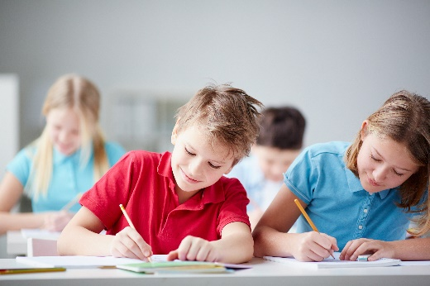
When students reflect on learning and analyse their own ideas and feelings, they self-evaluate, thereby improving their metacognitive skills. When students self-monitor or reflect, the most powerful learning happens.
iStock images
Journaling may take the form of a written or digital journal, a portfolio or a digital portfolio. Early childhood classrooms may use a class reflective floor book with pictures of the learning experience and scribed conversations.
Teachers can model the journaling process by thinking aloud and showing students how they can express learning and thoughts in a variety of ways including diagrams, pictures and writing.
Journals are a useful tool that gives teachers additional insight into how students value their own learning and progress, as well as demonstrating their individual achievements.
The following links provide background information and useful apps for journaling.
Kidblog – digital portfolios and blogging
kidblog.org/home
Edmodo – for consolidating and storing class notes and learning materials
www.edmodo.com
Explain Everything™ – a screen casting, video and presentation tool all in one
Explaineverything.com
Popplet – allows you to jot down your ideas and then sort them visually
Popplet.com
Seesaw – for capturing work completed by students in class, using a device’s camera function
Web.seesaw.me
Connect – the Department of Education’s integrated, online environment
connect.det.wa.edu.au
Evernote (a digital portfolio app)
evernote.com
Digital portfolios for students (Cool tools for school)
cooltoolsforschool.wordpress.com/digital-student-portfolios

Appendix 6: Student activity sheet 1.0: Journal checklist
As an ongoing part of this module, you will have been keeping a journal of your work.
Before submitting your journal to your teacher please ensure you have included the following information.
- Tick each box once complete and included.
- Write N/A for items that were not required in this module.
iStock images
Your name and group members’ names or photographs.
An explanation of the problem you are solving.
Your notes from Activity 1
Your notes from Activity 2
Your notes from Activity 3
Your notes from Activity 4
Student activity sheet 1.6: Mind map
Student activity sheet 1.7: I see, I think, I wonder
Student activity sheet 1.8: Animation – Storyboarding
Design brief
Student activity sheet 2.2: Infographic
Student activity sheet 3.1: Action plan
Student activity sheet 4.6: Self-evaluation
Student activity sheet 4.8: Design review
Student activity sheet 1.0: Journal checklist

Appendix 7: Teacher resource sheet 1.1: Cooperative learning – Roles
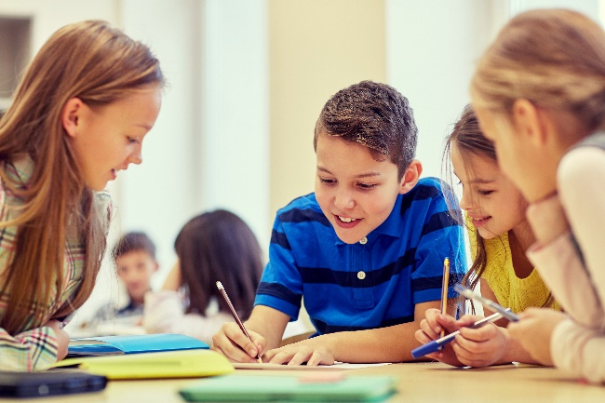
Cooperative learning frameworks create opportunities for groups of students to work together, generally to a single purpose.
As well as having the potential to increase learning for all students involved, using these frameworks can help students develop personal and social capability.
When students are working in groups, positive interdependence can be fostered by assigning roles to group members.
iStock images
These roles could include:
- working roles such as Reader, Writer, Summariser, Time-keeper.
- social roles such as Encourager, Observer, Noise monitor, Energiser.
Teachers using the Primary Connections roles of Director, Manager and Speaker for their science teaching may find it effective to also use these roles for STEM learning.
Further to this, specific roles can be delineated for specific activities that the group is completing.
It can help students if some background to the purpose of group roles is made clear to them before they start, but at no time should the roles get in the way of the learning. Teachers should decide when or where roles are appropriate to given tasks.
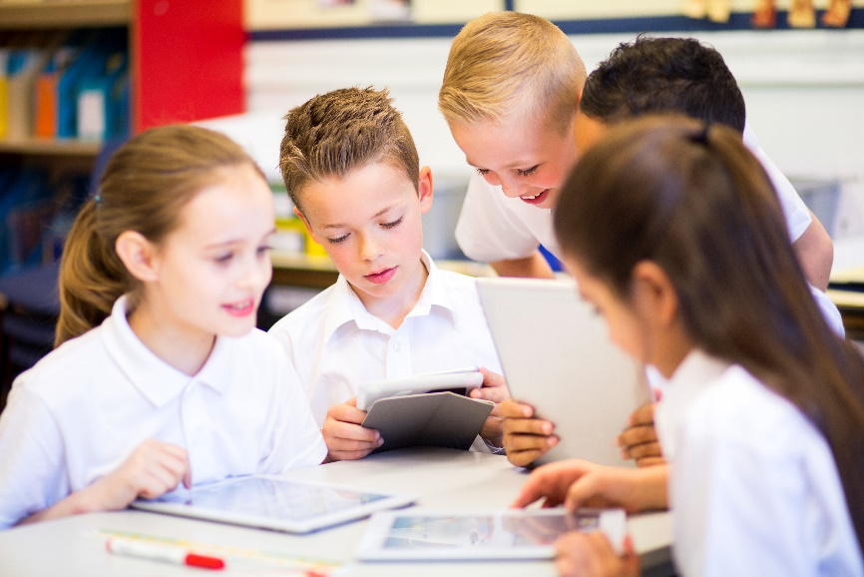
iStock images

Appendix 8: Teacher resource sheet 1.2: Cooperative learning – Jigsaw
This resource sheet provides a brief outline of a collaborative learning strategy known as 'jigsaw'.
Cooperative learning frameworks create opportunities for groups of students to work together, generally for a single purpose.
As well as having the potential to increase learning for all students involved, using these frameworks can help students develop personal and social capability.
The jigsaw strategy typically has each member of the group becoming an 'expert' on one or two aspects of a topic or question being investigated. Students start in their cooperative groups, then break away to form 'expert’ groups to investigate and learn about a specific aspect of a topic. After developing a sound level of understanding, the students return to their cooperative groups and teach each other what they have learnt.
Within each expert group, issues such as how to teach the information to their group members are considered.

Step 1 | Cooperative groups  (of four students) | 1 2 3 4 |  | 1 2 3 4
Step 2 | Expert groups  (size equal to the number of groups) | 1 1 | 2 2 | 3 3 | 4 4
Step 3 | Cooperative groups  (of four students) | 1 2 3 4 |  | 1 2 3 4

Appendix 9: Teacher resource sheet 1.3: Cooperative learning – Placemat
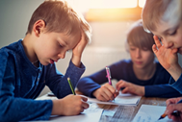
This resource sheet provides a brief outline of a cooperative learning strategy known as 'placemat'.
Getty images
Cooperative learning frameworks create opportunities for groups of students to work together, generally for a single purpose.
As well as having the potential to increase learning for all students involved, using these frameworks can help students develop personal and social capability.
The placemat strategy involves students working collaboratively to record prior knowledge about a common topic and brainstorm ideas. It also allows teachers to readily see the contribution of each student. The diagram below shows a typical placemat template.
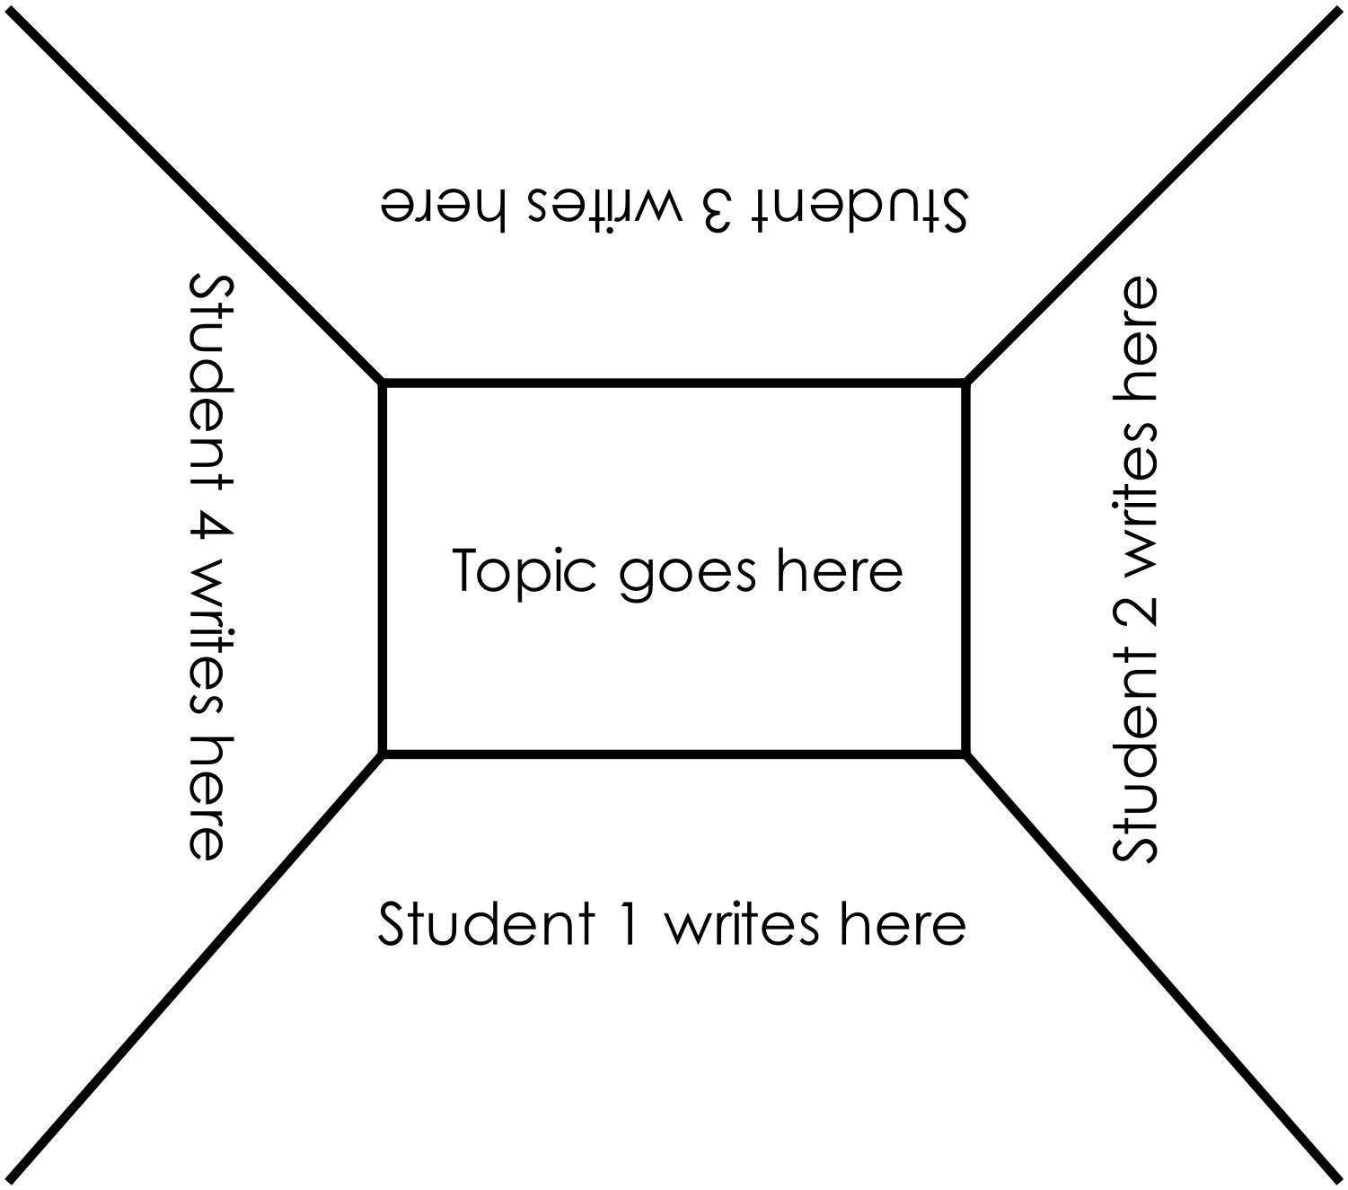
STEM Consortium

Appendix 10: Teacher resource sheet 1.4: Cooperative learning – Think, Pair, Share
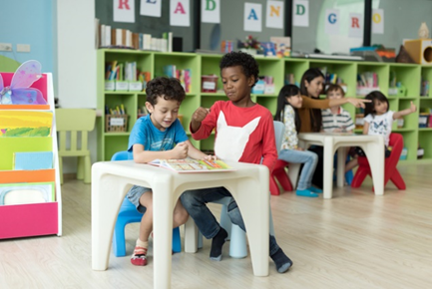
This resource sheet provides a brief outline of a cooperative learning strategy known as 'think, pair, share'.
Cooperative learning frameworks create opportunities for groups of students to work together, generally to a single purpose.
As well as having the potential to increase learning for all students involved, using these frameworks can help students develop personal and social capability.
iStock images
In the 'think' stage, each student thinks silently about a question asked by the teacher.
In the 'pair' stage, students discuss their thoughts and answers to the question in pairs.
In the 'share' stage, the students share their answer, their partners answer or what they decided together. This sharing may be with other pairs or with the whole class. It is important also to let students 'pass'. This is a key element of making the strategy safe for students.
Think – pair – share increases student participation and provides an environment for higher levels of thinking and questioning.

iStock images

Appendix 11: Teacher resource sheet 1.5: Picture stimuli

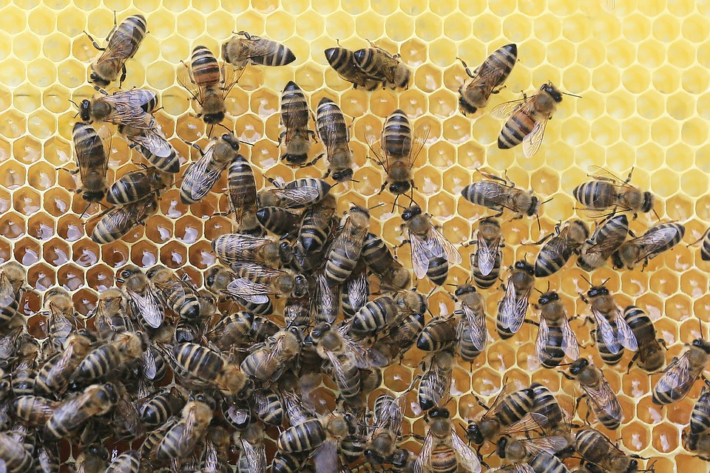

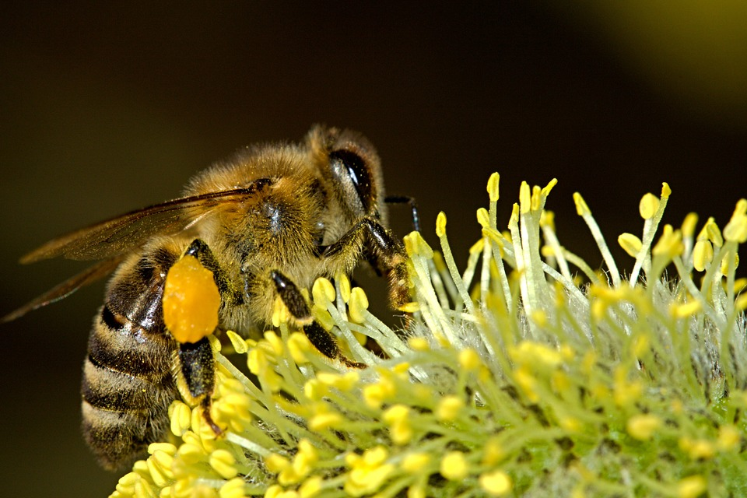
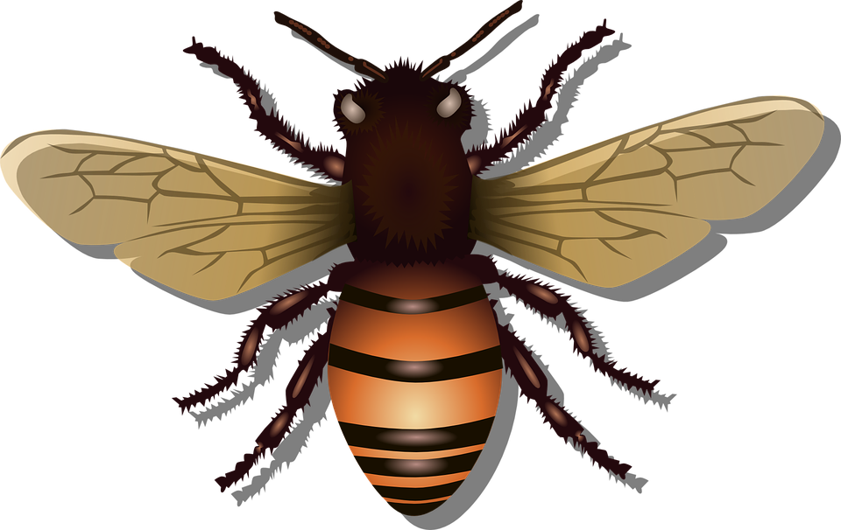
Pixabay images

Appendix 12: Student activity sheet 1.6: Mind map
Pixabay images
What do they do?

Where do they live?

What do they look like?
Interesting Facts

Appendix 13: Student activity sheet 1.7: I see, I think, I wonder
What do you see when you look at this image?
What are you thinking about as you look at this image?
What are your wonderings (questions)?
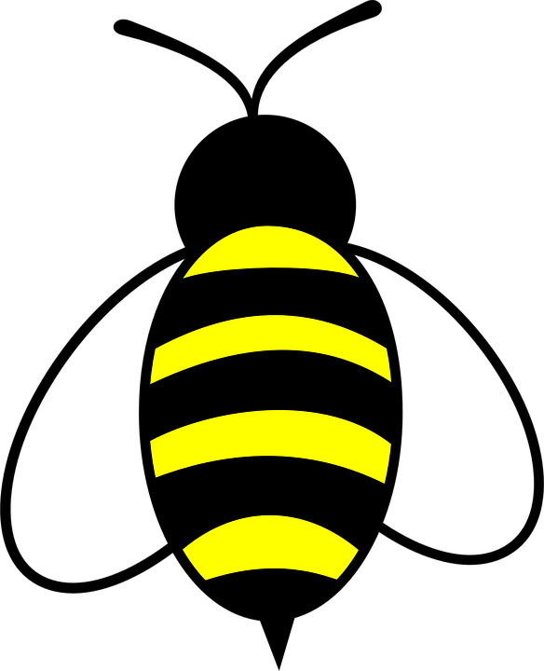
Pixabay images

Appendix 14: Student activity sheet 1.8: Animation – Storyboarding
Scene 3

Scene 2

Scene 1

Pixabay images
Music and FX
Sprites and backgrounds

Appendix 15: Student activity sheet 1.9: Pollinated by honey bees
kiwi fruit | onion | cashew | celery | strawberry
beetroot | mustard | broccoli | cauliflower | cabbage
turnip | canola | chili | capsicum | watermelon
orange | coffee | coriander | melon | cucumber
lemon | lime | carrot | cardamom | cotton
sunflower | lychee | macadamia | apple | mango
avocado | kidney bean | apricot | cherry | plum
almond | peach | pomegranate | pear | currant
boysenberry | raspberry | elderberry | sesame | tamarind
blueberry | cranberry | grape | guava | string bean
Pixabay images

Appendix 16: Teacher resource sheet 1.10: Glossary
Glossary

Pollination | The transfer of pollen from the anther to the stigma.
Pollen | The fertilising element of flowering plants, consisting of fine, powdery, yellowish grains of spore, sometimes in masses.
Ovum | The female reproductive cell which can develop, usually only after fertilisation, into a new individual.
Anther | The pollen-bearing part of a stamen.
Flowers | The seed-bearing part of a plant, consisting of reproductive organs (stamens and carpels) that are typically surrounded by a brightly coloured corolla (petals) and a green calyx (sepals).
Nectar | The sweet secretion of a plant which attracts the insects or birds that pollinate the flower.
Ovule | A rudimentary seed. The plant part that contains the embryo sac and hence the female germ cell, which after fertilisation develops into a seed.
Pistil | The ovule-bearing or seed-bearing female organ of a flower consisting, when complete, of ovary, style and stigma.
Stamen | The pollen-bearing organ of a flower consisting of the filament and the anther.
Virus | An ultramicroscopic (20 to 300 nm in diameter), metabolically inert, infectious agent that replicates only within the cells of living hosts, mainly bacteria, plants, and animals. Composed of an RNA or DNA core, a protein coat, and in more complex types, a surrounding envelope.
Bacteria | Ubiquitous one-celled organisms, spherical, spiral or rod shaped and appearing singly or in chains. Comprising the Schizmycota, a phylum of the kingdom Monera (in some classification systems the plant class Schizomycetes), various species of which are involved in fermentation, putrefaction, infectious diseases or nitrogen fixation.
Quarantine | A strict isolation imposed to prevent the spread of disease.
Hive or beehive | A shelter constructed for housing a colony of honey bees.
Insecticides | Chemical, biological or other agents used to destroy insect pests.

Appendix 17: Student activity sheet 2.1: Percentage grids
Category ___________________
Number of plants____________
Number with bees __________
Fraction ______ / ______
% value each plant ________%
% plants with bees _______%
Category ___________________
Number of plants____________
Number with bees __________
Fraction ______ / ______
% value each plant ________%
% plants with bees _______%
Category ___________________
Number of plants____________
Number with bees __________
Fraction ______ / ______
% value each plant ________%
% plants with bees _______%
Category ___________________
Number of plants____________
Number with bees __________
Fraction ______ / ______
% value each plant ________%
% plants with bees ________%
% plants with bees _______%

Appendix 18: Student activity sheet 2.2: Example design brief
Design brief
Design an interactive game that will teach players about bees and the decline in bee numbers across the world. By the end of the game we want players to know more about bees and what they can do to help increase bee populations.
Your game will need to include
Completed
Information
Information about the causes of…..
Information about solutions to ……
Design
Interesting graphics or colour
Engaging typograhy
Gameplay
Incorporate a point system
Honey bees are the major character
Use technology or robotics
Earn tokens
Multi-player or take turns

Pixabay images

Appendix 19: Student activity sheet 2.3: Infographic
The problem

Pixabay images
Plant bee friendly plants
The causes
What can we do?

Problem: Pesticides
Pixabay images
Solution:

Problem: Monoculture farming

Solution:

Problem: Climate change

Problem: Viruses or bacteria

Solution:

Solution:

Appendix 20: Student activity sheet 3.1: Action plan
Design brief
Team members | Blueprint
Materials
Pixabay images

Appendix 21: Student activity sheet 3.2: Prototype troubleshooting
Problem | Reason for the problem | Possible changes to your design to solve the problem

Pixabay images

Appendix 22: Teacher resource sheet 4.1: Question prompts
The hive
The hive

Pixabay images
- What is the problem?
- What would happen if bee populations dropped?
- What are the causes?
- Is there anything we can do?

- What is the problem?
- What would happen if bee populations dropped?
- What are the causes?
- Is there anything we can do?

- What is the problem?
- What would happen if bee populations dropped?
- What are the causes?
- Is there anything we can do?

- What is the problem?
- What would happen if bee populations dropped?
- What are the causes?
- Is there anything we can do?

The hive
The hive

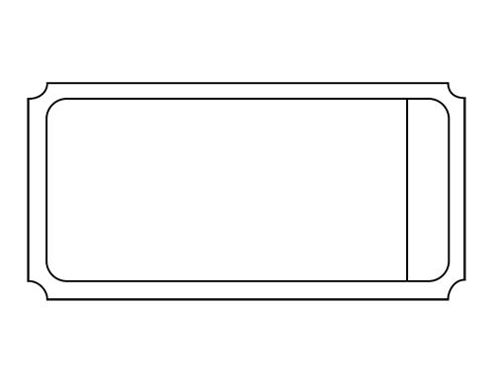
Appendix 23: Teacher resource sheet 4.2: Game tokens

The hive
Redeem to
adopt a bee
The hive
Redeem to
adopt a bee

Pixabay images
The hive
Redeem to
adopt a bee
The hive
Redeem to
adopt a bee
The hive
Redeem to
adopt a bee
The hive
Redeem to
adopt a bee
The hive
Redeem to
adopt a bee
The hive
Redeem to
adopt a bee

Appendix 24: Teacher resource sheet 4.3: Example flyer
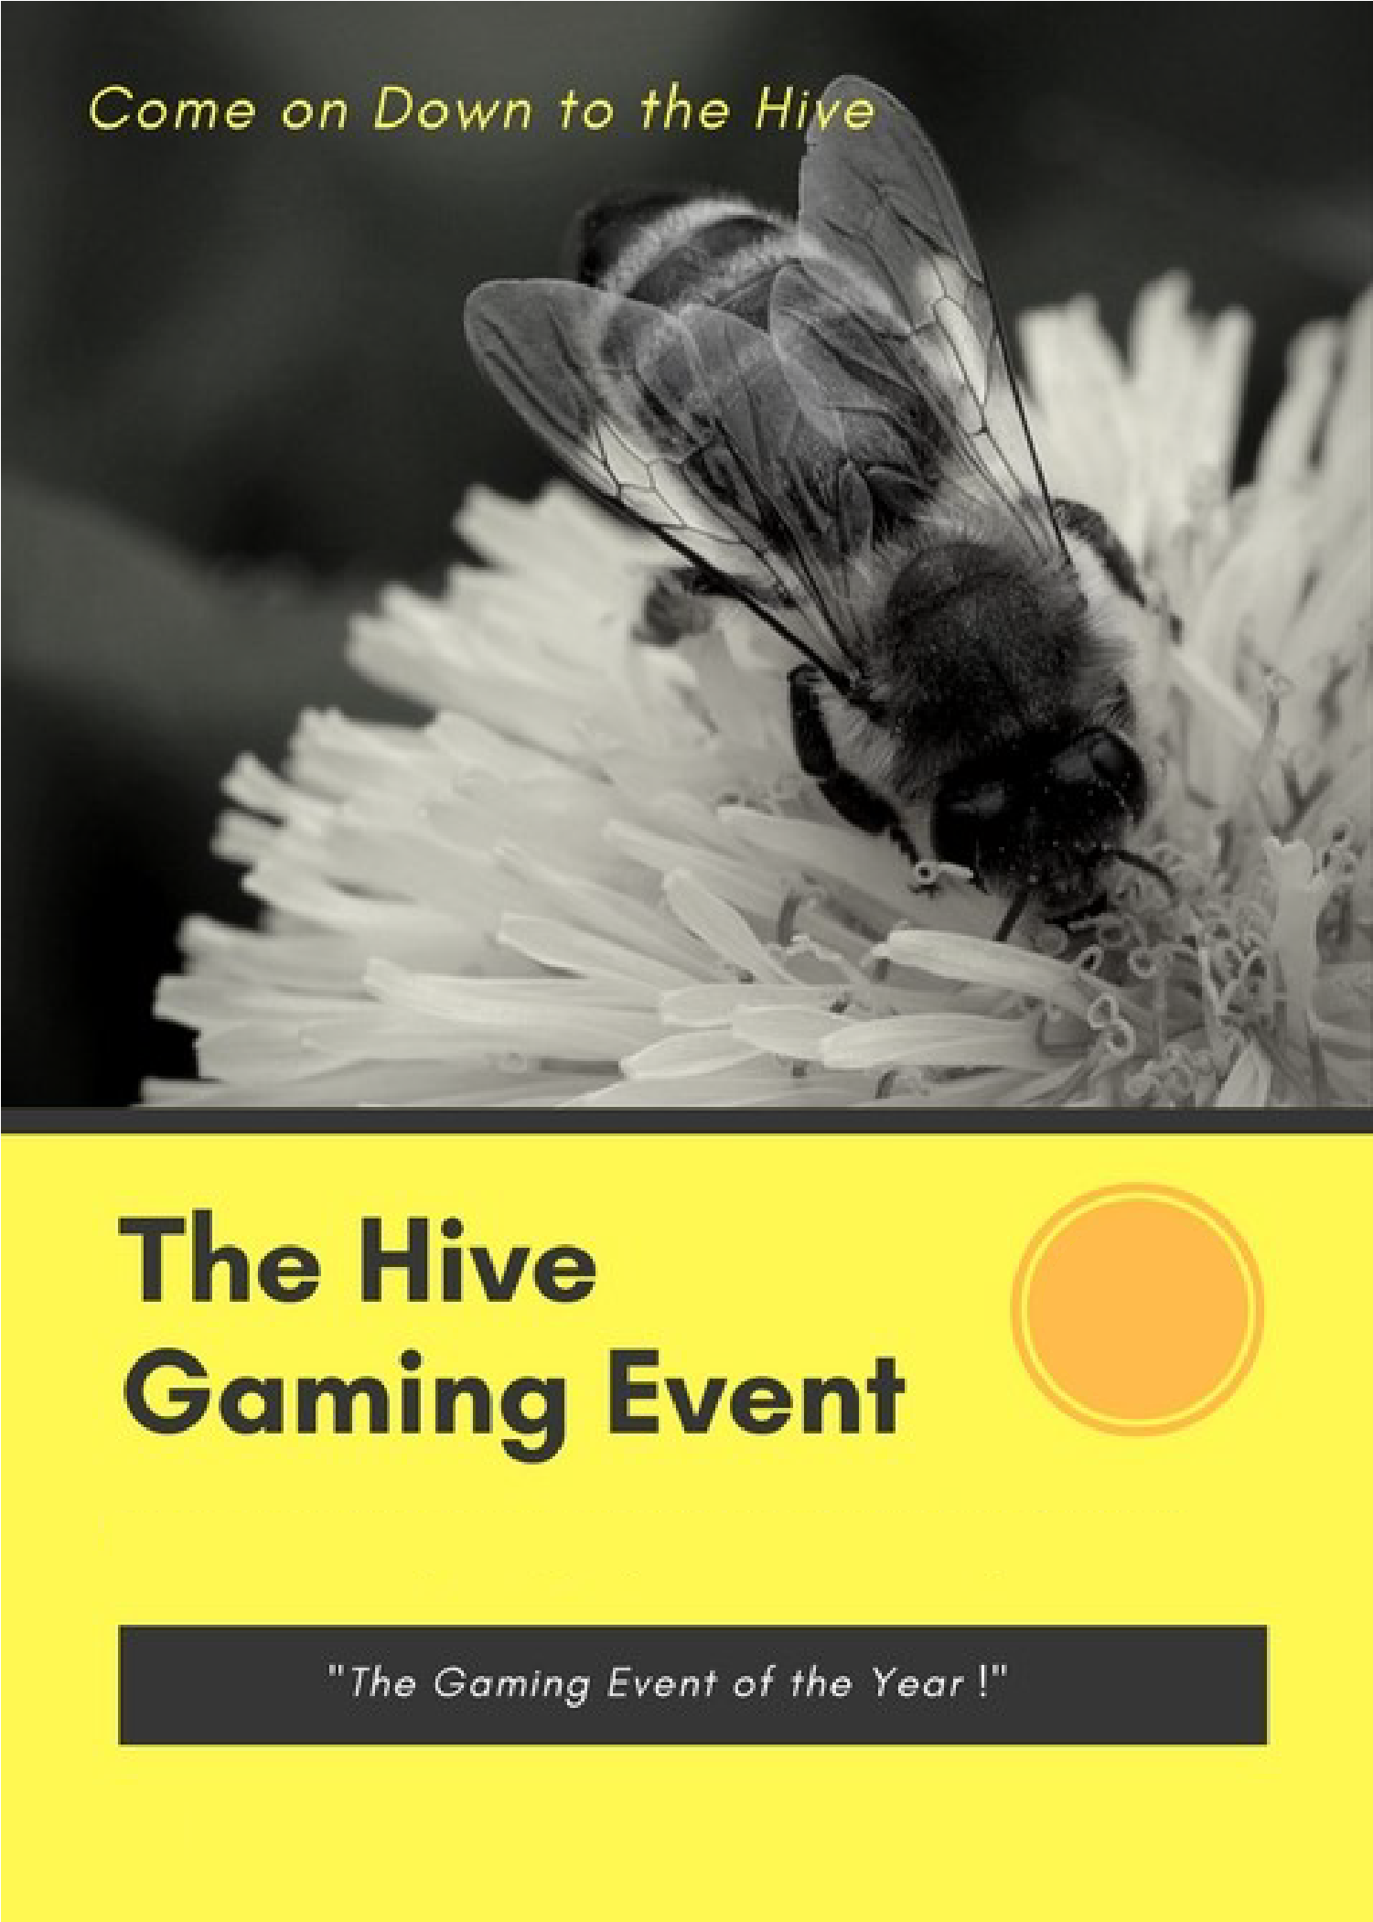
Pixabay images
An interactive gaming experience hosted by <insert class name>
<insert date>
When: <insert time> Where: <insert location>

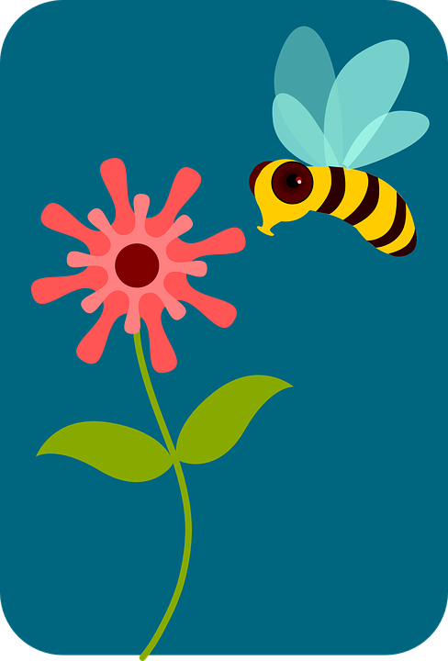
Appendix 25: Teacher resource sheet 4.4: Adopt a bee (seed envelope labels)
Pixabay images

Inside this pack you will see
Seeds to grow for a honey bee
Roses, lavenders and sunflowers too
When they flower I’ll collect honey for you

Plant a seed and adopt a bee
60 mm
110 mm
Plant a seed – Adopt a bee

Inside this pack you will see
Seeds to grow for a honey bee
Roses, lavenders and sunflowers too
When they flower I’ll collect honey for you

Plant a seed and adopt a bee
Plant a seed – Adopt a bee
110 mm
60 mm

Appendix 26: Teacher resource sheet 4.5: Peer or parent feedback
Please provide some feedback about the game you just played.
Did you have fun? What did you learn? What action will you take?
Feedback 1 | Feedback 2 | Feedback 3
Feedback 4 | Feedback 4 | Feedback 6
Feedback 7 | Feedback 8 | Feedback 9
Pixabay images

Appendix 27: Student activity sheet 4.6: Self-evaluation
Game reflection
Photograph or drawing
What did you make? | How did you feel about your game?
What did you like about your game? | What could you have done better?
What would you do differently?
www.debono.com/six-thinking-hats-summary
Pixabay images

Appendix 28: Teacher resource sheet 4.7: Student evaluation
Key:  - Rarely  - Sometimes  - Usually  - Always | Student name
Remains focused on tasks presented
Completes set tasks to best of their ability
Uses time well
Cooperates effectively within the group
Contributes to group discussions
Shows respect and consideration for others
Uses appropriate conflict resolution skills
Actively seeks and uses feedback

Appendix 29: Student activity sheet 4.8: Design review
Things I would keep the same _________________________________________________________________________________________________________________________________________________________________________________________________________________________
Things I would change
________________________________________________________________________________________________________________________________________________________________________________________________________________________________________________________
Photograph or drawing

Notes
________________________________________________________________________________________________________________________________________________________________________________________________________________________________________________________________________________________________________________________________________________________________________________________________________________________________________________________________________________________________________________________________________________________________________________________________________________________________________________________________________________________________________________________________________________________________________________________________________________________________________________________________________________________________________________________________________________________________________________________________________________________________________________________________________________________________________________________________________________________________________________________________________________________________________________________________________________________________________________________________________________________________________________________________________________________________________________________________________________________________________________________________________________________________________________________________________________________________

