**Alignment and Flexibility Exercises – Section 3**

**POSITION 4:** Forward standing roll (spinal articulation up) side angle.

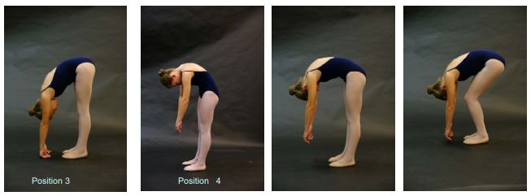

**POSITION 2:** Repeat Position 1 with your arms lifted above your head. Hold each position for 3 seconds.

**POSITION 3:** Forward standing roll (spinal articulation down).

**POSITION 1:** Candidate faces the camerain a neutral position – arms by the side and feet parallel (together). By quarters, turn to face the side, back and front again. Hold each position for 3 seconds.

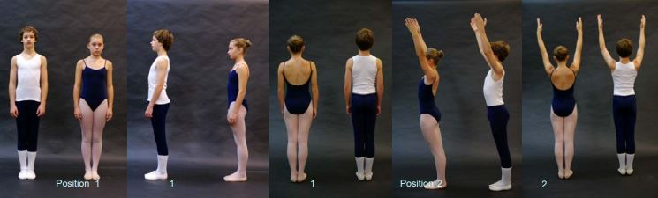

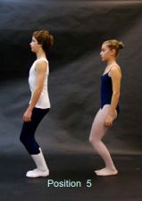

**POSITION 5:** Demi plie in closed parallel (feet together) side angle.

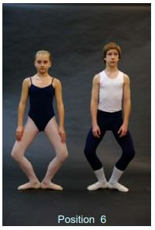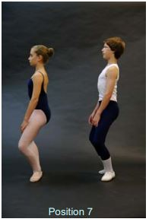

**POSITIONS 6 AND 7:** Demi plie in rotated position (changing directions – facing forward and then to the side)



**POSITIONS 8 AND 9:** Frog position (back upright and then bending forward over the legs).

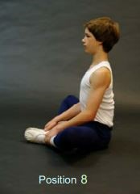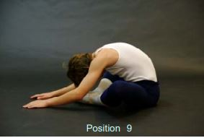

**POSITIONS 10 AND 11:** Sitting position, legs extended forward, body bending over legs and then upright).

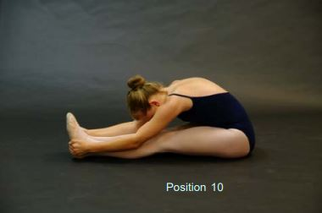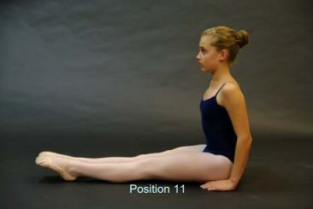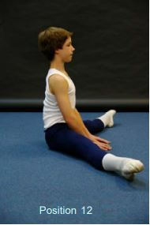

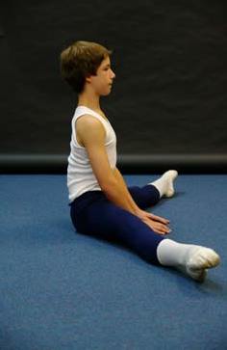

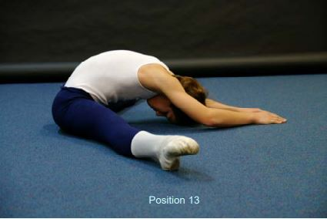

**POSITIONS 12 AND 13:** Second position (upright and then bending forward)

Position 12

**POSITION 14:** Face down, long body and then lift to bend back off the floor.

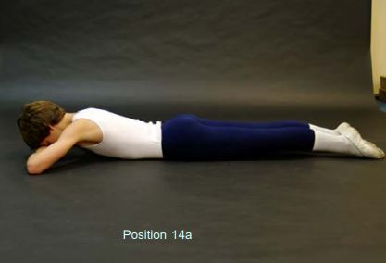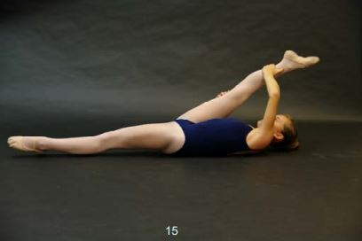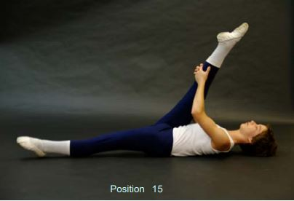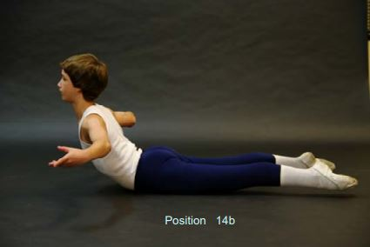

**POSITION 15:** Face up, long body and then lift leg for hamstring stretch (right and left).