PARENT/CARER
AND STUDENT
HANDBOOK

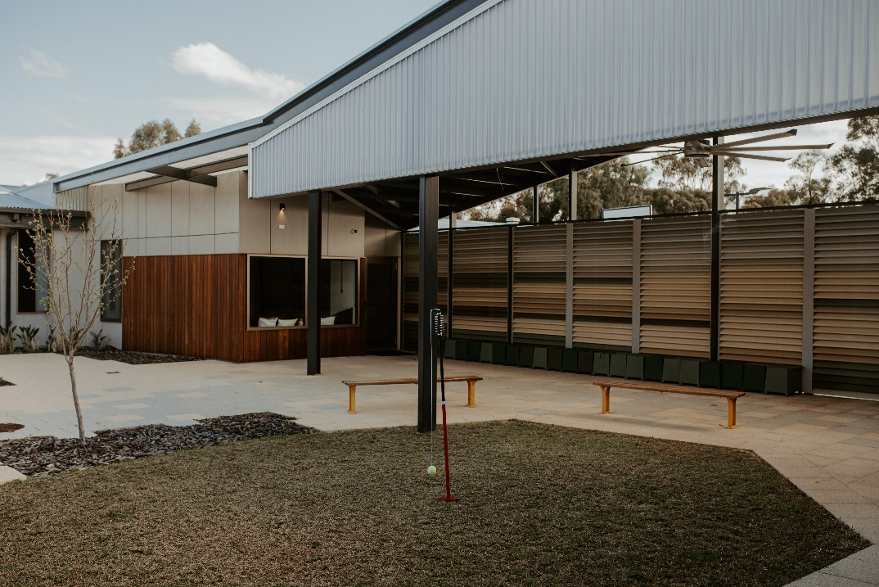

Moora Residential College

CONTENTS

CONTACT DETAILS 3
WELCOME TO MOORA RESIDENTIAL COLLEGE 4
COSTS AND CHARGES 6
LEARNING SUPPORT 7
WHAT YOUR CHILD NEEDS TO BRING 9
LEAVE ARRANGEMENTS 12
STUDENT TRANSPORT 14
COLLEGE LIFE 15
HEALTH AND SAFETY 20
SAFETY AND WELFARE – FOR STUDENTS 23
APPENDIX: RESIDENTIAL COLLEGE CODE OF CONDUCT 27

Moora Residential College and its staff respectfully acknowledge the Yued people who are the traditional custodians of the land on which our students live and are educated.

We pay respect to Elders past, present and those who are emerging.

CONTACT DETAILS
Moora Residential College
Lot 381 Edgar Lewis Place,
MOORA WA 6510

Supervisors

Telephone: 08 9653 9700
Mobile: 0467 811 683
E-mail: moora.rescol@education.wa.edu.au

Administration and finance

Telephone: 08 9653 9700
E-mail: moora.rescol@education.wa.edu.au
Website:https://www.education.wa.edu.au/web/mooraresidentialcollege

Department of Education

151 Royal Street
East Perth WA 6004
T: 9264 4111
W: www.education.wa.edu.au

Inward telephone
If your child does not have a mobile phone, you can contact them at the college on the following number:

Student telephone 1: Female: 0467 811 683 OR Male 0499 821 257

Students are asked to remind family and friends that they are unavailable to receive incoming calls during mealtimes, study time or after lights out.

Inward mail
You can send mail to your child at the College’s address above.

Emergency contact
Students are discouraged from using their mobile phones after lights out. In case of emergency, please call the college Supervisors on 0467 811 683 or 0499 821 257. A Supervisor will then contact your child with minimum disruption to other students.

WELCOME TO MOORA RESIDENTIAL COLLEGE

Thank you for choosing Moora Residential College for your child.

We look forward to working with you as we raise our boarders together and watch them grow over the years to come. All college staff are committed to providing a safe and caring environment to support your child in their personal development and education.

We aim to provide a high-quality boarding service which is valued by you and your children. Your suggestions on how we can improve our service are always welcome.

About us
For over 40 years, the College has provided high quality care. It has an excellent reputation and consistently receives rave reviews from parents in independent surveys. We are known for creating a caring environment for our students, providing delicious and healthy food, communicating well with parents, and organising fun activities for students. We opened the new building in March 2021.

Boarders
We currently have 41 students boarding at Moora Residential College. Many come from pastoral areas and coastal communities such as Jurien Bay and Lancelin, while some come from as far as Marble Bar. Being from small communities, they enjoy living in a country town with a welcoming community and strong country values.
Whilst at the college, they attend Central Midlands Senior High School from Years 7 to 12.

Our staff
Residential college staff comprise of a supervisory team and a support team, both of which report to the College Manager. The College Manager reports to the Manager Residential Colleges in the Department of Education in Perth.

Supervisory staff hold various qualifications including:
- Certificate IV in Community Services – Student Residential Care
- First Aid Certificate (including CPR)
- Aquatic Rescue for Group 3 Pool Award
- LR Class Driver’s Licence with passenger transport driver (PTD) authorisation.

College governance
Moora Residential College is governed by the School Education Act 1999 and is administered by the Western Australian Department of Education. The College Manager works with staff to develop local processes in line with Department of Education policies and procedures.

All Department of Education policies can be viewed at www.det.wa.edu.au/policies.

LINC Committee
Supporting Moora Residential College is our Local Input Networking and Communications (LINC) committee.

The purpose of the LINC committee is to enable parents and members of the community to provide input to the College Manager regarding the operation and management of the college. Please speak with us if you would like to join this important advisory group.

Head students
Head students and their deputies are selected late in the year to take up the role for the following year. Students are selected by their peers and endorsed by our Supervisors and College Manager.

They are students that demonstrate positive behaviour as role models for their peers and accept the responsibility of presenting and advocating ideas on their behalf.

Our code of conduct
The Residential College Code of Conduct (the Code), reproduced in the Appendix, sets out some simple expectations for students:
- In respect to self
- In respect to other students
- In respect to staff
- In respect to property.

When signing the Boarding Agreement for your child, you are undertaking that your child will comply with the Code.

When your child signs the Boarding Agreement, they agree they have read, understood, and will follow the Code; and understand that there may be consequences for breaches.

Positive Behaviour Support (PBS)
We are committed to the PBS program which supports the implementation of the Department of Education’s Student Behaviour in Public Schools Policy and Procedures. Our goal is to create a safe, positive environment where students are engaged and successful.

Moora Residential Colleges three words for PBS are the following:
- Respect
- Responsible
- Resilient

COSTS AND CHARGES

Annual boarding fee
The boarding fee covers a student’s bed, meals, facilities, and pastoral care. It applies to all Department of Education Residential Colleges and is the same for all year levels.

Refer to our website https://www.education.wa.edu.au/web/mooraresidentialcollege for the latest information on costs and charges.

Bond
A $300 bond is required as part of the Boarding Agreement. The bond is security for the performance of your obligations under the agreement. It may be used to compensate the residential college for any outstanding costs or for repairing damage a student may cause to college property. At the completion of the Boarding Agreement the balance of the $300 will be returned to you.

Other costs – individual services
The residential college recovers the cost of providing individual services to students such as the purchase of required medications and participation in optional organised activities.

Payment
By accepting a place at the college and signing the Boarding Agreement you agree to:
- Pay the invoiced amount for accommodation and individual services each year.
- Complete required payments prior to the first day of term unless a prior arrangement or payment plan has been approved by the College Manager.
- Pay any outstanding amounts if the Boarding Agreement is terminated.

Payment options
☺  in Person  cash, cheque, EFTPOS  Moora Residential College  Lot 381 Edgar Lewis Place  MOORA WA 6510 |   by Mail  cheque, money order  Moora Residential College  Lot 381 Edgar Lewis Place  MOORA WA 6510 |   via EFT  electronic bank transfer  BSB: 066519  A/C: 00901048  Please use student name as the reference

Financial assistance and allowances
It is a condition of the Boarding Agreement that you assign to the residential college any subsidies or payments received to offset the charge for accommodation each year.

Please refer to the residential college’s website https://www.education.wa.edu.au/residential-colleges for the latest information on fees and allowances.

LEARNING SUPPORT

The main reason a student boards with us is their desire to access a quality education. At Moora Residential College we provide several supports to assist students to achieve their academic goals.

Please note that residential college staff are not authorised to sign school documentation such as permission slips on parents’ behalf.

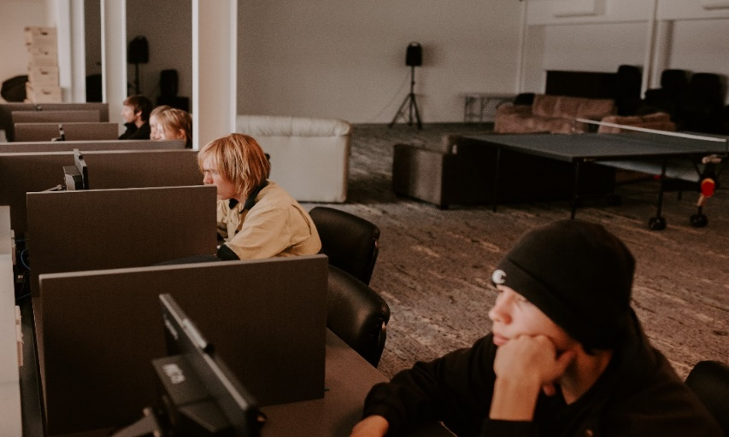

Homework and study
All students are expected to practise sound study habits and be respectful of other students’ needs for a distraction free environment. The college study times are:

- Monday 4:00pm – 5:00pm
- Tuesday 6:30pm – 7:30pm (Tutor will be on site to help students)
- Wednesday 4:00pm – 5:00pm
- Thursday 6:30pm – 7:30pm (Tutor will be on site to help students)

Students are expected to work constructively during these study times and may need to dedicate extra effort outside of these times to complete all academic requirements.
Students without set homework on any given day are required to remain focused during study time on other tasks such as revision, recreational reading, writing, or other Supervisor approved recreational activity of their choice.

Term 3 school holidays ATAR exams
Some ATAR exams take place during the Term 3 school holiday period. With sufficient advanced notice, we can remain open during this time to facilitate those students’ requiring accommodation in order to attend exams.

A modified boarding service is offered with fewer staff than normal, with the expectation that Year 12 students will demonstrate high levels of responsibility and self-management.

Please let our staff know as soon as possible should your child require this service.

Tutoring
If students require additional help with their schooling, they should always avail themselves of the school programs on offer. If students are unable to attend these, or if what is offered by the school and college is not sufficient, you may consider engaging a private tutor. Private tutoring costs are not covered by student boarding fees, but college staff will assist in finding a suitable place for private tutoring to occur.

Computers and internet access
College internet is set up for students to be able to study and research their required schoolwork.

There is also scope for students to use the network for reasonable personal use. Students are discouraged from using the college network for online gaming and/or streaming which may slow user speeds for others.

To access college internet, you and your child will sign an online services acceptable use agreement setting out rules surrounding Department of Education-provided online services.

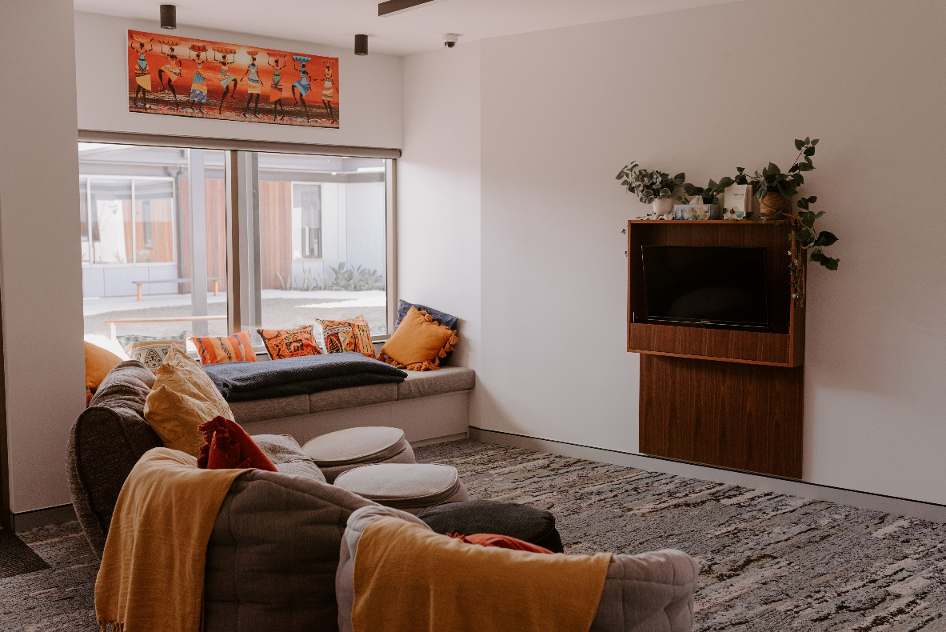

WHAT YOUR CHILD NEEDS TO BRING

The essentials
- Clothes and shoes for all seasons
- School uniforms and shoes
- Bathers, rashie and towel
- Study and school requirements
- Bedding requirements – King single size sheets
- Toiletries, bath towels miscellaneous

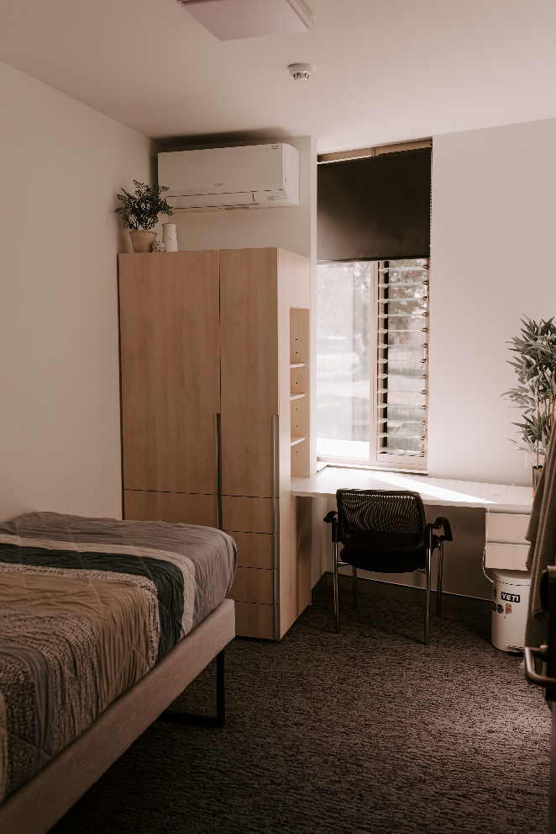

Personal computers
Computer access has become an integral part of schooling and a personal device is a great idea. Please check with your child’s school to see what type of device they recommend.

If your child brings their personal device to the residential college please ensure all appropriate cabling, any required adaptors and USB devices are included. Our advice is having the devices covered under your own Contents Insurance, the college does not take responsibility for any damage that may occur at the college.

Personal devices are primarily for study purposes and are not to be used after lights out.

Mobile phones
Mobile phones are not to be used at mealtimes, during study or after lights out. Juniors are to hand their tech devices including mobile phones in at 8:30pm, Seniors will need to hand their phones in if they do not follow the college guidelines.

Students are to provide their mobile phone number to staff and enter the college phone number into their contacts list.

Student property

Insurance
The Department of Education does not have insurance cover for student property that is lost, stolen or damaged.

Security
Please ensure your child’s personal property including clothing and bedding is clearly and permanently labelled or marked for easy identification.

The college will take all practical precautions to care for your child’s personal belongings and retrieve lost or stolen items but accepts no responsibility for any items that are damaged or lost.

Bicycles, scooters, and skateboards
Parents’ written permission is required to have a bicycle, scooter, or skateboard at the college. Staff will advise when and where they may be used on college grounds.

Inappropriate items
Students are not to bring offensive material into the residential college. Neither are they to display inappropriate material in their room. If in doubt, students can check with college staff who will indicate if it is acceptable. College staff may confiscate items deemed offensive, inappropriate or in poor taste, and students will be asked to take the item home.

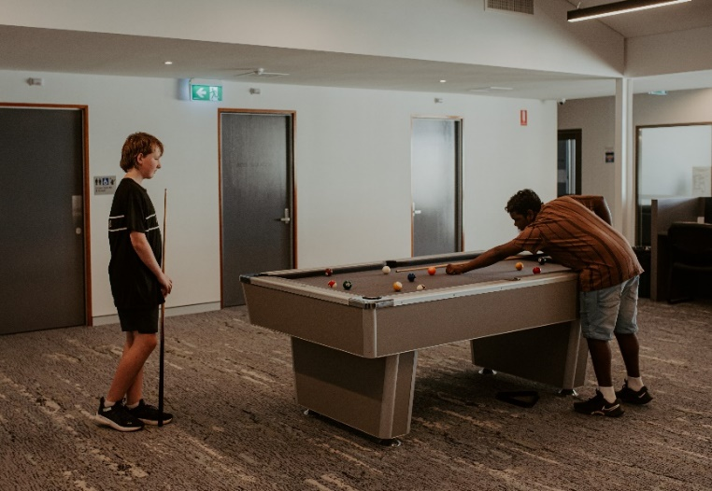

Student room searches
To ensure the health and safety of students, residential college staff may search student rooms if they have sufficient reason to do so. Room searches normally take place when staff have formed a reasonable belief that:
- A student is at risk of self-harm.
- Dangerous or banned items or illegal substances may have been brought into the residential college.
- A student may be in possession of stolen property.

Any items confiscated will be given to you or returned to your child to take home unless it has been delivered into the custody of the Police.

Student mail
We will contact you if your child receives a package that we believe looks suspicious or may contain contraband. We may ask your child to open the package in front of a staff member or give the unopened package to you. We will never open student mail.

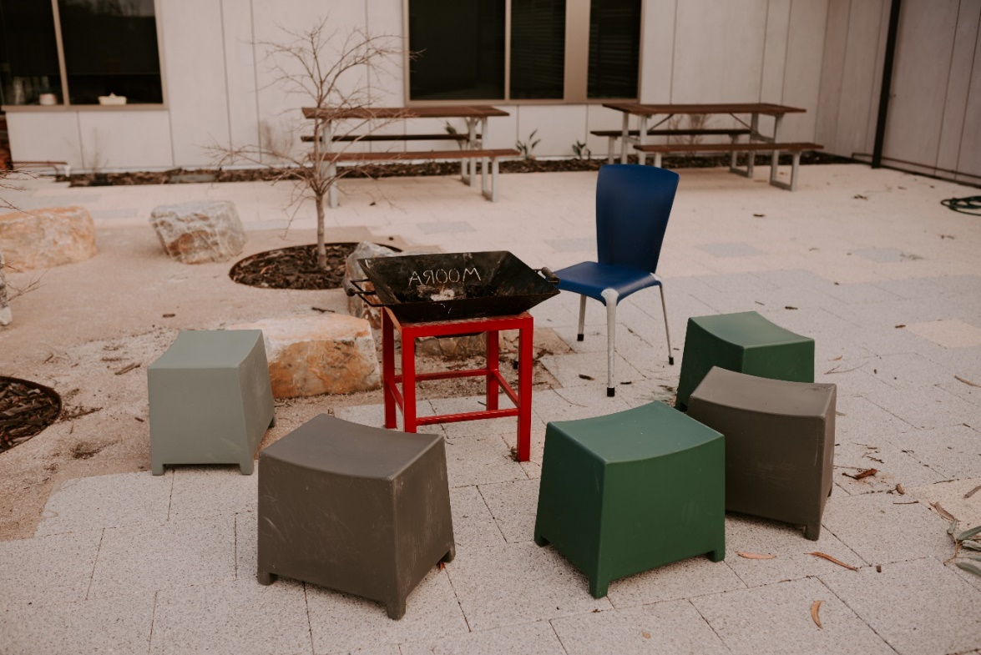

LEAVE ARRANGEMENTS

A record of students’ whereabouts is maintained at all times. When leaving the college, all students must ‘sign out' in the appropriate way and ‘sign in’ on returning.

Leave while under college care
Different leave arrangements enable students to participate in a range of sporting, cultural and social activities held outside school hours and away from the residential college.

Leaving residential college grounds
Except when leaving to attend school, students must receive permission from a supervisor before leaving the residential college grounds.

The College Manager may revoke approval to leave the college grounds for disciplinary reasons.

‘Town leave’
With your permission, students will be given leave on set days each week.

- Shopping, banking.
- Students can go downtown on Tuesday afternoons and Saturday mornings
- Can students walk to town, or will they need transportation?

There is no direct supervision during this leave and students are expected to be an ambassador of the residential college and behave in line with the Code of Conduct.

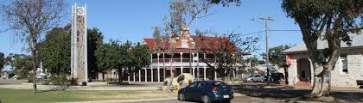

Casual Employment Leave
After consultation between parents, the student and the College Manager, your child may be given leave to undertake casual employment. College staff will endeavour to assist with transportation needs, but as this may not always be possible students are encouraged to organise their own transportation to and from their workplace.

Leave under another’s care
Students are entitled to seven-day care throughout the school term. However, we do support and encourage students to spend time with family and friends wherever possible.

College staff have a duty of care to protect students from risk of harm. In consultation with you, we may refuse a leave request, or refuse to release a student where leave has previously been approved, if we consider the host may pose a risk to your child.

If your child is unable to return on schedule, please contact college staff to let them know when they will be returning.

REACH boarding school system
Moora Residential College uses REACH boarding school software.

REACH is designed to make leave requests and other residential college procedures accurate, easy to use and always available.

At the beginning of your child’s residency at the college they will be assigned a profile on REACH and shown how to use the system. Parents also will be assigned a profile which will allow you to log into the portal and arrange for and approve your child’s leave. You may choose to download the REACH app which provides similar functionality.

If you have any issues or queries about REACH, please don't hesitate to contact college staff or the REACH support team at www.reachboarding.com.
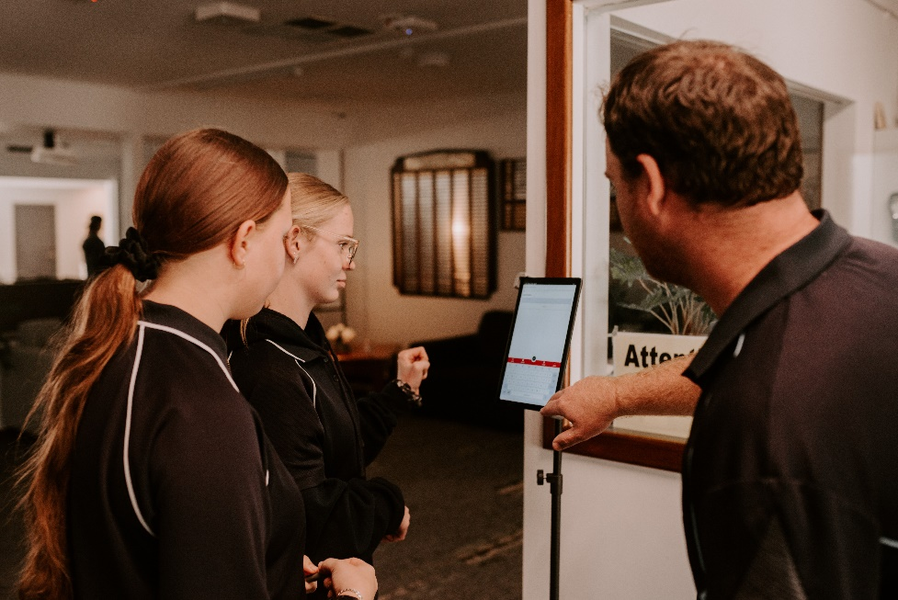

Sign out (‘host’) list
You can add any number of trusted adults (‘hosts’) into REACH that you can approve your child to go on leave with.

Leave requests
Leave requests are fully automated in REACH. Please submit all leave requests through REACH.

‘Day leave’ / Short Term leave
Students can go on day leave on the weekend and at various times during the week. We ask that students are returned to the college during the week by 7:30pm at the latest.

‘Overnight leave’
Students are permitted weekend overnight leave to return home or spend the weekend away from the college. We ask that students are returned to the college by 7:45pm on Sunday evenings
Overnight leave on a school night is discouraged and generally will only be granted for school purposes or to stay with parents or immediate family.

STUDENT TRANSPORT

Residential college vehicles
Moora Residential College maintains vehicles which Supervisors use to transport students. Staff transporting students have appropriate driving licences and passenger transport driver (PTD) authorisations.

The College endeavours to meet student transport requirements in and around town where practical.

Students are expected to be responsible passengers at all times.

Private motor vehicles
Your child is not permitted to travel in a private vehicle unless the driver is an approved host entered in REACH.

Your child will not travel in the personal private vehicle of a residential college staff member unless this is the best course of action in a medical emergency.

Student motor vehicles
Students are permitted to use their own vehicle only for transport to and from the college.

Students must:
- receive prior written approval from the College Manager to have a vehicle at the college.
- understand that vehicles are parked at the college at the car owners’ risk.
- receive prior written approval from the parents of any other student before providing them with a lift to and from their home.

COLLEGE LIFE
Moora Residential College offers: secure, air-conditioned accommodation, with ample storage for personal property, privacy in the bathrooms and common rooms in a comfortable setting. Our staff enjoy spending time getting to know the students, teaching, and encouraging good choices while at the college.

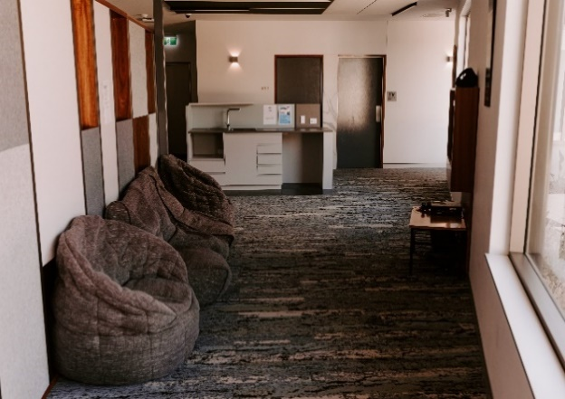

Daily routine
School Days:

7.00 am: Wake up, shower and breakfast.
8.30 am: Leave for school.
1.30 pm: Lunch delivered to school on Monday
3.00 pm: Return to college.
- Variety of after school activities include town leave on Tuesday afternoons, sport, casual work, study, swimming (seasonal).
5.30 pm: Dinner – all students compulsory attendance unless supervisors have been notified of illness. A late dinner can be organised for students involved in organised sport or casual work.

After dinner: free time, study etc.
9.00 pm: Bedtime for Years 7-9.
9.30 pm: Bedtime for Years 10-12. There is some flexibility until 10.30 pm for students who have extra homework load to complete.

Weekends:
8.00 am -9.30 am: Breakfast
9.00am – 11.45am – Town leave for shopping
12 noon: Lunch
5.30 pm: Dinner
Lights out on Friday and Saturday nights is 10.30pm.

With permission from parents, students can use weekends for sporting pursuits or casual work. It is also an opportunity to catch up on outstanding homework or extra study, cleaning bedrooms, washing clothes and bed linen. Students are actively encouraged to use the recreational facilities at the college.

Bedrooms
Students are expected to keep their room neat and tidy. College staff regularly inspect rooms to monitor this.

Dress code
Students are expected to be fully dressed at all times throughout the college. Students should be mindful of the CCTV and note that in some instances a supervisor of a different gender may need to access their dormitory.

Meals
Moora Residential College supports healthy eating. ‘Eat Learn Thrive’ is the health and wellbeing program at all Department of Education Residential Colleges. It is based on the Department’s Healthy Food and Drink in Public Schools Policy and the ‘traffic light’ system of menu planning.

The college supports and will cater for any medically required or religious dietary requirements. The kitchen staff can also prepare vegetarian and gluten free options where required, so please advise us of any special dietary needs. Students can speak with college staff and the chef to suggest additions to the menu.

- Dinner each evening is at 5:30pm
- Breakfast is from 6.45am during the week and 8:00am on the weekends

Meal requirements outside of regular mealtimes
Fruit, water, and hot drinks are available at any time.

Students can order a late, packed, or early meal if they will not be present at a mealtime (e.g., for sports training or medical appointments). In most instances staff will be able to arrange these meals, but students should plan ahead and notify staff if they need one.

Personal food and snacks
Food snacks can be purchased or sent from home but for hygiene reasons are best kept in sealed containers. Energy drinks and chewing gum are banned from the college.

Recreation and Social
We aim to provide a range of activities while also allowing for individual needs. Here are some of our facilities and activities on offer to our students.

Please note that charges may apply to some activities. We do not seek to profit from these events and your child’s participation in any activity requiring payment is at your discretion.

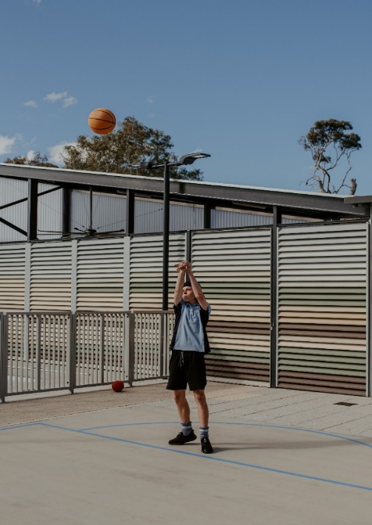
Sport and hobbies
Students are encouraged to participate in a range of individual and team sports and hobbies according to their interests. We do this to promote fitness, fun and social interaction.
- The college organises a wide variety of fun activities throughout the year.
- Details of local sporting clubs and associations can be supplied by college staff if required.
- Students will need to meet the cost of any membership fees, personal equipment, and uniforms.

The college welcomes suggestions for activities from students and parents, and we will endeavour to accommodate all reasonable requests.
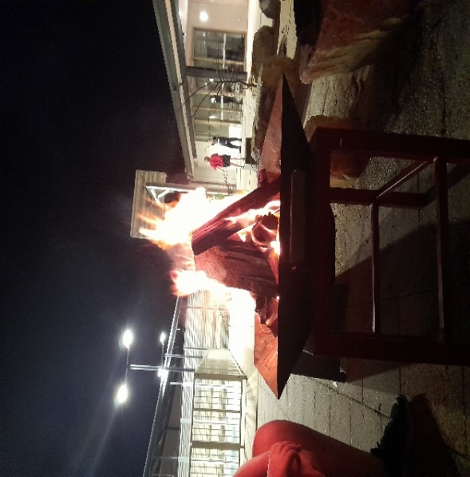
Camps and outings

The college organises camps and outings throughout the year. These activities are voluntary and there is no obligation for your child to participate.
You will be asked to provide written permission for your child to attend.

Swimming pool, recreation room and gym facilities

Students are encouraged to make good use of college facilities. Students are expected to look after the equipment and observe the user requirements on display. While using the college pool students are expected to wear a Rashie, we are a Sun Smart college.

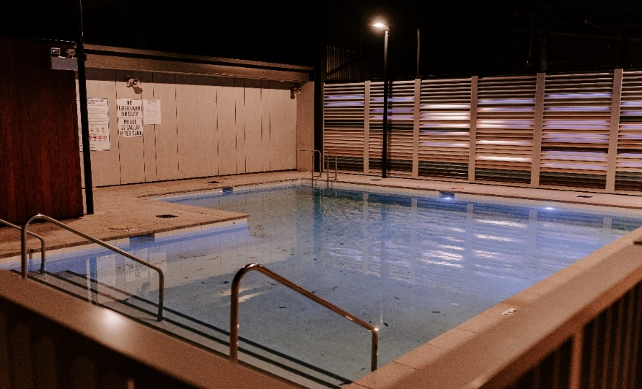

Movies and gaming
Gaming consoles are permitted at the college for use only on weekends. With permission, students may attend the cinema on weekends at their own cost to see approved films. Students can also select films that they would like to have shown in-house.

All media (television, movies, computer games, DVDs, magazines etc.) accessed by your child whilst residing at Moora Residential College will be consistent with Australian Government classification ratings for films and computer games.

The college permits content rated G, PG and M. All content remains at the discretion of college staff and will be removed or confiscated if it is deemed inappropriate. Material rated MA15+ will not be displayed in the college.

Visitors
To ensure the safety of all students, we ask that you enter and leave through reception and to register in the visitors’ book. Visitors are permitted in the main Common Room and in the Dining Room.

Visitors are not permitted to enter student bedrooms/common rooms/units other than on approved dates and times – usually at the start and end of each term.

Students are welcome to invite their school friends to visit the college. Friends are also required to register in the visitor book and are not permitted in bedrooms /common rooms/units. Students’ friends are required to follow staff instructions whilst on college grounds.

Chores
Students will be required to work as a team to assist around the college with simple duties such as:
- tidying common rooms or other sections of the college
- loading the dishwashers after meals
- simple gardening.

Assisting with the cleaning, kitchen and grounds staff replicates what students may be expected to do at home. It encourages cooperation and provides some practical domestic skills for when they leave home.

Laundry
We have washing machines and clotheslines for students to do their own laundry. Irons and ironing boards are also available.

Religious freedom
Under the School Education Act 1999 the curriculum and teaching in government schools is not to promote any particular religious practice, denomination, or sect. We also adhere to this principle at Moora Residential College.

The college supports students who wish to practise their beliefs. Staff will assist where possible for your child to attend any religious services and cultural events they choose.

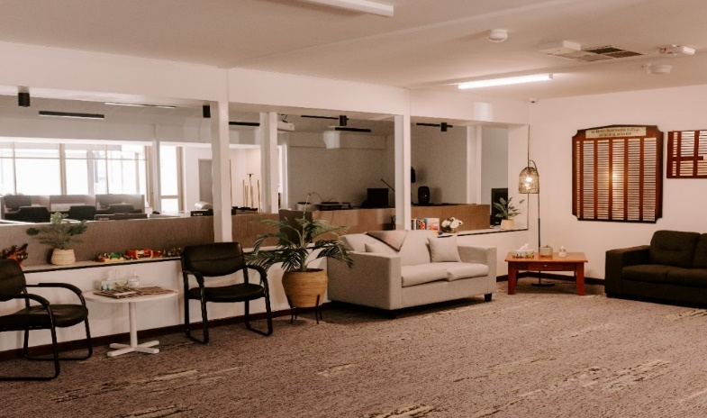

HEALTH AND SAFETY

Student health
Our staff care for your child’s health and wellbeing and all Supervisors have a First Aid Certificate. When we offer a place at the college, we ask that you complete a ‘Student Health Care Summary’ form so that college staff have the knowledge to support the management of your child’s health care needs.

Unwell student
Students who are too sick to go to school will be confined to bed in the sick bay and will be excused from normal activities until they are well. College staff will contact you and your child’s school to notify them of the absence. If a doctor’s appointment is necessary, we will organise for this and notify you at the earliest convenience.

For the protection of all students and staff, any child that contracts an infectious disease (e.g. COVID-19, chicken pox, measles) must return home until they have served the appropriate isolation period and are no longer contagious.

Medical appointments
We work with all our families to help maintain the health of students. Please advise us if your child requires a medical appointment and we can make one for you.

All medical expenses, including the cost of an ambulance in an emergency, remain the responsibility of parents. You may choose to take out insurance, including ambulance cover, for your child’s health needs.

Cancellation of ambulance call-out by parents
We have a duty of care for our students. If we call an ambulance for a student at risk, but when parents are contacted, they request cancellation, we will not do so until parents arrive, and the student is handed into their care.

Medication
We have a medical box to secure medications in and all medications are administered through REACH, the college has epi-pens located in an easily accessible location and we also have a Defibrillator in case of emergencies

With your written permission, college staff can administer medication to your child. We will give you a Short/Long Term Medication form upon accepting a place at the college seeking your approval.

Please inform the college of any medication being taken by your child. If your child requires short term medication, such as antibiotics or some other prescription, we will ask you to complete and sign an Administration of Medication form with the appropriate details. All medications brought into the college must be disclosed and given to college staff to be dispensed as required. They should be in the original packaging and clearly labelled with the student’s name.

With your written permission, senior students may self-administer their medication. You can authorise this on the Administration of Medication form. However, all medications must still remain with the college for safekeeping.

All medication given to students is recorded. Prescription medications that student’s self-administer are also recorded in the event that information is required by a health practitioner. Students may keep their asthma inhaler with them in their room.

Mental Health
Our supervisors keep a close watch on all our students’ mental health, and we will speak with you if we have any reason to feel concerned about your child. We also have regular organised access to a school psychologist who works with students and staff to improve student wellbeing.

We partner with the School Physiologist, referral to this is completed by the College Manager in partnership with the student’s parent.

Care is taken by staff to ensure that the college is a safe and comfortable place for students. We have zero tolerance to bullying and any instances will be dealt with in line with the College code of conduct.

Being homesick
It is possible that students may become homesick when living away from home. Staff have a great deal of experience in assisting students and parents when students show signs of missing home. Homesickness can affect each student in different ways so there are several methods used by staff to support and care for students. Staff work with you to help your child with coping skills and to build resilience in living in a boarding community.

CCTV
To support the safety of staff and students, CCTV is installed to provide coverage of select areas of the college.

Emergencies and accidents
The college maintains an Incident Management Plan to guide all aspects of prevention, preparedness, response, and recovery. We regularly practise evacuation and lockdown drills.

Fire Safety
Moora Residential College is listed on the Department of Fire and Emergency Services Bushfire Zone Register. Accordingly, we have a separate and stand-alone bushfire plan and practise further evacuation drills during bushfire season.

The college has fire alarms, smoke detectors, fire extinguishers, and emergency evacuation plans. Students are trained in emergency evacuation procedures and practise evacuation drills regularly.

The Department of Fire and Emergency Services may charge a fee to attend premises in response to an alarm where there is no fire. Where it can be established a student has deliberately caused a false fire alarm, they may be asked to contribute to the costs of the callout.

PARENT CONCERNS AND COMPLAINTS

Residential college concerns and complaints
Moora Residential College is committed to providing a high-quality boarding service. We are always considering how to improve, and we value your feedback.

If you have any concerns about our service or facilities, we want to know. The College Manager is happy to speak with you at any time to hear your concerns or discuss a complaint. You can also talk about it with any member of staff. We also welcome positive feedback.

Queries, concerns, and complaints are best managed at the college, in line with the Department of Education’s Disputes and Complaints policy. If a satisfactory resolution has not been found after providing the College Manager with sufficient time and opportunity to address the matter, you may choose to make contact with the Manager Residential Colleges on 9264 4425 or residential.colleges@education.wa.edu.au.

Child protection concerns
Moora Residential College is committed to the care, safety, and protection of all students. We provide protective behaviours awareness training to our students and our supervisors have undertaken training in child protection and are mandatory reporters of suspected child abuse.

Reporting a child protection incident or concern
There are several avenues for communicating incidents or concerns:

- Inform the College Manager and/or the Manager Residential Colleges.

- Contact the Department of Education’s Standards and Integrity Directorate on 9264 4740 or email complaints@education.wa.edu.au.
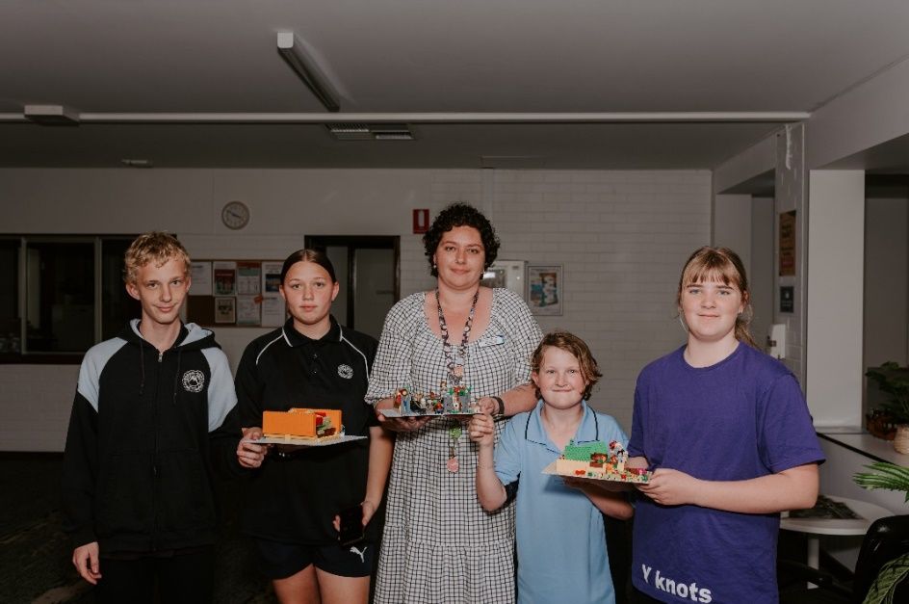

SAFETY AND WELFARE – FOR STUDENTS

The following sections are for students.

At Moora Residential College our supervisors are always on hand. You can talk with us about anything. We will listen and give you advice and support. If we think a matter needs to be discussed with others, we might refer you to someone more qualified to provide specialised support. This might be the College Manager or school psychologist.

Your safety and the safety of others
Firstly, you have the RIGHT to be safe and to always feel safe. If you have concerns or a complaint about what might be happening at the college, there are people who are able to help you.

Safety concerns may include things like:
- inappropriate social approaches by a person to make friends with you or start a close relationship with you
- inappropriate touching by a person which makes you feel uncomfortable
- sexual talk, personal emails or personal contact via mobile phones or social media
- inappropriate physical handling (hitting, pushing, hugging).
- We carry out weekly Head lice checks and treat when required, ensure that the bed linen is washed and returned to the student’s room.

You might also be concerned about similar behaviour towards someone else at the college. It’s OK for you to make a complaint on behalf of another student and we encourage you to do so.

Residential college student complaints
T: 1800 011 114 (Monday to Friday 8am to 5pm)
E: residentialstudentcomplaints@education.wa.edu.au
W: www.education.wa.edu.au/complaints

When you call you will speak to someone trained in protective behaviours. They care and understand that you may feel a range of emotions about contacting them including anxiety, shame, or relief. You can talk with them about yourself or someone else you are concerned about. You can remain anonymous but if you would like someone to get back to you, you will need to provide some contact details.

If your complaint is urgent or is an emergency please call the Police, Crisis Care or Kids Helpline.

Police
24 hours a day, seven days a week
T: 131 444 (000 for emergencies)
W: www.police.wa.gov.au

When you call you will be asked to:
Press ‘1’ for immediate police attendance
Press ‘2’ for general information, or to report an incident that does not need immediate police attendance

Remember, if it’s an emergency, immediately hang up and call 000.

Crisis Care
24 hours a day, seven days a week
T: 9223 1111
T: 1800 199 008 (country free call)
T: 9325 1232 (TTY)
W: www.dcp.wa.gov.au/crisisandemergency

Crisis Care is a crisis information and counselling service of the Department of Communities Child Protection and Family Support for people needing urgent help.

Crisis Care can help when:
- you need immediate help with a serious problem
- you are concerned about your wellbeing or that of another person
- you are alone or afraid and urgently need to talk with someone
- you need counselling, information, or other support.

Kids Helpline
24 hours a day, seven days a week
T: 1800 55 1800
W: www.kidshelpline.com.au

Kids Helpline is Australia's only free, private, and confidential telephone and online counselling service specifically for young people aged between five and 25.

- If you need to talk with someone immediately, the fastest way is to call and speak with a counsellor.
- If you're not sure about talking with someone on the phone, or you can't get to a phone, use the web, or email service.
- Calls from mobile phones, landlines and payphones are free if you are calling from within Australia.

You can talk with Kids Helpline about anything including:
- relationships with your family, boyfriend, or girlfriend
- a friend who needs help
- school or study worries
- how you are feeling, such as angry, sad, or confused.

Your health and wellbeing concerns
It’s OK to have concerns about what might happen at school or where you are living during the school year. We understand there might be times when you want help so, please use the helplines listed here.

School concerns
If you have concerns about school such as homework, school activities or other students you can talk with your parents or carers or with school staff such as:
- your teachers
- school psychologist
- school nurse
- school chaplain
- any other staff member.

Residential college concerns
Raise any concerns about the Residential College – e.g. facilities; meals; leave arrangements – with college staff. Discuss your concerns with other students to see what they think.

You can take your concerns to:
- any member of staff including the College Manager
- your parents/carers
- the Residential college student complaints line.
Residential college student complaints
T:1800 011 114 (Monday to Friday 8am to 5pm)
E: residentialstudentcomplaints@education.wa.edu.au
W: www.education.wa.edu.au/complaints

Anti-bullying policy
Moora Residential College does not tolerate bullying in any form. We are committed to providing you with a safe and caring environment where you feel happy and safe. Whenever you have concerns about feeling unsafe or threatened, we encourage you to speak to staff.

Suggestions
If there is anything we can do better, please let us know. You can raise your suggestions with your student council or any member of staff at any time.

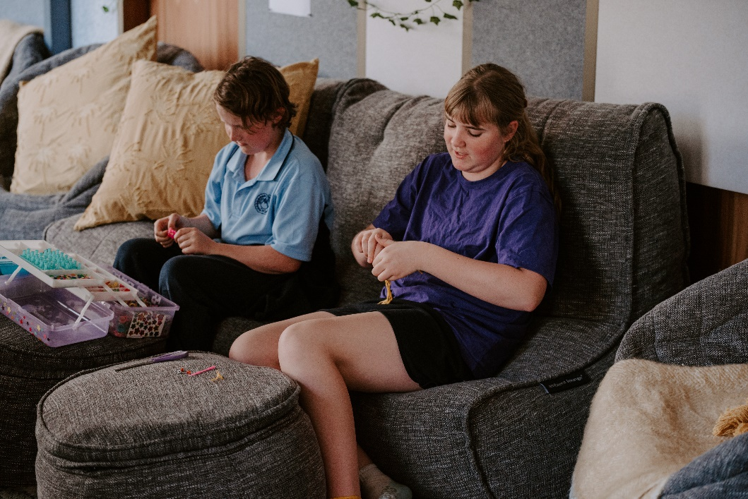

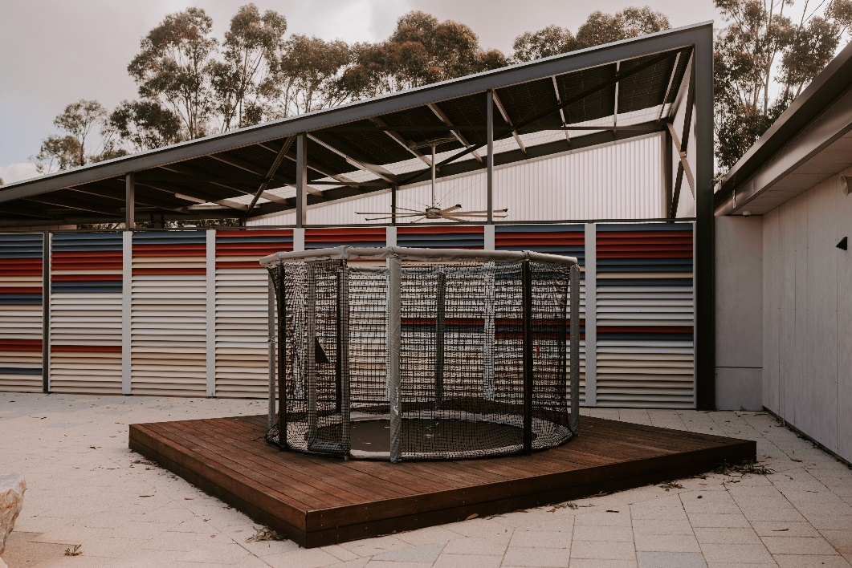

APPENDIX: RESIDENTIAL COLLEGE CODE OF CONDUCT
- AUTHORITY
The Code of Conduct (the Code) is issued and published pursuant to section 213J of the School Education Act 1999.
- PURPOSE
The Boarding Agreement provides that the student must obey the Code.

The purpose of the Code is to set out the required standard of conduct to be observed by a student while boarding at a residential college.

Students who breach the Code may be subject to disciplinary action. The College Manager can suspend or terminate a boarding agreement for substantial breaches of the Code.

- SCOPE
This Code applies to all students who board at a residential college.

- CONDUCT IN RESPECT TO SELF

Students will:
- act with proper regard for their safety, education, welfare, and health (mental and physical).
- conduct themselves in a respectful, responsible, and lawful manner.
- behave in a way that upholds the values, integrity, and reputation of the residential college; and
- accept responsibility for their actions.

- CONDUCT IN RESPECT TO OTHER STUDENTS

Students will:
- treat other students with respect, dignity, courtesy, honesty, and fairness and with proper regard for others’ rights, safety, and welfare.
- live in harmony with other students and respect others’ views and opinions.
- respect the privacy of others; and
- report a breach of the Code to appropriate staff.

- CONDUCT IN RESPECT TO STAFF

Students will:
- treat staff with respect, dignity, courtesy, honesty and fairness and with proper regard for their rights, safety and welfare.
- respect their property, views, and opinions; and
- comply with any reasonable request of a staff member.

- CONDUCT IN RESPECT TO PROPERTY

Students will:
- treat residential college property and facilities with respect; and
- treat staff and fellow students’ property with respect.

