CURRICULUM RESOURCE MODULE
Our new playground
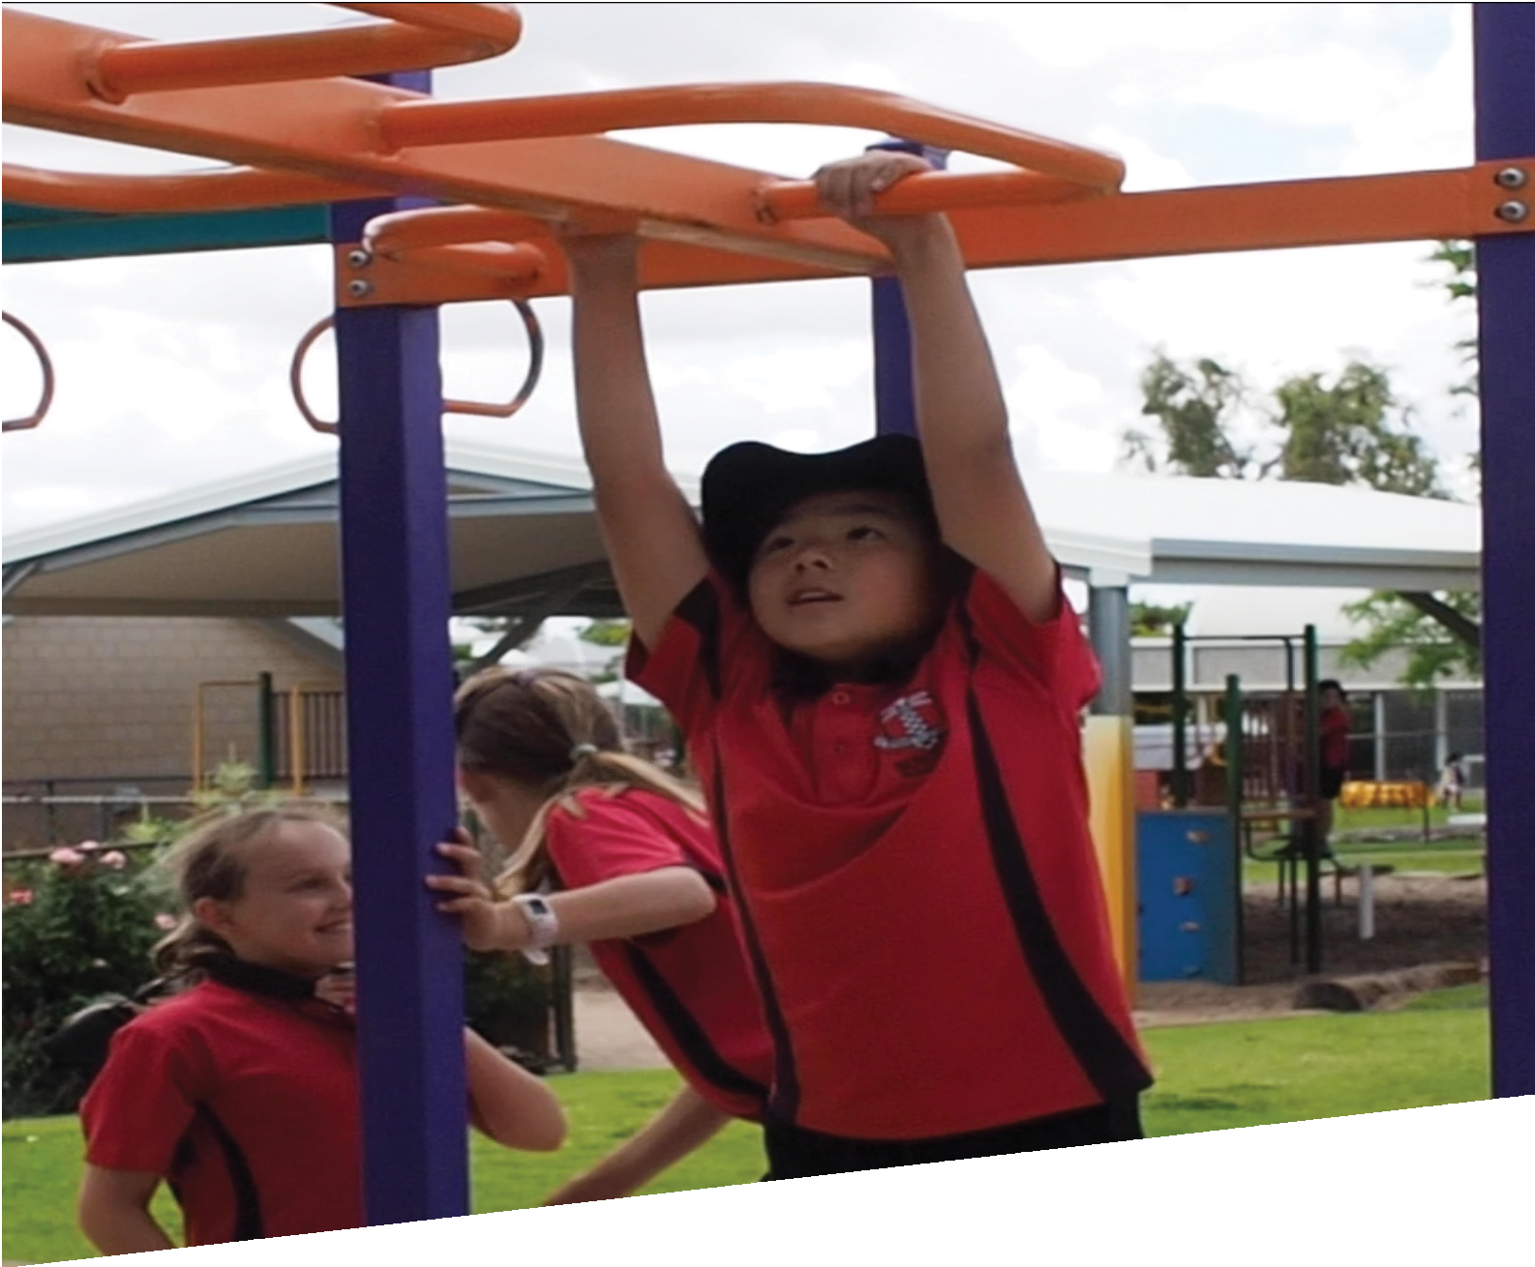
YEAR 4
Acknowledgements
The STEM Learning Project respectfully acknowledges the Traditional Custodians of the lands upon which our students and teachers live, learn and educate.

The STEM Learning Project is funded by the Western Australian Department of Education (the Department) and implemented by a consortium in STEM education comprising the Educational Computing Association of WA, the Mathematical Association of WA, the Science Teachers Association of WA and Scitech. We acknowledge and thank the teachers and schools who are the co-creators of these resources.

Copyright and intellectual property
The copyright and intellectual property of this module remain the property of the Western Australian Department of Education (the Department).

Any Western Australian Curriculum content in this resource is used with the permission of the School Curriculum and Standards Authority (the Authority); this permission does not constitute Authority endorsement of the resource. The Authority accepts no liability for any errors or damages arising from reliance on its content.

The Western Australian Curriculum content may be freely copied, or communicated on an intranet, for non-commercial purposes in educational institutions, provided that the Authority is acknowledged as the copyright owner. Copying or communication for any other purpose can be done only within the terms of the Copyright Act 1968 or with prior written permission of the Authority. Any Australian Curriculum content in the Western Australian Curriculum is used by the Authority under the terms of the Creative Commons Attribution NonCommercial 3.0 Australia licence.

Any content on the www.scsa.wa.edu.au domain that has been derived from the Australian Curriculum may be used under the terms of Creative Commons Attribution-NonCommercial 3.0 Australia licence.

Appendix 2: General capabilities continuums are adapted from ACARA, © Australian Curriculum, Assessment and Reporting Authority (ACARA) 2009 to present, unless otherwise indicated. This material was downloaded from the ACARA website (www.acara.edu.au) (accessed December 2015) and was not modified. The material is licensed under CC BY 4.0 (https://creativecommons.org/licenses/by/4.0/). ACARA does not endorse any product that uses ACARA material or make any representations as to the quality of such products. Any product that uses material published on this website should not be taken to be affiliated with ACARA or have the sponsorship or approval of ACARA. It is up to each person to make their own assessment of the product.

This resource includes references and examples of iOS, Android and other apps. The Department does not endorse or recommend any commercial products and simply provides these as examples for teachers.

The Department is committed to providing quality information to its customers. Whilst every effort has been made to ensure accuracy, currency and reliability of the information within these documents, the Department accepts no responsibility for errors, omissions or amendments made since the time of publishing. Confirmation of information may be sought from the Department or the originating bodies providing the information. The Department has no control over the content of material published on websites to which users are referred in this resource. It is the responsibility of the internet user to make their own decision as to the relevancy, accuracy, currency and reliability of information found on those sites.
Attributions: PlayPump, SketchUp, PowerPoint, iMovie, PuppetPals, Google Play Store, Tinkercad, eBook, Pages, Keynote, Seesaw, Class Dojo, Lidar, Arduino, Survey Monkey, Kahoot, Lego.

Table of contents

The STEM Learning Project 2
Overview 3
Activity sequence and purpose 7
Background 8
Activity 1: Play spaces 10
Activity 2: Analysing the space and equipment 17
Activity 3: Design for excitement 23
Activity 4: Share our thinking 28
Appendix 1A: Links to the Western Australian Curriculum 32
Appendix 1B: Mathematics proficiency strands 34
Appendix 2: General capabilities continuums 35
Appendix 3: Materials list 38
Appendix 4: Design process guide 39
Appendix 4B: Drawing in the design process 40
Appendix 5: Reflective journal 41
Appendix 6: Student activity sheet 1.0: Journal checklist 42
Appendix 7: Teacher resource sheet 1.1: Cooperative learning – Roles 43
Appendix 8: Teacher resource sheet 1.2: Cooperative learning – Jigsaw 44
Appendix 9: Teacher resource sheet 1.3: Cooperative learning – Placemat 45
Appendix 10: Teacher resource sheet 1.4: Cooperative learning – Think, Pair, Share 46
Appendix 11A: Student activity sheet 2.1: Playground forces 47
Appendix 11B: Teacher resource sheet 2.1: Playground forces 48
Appendix 12: Student activity sheet 3.1: Prototype troubleshooting 49
Appendix 13: Teacher resource sheet 4.1: Student evaluation 50
Appendix 14: Student activity sheet 4.2: Design review 51
Appendix 15: Teacher resource sheet 4.3: 3 – 2 – 1 Reflection 52

The STEM Learning Project
The aim of the STEM Learning Project is to generate students’ interest, enjoyment and engagement with STEM (Science, Technology, Engineering and Mathematics) and to encourage their ongoing participation in STEM both at school and in subsequent careers. The curriculum resources will support teachers to implement and extend the Western Australian Curriculum and develop the general capabilities across Kindergarten to Year 12.
Why STEM?
A quality STEM education will develop the knowledge and intellectual skills to drive the innovation required to address global economic, social and environmental challenges.
STEM capability is the key to navigating the employment landscape changed by globalisation and digital disruption. Routine manual and cognitive jobs are in decline whilst non-routine cognitive jobs are growing strongly in Australia. Seventy-five per cent of the jobs in the emerging economy will require critical and creative thinking and problem solving, supported by skills of collaboration, teamwork and literacy in mathematics, science and technology. This is what we call STEM capability. The vision is to respond to the challenges of today and tomorrow by preparing students for a world that requires multidisciplinary STEM thinking and capability.
The approach
STEM capabilities are developed when students are challenged to solve open-ended, real-world problems that engage students in the processes of the STEM disciplines.
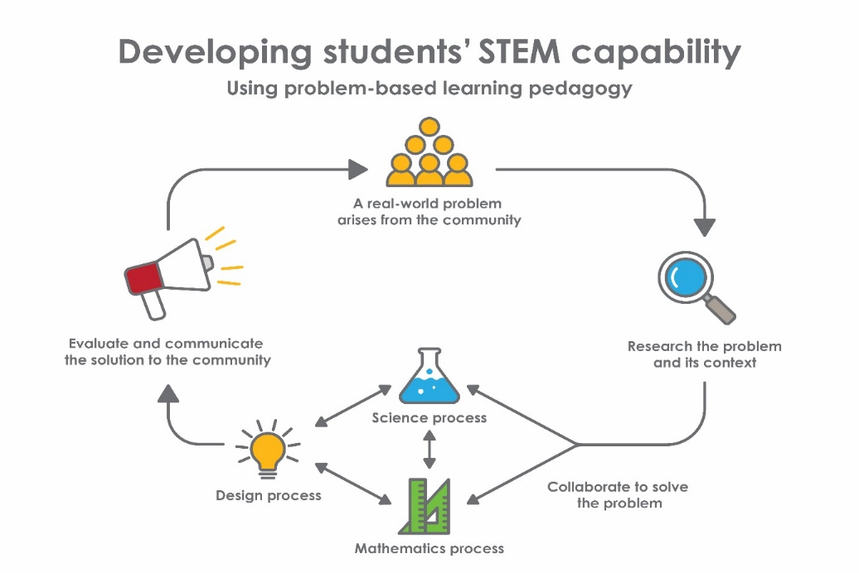

Department of Education WA
Year 4 – Our new playground

Overview
Many students spend too much time using electronic devices. Their ability to tackle physical and related mental challenges is compromised by their inactivity. There is an increasing need to design outdoor play spaces that safely and effectively excite and challenge students.
This module encourages students to consider the function of their existing school playground, how movements like sliding, swinging and spinning feature in playground equipment, and design a new piece of equipment to add to the excitement of their playground.
What is the context?
Many students spend too much time on sedentary activities and need an outdoor play space that excites and stimulates them.
What is the problem?
How can playground equipment be designed to be engaging and exciting?
How does this module support integration of the STEM disciplines?
Students think creatively and critically about the way play equipment design can stimulate and engage students. Students analyse the design of their school playground, assess how well it meets students’ needs and identify ways of enhancing the space by using their understanding of movement and forces, mathematical area, digital representation and engineering design processes.
Science
Students develop and apply understandings of push and pull forces, contact forces, forces that act at a distance and the relationship between forces and movement (ACSSU076) as they analyse existing play equipment.
Students research and explore alternatives to traditional playground equipment, and use this information to design a new item of playground equipment based on their understanding of forces (ACSSU076).
Mathematics
Students in Year 3 are introduced to standard units of length, mass and capacity and are typically given experience measuring with physical units such as centimeter cubes, kilogram weights on balance scales and litre containers. For length, they may also use a 30 cm ruler to measure in centimetres and a trundle
wheel to measure in metres, but are not expected to use measuring instruments
with calibrated scales, where they need to interpret the calibrations between the labelled marks. These are the concepts being introduced in Year 4.
When measuring the dimensions of their play area, students should be given experience using both a builders measuring tape and a trundle wheel, helping them to interpret the measuring tape calibrations and labels as metres and centimetres. Use scaled instruments to measure and compare lengths, masses, capacities and temperatures (ACMMG084).
There is opportunity to connect their new knowledge about decimal notation to length measurements expressed in metres to two decimal places. Recognise that the place value system can be extended to tenths and hundredths. Make connections between fractions and decimal notation (ACMNA079).
Students in Year 4 are beginning to understand how a map and a plan differ, but only have an intuitive understanding of scale relationships. In this module they build on their early understandings to draw a labelled plan of their playground using informal scale, showing the dimensions of play equipment and the distances between them in metres to two decimal places. Use simple scales, legends and directions to interpret information contained in basic maps (ACMMG090).
While Year 4 students learn to interpret the meaning of simple scales given on maps, they are not expected to draw plans to scale or understand the use of scale factors until later years. However, during this module, they can be asked to examine their informal drawings of the play equipment compared to their measurements and reason, for example that their slide needs to be longer because “the slide part is much longer than wide, but I drew the length and width the same size”. This kind of problem-solving and reasoning will lay foundations for future learning when enlarging and reducing to scale will be formally introduced.
Some opportunity is also provided to construct surveys for a purpose, using an open-ended question, the responses to which need to be categorised and frequencies graphed according to the response categories. Select and trial methods for data collection, including survey questions and recording sheets (ACMSP095) and Construct suitable data displays, with and without the use of digital technologies, from given or collected data. Include tables, column graphs and picture graphs where one picture can represent many data values (ACMSP096).
Technology
Students consider how forces and materials affect the behaviour of systems (ACTDEK011). They represent their design as an annotated diagram, use computer-aided design (CAD) technology to draw their design and build a three-dimensional model.

Students work collaboratively and summarise their learning when presenting their designs to an authentic audience, which may include a representative from a playground company. Students use software (ACTDIP009) to create multimodal reports to communicate their design ideas and science understandings (ACSIS071) to their audience.
The Design process guide is included as a resource to provide assistance to teachers in understanding the complete design process as developed in the Technologies syllabus.
General capabilities
There are opportunities for the development of general capabilities and cross-curriculum priorities as students engage with Our new playground. In this module, students:
- Develop problem solving skills as they research the problem and its context (Activity 1); investigate parameters impacting on the problem (Activity 2); imagine and develop solutions (Activity 3); and evaluate and communicate their solutions to an audience (Activity 4).
- Utilise creative thinking as they generate possible design solutions; and critical thinking, numeracy skills and ethical understanding as they choose between alternative approaches to solving the problem.
- Utilise personal and social capability as they develop socially cohesive and effective working teams; collaborate in generating solutions; adopt group roles; and reflect on their group work capabilities.
- Utilise a range of literacies and information and communication technologies (ICT) capabilities as they collate records of work completed throughout the module in a journal and represent and communicate their solutions to an audience using digital technologies in Activity 4.
What are the pedagogical principles of the STEM learning modules?
The STEM Learning Project modules develop STEM capabilities by challenging students to solve real-world problems set in authentic contexts. The problems engage students in the STEM disciplines and provide opportunities for developing higher order thinking and reasoning, and the general capabilities of creativity, critical thinking, communication and collaboration.
The design of the modules is based on four pedagogical principles:
- Problem-based learning
This is an underlying part of all modules with every module based around solving an initial problem. It is supported through a four-phase instructional model: research the problem and its context; investigate the parameters
impacting on the problem; design and develop solutions to the problem; and evaluate and communicate solutions to an authentic audience.
- Developing higher order thinking
Opportunities are created for higher order thinking and reasoning through questioning and discourse that elicits students' thinking, prompts and scaffolds explanations, and requires students to justify their claims. Opportunities for making reasoning visible through discourse are highlighted in the modules with the icon shown here.
- Collaborative learning
This provides opportunities for students to develop teamwork and leadership skills, challenge each other’s ideas, and co-construct explanations and solutions. Information that can support teachers with aspects of collaborative learning is included in the resource sheets.
- Reflective practice
Recording observations, ideas and one’s reflections on the learning experiences in some form of journal fosters deeper engagement and metacognitive awareness of what is being learnt. Information that can support teachers with journaling is included in the resource sheets.
These pedagogical principles can be explored further in the STEM Learning Project online professional learning modules located in Connect Resources.
Department of Education WA

Activity sequence and purpose
Play spaces | To capture students’ interest and engage them with the problem, students research the design of playgrounds, paying attention to current trends and innovation. Students measure the dimensions and create a plan of their play area.
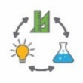  Analysing the space and equipment | Students investigate the way they play in their school play areas and consider new equipment that could enhance play. They investigate how forces create different types of movement.
Design for excitement | Using inspiration from their research, students work in small groups to design a piece of innovative playground equipment. They represent their design digitally and as a three-dimensional model, applying movement and force concepts.
Share our thinking | Using a choice of multimedia, students present their design to the class or a wider audience, justifying their choices and how these meet the identified needs of playground users.

Background
Expected learning | Students will be able to:  - Draw a labelled plan of their school playground area using an informal scale.  - Interpret the meaning of the calibrations on a builder’s tape measure in metres and centimetres and write these in metres to two decimal places.  - Explain the relationship between forces and the movement of playground equipment.  - Identify push and pull forces acting through contact or at a distance on playground equipment and represent them in diagrams using arrows.  - Explain how the forces and types of materials used in their design affect the movement of their new item of playground equipment.  - Create an annotated two-dimensional representation and a three-dimensional model of a new item of playground equipment and communicate how it meets the design criteria.  - Evaluate the effectiveness of their designs using oral group feedback and personal reflection strategies.
Timing | There is no prescribed duration for this module. The module is designed to be flexible enough for teachers to adapt. Activities do not equate to lessons; one activity may require more than one lesson to implement.
Vocabulary | This module uses subject-specific vocabulary, some of which includes:  angled, bird’s-eye view, contact, cone, corners, curved, cylinder, diagonal, direct, distance, elevate, exertion, force, gravity, height, horizontal, indirect, innovation, length, magnetism, movement, polygon, prism, rotate, scale, shape, side-view, slope, space, tessellate, top-view, vertical, weight, width.
Consumable materials | A Materials list is provided for this module. The list outlines materials outside of normal classroom equipment that will be needed to complete the activities.
Safety notes | There are potential hazards inherent in these activities and with the equipment being used, and a plan to mitigate any risks will be required.  Potential hazards specific to this module include but are not limited to:  - Possible exposure to cyber bullying, privacy violations and uninvited solicitations when using the internet.  - Sun exposure.
Assessment | The STEM modules have been developed to provide students with learning experiences to solve authentic real-world problems using science, technology, engineering and mathematics capabilities. While working through the module, the following assessment opportunities will arise:  - When measuring and mapping the playground area  - When analysing the playground equipment and describing movement and force on Student activity sheet 2.1: Playground forces  - When designing solutions, applying mathematical and science concepts  - Through journaling activities  - Through the end of module presentation.  The STEM modules have been developed to provide students with learning experiences that solve authentic real-world problems using science, technology, engineering and mathematics capabilities. Appendix 1 indicates how the activities are linked to the Western Australian Curriculum.  Evidence of learning from journaling, presentations and anecdotal notes from this module can contribute towards the larger body of evidence gathered throughout a teaching period and can be used to make on-balance judgements about the quality of learning demonstrated by the students in the science, technologies and mathematics learning areas.  Students can further develop the general capabilities including Information and communication technology (ICT) capability, Critical and creative thinking and Personal and social capability. Continuums for these are included in the General capabilities continuums but are not intended to be for assessment purposes.

Activity 1: Play spaces
Activity focus | To capture their interest, students research playground equipment designs, paying attention to current trends and innovation. Students discuss interesting play spaces they have visited and compare these to the equipment in their school playground. They draw a plan of the school playground using informal scale and measure and record dimension on their plan.
Background information | When using playground equipment, children apply and experience forces that create different forms of movement.  This has sometimes been utilised in innovative ways. In developing countries some playground designs utilise the energy from students at play to address social purposes. For example, the PlayPump systems are water pumps powered by students. By playing on the PlayPump merry-go-round, students can attend school and pump clean water from distant sources, rather than travelling many miles on foot to collect water for their family.  Builders measuring tapes are usually calibrated in millimetres with every centimetre labelled progressively in millimetres. The metre marks, may or may not be labelled as metres. This is often confusing to students and they need to be taught how to read these calibrations accurately. If not given experience with these tapes, students typically make errors when they are asked to measure, for example when participating in long jump.
Instructional procedures | Students could take photos of the playground equipment they enjoy in their local park and share these in class.  This activity provides an opportunity to explore different length measurement instruments including a builder’s tape measure and a trundle wheel. Laser measuring tools may be introduced if available. Students compare the different measuring instruments and learn to interpret and write their measurements to two decimal places, regardless of the way the different tools are calibrated and labelled.
Expected learning | Students will be able to:  - Use their informal sense of scale to draw a plan of their school playground equipment. (Mathematics)  - Measure dimensions and distances using a builder’s tape measure and interpret and write the result in metres to two decimal places. (Mathematics)
Equipment required | For the class:  Digital devices for research  Photo bank of playground equipment in their school  Trundle wheels and builder’s tape measure for each group  Optional equipment  Laser measuring tools
For the students:
Learning journals
A4 paper and clipboard
Activity parts | Part 1: Researching playground designs  In groups, students research different types of playground equipment. They work cooperatively, learning through sharing and discussion.  Provide a focus question:  What interesting photos or information can you find about playground equipment?  Students discuss playground innovation, comparing interesting play spaces they have been to and particular kinds of playground equipment they have seen. They share photos they have taken at their local park playground and discuss why the equipment is fun.  - Which playground equipment do you enjoy playing on? Why?  - Which playground equipment is the least enjoyable? Why?  Students use their photos of playground equipment as well as photos of innovative playground designs they have found online, to create a class display.  Discuss how pictures can be categorised for the display. Student thoughts can be scribed and added to the display to make thinking visible. For example, a ‘slide’ is a basic category of play equipment. What are the different ways this equipment can be constructed? Ask students to identify the essential elements of the range of equipment that enables them all to be called ‘slides’? “These are all slides because …”  Links for images can be found in the Digital resources section.  This is an opportunity to develop ICT capability, developing understanding of ownership and usage of images from the internet.
Part 1: Drawing the playground
To engage students with the problem, take a walk around the school playground. Use the questions below to focus observations through discussion:
What can we play on or with?
How do we use our bodies to play on it?
How does our school play equipment compare with our research?
Which are your favourite pieces of play equipment? Why….because?
Introduce the problem and inform the students that they will be designing some new, improved play equipment, but that first they need to investigate the spaces available in the playground.
Ask students to draw a plan of the current playground area and equipment. Orient them to the playground and the A4 page on which they will be representing the playground. Discuss with them the idea that the plan will be a scaled down birds-eye view, so they need to imagine they are a bird flying over the playground from a height and looking down, or perhaps a drone taking a picture from above.
Ask: “How would a top-view of the equipment look different to the side-view from where you are standing?” Use this question to elicit the following:
- Everything would look smaller.
- They won’t be able to see the ‘side-view’ shapes.
- They will be able to see the ‘top-view’ shapes and the overall length and width.
- They won’t be able to see how high it is.
Draw attention to one of the pieces and discuss the top view shape or shapes you would see. This might be a rectangle, a square, a circle, a triangle, some other ‘polygon’ (a shape with many straight sides), or combinations of shapes. Ask students to draw these on their page, while thinking about how big it should be if all the other equipment has to fit on the page.
Sketching the initial plan in the playground is best done individually, then ask students to compare their plans, in class, in pairs or small groups. Challenge them to have one person in the group redraw the plan, improving the shapes, sizes and placements of the equipment and labelling each piece of equipment with an agreed name.
Part 2 Measuring the Playground
Inform students that we now know the types of equipment we have, where it is located in the playground and the shape of the space on the ground it occupies. What we don’t know is the exact size of each item, and how far apart the items are. Tell students they will now be taking some measurements in the playground, and recording them on their plans.
Introduce builders tape measures and trundle wheels. Ask students to look carefully at the markings and numbers on both pieces of length measuring instruments and ask:
- How are they the same and how are they different?
The trundle wheel has 100 centimetre marks, usually labelled every 10 centimetres. One full turn is a metre. The Builders tape has marks that are a millimetre apart with every 10 millimetres labelled.
Challenge each group to choose and mark with chalk a distance, either inside the classroom or on the veranda, that is more than a metre long. They then measure the distance with the trundle wheel, and then the builder’s tape, recording each measurement according to the units shown on each instrument. Record these in a class table.
Draw out the relationships between millimetres and centimetres, and between millimetres and metres. Invite students to use the table to reconcile the measurements, so they see the connection and can confidently say how many metres and centimetres match (or approximate) the number of millimetres shown on the builder’s tape. Draw out the connection to place value, i.e 1 000s are metres, 100s are decimeters, 10s are centimetres; and that there could be some millimetres left over that will be less than 1 cm.
Depending on how much decimal work students have done, either teach or re-teach the decimal connection between giving a measurement in metres and centimetres and writing it down in metres to two decimal places. Stress the sharing and fraction connection between the places through questioning as:
- If we shared a metre length equally between ten people, they would each get 10 cm or a tenth of a metre, which is 0.1 metres.
- If we shared out zero point one of a metre length equally between ten people, they would get 1 cm or a hundredth of a metre (a tenth of a tenth) which is 0.01 metres.
Together, write in metres the measurements shown in the table constructed earlier.
For example:
Group | Trundle | Tape | Metres and centimetres | Metres  (2 decimal places)
1 | 3 turns, and 15 | 3 152 mm | 3 m 15 cm | 3.15 m
2 | 2 turns and 4 | 2 040 mm | 2 m 4 cm | 2.04 m
3 | 1turn and 95 | 1 949 mm | 1 m 95 cm | 1.95 m
4 | 2 turns and 40 | 2 400 mm | 2 m 40 cm | 2.4 m
Draw out the need for the zero place holder for less than 10 centimetres; the rounding to a centimetre that may be needed when the measurement with the millimetre tape includes less than 10 mm; and that the final zero is not needed when a measurement is an even 10 cm.

Additional learning opportunity
Teachers may choose to show the third decimal place as 0.01 shared between ten people would be written as 0.001 metres. However, this goes beyond expectations for Year 4. They may be exposed to this information but are not expected to learn or demonstrate it.
Ask student groups to take the tape and the trundle wheel and measure the dimensions of the play area, the equipment and some spaces between the equipment, writing the measurements on their final plan in metres to two decimal places.
In class, ask students to look at their measurements and think about whether their plan ‘makes sense’. Stimulate their thinking by asking:
- What would need to change on your plan so that the distances between the equipment matches how much space you left on the map?
- How does the size of the slide compare to the distance of the flying fox?
- The length of the monkey bars is much less than the length of the flying fox? How do your drawings of those items show this?
Explain that the purpose for recording sizes and distances on the plan is to help groups decide how big their new designed equipment should be and where it can fit into the playground.
Part 4: Reflection
In response to the following questions ask students to record thinking in their journals:
- What did I learn about measurements and decimals?
- How did our playground equipment compare to our researched equipment?
- How will knowing the measurements of our playground and equipment help me plan new equipment?
- If we design an exciting new piece of playground equipment, what features should it have?
Thinking can be represented through drawings, photos, mind maps or structured sentences.

Digital resources | Innovative playground equipment  Ten pieces of park play equipment to reinvigorate a park (Urban Play, 2017)  urbanplay.com.au/reinvigorating-park-play-equipment
Our playgrounds (Rhinoplay, 2017)
www.rhinoplay.com.au/products/
Innovative play spaces (KaBOOM!, 2017)
au.pinterest.com/kaboomplay/innovative-playspaces/
Fun physics activities for kids (Editors of Publications International Ltd, 2007)
lifestyle.howstuffworks.com/crafts/seasonal/summer/fun-physics-activities-for-kids4.htm

Activity 2: Analysing the space and equipment
Activity focus | Students conduct a survey to gather information about student preferences for play equipment. They investigate the way they play in their school and question whether new equipment could enhance their play environment. They investigate how forces create different types of movement.  Students sort images of playground equipment, discussing the science behind movement and how forces of pushing or pulling impact the design in terms of space and safety.
Background information | In this activity, students engage with the mathematics of creating a survey, collating and representing data.  Questions in the survey should be open so that students will need to categorise the responses in order to interpret and report the result. Students may be introduced to the idea of ‘sampling’ rather than surveying the whole school. However, understanding what is meant by a representative sample is beyond expectations for the year level.  Sir Isaac Newton (1642–1727) was an Englishman who made important advances in mathematics and physics. He is famous for developing the three laws of motion. The first law provides the scientific background to this module.  The first law states that an object at rest (not moving) will stay at rest, and an object in motion tends to stay in motion with the same direction and speed, unless acted upon by a force. For example, a heavy shopping trolley rolling down a slope will only be slowed when someone grabs hold of it and pulls it back, that is, applies a force to oppose the motion of the trolley. To make a shopping trolley that is at rest start to move, a push or pull force must be applied to overcome the inertia of the trolley and start the trolley wheels rolling. The mass of the trolley is what resists its motion.  This tendency not to move is what we call inertia. An increase in mass equals an increase in inertia.  Forces can be classified as pushes or pulls, and also as contact forces or forces acting at a distance. When we grab hold of a trolley handle and push, we are applying a contact force, a force that is in direct contact with the object being pushed.  The two best examples of forces acting at a distance are magnetism and gravity. The force of attraction from a magnet will pull a paper clip towards the magnet. The force of gravity pulls all objects towards the centre of the Earth so a ball thrown up into the air will be pulled back down by the force of gravity.  In both examples of magnetism and gravity, objects are caused to move by a pull force acting at a distance from the object. That is, the magnet and the Earth which exert the pull forces are not in direct contact with the objects being pulled towards them.  Playground equipment provides an engaging context to explore push and pull forces as well as forces that act when in contact or at a distance. The most common types of movement found in playground equipment are sliding, climbing, swinging and spinning. Students slide down slopes pulled by the force of gravity.  Students climbing upwards move their bodies up against the force of gravity by applying forces downward through their legs onto the rungs of ladders propelling their bodies upward. Students at rest (not moving) on a swing, have to be pushed to start the swinging motion which is both forwards and upwards.  As the swing reaches the top of its arc, the speed of movement slows and for a moment stops, before gravity pulls the swing back down to the starting position.  Forces are normally represented in drawings as arrows which point in the direction the force is acting.
Expected learning | Students will be able to:  - Design a survey, collect, collate, represent and interpret the survey data (Mathematics).  - Identify two-dimensional shapes and three-dimensional objects found in playground equipment (Mathematics).  - Explain the relationship between forces and movement of playground equipment (Science).  - Identify push and pull forces acting through contact or at a distance on playground equipment and represent them in diagrams using arrows (Science).
Equipment required | For the class:  Interactive whiteboard or similar  1 metre long arrows (three or four for the class)
For the students:
Digital devices – at least one per group of three students
Student activity sheet 2.1: Playground forces
Preparation | Print Student activity sheet 2.1: Playground forces  View Teacher resource sheet 2.1: Playground forces
Activity parts | Part 1: Survey  Remind students that other children in the school use the playground and their views should be considered in planning for new equipment. Explain that they will help create questions for a survey to find out what play equipment children like.  After the survey is conducted, students will interpret and categorise the responses and contribute to a class summary of the data.  Working as a class, help students decide on two or three open-ended survey questions. For example:  - What type of playground equipment do you find exciting?  - What type of play equipment do you use most often?  - What is your favourite way to play in a playground?  - What do you prefer your playground equipment to be made of?  These kind of questions will elicit a wide range of responses which students can interpret and, with assistance, group into response categories.  Discuss who the students will survey. While they are not likely to understand the idea of sampling, they will recognise, for example, that if you only asked Year 4 students what they like, you might not find out what a Year 1 or a Year 6 student would like. Ask the students:  - If we can’t ask everyone in the school, how can we decide who to survey?  - Why might it not be ‘fair’ if we only asked the Year 1 students what they like?  - How could we find out what students in all year levels like without having to ask every student?  After students have either interviewed and recorded responses (better for younger students) or collected written surveys, provide time for them to read and share responses.
Part 2: Representing data
Introduce the idea that the responses need to be grouped in some way so we can work out which are the most popular designs. In their groups students can suggest responses that ‘go together’.
Draw out that there is likely to be more than one way to categorise the responses. Remind them that the purpose is to help them design the new equipment, so finding out the most popular physical features and actions of playground equipment should focus the categorising process.
When the responses have been suitably grouped, count the frequencies of each response category. This is an opportunity for the teacher to model setting up a frequency table in an Excel spreadsheet and creating a bar graph using the technology. Student can assist by deciding the response category labels, the titles for the axes, the title for the graph and the frequencies.
Part 3: Analyse data
Information from the survey will provide the criteria for students to design their own playground equipment.
Have students analyse the survey data and ask:
- How do the frequencies help you choose a design that would be popular?
- Which feature was selected most often?
- Is this the most important feature for playground equipment? Why or why not?
- Which feature was selected least often? Is this feature less important? Why or why not?
- What else was in the data that could help you design something different (one unusual response could simulate and innovative design)?
In their groups students develop a set of broad criteria that they believe should be included in the design of the playground equipment. They list their criteria on a poster. Display the posters and conduct a ‘gallery walk’ where students move around and read what others have written.
Part 4: Investigating our playground
Ask students it identify the movements that make playground equipment fun?
Use this question as a prompt to introduce the idea that push and pull forces cause movement and have students consider the different ways those forces are created when playing on the equipment.
Take students to the playground and investigate two or three items of equipment. Ask one student to play on the equipment and ask the others the following questions to prompt thinking:
- What types of movement are there?
- Why does the movement occur? … Because ...
- What forces are involved? …Because…
Use arrows of one metre length to show the direction of movement and the direction of forces on the playground equipment. The concrete representations may help students picture the abstract concept of force.
After returning to class students work in small groups to recall their experiences of playing on equipment and annotate diagrams using one type of arrow to show forces and another type of arrow to show movement (Student activity sheet 2.1: Playground forces). Students label the forces as push, pull and gravity.
Alternatively, this may work as a class activity using an interactive whiteboard or similar. Introduce the concept of contact (the child pushing the swing) and non-contact forces (gravity pulling down on the swinging child).
Encourage higher order thinking through questioning:
- How would I show a push force on the swing diagram?
- How do you know whether this is a force acting in contact or at a distance?
- How would I show a force acting on a child who is on the slide?
- How can you work out whether this a push force or a pull force?
- Can you name a force acting on your body now?
- What else was there in the playground that helped create movement. What push and pull forces were involved?
Draw attention to the simple machines found in playground equipment and that simple machines make pushing and pulling easier. The main types of simple machines are: wheel and axel, lever, wedge, pulley and the inclined plane, some of which students may well notice during this activity. The relationship to the push pull forces under discussion can be emphasised. Students may wish to include these ideas in their design.
Links to simple machine investigations can be found in the Digital resources section.
Part 5: Reflection
Students record personal reflections in their learning journals. Prompt student reflections with questioning:
- What were the most important things you learned about creating and taking a survey and representing this data?
- How do forces make play fun?
- Describe what your group will design?
Resource sheets | Student activity sheet 2.1: Playground forces  Teacher resource sheet 2.1: Playground forces  Teacher resource sheet 1.4: Cooperative learning – Think, Pair, Share  Websites such as teachthis.com and teachstarter.com have teacher support material on simple machines.
Digital resources | Simple machines – Facts (Idaho Public Television, 2017)  idahoptv.org/sciencetrek/topics/simple_machines/facts.cfm
Simple Machines (BrainPOP, 2017)
www.brainpop.com/games/simplemachines/
Forces (BrainPOP, 2017)
www.brainpop.com/science/energy/forces/

Activity 3: Design for excitement
Activity focus | Using inspiration from their research, students work in small groups to design a piece of innovative playground equipment, represent their design digitally and then as a three-dimensional model.  Students apply shape, movement and force concepts to their design.
Background information | Photographs or videos of the construction processes should be taken for the digital presentations in Activity 4.  The Design process is a series of steps that guides the development of a solution to a problem. The core steps in the process are the same whether applied in engineering or areas such as software design. These steps are:  Define the problem: What is the need?  Research and gather information.  Analysis: Imagine: Brainstorm ideas.  Ideation: Plan: Pick the best idea, how will it work? Draw a diagram, what materials or tools will be needed?  Development/ production: Create: Build the solution and test it out.  Evaluation: Improve: What works, what doesn’t, what could work better? Repeat the cycle.  Refer to Design process guide and Drawing in the design process for further information on design in the technologies curriculum.
Instructional procedures | Access to technology such as a 3D printer could be considered for final designs.  Students should be encouraged to create their designs using computer-aided design (CAD) software. Students will need opportunities to learn to use CAD technology.  Students can digitally represent an ideal playground design using SketchUp, Tinkercad or a similar program (see Drawing in the design process). The three-dimensional models created can be combined to create a collaborative representation of a new playground.  Negotiation, critical thinking and reasoning skills will be displayed by the students as they work on their designs. Problem solving in collaborative situations is a STEM capability that students need to exercise. Allowing students to negotiate amongst themselves will encourage the development of this skill.
Expected learning | Students will be able to:  - Imagine and design a new item of playground equipment and represent it using an annotated two-dimensional digital representation and appropriate technical terms, indicating how forces and materials affect the behaviour of the product (Technologies).  - Based on their design, build a three-dimensional model of the new item of playground equipment (Technologies).  - Evaluate their design, using verbal group feedback and personal reflection strategies in learning reflection journals (Technologies).
Equipment required | For the class:  Resources to build designs
For the students:
Suitable ICT
Student activity sheet 3.1: Prototype troubleshooting – one per group
Preparation | Students may need to be provided with opportunities to practice the use of CAD technology. This is a good opportunity to invite experts in from the community to assist (ie high school students, parent helpers or industry professionals).  Support resources for using CAD software can be found in Drawing in the design process.  Resources will need to be sourced for the construction of the students’ models. Some options include:  - 3D printer  - Lego  - Woodwork or metalwork materials  - A range of scrap materials  - Papier-mâché
Activity parts | Part 1: Design criteria  Working in small groups, students develop a set of design criteria for their play equipment idea. Drawing on their knowledge from their research and the survey data from Activity 2, students consider movement, durable materials and safety.  Challenge students to establish a design brief for playground equipment that will be stimulating and engaging.  What features should the new play equipment have to make it exciting? Why?  What did you learn from the survey and from our push-pull activity?  Why should you consider the views of other students?  What materials should it be made from? Why?  How will you decide how high, wide, long it will be?  What new measurements might you want to take before you begin your planning?  How will you make sure the equipment is safe?  If students are going to collaborate and add their models together to create one playground (Activity 3, Part 5) then considerations will need to be made around what each group will design to ensure a range and in so enhancing the end product.
Part 2: Sketching and digital design
Continuing to work in groups students develop a design sketch for their playground equipment. Initial design work is best using pencil and paper alongside a CAD program if it is to be used.
With teacher support, students follow the design process (see Design process guide) to refine and enhance their model. The steps of ideation, development and production are specifically followed in this activity. Students are encouraged to build resilience and embrace the design cycle as they seek to improve initial design ideas.
Students annotate their sketch and or CAD addressing movement, forces, safety, materials and scale.
Students justify their design choices using scientific and mathematical reasoning and draw on information from the survey (see Drawing in the design process).
Part 3: Three-dimensional model
Working from the sketch and digital representation, students build a three-dimensional model of their playground equipment design using sourced materials.
If it is intended that students join their models together to produce a model playground, the size and scale of the individual models may need to be considered.
It may be possible for students to print their designs using a 3D printer.
It is recommended students continue to work in small groups for this activity.
Part 4: Playground collaboration
If students will join their playground pieces together on a large model of their playground space, the following will need to be considered:
- How much area is needed for shared play space?
- How much equipment is essential to the functioning of the playground?
- Does there need to be space for collaborative, free play areas?
- What is the maximum sized piece of equipment each group can have?
- What alternatives could be used?
Students consider and identify the elements they would like to include in their own play space, as distinct to the ideas of the small group.
Model a bird’s-eye view of the proposed playground to the students on the board to develop the idea of shared space. There needs to be multiple options in their designs to encourage choice.
Informal scale and proportion can be discussed, however, Year 4 students have not yet developed formal proportional reasoning. They can use full size measurements in real spaces to decide if there is enough room to move, or whether their design will fit.
References to scale drawings and models, however, need to depend on what ‘looks right’ – an intuitive sense of scale - not on scale factors and calculations.
Part 5: Reflection
In groups, students reflect on and evaluate the effectiveness of their design solution, justifying their choice of materials, shape and form, and the types of movement that occurs. Together, they complete Student activity sheet 3.1: Prototype troubleshooting.
Individually, students record this information as well as their personal reflections in their learning journals.
Prompt student reflections with:
- What worked?
- What didn’t work – why?
- What would you do again? What would you not repeat? Why?
- Do you have any further recommendations for developing this idea?
Resource sheets | Student activity sheet 3.1: Prototype troubleshooting
Digital resources | How to use SketchUp (Tim Slavin, 2014)  www.kidscodecs.com/3d-sketchup-for-beginners/

Activity 4: Share our thinking
Activity focus | Using a choice of multimedia applications, students present the design to the class and a wider audience such as parents, carers, teachers and architects. Students justify design choices and explain how they meet the identified needs of playground users. Students explain how forces create movements when the equipment is used.
Instructional procedures | Students will need support to prepare and deliver their presentation. This could be scaffolded into three phases: deciding on the content of the presentation, selecting appropriate media and preparing the posters or slides, and delivering the presentation. It is suggested that presentations are group based and that each student has a group role and responsibility to support collaborative work. This will provide an opportunity to develop leadership and collaboration skills associated with the general capability of Personal and social capability. See Teacher resource sheet 1.1: Cooperative learning – Roles.  This activity provides opportunities for cross-curricula assessment of literacy, listening and speaking. Depending on student's prior knowledge or ability, time may need to be dedicated to developing oral presentation skills.  Presentation options include creating a comic strip, eBook, poster in Pages, Keynote or PowerPoint or simple iMovie (or similar), which can then be shared through a digital platform such as Connect, Seesaw or Class Dojo, added to a class blog, or shared on the interactive whiteboard. Students may require explicit instruction when using these apps.  If ICT is not accessible, students could share their project using a traditional poster or recount.  To enable the completion of the design process students should be given time to make improvements to their work based on feedback received from the presentations. This could be in groups or as a private reflection in learning journals. Time should be taken to discuss how to give constructive feedback and how to take feedback positively.  There is the opportunity to monitor students’ development of the general capability of Personal and social capability using Teacher resource sheet 4.1: Student evaluation.
Expected learning | Students will be able to:  - Create a digital representation of their piece of play equipment and the design process using software (Technologies).  - Explain the relationship between forces and movement of their playground equipment (Science).  - Describe the design process and what changes were made to improve the outcome (Technologies).
Equipment required | For the class:  Media for presentations
For the students:
Three-dimensional models and digital representations
Digital devices for presentations
Student activity sheet 4.2: Design review
Preparation | Ensure technology is accessible and students have the required skills.  Schedule sufficient time for each group to present.  Information on developing presentation skills and teacher resources for scaffolding student learning can be sourced from the TED Talk resources in the Digital resources section.
Activity parts | Part 1: Deciding on content  Groups of three to four students are recommended for this activity. To scaffold cooperative group work, each member of the group should have a role and responsibility. See Teacher resource sheet 1.1: Cooperative learning – Roles  All students would contribute to all three phases of deciding on content, preparing the media presentation and delivering the presentation. One student may have overall responsibility for managing each phase of the task.  Students decide on the content of their presentation by asking:  - Why is there a need for a new item of playground equipment?  - What were we trying to achieve in our design?  - What decisions did we make as we developed our design?  - What types of movement will be created when we play on the equipment?  - What types of forces create these movements?  - How did CAD help us develop our ideas?  - How did our mathematics knowledge help us develop our ideas?  - What audience will we pitch our ideas to? What marketing techniques will we use?
Part 2: Choosing media
Students decide on the media to be used for their presentation. Options include:
A talk using the model or a poster.
Speak to slides which include photos of the model.
Digital platforms such as; comic strips, eBook, poster in Pages, Keynote or PowerPoint or simple iMovie (or similar), which can then be shared through a digital platform such as Connect, Seesaw or Class Dojo, or added to a class blog.
Part 3: Creating and delivering presentations
Students work in groups to prepare their presentations. Timing and public speaking skills will need to be discussed as well as content for the slides (eg slides should not be text heavy).
Teacher resources for developing presentation skills in students can be found in the Digital resources section under TED Talks. Students will need help developing the skills needed for pitching their ideas.
Students deliver their presentation to an authentic audience. This also presents an opportunity to develop community partnerships.

Part 4: Reflection
Teachers may use this opportunity to complete the Teacher resource sheet 4.1: Student evaluation.
Students may also complete a design review using Student activity sheet 4.2: Design review.
Students can give and receive feedback with Teacher resource sheet 4.3: 3 – 2 – 1 Reflection.
Allow time for students to give and receive feedback and to apply changes or reflect on their learning journey in journals.
Resource sheets | Teacher resource sheet 4.1: Student evaluation  Student activity sheet 4.2: Design review  Teacher resource sheet 4.3: 3 – 2 – 1 Reflection.
Digital resources | Apps available via App Store: iMovie, PuppetPals  PowerPoint, Sway, Prezi.  There is also a wide variety of design apps available at the Google Play Store for use on android devices.
TED-Ed talks
phys.org/news/2014-01-kids-pitch-world-changing-ideas.html

Appendix 1A: Links to the Western Australian Curriculum
The Our new playground module provides opportunities for developing students’ knowledge and understandings in science, technologies and mathematics. The table below shows how this module aligns to the content of the Western Australian Curriculum and can be used by teachers for planning and monitoring.
OUR NEW PLAYGROUND  Links to the Western Australian Curriculum | ACTIVITY
 | 1 | 2 | 3 | 4
SCIENCE
SCIENCE UNDERSTANDING
Physical sciences: Forces can be exerted by one object on another through direct contact or from a distance (ACSSU076) | ● | ● | ● | ●
DESIGN AND TECHNOLOGIES
KNOWLEDGE AND UNDERSTANDING
Technologies contexts: Engineering principles and systems: Forces, and the properties of materials, affect the behaviour of a product or system (ACTDEK011) |  |  | ● | ●
PROCESS AND PRODUCTION SKILLS
Creating solutions by: Designing: Develop and communicate design ideas and decisions using annotated drawings and appropriate technical terms (WATPPS23) |  | ●
Evaluating: Use criteria to evaluate and justify simple design processes and solutions (WATPPS25) |  |  |  | ●
Further information about assessment and reporting in the Western Australian Curriculum can be found at: k10outline.scsa.wa.edu.au/home

OUR NEW PLAYGROUND  Links to the Western Australian Curriculum | ACTIVITY
 | 1 | 2 | 3 | 4
MATHEMATICS
NUMBER AND ALGEBRA
Number and place value: Recognise that the place value system can be extended to tenths and hundreds. Make connections between fractions and decimal notation (ACMNA079)
MEASUREMENT AND GEOMETRY
Using units of measurement: Use scaled instruments to measure and compare lengths, masses, capacities and temperatures (ACMMG084) | ● | ● | ●
Location and transformation: Use simple scales, legends and directions to interpret information contained in basic maps (ACMMG090)
STATISTICS AND PROBABILITY
Data representations and interpretation: Select and trial methods for data collection, including survey questions and recording sheets (ACMSP095) |  | ●
Data representations and interpretation: Construct suitable data displays, with and without the use of digital technologies, from given or collected data. Include tables, column graphs and picture graphs where one picture can represent many data values (ACMSP096) |  | ●
Further information about assessment and reporting in the Western Australian Curriculum can be found at: k10outline.scsa.wa.edu.au/home

Appendix 1B: Mathematics proficiency strands
Key ideas
In Mathematics, the key ideas are the proficiency strands of understanding, fluency, problem-solving and reasoning. The proficiency strands describe the actions in which students can engage when learning and using the content. While not all proficiency strands apply to every content description, they indicate the breadth of mathematical actions that teachers can emphasise.
Understanding
Students build a robust knowledge of adaptable and transferable mathematical concepts. They make connections between related concepts and progressively apply the familiar to develop new ideas. They develop an understanding of the relationship between the ‘why’ and the ‘how’ of mathematics. Students build understanding when they connect related ideas, when they represent concepts in different ways, when they identify commonalities and differences between aspects of content, when they describe their thinking mathematically and when they interpret mathematical information.
Fluency
Students develop skills in choosing appropriate procedures; carrying out procedures flexibly, accurately, efficiently and appropriately; and recalling factual knowledge and concepts readily. Students are fluent when they calculate answers efficiently, when they recognise robust ways of answering questions, when they choose appropriate methods and approximations, when they recall definitions and regularly use facts, and when they can manipulate expressions and equations to find solutions.
Problem-solving
Students develop the ability to make choices, interpret, formulate, model and investigate problem situations, and communicate solutions effectively. Students formulate and solve problems when they use mathematics to represent unfamiliar or meaningful situations, when they design investigations and plan their approaches, when they apply their existing strategies to seek solutions, and when they verify that their answers are reasonable.
Reasoning
Students develop an increasingly sophisticated capacity for logical thought and actions, such as analysing, proving, evaluating, explaining, inferring, justifying and generalising. Students are reasoning mathematically when they explain their thinking, when they deduce and justify strategies used and conclusions reached, when they adapt the known to the unknown, when they transfer learning from one context to another, when they prove that something is true or false, and when they compare and contrast related ideas and explain their choices.

Source:
www.australiancurriculum.edu.au/f-10-curriculum/mathematics/key-ideas/?searchTerm=key+ideas#dimension-content

Appendix 2: General capabilities continuums
The general capabilities continuums shown here are designed to enable teachers to understand the progression students should make with reference to each of the elements. There is no intention for them to be used for assessment.
ICT capability learning continuum
Sub-element | Typically by the end of Year 2 | Typically by the end of Year 4 | Typically by the end of Year 6
Create with ICT  Generate ideas, plans and processes | use ICT to prepare simple plans to find solutions or answers to questions | use ICT to generate ideas and plan solutions | use ICT effectively to record ideas, represent thinking and plan solutions
Create with ICT  Generate solutions to challenges and learning area tasks | experiment with ICT as a creative tool to generate simple solutions, modifications or data representations for particular audiences or purposes | create and modify simple digital solutions, creative outputs or data representation/ transformation for particular purposes | independently or collaboratively create and modify digital solutions, creative outputs or data representation/ transformation for particular audiences and purposes
Communicating with ICT  Collaborate, share and exchange | use purposefully selected ICT tools safely to share and exchange information with appropriate local audiences | use appropriate ICT tools safely to share and exchange information with appropriate known audiences | select and use appropriate ICT tools safely to share and exchange information and to safely collaborate with others

Critical and creative thinking learning continuum
Sub-element | Typically by the end of Year 2 | Typically by the end of Year 4 | Typically by the end of Year 6
Inquiring – identifying, exploring and organising information and ideas  Organise and process information | organise information based on similar or relevant ideas from several sources | collect, compare and categorise facts and opinions found in a widening range of sources | analyse, condense and combine relevant information from multiple sources
Generating ideas, possibilities and actions  Imagine possibilities and connect ideas | build on what they know to create ideas and possibilities in ways that are new to them | expand on known ideas to create new and imaginative combinations | combine ideas in a variety of ways and from a range of sources to create new possibilities
Generating ideas, possibilities and actions  Seek solutions and put ideas into action | investigate options and predict possible outcomes when putting ideas into action | experiment with a range of options when seeking solutions and putting ideas into action | assess and test options to identify the most effective solution and to put ideas into action
Reflecting on thinking and processes  Transfer knowledge into new contexts | use information from a previous experience to inform a new idea | transfer and apply information in one setting to enrich another | apply knowledge gained from one context to another unrelated context and identify new meaning

Personal and social capability learning continuum
Sub-element | Typically by the end of Year 2 | Typically by the end of Year 4 | Typically by the end of Year 6
Social management  Work collaboratively | identify cooperative behaviours in a range of group activities | describe characteristics of cooperative behaviour and identify evidence of these in group activities | contribute to groups and teams, suggesting improvements in methods used for group investigations and projects
Social management  Negotiate and resolve conflict | practise solving simple interpersonal problems, recognising there are many ways to solve conflict | identify a range of conflict resolution strategies to negotiate positive outcomes to problems | identify causes and effects of conflict, and practise different strategies to diffuse or resolve conflict situations
Social management  Develop leadership skills | discuss ways in which they can take responsibility for their own actions | discuss the concept of leadership and identify situations where it is appropriate to adopt this role | initiate or help to organise group activities that address a common need
Further information about general capabilities is available at:
k10outline.scsa.wa.edu.au/home/p-10-curriculum/general-capabilities-over/general-capabilities-overview/general-capabilities-in-the-australian-curriculum

Appendix 3: Materials list
The following materials are needed to complete this module:
- camera or device
- butcher's paper
- scissors
- markers
- crayons
- paint
- builders tape measure, trundle wheel or laser measuring tool
- foam
- modelling clay
- blocks
- toothpicks
- pipe cleaners
- wooden craft sticks
- rubber bands
- straws
- string
- glue
- drawing paper
- construction paper
- tracing paper
- lined writing paper.

Appendix 4: Design process guide
Safe production of the final design or multiple copies of the final design.
Fine tuning the production process, such as division of labour for batch or mass production.
Use of intended materials and appropriate tools to safely make the solution to the design problem.
Reflection on the process taken and the success of the design.
Evaluation can lead to further development or improvement of the design and can be a final stage of the design process before a conclusion is reached.
Could be formal or informal and verbal or written.
Ideation
Development
Development of the design ideas. Improvements, refinements, adding detail, making it better.
Activities such as detailed drawings, modelling, prototyping, market research, gaining feedback from intended user, further research – if needed – to solve an issue with the design, testing different tools or equipment, trialling production processes, measuring or working out dimensions, testing of prototypes and further refinement.
Idea generation – turning ideas into tangible forms so they can be organised, ordered and communicated to others.
Activities such as brainstorming, mind mapping, sketching, drawing diagrams and plans, collecting colour samples and/or material samples and talking through these ideas can help to generate further creative ideas.
Using the SCAMPER model can assist with this: www.mindtools.com/pages/article/newCT_02.htm
www.designorate.com/a-guide-to-the-scamper-technique-for- creative-thinking
Analysis
Finding useful and helpful information about the design problem.
Gathering information, conducting surveys, finding examples of existing solutions, testing properties of materials, practical testing.
Understanding the meaning of the research findings.
Analysing what the information means, summarising the surveys, judging the value of existing solutions, understanding test results.
Research
Production
Evaluation

Appendix 4B: Drawing in the design process
Incorporating the design process into the STEM modules will often result in the need for students to draw plans of their designs. This can be done at a simple level using hand drawn sketches or at a more technical level using computer-aided design (CAD).
By developing skills using industry standard software, students may be well-placed to explore future career pathways.
Source: iStock
There are a number of CAD software options, two free examples are detailed below. Autodesk is a third package that is also free for educational use.
Tinkercad
- Format: Web-based app requiring internet access via a browser
- Purpose: A simple, online 3D design and 3D printing app
- Home: www.tinkercad.com
- Blog: blog.tinkercad.com
- Tutorials: www.tinkercad.com/learn
- Feature: Connects to 3D printing and laser cutting.
SketchUp
- Format: Can be downloaded and installed on devices, or used in a browser
- Purpose: Enables students to draw in 3D
- Home: www.sketchup.com 'Products' 'SketchUp for Schools'
- Help centre: help.sketchup.com/en
- Blog: blog.sketchup.com
- Tutorials: www.youtube.com/user/SketchUpVideo. From beginner tool tips to intermediate and advanced modelling techniques, the video tutorials help to build SketchUp skills.

Appendix 5: Reflective journal
When students reflect on learning and analyse their own ideas and feelings, they self-evaluate, thereby improving their metacognitive skills. When students self-monitor or reflect, the most powerful learning happens.
Journaling may take the form of a written or digital journal, a portfolio or a digital portfolio. Early childhood classrooms may use a class reflective floor book with pictures of the learning experience and scribed conversations.
Source: iStock
Teachers can model the journaling process by thinking aloud and showing students how they can express learning and thoughts in a variety of ways including diagrams, pictures and writing.
Journals are a useful tool that gives teachers additional insight into how students value their own learning and progress, as well as demonstrating their individual achievements.
The following links provide background information and useful apps for journaling.
Kidblog – digital portfolios and blogging
kidblog.org/home
Edmodo – for consolidating and storing class notes and learning materials
www.edmodo.com/
Explain Everything™ – a screen casting, video and presentation tool all in one
explaineverything.com
Popplet – allows you to jot down your ideas and then sort them visually
Popplet.com
Seesaw – for capturing work completed by students in class, using a device’s camera function
web.seesaw.me
Connect – the DoE portal for teachers
connect.det.wa.edu.au
Evernote (a digital portfolio app)
evernote.com
Digital portfolios for students (Cool tools for school)
cooltoolsforschool.wordpress.com/digital-student-portfolios

Appendix 6: Student activity sheet 1.0: Journal checklist
As an ongoing part of this module, you have been keeping a journal of your work.
Before submitting your journal to your teacher please ensure you have included the following information.
- Tick each box once complete and included.
- Write N/A for items that were not required in this module.
Source: iStock

Your name and group member's names or photographs
An explanation of the problem you are solving
Your notes from Activity 1
Your notes from Activity 2
Your notes from Activity 3
Your notes from Activity 4
Student activity sheet 2.2: Playground forces
Student activity sheet 3.1: Prototype troubleshooting
Student activity sheet 4.2: Design review
Student activity sheet 1.0: Journal checklist

Appendix 7: Teacher resource sheet 1.1: Cooperative learning – Roles
Cooperative learning frameworks create opportunities for groups of students to work together, generally to a single purpose.
As well as having the potential to increase learning for all students involved, using these frameworks can help students develop personal and social capability.
When students are working in groups, positive interdependence can be fostered by assigning roles to group members.
Source: iStock
These roles could include:
- working roles such as Reader, Writer, Summariser, Time-keeper.
- social roles such as Encourager, Observer, Noise monitor, Energiser.
Teachers using the Primary Connections roles of Director, Manager and Speaker for their science teaching may find it effective to also use these roles for STEM learning.
Further to this, specific roles can be delineated for specific activities that the group is completing.
It can help students if some background to the purpose of group roles is made clear to them before they start, but at no time should the roles get in the way of the learning. Teachers should decide when or where roles are appropriate to given tasks.
Source: iStock

Appendix 8: Teacher resource sheet 1.2: Cooperative learning – Jigsaw
This resource sheet provides a brief outline of a collaborative learning strategy known as 'jigsaw'.
Cooperative learning frameworks create opportunities for groups of students to work together, generally for a single purpose.
As well as having the potential to increase learning for all students involved, using these frameworks can help students develop personal and social capability.
The jigsaw strategy typically has each member of the group becoming an 'expert' on one or two aspects of a topic or question being investigated. Students start in their cooperative groups, then break away to form 'expert’ groups to investigate and learn about a specific aspect of a topic. After developing a sound level of understanding, the students return to their cooperative groups and teach each other what they have learnt.
Within each expert group, issues such as how to teach the information to their group members are considered.

Step 1 | Cooperative groups  (of four students) | 1 2 3 4 |  | 1 2 3 4
Step 2 | Expert groups  (size equal to the number of groups) | 1 1 | 2 2 | 3 3 | 4 4
Step 3 | Cooperative groups  (of four students) | 1 2 3 4 |  | 1 2 3 4
Department of Education WA

Appendix 9: Teacher resource sheet 1.3: Cooperative learning – Placemat
This resource sheet provides a brief outline of a cooperative learning strategy known as 'placemat'.
Cooperative learning frameworks create opportunities for groups of students to work together, generally for a single purpose.
As well as having the potential to increase learning for all students involved, using these frameworks can help students develop personal and social capability.
Source: iStock
The placemat strategy involves students working collaboratively to record prior knowledge about a common topic and brainstorm ideas. It also allows teachers to readily see the contribution of each student. The diagram below shows a typical placemat template.

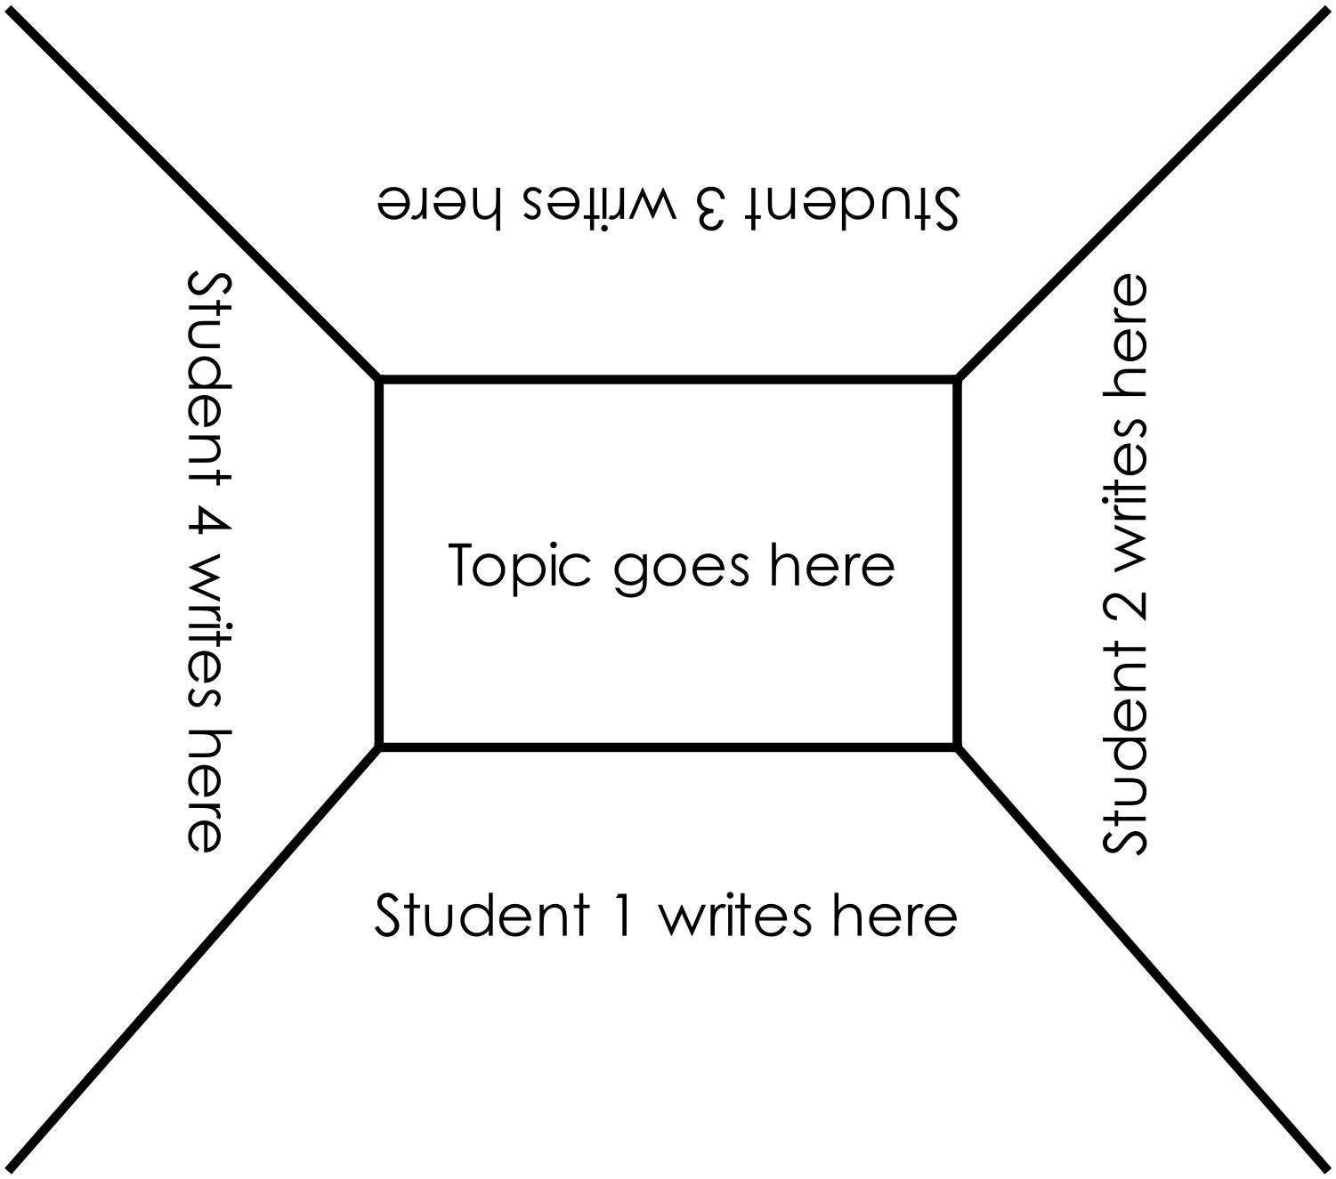

Department of Education WA

Appendix 10: Teacher resource sheet 1.4: Cooperative learning – Think, Pair, Share
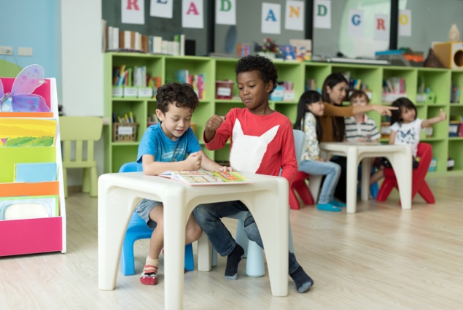
This resource sheet provides a brief outline of a cooperative learning strategy known as 'think – pair – share'.
Cooperative learning frameworks create opportunities for groups of students to work together, generally to a single purpose.
As well as having the potential to increase learning for all students involved, using these frameworks can help students develop personal and social capability.
Source: iStock
In the 'think' stage, each student thinks silently about a question asked by the teacher.
In the 'pair' stage, students discuss their thoughts and answers to the question in pairs.
In the 'share' stage, the students share their answer, their partners answer or what they decided together. This sharing may be with other pairs or with the whole class. It is important also to let students 'pass'. This is a key element of making the strategy safe for students.
Think – pair – share increases student participation and provides an environment for higher levels of thinking and questioning.
Source: iStock

Appendix 11A: Student activity sheet 2.1: Playground forces
- Draw arrows on the images below to show the direction of movement.
- Using a different colour, draw arrows to show push and pull forces. Label if they are acting through contact or at a distance.
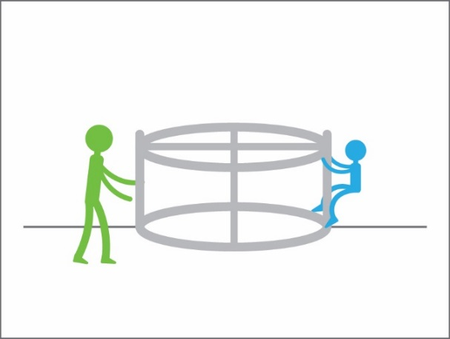
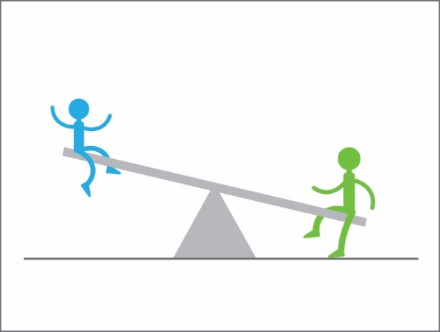

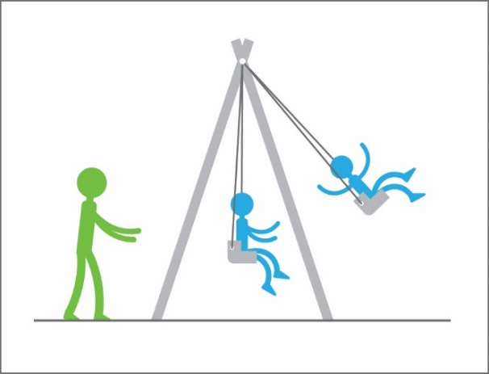
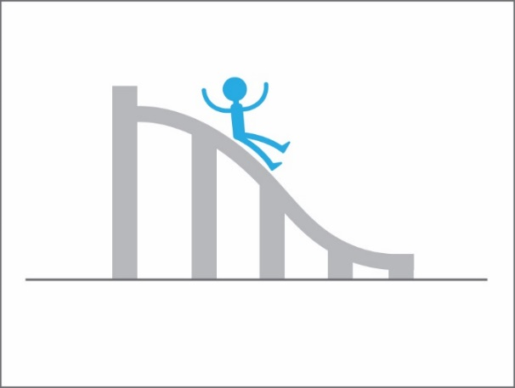
Department of Education WA

Appendix 11B: Teacher resource sheet 2.1: Playground forces
Links to the Western Australian Curriculum

Science | Science understanding | Physical sciences| Forces can be exerted by one object on another through direct contact or from a distance (ACSSU076)
- Draw arrows on the Playground ages below to show the direction of movement.
- Using a different colour, draw arrows to show push and pull forces. Label if they are acting through contact or at a distance.
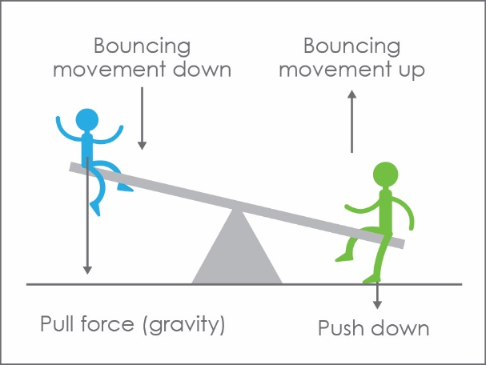
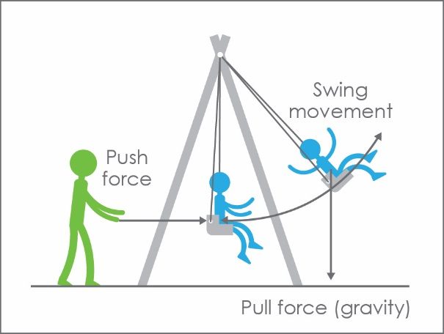
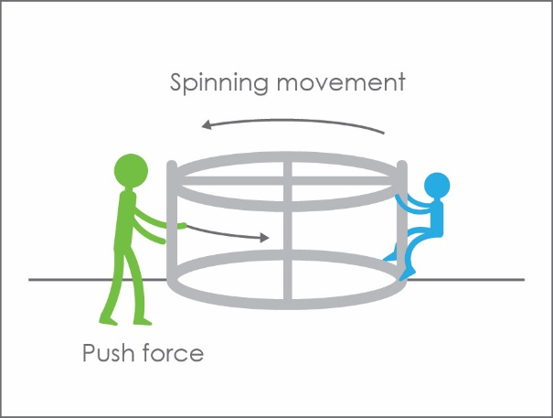
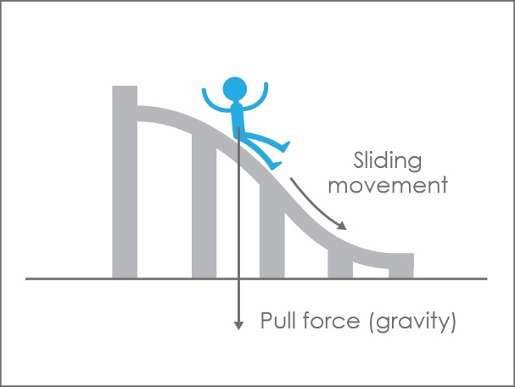
Department of Education WA

Appendix 12: Student activity sheet 3.1: Prototype troubleshooting
Problem | Reason for the problem | Possible changes to your design to solve the problem

Appendix 13: Teacher resource sheet 4.1: Student evaluation
Key:  1 Sometimes  2 Usually  3 Independently and  consistently | Student name
Remains focused on tasks presented
Completes set tasks to best of their ability
Works independently without disrupting others
Manages time effectively
Cooperates effectively within the group
Contributes to group discussions
Shows respect and consideration for others
Uses appropriate conflict resolution skills
Actively seeks and uses feedback

Appendix 14: Student activity sheet 4.2: Design review
Things I would keep the same _________________________________________________________________________________________________________________________________________________________________________________________________________________________
Things I would change
________________________________________________________________________________________________________________________________________________________________________________________________________________________________________________________
Photograph or drawing

Appendix 15: Teacher resource sheet 4.3: 3 – 2 – 1 Reflection
3 – 2 – 1 Reflection
Name | 3 things I learnt | 2 things I found interesting | 1 thing I found difficult

