Draft school newsletter
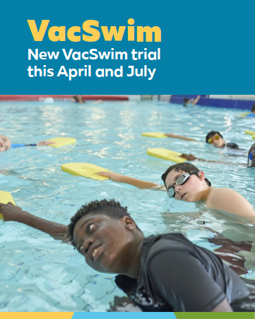
Headline:
We’re bringing VacSwim to you this April and July
Body copy:
Learning to swim is a lifesaving skill that every child needs. Your community has been selected for the VacSwim trial during the April and July school holidays at [Derby Memorial Swimming Pool / Wickham Aquatic Centre].
Enrolments open Wednesday 18 February 2026.
CTA:
For more information or to enrol, visit education.wa.edu.au/vacswimtrial
Breakout box:
Come see us at the school office if you need a postal enrolment form.

