D23/0830085

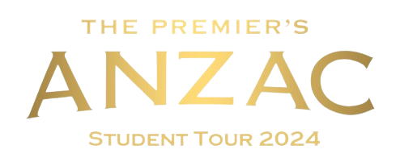

Student Application Package

2024
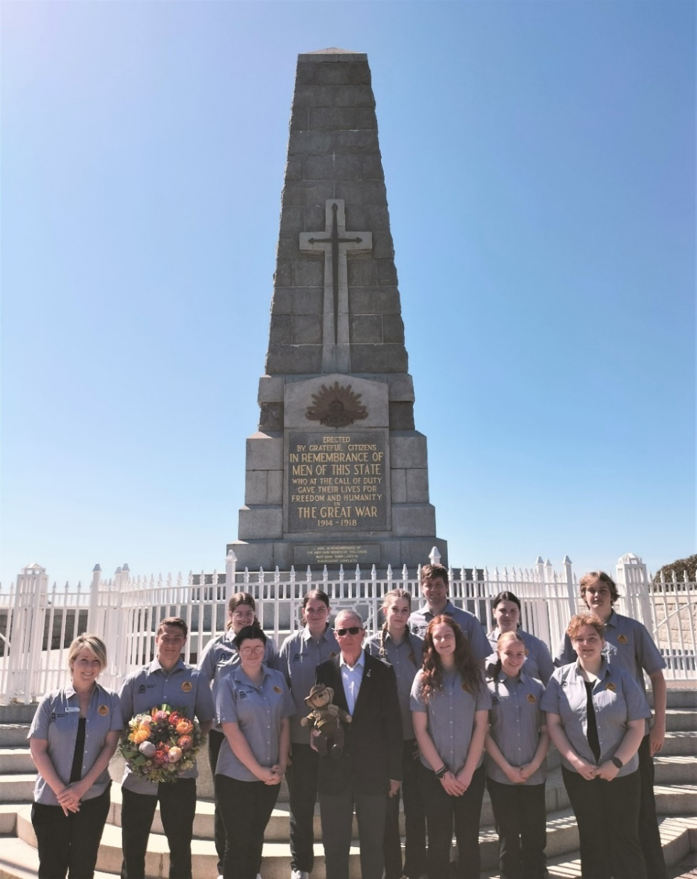
Image: https://freesvg.org/australian-world-war-1-soldiers-silhouette

The 2024 Premier’s Anzac Student Tour
The Premier’s Anzac Student Tour invites you to become an ambassador and represent Western Australia on a commemorative overseas study tour.
In 2024, the Premier’s Anzac Student tour will travel to Singapore to commemorate the 82nd anniversary of the fall of Singapore and 106 years since the signing of the Armistice.
Over 993,000 Australians served in the armed forces during World War II. Of those, 27,073 were killed in action or died, 23,477 were wounded, and 30,560 were taken as prisoners of war by other nations. Of those taken prisoner, 8,296 died while in captivity. Remembrance in the broader context acknowledges men and women of the Commonwealth forces who died in all wars.
The tour will visit important historical sites including Changi Chapel and Museum, Kranji War Cemetery and Fort Canning.
Applications close at 5.00 pm on Friday 11 August 2023.

Tour details
Ten students will be selected to participate in this historical commemorative study tour to Singapore from Friday 5 April to Monday 15 April 2024. Selected students will be accompanied by 3 adult supervisors.
The Western Australian Government will meet the cost of international airfares, official clothing, accommodation, and the group’s meals when travelling. Parents will be responsible for meeting passport and visa expenses, travel insurance, immunisations and personal expenses.

Eligibility
To be eligible you must be a Western Australian student currently enrolled in Years 8 to 11 and display:
- a genuine interest in the Anzac experience
- an appreciation of the study of history
- excellent interpersonal skills and self-confidence
- a willingness to share your experiences (if selected) in your school and local community.
You will demonstrate an understanding of some of the positive values exhibited in times of war, the lessons of war for the current generation, and the importance of international peacekeeping processes and non-violent means of resolving conflict.

Competition process
Students may prepare individual responses as a class assessment task or as a personal project outside any assessment schedule.
To be eligible, all entrants require a nominating teacher and principal endorsement to attest to their suitability to represent their schools, communities, and the State as youth ambassadors on the 2024 Premier’s Anzac Student Tour.
Schools may conduct their own selection process and can nominate up to three students in each of the two categories: Years 8 and 9, Year 10 and 11. All entries should be received no later than 5.00 pm on Friday, 11 August 2023.
Shortlisted applicants will progress to a State final where they will discuss their understanding of the Anzac legacy, and their capacity to act as youth ambassadors for Western Australia. Ten students will be selected to participate in the tour.

How to apply
There are 2 parts to the application:
PART 1: Written response
PART 2: Completion of application form
-----------------------------------------------------------------------------------------------------------------------------------------
PART 1: Written response
Prepare and submit a written response of no more than 1000 words to the following topic:

By exploring a selected Western Australian individual, community group or organisation explain how they demonstrate the values and actions of the Anzac spirit and the impact this has had on society?

Please note
Entries should:
- be presented in a suitable form, or combination of forms, such as an article, essay, letter, speech, or short story of no more than 1000 words (excluding the bibliography)
- demonstrate historical understanding
- be clearly related to the 2024 topic
- be clearly expressed and logically structured
- include an accurate bibliography acknowledging references made (ensuring a variety of resource types are used – not just those found online)
- be original and not use the words or ideas of other people without acknowledgement
- use Arial 11 font
- be saved as a PDF
- be submitted no later than 5.00 pm on Friday, 11 August 2023 by email anzactour@education.wa.edu.au

Possible topics (Note: You are not restricted to these)

- RSLWA and Sub-branches
- Australian War Widows (WA) Inc
- Humanitarian, resistance and peace movements in Western Australia
- Red Cross WA
- Western Australian filmmakers, journalists
- Cadets, Scouts
- Fundraising groups
- Australian Defence Force activated during natural disasters
- Country Women’s Association of WA
- Ex-service men and women who initiate projects
- Community activism or advocacy
- Programs supported by Department of Veterans’ Affairs
- Programs supported by State Government WA
- Legacy WA

To assist with your written response, refer to the 2024 competition rubric provided on page 7.

PART 2: Completion of application form
Complete all sections of the form.
To assist with the completion of part 2, refer to the 2024 application form rubric provided on page 7.

Student application form

Please type all sections, then print, sign, scan and email to: anzactour@education.wa.edu.au

Personal details
First Name
Last name
Preferred name
Preferred pronouns | ☐ he/him ☐ she/her ☐ they/them
Aboriginal or Torres Strait Islander | ☐ yes ☐ no
Home address
Suburb/town |  | Postcode
Home phone number
Mobile phone number
Personal email
Year group in 2023 | ☐ Year 8 ☐ Year 9 ☐ Year 10 ☐ Year 11
Citizenship | ☐ Australian citizen ☐ permanent resident ☐ temporary visa
Current passport | ☐ yes ☐ no  NOTE: Students selected for 2024 Premier’s Anzac Student Tour who do not currently hold a valid passport will need to submit a passport application.

School details
 | School you attend in 2023
 | School you will attend in 2024
 | Current school address
 | Suburb/Town |  | Postcode
 | Telephone
 | Nominating teacher
 | Email
 | Nominating principal
 | Email

Write a short statement that accurately describes you to the selection panel.
Applicants are advised to confine responses to the space provided.
Why should you be selected to join the 2024 Premier’s Anzac Student Tour?
Applicants are advised to confine responses to the space provided.
Have you previously travelled or studied away from home within the past five years? If yes, please indicate where, when, for how long, and any lessons learned.
Applicants are advised to confine responses to the space provided.

Student declaration
I declare that the information provided is a true and accurate account and my written entry is my original work with no more than general guidance provided by others.

Full name
Signature
Date

Principal (or delegate) declaration
I support the entry of the above-named student as a suitable nominee for the 2024 Premier’s Anzac Student Tour as an ambassador for Western Australia.

Full name
Position
Signature
Date

Parent/Guardian declaration

I give permission for my son/daughter ___________________________ to participate in the 2024 Premier’s Anzac Student Tour competition and, if selected, to travel on an interstate and overseas study tour in April 2024.

Full name
Relationship to student
Signature
Date

2024 Competition rubric

Part A  Written response | Excellent  achievement | High  achievement | Satisfactory achievement
Historical knowledge and understanding demonstrated in response to the 2024 topic | Excellent use of relevant historical knowledge and understanding in response to the 2024 topic. Clearly articulates the impact of the selected example on society. | Good use of some relevant historical knowledge and understanding in response to the 2024 topic. Includes a discussion of the impact of the selected example on society. | Some examples of historical knowledge and understanding are evident in response to the 2024 topic. Includes a limited discussion of the impact of the selected example on society.
 | Complex development of ideas and researched detail of a WA example that is relevant and has a clear connection to the Anzac Spirit. | Well-developed ideas with researched detail of a WA example that is relevant and has some connection to the Anzac Spirit. | Includes researched detail of a WA example that has some relevance and connection to the Anzac Spirit.
Use of written communication form  (article, essay, letter, short story, speech) | Sophisticated use of subject specific vocabulary throughout. Language conventions, spelling and grammar are accurate and appropriate to the form chosen. | Subject specific vocabulary used throughout. Language conventions, spelling and grammar are mostly accurate and appropriate to the form chosen. | Some subject specific vocabulary used throughout. Language conventions, spelling and grammar are sometimes accurate and appropriate to the form chosen.
Use of primary and secondary sources | Evidence of a wide range of primary and secondary sources used to explore the 2024 topic. | Evidence of primary and secondary sources used to explore the 2024 topic. | Evidence of primary and secondary sources used in response to the 2024 topic.
Bibliography  Acknowledgement of references | Accurate bibliography and references throughout. | Accurate bibliography and references acknowledged. | Bibliography included and references acknowledged.

Part B  Application form | Excellent  achievement | High  achievement | Satisfactory achievement
Genuine interest in the Anzac experience | Strong examples that demonstrate a genuine interest in the Anzac experience. | Suitable examples that show genuine interest in the Anzac experience. | Some examples showing interest in the Anzac experience.
Capacity to act as youth ambassador | High awareness of own skills and attributes. | Awareness of own skills and attributes. | Includes some awareness of skills and attributes.

Application submission
All entries should be received by the Tour Coordinator no later than 5 pm Friday, 11 August 2023.
Late applications will not be accepted. E: anzactour@education.wa.edu.au

Important dates

- 11 August 2023 Applications close
- 22-26 August 2023 Selection panels shortlist State finalists
- 19 September 2023 State finalists announced
- 6 October 2023 State final group discussion
- 11 November 2023 Announcement of the 10 successful students
- 7 March - 9 March 2024 Pre-tour briefing
- 5 April - 15 April 2024 Tour

Enquiries and information

Karen Lamond
E: anzactour@education.wa.edu.au
W:https://www.education.wa.edu.au/premiers-anzac-student-tour
T: 9402 6123

Premier’s Anzac Student Tour Coordinator
Secondary Schools, District Hight Schools & Post-School Pathways
Statewide Services Centre 33 Giles Avenue
PADBURY WA 6025

