

D26/0214938



Teacher Supervisor
Application Package
2027
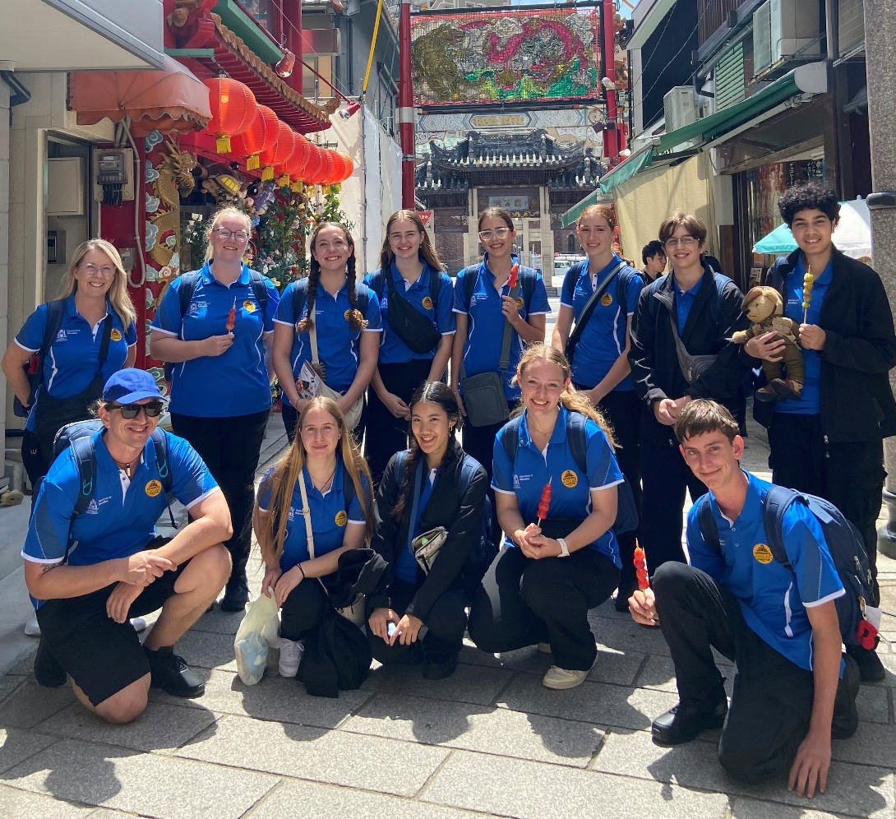


Image: https://freesvg.org/australian-world-war-1-soldiers-silhouette
The 2027 Premier’s ANZAC Student Tour

The Premier’s ANZAC Student Tour invites secondary school students to become ambassadors and represent Western Australia on a commemorative overseas study tour.
In 2027, the Premier’s ANZAC Student Tour will travel to New Zealand to commemorate more than a century of shared military history between Australia and New Zealand, tracing the ANZAC spirit from Gallipoli in 1915 through to more recent conflicts.
Investigation of key locations will bring to life the experiences of service personnel, their families, and their communities. Students will attend an ANZAC Day service and will visit significant historical sites such as Stony Batter historic defence installation, Torpedo Bay Navy Museum, and the Auckland War Memorial Museum.
There is an opportunity for 2 teacher supervisors to join the tour to:
- assist with organising the tour
- provide support in developing and delivering the history education program
- chaperone 10 students (in accordance with the Department of Education’s Excursions in Public Schools Procedures).
Costs for the tour, except for personal expenses, are met by the Department of Education.

Eligibility
To be eligible, all applicants must be endorsed by the principal and:
- have student(s) participating in the 2027 Premier’s ANZAC Student Tour competition at their school
- be registered with the Teacher Registration Board of Western Australia
- hold a current Working with Children Check.
Please note: if selected, supervisors who are not currently employed by the Department of Education are required to seek clearance through the Department of Education’s Nationally Coordinated Criminal History Check

Selection criteria
- Demonstrated innovative teaching practice to engage students.
- Demonstrated interest in the Australian war experience and participation in ANZAC related commemoration activities.
- Demonstrated experience in conducting extended excursions involving secondary students, including the ability to develop and implement tour education activities, work collaboratively in a team and maintain effective working relationships.

Application process
Applicants must complete the Application Form included in this package, which includes:
- relevant qualifications and experience
- responses to selection criteria
- 2 referees and principal endorsement.
Completed applications must be emailed by 4:00pm on Friday 14 August 2026 to anzactour@education.wa.edu.au.
Late and handwritten applications will not be accepted.
Interviews will be conducted in October 2026. The outcome of the selection process will be advised early Term 4.
For more information, contact:
Ms Karen Lamond
T: 9402 6123
E: anzactour@education.wa.edu.au
W: https://www.education.wa.edu.au/premiers-anzac-student-tour

Application Form
Responses should be typed

Personal details
First name
Last name
Title
Preferred pronouns | ☐ he/him ☐ she/her ☐ they/them
Aboriginal or Torres Strait Islander | ☐ yes ☐ no
Home address
Suburb/town |  | Postcode
Home phone number
Mobile phone number
Email

Employment details
Name of school
School address
Suburb/town |  |  |  | Postcode
Work email
E Number*
TRBWA number |  | Expiry date
WWCC number |  | Expiry date
*if Department of Education employee

Qualifications and experience
Tertiary qualifications

Summary of teaching experience (including current role): Applicants are advised to confine responses to the space provided.
List your membership in professional associations and relevant committee or representational roles undertaken in the previous 5 years Applicants are advised to confine responses to the space provided.
List your participation in previous school-based extended excursions. Please include the year and duration of the extended excursions Applicants are advised to confine responses to the space provided.
Addressing the selection criteria
The 2027 Premier’s ANZAC Student Tour promotes understanding of the ANZAC legacy. Western Australian secondary school students visit commemorative sites of significance to Australians.
The role of the accompanying teacher supervisors is to support the tour coordinator in:
- chaperoning 10 students (in accordance with Department of Education's Excursions Procedures)
- providing support in developing and delivering the history education program
- assisting with organising the tour.
Responses should address all 3 selection criteria in the context of your contribution at a school and system/sector level.
Demonstrated innovative teaching practice to engage students.
Applicants are advised to confine responses to the space provided.
Demonstrated interest in the Australian war experience and participation in ANZAC related commemoration activities. Applicants are advised to confine responses to the space provided.
Demonstrated experience in conducting extended excursions involving secondary students, including the ability to develop and implement tour education activities, work collaboratively in a team and maintain effective working relationships. Applicants are advised to confine responses to the space provided.
Other relevant qualifications and expertise
Describe any additional qualifications and/or expertise that may be of interest to the selection panel. For example, first aid qualifications, previous travel, photographic and/or applied ICT skills, Bronze Medallion. Applicants are advised to confine responses to the space provided.
Reasons for application
Describe your reasons for applying to become a teacher supervisor on the 2027 Premier’s ANZAC Student Tour. Applicants are advised to confine responses to the space provided.

Referee details
Referee 1: A person other than your school principal who can confirm your suitability
Title |  | First name |  |  |  | Last name
Position
School
Phone number | Work |  |  |  | Mobile
Email
Referee 2: A person other than your school principal who can confirm your suitability
Title |  | First name |  |  |  | Last name
Position
School
Phone number | Work |  |  |  | Mobile
Email
Endorsement by principal
The following endorsement requires verification by your school principal:
- I confirm that the applicant named on this application form is a teacher at the school specified.
- I confirm that the applicant named on this application has actively promoted the 2027 Premier’s ANZAC Student Tour within this school and has supported students to participate.
- I endorse this application and the candidate's suitability to assume the role of teacher supervisor.
- I endorse and support the applicant as a suitable ambassador for the Premier of Western Australia and the State of Western Australia.
- Should the applicant be selected to join the 2027 Premier’s ANZAC Student Tour as a teacher supervisor, I understand that there will be program commitments that require the individual to be absent from work on occasion, and that the Department of Education will meet teacher relief costs.
Name
Signature
School
Phone number
Email
Date
Declaration by applicant
I declare that the information supplied is complete and correct. I authorise the Department of Education to obtain from other education institutions and relevant authorities, at any time, details of my work experience and qualifications. I consent for these details and any information contained in this application form to be made available to the Department and the selection panel. I confirm that I will comply with the requirements of the position of teacher supervisor for the 2027 Premier’s ANZAC Student Tour.
Name
Signature
Date
Number of students participating in the 2027 Premier’s ANZAC Student Tour competition at your school |  |  |  | Total participants:
 |  |  |  | Number of entries submitted for judging:

Privacy notice
The personal information collected on this application may be used for assessing and verifying the details provided, conducting referee checks, Working with Children Check and publicising and administering the 2027 Premier’s ANZAC Student Tour. The information may be accessed and used by various Western Australian Government Departments and others that provide assistance to the program. The applicant consents to all such use by signing this application form.
Application submission
Completed and endorsed teacher applications must be received by the Tour Coordinator by 4:00pm Friday 14 August 2026. Late applications will not be accepted.
Interviews, if required, will be conducted during October 2026 and the outcome of the selection process known to all applicants by the beginning of Term 4.

For more information and a copy of the Department’s Excursions Policy, contact Karen Lamond:
T: 9402 6123
E: anzactour@education.wa.edu.au

Premier’s ANZAC Student Tour Coordinator
Secondary, District High Schools & Post-School Pathways
Statewide Services
33 Giles Avenue
PADBURY WA 6025

