
D26/0214939



Student Application Package

2027
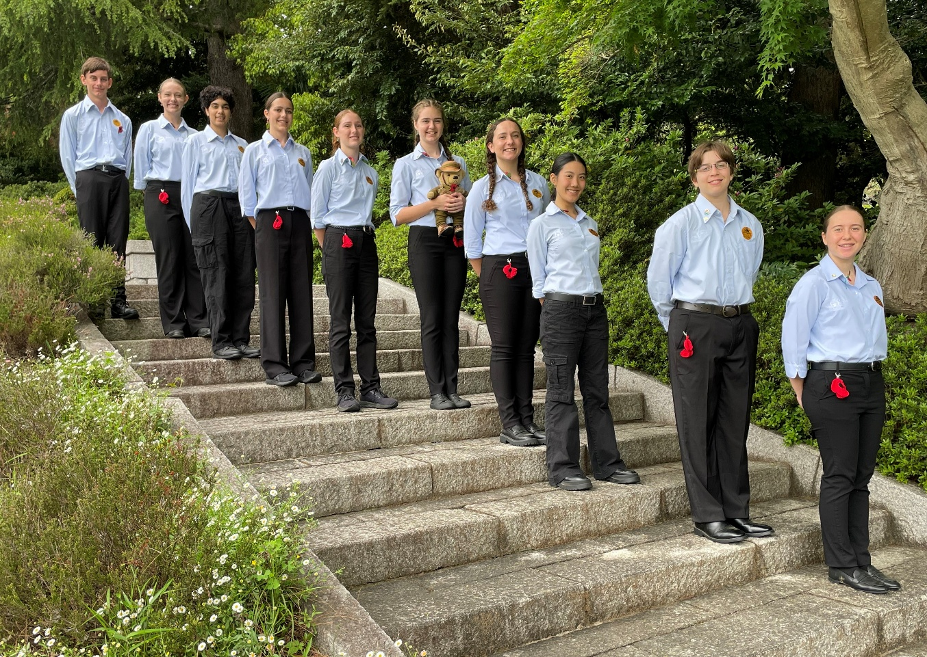

Image: https://freesvg.org/australian-world-war-1-soldiers-silhouette
The 2027 Premier’s ANZAC Student Tour
The Premier’s ANZAC Student Tour invites you to become an ambassador and represent Western Australia on a commemorative overseas study tour.
In 2027, the Premier’s ANZAC Student Tour will travel to New Zealand to commemorate more than a century of shared military history between Australia and New Zealand, tracing the ANZAC spirit from Gallipoli in 1915 through to more recent conflicts.
Investigation of key locations will bring to life the experiences of service personnel, their families, and their communities. You will attend an ANZAC Day service, and visit significant historical sites such as Stony Batter historic defence installation, Torpedo Bay Navy Museum, and the Auckland War Memorial Museum.

Tour details
Ten students will be selected to participate in this 7-day historical, commemorative study tour to New Zealand in the Term 1 school holidays in 2027. Selected students will be accompanied by
3 adult supervisors.
The Western Australian Government will meet the cost of airfares, official clothing, accommodation, and the group’s meals when travelling. Parents will be responsible for meeting passport and visa expenses, travel insurance, immunisations and personal expenses.

Eligibility
To be eligible you must be a Western Australian student currently enrolled in Years 8 to 11 and display:
- a genuine interest in the ANZAC experience
- an appreciation of the study of history
- excellent interpersonal skills and self-confidence
- a willingness to share your experiences (if selected) in your school and local community.

You will demonstrate an understanding of the qualities, experiences, and lessons that emerge from Australia and New Zealand’s wartime history, showing an appreciation of the enduring ANZAC values and how they continue to guide young people today. You will recognise that past conflicts provide important lessons for the modern world, reflecting on how war shapes societies, the responsibilities of citizenship in challenging times, and the importance of remembering the service and sacrifice of those who came before us.

Competition process
Students may prepare individual responses as a class assessment task or as a personal project outside any assessment schedule.
To be eligible, all entrants require a nominating teacher and principal endorsement to attest to their suitability to represent their school, community and WA, as youth ambassadors on the 2027 Premier’s ANZAC Student Tour.
Schools may conduct their own selection process and can nominate up to 3 students in each of the 2 categories:
- Years 8 and 9
- Years 10 and 11.
Applications close at 4:00 pm on Thursday 30 July 2026.
Shortlisted applicants will progress to a state final where they will discuss their understanding of the ANZAC legacy, and their capacity to act as youth ambassadors for Western Australia.

How to apply
Applications will only be accepted through the online platform Formstack.
There are 3 parts to the application:
- Online application form in Formstack
- Written response (upload to Formstack in PDF format)
- Selection criteria and signed declarations (upload to Formstack in PDF format)
PART 1: Completion of the online application form
Click here to complete all sections of the online form in Formstack.
Before starting, please ensure you have all the information listed below ready to upload, as the form does not allow you to save your progress and return later.
You will be asked to provide the following information:
Personal details
- First and last name
- Preferred pronouns
- Aboriginal or Torres Strait Islander
- Home address (including postcode)
- Student phone number
- Parent/carer phone number
- Student email
- Year group in 2026
- Citizenship
- Current passport details
  - Note: Students selected for 2027 Premier’s ANZAC Student Tour who do not currently hold a valid passport will need to submit a passport application.

School details
- School you are attending in 2026
- School you will attend in 2027
- Current school address (including postcode)
- School telephone
- Nominating teacher’s name and email
- Nominating principal’s name and email.
Please ensure your nominating teacher is aware that they may be contacted.

PART 2: Written response
Prepare and submit a written response of no more than 1000 words to the following:

Regardless of whether war is won or lost, it leaves lasting impacts on individuals and communities. Use a Western Australian example to illustrate your response.

Responses should:
- be presented in a suitable form, or combination of forms, such as an article, essay, letter, speech, or short story of no more than 1000 words (excluding the bibliography)
- demonstrate historical knowledge and understanding
- be clearly linked to the 2027 prompt above and competition rubric (page 7)
- be clearly expressed and logically structured
- include an accurate bibliography acknowledging references made (ensuring a variety of resource types are used – not just those found online)
- be original and not use the words or ideas of other people without acknowledgement
- use Arial 11 font
- be saved as a PDF
- be submitted no later than 4:00 pm on Thursday 30 July 2026 via the Formstack link.

Possible topics (NOTE: You are not restricted to these topics)
- Legacy WA
- A family member
- Australian War Widows (WA)
- Humanitarian and peacekeeping operations
- Victoria Cross recipients
- Returned & Services League of Australia (WA)
- Economic, social, political impact
- Health
- Post-traumatic stress disorder
- Regional Australia
- BCOF occupation Japan
- Gallipoli Campaign
- 10th Light Horse Regiment
- Bombing of Broome.

To assist with your written response, please refer to the 2027 competition rubric provided on page 7.
PART 3: Selection criteria and declaration forms
Please type in the boxes below and confine responses to the spaces provided.
Write a short statement that accurately describes you to the selection panel.
Why should you be selected to join the 2027 Premier’s ANZAC Student Tour?
Have you previously travelled or studied away from home within the past 5 years? If yes, please indicate where, when, for how long, and any lessons learned.

This section may be handwritten

Student declaration
I declare that the information provided is a true and accurate account and my written entry is my original work with no more than general guidance provided by others.
Full name
Signature
Date

Principal declaration
I support the entry of the above-named student as a suitable nominee for the 2027 Premier’s ANZAC Student Tour as an ambassador for Western Australia.
Full name
Position
Signature
Date

Family/Caregiver declaration
I give permission for my child ___________________________to participate in the 2027 Premier’s ANZAC Student Tour competition and, if selected, to travel on an overseas study tour in April 2027.
Full name
Relationship to student
Signature
Date

2027 Premiers ANZAC Student Tour - Competition Rubric

PART 2:  Written response | Excellent  achievement | High  achievement | Satisfactory  achievement
Historical knowledge and understanding demonstrated in response to the 2027 topic  Regardless of whether war is won or lost, it leaves lasting impacts on individuals and communities. Use a Western Australian example to illustrate your response | Insightful use of relevant historical knowledge and understanding in response to the 2027 topic.  Comprehensively uses a Western Australian example to illustrate the lasting impacts of war on individuals and communities. | Effective use of relevant historical knowledge and understanding in response to the 2027 topic.  Uses a Western Australian example to clearly illustrate the lasting impacts of war on individuals and communities. | Adequate use of historical knowledge and understanding evident in response to the 2027 topic.  Uses a Western Australian example to partially illustrate the lasting impacts of war on individuals and communities.
 | Complex development of ideas and researched detail of a WA example. | Well-developed ideas with researched detail of a WA example. | Includes researched detail of a WA example.
Use of written communication form  (article, essay, letter, short story, speech) | Sophisticated use of subject specific vocabulary throughout. Language conventions, spelling and grammar are accurate and applies conventions of selected form. | Subject specific vocabulary used throughout. Language conventions, spelling and grammar are mostly accurate and applies conventions of selected form. | Some subject specific vocabulary used throughout. Language conventions, spelling and grammar are sometimes accurate and appropriate to the form chosen.
Use of primary and secondary sources | Evidence of a wide and well-selected range of primary and secondary sources used to explore the 2027 topic. | Evidence of a sufficient and relevant range of primary and secondary sources used to explore the 2027 topic. | Evidence of an adequate but limited range of primary and secondary sources used to respond to the 2027 topic.
Bibliography  Acknowledgement of references | Accurate bibliography and references acknowledged throughout. | Accurate bibliography and references acknowledged. | Bibliography included and references acknowledged.

PART 3:  Selection criteria | Excellent  achievement | High  achievement | Satisfactory  achievement
Genuine interest in the ANZAC legacy | Strong examples that demonstrate a genuine interest in the ANZAC legacy. | Suitable examples that show genuine interest in the ANZAC legacy. | Some examples showing interest in the ANZAC legacy.
Capacity to act as youth ambassador | High awareness of own skills and attributes. | Awareness of own skills and attributes. | Includes some examples of skills and attributes.

Application submission
All entries should be submitted by no later than 4:00 pm Thursday 30 July 2026.

Formstack: https://tinyurl.com/2027ANZACtour

Late applications will not be accepted.

Important dates
- 30 July 2026 Applications close
- 10 - 24 August 2026 Selection panels shortlist state finalists
- 11 September 2026 State finalists announced
- 9 October 2026 State final group discussion
- November 2026 Announcement of the10 successful students
- March 2027 Pre-tour briefing
- April holidays 2027 Tour

Enquiries and information

Karen Lamond
E: ANZACtour@education.wa.edu.au
W: https://www.education.wa.edu.au/premiers-ANZAC-student-tour
T: 9402 6123

Premier’s ANZAC Student Tour Coordinator
Secondary, District Hight Schools & Post-School Pathways
Statewide Services
33 Giles Avenue
PADBURY WA 6025

