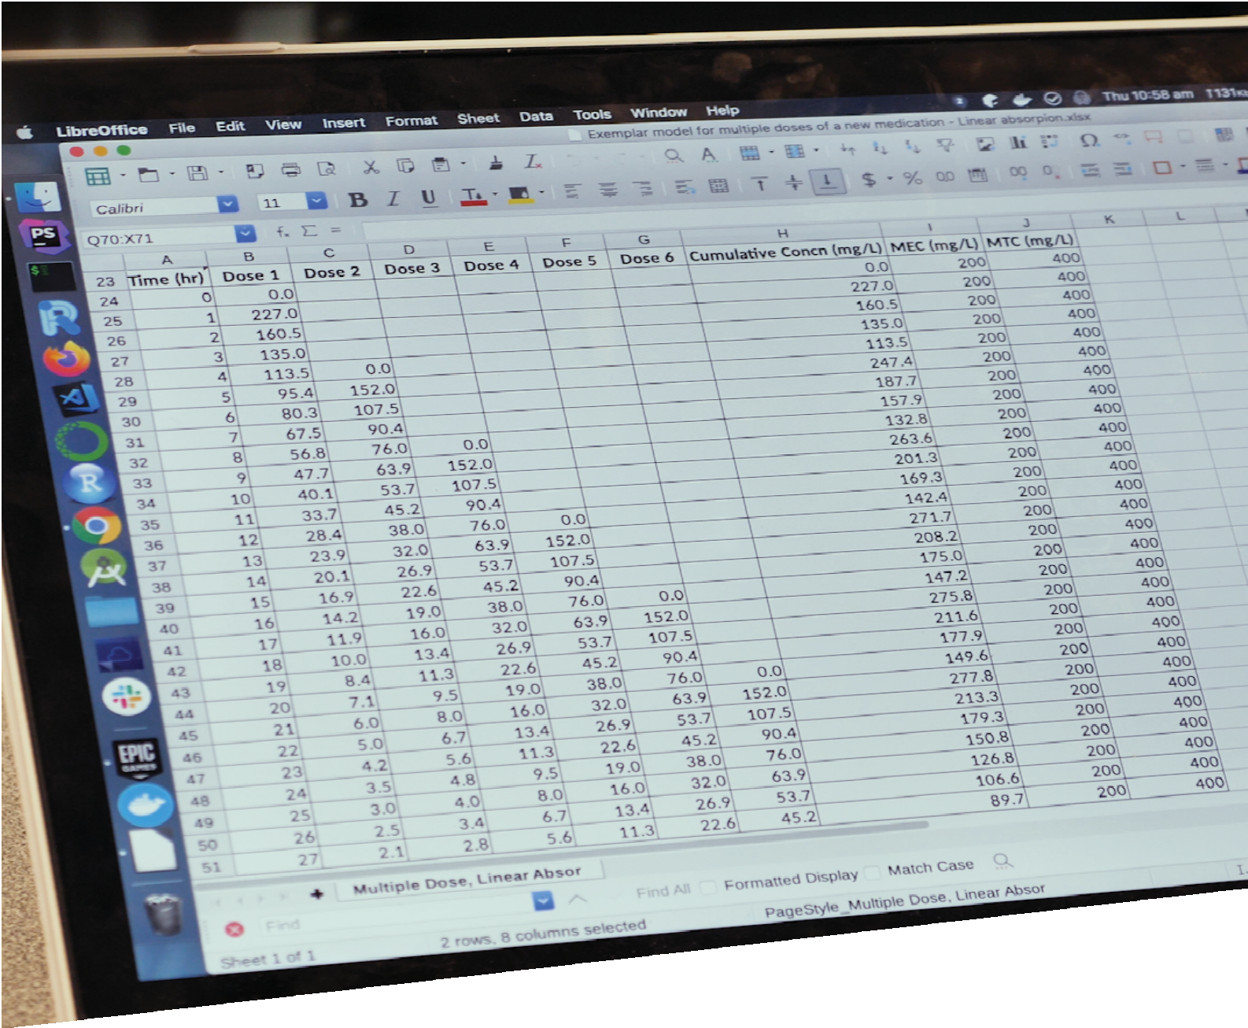


CURICULUM RESOURCE MODULE
Deciding dosages
YEAR 10
Acknowledgements

The STEM Learning Project respectfully acknowledges the Traditional Custodians of the lands upon which our students and teachers live, learn and educate.

The STEM Learning Project is funded by the Western Australian Department of Education (the Department) and implemented by a consortium in STEM education comprising the Educational Computing Association of WA, the Mathematical Association of WA, the Science Teachers Association of WA and Scitech. We acknowledge and thank the teachers and schools who are the co-creators of these resources.

Copyright and intellectual property

The copyright and intellectual property of this module remain the property of the Department.

Any Western Australian Curriculum content in this resource is used with the permission of the School Curriculum and Standards Authority (the Authority); this permission does not constitute Authority endorsement of the resource. The Authority accepts no liability for any errors or damages arising from reliance on its content.

The Western Australian Curriculum content may be freely copied, or communicated on an intranet, for non-commercial purposes in educational institutions, provided that the Authority is acknowledged as the copyright owner. Copying or communication for any other purpose can be done only within the terms of the Copyright Act 1968 or with prior written permission of the Authority. Any Australian Curriculum content in the Western Australian Curriculum is used by the Authority under the terms of the Creative Commons Attribution-NonCommercial 3.0 Australia licence. Any content on the www.scsa.wa.edu.au domain that has been derived from the Australian Curriculum may be used under the terms of Creative Commons Attribution-NonCommercial 3.0 Australia licence.

Appendix 2: General capabilities continuums is adapted from ACARA, © Australian Curriculum, Assessment and Reporting Authority (ACARA) 2009 to present, unless otherwise indicated. This material was downloaded from the ACARA website (www.acara.edu.au) (Website) (accessed December 2015) and was not modified. The material is licensed under CC BY 4.0 (https://creativecommons.org/licenses/by/4.0/). ACARA does not endorse any product that uses ACARA material or make any representations as to the quality of such products. Any product that uses material published on this website should not be taken to be affiliated with ACARA or have the sponsorship or approval of ACARA. It is up to each person to make their own assessment of the product.

This resource includes references and examples of iOS, Android and other apps. The Department does not endorse or recommend any commercial products and simply provides these as examples for teachers.

The Department is committed to providing quality information to its customers. Whilst every effort has been made to ensure accuracy, currency and reliability of the information within these documents, the Department accepts no responsibility for errors, omissions or amendments made since the time of publishing. Confirmation of information may be sought from the Department or the originating bodies providing the information. The Department has no control over the content of material published on websites to which users are referred in this resource. It is the responsibility of the internet user to make their own decision as to the relevancy, accuracy, currency and reliability of information found on those sites.

This resource contains various images from iStock used under license.

Attributions: Google Slides, Google Docs, Microsoft Office 365, Microsoft Excel, PowerPoint, Sharepoint and OneDrive, Kidblog, Weebly, Evernote, Autodesk, Tinkercad, SketchUp.


Table of contents
The STEM Learning Project 3
Overview 4
Activity sequence and purpose 9
Background 10
Activity 1: Medications and calculating doses 12
Activity 2: Investigating doses 21
Activity 3: Developing a dosage regime 27
Activity 4: Reporting and evaluation of dosage recommendations 32
Appendix 1: Links to the Western Australian Curriculum 35
Appendix 1B: Mathematics proficiency strands 38
Appendix 2: General capabilities continuums 39
Appendix 3: Materials list 42
Appendix 4: Design process guide 43
Appendix 4B: Drawing in the design process 44
Appendix 5: Student journal 45
Appendix 6: Student activity sheet 1.0: Journal checklist 46
Appendix 7: Teacher resource sheet 1.1: Cooperative learning – Roles 47
Appendix 8: Teacher resource sheet 1.2: Cooperative learning – Jigsaw 48
Appendix 9: Teacher resource sheet 1.3: Cooperative learning – Placemat 49
Appendix10: Teacher resource sheet 1.4: Cooperative learning – Think, Pair, Share 50
Appendix 11: Teacher resource sheet 1.5: Vocabulary list 51
Appendix 12: Student activity sheet 1.6: Patient modelling 52
Appendix 13: Student activity sheet 2.1: Recommended dosages 56
Appendix 14: Student activity sheet 2.2: Investigating concentrations 59
Appendix 15: Student activity sheet 2.3: Investigating a model for a single dose of medication 61
Appendix 16: Teacher resource sheet 2.4: Exemplar model for a single dose of medication 62
Appendix 17: Teacher resource sheet 2.5: How to derive a general exponential relationship from half-life 64
Appendix 18: Student activity sheet 3.1: Investigating a model for multiple doses of a new medication 65
Appendix 19: Teacher resource sheet 3.2: Exemplar model for multiple doses of a new medication 66
Appendix 20: Student activity sheet 4.1: Peer evaluation 72
Appendix 21: Student activity sheet 4.2: Self-evaluation 73

The STEM Learning Project
The aim of the STEM Learning Project is to generate students’ interest, enjoyment and engagement with STEM (Science, Technology, Engineering and Mathematics) and to encourage their ongoing participation in STEM both at school and in subsequent careers. The curriculum resources will support teachers to implement and extend the Western Australian Curriculum across Kindergarten to Year 12 and develop the general capabilities.
Why STEM?
A quality STEM education will develop the knowledge and intellectual skills to drive the innovation required to address global economic, social and environmental challenges.
STEM capability is the key to navigating the employment landscape changed by globalisation and digital disruption. Routine manual and cognitive jobs are in decline whilst non-routine cognitive jobs are growing strongly in Australia. Seventy-five per cent of the jobs in the emerging economy will require critical and creative thinking and problem solving, supported by skills of collaboration, teamwork and literacy in mathematics, science and technology. This is what we call STEM capability. The vision is to respond to the challenges of today and tomorrow by preparing students for a world that requires multidisciplinary STEM thinking and capability.
The approach
STEM capabilities are developed when students are challenged to solve open-ended, real-world problems that engage students in the processes of the STEM disciplines.
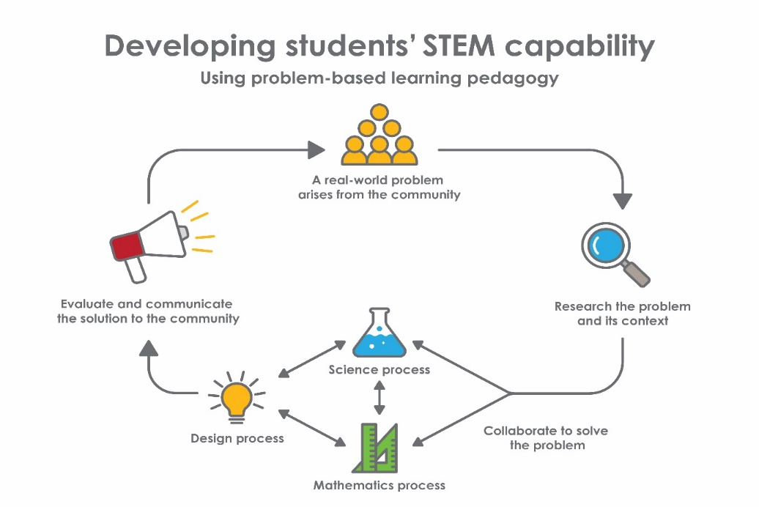
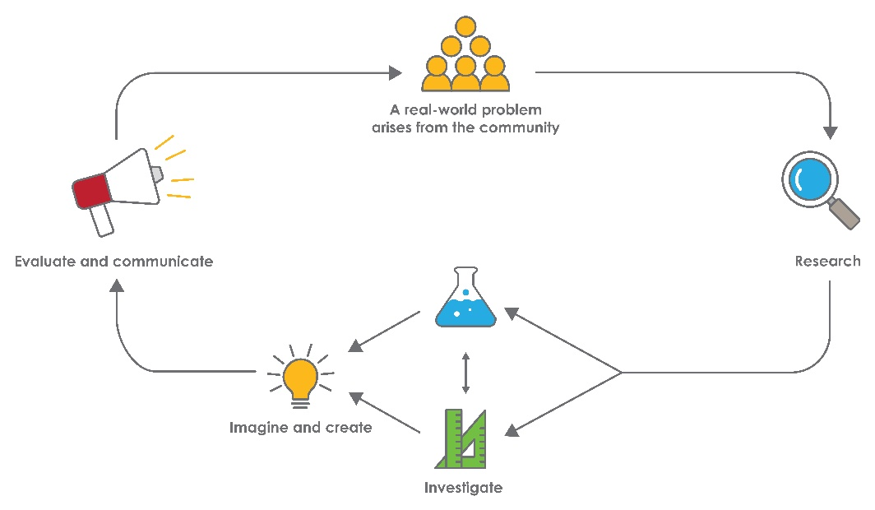
Year 10 – Deciding dosages
STEM Consortium

Overview
What is the context?
When prescribing medications, doctors consider the potential effectiveness as well as the required dose for each patient. For example, dosage may differ with patient age or weight.
Mathematical models can help medical researchers explore dosage options and provide guidance to ensure optimal doses of medications are prescribed.
This module challenges students to develop a mathematical model that can be used to determine optimal dosage regimes and supports students to better understand medical advice and avoid over, or under, utilisation of medications.
What is the problem?
How can optimum medication dosage guidelines be determined?
How does this module support integration of the STEM disciplines?
This module engages students in mathematical modelling and computer simulations within the context of the biological systems associated with the absorption and elimination of medications from the body.
Science
Students develop an appreciation of how scientific discoveries have developed our understanding of traditional medications and contributed to the development of modern medical therapies (ACSHE192: Advances in scientific understanding often rely on technological advances and are often linked to scientific discoveries). By developing and refining successive iterations of a model showing the concentration of medication in the bloodstream over time, students develop an appreciation of how models are refined through a process of experimentation and review (ACSHE191: Scientific understanding, including models and theories, is contestable and is refined over time through a process of review by the scientific community).
Students analyse patterns and trends in experimental data; describe relationships between variables; identify and explain inconsistencies in the data (ACSIS203: Analyse patterns and trends in data, including describing relationships between variables and identifying inconsistencies); and draw conclusions that are consistent with evidence (ACSIS204: Use knowledge of scientific concepts to draw conclusions that are consistent with evidence). They communicate the scientific basis for their medication dosage model; construct evidence-based arguments; and use appropriate scientific language, conventions and representations to convince their audience of the validity of their model (ACSIS208: Communicate scientific ideas and information for a particular purpose, including constructing evidence-based arguments and using appropriate scientific language, conventions and representations).
Technology
Students determine the path of medications through the body and the variables that influence their concentration in blood plasma. They create a design brief (WATPPS62: Create and critique briefs to solutions, WATPPS65: Design possible solutions, analysing designs against criteria, including functionality, accessibility, usability and aesthetics using appropriate technical terms and technology) for a model that shows the concentration of medication in the bloodstream over time and consider the health and safety issues that need to be addressed by their model (WATPPS61: Identify the needs of the client/stakeholder to determine the basis for a solution).
Spreadsheet tools are used to generate and display data sets to model different absorption and elimination rates on plasma drug concentrations (ACTDIP037: Analyse, visualise and model processes and entities, and their relationships, using structured data). Design thinking and creativity are used to develop increasingly sophisticated iterations of the model (WATPPS64: Apply design thinking, creativity, enterprise skills and innovation to develop, modify and communicate design ideas of increasing sophistication). Students evaluate their models against criteria they have developed (WATPPS67: Analyse design processes and solutions against student developed criteria) and employ technology to describe their model using appropriate technical terms.
While developing their solution, students work independently and collaboratively to manage their project (WATPPS68: Work independently, and collaboratively to manage projects, using digital technology and an iterative and collaborative approach. Considers time, cost, risk, safety, production processes, sustainability and legal responsibilities).
The Design process guide is included as a resource to help teachers understand the complete design process as developed through the Technologies curriculum.
Mathematics
Students develop mathematical understandings and reasoning as they create models showing the concentration of medication in the bloodstream over time and investigate optimal dosage regimes based on exponential decay. Graphing of time-dependent relationships, substitution, transformation and interpretation of graphs are all key elements of this process (ACMSP252: Investigate and describe bivariate numerical data where the independent variable is time, ACMNA267: Describe, interpret and sketch parabolas, hyperbolas, circles and exponential functions and their transformations).
While using a spreadsheet to develop their mathematical model, students create formulas and use formulas to determine the concentration of medications over time (ACMNA234: Substitute values into formulas to determine an unknown, ACMNA265). Time interval graphs are created to model the exponential decay of the concentration of medication and the graphs are analysed to determine the time over which optimal concentration of medication is maintained. The relationships between the algebraic formulae and the graphical representation of the data (ACMNA239: Explore the connection between algebraic and graphical representations of relations such as simple quadratics, circles and exponentials using digital technology as appropriate) are investigated.
Students use the language of ‘if...then', ‘given’ and ‘knowing that’ to talk about assumptions underlying their models (ACMSP247: Use the language of ‘if ....then', ‘given’, ‘of’, ‘knowing that’ to investigate conditional statements and identify common mistakes in interpreting such language).
General capabilities
There are opportunities for the development of general capabilities and cross-curriculum priorities as students engage with Deciding dosages. In this module, students:
- Develop problem-solving skills as they research the problem and its context (Activity 1); investigate parameters impacting on the problem (Activity 2); imagine and develop solutions (Activity 3); and evaluate and communicate their solutions to an audience (Activity 4).
- Utilise creative thinking as they generate possible design solutions; and critical thinking, numeracy skills and ethical understanding as they choose between alternative approaches to solving the problem of determining medication dosages for patients.
- Utilise personal and social capability as they develop socially cohesive and effective working teams; collaborate in generating solutions; adopt group roles; and reflect on their group work capabilities through self and peer evaluation.
- Utilise a range of literacies as they collate records of work completed throughout the module in a journal; work with models and data; and represent and communicate their solutions to an audience using digital technologies in Activity 4.
- Develop information and communication technology (ICT) capability while developing models using spreadsheet formulas and graphing functions.

What are the pedagogical principles of the STEM learning modules?
The STEM Learning Project modules develop STEM capabilities by challenging students to solve real-world problems set in authentic contexts. The problems engage students in the STEM disciplines and provide opportunities for developing higher order thinking and reasoning, and the general capabilities of creativity, critical thinking, communication and collaboration.
The design of the modules is based on four pedagogical principles:
- Problem-based learning
This is an underlying part of all modules with every module based around solving an initial problem. It is supported through a four-phase instructional model: research the problem and its context; investigate the parameters impacting on the problem; design and develop solutions to the problem; and evaluate and communicate solutions to an authentic audience.
- Developing higher order thinking

Opportunities are created for higher order thinking and reasoning through questioning and discourse that elicits students' thinking, prompts and scaffolds explanations, and requires students to justify their claims. Opportunities for making reasoning visible through discourse are highlighted in the modules with the icon shown here.
- Collaborative learning
This provides opportunities for students to develop teamwork and leadership skills, challenge each other’s ideas, and co-construct explanations and solutions. Information that can support teachers with aspects of collaborative learning is included in the resource sheets.
- Reflective practice
Recording observations, ideas and one’s reflections on the learning experiences in some form of journal fosters deeper engagement and metacognitive awareness of what is being learnt. Information that can support teachers with journaling is included in the resource sheets.
These pedagogical principles can be explored further in the STEM Learning Project online professional learning modules located in Connect Resources.

istockphoto.com

Activity sequence and purpose
 | Medications and calculating doses  Students research the origins and uses of a common medication. They create a representation of the path a medication takes through the body from ingestion to elimination and consider the variables that might impact on medication dosages.
 | Investigating doses  Students investigate the taste of various concentrations of cordial to model minimum and maximum concentrations of a medication that would be effective. Formulas are used to estimate the blood plasma volume of different people. A simple model is created to graph the change in concentration of a single dose of a medication in the blood plasma over time.
 | Developing a dosage regime  Students use a spreadsheet to design a mathematical model to show how blood plasma concentration of medication changes during a series of doses. Dosage recommendations are developed for a particular patient.
 | Reporting and evaluation of dosage recommendations  Students present their models, explaining and justifying their assumptions. Feedback from peer evaluations and guests are used to inform enhancements to their models.

Background
Expected learning | Students will be able to:  - Explain how scientific discoveries of new medications and the use of mathematical modelling using digital tools contribute to modern medical therapies.  - Substitute values into formulas to determine an unknown.  - Create tabular and graphical representations of investigation data.  - Interpret data using scientific and mathematical principles.  - Conduct an investigation, collect data, analyse patterns and trends in experimental data, describe relationships between variables, identify and explain inconsistencies in data and draw conclusions consistent with the evidence.  - Work effectively in groups to design, develop, evaluate and optimise their model.  - Effectively communicate their ideas, arguments and evidence supporting their solution using appropriate technical language, representations and digital technologies.
Vocabulary | This module uses subject-specific terminology which is shown in Teacher resource sheet 1.5: Vocabulary list.
Timing | There is no prescribed duration for this module. The module is designed to be flexible enough for teachers to adapt. Activities do not equate to lessons; one activity may require more than one lesson to implement.
Consumable materials | A Materials list is provided for this module. The list outlines materials outside of normal classroom equipment that will be needed to complete the activities.
Safety notes | There are potential hazards inherent in these activities and with the equipment being used, and a plan to mitigate any risks will be required.  Potential hazards specific to this module include but are not limited to:  - Possible exposure to cyber bullying, privacy violations and uninvited solicitations when using the internet  - Food hygiene risks associated with making and drinking dilutions of cordial.
Enterprise skills | The Deciding dosages module focuses on higher order skills, with significant emphasis on outcomes from the general capabilities and enterprise skills.  Enterprise skills include problem solving, communication skills, digital literacy, teamwork, critical thinking and presentation skills.  Further background is available from the Foundation for Young Australians in the New Work Order six report series. A summary can be found at www.fya.org.au/report/new-work-order-summary.
Assessment | The STEM modules have been developed to provide students with learning experiences to solve authentic real-world problems using science, technology, engineering and mathematics capabilities. While working through the module, the following assessment opportunities will arise:  - Flow charts representing aspirin’s path through the body in Activity 1  - Spreadsheets and analysis in Activity 2 and Activity 3  - Presentations in Activity 4  - Student journals.  Appendix 1 indicates how the activities are linked to the Western Australian Curriculum.  Evidence of learning from journaling, presentations and anecdotal notes from this module can contribute towards the larger body of evidence gathered throughout a teaching period and can be used to make on-balance judgements about the quality of learning demonstrated by the students in the science, technologies and mathematics learning areas.  Students can further develop the general capabilities within Information and communication technology (ICT) capability, Critical and creative thinking and Personal and social capability. Continuums for these are included in the General capabilities continuums but are not intended to be for assessment purposes.

Activity 1: Medications and calculating doses
  Activity focus | Students research the origins and uses of a common medication. They create a representation of the path a medication takes through the body from ingestion to elimination and consider the variables that might impact on medication dosages.
Background information | Traditional Aboriginal medicines  Traditional medicine within Aboriginal and Torres Strait Islander cultures in Australia has been practised for over sixty thousand years.  While conventional medication deals with direct causes of illness and science-based views of health, the Aboriginal perspective on health encompasses a holistic worldview and involves not only the physical wellbeing of the individual but the social, emotional and cultural wellbeing of the person and the community.  Before colonisation, traditional forms of healing included the use of traditional healers, healing songs and plant-based medicines. Knowledges about traditional healing and plant-based medicines are passed down from generation to generation and these knowledges and practices continue in some communities today.  Contemporary science is now paying attention to the benefits of traditional and holistic healing and considering how its application aligns with modern medicine. There are already Aboriginal healers providing complementary services in some hospitals in Australia.  Plant-based medicines play an important role in Aboriginal medicine practices and many plants contain anti-bacterial and anti-inflammatory compounds that are known to western medicine. Other substances used in traditional healing include fire, smoking, coal and ash, ochre and animal fats.  Traditional healing practices and plant-based medicines vary across Aboriginal cultures. Engage with your local Aboriginal Elders and community to draw on their perspective and use traditional knowledges as the context for learning about traditional healing and the use of plant-based medicines.  There is evidence that the Egyptians were using the bark from willow trees as a medication 3500 years ago. The use of willow bark for pain relief continued through ancient Greece, and in the time of the Romans was used to relieve the pain of childbirth. The active ingredient in willow bark was first discovered by Johann Buchner in 1828 who extracted yellow crystals from the bark which he named Salicin after Salix, the genus of the willow tree. Further refinements and modifications of the willow bark extract gave us what is now called aspirin which is used for pain relief.  Aspirin is available as an oral medication. It is absorbed through the wall of the gut into the bloodstream and distributed to all tissues of the body. Aspirin breaks down into salicylic acid and is changed into metabolites in the liver, before being excreted by the kidneys.  A great deal of scientific research is focused on identifying chemical compounds that have medicinal properties. Once identified, appropriate dosage regimes need to be established to ensure doses are high enough to be effective but not so high as to be toxic. To understand dosage requirements, the path of a medication through the body needs to be mapped – from ingestion to absorption in the gut and distribution to the tissues through the circulatory system and finally to elimination by the kidneys. This is demonstrated in the figure below.  STEM Consortium
Instructional procedures | This activity sets the context for the module. It starts with the traditional uses of herbal medications, explores the path of medications through the body, and considers factors that influence doses required by persons differing in age, gender and size.  There is an opportunity to make connections with the cross-curriculum priority of Aboriginal and Torres Strait Islander histories and cultures as students research plant-based medicines.  Engage with your local Aboriginal Elders and community to draw on their perspective and use traditional knowledges as the context for learning about traditional healing and the use of plant-based medicines.
Expected learning | Students will be able to:  - Explore medicine and healing from an Aboriginal perspective and worldview.  - Describe the history of aspirin.  - Describe the path of a medication through the human body and why patient characteristics must be considered when developing dosage guidelines (Science).  - Substitute values into formulas to calculate blood volumes for people of different weight, height and gender (Mathematics).  - Create formulas within a spreadsheet to calculate values that are plotted using a graphing function (Mathematics).  - Select a graph type suited to a data set, create the graph, and describe and interpret the relationship between the variables (Mathematics).
Equipment required | For the class:  Interactive whiteboard  Access to online articles and video clips about traditional Aboriginal bush medications and the history of aspirin (see Digital resources).
Equipment required | For the students:  Access to computers and a spreadsheet app  Student activity sheet 1.6: Patient modelling
Preparation | Ensure access to digital devices for online research.  Check the websites listed in the Digital resources section are accessible to students for their research.  Provide students with access to Student activity sheet 1.6: Patient modelling.  Ensure that the information gathered about traditional Aboriginal healing and plant-based medicines is relevant to your local context. For example, on Noongar country, the book Noongar Bush Medicine by Vivienne Hansen and John Horsfall is a valuable resource. Vivienne also delivers workshops. There is an opportunity for connection to the cross-curriculum priority of Aboriginal and Torres Strait Islander histories and cultures. Engage with your local Aboriginal Elders and community to draw on their valuable perspective and use traditional knowledges as the context for learning about traditional healing and the use of plant-based medicines.  Consider this in the context for your school’s broader approaches to implementing the Aboriginal Cultural Standards Framework and embedding Aboriginal histories cultures and languages.
Activity parts | Part 1: Medication throughout the ages  Facilitate a class discussion about the history of medicine with questions such as:  - What were the sources of the first medicines used by people?  - What do we know about the medicines used by Aboriginal people?  - How much of a medicine like paracetemol do you take? Why that amount? Why not less or more?  Explain that through research and investigation, they are going to develop a model to determine the effective dosage of a medication. The problem they are working on is:  How can optimum medication dosage guidelines be determined?  Students work in pairs to research Aboriginal bush medicines and the history of aspirin and then report their findings to the class. Useful sources include:  Top 10 Aboriginal Bush Medicines (Everything Geraldton, 2016) youtu.be/EwYR2oR3NAo  A History of Aspirin (Dawn Connelly, 2014)  www.pharmaceutical-journal.com/news-and-analysis/infographics/a-history-of-aspirin/20066661.article  Key discussion points following the research include:  - What key words will improve your online search results?  - How can you determine which information is credible? Why? …because…  - How can you efficiently organise information you find?  - Why is it important to reference resources correctly?  Ask student pairs to report back to the class using the following focus questions:  - What were the main sources of traditional medicines?  Engage with your local Aboriginal Elders and community to draw on their perspective and use traditional knowledges as the context for learning about traditional healing and the use of plant-based medicines.  - What do we know about the traditional healing practices and plant-based medicines used by Aboriginal people?  Ensure this learning is about the knowledges of the Aboriginal people who are connected to the country on which your school is located.  - What role has scientific research played in developing aspirin as a modern medicine?  - Why is it useful to know about the historic discoveries of medications?  Explain to students that, through research and investigation, they are going to develop a model to determine how much and how often a medication should be taken for it to be effective, and so develop a solution to the problem: How can optimal medication dosage guidelines be determined?
Part 2: Path through the body
Students view the video clip, Aspirin journey through the body – 3D animation (see Digital resources). This video clip is information dense. Show the clip once to the whole class and then allow students to view the clip repeatedly to extract information, preferably on their own devices.
Challenge students to work in pairs to create a flowchart or diagram to show the path aspirin follows from ingestion to various organs and systems, to finally being eliminated from the body.
Focus questions for a summary might include:
- How does aspirin get into the body?
- How does aspirin get to all the tissues of the body?
- Does aspirin stay in the body? Does the concentration of aspirin in the body stay the same over time?
- How is aspirin removed from the body?
Students share their flowcharts with the class and compare and critique each other’s work. Encourage students to develop a shared model that best represents the path of aspirin through the body, highlighting key processes including ingestion, absorption, therapeutic effects, processing in the liver and elimination.
Part 3: One size does not fit all
All medications can produce beneficial as well as harmful effects. Explain to students that for a medication to be effective it needs to reach a particular concentration in a person’s body; however, many medications can be toxic if the concentration is too high. Taking medications correctly and understanding the correct way to administer them can reduce the associated risks.
Show the class the dosage guidelines for a common brand of over-the-counter medication. We have used paracetamol in this example. Review how oral medication is absorbed into the bloodstream through the digestive system and transported throughout the body. It is ultimately eliminated via the kidneys.
Dosage guidelines for 500mg paracetamol tablets
Children (7-12 years):
1 tablet every 4 to 6 hours as necessary
(maximum of 4 tablets in 24 hours).
Do not give to children for more than 48 hours unless advised by a doctor.
Adults and children over 12 years:
1 to 2 tablets every 4-6 hours as necessary (maximum 8 tablets in 24 hours).
Do not take for more than 48 hours (adolescents) or a few days at a time (adults) unless advised by a doctor.

Students answer the following questions to assist with interpreting these guidelines:
- What key things need to be considered when determining the correct dose to take?
- Why does a child require a smaller dose of paracetamol than an adult?
- Why is the age of a patient important to consider when dosing paracetamol?
- What will determine the concentration of the paracetamol in the patient’s blood? Why?
- Why do the dosage guidelines recommend not to take paracetamol over an extended period without medical advice?
Facilitate a class discussion with students’ responses to these questions. This can be used to introduce the concept of blood volume into which a medication is dissolved that is determined by patient height and weight. The medication is carried in solution by the person’s blood to the tissues where its concentration level in the blood is critical to its effectiveness. Therefore, the key variables impacting on the concentration of a medication, and so its therapeutic effect, that will be used to determine optimal dosage guidelines are blood volume and the rates of absorption and elimination.

Part 4: Estimating blood volume
In preparation for developing a model showing the concentration of medication in the bloodstream over time, students learn how to estimate a person’s blood volume using the Australian Red Cross formula and Nalder method in Student activity sheet 1.6: Patient modelling. Given that medications are dissolved in the liquid component of blood, the blood plasma, students also calculate the volume of the blood plasma. Discuss the results of the students’ calculations.
It is best if students use a spreadsheet to perform the calculations and create a graph. This will help them to become familiar with the functions they will use throughout this module.

Part 5: Review, reflection and journaling
Review the findings from students’ research in Activity 1 and ask students to record their reflections in their journal.
Reflections could focus on:
- What have we learnt from ancient cultures about sources and uses of medicines?
- How has scientific research contributed to the development of medications such as aspirin?
- Why does a child require a smaller dose of a medication than an adult?
- Why do we need to know a person’s blood plasma volume when making dosage recommendations?
- What are the efficiencies of using a spreadsheet for making calculations and plotting graphs?
Students record their reflections in a journal. This journal should also be updated with their reflections after each activity. See Student journal for more information.
Resource sheets | Student journal  Student activity sheet 1.6: Patient modelling
Digital resources | NPS Medicinewise medicine finder (NPS Medicinewise, n.d)  www.nps.org.au/medicine-finder
Digital resources | Top 10 Aboriginal Bush Medicines (Everything Geraldton, 2016)  youtu.be/EwYR2oR3NAo
Digital resources | A history of aspirin (Dawn Connelly, 2014)  www.pharmaceutical-journal.com/news-and-analysis/infographics/a-history-of-aspirin/20066661.article?firstPass=false
Digital resources | Aspirin journey through the body – 3D animation (3D Steve, 2017)  youtu.be/Jiml3iGBs88
Digital resources | Haemorrhage (Australian Red Cross, 2016)  transfusion.com.au/disease_therapeutics/haemorrhage

The Nalder method for calculating blood volume
Blood Volume Calculator (AVCalc Limited Liability Company, n.d)
www.aqua-calc.com/calculate/blood-volume
Reference | Noongar Bush Medicine by Vivienne Hansen and John Horsfall

Activity 2: Investigating doses
Activity focus | Students investigate the taste of various concentrations of cordial to model minimum and maximum concentrations of a medication that would be effective. Formulas are used to estimate the blood plasma volume of different people. A simple model is created to graph the change in concentration of a single dose of a medication in the blood plasma over time.
Background information | The concentration of a medication in blood plasma should be between the Minimum Effective Concentration (MEC) and the Minimum Toxic Concentration (MTC) to provide risk-free therapeutic effects. This range of effective concentrations is called the therapeutic window. If the concentration is higher than the MTC, then it will elicit toxic effects. If the concentration is lower than the MEC, there will be no therapeutic effect. The figure below demonstrates blood plasma concentrations of a medication over time.  Blood plasma concentrations of a medication over time  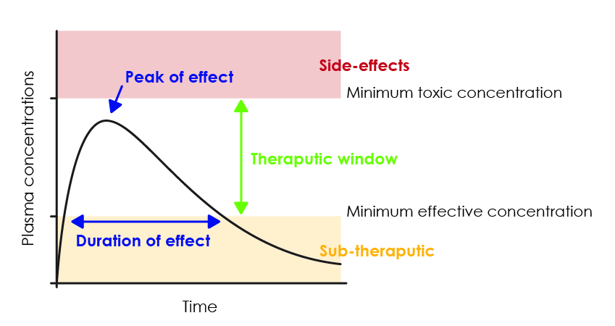  STEM Consortium  Given that the concentration of the medication in the blood rises as it is absorbed into the bloodstream and then falls as it is eliminated from the body, the duration of effect is the time where the plasma concentration is between the MEC and the MTC. Dosage regimes need to maximise the time when the concentration of the medication is optimal.

Functions which can be plotted in a two-dimensional X-Y cartesian plane are explored in the activity and are one of the following.
Straight Lines
- linear functions, i.e. straight lines with a first-order equation of the form y = a x + b
Curved Lines (i.e. non-linear functions)
- quadratic functions, i.e. parabolic curved lines with a second-order equation of the form y = a x² + b x + c
- cubic functions, i.e. curved lines with a third-order equation of the form y = a x³ + b x² + c x + d
- exponential functions, i.e. curved lines with an equation of the form y = a x + b
- logarithmic functions, i.e. curved lines with an equation of the form y = a log _{b} x + c
Instructional procedures | It is recommended that students work in small groups so they can develop collaborative problem-solving skills.  Students develop a mathematical model showing the variation in concentration of a medication in blood plasma over time. It is recommended that this task is completed using a spreadsheet, as the same methods will be required in Activity 3 when students develop a solution to the problem: How can optimum medication dosage guidelines be determined?
Expected learning | Students will be able to:  - Analyse and interpret data presented in different units of measurement and make conversions between units of measurement (Mathematics).  - Conduct an investigation, record observations, identify and explain inconsistencies in data and ways of improving the investigation so that more accurate and reliable data are produced (Science).  - Create formulas within a spreadsheet to make a series of calculations and draw on this data set to create a graph of the appropriate type to represent the patterns in the data (Mathematics and Technologies).  - Generate an accurate graph of the concentration of medication vs time based on the given set of parameters. Analyse this graph to determine when the concentration is in the therapeutic window (Mathematics).
Equipment required | For the class:  Data projector or interactive whiteboard
Equipment required | For the students:  Access to computers and a spreadsheet app  Materials for the cordial experiment (see Materials list)  Student activity sheet 2.1: Recommended dosages  Student activity sheet 2.2: Investigating concentrations  Student activity sheet 2.3: Investigating a model for a single dose of medication
Preparation | Review the steps of the activity and the resource sheets.  Provide students with access to the activity sheets.  Source the materials for the cordial experiment (see Materials list).  Review appropriate safety and hygiene procedures for the cordial experiment. Note: Food and drink cannot be consumed in a science laboratory.
Activity parts | Part 1: Recommended dosages  For many medications, it is possible to access guidelines to determine how much to administer. See Digital resources for a link to Over the counter medicine monograph: Ibuprofen for oral use.  Students complete Student activity sheet 2.1: Recommended dosages where they compare the recommended dosages of ibuprofen, a common medication available in many formulations.  Discuss the answers to this activity as a class and ask students to reflect on the following and encourage them to use relevant language:  - What key features are included in existing dosage guidelines for medications?  - How has this activity improved your understanding of dosage guidelines?  - Why is it beneficial to calculate dosages to suit a specific patient?
Activity parts | Part 2: Investigating concentrations  When substances are dissolved, the amount of solute (eg ibuprofen) and solvent (eg blood plasma) determines the concentration of the solution. For a medication to be effective, its concentration needs to be in the therapeutic window.  Students use Student activity sheet 2.2: Investigating concentrations to investigate MEC and MTC by preparing and tasting dilutions of cordial. The cordial provides a model of the effectiveness of various concentrations of medications.  Ascertain students’ understanding of the investigation by reviewing their answers to the activity sheet discussion questions.
Activity parts | Part 3: Developing a model showing medication concentration over time  When oral medication is taken, it goes through a process of absorption and a period of effectiveness before being eliminated from the body. Review the flowchart students constructed to represent these processes in Activity 1,  Part 2. This process can be modelled to estimate the change in concentration of the medication in the blood plasma over time.  Facilitate a brainstorm to produce a list of variables that might need to be taken into consideration when building a mathematical model to show how the concentration of a dose of medication in the blood plasma changes over time. Students may suggest:  - The dose (mg)  - Volume of the person’s blood plasma  - Time taken for the medication to be absorbed and reach the bloodstream  - MEC and MTC  - The medication’s half-life (ie the time taken for half of the medication to be metabolised and eliminated from the body).  Students read through the task brief in Student activity sheet 2.3: Investigating a model for a single dose of medication.  Working in pairs, students use a spreadsheet to develop a mathematical model to show the change in blood plasma concentration of a single dose of medication over time.  Ask students to consider the following guiding questions when designing their model:  - What time intervals will you use to map the changing medication concentrations? Why? … because …  - Which variables will determine the medication concentration in the blood plasma?  Plasma volume, dosage, half-life and time.  - How do you calculate the concentration of the medication at different times?  Halving the dosage amount every half-life is the easiest way. It can also be calculated through a generalised formula. Teacher resource sheet 2.5: How to derive a general exponential relationship from half-life shows how to derive a general formula for concentration vs time. Note: It is possible to continue the project using only the half-life intervals.  - What assumption has been made about the absorption of the medication?  That it is instantaneous.  - How much of the medication will be in the blood at time zero?  The entire dose (based on the assumption above).  - What commands will you use to create the graph on your spreadsheet?  - What type of graph is best suited to this data set? Why?  A line graph is most appropriate because the data is continuous.  Teacher resource sheet 2.4: Exemplar model for a single dose of medication shows a sample set of data and graph for this task.
Activity parts | Part 4: Review, reflection and journaling  Review and compare students’ models and discuss as a class the questions on data and model analysis from Student activity sheet 2.3: Investigating a model for a single dose of medication.  Provide time for student reflection and journaling of key information and ideas from this activity and the discussions they consider important for creating dosage guidelines in Activity 3.

Resource sheets | Student activity sheet 2.1: Recommended dosages  Student activity sheet 2.2: Investigating concentrations  Student activity sheet 2.3: Investigating a model for a single dose of medication  Teacher resource sheet 2.4: Exemplar model for a single dose of medication  Teacher resource sheet 2.5: How to derive a general exponential relationship from half-life
Digital resources | Over the counter medicine monograph: Ibuprofen for oral use (Department of Health, 2013)  www.tga.gov.au/otc-medicine-monograph-ibuprofen-oral-use

Activity 3: Developing a dosage regime
  Activity focus | Students use a spreadsheet to design a mathematical model to show how blood plasma concentration of medication changes during a series of doses. Dosage recommendations are developed for a particular patient.
Background information | Unlike the assumption of instantaneous absorption in the simple model developed in Activity 2, medications administered orally take time to be absorbed into the bloodstream. Medications are metabolised and then removed from the blood by the kidneys and eliminated from the body in the urine at a rate described by its half-life. Given that a medication must be at an effective concentration for a reasonable time to have an effect, repeated doses are required to maintain the plasma concentration in the therapeutic window, that is, between the Minimum Effective Concentration (MEC) and the Minimum Toxic Concentration (MTC).  Testing is required to determine the MEC, MTC and half-life of new medications. These variables can then be included in mathematical models to develop dosage guidelines for patients.
Instructional procedures | In this activity, students imagine, design and create a mathematical model for repeat doses of a new medication. From their model, they develop dosage guidelines for a single patient. They develop their model in a spreadsheet. Students may choose a simple model of instantaneous absorption or a more advanced (and realistic) model that accounts for absorption time. Teacher resource sheet 3.2: Exemplar model for multiple doses of a new medication shows different models based on different absorption rates.  This problem-solving task will be most effective when students work collaboratively in small groups.
Expected learning | Students will be able to:  - Develop a design brief that includes success criteria for a model of the blood concentrations of a medication taken as repeated doses (Technologies).  - Imagine, design and create a model, evaluate the model, and through successive iterations refine and optimise the model (Technologies).  - Create formulas within a spreadsheet to make a series of calculations for multiple doses and draw on this data set to create a graph to model changes in blood concentrations of a medication (Mathematics, Technologies).  - Generate an accurate graph of the concentration of the medication vs time based on the given set of parameters with multiple doses. Analyse this graph to determine how long the concentration is in the therapeutic window (Mathematics).
Equipment required | For the class:  Data projector or interactive whiteboard
Equipment required | For the students:  Access to computers and spreadsheet app  Student activity sheet 3.1: Investigating a model for multiple doses of a new medication
Preparation | Review the steps of this activity and the resource sheet.  Provide students with access to the activity sheet.
Activity parts | Part 1: Design brief  Set the context for the design task by explaining that a new medication has been developed and testing has been completed to determine its MEC, MTC and half-life. Dosage guidelines now need to be developed. To do this, a mathematical model needs to be created to show the plasma concentrations of the medication under different dosage regimes.  The problem to be addressed is: How can optimum medication dosage guidelines be determined?  Student activity sheet 3.1: Investigating a model for multiple doses of a new medication provides the design task details.  Discuss with students the requirements of the design brief, which should include the following:  - The spreadsheet to be used to create their model  - Characteristics of the medication (ie dose, absorption rate, MEC, MTC and half-life)  - Characteristics of the patient (ie age, height, weight, gender etc)  - Suitable success criteria  - Information to be included in dosage guidelines.  Students should be made aware of the cumulative effect of repeat doses on the blood concentration of the medication and how this relates to MEC and MTC over time.  Clarify any other task requirements and constraints and establish working groups and roles before students commence writing their design brief. See Teacher resource sheet 1.1: Cooperative learning – Roles.  Students develop and modify their model using various dosages and intervals between dosages to establish the optimum regime. The optimum regime should stay below the MTC at all times and above the MEC for as long as possible, using the least amount of the medication to achieve this.  Where students choose to work on a more advanced model, by accounting for a delay in absorption, they should be encouraged to research absorption times of common medications (eg aspirin) to base their model on a realistic assumption.  Teacher resource sheet 3.2: Exemplar model for multiple doses of a new medication provides a sample model for a sequence of doses showing the cumulative plasma concentrations of the medication, with different assumptions on absorption.
Part 2: Building the mathematical model and testing dosage regimes
Working from their design brief, students use a spreadsheet to commence building and testing their mathematical model. This will be a recursive process as various doses and dosage intervals are trialled to determine the optimal therapeutic effect.
As students work on the design of their mathematical model prompt and challenge their thinking using the following questions:
- What time intervals will you use to model the changing concentration of the medication? Why? … because …
- Which dose will you include in the model and how often will the dose be taken? Why?
- Which spreadsheet functions will you use to generate the data and graph?
- Which type of graph is best suited to this data? Why?
- How will you change the dose and interval to maximise the time the plasma concentration falls between MEC and MTC?
Students could be challenged to adapt their model for different patients (eg child or adult).
When students are satisfied that their model, within the limits of their assumptions, provides an optimal dosage regime, they can record their findings in their journal. They should include their dosage guidelines with the supporting evidence generated using their mathematical model.
Part 3: Review, reflection and journaling
Pair groups of students so they can share their findings and analyse how their models and guidelines differ. Students should test each other’s models to determine their accuracy.
Facilitate a class review, discussing how students developed and validated their models Provide time for students to record their reflections in their journal and consider the following questions:
- How did you determine rates of absorption and elimination?
- Describe how you kept track of the concentration in the blood from each dose and the overall concentration.
- What did you notice about the relationships between half-life, dose frequency, dose amount and whether or not the model predicted a stable concentration within the therapeutic window?
- As you repeatedly refined your model, were you able to better predict amounts or frequency of doses to keep the concentration within the therapeutic window? How?
- What have you learnt from this experience about how models are developed and refined?

Resource sheets | Teacher resource sheet 1.1: Cooperative learning – Roles  Student activity sheet 3.1: Investigating a model for multiple doses of a new medication  Teacher resource sheet 3.2: Exemplar model for multiple doses of a new medication

Activity 4: Reporting and evaluation of dosage recommendations
  Activity focus | Students present their models, explaining and justifying their assumptions. Feedback from peer evaluations and invited guests are used to inform enhancements to their models.
Instructional procedures | Each group prepares a multimedia presentation on their model and guidelines.  Presentation options include presentations to 1-3 guest/s within small groups, selected groups presenting to the whole class and guests, or loading the presentations in a folder that can be shared with the school community.
Expected learning | Students will be able to:  - Develop and deliver a multimedia presentation communicating their mathematical model and dosage recommendations (Mathematics and Technologies).  - Make a scientifically and mathematically sound argument for the adoption of their dosage regime (Mathematics and Science).  - Provide suggestions for improvement for their own and others’ models, analyses and presentations (Mathematics, Science and Technologies).
Equipment required | For the class:  Data projector or interactive whiteboard
Equipment required | For the students:  Access to computers and appropriate apps  Student activity sheet 4.1: Peer evaluation  Student activity sheet 4.2 Self-evaluation  Student activity sheet 1.0: Journal checklist
Preparation | Provide access to a collaborative online presentation app such as Google Slides or Microsoft Office 365 PowerPoint.  Invite a suitable audience to attend the presentations. This could include Year 11 or 12 biology, human biology, chemistry or mathematics students and teachers, parents, a nurse, pharmacy students or a pharmacist.  Arrange a room for the presentations, with access to computers.  Provide students with access to the activity sheets.
Activity parts | Part 1: Presentations  Students work in their small groups to prepare and deliver a multimedia presentation that communicates:  - The key elements of the design brief including patient characteristics  - An overview of their mathematical model and the method used to generate the data relating to dosage regimes that were modelled  - Comparisons between different dosage regimes  - Outcomes of testing their model using a spreadsheet  - A rationale for their recommended dosage guidelines.  It is expected that their presentation will include an embedded spreadsheet so that the model can be demonstrated.  Provide a combination of class and homework time for the development, review and refining of presentations, drawing on a range of digital resources including any shared documents such as Google docs, Google slides, Sharepoint or OneDrive.  The presentation will be delivered to the class and other appropriate audience members.
Part 2: Peer feedback
After the presentation, time should be allocated for students to give feedback on the presentation, addressing the questions below. Groups should take turns to provide written feedback. Questions that could be used to help structure feedback could include:
- Do you trust the recommendations? Why/Why not?
- What would convince you further?
- What improvements to the model and analysis could you suggest?
- How could the presentation be improved?
Part 3: Review, reflection and journaling
Review students’ models and their thinking in a class discussion:
- How was the understanding of exponential, linear and quadratic equations relevant to developing a model?
- What did you learn about absorption, concentration and elimination that was crucial to developing a useful model?
- How was the final model shaped by the design brief, testing and evaluating?
- What changes could you make to improve your model and analysis?
- What aspects of your argument were effective at communicating the validity of your dosage regime?
- What elements could you improve or add to your argument to convince others of the validity of your dosage regime?
- What have you learnt about the benefits and limitations of modelling in modern medical therapies?
Provide time for reflection and journaling. Encourage students to incorporate insights from peer feedback in their journals and to address these questions specifically for their model, guidelines and presentation.
Students should ensure that all relevant activities on Student activity sheet 1.0: Journal checklist are included in their journal. Advise students if they need to submit their journal for feedback and assessment.
Resource sheets | Student activity sheet 1.0: Journal checklist  Student activity sheet 4.1: Peer evaluation  Student activity sheet 4.2: Self-evaluation

Appendix 1: Links to the Western Australian Curriculum
The Deciding dosages module provides opportunities for developing students’ knowledge and understandings in science, technologies and mathematics. The tables below show how this module aligns to the content of the Western Australian Curriculum and can be used by teachers for planning and monitoring.
DECIDING DOSAGES  Links to the Western Australian Curriculum | ACTIVITY
DECIDING DOSAGES  Links to the Western Australian Curriculum | 1 | 2 | 3 | 4
SCIENCE
SCIENCE AS A HUMAN ENDEAVOUR
Nature and development of science: Advances in scientific understanding often rely on technological advances and are often linked to scientific discoveries (ACSHE192) | ●
Nature and development of science: Scientific understanding, including models and theories, is contestable and is refined over time through a process of review by the scientific community (ACSHE191) |  | ● | ● | ●
SCIENCE INQUIRY SKILLS
Processing and analysing: Analyse patterns and trends in data, including describing relationships between variables and identifying inconsistencies (ACSIS203) |  | ● | ●
Processing and analysing: Use knowledge of scientific concepts to draw conclusions that are consistent with evidence (ACSIS204) |  | ● | ●
Communicating: Communicate scientific ideas and information for a particular purpose, including constructing evidence-based arguments and using appropriate scientific language, conventions and representations (ACSIS208) |  |  |  | ●
DECIDING DOSAGES  Links to the Western Australian Curriculum | ACTIVITY
DECIDING DOSAGES  Links to the Western Australian Curriculum | 1 | 2 | 3 | 4
DIGITAL TECHNOLOGIES
PROCESSES AND PRODUCTION SKILLS
Collecting, managing and analysing data: Analyse, visualise and model processes and entities, and their relationships, using structured data (ACTDIP037) |  | ● | ●
Investigating and defining: Identify the needs of the client/stakeholder to determine the basis for a solution (WATPPS61) |  | ● | ● | ●
Investigating and defining: Create and critique briefs to solutions (WATPPS62) |  | ● | ● | ●
Designing: Apply design thinking, creativity, enterprise skills and innovation to develop, modify and communicate design ideas of increasing sophistication (WATPPS64) |  | ● | ● | ●
Designing: Design possible solutions, analysing designs against criteria, including functionality, accessibility, usability and aesthetics using appropriate technical terms and technology (WATPPS65) |  | ● | ● | ●
Evaluating: Analyse design processes and solutions against student developed criteria (WATPPS67) |  | ● | ● | ●
Collaborating and managing: Work independently, and collaboratively to manage projects, using digital technology and an iterative and collaborative approach. Considers time, cost, risk, safety, production processes, sustainability and legal responsibilities (WATPPS68) |  | ● | ● | ●
DECIDING DOSAGES  Links to the Western Australian Curriculum | ACTIVITY
DECIDING DOSAGES  Links to the Western Australian Curriculum | 1 | 2 | 3 | 4
MATHEMATICS
NUMBER AND ALGEBRA
Patterns and algebra: Substitute values into formulas to determine an unknown (ACMNA234) | ● | ● | ●
Linear and non-linear relationships: Explore the connection between algebraic and graphical representations of relations such as simple quadratics, circles and exponentials using digital technology as appropriate (ACMNA239) |  | ● | ●
Linear and non-linear relationships: Describe, interpret and sketch parabolas, hyperbolas, circles and exponential functions and their transformations (ACMNA267) |  | ● | ● | ●
STATISTICS AND PROBABILITY
Data representation and interpretation: Investigate and describe bivariate numerical data where the independent variable is time (ACMSP252) |  | ● | ● | ●
Chance: Use the language of ‘if ....then', ‘given’, ‘of’, ‘knowing that’ to investigate conditional statements and identify common mistakes in interpreting such language (ACMSP247) |  |  |  | ●
Further information about assessment and reporting in the Western Australian Curriculum can be found at k10outline.scsa.wa.edu.au/home

Appendix 1B: Mathematics proficiency strands
Key ideas
In Mathematics, the key ideas are the proficiency strands of understanding, fluency, problem-solving and reasoning. The proficiency strands describe the actions in which students can engage when learning and using the content. While not all proficiency strands apply to every content description, they indicate the breadth of mathematical actions that teachers can emphasise.
Understanding
Students build a robust knowledge of adaptable and transferable mathematical concepts. They make connections between related concepts and progressively apply the familiar to develop new ideas. They develop an understanding of the relationship between the ‘why’ and the ‘how’ of mathematics. Students build understanding when they connect related ideas, when they represent concepts in different ways, when they identify commonalities and differences between aspects of content, when they describe their thinking mathematically and when they interpret mathematical information.
Fluency
Students develop skills in choosing appropriate procedures; carrying out procedures flexibly, accurately, efficiently and appropriately; and recalling factual knowledge and concepts readily. Students are fluent when they calculate answers efficiently, when they recognise robust ways of answering questions, when they choose appropriate methods and approximations, when they recall definitions and regularly use facts, and when they can manipulate expressions and equations to find solutions.
Problem solving
Students develop the ability to make choices, interpret, formulate, model and investigate problem situations, and communicate solutions effectively. Students formulate and solve problems when they use mathematics to represent unfamiliar or meaningful situations, when they design investigations and plan their approaches, when they apply their existing strategies to seek solutions, and when they verify that their answers are reasonable.
Reasoning
Students develop an increasingly sophisticated capacity for logical thought and actions, such as analysing, proving, evaluating, explaining, inferring, justifying and generalising. Students are reasoning mathematically when they explain their thinking, when they deduce and justify strategies used and conclusions reached, when they adapt the known to the unknown, when they transfer learning from one context to another, when they prove that something is true or false, and when they compare and contrast related ideas and explain their choices.

Source: ACARA - www.australiancurriculum.edu.au/f-10-curriculum/mathematics/key-ideas/?searchTerm=key+ideas#dimension-content

Appendix 2: General capabilities continuums
The general capabilities continuums shown here are designed to enable teachers to understand the progression students should make with reference to each of the elements. There is no intention for them to be used for assessment.
Information and communication technology (ICT) capability learning continuum
Sub-element | Typically by the end of Year 6 | Typically by the end of Year 8 | Typically by the end of Year 10
Create with ICT  Generate ideas, plans and processes | use ICT effectively to record ideas, represent thinking and plan solutions | use appropriate ICT to collaboratively generate ideas and develop plans | select and use ICT to articulate ideas and concepts, and plan the development of complex solutions
Create with ICT  Generate solutions to challenges and learning area tasks | independently or collaboratively create and modify digital solutions, creative outputs or data representation/ transformation for particular audiences and purposes | design and modify simple digital solutions, or multimodal creative outputs or data transformations for particular audiences and purposes following recognised conventions | design, modify and manage complex digital solutions, or multimodal creative outputs or data transformations for a range of audiences and purposes
Communicating with ICT  Collaborate, share and exchange | select and use appropriate ICT tools safely to share and exchange information and to safely collaborate with others | select and use appropriate ICT tools safely to lead groups in sharing and exchanging information, and taking part in online projects or active collaborations with appropriate global audiences | select and use a range of ICT tools efficiently and safely to share and exchange information, and to collaboratively and purposefully construct knowledge

Critical and creative thinking learning continuum
Sub-element | Typically by the end of Year 6 | Typically by the end of Year 8 | Typically by the end of Year 10
Inquiring – identifying, exploring and organising information and ideas  Organise and process information | analyse, condense and combine relevant information from multiple sources | critically analyse information and evidence according to criteria such as validity and relevance | critically analyse independently sourced information to determine bias and reliability
Generating ideas, possibilities and actions  Imagine possibilities and connect ideas | combine ideas in a variety of ways and from a range of sources to create new possibilities | draw parallels between known and new ideas to create new ways of achieving goals | create and connect complex ideas using imagery, analogies and symbolism
Generating ideas, possibilities and actions  Seek solutions and put ideas into action | assess and test options to identify the most effective solution and to put ideas into action | predict possibilities, and identify and test consequences when seeking solutions and putting ideas into action | assess risks and explain contingencies, taking account of a range of perspectives, when seeking solutions and putting complex ideas into action
Reflecting on thinking and processes  Transfer knowledge into new contexts | apply knowledge gained from one context to another unrelated context and identify new meaning | justify reasons for decisions when transferring information to similar and different contexts | identify, plan and justify the transfer of knowledge to new contexts

Personal and social capability learning continuum
Sub-element | Typically by the end of Year 6 | Typically by the end of Year 8 | Typically by the end of Year 10
Social management  Work collaboratively | contribute to groups and teams, suggesting improvements in methods used for group investigations and projects | assess the extent to which individual roles and responsibilities enhance group cohesion and the achievement of personal and group objectives | critique their ability to devise and enact strategies for working in diverse teams, drawing on the skills and contributions of team members to complete complex tasks
Social management  Negotiate and resolve conflict | identify causes and effects of conflict, and practise different strategies to diffuse or resolve conflict situations | assess the appropriateness of various conflict resolution strategies in a range of social and work-related situations | generate, apply and evaluate strategies such as active listening, mediation and negotiation to prevent and resolve interpersonal problems and conflicts
Social management  Develop leadership skills | initiate or help to organise group activities that address a common need | plan school and community projects, applying effective problem-solving and team-building strategies, and making the most of available resources to achieve goals | propose, implement and monitor strategies to address needs prioritised at local, national, regional and global levels, and communicate these widely  discuss the concept of leadership and identify situations where it is appropriate to adopt this role
Further information about general capabilities is available at:
k10outline.scsa.wa.edu.au/home/p-10-curriculum/general-capabilities-over/general-capabilities-overview/general-capabilities-in-the-australian-curriculum

Appendix 3: Materials list

The following materials are required to complete this module.

Activity 2: Cordial experiment
- Water (600 mL)
- Cordial (~150 mL)
- 6 disposable cups
- 10 mL and 50 mL measuring equipment
- Disposable plastic spoons

Appendix 4: Design process guide
Safe production of the final design or multiple copies of the final design.
Fine tuning the production process, such as division of labour for batch or mass production.
Use of intended materials and appropriate tools to safely make the solution to the design problem.
Reflection on the process taken and the success of the design.
Evaluation can lead to further development or improvement of the design and can be a final stage of the design process before a conclusion is reached.
Could be formal or informal and verbal or written.
Ideation
Development
Development of the design ideas. Improvements, refinements, adding detail, making it better.
Activities such as detailed drawings, modelling, prototyping, market research, gaining feedback from intended user, further research – if needed – to solve an issue with the design, testing different tools or equipment, trialling production processes, measuring or working out dimensions, testing of prototypes and further refinement.
Idea generation – turning ideas into tangible forms so they can be organised, ordered and communicated to others.
Activities such as brainstorming, mind mapping, sketching, drawing diagrams and plans, collecting colour samples and/or material samples and talking through these ideas can help to generate more creative ideas.
Using the SCAMPER model can assist with this: www.mindtools.com/pages/article/newCT_02.htm
www.designorate.com/a-guide-to-the-scamper-technique-for- creative-thinking
Analysis
Finding useful and helpful information about the design problem.
Gathering information, conducting surveys, finding examples of existing solutions, testing properties of materials, practical testing.
Understanding the meaning of the research findings.
Analysing what the information means, summarising the surveys, judging the value of existing solutions, understanding test results.
Research
Production
Evaluation

Appendix 4B: Drawing in the design process
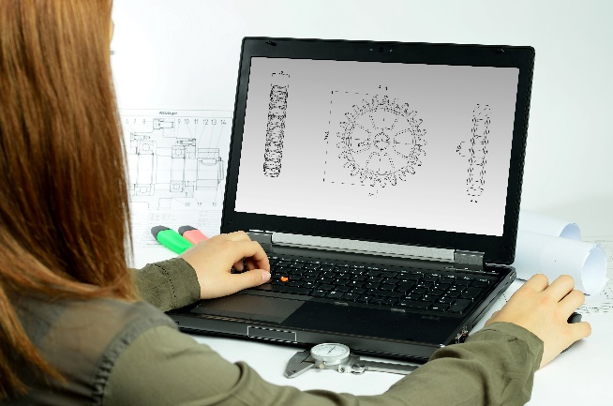
Incorporating the design process into the STEM modules will often result in the need for students to draw plans of their designs. This can be done at a simple level using hand-drawn sketches or at a more technical level using computer-aided design (CAD).
By developing skills using industry-standard software, students may be well-placed to explore future career pathways.
istockphoto.com
There are several CAD software options, two free examples are detailed below. Autodesk is a third package that is also free for educational use.
Tinkercad
- Format: Web-based app requiring internet access via a browser
- Purpose: A simple, online 3D design and 3D printing app
- Home: www.tinkercad.com
- Blog: blog.tinkercad.com
- Tutorials: www.tinkercad.com/learn
- Feature: Connects to 3D printing and laser cutting.
SketchUp
- Format: Can be downloaded and installed on devices, or used in a browser
- Purpose: Enables students to draw in 3D
- Home: www.sketchup.com 'Products' 'SketchUp for Schools'
- Help centre: help.sketchup.com/en
- Blog: blog.sketchup.com
- Tutorials: www.youtube.com/user/SketchUpVideo. From beginner tool tips to intermediate and advanced modelling techniques, the video tutorials help to build SketchUp skills.

Appendix 5: Student journal

When students reflect on learning and analyse their ideas and feelings, they self-evaluate, thereby improving their metacognitive skills.
These modules encourage students to self-reflect and record the stages of their learning in a journal. This journal may take the form of a written journal, a portfolio or a digital portfolio.
istockphoto.com
Using digital portfolios can help develop students’ information and communication technology (ICT) capability.
Reflective practice and recording can be supported in classrooms by creating opportunities for students to think about and record their learning through notes, drawings or pictures. Teachers should encourage students to revisit earlier journal entries to help them observe the progress of their thoughts and understanding.
Journals are a useful tool that gives teachers additional insight into how students value their learning and progress, as well as demonstrating their individual achievements.
The following links provide background information and useful apps for journaling.
Reflective journal (University of Technology Sydney)
www.uts.edu.au/sites/default/files/reflective_journal.pdf
Reflective writing (University of New South Wales Sydney))
student.unsw.edu.au/reflective-writing
Balancing the two faces of ePortfolios (Helen Barrett, 2009)
electronicportfolios.org/balance/Balancing.jpg
Digital portfolios for students (Cool tools for school)
cooltoolsforschool.wordpress.com/digital-student-portfolios
Kidblog – digital portfolios and blogging
kidblog.org/home
Evernote (a digital portfolio app)
evernote.com
Weebly for education (a drag and drop website builder)
education.weebly.com
Connect – the Department of Education’s integrated, online environment
connect.det.wa.edu.au

Appendix 6: Student activity sheet 1.0: Journal checklist

As an ongoing part of this module, you have been keeping a journal of your work.
Before submitting your journal to your teacher please ensure you have included the following information.
- Tick each box once complete and included.
- Write N/A for items that were not required in this module.
istockphoto.com

Your name and group members’ names or photographs
An explanation of the problem you are solving
Your notes from Activity 1
Your notes from Activity 2
Your notes from Activity 3
Your notes from Activity 4
Student activity sheet 1.6: Patient modelling
Student activity sheet 2.1: Recommended dosages
Student activity sheet 2.2: Investigating concentrations
Student activity sheet 2.3: Investigating a model for a single dose of medication
Student activity sheet 3.1: Investigating a model for multiple doses of a new medication
Student activity sheet 4.1: Peer evaluation
Student activity sheet 4.2: Self-evaluation
Student activity sheet 1.0: Journal checklist

Appendix 7: Teacher resource sheet 1.1: Cooperative learning – Roles

Cooperative learning frameworks create opportunities for groups of students to work together, generally to a single purpose.
As well as having the potential to increase learning for all students involved, using these frameworks can help students develop personal and social capability.
When students are working in groups, positive interdependence can be fostered by assigning roles to group members.
istockphoto.com
These roles could include:
- Working roles such as Reader, Writer, Summariser, Time-keeper
- Social roles such as Encourager, Observer, Noise monitor, Energiser.
Further to this, specific roles can be delineated for specific activities that the group is completing. It can help students if some background to the purpose of group roles is made clear to them before they start, but at no time should the roles get in the way of the learning. Teachers should decide when or where roles are appropriate to given tasks.


istockphoto.com

Appendix 8: Teacher resource sheet 1.2: Cooperative learning – Jigsaw
Cooperative learning frameworks create opportunities for groups of students to work together, generally for a single purpose.
As well as having the potential to increase learning for all students involved, using these frameworks can help students develop personal and social capability.
The jigsaw strategy typically has each member of the group becoming an 'expert' on one or two aspects of a topic or question being investigated. Students start in their cooperative groups, then break away to form 'expert’ groups to investigate and learn about a specific aspect of a topic. After developing a sound level of understanding, the students return to their cooperative groups and teach each other what they have learnt.
Within each expert group, issues such as how to teach the information to their group members are considered.

Step 1 | Cooperative groups  (of four students) | 1 2 3 4 |  | 1 2 3 4
Step 2 | Expert groups  (size equal to the number of groups) | 1 1 | 2 2 | 3 3 | 4 4
Step 3 | Cooperative groups  (of four students) | 1 2 3 4 |  | 1 2 3 4

Appendix 9: Teacher resource sheet 1.3: Cooperative learning – Placemat

Cooperative learning frameworks create opportunities for groups of students to work together, generally for a single purpose.
As well as having the potential to increase learning for all students involved, using these frameworks can help students develop personal and social capability.
The placemat strategy involves students working collaboratively to record prior knowledge about a common topic and brainstorm ideas. It also allows teachers to readily see the contribution of each student. The diagram below shows a typical placemat template.
istockphoto.com
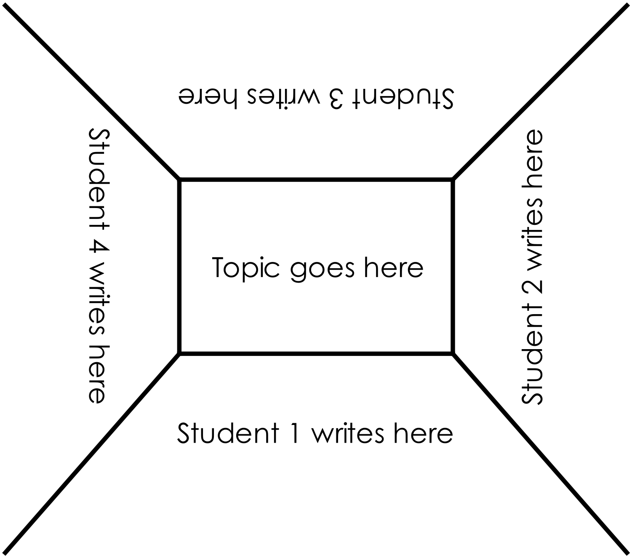

STEM Consortium

Appendix10: Teacher resource sheet 1.4: Cooperative learning – Think, Pair, Share
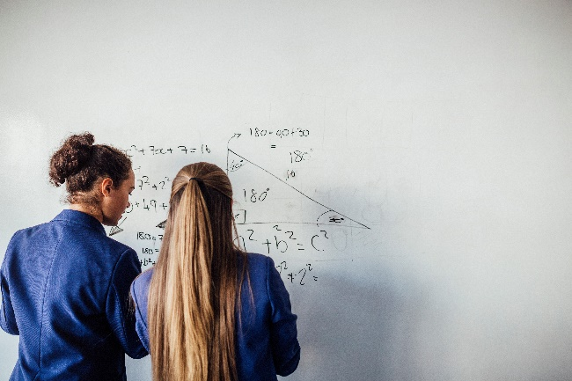
Cooperative learning frameworks create opportunities for groups of students to work together, generally to a single purpose.
As well as having the potential to increase learning for all students involved, using these frameworks can help students develop personal and social capability.
In the 'think' stage, each student thinks silently about a question asked by the teacher.
istockphoto.com
In the 'pair' stage, students discuss their thoughts and answers to the question in pairs.
In the 'share' stage, the students share their answer, their partner’s answer or what they decided together. This sharing may be with other pairs or with the whole class. It is important also to let students 'pass'. This is a key element of making the strategy safe for students.
Think-pair-share increases student participation and provides an environment for higher levels of thinking and questioning.

istockphoto.com

Appendix 11: Teacher resource sheet 1.5: Vocabulary list
Absorption
Blood plasma
Concentration
Dosage
Elimination
Exponential decay
Haematocrit
Half-life
Ingestion
Interval
Linear
Medication
Minimum Effective Concentration (MEC)
Minimum Toxic Concentration (MTC)
Model
Parameter
Quadratic
Regime
Solute
Solvent

Appendix 12: Student activity sheet 1.6: Patient modelling
Materials
Spreadsheet/graphing app or graph paper
Introduction
When taking medications, it is important to get the dosage correct. If too little is administered, it will be ineffective, and too much may do harm.
Blood is a complex fluid made up of plasma, a straw-coloured liquid, as well as red blood cells, white blood cells and platelets. The average volume of blood in an adult is about 5 litres. Females generally have a lower blood volume than males.
Children and adults need different dosages because they have different volumes of blood in which the medication is dissolved, giving different blood concentrations.
Task 1: Blood volume
Analyse the scatter graph below and show working to estimate the average volume of blood for each kilogram of an adult.

STEM Consortium

Analyse the scatter graph below and show working to estimate the average volume of blood for each kilogram of a child.

STEM Consortium

Record your estimates for the average volume of blood in the table below.
Person | Total blood volume (mL/kg)
Adult
Child
How did you estimate these values?

The Australian Red Cross website (transfusion.com.au/disease_therapeutics/haemorrhage) indicates that ‘total blood volume can be estimated as approximately 70 mL/kg for adults, 80 mL/kg in children and 100 mL/kg in neonates’. How do your estimates compare with the Red Cross values?

The Nalder method for calculating total blood volume (www.aqua-calc.com/calculate/blood-volume) is based on a person’s height, weight and sex:
Male: TBV = 0.3669 × h³ + 0.03219 × w + 0.6041
Female: TBV = 0.3561 × h³ + 0.03308 × w + 0.1833
where TBV is total Blood Volume, h is person's height in metres, and w is person's weight in kilograms.
Calculate the total blood volume of a 70 kg adult male who is 1.76 m tall showing working using the Australian Red Cross formula and the Nalder method. Calculate your own blood volume.

Method | Total blood volume (L)  Adult male | Total blood volume (L)  Your own
Red Cross
Nalder

Did you get the same result from the two methods? By how much did they differ? Is this significant?

Which method do you think gives the more accurate result? Why?

Task 2: Plasma volume
Medications are dissolved in the blood plasma. Therefore, to determine the concentration of a medication in the blood, the volume of blood plasma needs to be known. This can be calculated using the following formula:
PV = TBV * (1-Hct)
where, PV is the plasma volume, TBV is the total blood volume, and Hct, the haematocrit, is the proportion of the blood made up of the red blood cells. The haematocrit is typically 45% of the total blood volume. Therefore, this formula can be simplified as follows:
PV = TBV * 0.55
Which is the same as
PV = 0.55 * TBV
Choose appropriate formulas to calculate and graph the blood volume and plasma volume for a 176 cm tall adult with a weight of 50 kg, 60 kg, 70 kg, 80 kg, 90 kg and 100 kg. Use a spreadsheet to perform the calculations and create the graph. Cut and paste your graph below.

Use the graph to determine your own blood and plasma volumes.

Could you use this graph to determine the blood and plasma volumes for a child?

Would the calculation be valid? Why/Why not?

Appendix 13: Student activity sheet 2.1: Recommended dosages
Introduction
For many medications, it is possible to access guidelines to determine how much to administer. Consider the table below for dosages of ibuprofen for children.
- Column one gives the age of a child.
- Column two gives the weight of the child in kilograms (kg).
- Columns three and four give the dosages of children’s liquid suspension for two concentrations of ibuprofen.
- Column five shows the dosage for the tablet form.

Ibuprofen dosage recommendations for children
Ibuprofen  (every 6 – 8 hours) |  | Liquid suspension |  | Chewable tablet  (100 mg)
 |  | 20 mg/mL  (mL) | 40 mg/mL  (mL) | Chewable tablet  (100 mg)
Age | Weight (kg) | 20 mg/mL  (mL) | 40 mg/mL  (mL) | Chewable tablet  (100 mg)
3-6 months | 6-8 | 2-3 | 1.5-2
6-12 months | 8-10 | 3-4 | 2-2.5
1-3 years | 10-14 | 4-6 | 2.5-3.5
3-5 years | 14-18 | 6-7 | 3.5-4.5
5-7 years | 18-22 | 7-9 | 4.5-5.5
7-10 years | 22-32 | 9-12 | 5.5-7.0 | 2
10-12 years | 32-41 | 12-15 | 7.0-10 | 3
Questions
- Medications for children in liquid form can be given in a syringe, spoon or measuring cup. However, spoon size can vary greatly leading to incorrect doses. There is 5 mL in a teaspoon. If a parent used an oversized spoon which holds 7 mL, by what percentage would the dose be increased?

- What are the benefits of using a syringe or measuring cup to dose children instead of teaspoon?
____________________________________________________________________________
____________________________________________________________________________

- What is the benefit of a medication being available in different formulations?
____________________________________________________________________________
____________________________________________________________________________

- Why have the recommended dosages changed from column three to column four of the children’s liquid suspension?
____________________________________________________________________________
____________________________________________________________________________

- A mother assumed from the dosage guidelines above she could give her
6-month-old twins 2 mL of the 40 mg/ml suspension to help with their teething pain. As a new mum, she wanted to ask her pharmacist if this was the correct amount before dosing. The Pharmacist checked her references showing that the dosage should be 10 mg per kilogram and the dose is to be given every 6 to 8 hours. One twin weighed 7.6kg and the other 7.2kg. What volume of the suspension did the pharmacist recommend for each twin?

- What advantage is there in using age to calculate the dosage?
____________________________________________________________________________
____________________________________________________________________________

- What is a disadvantage of using age to calculate dosage?
____________________________________________________________________________
____________________________________________________________________________

- Why do you think it is necessary to repeat a dose after a period of time?
____________________________________________________________________________
____________________________________________________________________________

Appendix 14: Student activity sheet 2.2: Investigating concentrations
Materials
Per group:
- Water (600 mL)
- Cordial (~150 mL)
- 6 disposable cups
- 10 mL and 50 mL measuring equipment
- 5 disposable plastic spoons per group member
Introduction
A medication’s effectiveness is largely determined by its concentration in the blood plasma.
When substances are dissolved, the amounts of solute and solvent determine the concentration of the solution. For medications to be effective, they need to be at a sufficient concentration (Minimum Effective Concentration, MEC) but not at a concentration high enough to be toxic (Minimum Toxic Concentration, MTC).
In this experiment you will investigate the Minimum Enjoyable Concentration (MEC) and Minimum Too-sweet Concentration (MTC) of cordial by preparing and tasting dilutions of cordial. This will be a model of the concentration effect of medications.
Question
What is the MEC and MTC of cordial in water?
Procedure
- Mix five cups of water and cordial in the ratios: 50:1, 25:1, 10:1, 5:1 and 1:1.
- Start with 50 mL of water in the five cups and calculate how much cordial will be required to form these ratios.
- Calculate the concentration of cordial in each cup as a percentage and write this in the results table.
- Each student in the group should taste the different mixtures and put a tick in their box on the results table indicating it was acceptable to drink, or a cross to indicate it was not acceptable. Each student uses a fresh spoon for each tasting to maintain good hygiene.
- List the range of concentrations that are acceptable to most (or all) members of the group.

Results
Minimum Enjoyable Concentration and Minimum Too-sweet Concentration for cordial
Ratio | Volume of cordial (mL) | Concentration  (%) | Student
Ratio | Volume of cordial (mL) | Concentration  (%) | 1 | 2 | 3 | 4 | 5
50:1
20:1
10:1
5:1
1:1

Your group should have an upper and lower value for concentrations that are acceptable. These values can be called the Minimum Enjoyable Concentration (MEC) and the Minimum Too-sweet Concentration (MTC). The MEC is the weakest concentration that tastes good. The MTC is the concentration at which the cordial gets too sweet to drink.
Discussion
- How consistent was your data? How would you explain variations between individuals’ responses to the taste tests?

- What values best represent the MEC and MTC for your sample of students?
MEC: ______________________________ MTC: ______________________________
- Did you select a mean, mode or median value to represent your group’s MEC and MTC? Why?

- How would you change this investigation to produce more accurate measures of MEC and MTC? Why would that improve accuracy?

Appendix 15: Student activity sheet 2.3: Investigating a model for a single dose of medication
Introduction
When a dose of medication is taken orally, it is absorbed into the bloodstream, carried around the body, gradually broken down and then eliminated by the kidneys. Half-life is defined as the time taken for half of the medication in the body to be eliminated. The half-life of a medication is important in the timing of its administration because it determines:
- The duration of the medication’s effectiveness (eg generally the longer the half-life, the longer the plasma concentration will remain in the effective range)
- The frequency of dosing (eg a medication with a short half-life will need to be given more frequently to achieve a constant therapeutic effect).
Task brief
Use a spreadsheet to develop a mathematical model that shows the changing plasma concentration of a single dose of medication over a 24-hour period. Represent your model as a table of values as well as a graph of blood concentration of medication over 24 hours. The following assumptions can be used when creating a model:
- A single dose of 600 mg of medication is taken
- 80 kg male with 70 mL/kg blood and haematocrit of 45%
- Instantaneous absorption
- Half-life is 3 hours
- Minimum Effective Concentration (MEC) is 150 mg/L
- Minimum Toxic Concentration (MTC) is 350 mg/L
Analysis of data
- How would you describe the relationship between the blood plasma concentration of medication and time?
- Over what time period does the blood plasma concentration of medication fall in the therapeutic window? What does this mean?
- How would the assumptions you built into your model change for a child? Why?
Analysis of model
- Was using a spreadsheet an effective way of creating your model? What aspects were effective? What changes would improve the method?
- How well does your model match reality? How realistic were the assumptions?
- What changes would you make to the model and its assumptions to better model a real system?

Appendix 16: Teacher resource sheet 2.4: Exemplar model for a single dose of medication
Introduction
The following sample model is provided for the teacher to illustrate what might be generated by students based on the task brief in Student activity sheet 2.3: Investigating model for a single dose of medication.
Exemplar model for a single dose of medication
Parameters:
Instantaneous absorption
Dosage of 600 mg
Half-life of 3 hours
80 kg male with 70 ml/kg blood and haematocrit of 45%
Plasma volume = 70 ml/kg x 80 kg x 55% = 3080 mL = 3.08 L
Minimum Effective Concentration (MEC) is 150 mg/L
Minimum Toxic Concentration (MTC) is 350 mg/L
The formula for Concentration (Conc) = mass (dosage)/volume (plasma volume).

STEM Consortium
The dosage concentration is in the therapeutic window for the first hour and a half after taking the medication. After that, it would be deemed ineffective. The dosage is never above the MTC so there is low risk associated.

Appendix 17: Teacher resource sheet 2.5: How to derive a general exponential relationship from half-life
Introduction
An exponential formula can be used to calculate concentrations of a medication at times other than multiples of the half-life. This can give a more fine-grained plot, such as concentration at every hour. This is one way students can improve their model showing an exponential continuous growth or decay. The following can be taken as an extension as it is possible to continue the project in Activity 2 using only the half-life intervals.
Half-life (h) is the amount of time taken for half of the medication in the body to be eliminated. If (D₀) is the initial concentration of a medication in the body, (t) is time, and the variable dosage at any time is (D_{t}). A relationship between these parameters can be expressed as: D_{t} = D₀ (½)^{t/h} or D_{t} = D₀ × 2^{-t/h}.
(Note: This formula is sufficient to perform all further calculations)
Exponential relationships are often expressed in a standard format of the form:
A = A₀e^{-kt}, where, e is a function whose value is a constant.
The formula for concentration, above, can be adapted to this format using natural logs. This may be an exercise to go through with the students as an application of the log laws. The following mathematical cqoncepts should be reviewed before students are shown how this formula can be adapted:
- Every exponential function has an inverse function called the logarithmic function with base a and is denoted by log a.
- The logarithm with base e is called the natural logarithm and is denoted by ln where, ln x = log_{e} x . The natural logarithmic function y = ln x is the inverse function of the exponential function y = e^{x}
- Laws of Logarithms – see the following resource for a review of these laws:
Logarithms (Math Centre, 2009) www.mathcentre.ac.uk/resources/uploaded/mc-ty-logarithms-2009-1.pdf
The following shows how the above formula for concentration can be arranged to standard form by taking the natural logarithm of each side and using the Laws of Logarithms:
D_{t} = D₀ (2^{-t/h})  ln D_{t} = ln[D₀ (2^{-t/h})]  ln D_{t} = ln(D₀)+ln(2^{-t/h})  ln D_{t} = ln(D₀) – (t/h)ln2  ln D_{t} – ln(D₀) = -(t/h)ln2 | ln(D_{t} /D₀) = -(ln2/h)t  D_{t} /D₀ = e^{-(ln2/h)t}  D_{t} =D₀ e^{-(ln2/h)t}  D_{t} =D₀ e^{-kt}, where k = -ln2/h

Appendix 18: Student activity sheet 3.1: Investigating a model for multiple doses of a new medication
Introduction
A new medication has been developed and testing has been completed to determine its Minimum Effective Concentration (MEC), Minimum Toxic Concentration (MTC) and half-life. Dosage guidelines now need to be developed. To do this a mathematical model is to be created to show the blood plasma concentrations of the medication under different dosage regimes.
The problem to be addressed is: How can the optimal medication dosage guidelines be determined?
Task
Use a spreadsheet to develop a mathematical model of the changing plasma concentration of multiple doses of a new medication over a 24-hour period. Spreadsheets created in Student activity sheet 2.3: Investigating a model for a single dose of medication should be used to help you decide on the most appropriate ways to represent your model.
Create your own criteria and assumptions about the new medication based on your research from Activity 1 and include:
- Dose (mg)
- Absorption pattern for the medication (instantaneous, linear, exponential, quadratic etc)
- Half-life
- MEC
- MTC
You should also make your own assumptions about the characteristics of the patient.
Key steps:
- Develop a design brief that outlines your criteria, assumptions and features of your model, including success criteria.
- Create the model using an Excel spreadsheet. This may require several iterations to develop a model and dosage regime that optimises the therapeutic effect of the medication.
- Present your dosage guidelines for a patient and your justification for these guidelines.

Appendix 19: Teacher resource sheet 3.2: Exemplar model for multiple doses of a new medication
Introduction
The following sample models are intended for use by the teacher only to provide an example of what might be generated by students in Activity 3 using Student activity sheet 3.1: Investigating a model for multiple doses of a new medication.

Model 1
Parameters:
Instantaneous absorption
Dosage of 300 mg or 200 mg
Half-life of 4 hours
30 kg child with 80 ml/kg blood and haematocrit of 45%
Plasma volume = 80 ml/kg x 30 kg x 55% = 1320 mL = 1.32 L
Minimum Effective Concentration (MEC) is 200 mg/L
Minimum Toxic Concentration (MTC) is 400 mg/L
Concentration of a single 300 mg dose is 300/1.32 = 227
Concentration of a single 200 mg dose is 200/1.32 = 152
In this example, we will trial a 300 mg dose in the first hour and 200 mg doses every
4 hours afterwards.

Time (hr) | Blood Concentration (mg/L) |  |  |  |  |  | Cumulative  Conc  (mg/L) | MEC  (mg/L) | MTC  (mg/L)
Time (hr) | Dose 1 | Dose 2 | Dose 3 | Dose 4 | Dose 5 | Dose 6 | Cumulative  Conc  (mg/L) | MEC  (mg/L) | MTC  (mg/L)
0 | 227.3 |  |  |  |  |  | 227.3 | 200 | 400
4 | 113.6 | 151.5 |  |  |  |  | 265.2 | 200 | 400
8 | 56.8 | 75.8 | 151.5 |  |  |  | 284.1 | 200 | 400
12 | 28.4 | 37.9 | 75.8 | 151.5 |  |  | 293.6 | 200 | 400
16 | 14.2 | 18.9 | 37.9 | 75.8 | 151.5 |  | 298.3 | 200 | 400
20 | 7.1 | 9.5 | 18.9 | 37.9 | 75.8 | 151.5 | 300.7 | 200 | 400
24 | 3.6 | 4.7 | 9.5 | 18.9 | 37.9 | 75.8 | 150.3 | 200 | 400
28 | 1.8 | 2.4 | 4.7 | 9.5 | 18.9 | 37.9 | 75.2 | 200 | 400
32 | 0.9 | 1.2 | 2.4 | 4.7 | 9.5 | 18.9 | 37.6 | 200 | 400
36 | 0.4 | 0.6 | 1.2 | 2.4 | 4.7 | 9.5 | 18.8 | 200 | 400

STEM Consortium
The dosage concentration remains in the therapeutic window for about 22 hours. It never goes above the MTC and therefore remains safe. It seems it would be possible to administer a similar regime starting with a higher dose (and perhaps higher doses later) and be able to stay below the MTC while allowing the medication to have a stronger therapeutic effect. This could be considered if a patient is not receiving the desired therapeutic effect. More simulations should be run to determine the optimal regime, where the patient is receiving the desired therapeutic effect from the minimum does of medication. In fact, this regime may be considered optimal. Assuming the patient receives the desired therapeutic effect from the dose, it remains in the bottom half of the therapeutic window.
Model 2
Parameters:
Linear absorption
Dosage of 300 mg or 200 mg
Half-life of 4 hours
Linear absorption, from 0% to 100%, over 1 hour. This is based on a fair approximation of medication absorption graphs students may find on the internet. (Students should provide sources.)
30 kg child with 80 ml/kg blood and haematocrit of 45%
Plasma volume = 80 ml/kg x 30 kg x 55% = 1320 mL = 1.32 L
Minimum Effective Concentration (MEC) is 200 mg/L
Minimum Toxic Concentration (MTC) is 400 mg/L
Concentration of a single 300 mg dose is 300/1.32 = 227
Concentration of a single 200 mg dose is 200/1.32 = 152.
For each dose:
Apply the linear formula for concentration, C = C0 * t for the first hour. Apply the exponential formula for concentration, C = C0 x (2) ^ (- t / 4 ) for the remaining hours. C0 is the initial concentration of a dose, 227 for 300 mg and 152 for 200 mg.
Trial the same regime as in Model 1, one initial dose of 300 mg, followed by 200 mg at every 4 hours.

Time (hr) | Concentration (mg/L) |  |  |  |  |  | Cumulative  Conc  (mg/L) | MEC  (mg/L) | MTC  (mg/L)
Time (hr) | Dose 1 | Dose 2 | Dose 3 | Dose 4 | Dose 5 | Dose 6 | Cumulative  Conc  (mg/L) | MEC  (mg/L) | MTC  (mg/L)
0 | 0 |  |  |  |  |  | 0.0 | 200 | 400
1 | 227.3 |  |  |  |  |  | 227.3 | 200 | 400
2 | 160.7 |  |  |  |  |  | 160.7 | 200 | 400
3 | 135.1 |  |  |  |  |  | 135.1 | 200 | 400
4 | 113.6 | 0.0 |  |  |  |  | 113.6 | 200 | 400
5 | 95.6 | 151.5 |  |  |  |  | 247.1 | 200 | 400
6 | 80.4 | 107.1 |  |  |  |  | 187.5 | 200 | 400
7 | 67.6 | 90.1 |  |  |  |  | 157.7 | 200 | 400
8 | 56.8 | 75.8 | 0.0 |  |  |  | 132.6 | 200 | 400
9 | 47.8 | 63.7 | 151.5 |  |  |  | 263.0 | 200 | 400
10 | 40.2 | 53.6 | 107.1 |  |  |  | 200.9 | 200 | 400
11 | 33.8 | 45.0 | 90.1 |  |  |  | 168.9 | 200 | 400
12 | 28.4 | 37.9 | 75.8 | 0.0 |  |  | 142.0 | 200 | 400
13 | 23.9 | 31.9 | 63.7 | 151.5 |  |  | 271.0 | 200 | 400
14 | 20.1 | 26.8 | 53.6 | 107.1 |  |  | 207.6 | 200 | 400
15 | 16.9 | 22.5 | 45.0 | 90.1 |  |  | 174.6 | 200 | 400
16 | 14.2 | 18.9 | 37.9 | 75.8 | 0.0 |  | 146.8 | 200 | 400
17 | 11.9 | 15.9 | 31.9 | 63.7 | 151.5 |  | 274.9 | 200 | 400
18 | 10.0 | 13.4 | 26.8 | 53.6 | 107.1 |  | 210.9 | 200 | 400
19 | 8.4 | 11.3 | 22.5 | 45.0 | 90.1 |  | 177.4 | 200 | 400
20 | 7.1 | 9.5 | 18.9 | 37.9 | 75.8 | 0.0 | 149.1 | 200 | 400
21 | 6.0 | 8.0 | 15.9 | 31.9 | 63.7 | 151.5 | 276.9 | 200 | 400
22 | 5.0 | 6.7 | 13.4 | 26.8 | 53.6 | 107.1 | 212.6 | 200 | 400
23 | 4.2 | 5.6 | 11.3 | 22.5 | 45.0 | 90.1 | 178.8 | 200 | 400
24 | 3.6 | 4.7 | 9.5 | 18.9 | 37.9 | 75.8 | 150.3 | 200 | 400
25 | 3.0 | 4.0 | 8.0 | 15.9 | 31.9 | 63.7 | 126.4 | 200 | 400
26 | 2.5 | 3.3 | 6.7 | 13.4 | 26.8 | 53.6 | 106.3 | 200 | 400
27 | 2.1 | 2.8 | 5.6 | 11.3 | 22.5 | 45.0 | 89.4 | 200 | 400
28 | 1.8 | 2.4 | 4.7 | 9.5 | 18.9 | 37.9 | 75.2 | 200 | 400
29 | 1.5 | 2.0 | 4.0 | 8.0 | 15.9 | 31.9 | 63.2 | 200 | 400
30 | 1.3 | 1.7 | 3.3 | 6.7 | 13.4 | 26.8 | 53.2 | 200 | 400
31 | 1.1 | 1.4 | 2.8 | 5.6 | 11.3 | 22.5 | 44.7 | 200 | 400
32 | 0.9 | 1.2 | 2.4 | 4.7 | 9.5 | 18.9 | 37.6 | 200 | 400
33 | 0.7 | 1.0 | 2.0 | 4.0 | 8.0 | 15.9 | 31.6 | 200 | 400
34 | 0.6 | 0.8 | 1.7 | 3.3 | 6.7 | 13.4 | 26.6 | 200 | 400
35 | 0.5 | 0.7 | 1.4 | 2.8 | 5.6 | 11.3 | 22.3 | 200 | 400

STEM Consortium
Under these assumptions, this model shows the dosage concentration below the MEC for long periods, taking a long time to become effective. It is also unclear whether this may go above the MTC with more doses. Ways this can be addressed in next trial model include increasing initial dosage, restricting the overall length of consumption (i.e. do not take for more than 24 hours) and/or reducing the number the subsequent doses. Experimenting with different times between doses may also produce a better dosage regime.
These models are based on the following assumptions about the new medication:
- Tablets can be made with 200 mg or 300 mg of active ingredient per tablet
- Absorption of the medication is instantaneous and can be either linear, exponential or quadratic. Teachers are free to choose which absorption to use when demonstrating a sample model.
- Half-life = 4 hours
- Minimum Effective Concentration = 200 mg/L
- Minimum Toxic Concentration = 400 mg/L
The following links can be used as a review of features of Excel used to create these models if required:
- SUM function (Microsoft)
support.office.com/en-us/article/sum-function-043e1c7d-7726-4e80-8f32-07b23e057f89?ui=en-US&rs=en-AU&ad=AU
- POWER function (Microsoft)
support.office.com/en-us/article/POWER-function-D3F2908B-56F4-4C3F-895A-07FB519C362A
- Absolute cell references (Excel Trick)
www.exceltrick.com/formulas_macros/excel-relative-and-absolute-references/
It may be useful to view the formulas used in the sample models. Clicking on cells will display their formula in the formula bar.
The following links can be used as a review of mathematical concepts relating to creating a model for Student activity sheet 3.1: Investigating a model for multiple doses of a new medication if required:
- Linear equations (BBC)
www.bbc.com/bitesize/guides/z9387p3/revision/3
- Quadratic functions (BBC)
www.bbc.com/bitesize/guides/z3hb97h/revision/4
- The exponential function (Math Insight)
mathinsight.org/exponential_function

Appendix 20: Student activity sheet 4.1: Peer evaluation
 | Always | Usually | Sometimes | Rarely
Remains focused on tasks presented
Completes set tasks to best of their ability
Works independently without disrupting others
Uses time well
Cooperates effectively within the group
Contributes to group discussions
Shows respect and consideration for others
Uses appropriate conflict resolution skills
Comes to class prepared for activities
Actively seeks and uses feedback

Comments: __________________________________________________________________________________________________________________________________________________________________________________________________________________________________________________________________________________________________________________________________________________________

Appendix 21: Student activity sheet 4.2: Self-evaluation
 | Always | Usually | Sometimes | Rarely
Remains focused on tasks presented
Completes set tasks to best of their ability
Works independently without disrupting others
Uses time well
Cooperates effectively within the group
Contributes to group discussions
Shows respect and consideration for others
Uses appropriate conflict resolution skills
Comes to class prepared for activities
Actively seeks and uses feedback

Comments: __________________________________________________________________________________________________________________________________________________________________________________________________________________________________________________________________________________________________________________________________________________________

