Register for a public user account (P-account) in PLIS
The Department’s Professional Learning Information System (PLIS) calendar is where public users can search and register to attend our professional learning events.

You need to have a public user account (P-account) to access the public user calendar and register for an event.

A Connect P-account cannot be used for PLIS.

A PLIS P-account can only be created by the individual who will be the owner of the account.

Members of the public use this information to register for a P-account.

Step 1: Access the PLIS calendar
- Access the PLIS public calendar:
https://plis.education.wa.edu.au/public.aspx
Step 2: Register for an account
- Select ‘Register’. This is in the upper right-hand side of the screen.
Step 3: Enter your details  - Enter in your personal information.  - Select ‘Next’.  Note:  PLIS will prompt you to log in if you already have an account. If you don’t know your username (P-number) or password, select the ‘Forgot your password’ link.  - Continue to enter your contact details.  - Select ‘Next’.  - Enter your dietary and access requirements.  - Select ‘Next’.  - Set and confirm a password.  - Select ‘Register’.  PLIS will confirm if your registration was successful. | 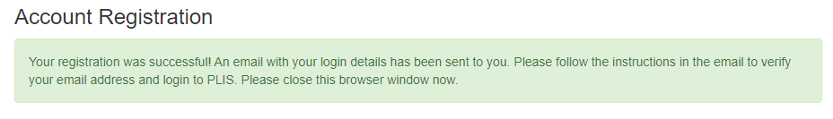
Step 4: Confirm your registration  - You will receive a verification email to your nominated email address.  - Open the account verification email.  - Select the ‘Click here’ link to verify your account. The PLIS public calendar will launch.  - Log into your account.  - The system message ‘Your email address was verified’ will display, you can now search and register for an event. | 