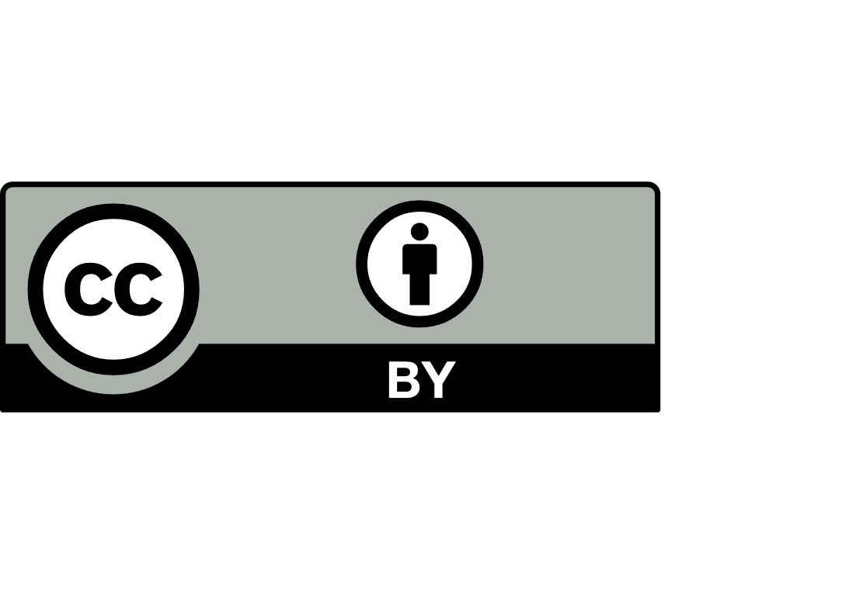
Community based course provider request
Non-Government School Regulation

Introduction
The School Education Act 1999 (WA) recognises the right of every child in the state to receive a school education and acknowledges the importance of the involvement and participation of a child’s parents in the child’s education. A child must attend school until they are 18 years old, unless they are participating in other approved options, including other education, training, apprenticeships and employment, and courses approved by the Minister for Education.

These courses which the Minister may approve are known as community based courses (CBCs).

What is a community based course?
CBCs provide alternative options for young people, particularly those in the last 2 years of compulsory school age education (Years 11 and 12). They enable students to undertake activities which are better suited to their particular needs and interests in a different learning environment to mainstream and curriculum and re-engagement in education (CARE) schools.

CBCs enable young people to meet the requirement for completing compulsory education while continuing to develop their literacy, numeracy, social and life skills in a safe and secure environment that is comfortable for them and conducive to learning.

CBCs are approved for a specified provider at a specified location or locations, for a set period of time.
They are prescribed by the Minister and their details are published in the Government Gazette. The Department of Education provides advice to the Minister about CBCs.

What standards does a community based course have to meet?
The Minister has established Guidelines for Community Based Courses to assist providers to understand the types of things the Minister will consider when assessing a provider’s application to establish a CBC. Recognising that every CBC is different, these are guidelines only, and each applicant is assessed on a case-by-case basis.

The guidelines clearly establish an expectation that a student’s participation in a CBC will be in their interests. Fundamentally, all CBCs must be safe for students, and must provide a service which meets students’ needs.

A CBC must be conducted at all times in the manner described in the application. Failure to do so may result in the Minster withdrawing the CBC’s approval.

The guidelines also specify that a CBC must meet the requirements of the applicable registration standards for non-government schools. In general, it is expected that the standards identified within the request will be applicable to a CBC.
Establishing, renewing or changing a community based course
Applications to establish a new CBC, or to renew or change an existing CBC, must be made to the Department of Education’s Non-Government School Regulation directorate using this application form.

Provider request
Submission of this request to prescribe a new, renew or change a course enables the Minister for Education to assess a proposed provider’s compliance with:
- School Education Act 1999
- Guidelines for Community Based Courses as approved by the Minister on 19 July 2019
- applicable Standards for non-government schools (2024).
The Minister’s assessment about course prescription takes into account relevant information about the provider and the course or courses.

How to complete this application
- Complete the provider and course details in part A, record responses in part B and sign the submission statutory declaration.
- Attach or provide hyperlink references for all documents identified in part B.
- Submit parts A and B along with all documents to us.

Supplementary evidence
Following submission of parts A, B and associated documentation, you may be asked to provide further information.

Provider visit
To facilitate the assessment of an application, a video conference or visit may be required. If a video conference or visit is to be undertaken, you will be advised of the scheduled date well in advance.

Closer to the date of the visit, we will contact you to discuss the aspects of assessment that will be the focus of discussions for the visit or video conference.

Collection notice
We collect personal information for the purpose of administering key clauses of the School Education Act 1999 and the School Education Regulations 2000 and make recommendations to the Director General of the Department and Minister for Education about provider requests.

We will use the information to register, assess and monitor your request and ongoing responsibilities. Information may be shared with authorised Department staff and, where necessary, other agencies or parties as permitted or required by law. Your information will be stored securely within Australia with access restricted to authorised staff. Personal information is retained and disposed of following the Department’s Records Management policy and the State Records Act 2000.

If the information is not collected we cannot assess your provider request. You may request access to, or correction of, your information by contacting the Non-Government School Regulation directorate (NGSRegulation@education.wa.edu.au). For further information about how we handle personal information, refer to the directorate’s Collection notice for non-government school regulation and our Privacy statement.

Submission:

We encouraged you to create a folder within your preferred cloud sharing platform and email a link to the submission to NGSRegulation@education.wa.edu.au.

Enquiries:
Telephone: (08) 9441 1900
Email: NGSRegulation@education.wa.edu.au

Part A – applicant details

Registered legal entity
Head office (in Australia)
Name of provider | Click or tap to enter text.
Type of legal entity | Click or tap to enter text.
Street address | Click or tap to enter text.
Suburb | Click or tap to enter text. |  |  |  |  | Postcode |  | Click or tap
Postal address (if different to street address) | Click or tap to enter text.
Suburb | Click or tap to enter text. |  | State |  | Click or tap | Postcode |  | Click or tap
Australian Business Number (ABN) or Australian Company Number (ACN) |  | Click/tap to enter text.
Registered Business Name | Click or tap to enter text. |  |  | Telephone number |  |  | Click or tap to enter text.
Email address | Click or tap to enter text. |  |  | Website address |  |  | Click or tap to enter text.
Contact name | Click or tap to enter text. |  |  | Telephone number |  |  | Click or tap to enter text.
Contact email address | Click or tap to enter text.

Course details
Course name |  | Click or tap to enter text.
Course overview 
Click or tap to enter text.
Course locations
Street address | Click or tap to enter text.
Suburb | Click or tap to enter text. |  | Postcode | Click or tap to enter text.
Third party arrangements
Click or tap to enter text.

Required Documents

Separate schedule of other provider course locations for which assessment is sought.

Third party arrangement agreements.

Part B – responses and declarations

Guidelines for Community Based Courses (CBC)
Considerations
- Given the educational, social, emotional and/or life skills needs of the students the provider proposes to serve, what does the provider consider comprises a suitable learning environment?
Click or tap to enter text.
How does the provider engage other services to support the needs of students? 
Click or tap to enter text.
How does the provider ensure that students with special needs and/or disabilities make satisfactory progress?
Click or tap to enter text.
How does the provider support consistent improvement for students with low attainment?
Click or tap to enter text.
How does the provider ensure that students are well prepared for the next stage of their education, employment or training?
Click or tap to enter text.

Required Documents
- Policies, procedures and other documents relevant to the processes identified above

- How does the legal entity (provider) identify onsite and offsite  risks to the provision of satisfactory levels of care to students?
Click or tap to enter text.
How does the provider ensure that it adequately mitigates these risks?
Click or tap to enter text.

Required Documents
- Policies, procedures and other documents relevant to the processes identified above

- How are conflicts of interests managed by the provider (check all which apply)?
☐ | The constitution or policy specifies how conflicts of interests are to be managed
☐ | Conflicts of interest are a standing item for provider meeting minutes
☐ | Conflicts of interest are noted in provider meeting minutes
☐ | A member is required to withdraw during provider discussion of a matter about which the member has a conflict of interest
☐ | The provider maintains a register of members’ conflicts of interests
☐ | Other (specify): Click or tap to enter text.

Required Documents
- Provide meeting agendas including reports relating to CBC operation and outcomes along with minutes for past twelve months
- Strategic plan
- Constitution
- Any policy referred to in Consideration 3

- How does the provider ensure staff engaged in management roles including those elected to a board of governance are fit and proper persons with relevant qualifications and experience?
Click or tap to enter text.
Refer to ‘Standards’ section below.
No questions for this consideration, however attachments as below.

Required Documents
- Most recent audited financial statements, independent audit report, independent auditor’s management letter, and management responses to the letter.
- A schedule of loan agreements is required, including loans made to and by the provider, all external commercial loans with financial institutions, any private loans with individuals or businesses, and any loans with provider members or employees. The schedule should include a description of the loan, interest rate, interest principal payments and the outstanding balance.
- A schedule of property lease or rental agreements is required, including the length of the lease or rental agreement and the annual cost of accommodation services.
- Current year’s budget and forecast budgets providing information about predicted future enrolment trends, income, expenditure and cash flow.
- Public liability, professional indemnity, building insurance and all other risk policies.

- How has the proposed provider identified the needs of the proposed cohort are not already met by existing alternatives reasonably available to those students (not applicable for renewal of prescribed course or courses)?
Click or tap to enter text.

Standards
Curriculum 1.3
  - How does the provider establish a programme of study to meet the needs of each student delivered through an individual education plan?
Click or tap to enter text.
1.2 How and how often does the provider monitor and adjust strategies to support student progress based on the individual education plan?
Click or tap to enter text.

Required Documents
- Teaching and learning plans for students in the final 2 years of their compulsory education period or above as permitted by law 
- Assessment and reporting policy
- De-identified Individual Education Plans
- De-identified sample reports/course progress documentation to parents for students in the final 2 years of their compulsory education period or above as permitted by law

Staff to student ratios 2.1
2.1 Please specify the staff to student ratio based on delivery of the course
Total number of students | Click or tap to enter text.
Total number of staff  | Click or tap to enter text.
Registered teachers | Click or tap to enter text.
Trainers | Click or tap to enter text.
Education support  | Click or tap to enter text.
Non-teaching | Click or tap to enter text.

Days and hours of instruction 3.4
  - Outline the number of hours each student will be expected to attend to meet course requirements.
Click or tap to enter text.

Staff 4.1, 4.4-4.5
4.1 How does the provider ensure:
Describe process or insert policy name
ongoing compliance with teacher registration (if applicable) and working with children law in relation to staff and volunteers. |  | Click or tap to enter text.
all new staff, including staff who commence after the beginning of the provider year, are inducted into:  - the code of conduct  - student safety and wellbeing policies, procedures and practices  - mandatory reporting law. |  | Click or tap to enter text.
professional development of all staff |  | Click or tap to enter text.
staff performance is monitored and managed |  | Click or tap to enter text.
Premises and facilities 5.1, 5.3-5.5
5.1 How does the provider ensure:
Describe process or insert policy name
compliance with the Building Code of Australia and local planning regulations | Click or tap to enter text.
compliance with occupational health and safety requirements | Click or tap to enter text.
the premises and facilities, are safe and well maintained (including for boarding students if applicable) | Click or tap to enter text.
vehicles used for student transport, including, as applicable, contracted vehicles, vehicles owned by the provider and/or parent/staff vehicles are safe and well-maintained including Department of Transport annual inspections | Click or tap to enter text.

the premises and facilities are sufficient and appropriate for the provision of a satisfactory standard of education and satisfactory levels of care, including for boarding students (if applicable) | Click or tap to enter text.

Required Documents
- Policies for premises and facilities

Enrolment and attendance procedures 6.1

Required Documents
- Policies for enrolment and attendance

Critical and emergency incidents 7.1
7.1 How does the provider respond to critical and emergency incidents including those as defined in the standards?
Click or tap to enter text.
7.2 How does the provider ensure that incidents are managed in such a way as to give highest priority to the best interests of students, minimise trauma and distress to students and ensure the education program is maintained or resumed?
Click or tap to enter text.
7.3 How does the provider document the reporting and management of incidents?
Click or tap to enter text.

Required Documents
- Policies for managing critical and emergency incidents

Boarding 8.1-8.4
Only for providers with boarding facilities.
8.1 Describe the process undertaken for consulting with boarding students, the topics on which students were consulted, and the extent of agreement reached.
Click or tap to enter text.

Required Documents
- Policies specific to boarding students, including recruitment of boarding supervisory staff.

Complaints 9.1-9.2
9.1 Where are the following items satisfied in the provider’s complaint handling policy?
Page or section
number if applicable
roles and responsibilities of leadership, staff and volunteers | Click or tap to enter text.
approaches to dealing with different types of complaints | Click or tap to enter text.
obligations to act and report, including to relevant authorities, whether or not the law requires reporting, and co-operates with law enforcement. | Click or tap to enter text.
9.2 How does the provider ensure each of the following in respect of the complaints system?
Specify relevant policy or other documents and page or section or provide a brief description.
Click or tap to enter text.
is understood by children and young people, staff, families and volunteers | Click or tap to enter text.
is culturally safe | Click or tap to enter text.
complaints are taken seriously, and responded to promptly and thoroughly | Click or tap to enter text.
conforms to the rules of procedural fairness | Click or tap to enter text.
ensures reporting, privacy and employment law obligations are met. | Click or tap to enter text.
complaints are analysed to identify causes and systemic failures so as to inform continuous improvement | Click or tap to enter text.
9.3 How does the provider inform the community of its complaints process and the results of reviews undertaken?
Click or tap to enter text.

Required Documents
- Policy(s) for managing complaints.
- Any other policy(s) or other document referred to above.
- Any publications referred to above.

Preventing and responding to child abuse 10.1-10.2, 10.4-10.10
10.1 Describe the steps taken by the provider to implement the National Child Safe Organisation Principles as they relate to the student cohort?
Click or tap to enter text.
10.2 Describe the process undertaken for consulting students in the review of child safety policies, procedures and practices, including the topics on which students were consulted, and the extent of agreement reached?
Click or tap to enter text.
10.3 Where are the following items in the provider’s code of conduct?
 | Page or section number if applicable
applies to all staff, provider members and volunteers, and boarding staff (if relevant) | Click or tap to enter text.
requires reporting of objectively observable behaviour which breaches or is suspected of breaching the code, other than those subject to mandatory reporting obligations, to the person in charge of the provider, a designated senior staff member, or the chair of the provider | Click or tap to enter text.
assures protection from victimisation or other adverse consequences if reports are made in good faith | Click or tap to enter text.
10.4 How does the provider ensure that the code of conduct is consistent with the:
- Australian Human Rights Commission Example Code of Conduct
- National Child Safe Organisation Principles.
10.5 Which of the following required items about child safety professional learning are satisfied?
☐ | Delivered to all people to whom the code of conduct applies
☐ | Covers the law with respect to mandatory reporting of child sexual abuse (if applicable)
☐ | Covers the provider’s policies, procedures and practices for ensuring children’s safety  and wellbeing at the provider and during provider related activities (including child-safe  physical and online environments)
10.6 How does the provider ensure that all people to whom the code of conduct applies receive at least annual child safety professional learning, including people who may be absent during scheduled sessions?
Click or tap to enter text.

10.7 Where are the following items in the provider’s student code of conduct?
Page or section number
if applicable
Sets out minimum standards of conduct | Click or tap to enter text.
Prohibits bullying, harassment and other forms of peer-to-peer abuse | Click or tap to enter text.
Requires respect for the privacy and human dignity of other students, and boarders (where relevant) | Click or tap to enter text.
10.8 Describe the process undertaken for consulting students in the development/review of the student code of conduct, including the topics on which students were consulted, and the extent of agreement reached?
Click or tap to enter text.
10.9 Which of the following required items about records of complaints, allegations and findings related to grooming and child abuse, whether involving former or current staff or student records, are satisfied?
☐ | contain as much detail as possible
☐ | stored securely
☐ | retained permanently

Required Documents
- Code of conduct consistent with the Example Code of Conduct
- Student code of conduct
- Policies relevant to child abuse prevention, reporting and response
- Schedule of review for policies, procedures and practices relevant to child abuse prevention, reporting and response
- Schedule of learning opportunities about child abuse prevention matters for those to whom the Code of Conduct relates

Management of students’ behaviour 12.1-12.3
12.1 Please list all provider publications (and page/section numbers) which explicitly forbid the use of any form of child abuse, corporal punishment or other degrading punishment and define each of those terms?
Click or tap to enter text.

Required Documents
- All publications referred to above
Part C– Registers and declarations

Register of all persons concerned in the management and control of the legal entity
Start date | Title  (for example, Dr, Mr, Ms) | Full legal name | Position within legal entity or course provision business
Click or tap to enter a date. | Click or tap here to enter text. | Click or tap here to enter text. | Click or tap here to enter text.
Click or tap to enter a date. | Click or tap here to enter text. | Click or tap here to enter text. | Click or tap here to enter text.
Click or tap to enter a date. | Click or tap here to enter text. | Click or tap here to enter text. | Click or tap here to enter text.
Click or tap to enter a date. | Click or tap here to enter text. | Click or tap here to enter text. | Click or tap here to enter text.
Click or tap to enter a date. | Click or tap here to enter text. | Click or tap here to enter text. | Click or tap here to enter text.
Click or tap to enter a date. | Click or tap here to enter text. | Click or tap here to enter text. | Click or tap here to enter text.
Click or tap to enter a date. | Click or tap here to enter text. | Click or tap here to enter text. | Click or tap here to enter text.
Click or tap to enter text. |  | Click or tap to enter a date.
Name of board chair or applicant | Signature | Date

Submission of provider request
This request is made by me on behalf of Click or tap to enter text..
I certify that, to the best of my knowledge and belief, all the information provided in and with this application is true and correct and that the provider complies with the requirements of the School Education Act 1999 and all other state and Australian Government legal requirements associated with its operation.

Signed for and on behalf of the provider by:

Click or tap to enter text. |  | Click or tap to enter text. |  |  |  |  | Click or tap to enter a date.
Name |  |  | Position |  | Signature |  |  | Date

