Department of Education
Annual Report
2018–19

Accessible version - The accessible profile is customised for a text-only screen reader such as JAWS.

Copyright and catalogue information

This report is made available under the terms of the Creative Commons Attribution Non-Commercial No-Derivatives 4.0 International license unless it is Excluded Material.

Excluded Material: The Government of Western Australia and Department of Education logos, other logos, student images, third party works and trade mark protected material are not licensed under a Creative Commons licence and may only be reproduced as part of this publication. Any further use of Excluded Material requires the specific permission of the owners of that material.

If you wish to reproduce this work in whole or part for commercial purposes or with changes, please telephone our general enquiries number on 9 2 6 4 4 1 1 1.

This report can be downloaded as an accessible Microsoft© Word version for text-only screen readers and is available online. It is also available on request in other alternative formats.

Department of Education Annual Report 2018–19
ISSN: 1449–0315 (Print)
ISSN: 1843–2396 (Web)
SCIS No: 1155879
© Department of Education 2019

OVERVIEW 4
Statement of compliance 4
Director General’s foreword 5
About us 7
Executive summary 11
Our structure and senior staff 16
Governance framework 28
Significant issues for the next financial year 31
OUR PERFORMANCE 33
Providing public education 33
Contemporary curriculum and assessment 34
High quality teaching 44
Effective leadership 46
Good governance 49
Safe, healthy and resilient learners 57
Strong partnerships and collaboration 61
As a regulator and funder 63
Contemporary curriculum and assessment 63
High quality teaching, effective leadership and good governance 63
Safe, healthy and resilient learners 66
Strong partnerships and collaboration 67
DISCLOSURES AND LEGAL COMPLIANCE 68
General disclosures 68
Compliance with public sector standards and ethical codes 76
Occupational safety, health and injury management 81
Staff 85
Major capital works 90
TEACHER REGISTRATION BOARD OF WESTERN AUSTRALIA ANNUAL REPORT 2018–19 94
KEY PERFORMANCE INDICATORS AND FINANCIAL STATEMENTS 112
Key performance indicators 104
Financial statements 112
APPENDICES 113
1. Student enrolment 113
2. NAPLAN results 120
3. Student participation, achievement and satisfaction 124
4. Staffing 130
5. Changes to our Outcomes Based Management reporting structure 132
6. Annual estimates for 2019–20 135

OVERVIEW

This report details our achievements and successes as well as the challenges we face and the opportunities ahead. It also outlines our contribution to broader Government desired outcomes and compliance with legislation and policy.

The report addresses reporting requirements in Treasurer’s Instruction 903: Agency Annual Reports and the Western Australian Public Sector Commission’s Annual reporting guidelines.

Activities and performance for the 2018–19 financial year are in the context of our strategic outline, strategic plan for public schools, State Government budget papers and other strategy documents.

This report includes the annual report of the Teacher Registration Board of Western Australia. Public school annual reports by calendar year are published on Schools Online.

This report uses the term ‘Aboriginal' to respectfully and inclusively refer to Aboriginal and Torres Strait Islander people.

Reference to parents is inclusive of caregivers, families and extended families with responsibility for the care of their children.

Statement of compliance

Hon Sue Ellery MLC
Minister for Education and Training

In accordance with section 63 of the Financial Management Act 2006, I hereby submit for your information and presentation to Parliament the annual report of the Department of Education for the financial year ended 30 June 2019.

The report has been prepared in accordance with the provisions of the Financial Management Act 2006.

In accordance with section 114 of the Teacher Registration Act 2012, the annual report of the Teacher Registration Board of Western Australia for the financial year ended 30 June 2019 is included in this report.

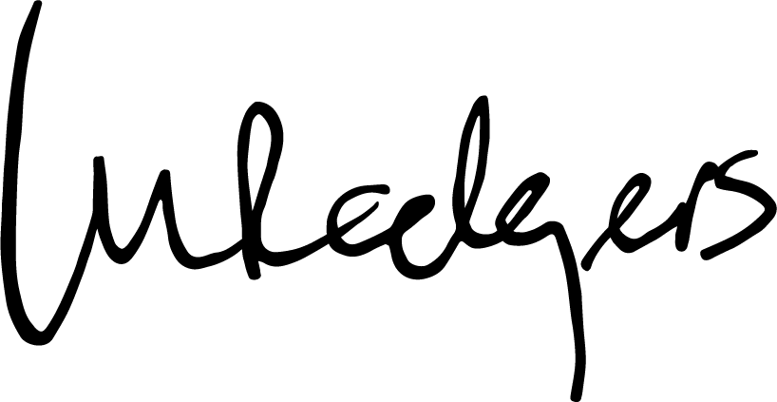
Lisa Rodgers
Director General
(Accountable Authority)

20 September 2019

Director General’s foreword

Following my appointment as Director General in January 2019, I am pleased to present my first annual report.

I would like to take this opportunity to acknowledge Ms Jennifer McGrath for her valuable contribution and stewardship as Acting Director General until 28 January 2019, following the departure of Ms Sharyn O’Neill in July 2018.

During the year we continued to implement a number of the State Government’s election commitments in relation to public schools, including more teachers and education assistants in classrooms.

We also began developing a plan, in collaboration with other agencies, to meet the State Government’s Our Priorities targets. Under the banner of A Bright Future, we are leading the shared effort to achieve specific targets to improve the health and wellbeing of children in the early years, increase students’ knowledge and skills in reading and numeracy, and increase participation in science, technology, engineering and mathematics (STEM).

We continued to work closely with the School Curriculum and Standards Authority, Teacher Registration Board of Western Australia, and the Training Accreditation Council (until 31 December 2018) to ensure they were provided with secretariat services.

With an ever-growing infrastructure portfolio requiring ongoing maintenance and minor works, we continued an extensive capital works program to ensure the best learning environments and experiences for students, staff and school communities, including specialist facilities for students with special education needs.

Ensuring the safety and wellbeing of our principals, staff and students remained a priority as we rolled out a range of strategies, including resources for principals and school communities in addressing challenging behaviours of some students.

We also launched our comprehensive Leadership Strategy and system of public school reviews focused on building the capacity of our school leaders.

In presenting this report, I want to acknowledge and thank our staff for their commitment to our strategic directions and in delivering high quality education and care to students across the State. I also acknowledge and thank all the partners who contributed to our work this year.

Lisa Rodgers
Director General

About us

We have a role in influencing the education of all students in Western Australia and enact this in different ways in line with relevant legislation – directly through a system of public schools and indirectly through regulation and funding of Catholic and Independent schools.

Regardless of these differences, the aim is the same: to deliver a high quality education to all students in all learning environments. We are committed to all students achieving their best and being lifelong learners who contribute actively to their communities and to society.

We recognise and respect the independence of Catholic and Independent schools; and undertake our responsibilities to all schools, systems and sectors with diligence and integrity. We are impartial in our role as a regulator and funder.

Our vision

All students in Western Australia, regardless of background and across all schools and learning environments, reach their learning and achievement potential.

To achieve this vision, we work to deliver our aspirations across six key objectives. The tools and approaches we use to deliver these aspirations are different for the provision of public education and for the regulation and funding of Catholic and Independent schools.

Our objectives

Contemporary curriculum and assessment
Curriculum and assessments meet the needs of students and deliver contemporary learning experiences for students to become confident, creative learners and active, informed citizens.

High quality teaching
All teachers are supported, developed and challenged to be their best and to deliver differentiated curriculum to students that enhances their learning experiences.

Effective leadership
School leaders have high aspirations for their students and teachers, and drive improvement in student outcomes using evidence-based practice.

Good governance
Schools and school systems are governed effectively to ensure appropriate standards are delivered.

Safe, healthy and resilient learners
Students are healthy and resilient, and all schools and learning environments are child safe organisations.

Strong partnerships and collaboration
Schools, school sectors and systems work together to improve outcomes for all students.
Our values

Learning
We have a positive approach to learning and encourage it in others.
We advance student learning based on our belief that all students have the capacity to learn.

Excellence
We have high expectations of students and ourselves. We set standards of excellence and strive to achieve them. The standards and expectations challenge all of us to give our best.

Equity
We recognise the differing circumstances and needs of students and are dedicated to achieving the best possible outcomes for all. We strive to create workplaces and learning environments that are free of discrimination, abuse and exploitation.

Care
We treat all individuals with care. Our relationships are based on trust, mutual respect and the acceptance of responsibility. We recognise the value of working with parents and the wider community to provide a high quality education for students.

Integrity
We act with integrity, responsibility and transparency in all that we do.

Respect
We treat everyone fairly, and we treat all schools, school systems and school sectors with respect.

Operational structure

Our Minister is Hon Sue Ellery MLC, Minister for Education and Training.

Our accountable authority in 2018–19 was Ms Sharyn O’Neill, from 1 July to 29 July 2018; Ms Jennifer McGrath (Acting) from 30 July 2018 to 27 January 2019; and Ms Lisa Rodgers, from 28 January to 30 June 2019.

Our enabling legislation is the Public Sector Management Act 1994 in which the Department of Education is established under section 35.

We are responsible for the following legislation in accordance with the allocation of legislation to portfolios, Western Australian Government Gazette 3 July 2017:
- Curriculum Council (Fees and Charges) Act 2006
- Curtin University Act 1966
- Edith Cowan University Act 1984
- Education Service Providers (Full Fee Overseas Students) Registration Act 1991
- Hale School Act 1876
- Higher Education Act 2004
- Murdoch University Act 1973
- School Curriculum and Standards Authority Act 1997
- School Education Act 1999
- Teacher Registration Act 2012
- University Colleges Act 1926
- University of Notre Dame Australia Act 1989
- University of Western Australia Act 1911
- Vocational Education and Training Act 1996 Part 4.

We provided staff, facilities and resources to a number of entities created under legislation enacted by the Western Australian Parliament or by Ministerial administrative action:
- Non-Government Schools Planning Advisory Panel
- Non-Government Schools Registration Advisory Panel
- Rural and Remote Education Advisory Council
- School Curriculum and Standards Authority
- Training Accreditation Council (from 1 July to 31 December 2018)
- Teacher Registration Board of Western Australia
- Western Australian Higher Education Council.

The Training Accreditation Council secretariat function was transferred to the Department of Training and Workforce Development from 1 January 2019.

Performance management framework
Government Goal
Strong Communities: Safe communities and supported families

Desired Outcome
School students across Western Australia have access to high quality education

Services
- Public Primary Education
- Public Secondary Education
- Regulation and Non-Government Sector Assistance
- Support to the School Curriculum and Standards Authority

These services are as per our new Outcomes-Based Management (OBM) reporting structure, which was approved in 2018–19 to better reflect our current operations. Further information on the changes to our OBM reporting structure is in Appendix 5.

Our strategic directions

Our strategic outline reflects the role of the Department in influencing the education of all students in Western Australia and how this is enacted in line with relevant legislation.

Our strategic plan for public school education from 2016 to 2019, High Performance – High Care, focuses our improvement efforts directly on student learning. It sets expectations for the creation of a culture of high performance and high care in every school, and in regional and central offices to enable us to achieve the best outcomes for students.

To provide specific directions for public education each school year, we published Focus 2018 and Focus 2019. Aligned to our strategic plan, these documents provided direction for public schools and the Department.

Executive summary

Our students and schools in 2019
Infographics page displaying the following information:
460,035 students were enrolled in Western Australian (WA) schools. This included 311,199 students in public schools and 148,836 students in non-government schools. 67.6% of WA students were enrolled in public schools.
1,121 schools across eight education regions. We were responsible for 812 public schools, including opening three new schools. There were 309 non-government schools.
75.8% of public school students were in metropolitan schools, 16.9% were in regional schools, 7.4% were in remote or very remote schools.
26,002 (83.9%) of WA’s 31,007 Aboriginal students were enrolled in public schools.
37,926 full-time equivalent staff were employed in public schools; nearly 97% of all our staff.
See Appendix 1 for further enrolment data.
Year scorecard

We supported our Government Goal – Strong Communities: Safe communities and supported families – through our desired outcome ‘School students across Western Australia have access to high quality education’.

Key performance indicators helped us assess and monitor the extent to which we achieved this outcome and enhanced our ability to account to the community for our performance.

Effectiveness indicators (see note a) | Target (see note b) | Result
Rate of participation in education (proportion of persons aged 15 to 17 years in some form of education) | 97% | 98.0%
Retention in public schooling (proportion of Year 8 public school cohort studying in Year 12) | 81% | 81.4%
Western Australian Certificate of Education (WACE) achievement rate by Year 12 public school students | 80% | 80.5%
Year 3 public school students achieving proficiency in:  - Reading | 68% | 70.0%
Year 3 public school students achieving proficiency in:  - Numeracy | 68% | 69.2%
Year 5 public school students achieving proficiency in:  - Reading | 66% | 68.4%
Year 5 public school students achieving proficiency in:  - Numeracy | 65% | 66.3%
Year 7 public school students achieving proficiency in:  - Reading | 63% | 64.3%
Year 7 public school students achieving proficiency in:  - Numeracy | 62% | 62.1%
Year 9 public school students achieving proficiency in:  - Reading | 66% | 71.1%
Year 9 public school students achieving proficiency in:  - Numeracy | 66% | 70.5%
Efficiency indicators | Target (see note b) | Result
Service 1: Public Primary Education  - Cost per student full-time equivalents | $15,384 | $15,242
Service 2: Public Secondary Education  - Cost per student full-time equivalents | $18,870 | $18,488
Service 3: Regulation and Non-Government Sector Assistance  - Cost of non-government school regulatory services per non-government school | $7,824 | $6,747
Service 3: Regulation and Non-Government Sector Assistance  Cost of teacher regulatory services per teacher | $107 | $110
Service 4: Support to the School Curriculum and Standards Authority  - Cost per student of support to the School Curriculum and Standards Authority | $75 | $77
(a) To achieve proficiency, students must meet much higher standards of reading and numeracy than the national minimum standards reported under our old Outcomes Based Management (OBM) reporting structure. See Appendix 2 for our 2018 results against national minimum standards.
(b) Targets for 2018–19 for our new OBM reporting structure are as reported in the 2019–20 State Budget.
Further information is in Key performance indicators.
Year in dollars

The total cost of providing our services in 2018–19 was $5.5 billion. Figures 1 and 2 summarise sources of revenue and cost of services. Full details of financial performance during 2018–19 are in the Financial statements.

Figure 1: Revenue sources 2018–19
Revenue sources presented as a pie chart. In 2018–19, Revenue sources were as follows: 79.15% Income from State Government, 15.66% Australian Government grants and contributions, 2.61% User contributions, charges and fees, 2.20% Other revenue, and 0.37% Interest revenue.
Source: Education Business Services

Figure 2: Costs 2018–19
Costs presented as a pie chart. In 2018–19, Costs were as follows: 70.34% Employee benefits expense, 16.40% Supplies and services, 8.53% Asset revaluation decrement, 3.42% Depreciation and amortisation expense, 0.60% Grants and subsidies, 0.56% Finance costs, and 0.14% Other expenses.
Source: Education Business Services
Our results in 2018–19 against agreed financial targets (based on Budget Statements and the Resource Agreement) are in Table 1.

Table 1: Budget targets compared to actual results 2018–19 (see note a)
 | 2018–19 budget  ($’000) | 2018–19 actual  ($’000) | Actual vs budget  ($’000)
Total cost of services | 5,090,961 | 5,494,485 | 403,524
Net cost of services | 4,045,542 | 4,411,809 | 366,267
Total equity | 14,343,354 | 13,648,178 | (695,176)
Net increase/(decrease) in cash held | (22,271) | 40,930 | 63,201
 | 2018–19 budget  (FTE) (see note b) | 2018–19 actual  (FTE) | Actual vs budget  (FTE)
Staff | 39,548 | 39,205 | (343)
Source: Education Business Services
(a) Results in brackets indicate a negative value.
(b) Full-time equivalent.

The overspend of $403.5 million (7.9%) in actual total cost of services to budget estimate total cost of services was due solely to a non-cash decrease in the value of land and buildings ($468.4 million). Without the decrease in the value of land and buildings, the Department underspent its budget by $64.9 million (1.3%). Partly offsetting the impact of the decrease in the value of land and buildings were the following:
- Lower supplies and services expenditure including lower direct school expenses, which was partly due to schools making more capital purchases for assets above $5,000 than projected.
- The Royalties for Regions funded Kimberley Schools Project expenditure was $6.8 million lower than the 2018–19 estimate due to the re-profiling of the project’s service delivery during the year.
- Depreciation was lower than the estimated actual due to changes in school building values.

The net cost of services of $4.4 billion was higher than the budget estimate by $366.3 million (9.0%) primarily due to the overspend of $403.5 million and revenue being $37.3 million (3.6%) higher than expected. The latter was mainly due to a higher than anticipated RiskCover Workers’ Compensation performance adjustment for 2015–16 and additional revenue generated by schools.

The decrease of $695.2 million in total equity compared with the budget estimate was mainly due to the $468.4 million decrement to land and buildings in 2018–19.

The 2018–19 average FTE of 39,205 was 343 FTE (0.9%) lower than the 2018–19 budget estimate due to slightly lower than expected student growth and the extension of the Voluntary Targeted Separation Scheme. Since 2015, funding for schools has been delivered through a one-line budget. This provides flexibility to determine how budgets are used to deliver the education programs and support their students, including staffing decisions which are made at the local school level.

Our structure and senior staff
At 30 June 2019
A full organisational chart is in Appendix 4.
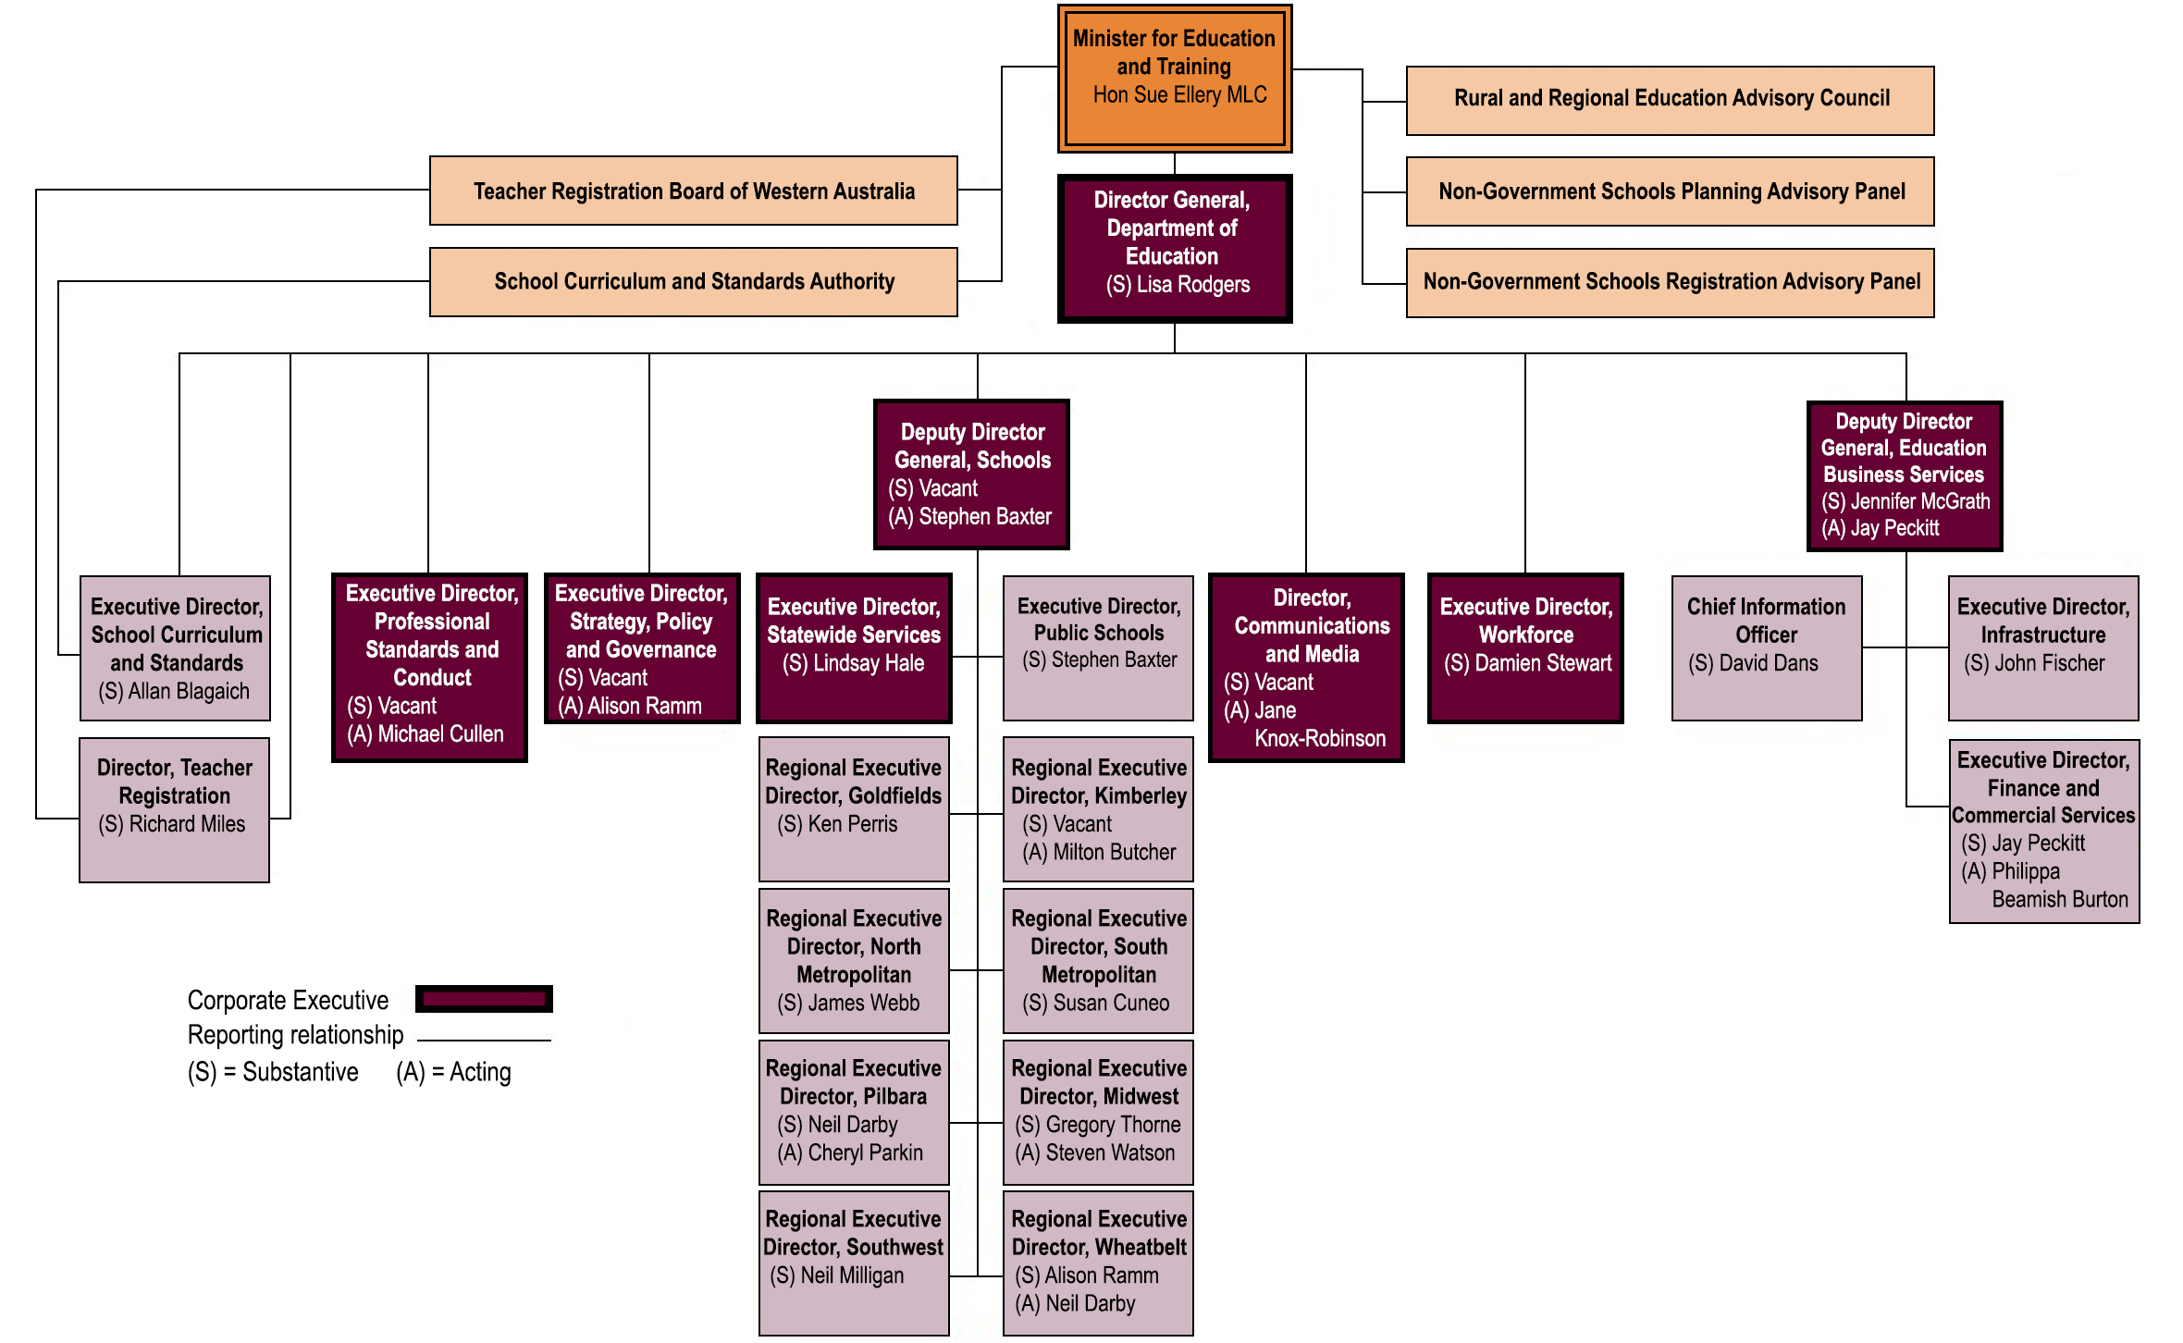
Our responsibilities at 30 June 2019

We realigned our structure during the year to better reflect our current operations, purpose and the intent of the Machinery of Government and other changes since 1 July 2017.

School Curriculum and Standards
- Secretariat services and support to the School Curriculum and Standards Authority

Teacher Registration
- Secretariat services and support to the Teacher Registration Board of Western Australia

Communications and Media
- Media and crisis communications
- Public relations and marketing
- Internal communications management

Professional Standards and Conduct
- Standards of staff professional conduct and integrity
- Internal audit and risk management
- Screening of criminal history records for staff
- Monitoring compliance with Working with Children legislation
- Management of allegations of staff misconduct
- Legal advice

Strategy, Policy and Governance
- Ministerial services and support
- Policy and governance framework
- System reform initiatives to support increased school autonomy, including leadership strategy
- Intergovernmental relations
- Coordination of the move to National Assessment Program – Literacy and Numeracy (NAPLAN) online
- School and system performance, evaluation, and accountability including student assessment and reporting
- Higher education
- International education
- Public school planning

Schools
- Non-government school registration and regulation
- School performance and effectiveness reviews
- Leadership in regions
- Residential colleges
Statewide Services
- Support and services for students and schools in curriculum, student behaviour and wellbeing, inclusive education, literacy and numeracy, and pathways
- Online learning including contemporary teaching and learning technologies and systems
- Support for schools to meet the needs of Aboriginal students
- Policy and strategic planning in early childhood education
- Professional learning for staff

Workforce
- Human resource and recruitment consultancy services
- Workforce strategic policy
- Industrial relations matters
- Employee support services
- Compliance with public sector legislation related to employment

Education Business Services
- Strategic and operational financial management
- Public and non-government school funding
- Payroll and information management
- Contracting and procurement processes
- Capital works, maintenance programs and property services
- Asset planning
- Information and communication technologies services

Our senior staff at 30 June 2019

Corporate Executive

Lisa Rodgers – Director General

Lisa was appointed for the start of 2019.

Prior to joining the Department of Education, she was Chief Executive Officer of the Australian Institute of Teaching and School Leadership (AITSL). She has also held the positions of Deputy Secretary, Early Learning and Student Achievement and Deputy Secretary, Evidence, Data and Knowledge in the Ministry of Education in New Zealand.

With over 16 years’ experience in Education, Lisa has led significant reforms in assessment innovation, curriculum and the use of evidence for impact at the classroom and national level.

She has an Honours Degree in Psychology and has held several other substantial posts in Justice, Health and Defence.

Stephen Baxter – Acting Deputy Director General, Schools

Stephen took up this acting position in March 2018.

He is a qualified teacher and has more than 40 years’ experience in public education. Stephen has held a number of senior executive positions, including in regional Western Australia.

Jay Peckitt – Acting Deputy Director General, Education Business Services

Jay joined the Department in 2016 and has been in the Western Australian public sector for 16 years. He has held senior positions at the Department for Child Protection and Family Support and the Department of Finance.

He has a Bachelor of Business, is a Certified Practising Accountant, and in 2018 was named as the Public Sector Commission Young Leader of the Year and the Chief Financial Officer of the Year by the Institute of Public Administration Australia.

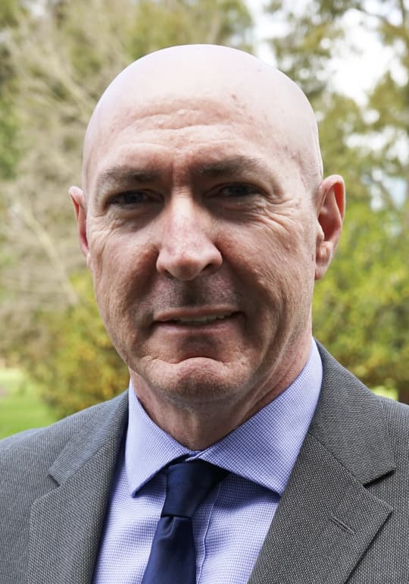
Mike Cullen – Acting Executive Director, Professional Standards and Conduct

Mike took up this acting position in 2018.

He joined the Department in 2012 with 21 years’ experience in public sector positions overseas and in Western Australia. Mike has held senior executive positions in a number of State Government agencies, including the Department of Justice and the Department of Corrective Services. He has a Bachelor of Arts (Hons) in Community Justice.

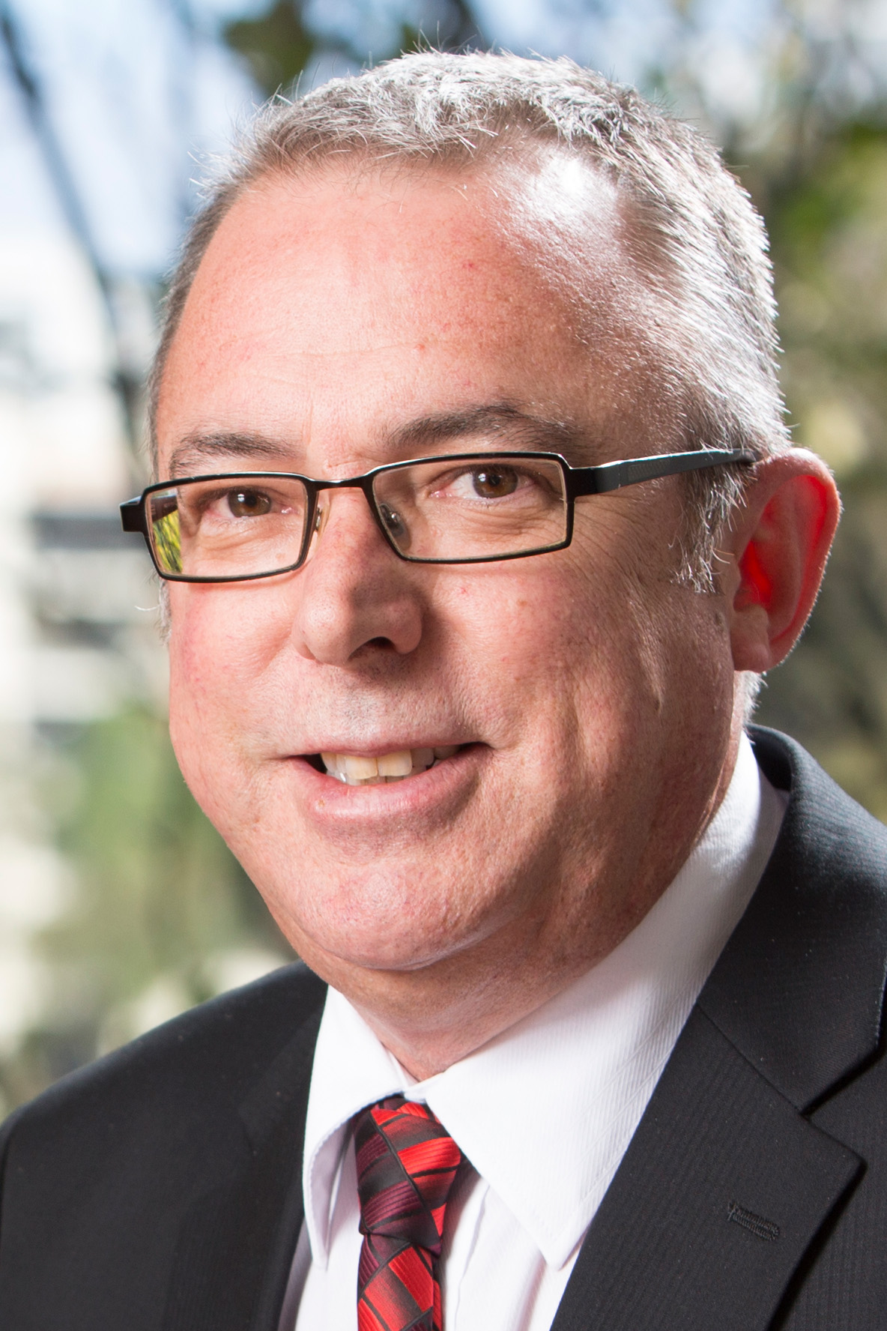
Lindsay Hale – Executive Director, Statewide Services

Lindsay was appointed to this position in 2014.

He joined the Department in 1984 as a teacher and worked in a range of positions before being appointed Principal of Belmont City College. Lindsay was foundation Managing Director of the then Institute for Professional Learning and has held a number of executive positions. He has a Master of Education Administration.

Alison Ramm – Acting Executive Director, Strategy, Policy and Governance

Alison took up this acting position in 2019.

She comes from her role as Regional Executive Director, Wheatbelt and other leadership positions that helped shape and implement significant reforms in school staffing, funding, resourcing, and autonomy. She also has teaching and leadership experience in schools across the State.

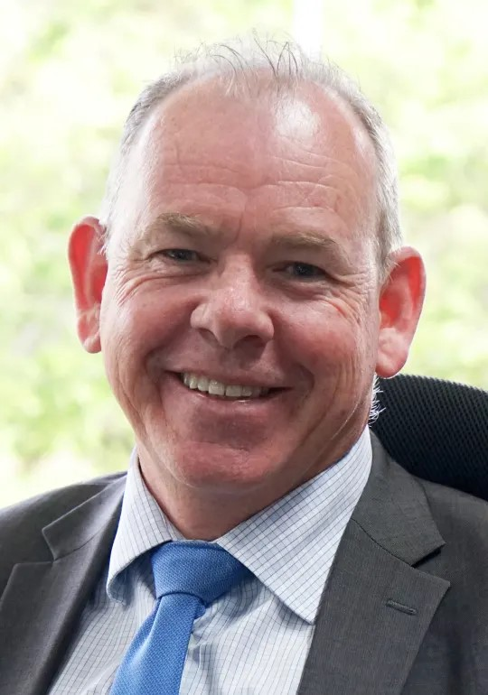
Damien Stewart – Executive Director, Workforce

Damien was appointed to this position in 2017.

He has more than 30 years’ experience in the State’s public sector across a number of Government agencies, including holding executive positions in the departments of the Premier and Cabinet, Child Protection and Family Support, and Corrective Services.

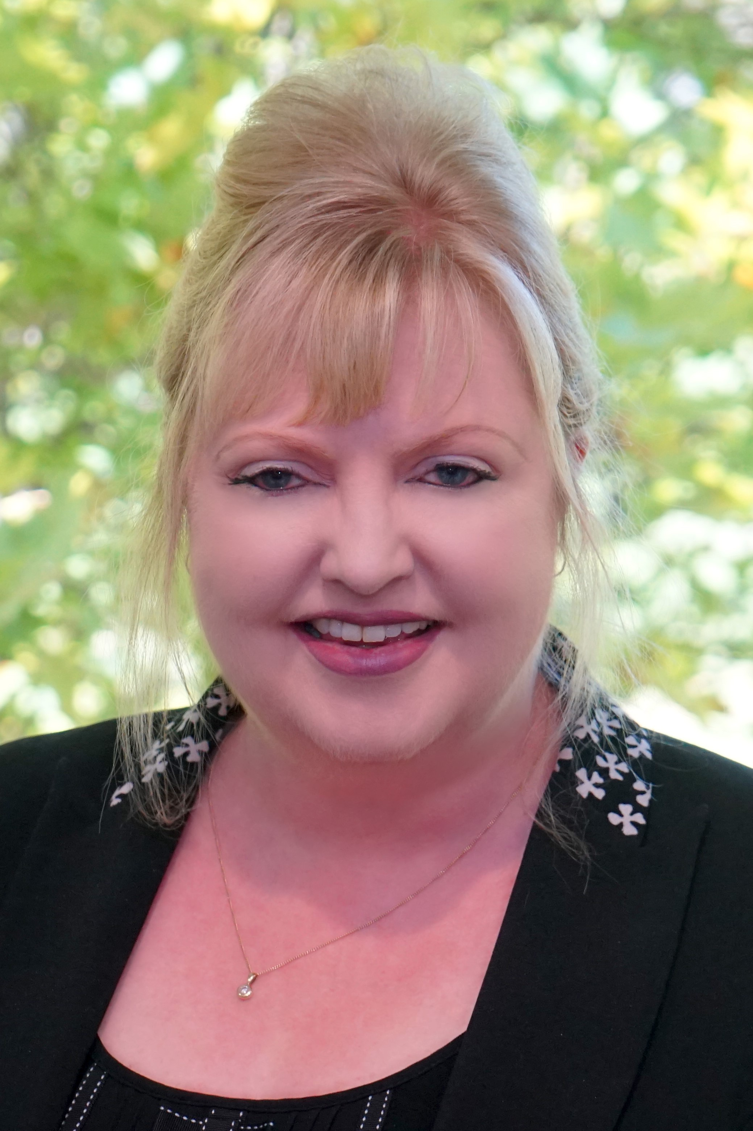
Jane Knox-Robinson – Acting Director, Communications and Media

Jane took up this acting position in October 2018.

She joined the Department in 2010 with over 20 years’ experience in communications and marketing in both the public and private sectors. Her professional experience includes education, vocational education and training, and community services.

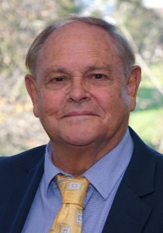
Kevin O’Keefe – Principal Advisor, Aboriginal Education Teaching and Learning

Kevin was co-opted as a member of Corporate Executive in May 2019 to provide advice and guidance drawn from his extensive experience in Aboriginal education in school and system contexts.

He has held a number of teaching and senior leadership positions in a range of schools, including leading a multi-campus remote community school in the Western Desert as Executive Principal of the Ngaanyatjarra Lands School. He was also an executive director in the former Department of Education and Training with oversight for Aboriginal education and training, and worked as a senior research officer at Edith Cowan University leading a national research project into Indigenous education.

Kevin is a Noongar person with roots in Yued country.

Other senior officers or division heads

Allan Blagaich – Executive Director, School Curriculum and Standards

Allan took up this position in 2017. Before this, he was Chief Executive Officer of the School Curriculum and Standards Authority, appointed in 2011.

He has many years’ experience in education leadership, having held executive roles in Statewide Planning and metropolitan public schooling. Allan is a board member of the Australian Curriculum, Assessment and Reporting Authority and chairs the Australasian Curriculum, Assessment and Certification Authorities' vocational education and training committee.
Philippa Beamish Burton – Acting Executive Director, Finance and Commercial Services

Philippa joined the Department in late 2017 as the Director, Financial Planning and Resourcing. With over 15 years’ experience in the Western Australian public sector she has held senior positions at the Department for Child Protection and Family Support and the Department of Communities.

She has a Bachelor of Business, is a Certified Practising Accountant, and in 2017 was named as the Finance Practitioner of the Year by the Institute of Public Administration Australia.

David Dans – Chief Information Officer

David was appointed to this position in 2017.

He has over 30 years’ experience working in the technology and commercial arena for public and private sectors in Australia and overseas. Before joining the Department, he was Chief Digital Officer at Landgate.

John Fischer – Executive Director, Infrastructure

John was appointed to this position in 2011.

He previously worked for the Department of Transport for five years and Main Roads Western Australia for 32 years.

Richard Miles – Director, Teacher Registration

Richard was appointed to this position in 2013.

He has a Master of Arts (Political Science), Bachelor of Laws and Graduate Diploma in Practical Legal Training.

Regional Executive Directors, Public Schools

Milton Butcher – Regional Executive Director, Kimberley

Milton has more than 30 years' experience with the Department in teaching and leadership positions in regional and metropolitan secondary schools.

He has also held positions in curriculum reform and the Year 7 to secondary initiative.

Susan Cuneo – Regional Executive Director, South Metropolitan

Sue was appointed to this position in 2016 after working as Pilbara Regional Executive Director since 2011.

She has more than 30 years’ experience as a teacher, deputy principal and principal in small remote schools, large metropolitan schools and district high schools. She has also held a director of schools position.

Neil Darby – Acting Regional Executive Director, Wheatbelt

Neil took up this position in 2019 coming from his role as Regional Executive Director, Pilbara. He was previously a director of schools review and a director in the Goldfields, Albany and Fremantle-Peel districts.

His teaching and leadership experience includes principalships of metropolitan, regional and remote schools, and consultant positions in science and Aboriginal education.

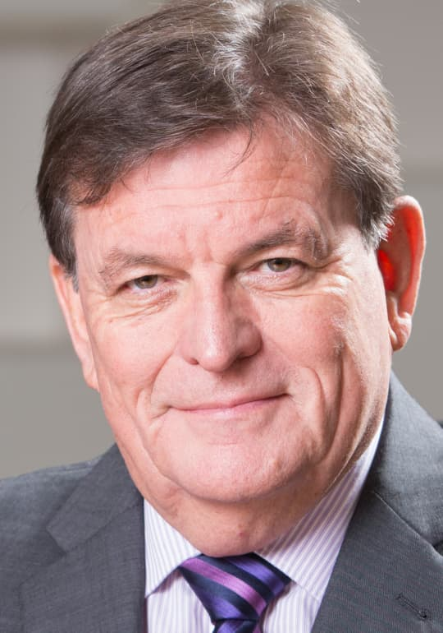
Neil Milligan – Regional Executive Director, Southwest

Neil was appointed to this position in 2011. His experiences as an education leader have covered the diversity of the State, ranging from the challenges of the Ngaanyatjarra Lands to the complexities of the growing southwest.

Cheryl Parkin – Acting Regional Executive Director, Pilbara

Cheryl took up this position in 2019 coming from her role as Principal of Piara Waters Primary School.

She has contributed to system-wide initiatives and reforms and brings to the role extensive experience as principal of primary schools in Piara Waters, Embleton, Boulder and Kalgoorlie. She has also been a project manager for a behaviour centre.

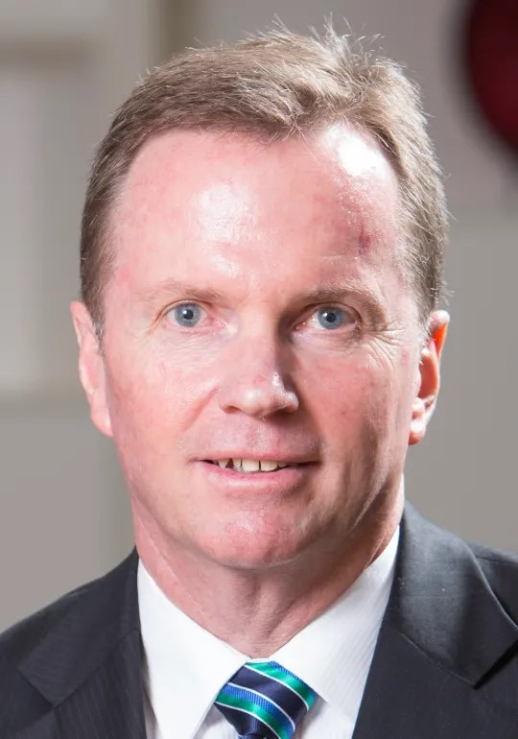
Ken Perris – Regional Executive Director, Goldfields

Ken was appointed to this position in 2013. Prior to this he was a director with the Expert Review Group.

He has more than 30 years’ experience with the Department, having had roles in teaching and leadership in rural, remote and metropolitan schools, as well as leadership development and other directorial roles.

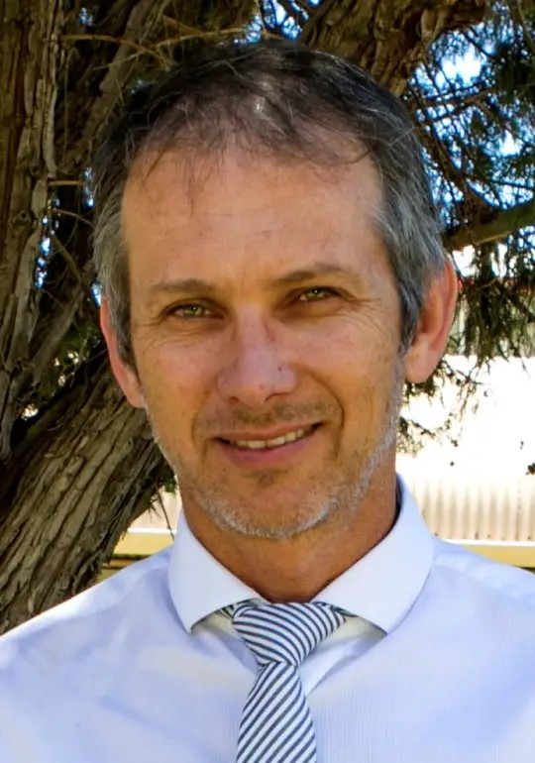
Steven Watson – Acting Regional Executive Director, Midwest

Steve took up this position in 2019 while Gregory Thorne was on leave.

Steve brings extensive experience to the role from both a school and system level as Principal of the School of Special Educational Needs: Behaviour and Engagement. He was part of the 2018–19 Principals’ Fellowship Program.

James Webb – Regional Executive Director, North Metropolitan

Jim was appointed to this position in 2011.

His experiences in the Department span more than 40 years as a teacher and principal in country and metropolitan schools, as well as in leadership roles in regional offices.

Senior officers who left the Department during 2018–19

- Sharyn O’Neill left the Department in July 2018 after 12 years as Director General. She was appointed Public Sector Commissioner.
- Jane Machin-Everill, Director, Executive and Communications Services (under the Department’s previous structure) left the Department in February 2019.
- Jennifer McGrath, Acting Director General and Deputy Director General, Education Business Services took up the opportunity to act as Western Australia’s Mental Health Commissioner in June 2019.
- Greg Robson, Regional Executive Director, Kimberley left the Department in December 2018.
- Eamon Ryan, Executive Director, Professional Standards and Conduct left the Department in November 2018.
- Peter Titmanis, Executive Director, Strategic Initiatives and Performance (under the Department’s previous structure) left the Department in January 2019.

Governance framework

Corporate Executive

Corporate Executive, chaired by the Director General, met 20 times during the year.

The Director General had a performance agreement with the Minister for Education and Training. All other Corporate Executive members had performance agreements with the Director General, except the Executive Director, Statewide Services, who had a performance agreement with the Deputy Director General, Schools and the Principal Advisor, Aboriginal Education Teaching and Learning, who had a performance agreement with the Assistant Executive Director, Early Childhood and Aboriginal Education.

See Our structure and senior staff for information about members and their responsibilities.

Updated governance framework

Corporate Executive oversaw the review of our governance structures to align better with our functions and responsibilities.

The restructure was implemented from 1 April 2019.

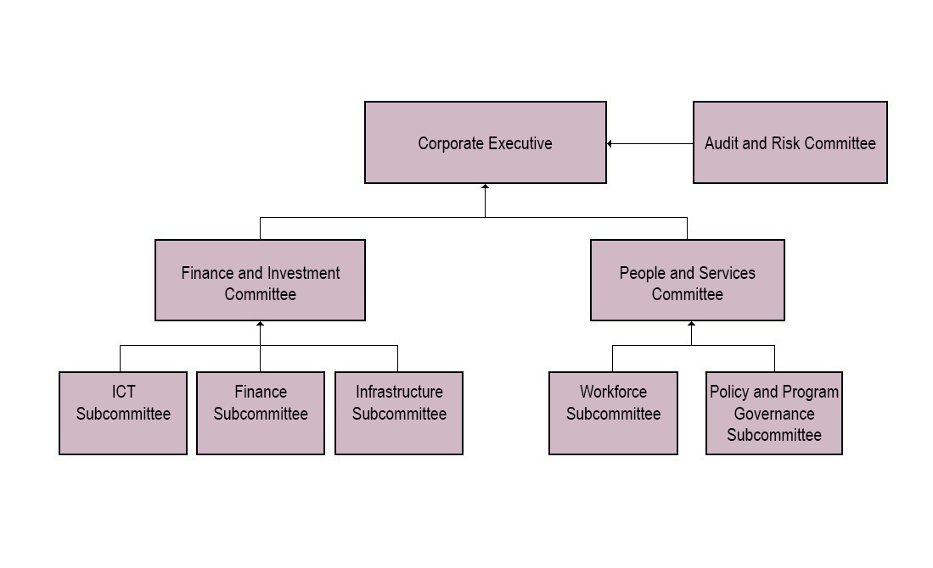

The Audit and Risk Committee supports the Director General and Corporate Executive in fulfilling their governance and oversight responsibilities and obligations under the Financial Management Act 2006 and related Treasurer’s Instructions.

The committee is responsible for providing independent assurance and advice on the Department’s system of internal control, risk oversight, assurance and governance. A representative from the Office of the Auditor General is an observer on the Audit and Risk Committee.

Three scheduled committee meetings were held during 2018–19.

The Finance and Investment Committee assists Corporate Executive to fulfil its fiduciary and corporate governance responsibilities in relation to our obligations as a public sector agency, financial reporting, financial management, major investments including infrastructure and information and communication technology (ICT), and internal control, risk management and compliance systems.

It is supported by:
- the Finance Subcommittee which ensures our finances are managed efficiently and effectively and in accordance with our obligations
- the ICT Subcommittee which supports effective and efficient management of ICT program and project governance and other information management matters
- the Infrastructure Subcommittee which provides strategic oversight and guidance on infrastructure matters and transparency of infrastructure recommendations.

The People and Services Committee assists Corporate Executive to fulfil its responsibilities in relation to policy and program governance, human resource management and state-wide service delivery.

It is supported by:
- the Policy and Program Governance Subcommittee which provides effective and efficient management of policy strategies and practices, delegations, and program and project governance
- the Workforce Subcommittee which provides effective and efficient management of human resource policies, strategies, practices, and project governance.

Corporate Executive committees: Summary of 2018–19

During the year, and across both governance frameworks, 13 work proposals (14 in 2017–18) for new ICT projects were approved and 18 ICT projects (20 in 2017–18) were closed on time and within budget. At 30 June 2019, 32 ICT projects (16 at 30 June 2018) were being monitored.

This year, the Policy Subcommittee and the People and Services Committee in the new framework examined, proposed and revised policies, and provided recommendations to Corporate Executive for approval. Sixteen policies underwent major assessments (five in 2017–18), 46 policies had minor amendments (19 in 2017–18) and four policies were removed (four in 2017–18).

There was a significant increase in minor amendments to policies to include systemic changes due to the Machinery of Government changes.

Our Policies website continued as the definitive repository for all policies.

We continue to provide oversight through our governance committees for projects, programs, operations, grants, services, funding agreements, evaluations, reviews, pilots and trials to ensure these align strategically with our priorities.

Through the Program Governance Group in the previous structure, and the Finance and Investment Committee and People and Services Committee in the new structure, at 30 June 2019, 90 projects (67 in 2017–18), 63 programs (66 in
2017–18) and 176 operations (202 in 2017–18) were documented.

During the year, 48 new projects (27 in 2017–18) were recommended to Corporate Executive and approved by the Director General, and all projects due to close either closed on time (22 projects in 2018–19, 42 in 2017–18) or obtained the appropriate variations as necessary.

Significant issues for the next financial year

Given the high expectations of success for every student, the Department’s priorities include:
- having senior secondary students on learning pathways that explicitly connect to further training or higher education
- building student interest, aspiration, participation and capability in science, technology, engineering and mathematics (STEM)
- improving student writing, reading and numeracy
- focus on growth in student achievement as well as standards
- providing deliberate opportunities for students to develop critical thinking, creativity and entrepreneurship.

Best possible teaching practices remain a key focus, including supporting teachers through professional learning and action research supported by expert practitioners to cater for the needs of academically able primary students, and the development of the Centre for Excellence in the Explicit Teaching of Literacy.

The next enterprise bargaining agreements for the Public Service and Government Officers General Agreement 2019 are underway. Separate logs of claims are expected from the Civil Service Association. Bargaining parameters are being developed based on the Public Sector Wages Policy and Statement 2017.

Increasing complexity and challenge in the broader community often impacts our students and schools. School leaders deal with this challenge together with their teams and with support from the Department. We continue to improve our efforts to maintain the health and wellbeing of all our employees.

Improved engagement and educational outcomes for Aboriginal students remain disproportionately low in comparison with non-Aboriginal students. Priorities for public schools include using the Aboriginal Cultural Standards Framework to improve outcomes for Aboriginal students, develop research partnerships, continue KindiLink for a further three years and progressively implement KindiLink across all schools involved in the Kimberley Schools Project. Embedding Aboriginal histories, cultures and languages in classroom practice is also a priority.

An ongoing focus in the early years on improving health and wellbeing of children is required to ensure all Western Australian children have a solid foundation for education. Identifying target groups of students where connected intervention across multiple agencies will generate positive outcomes will be a key focus in meeting the targets of Our Priorities.

The number of teachers with expertise in teaching STEM remains a challenge. Strategies to address this include professional learning for teachers in secondary subject areas, for example the Leap Program, attraction of teachers through initiatives such as Teach for Australia and working closely with universities to advocate for secondary teaching. The State Government’s investment of $1,962,000 to deliver the STEM Enterprise Schools program will also assist in addressing the challenge.

The wellbeing, resilience, emotional regulation and behaviour of children and young people continue to be challenging community issues that have an impact on the safety of students and staff in schools. Priorities include the 10 point action plan on addressing violence, better alignment and integration of services for at-risk students and a pilot of alternative learning settings for the most violent students.

To meet the increased need to support students with autism, additional specialist programs are being set up in public schools to provide a seamless education across Kindergarten to Year 12. With the increase in the number of students identified as requiring support, the disability allocation funding distributed to schools each year is increasing.

Of the 409 recommendations from the Royal Commission into Institutional Responses to Child Sexual Abuse, many are directly or indirectly relevant to, or have an impact on, the operations of schools and the Department.

With continuing high demand for vocational education and training in schools, a plan is being implemented to improve quality of training in schools and strengthen the focus on supporting future job prospects for students.

Following the tabling of the report ‘Setting the Stage for Improvement: Department of Education’s Management of Student Attendance’, further work has commenced to improve student attendance, with a focus on partnerships with stakeholders from across Government and the broader community.

In response to student enrolment growth across the State, and challenges of an ageing asset portfolio, an investment of $452.8 million will be made in 2019–20. This will deliver new schools and expand and upgrade existing ones to strengthen the delivery of education services. This significant capital investment also supports local jobs to strengthen the State’s economy.

The State Government signed the National School Reform Agreement in December 2018, ensuring Western Australia receives a fairer share of Commonwealth education funding. As part of the National School Reform Agreement, the Department has committed to delivering a number of education reforms, including enhanced measures to individually assess student progress, implementation of a leadership strategy and new public school review process, and the provision of resources to increase the capacity of teachers to embed the Aboriginal Cultural Standards Framework in classrooms.

Following release of the Government’s whole-of-government vision of Sharing Prosperity, work is already underway in developing a plan, in collaboration with other agencies, to meet the Our Priorities targets. Specifically, the focus is on a new way of working across the public sector to improve the outcomes for all young people in Western Australia as defined by the targets of A Bright Future, Aboriginal Wellbeing and A Safer Community.

OUR PERFORMANCE

Providing public education

We provide high quality education for children and young people throughout Western Australia, helping each to achieve academic and personal success.

We work with parents, families, agencies and organisations to prepare students with the skills, understandings and values to reach their potential and make a positive contribution to society.

In 2019, we enrolled 311,199 students from Kindergarten to Year 12 in 812 public schools across the State. Public schools increased market share for the eighth consecutive year, up from 67.5% in 2018 to 67.6%. Enrolment and school information is in Appendix 1.

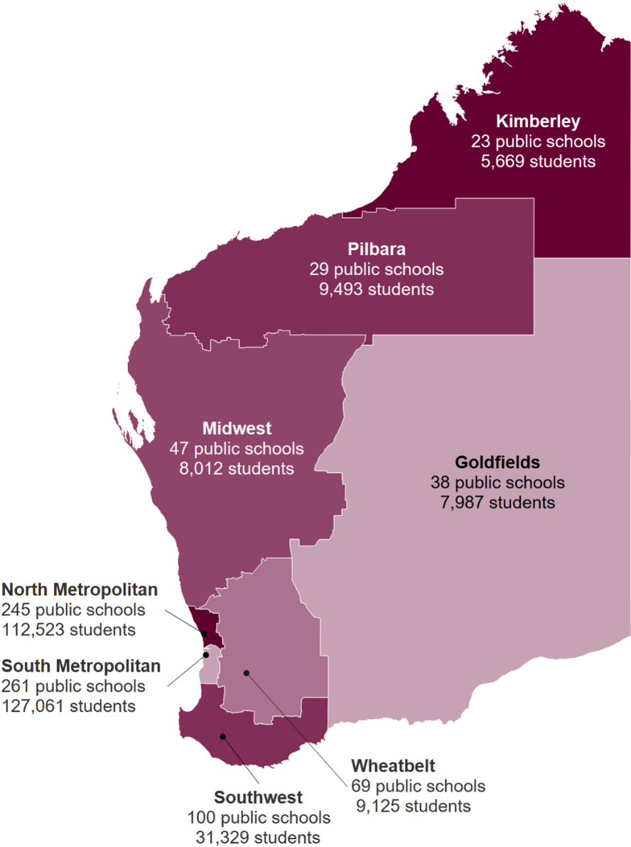

We were the largest public sector employer in the State, with 39,205 full-time equivalent staff. Nearly 97% of all our staff were employed in public schools.

Watch our video, Welcome to Public Education in Western Australia, to find out more about our schools, our students and our people.

Contemporary curriculum and assessment

We supported schools to achieve positive learning outcomes for their students. We set high expectations of success for every student in every public school to best prepare them for life.

Public school Year 12 student performance and achievement

The student attainment rate remained high, though it declined slightly from 96.2% in 2017 to 95.6% in 2018. The attainment rate for Aboriginal students improved slightly from 89.4% in 2017 to 89.9% in 2018.

The Year 12 Western Australian Certificate of Education (WACE) achievement rate (as per our key performance indicators) increased slightly in 2018 to 80.5%, from 79.5% in 2017. The WACE achievement rate of Aboriginal students also increased to 47.7% in 2018, from 44.8% in 2017.

In order to achieve a WACE, students must demonstrate a minimum standard of literacy (reading and writing) and numeracy. These standards were achieved by 92.1% of Year 12 students who met enrolment requirements to achieve the WACE (90.8% in 2017). For Year 12 Aboriginal students who met the enrolment requirements to achieve the WACE, 75.5% demonstrated the literacy and numeracy standard (72.7% in 2017).

Details of Year 12 student achievement are in Appendix 3.

In 2018, public school students received 1,815 School Curriculum and Standards Authority awards (1,858 in 2017). Pooja Ramesh from Perth Modern School won the Beazley Medal: WACE after recording the highest examination marks across five Australian Tertiary Admission Rank (ATAR) courses in Year 12.

The 2018 Rob Riley Memorial Prizes for the top Year 12 Aboriginal students from public schools were won by Claudia Walton-McDermott from Perth Modern School (ATAR) and Chloe Barber from Manea Senior College (vocational education and training, VET).

New WACE requirements for Year 12 students from 2021, announced on 2 May 2019, will add a third study pathway through which students can achieve a WACE by completing five General Courses. Currently, to achieve the WACE, students must complete a minimum of five courses in Year 12 (with a minimum of four ATAR courses), or complete four General Courses with a certificate II or higher VET qualification.

The Western Australian Government’s Our Priorities: Sharing Prosperity 2024 target under A Bright Future is to have 85% of Year 12 students completing two or more science, technology, engineering and mathematics (STEM) courses and/or STEM related VET qualifications. In 2018, 74% of Western Australia’s Year 12 public and non-government school students completed two or more STEM subjects.

Public school student NAPLAN performance

In May 2018, 88,058 Western Australian public school students in Years 3, 5, 7 and 9 were assessed in aspects of literacy and numeracy as part of the National Assessment Program – Literacy and Numeracy (NAPLAN).

With the exception of Year 3 Writing, NAPLAN is currently transitioning from pen and paper to online assessments. In 2018, 31,105 students in 229 public schools completed the assessments online.

For the first time, the Department’s NAPLAN key effectiveness indicators relate to the percentage of students achieving proficiency in Reading and Numeracy. Proficiency indicates students are on track to meet the curriculum expectations for the year level and assessment area.

We exceeded all eight key performance indicator targets in 2018 relating to students achieving the proficiency standards in Reading and Numeracy. With the exception of Year 7 Reading, the percentage of students achieving proficiency were the highest ever. See our Key performance indicators section for more information.

Since the baseline year of 2008, all of the Western Australian public schools’ mean scores for Reading, Spelling, Grammar and Punctuation, and Numeracy have increased substantially.

For Writing, since the baseline year of 2011, the mean scores have fallen, although only marginally for Years 3 and 9. The decline in Writing results is evident nationally.

Between 2017 and 2018, there were improvements in the means and the national minimum standards for Grammar and Punctuation in Years 5, 7 and 9. The mean for Year 9 Spelling also increased.

Females continued to substantially outperform males in all areas of literacy across all year levels.

By contrast, male students had marginally higher means and percentages achieving proficiency in Numeracy in all year levels. However, slightly higher percentages of females were at or above the national minimum standards in Numeracy than males in all year levels.

While there have been several notable gains for Aboriginal students, their performance remains well below that of non-Aboriginal students.

NAPLAN results tend to be lower as geographical remoteness increases, which is a contributing factor in the lower results for Aboriginal students compared to non-Aboriginal students.

Further NAPLAN results are in Key performance indicators and Appendix 2. Results from 2019 NAPLAN will be reported in next year’s annual report.

For the 2019 NAPLAN, 88,852 students in 724 public schools were registered to complete NAPLAN online. A national connectivity issue affected many students on the first day of testing. As a result, in Western Australian public schools, 5.5% (18,394) of all online assessments were reverted to paper, the majority in Writing.

The Western Australian Government’s Our Priorities: Sharing Prosperity 2024 target under A Bright Future is to have Western Australia’s Year 5 and 9 NAPLAN Reading and Numeracy mean scores improve by more than 10 scale points from 2017 performance.

The mean scores in 2018:
- for Year 5 were 502.6 for Reading and 490.0 for Numeracy (2024 targets are 509.0 and 498.7 respectively)
- for Year 9 were 589.4 for Reading and 602.0 for Numeracy (2024 targets are 592.6 and 605.4 respectively).

Best start to learning for young children

The Australian Early Development Census (AEDC) is collected every three years and measures the development of children in Australia in their first year of full-time school. It measures their development on five domains: physical health and wellbeing, social competence, emotional maturity, language and cognitive skills (school-based), and communication skills and general knowledge.

The Western Australian Government’s Our Priorities: Sharing Prosperity 2027 target is to improve the proportion of children developmentally on track on all five domains by 10% from Western Australia’s 2015 results of 55.2%. The 2018 results, released in early 2019, indicate Western Australia is making good progress towards this with 57.9% of children on track on all five domains.

This improvement is on the back of strong investment in the early years since 2009 through a range of Australian, State, and Local Government and community initiatives. These initiatives include: making Pre-primary compulsory, increased hours of Kindergarten, introducing the National Quality Standard, establishing Child and Parent Centres and KindiLink, stronger links between schools and community-based playgroups and Better Beginnings in public libraries.

Click here to learn how AEDC data is supporting Western Australian schools and early learning centres to enhance community partnerships.

Student attendance

Attendance at public schools has remained stable since 2013 at close to 91%. The attendance rate in 2018 was 90.7% (90.9% in 2017). In 2018, the rate was 75.3% for Aboriginal students, down from 75.8% in 2017. Details of attendance rates are in Appendix 3.

During 2018, persistent failure to attend school resulted in 94 attendance advisory panels being convened (57 in 2017 and 83 in 2016) and 156 responsible parenting agreements being initiated (149 in 2017 and 105 in 2016).

No parents have been prosecuted for their children’s non-attendance since 2014.

A Public Accounts Committee review of our approach to student attendance found that although we have improved our guidance to schools, further work is needed to address the Auditor General’s recommendations from the 2015 audit report, Follow-On: Managing Student Attendance in Western Australian Public Schools.

In March 2019, the Minister for Education and Training initiated a full review of our approach to attendance and we are implementing a plan of action which includes:
- a cross-agency approach to address the complex matter of low student attendance in remote and very disadvantaged communities
- developing operational approaches to provide stronger and more targeted support for schools
- updating our policy, procedures and guidance to improve schools’ local decision making to meet their legislated obligations.

We continued to work with other agencies and organisations to locate students whose whereabouts were unknown and reduce the number not participating in education or approved options. At June 2019, the whereabouts of 1,087 students of compulsory school age were unknown (1,286 in June 2018).

Targeted support for Aboriginal students

Based on positive evaluation findings, KindiLink (which was piloted between 2016 and 2018) was extended for a further three years, until the end of 2021. In 2019, the program operated in 43 schools. The play and learn sessions aimed at Aboriginal children, also available to non-Aboriginal children, supported children’s learning before starting school, forged positive home-school partnerships, and built the confidence and capability of families.

The independent evaluation of the KindiLink pilot was released in 2018, with the following key findings:
- upon entry to Kindergarten, Aboriginal children who attended KindiLink had better social, emotional, language and cognitive capabilities
- participating parents expressed increased confidence and capacity as their child’s first teachers
- there was a positive impact on relationships between family, school and community.

In 2018–19, initiatives funded under the Australian Government’s Indigenous Advancement Strategy continued to strengthen Aboriginal student outcomes, including the Aboriginal Youth Ranger Program, Remote School Attendance Strategy, and the Aboriginal Early Childhood Language Support Program for which funding ceased in December 2018.

In 2018, Follow the Dream: Partnerships for Success supported 1,204 Aboriginal secondary students (1,056 in 2017) across 25 host schools and a further 56 schools through outreach services. Participants accounted for 62% (65% in 2017) of Aboriginal students who achieved an ATAR at and above 55, 43% (42% in 2017) of Aboriginal students who achieved a WACE and 29% (34% in 2017) of Aboriginal students who received certificate II or higher VET qualifications.

The Clontarf Foundation Academies continued in 25 schools, and a new academy started to operate at Hedland Senior High School in 2019. The academies supported male Aboriginal secondary students through school and into post-school destinations.

In 2018, the Department provided seed funding to Glass Jar Australia, SHINE Inspire Achieve Belong, and Role Models and Leaders Australia to deliver programs to support Aboriginal girls’ engagement in education, and their transitions through school and into further study and work.

Student access to high quality learning environments

In 2019, 1,755 students (1,765 in 2018) in Years 5 and 6 were eligible to participate in courses through the Primary Extension and Challenge (PEAC) program.

In 2019, selective Gifted and Talented programs were delivered by 18 secondary schools. We offered 1,157 Year 7 places (1,054 in 2018) in selective academic, languages and arts programs. The academic program was also available online for selected students in Western Australia’s rural and remote regions.

In 2019, we received 4,537 applications for Year 7 secondary places commencing in 2020, an increase of 9.2% from 2018. We also received a further 1,563 applications from students applying for entry to Years 9, 10 and 11 in 2020.

We continued to fund the Purposeful Academic Classes for Excelling Students (PACES) program. The program invites identified high-performing senior secondary students to participate in specially designed tutorial sessions that aim to maximise their academic achievement.

We celebrated 100 years of distance education in 2018. Beginning as the WA Correspondence School, the School of Isolated and Distance Education (SIDE) was established in September 1918 with 55 students and one teacher. The main purpose was to provide education to isolated and ‘outback’ students at primary level. Since then the school has moved to an eLearning model of educational provision.

In 2018, SIDE provided education to more than 2,000 Kindergarten to Year 12 students across Western Australia unable to access regular schools or specific subjects. It delivered more than 4,000 virtual lessons each month and provided nearly 550 web-based courses.

We fully implemented the State Government election commitment to appoint an independent learning coordinator in 10 regional schools to help students undertaking courses through SIDE. These coordinators are supported by a regional learning specialist team comprised of eight specialist teachers in the curriculum areas of English, humanities and social sciences, mathematics and science. These teachers provide ongoing support to students and teachers in regional and rural schools. Since they commenced in January 2019, the team has visited 31 schools, provided face-to-face tuition to students in 26 ATAR courses and developed online revision resources in 26 ATAR courses.

We provided boarding facilities to 513 students in Semester 1, 2019 through eight country-based residential colleges and one metropolitan-based residential college. Seventy-three of these students were attending non-government schools.

Through the Boarding Away from Home Allowance for Isolated Children, we supported 1,357 public and non-government school students in 2018 (1,442 students in 2017) at a total cost of just over $2.6 million (just under $3.0 million in 2017). We also supported 294 public and non-government school students (263 in 2017) boarding at Western Australian Colleges of Agriculture and Edmund Rice College through the Agriculture Colleges Special Subsidy Boarding Away from Home Allowance, amounting to $543,979 ($537,828 in 2017).

Through the Secondary Assistance Scheme, in 2018 we supported 29,500 public and non-government school students in Years 7 to 12 from low income families to pay contributions and charges, and purchase school uniforms (28,380 in 2017). Payments of more than $6.8 million (more than $6.5 million in 2017) were made under the Education Program Allowance and just over $3.3 million (just over $3.2 million in 2017) under the Clothing Allowance.

A further nine schools (eight public and one non-government) joined the Kimberley Schools Project, which started in 2018 with 10 schools. These 19 schools were supported to intensify and accelerate children’s literacy learning through targeted teaching practices in Kindergarten to Year 2. Planning is underway to extend explicit literacy strategies beyond Year 2, and introduce targeted teaching numeracy strategies. Schools can also participate in the project’s leadership model and implement the KindiLink program, and moves to focus on a co-design community engagement linked to attendance are being piloted in several schools.

We continued to partner with BHP to improve education opportunities and outcomes for students in the Pilbara. Through targeted programs, the BHP Pilbara Education Partnership focused on increasing the range of school based traineeships and ATAR courses available to students, preparing pre-school children and their parents for school through a playgroup, and delivering academic enrichment programs for students in Years 4 to 6. Schools were also eligible for funding to trial projects and implement programs relevant to their local context.

Support for students with specific educational needs

In 2019, Intensive English Centres at 14 metropolitan public schools provided targeted programs to 958 primary and secondary students for whom English is an additional language. Funding is provided for students to attend a centre for 12 months, with an additional year of funding available for humanitarian entrant students with a limited schooling background. Mainstream schools were provided with additional funding and resources to support more than 10,000 English as an Additional Language or Dialect students in acquiring Standard Australian English.

In 2019, our five metropolitan language development centres provided intensive language intervention programs for approximately 1,350 students in the early years of schooling with a diagnosed language disorder. The centres also delivered support to teachers of young students across the State who have speech and language difficulties and do not attend a centre. This outreach service was supplemented in 2017 and 2018 with funding provided through the Australian Government’s Indigenous Advancement Strategy.

We provided support for students with Autism Spectrum Disorder (ASD) through:
- Specialised Learning Programs (SLP) for students with ASD, operating in 13 schools, with seven schools new to the program in 2019. Schools that previously ran the Secondary Autism Extension Program had all transitioned by 2019 to the SLP.
- the Early Intensive Intervention Program at education support centres, for students with ASD in Kindergarten and Pre-primary to equip them to transition to Year 1 at their local school. The program was delivered in nine education support centres in 2018 and eight at the start of 2019. The program is being phased out in centres with close proximity to schools running SLPs.

Our consulting teachers with specialist skills in supporting students with ASD assisted 323 students in 128 schools in 2018. Professional learning was also provided to 3,663 school staff in 2018 to develop the capacity of schools to support students with ASD. This included support to four regional schools through the Regional Autism Collaborative Model.

Click here to meet Alex, and learn how thoughtful, targeted adjustments can lead to positive outcomes for students with Autism Spectrum Disorder.

At the end of 2018, we were supporting 11,237 students through the student-centred funding model individual disability allocation to schools, up from 10,491 students at the same point the previous year. The increase is largely due to the number of allocations to schools for students with ASD.

In 2018, we provided teaching and learning adjustments to 20.8% of public school Pre-primary to Year 12 students with disability to enable them to participate in education on the same basis as their peers. Through workshops, seminars and online information we continued to support school staff to make informed judgements about which students met the broad definition of disability under the Disability Discrimination Act 1992 and the teaching and learning adjustments required by students.

Implementing the Western Australian Curriculum

In 2018, 44 Teacher Development Schools assisted with implementing the Western Australian Curriculum through 384 professional learning events with 5,185 attendances. They also provided tailored professional learning, with 3,757 attendances in response to 393 requests for support.

In 2019, 35 Teacher Development Schools and eight Primary Language Support Schools (previously operating as Teacher Development Schools) continued to provide curriculum implementation support.

As the Languages curriculum becomes mandatory for successive year groups (compulsory for students in Years 3 and 4 in 2019), we continue to provide additional supports including professional learning, mentoring and teaching resources.

Digital resources aligned to the Languages curriculum continued to be developed and made available in Connect, our integrated online learning environment. A short course, Leap Primary Languages, was available for teachers wishing to expand their skills and qualifications to teach a language program in a primary school. In
2018–19, 31 teachers across six languages completed the course.

New resources aligned to the Digital Technologies curriculum were made available to all teachers through Connect.

In 2018, we helped facilitate HASS week, a week-long series of events to celebrate humanities and social sciences. The new cross-sectoral initiative is in partnership with the University of Western Australia and supported by the State Library of Western Australia and Seven West Media. HASS week provided conferences, lectures, student presentations and teacher-networking opportunities and will be an annual event.

Science, technology, engineering and mathematics (STEM)

We continued to develop resources and provide professional learning to encourage greater interest and competence in STEM.

We are on track to meet the State Government’s election commitment to convert existing classrooms in 200 schools with primary enrolments to science laboratories by the end of 2020–21. Ninety-nine classroom conversions have been completed and are in use. The schools also each receive resource grants of $25,000 to purchase science resources.

In addition, small primary schools and education support centres not eligible for the science laboratories program were invited to apply for science resource grants. Thirty-six schools with an enrolment of up to 50 students received grants of $5,000. An additional 25 schools with enrolments of between 51 and 100 students received grants of $10,000.

Scitech facilitated eight Open Lab professional learning workshops where teachers running existing laboratories shared experiences and ideas with other teachers.

The Innovation Partnership Schools program continued with the aim to improve secondary engagement and retention of students; strengthen outcomes for Aboriginal students; and develop innovative practices in both digital technologies and STEM. In 2018, 27 schools completed workshops to design innovative teaching and learning practices. In 2019, the schools worked together to refine these practices, with a total of 68 schools involved in testing and final refinement.

Sixty STEM Enterprise Schools were selected and workshops began to develop whole-school approaches to building students’ STEM capability with a focus on building enterprise skills and developing future-focused career pathways. Twenty STEM Mentor Schools, schools with a strong STEM culture, were selected to each support a number of Enterprise Schools.

In 2018 and 2019, 26 of our Teacher Development Schools provided STEM related professional learning events and support.

In 2018–19, through professional learning we trained and supported 10 teacher trainers to deliver an inquiry-based STEM program called Little Scientists. These teachers went on to train 293 participants statewide.

The STEM Learning Project delivered 15 curriculum resource modules. In 2018–19, 52 workshops, with 1,612 participants, supported teachers and school leaders to implement the integrated STEM teaching and learning modules.

In response to the State Government election commitment to deliver professional learning to support the integration of coding in the curriculum, the Department contracted the University of Sydney to design, develop and deliver 16 Teachers Can Code professional learning modules to 110 lead teachers. In 2018, these lead teachers provided 230 professional learning opportunities, attended by over 2,000 teachers. Schools could also contact lead teachers directly to request support with implementing digital technologies education. During 2019, lead teachers are continuing to deliver Teachers Can Code modules in schools and networks across the State.

An additional State Government election commitment was to engage with the Australian Government to enhance the teaching and learning of coding. In 2018–19, we distributed a total of $439,584 from the Australian Government to schools for:
- Sponsorship Grants – to sponsor students to participate in conferences, competitions and other STEM-related events
- Maker Projects grants – to set up dedicated maker spaces that offer students hands-on STEM experiences in design, technology, innovation and entrepreneurship.

Watch our video to find out why STEM skills matter.

High quality teaching

We prioritised high quality teaching across public schools. We articulated high expectations and standards of teacher performance and assisted teachers to attain these through professional learning and support. We supported the physical, mental and social welfare of our staff.

Supporting pre-service and new teachers

Through our internship project, 24 high performing pre-service teachers were selected to undertake an extended practicum across 15 schools in 2019. Ten of these commenced in Semester 1. Participants were completing qualifications in subject areas of need and/or undertaking practicums at hard to staff schools. The project aims to increase capacity and work readiness by delivering more practical learning that integrates theory into classroom practice.

To build the supply of high quality staff applying for positions in our schools, we continued to promote careers in rural, regional and remote public education. In 2018, 82 student teachers and school psychologists were approved to receive financial support under our Country Practicum Program to undertake their final practicums in schools in the Goldfields, Midwest, Kimberley, Pilbara and Wheatbelt. We also mentored, coached and supported 113 high achieving third and fourth/final year students through the Rural and Remote Training Schools project.

Forty-eight Teach For Australia associates commenced teaching in eight country and 16 metropolitan secondary schools in 2019, complementing the 40 associates in 23 schools in their second year of teaching. Associates are high calibre graduates willing to work in relatively disadvantaged schools for two years while also completing a Master of Teaching.

In 2018–19, 3,587 teachers completed components of the Graduate Teacher Professional Learning Program and 601 accessed individual support through the In-Class Coaching component. All support is aligned to the Australian Professional Standards for Teachers.

Supporting teachers to attain high standards of performance

In 2018–19, Curtin University won the competitive tender process to partner with the Department and five public schools to establish the Western Australian Centre for Excellence in the Explicit Teaching of Literacy. This election commitment aims to strengthen explicit literacy practices in our public schools through an internship program for 60 teachers over three years. The five exemplary public schools are working with Curtin University to develop the internship program and supporting resources. Through expressions of interest 20 schools were invited to start round one of the internship program in Term 3, 2019.

Level 3 Classroom Teachers are exemplary teachers recognised for their exceptional teaching practices who provide and support high quality teaching in schools. In 2018–19, 101 teachers became Level 3 Classroom Teachers by successfully completing the application process. One hundred and eighty-four teachers completed the (now online) information session about becoming a Level 3 Classroom Teacher, 246 attended professional learning on developing their portfolios, and 93 attended professional learning about the reflective practice component.

In the same year, 550 teachers became Senior Teachers – experienced teachers committed to high quality teaching and ongoing professional learning – and 374 teachers interested in becoming Senior Teachers completed the online information session.

The Leap program continued to provide training in identified areas of need with a focus on secondary STEM and primary languages. Since the program commenced as Switch in 2013, 1,246 teachers have undertaken training, including 899 in STEM.

Through the annual WA Education Awards, we acknowledge our public school teachers, leaders and support staff for their role in making a difference in the lives of students in Western Australia.

Watch our video, We love passionate educators, featuring past WA Education Awards winners.

Data and online tools to inform practice

Access to high quality online data services, including the Student Achievement Information System and Online Student Information, assisted teachers to develop analytical and evaluative practices. In 2018–19, 10,509 active Connect Communities provided forums for principals and teachers to share practices, ideas and resources.

We assessed more than 25,400 Pre-primary students in the on-entry assessment program, giving teachers high quality diagnostic information about literacy and numeracy skills and understandings of students at the start of compulsory schooling.

Effective leadership

We understand the importance of strong, empowering leadership in public schools. We identified and selected talented school leaders to develop and put in place support and accountability mechanisms to drive school improvement.

A new leadership strategy

We released the Western Australian Public School Leadership Strategy 2018–2021 and introduced programs and processes to support its implementation. The strategy enhances some programs and processes already in place, and will progressively introduce a number of new initiatives.

The strategy focuses on early talent identification and selection; leadership development and support; performance improvement, management and feedback; and system leadership.

We introduced the Principal Performance Improvement Tool, which supports school leaders to self-assess their performance against six professional practices. The tool is informed by international research into the kinds of leadership that result in improved teaching and learning, and identifies better and worse leadership practices.

In 2018–19, we supported leadership teams in 50 schools to identify and develop future leaders in their schools in the first of three Western Australian Future Leaders Framework trials. Teachers identified as potential leaders will be supported to pursue their aspirations through personalised development programs, the support of a mentor and practical leadership experiences in schools.

Launch: Newly Appointed Principal Program, which commenced in 2019 with 49 participants, is designed to fast-track the learning curve for leaders in their first three years of principalship.

We began developing the Aspirant Aboriginal Leaders Program with advice from Aboriginal leaders including Professor Colleen Hayward AM, one of our Elders in Residence, and support from Department executives. We commissioned a report to inform the design of the program which reinforced the importance of a co-development approach involving aspirant and established Aboriginal leaders. Expressions of interest have been sought from our Aboriginal staff to assist in the design process.

The program will include mentoring and coaching programs and a suite of development opportunities specifically targeted to the needs of aspirant Aboriginal leaders.

Professional development for school leaders

We continued to offer professional learning for new, accomplished and expert principals, as well as for middle (teacher leaders and heads of learning areas) and emerging leaders. This included introducing new professional learning under the leadership strategy.

Along with a number of professional learning programs specifically for school leaders or school leadership teams, in 2018–19, we offered a suite of Leading School Improvement programs that were attended by 489 school leaders. The core program focused on primary, secondary, small school or special education need contexts. These were complemented by a further three programs (with 256 attendances) for improving whole school self-assessment, classroom observation and feedback, and a masterclass for those who had completed one of the core programs.

A fourth group of 20 principals was selected for the Principals’ Fellowship Program in April 2019. The first two groups of principals have completed the fellowship and form a pool of experienced leaders to support their colleagues and lead system change initiatives. The third group of principals are due to complete the fellowship in the second half of 2019.

Middle Leaders: Leading from Within is designed to help middle and emerging leaders understand their role to support those managing them and those they manage. In 2018–19, 74 participants attended the program.

Eighty-three teachers and classroom leaders aspiring to the role of principal completed Explore: A Career in School Leadership. During the online course, participants were supported to reflect on their current professional needs and understand the importance of the school leader’s role in developing a school culture that is focused on continuous improvement and learning.

We provided several coaching programs for a range of target audiences. Introduction to Leadership Coaching courses (for school leaders and Managers Corporate Services) were attended by 129 staff who learned how to manage colleagues through a coaching approach. Twenty-five staff participated in Instructional Coaching: Leading the Impact Cycle, a new program in 2019 that aims to support educators in establishing coaching cycles that are targeted and aligned to identified pedagogical practices in schools.

The 40 managers corporate services and school leaders we funded in 2017–18 to complete a Graduate Certificate of Education Business Leadership from Deakin University are due to complete the program in November 2019. In 2019, we funded another 32 managers corporate services and school leaders to complete the qualification in October 2020.

In 2018–19, 112 managers corporate services attended our Managing the Performance of School Support Staff workshop.

Recognising the importance of supporting employee mental health and wellbeing, in 2019 we began offering Mental Health for School and System Leaders. This one-day program informed leaders about common mental health issues prevalent in the workplace and provided tools to support their own mental health and that of colleagues. The program was attended by 184 participants.

The Verbal Judo program was attended by 244 staff who learned skills to influence and motivate people, and resolve conflict.

Support and accountability mechanisms for school leaders

Through the School Workforce Profile Report, school leaders can access detailed information about their school workforce, including comparative data for like schools, to support workforce planning and monitoring.

We implemented our new public school review process which acknowledges the achievements of schools and provides feedback to support principals and staff with their improvement planning. See Good governance for more information on our new public school reviews.

Leading improvements in Aboriginal education

In 2018–19, we delivered face-to-face, online and tailored workshops to over 3,000 principals and teachers to support schools to implement the Aboriginal Cultural Standards Framework. The framework assists staff to embed Aboriginal histories, cultures and languages across their schools. It aims to strengthen the participation, engagement and achievement of Aboriginal students by providing safe, stimulating and culturally responsive learning environments for them and their families.

Our Elders in Residence, Professor Colleen Hayward AM and Mr Ian Trust, provided advice to the Minister for Education and Training and our staff on matters relating to the learning and wellbeing of Aboriginal children and young people.

In May 2019, Kevin O’Keefe (Principal Advisor, Aboriginal Education Teaching and Learning) was co-opted as a member of Corporate Executive, to provide advice and guidance drawn from his extensive experience. See Our structure and senior staff for more information.

Good governance

At the system level, we supported public school leaders and staff while maintaining transparent accountability, governance and funding frameworks. At the school level, we supported governance mechanisms that ensured public schools were responsive to the needs of their communities and students.

Transparent accountability of schools

In 2018, we implemented a three-year review cycle for all Western Australian public schools, replacing the reviews undertaken by the Expert Review Group, and Independent Public School reviews previously conducted by the former Department of Education Services.

The new review process requires schools to submit evidence of their school performance self-assessment through the Electronic School Assessment Tool which is externally validated by a director and a principal peer reviewer. Schools are provided with a report that includes a performance rating of ‘Effective’ or ‘Needs Improvement’, and feedback to support improvement planning. Principals are expected to share the report with their school community and publish it on their website or on Schools Online.

By the end of Semester 1, 2019, a total of 186 schools had been reviewed since the introduction of the new review process in September 2018. This included 140 primary schools, 13 education support schools and centres, 18 district high schools and 15 secondary schools.

The Funding Agreement for Schools, introduced in 2016, continued to articulate accountability mechanisms for principals in managing their school budget to meet the learning and wellbeing needs of students. Principals reported school activities in annual reports published on Schools Online.

We supported school staff to maintain accountability and good governance through online services and applications, including Reporting Requirements of Schools, Online Incident Notification System, and School Survey which schools can use to develop and deliver their own surveys. The Year 12 student intentions and satisfaction survey continued to provide schools with valuable planning and evaluation information (see Appendix 3).

Each year, all schools with students from Kindergarten to Year 2 must complete an internal audit against the National Quality Standard (NQS). We provided 32 professional learning events in 2018 on the revised NQS Guide that was released in January 2018. To support consistent interpretation of the Standard, schools may seek verification of their school’s internal audit. In 2018, we verified the audits of 42 public schools.

We continued to support school council and board members to undertake their functions in school governance through 56 training workshops attended by 1,129 council and board members, and providing support materials.

In consultation with the Western Australian Council of State School Organisations, we developed a new resource to support principals to effectively engage with their school community and a support package for community members taking part in principal selection processes.

In 2019, more than two thirds (575) of our schools were operating as Independent Public Schools. This included 42 schools that in 2018 successfully completed the development and selection process to become an Independent Public School.

Information and communication technologies (ICT) to support public schools

Schools now have the ability to determine how many wireless access points they need and can add additional points as required. The current ratio remains at 17 students per wireless access point.

Throughout 2018–19 we worked to provide regional schools with metropolitan equivalent broadband services. The 23 remote schools that did not have access to fibre optic broadband services were provided with additional broadband services via alternate means (such as satellite and 4G) with ongoing plans to continually explore and add additional services where possible and available.

In 2018–19, the Department provided 1,725 new notebook computers to teachers through the Notebooks for Teachers program. We continued to provide technical support services, insurance and warranty cover to 8,100 teachers using a notebook provided by the program.

In 2018–19, more than 140,000 requests for ICT technical support, advice and consultancy were made by staff. More than 67% were resolved at first contact with more than 84% of staff reporting a positive service experience.

In 2018–19, more than 154,600 teachers, students and parents used our integrated online environment, Connect. More than 37,000 online classrooms provided students with learning opportunities and 163 schools provided parents with access to electronic versions of their children’s school reports through Connect at the end of Semester 1, 2019.

Developing and improving public school infrastructure

Expenditure in our asset investment program for 2018–19 was $416.9 million compared with $377.1 million last year.

This included completing construction of stage one of Ridge View Secondary College (planning name: South Baldivis Secondary School), and permanent facilities for students in Kindergarten to Year 6 at Aspiri, Aveley North, Oakwood and Southern Grove primary schools for the start of the 2019 school year. Grandis Primary School (planning name: Banksia Grove East Primary School) opened with Kindergarten and Pre-primary students and construction started on new permanent Kindergarten to Year 6 facilities at the school.

Stage one of Coastal Lakes College (planning name: Lakelands (Mandurah) Secondary School) procured through the WA Schools Public Private Partnership opened for the 2019 school year. Construction commenced on a new secondary school in Hammond Park (to open in 2020) and the second stage of Harrisdale Senior High School, both being delivered through the WA Schools Public Private Partnership.

Construction continued on Bob Hawke College in Subiaco (planning name: Inner City College), and Alkimos College (planning name: Butler North Secondary School), with both scheduled to open for 2020.

Take a virtual tour of Bob Hawke College, the new secondary college being built in Subiaco, opening in 2020.

Construction commenced for new primary schools in Baldivis North, Byford South East and Caversham South, all to open for 2020.

Planning commenced for new primary schools in Baldivis South, Brabham, Harrisdale North, Sunningdale and stage one of Southern River Precinct Three Primary School, all to open for the start of the 2021 school year. Planning also commenced for replacement Yanchep Lagoon Primary School to be completed for 2021. An annex for Harrisdale Primary School will open for Kindergarten and Pre-primary students for the start of the 2020 school year.

Planning commenced for stage two at Yanchep Secondary College, additions and refurbishments at Darling Range Sports College, upgrades at Wanneroo Secondary College, and new performing arts centres at Ocean Reef Senior High School, Belmont City College and Belridge Secondary College.

Construction started on the redevelopment of Balcatta Senior High School, a new performing arts centre at Ballajura Community College, and upgrades at Morley Senior High School and Southern River College. Construction continued for refurbishments and additions at Carine Senior High School and a new performing arts centre at Melville Senior High School.

Construction was completed on an additional stage at Shenton College and additions to Canning Vale College and City Beach Residential College.

Construction commenced for a new early childhood building at Attadale Primary School and Ballajura Primary School. Refurbishments were completed at Westfield Park Primary School to accommodate the relocation of the Child and Parent Centre from Challis Community Primary School.

Construction commenced at the old Doubleview Primary School to accommodate the relocation of the International School of Western Australia.

Construction was completed on a new two-storey classroom block at Mount Hawthorn Primary School to cater for local growth in enrolments.
Construction was completed for a new covered assembly area at Caversham Primary School, a new library at North Morley Primary School and an administration upgrade at Yokine Primary School.

Construction commenced on a new administration building at Weld Square Primary School.

Funding was provided for administration upgrades at five primary schools and toilet upgrades at 12 primary and district high schools, as well as at Broome Camp School.

In 2018–19, 49 schools received funding from the $1 million allocation for new playgrounds and shade structures as part of a program that began in 2011–12.

Work to provide science laboratories at the 99 primary schools in stage one of the Investing in Science program was completed. Planning commenced to provide science laboratories at the remaining 101 schools.

Under Royalties for Regions:
- planning commenced for additions at Broome Senior High School, a new science block at Eaton Community College, a STEM centre at Newton Moore Senior High School and additions and refurbishments at North Albany Senior High School and Albany Secondary Education Support Centre
- planning continued for additions at Bunbury Senior High School
- construction commenced for additions at Collie Senior High School
- construction commenced for early childhood teaching classrooms at both Eaton Primary School and Flinders Park Primary School, an early intervention centre at Glen Huon Primary School, and early learning and general teaching classrooms at South Bunbury Primary School
- construction continued for stage two at Cape Naturaliste College and Margaret River Senior High School and stage three at Carnarvon Community College
- additions at Champion Bay Senior High School (formerly John Willcock College) were completed.

Planning commenced for additions and alterations at Moora Residential College, following announcement of funding by the Australian Government’s Community Development Grants Programme.

Detailed information is in Major capital works.

At June 2019, 679 sites were protected by electronic security systems. The number of incidents reported is detailed in Table 2.

Table 2: Security incidents reported 2017–18 and 2018–19
 | 2017–18 At 3 July 2018 | 2017–18 Revised 1 July 2019 (see note a) | 2018–19 At 1 July 2019 (see note a)
Break-ins | 1,211 | 1,422 | 1,164
Wilful damage | 4,138 | 4,638 | 4,448
Arson | 2 | 2 | 4
Other (see note b) | 80 | 76 (see note c) | 88
Total | 5,431 | 6,138 | 5,704
Source: RiskCover and Department of Education’s Infrastructure
(a) Incidents may be reported or processed through to the Department after the end of the relevant financial year.
(b) Covers a range of security incidents from small fires and theft from perimeters of schools to bomb threats.
(c) Reduction from what was reported at 3 July 2018 due to four incidents being reported twice.

Finance and support

Since going live in May 2018, new services have been made available through our customer-focused intranet called Ikon (Information and knowledge online). Ikon supports the needs of schools by providing a single point of entry for staff to find information and services they need to do their jobs.

At the end of 2018, as part of State Government budget repair measures, the Department ceased to operate Landsdale Farm School, and camp schools at Bridgetown, Dampier, Geraldton, Kalgoorlie, Pemberton and Point Peron. Following a process to find alternative providers undertaken in 2018, the camps now operate under lease to Fairbridge Western Australia and Landsdale Farm operates under lease to Family Support WA. We continue to operate Broome Camp School.

An independent evaluation of our student-centred funding model (SCFM) undertaken in 2018 confirmed the model is a contemporary needs based funding model consistent with international and national good practice.

The evaluation outlined 17 recommendations for refining the existing SCFM methodology. Two recommendations, both relating to the Locality allocation and English as an Additional Language or Dialect allocation, will be implemented in 2020. We are committed to the continual improvement of the SCFM and will continue to consider the remaining recommendations, and further refinements based on stakeholder feedback and current best practice.

Our School Budget Review Committee provides a mechanism for public schools to seek additional funding during the school year. In 2018–19, 25 requests for additional funding from schools were approved with $2.16 million in additional funding allocated.

We provided 83 workshop and training sessions to 981 staff as part of a comprehensive professional learning program on leading, managing and monitoring school budgets. We also provided individual support for schools through online and in-school sessions.

We continued to arrange and subsidise housing to attract and retain staff in our rural, regional and remote public schools. In 2018–19, $60 million was paid in rent for 2,042 properties occupied by our staff and owned or leased by Government Regional Officers’ Housing (more than $61 million for 2,154 properties in 2017–18). Of this, we subsidised 71% (70% in 2017–18).

National and State commitments

The Royal Commission into Institutional Responses to Child Sexual Abuse made recommendations that are directly or indirectly relevant to, or impact on, the operations of schools and the Department.

The Department is contributing to a whole of State Government implementation framework for the recommendations of the Royal Commission. Consultation and development activities to integrate the National Principles for Child Safe Organisations in schools are being progressed.

Civil childhood sexual abuse claims for damages resulting from historical incidents commenced in Western Australia on 1 July 2018. Department staff have trained in trauma informed practice and vicarious trauma. The Department responds to civil claims on advice from the State Solicitor’s Office and is working with RiskCover to implement the State Government Whole of Government Guiding Principles for Responding to Civil Litigation involving Child Sexual Abuse.

The National Redress Scheme commenced in Western Australia on 1 January 2019. This scheme provides support to people who experienced institutional child sexual abuse. The Department is a participating institution and complies with the Scheme’s requirements.

In December 2018, the Western Australian Government signed the National School Reform Agreement, a new joint school funding agreement between the Australian Government, states and territories, which will operate from 2019 to 2023. The agreement sets out reforms in areas where collaborative national effort will have the greatest impact on lifting student outcomes across Australian schools. The Western Australian Government also signed a bilateral agreement with the Australian Government which outlines local initiatives to support improving student outcomes.

In 2018–19, we contributed to national policy developments and provided strategic advice in key national decision making forums, including the Council of Australian Governments (COAG) Education Council and the Australian Education Senior Officials Committee (AESOC). Agreements were negotiated with the Australian Government for five national programs or initiatives, including extensions to the National Partnership on Universal Access to Early Childhood Education and the School Chaplaincy Program. We also achieved the relevant milestones and associated payments for all Australian Government agreements.

We worked collaboratively with the National Disability Insurance Agency to support the implementation of the National Disability Insurance Scheme, a national scheme focusing on individualised funding support for people with disability. From 1 July 2018, the Agency assumed responsibility for the delivery of the scheme in Western Australia, which will be fully rolled out across the State by 2020.
In February 2019, the Premier announced Our Priorities: Sharing Prosperity to help Government deliver outcomes for the community across six priority areas. Under the banner of A Bright Future, the Department is working collaboratively in a shared effort to achieve specific targets to improve the health and wellbeing of children in the early years, increase students’ knowledge and skills in reading and numeracy, and increase participation in science, technology, engineering and mathematics (STEM).

In November 2018, the Department developed its International Education Action Plan 2018-2025 to support the State Government’s International Education Strategy 2018-2025. The action plan aims to increase the number of international fee-paying students attending Western Australian public schools. International students contribute to the Western Australian economy and enrich the educational, cultural and social context of their schools.

We continued to address the recommendations from the 2017 Education and Health Standing Committee’s Inquiry into vocational education and training (VET) in Western Australian schools. We worked with the Department of Finance to establish a panel of registered training organisations from which schools can select to deliver VET through an auspicing arrangement at the school. The panel will be available for use from Term 3, 2019. Professional learning for school staff covering use of the panel, contracts and contract management processes began in June 2019.

We also worked with the Department of Training and Workforce Development and TAFE colleges to progress developing a model for more targeted, efficient and equitable use of the existing funding and resources that provide public school students with VET programs.

Our Direct to Market program – introduced in 2017–18 and a State Government election commitment – allows schools to directly source contractors for maintenance and minor capital works, providing increased flexibility and the ability to use local contractors. During 2018–19, almost $0.5 million worth of projects were successfully delivered. Schools were supported through targeted training and an online hub.

We maintained transparent accountability by ensuring responses to Ministerial correspondence, briefing requests, Parliamentary questions and Cabinet requests were accurate and provided in a timely manner (see Table 3). We identified issues and trends from correspondence, and regularly updated contentious issues.

Table 3: Ministerial requests processed 2016–17 to 2018–19
Type | 2016–17 (see note a) | 2017–18 | 2018–19
Letters | 1,094 | 1,701 | 1,595
Briefing notes/advice | 1,220 (see note b) | 1,476 (see note c) | 1,561
Answers to Parliamentary questions | 186 | 262 | 208
Cabinet comments | 23 | 29 | 20
Contentious issues reports (average  number of briefings per report) | 12 (30) | 11 (33) | 10 (47)
Total | 2,535 | 3,479 | 3,394
Percentages processed on time | 95 | 93 | 94
Source: Strategy, Policy and Governance
(a) Caretaker period and subsequent time for new Cabinet to be sworn in affected number of requests.
(b) As budget was not handed down until 7 September 2017, briefings for Parliamentary Estimates Hearings were not prepared in 2016–17. As a result of 2017 State Election, briefings for incoming Government were included.
(c) As budget was not handed down until 7 September 2017, two Parliamentary Estimates Hearings were held in 2017–18, affecting number of briefings prepared.

Safe, healthy and resilient learners

We were committed to ensuring students in public schools feel safe, connected and able to contribute to their communities. We encouraged public schools to provide student wellbeing and support services to deliver mental health, pastoral care and psychological support. We expected our school leaders to develop a safe and friendly school culture for all.

Addressing concerning student behaviour

On 2 December 2018, the Minister for Education and Training launched Let’s take a stand together, the State Government’s plan which identifies 10 actions to address violence in schools.

As a result, we are providing better support for our school staff – including clear advice on preventing, managing and responding to aggression and violence. We have high expectations for student behaviour in schools which means under the plan students will be suspended for attacking other students, instigating a fight, or filming a fight between students.

In 2018, 14,243 students (4.5% of total enrolments throughout the year) were suspended compared to 14,075 in 2017 (also 4.5% of total enrolments throughout the year, previously reported as percentage of enrolments as at Semester 2 student census). The majority of public school students (95.5%) received no suspensions.

The plan includes an instruction to principals to automatically move to exclude any student who physically attacks school staff. There were 24 students excluded in 2018 compared to eight in each of 2017 and 2016.

Schools continue to rely on parents, caregivers and others in the community to model and reinforce positive behaviour. The plan includes the Positive Parenting Program (Triple P), a free parenting program for parents of young children.

In 2018, 4,947 (4,234 in 2017) parents attended Triple P, with 583 (446 in 2017) sessions offered through schools and Child and Parent Centres. The program provides general parenting strategies as well as tailored support for targeted groups such as parents of children with disability. It prioritised parents of children in the early years of schooling and transitioning to secondary schooling. Forty-three Department staff, predominantly school psychologists, were trained to deliver Triple P programs.

Watch our video, Kids don’t come with an instruction manual, describing the benefits of the Triple P – Positive Parenting Program.

In response to the action in the plan to provide training and support for school staff, Keeping Our Workplace Safe material is now part of the mandatory professional learning for new principals.

In 2018–19, more than 2,600 school staff completed training in violence de-escalation and restraint. This included 374 graduates who received training on how to de-escalate and manage aggressive behaviour as part of their induction program.

In 2018, 5,616 staff (6,391 in 2017) participated in Classroom Management Strategies and Positive Behaviour Support programs.

During 2018, 140 staff in senior leadership positions completed Building Resilience and Preventing Radicalisation to Violent Extremism training to address concerns of violent extremism and its effects on young people. This training assists school leaders to understand the concept of radicalisation to violent extremism and to identify potential warning signs of young people who may be at risk.

Supporting student wellbeing

An average 345.4 full-time equivalent (FTE) school psychologists in 2018 (331.2 FTE in 2017) supported school staff with student behaviour, learning and disability, mental health and wellbeing, and emergency and critical incident management. School psychologists provided consultation, assessment, intervention and management of students, with suicide prevention a priority.

In 2018 and 2019, as part of a State Government election commitment, 300 schools were provided with an additional 0.1 FTE Level 3 Classroom Teacher salary to oversee the delivery of mental health programs for students. By the end of 2018–19, 90% of these schools had undertaken Gatekeeper Suicide Prevention and Youth Mental Health First Aid professional learning.

In 2018, Gatekeeper Suicide Prevention training was delivered to 824 school staff (including staff from the schools mentioned above) and the teen Mental Health First Aid program was delivered to approximately 3,600 secondary students. Both programs were available to public and non-government schools. Youth Mental Health First Aid training was provided to more than 890 public school staff and other community members who work with young people.

As part of our pastoral care for students in 2018, 611 schools (637 in 2017) accessed chaplaincy services through in-school chaplaincy programs, school chaplaincy support and pastoral critical incident response services. In 2019, 501 schools were allocated funding for chaplaincy services.

The Department supports whole-school approaches to wellbeing, including a range of evidence-based social and emotional learning programs and resources. In 2018, programs made available to schools included Aussie Optimism, Friendly Schools Plus, and Promoting Alternative Thinking Strategies (PATHSTM).

Hon Samantha Rowe MLC, Parliamentary Secretary to the Minister for Education and Training led the Reducing Bullying in Schools project which resulted in a dedicated Connect Community for public school staff and the development of a number of resources published on our website. Resources include information to help schools develop an anti-bullying policy, and advice and strategies for parents if their child is the subject of bullying behaviour at school.

In 2019, we commenced management of the School Drug Education and Road Aware program (previously managed by Catholic Education Western Australia) with funding from the Mental Health Commission, Road Safety Commission and our Department. The program provides resources, professional development and advice to teachers for educating students to make safer choices on the road, and in alcohol and other drug related situations. A particular focus in 2019 has been on providing workshops and online resources for methamphetamine prevention education.

In 2019, 10 schools volunteered to pilot the Western Australian Respectful Relationships Teaching Support Program. The program, a State Government election commitment to address our State’s high rates of family and domestic violence, is being coordinated by the Department of Communities and delivered by White Ribbon Australia in partnership with Starick. It provides teachers with evidence-based skills and knowledge to implement a whole-school approach to deliver respectful relationships content.

We collaborated with Legal Aid WA to develop a new cyber safety guide for parents and students.

For the 2018 school year, 99% of the 790 schools that completed our protective behaviours education survey indicated they were implementing or partially implementing protective behaviours education for students. Schools that indicated no or partial implementation were supported to identify barriers and enact protective behaviours education. All schools were reminded of protective behaviours professional learning provided by the Department.

Support for students with specific educational and engagement needs

Our Schools of Special Educational Needs (Behaviour and Engagement, Disability, Medical and Mental Health, and Sensory) provide a range of services, some of which are available to staff and students at non-government schools. In 2018, the Schools of Special Educational Needs provided intensive support to 13,514 students (12,685 in 2017). The schools also delivered 1,087 professional learning workshops attended by 15,180 participants to strengthen their capacity to support students with a range of complex learning needs.

In 2018, the School of Special Educational Needs: Behaviour and Engagement managed 803 cases of intensive support for students with extreme, complex and challenging behaviours (862 in 2017). This included 27 students enrolled at the Midland Learning Academy which supports severely disengaged students, and students at our 13 engagement centres which provided intensive support to students with extreme, complex and challenging behaviours.

The School of Special Educational Needs: Disability provided support to 4,449 students in 2018. This was provided through a consulting teacher service to schools across four specialist areas: autism, assistive technologies, disabilities and learning difficulties.

Staff from the School of Special Educational Needs: Medical and Mental Health have relocated to the new Perth Children’s Hospital. Of the 86 staff the school employs across more than 40 health settings, approximately 50 staff are located at Perth Children’s Hospital. Relocation from Princess Margaret Hospital has increased patient bed capacity to 298 (up from 220) and provisioned nine purpose designed school rooms (up from six).

We began supporting a trial, led nationally by the MissingSchool organisation, which uses robot technology to support two students with serious medical conditions who cannot attend school. The robots provide a two-way real time video and audio connection between the absent students and their school. The student (or someone else) can move the robot within and between classrooms and around the school, allowing them to participate in some of their usual school activities and lessons.

The School of Special Educational Needs: Sensory supported national and State initiatives to improve awareness and embed preventative practices for trachoma, and otitis media and the resulting conductive hearing loss in Aboriginal children. The school assessed classroom acoustics at seven campuses of the Ngaanyatjarra Lands School and conducted hearing screenings of 123 students; 82 were found to have a conductive hearing loss. Teachers at these campuses were provided with advice on improving classroom acoustics and using Soundfield systems (which amplify teachers’ voices), and resources to embed preventative practices for these ear and eye issues.

At June 2019, 2,853 (93%) of the 3,064 children in the care of the Chief Executive Officer of the Department of Communities and enrolled in our schools had documented plans.

Four hundred and ninety-seven students undertook the NAPLAN reading tests while in care in both 2016 and 2018; and 494 undertook the NAPLAN numeracy tests. Between 2016 and 2018 the percentages of these children who were at or above the national minimum standard improved in numeracy for two of the three cohorts (Year 5 to Year 7 and Year 7 to Year 9) and in reading for one of the three cohorts (Year 5 to Year 7). See Table A16 for further information.

Strong partnerships and collaboration

We expect public school staff to develop positive, respectful relationships with students, parents and each other as part of caring learning environments that support student wellbeing. We worked with families and communities early to give their children the best start to learning. We built partnerships between our schools – and across sectors and systems – and other agencies to improve student outcomes.

Collaboration with other agencies and organisations

We maintained partnerships with other government agencies, including the Department of Communities and Department of Health, through established memoranda of understanding.

Services commenced in 2019 at the new Hobbs Drive Youth and Community Services Hub as part of the Full Service Schools three-year pilot at Armadale Senior High School. Government and non-government agencies are now providing a range of youth and family support services to the two initial target groups of young people: pregnant or parenting, and vulnerable to homelessness or family and domestic violence.

To support the provision of education services to children and young people in detention, we provided funding to the Department of Justice equivalent to the salaries and on-costs for three full-time equivalent teachers, who are employed at Banksia Hill Detention Centre. We also provided education staff at the centre with access to online professional learning courses.

Our School of Special Educational Needs: Behaviour and Engagement continued work with the Department of Justice to support students moving between Youth Justice Services and schools. This included sharing information with the schools that students enrolled in to provide continuity for their education and care needs.

Best start to learning for young children

In 2018–19, our 21 Child and Parent Centres provided 675 programs and services with approximately 95,000 child attendances and 93,000 adult attendances. The centres continued to support families and communities to provide young children with the best start to learning.

Work has been completed to relocate the Child and Parent Centre Challis to Westfield Park Primary School, for the start of Term 3, 2019. Planning continued for an additional centre at Arbor Grove Primary School in Ellenbrook, with construction to start in 2019–20.

A partnership between the departments of Education and Communities, Australian Government, Catholic Education Western Australia, Association of Independent Schools of Western Australia, and Playgroup WA supports stronger links between schools and community playgroups. This partnership aims to enhance families’ and children’s transition to Kindergarten. In 2018–19, the project supported 182 community-led playgroups with links to public schools (135 in 2017–18) and provided opportunities for wrap-around services, community engagement, and optimisation of children’s transition to school.

Through the National Partnership on Universal Access to Early Childhood Education, six new Education and Care Networks were established, bringing the total to 14. The networks supported shared professional learning opportunities for early childhood educators in schools and neighbouring long day care centres.

As a regulator and funder

The Department has a role in influencing the education of all students in Western Australia. We enacted this indirectly for non-government school education through regulation and funding of Catholic and Independent schools.

Approximately one-third of Western Australian students (148,836) were enrolled in 309 non-government schools in 2019. See Appendix 1 for further enrolment information.

Many non-government schools had religious affiliations, with more than half being Catholic schools (Table A13). Approximately one-third of all non-government schools were located in regional Western Australia. There were 18 remote sole provider schools in communities where there were no other education providers.

The non-government school sector also included 13 Curriculum and Re-engagement in Education (CARE) schools for secondary students.

We worked with the School Curriculum and Standards Authority, Training and Accreditation Council (up to the end of 2018) and Teacher Registration Board of Western Australia to ensure they were provided with secretariat services to support their functions.

Contemporary curriculum and assessment

We provided services and support to the School Curriculum and Standards Authority through a service level agreement to ensure it delivered its functions of:
- developing and maintaining the Kindergarten to Year 12 curriculum and syllabuses
- assessments, examinations, reporting and certification
- monitoring and reporting on standards of student achievement
- internationalisation of the Western Australian Curriculum and Assessment Outline and the Western Australian Certificate of Education.

We maintained internal systems and processes that ensured the Authority received independent advice and support from our staff, and that the data it collected and managed were protected.

As an independent statutory body with its functions prescribed in the School Curriculum and Standards Authority Act 1997, the Authority tables its own annual report in Parliament.

High quality teaching, effective leadership and good governance

We regulated Independent schools, and audited and reviewed the regulation of Catholic schools, against standards set by the Minister for Education and Training and other legislative requirements. We maintained procedural safeguards to ensure our regulatory functions are transparent, and that regulatory and delivery functions are appropriately separated. We provided funding to Catholic and Independent schools based on a formula approved by the Minister.
Non-government school regulation

The School Education Act 1999, registration standards determined by the Minister for Education and Training, and policies adopted by the Director General provided the regulatory framework for the quality assurance and registration of non-government schools.

New registration standards came into effect on 1 July 2018. These emphasised the responsibility of Catholic and Independent schools to provide a satisfactory standard of education which aims to make continuous improvements in student learning outcomes.

The standards and legislative requirements for Independent and Catholic schools also stipulated they have policies to provide for students’ education and care, and review them regularly. Independent and Catholic schools are required by legislation to implement good governance and accountability, including that governing body members must be fit and proper persons to operate a school.

The Director General assessed compliance of Independent schools with the registration standards and other requirements. During the year, the Director General approved one new non-government school, 35 registration renewals, seven additional sites/campuses, 16 extensions of year levels for existing schools, and three other registration changes.

Also during the year, secretariat support was provided to the Minister’s Non-Government Schools Planning Advisory Panel. The Panel provided advice to the Minister on 24 planning proposals seeking advance determination to establish a non-government school or to make a significant registration change.

Non-government school funding

Funding was provided on a per student basis based on a policy commitment over successive governments for students in non-government schools to receive a rate of funding equivalent to, on average, 25% of the costs of educating typical students in public schools. The annual Non-Government Schools Funding Order and Guidelines were issued by the Minister and set out funding amounts, and accountability and eligibility requirements.

The main sources of funding for non-government schools were State Government grants, Australian Government grants, and tuition fees paid by parents.

During the year, we provided more than $439 million in recurrent financial assistance for 146,796 students in non-government schools (more than $430 million for 147,813 students in 2017–18), including $29.7 million ($29.4 million in 2017–18) to support students with special education needs.

We provided $4.6 million to Catholic Education Western Australia (CEWA) and the Association of Independent Schools of Western Australia (AISWA) to administer the State Government’s Non-Government School Psychology Service.

We also provided $1.27 million to CEWA and AISWA to support the re-engagement of students at educational risk, and $181,000 to the Australian Music Examinations Board (WA).

As part of a 2017 election commitment, $3 million in grant funding was provided to CEWA for capital works projects at three Catholic primary schools. These projects were successfully completed during 2018–19.

Through the Low Interest Loan Scheme, there were 372 active loans for non-government schools and The University of Notre Dame Australia with an outstanding balance of $349.2 million (Table 4). Of the $46.3 million advanced during the year, $42.2 million was for new works and $4.1 million was for works in progress (Table 5). In 2018–19, we received recurrent appropriation of $1.3 million ($1.6 million in 2017–18) to meet the annual costs of the interest subsidy.

Table 4: Low interest loans summary 2016–17 to 2018–19
 | 2016–17 | 2017–18 | 2018–19
Balance outstanding | $314.1m | $334.4m | $349.2m
Number of active low interest loans | 429 | 397 | 372
Source: Education Business Services

Table 5: Low interest loans nature of works summary 2016–17 to 2018–19
 | 2016–17 | 2017–18 | 2018–19
New works | $44.5m | $47.7m | $42.2m
Works in progress | $4.6m | $5.0m | $4.1m
Source: Education Business Services

Further information about non-government school funding in 2018–19, including financial assistance to individual schools and a list of schools that received loans, is on our website.

Supporting teacher registration, training regulation and home education

We provided services and support to the Teacher Registration Board of Western Australia for it to deliver its functions, including to register teachers and accredit initial teacher education programs. We maintained internal processes and systems that ensured the Board received independent advice and support from our staff; the data it collected and managed were protected; and investigations remained confidential, noting that the best interests of children was the paramount consideration.

As an independent statutory body with its functions prescribed in the Teacher Registration Act 2012, the Teacher Registration Board of Western Australia produces its own annual report which is included in this report.

Key performance indicators and budget matters related to the Board are included in our report.

Following the 2018 statutory review of the Teacher Registration Act 2012, a strategic implementation group – with relevant representation across education sectors – was established to advise the Minister for Education and Training on implementation of the Review’s recommendations. The group formally advised the Minister in January 2019 that most recommendations were accepted and some recommendations require legal advice. The process for drafting and enacting the amendment Bill has commenced.

We provided the Training Accreditation Council with secretariat services until the end of 2018. Services supported the Council to deliver its functions including registering training providers, approving vocational education and training accredited courses, and investigating complaints against Council registered training providers. From 1 January 2019, secretariat staff previously employed by the Department of Education became staff of the Department of Training and Workforce Development.

We are responsible for registering home educators, and evaluating home education programs and children’s educational progress. In 2018–19, the Department provided $2.6 million for education regional offices to manage home education programs (largely for employment of home education moderators). See Table A11 for the number of students registered to receive home education.

Safe, healthy and resilient learners

The standards and legislative requirements for Independent and Catholic schools prioritise student safety and the prevention of bullying, harassment and abuse. Requirements include an expectation that Catholic and Independent schools implement a relevant child safe organisation framework.

All non-government school principals are required to notify the Chair of their governing body of critical incidents as defined in the registration Standards. The governing body is required to ensure that the Director General is notified as soon as practicable, and in any event, within 48 hours of the incident.

Information about the critical incident reporting requirement is published in the Guide to the Registration Standards and Other Requirements for Non-Government Schools. It is the responsibility of each school under the registration standards to ensure that incidents are managed in the best interests of children.

We assist all schools to provide a safe environment for children by ensuring that child welfare concerns are referred to relevant authorities and that the Teacher Registration Board of Western Australia is supported to undertake its regulatory functions.

The scheme of teacher registration administered by the Board is designed to ensure that only fit and proper persons are registered as teachers. The Teacher Registration Act 2012 places a number of obligations on employers and teachers to ensure that the teacher registration scheme operates effectively, with the best interests of children the paramount consideration.

See the Board’s annual report for further information about its activities in
2018–19.

Strong partnerships and collaboration

We worked with schools to share new ideas, research and best practice. We recognise the benefits that can accrue to all students through collaboration and sharing across schools, sectors and systems.

We provided secretariat services to the Western Australian Higher Education Council. Chaired by the Minister for Education and Training and comprising the vice-chancellors of Western Australia’s five universities, it met four times during the year and provided collaboration between the universities and the State Government on matters of mutual interest.

Priority projects included increasing higher education opportunities and encouraging university aspirations in students in regional Western Australia, working across universities in medical education and research, and marketing Perth internationally as an education destination.

We also provided secretariat services to the Rural and Remote Education Advisory Council chaired by Matthew Hughes MLA and including community, consumer, and funding provider group representatives. The Council provided the Minister for Education and Training with strategic advice to improve education outcomes of public and non-government school students in rural and remote schools. It also promoted cooperation between funding providers to enhance education service delivery in rural and remote regions.

DISCLOSURES AND LEGAL COMPLIANCE

General disclosures

Ministerial directives

No directives were issued by the Minister for Education and Training in 2018–19 relevant to the setting of desired outcomes or operational objectives, the achievement of desired outcomes or operational objectives, investment activities and financing activities.

Disability access and inclusion plan outcomes

Our Disability Access and Inclusion Plan 2018–2023, published in June 2018, identifies our strategies to enhance equitable inclusion of people with disability in our schools, services and employment. It covers outcomes required under the Disability Services Regulations 2004 and an additional outcome related to improving learning outcomes for students with disability.

Targeted professional learning was provided to enhance the capacity of over 9,400 staff to make teaching and learning adjustments, facilitate access to the curriculum and improve learning outcomes for students with disability and diverse learning needs. Our Schools of Special Education Needs provided support for students with specific educational and engagement needs.

To support increased recruitment and employment of persons with disability in our workforce, we:
- provided advice to more than 300 principals and line managers to support staff with injury, disability or medical conditions
- provided equal opportunity information to over 320 staff through equal opportunity contact officer training and recruitment and selection panel training
- held a forum for disability employment service providers focused on equal opportunity measures and reducing barriers to employment
- facilitated workplace assessments and equipment for staff through the Job Access Program and completed infrastructure modifications to accommodate staff with disability
- published our new online resource Enhancing Workplace Culture in March 2019, that provides research based information, strategies and ready-to-use activities assisting principals and line managers to facilitate positive and inclusive workplace cultures.
- provided consultancy and resources related to workplace accommodation under the Department’s Equal Opportunity, Discrimination and Harassment Policy.

Substantive equality

We continue to apply the Substantive Equality Guidelines and Equality and Inclusion Guidelines to consider the diverse needs of staff, students and their families in developing new and revised policies. In 2018–19, this included the major review and revision of our Bullying in the Workplace Policy and procedures to support staff to prevent and effectively manage bullying behaviour in the workplace.
Our human resource management system was upgraded to provide staff with the option to record their gender as indeterminate/intersex. This was in keeping with our commitment to strengthening inclusive and equitable practices and aligns with the Public Sector Commission’s reporting requirements.

To support inclusive learning and work environments that are free of discrimination and harassment, we continued to implement our revised Equal Opportunity, Discrimination and Harassment Policy (published in May 2018) through:
- incorporating updated equal employment opportunity information in training resources for equal opportunity contact officers and our recruitment and selection panel training
- our new online resource called Enhancing Workplace Culture. See Disability access and inclusion plan outcomes for further information.

Recordkeeping plans

We continued incorporating the Machinery of Government changes in compliance with the State Records Act 2000, including bringing the former Department of Education Services’ recordkeeping into the Department. We have commenced planning for the standardisation of the School Curriculum and Standards Authority recordkeeping into the Department’s Recordkeeping Plan.

The Royal Commission into Institutional Responses to Child Sexual Abuse identified recordkeeping issues and made recommendations that state, territory and national governments are currently addressing.

Agencies are required to review their Retention and Disposal Schedule every five years with approval by the State Records Commission. Our revised schedule submitted to the State Records Office in line with this requirement will be progressed once the Royal Commission’s recommendations have been addressed.

There were 5,508 staff who completed the mandatory online recordkeeping awareness training (including 5,209 school staff), 287 new TRIM users were trained and 83 staff participated in advanced TRIM training.

Corporate Information Services staff were provided with specialised TRIM training, including super-user training, administrator training and system technical training.

We held 41 records management workshops involving 706 school administrators and teachers; and 4,360 requests for assistance were received and resolved. Two hundred and forty-six visits (including follow-up visits) were made to schools to provide advice and support to staff on information management including how to improve recordkeeping practices to ensure legislative compliance.

Since the introduction of the school archives collection program in 2011, 466 schools have been invited to take part, with 427 schools completing the transfer of their archival records to a secure offsite facility for all Department records.

The pilot of the Student File Collection Program was completed in January 2019 and has now been integrated into our service delivery. A total of 68,800 hardcopy inactive student files from all schools have been transferred to relieve storage pressures, reduce the risk of loss or damage to records, and ensure current and inactive student files are more complete and accessible.

A number of business systems we use to manage human resources and procurement were integrated with TRIM. This reduces reliance on non-compliant systems such as shared drives and standardises the capture and management of these types of records across the Department.

An internal audit into recordkeeping for the Department, including central services, regional offices and schools commenced in 2019. The recommendations of this internal audit will inform improvements in the delivery of Corporate Information Services.

Freedom of information

Through the Freedom of Information Act 1992, the public has the right to access government information (subject to exemptions), including information held or controlled by the Department.

The Director General has authorised our principals, directors and managers to make decisions about releasing information held by the Department. Our general approach is to make information available to applicants, where possible and appropriate, without requiring a formal Freedom of Information (FOI) application.

Our information statement provides details about how the public can amend their personal information held by the Department, the range of information we hold, and how the information can be accessed.

The Information Statement can be found on our webpage.

Statistics about FOI applications are provided to the Information Commissioner’s Office as required by section 111(3)(a) of the Freedom of Information Act 1992 and published in its annual report, available on the Information Commissioner’s website.

Annual estimates

In the 2019–20 Budget Statement, the estimates for the Department of Education and the School Curriculum and Standards Authority are consolidated within a single Division 23 of the Consolidated Account Expenditure Estimates.

The annual estimates representing the budget for the Department of Education excluding the School Curriculum and Standards Authority are in Appendix 6.

Expenditure on advertising and market research

In 2018–19, we incurred expenditure centrally of $0.95 million ($0.64 million in
2017–18 and $0.83 million in 2016–17) with media advertising organisations, advertising agencies and market research organisations (see Table 6). There was no expenditure with polling and direct mail organisations.

Table 6: Central expenditure on advertising and market research 2018–19
Category and providers | $
Media advertising organisations  Adcorp Australia  Carat Australia Media  Initiative Media | 88,667
Advertising agencies (see note a)  Ad Capital  Rare Creativethinking  Gatecrasher | 668,009
Market research organisations  Advantage Communications and Marketing  Kantar TNS  Perth Market Research  Research Solutions | 192,795
Source: Communications and Media, and Education Business Services
(a) Provided full range of creative services.

Unauthorised use of credit cards

During 2018–19, staff reported 461 unauthorised uses of corporate credit cards with no cases referred for investigation. Forty-eight of these were reported by staff in central and regional offices and 413 by staff in schools. Generally, unauthorised transactions were as a result of cards being used in error. If repayment was not received within two working days, strategies were employed to recover the amount owing including reminder notices and cancellation of cards.

The number of instances reported in 2018–19 increased by approximately 16% (64 instances) in comparison to the 2017–18 results (397 instances). Further information is in Table 7.

Table 7: Unauthorised use of credit cards 2018–19
Category | $
Aggregate amount of personal use expenditure for the reporting period | 22,753.42
Aggregate amount of personal use expenditure settled by the due date (within five working days) | 17,359.35
Aggregate amount of personal use expenditure settled after the period (after five working days) | 5,393.79
Aggregate amount of personal use expenditure outstanding at balance date (see note a) | 0.28
Source: Education Business Service
(a) Outstanding amount for 2018–19 is due to rounding of $0.28.

Pricing policies of services provided

The Department charges for goods and services rendered on a full or partial cost recovery basis. We determined these fees in accordance with Costing and Pricing Government Services: Guidelines for Use by Agencies in the Western Australian Public Sector.

The School Education Act 1999 and School Education Regulations 2000 govern the setting of fees, charges and contributions for students in public schools. The amounts that may be requested of parents were limited to $60 a year for primary students and $235 a year for secondary students up to and including Year 10 for non-optional components of education programs. The amount of contributions and charges for each school was determined by the principal, approved by the school council/board and communicated to parents at least two months before the school year began.

The following were compulsory:
- course charges in Years 11 and 12 – the Education Program Allowance through the Secondary Assistance Scheme provided $235 towards these costs for eligible parents
- extra-cost optional components across all learning programs (for example, outdoor education programs, specialised design and technology courses, camps, excursions, visiting performances, graduation dinners and balls)
- fees for overseas students as defined in the Act and Regulations
- fees for adult students over the age of 19 years and six months by 1 January of the year in which they were enrolled
- fees for residential accommodation on school premises.

The Education Service Providers (Full Fee Overseas Students) Registration Regulations 1992 prescribes fees for registration and re-registration of international education service providers in Western Australia.

Under the Vocational Education and Training (General) Regulations 2009, the Training Accreditation Council (TAC) set fees for registration of training providers and regulation 28 outlined fees for course accreditation. The TAC secretariat function was transferred to the Department of Training and Workforce Development from 1 January 2019. As a result, the TAC fees only related to the Department of Education from 1 July to 31 December 2018.

Fees and charges associated with teacher registration were governed by the Teacher Registration (General) Regulations 2012 and the Teacher Registration (Accreditation of Initial Teacher Education Programmes) Regulations 2012. The Teacher Registration Board of Western Australia Schedule of Fees is available on the Board’s website.

The School Curriculum and Standards Authority charged for its regulatory functions relevant to certification, assessment and examinations as prescribed by the School Curriculum and Standards Authority Regulations 2005.

Fees for residential colleges were prescribed in regulation 14 (7) of the School Education (Student Residential Colleges) Regulations 2017.
Board and committee remuneration

Members of boards and committees, as defined in Premier’s Circular 2017/08 – State Government Boards and Committees, were remunerated as determined by the Minister for Education and Training, on the recommendation of the Public Sector Commissioner. Details of these remunerations are in tables 8 to 13.

Table 8: Training Accreditation Council remuneration 1 July to 31 December 2018 (see note a)
Position | Name | Period of membership | Type of Remuneration | Gross/actual remuneration (see note b)
Chair | Mr Ian Hill | 12 months | Annual | $23,008
Member | Miss Janelle Dawson | 12 months | Annual | $14,767
Member | Mr Ron Dullard | 6 months | Annual | $14,767
Member | Mr Neil Fernandes | 12 months | Annual | $14,767
Member | Ms Debra Goostrey | 12 months | Annual | $14,767
Member | Ms Louise Hillman | 12 months | Annual | $14,767
Member | Ms Siobhán Mulvey | 12 months | – | $1,846 (see note c)
 |  |  | Total | $98,689
Source: Department of Training and Workforce Development
(a) The Training Accreditation Council secretariat function was transferred to the Department of Training and Workforce Development from 1 January 2019. Includes final payments in January 2019 to members for December 2018 sitting fees.
(b) Amounts shown are for the period from 1 July to 31 December 2018 and include part of the 2017–18 sitting fees, paid in 2018–19.
(c) Not eligible for sitting fees in 2018–19. Payment relates to annual remuneration for 2017–18 sitting fees.

Table 9: Teacher Registration Board of Western Australia remuneration 2018–19
Position | Name | Period of membership | Type of Remuneration | Gross/actual remuneration (see note b)
Chair | Mrs Margaret Collins | 12 months | Annual | $23,433
Deputy Chair | Mr Ron Dullard | 12 months | Meeting | $5,555
Member | Mrs Nicole Brown | 4 months | Meeting | $1,515
Member | Mr Jeremy Bruse | 12 months | – | –
Member | Mr Peter Collins | 12 months | Meeting | $5,555
Member | Ms Tracey Gray | 6 months | Meeting | $2,525
Member | Ms Kate Offer | 12 months | Meeting | $5,050
Member | Ms Julie Woodhouse | 12 months | – | –
 |  |  | Total | $43,633
Source: Teacher Registration

Table 10: Non-Government Schools Planning Advisory Panel remuneration 2018–19
Position | Name | Period of membership | Type of Remuneration | Gross/actual remuneration (see note b)
Chair | Mrs Audrey Jackson AM | 12 months | Half/full day | $9,392
Member | Mr Gavin Agacy | 12 months | – | –
Member | Dr Anne Coffey | 9.5 months | – | –
Member | Mrs Natalie Gulberti | 9.5 months | – | –
Member | Ms Giselle Lau | 9.5 months | – | –
Member | Ms Carmel Quin | 9.5 months | – | –
Member | Mr Llewellyn Woodford | 12 months | Half/full day | $2,250
 |  |  | Total | $11,642
Source: Schools Division

Table 11: School Curriculum and Standards Authority Board remuneration 2018–19
Position | Name | Period of membership | Type of Remuneration | Gross/actual remuneration (see note b)
Chair | Emeritus Professor Patrick Garnett | 12 months | Annual | $37,380
Member | Chapple Professor David Andrich | 12 months | Annual | $23,475
Member | Associate Professor Lennie Barblett | 12 months | Annual | $23,475
Member | Ms Pauline Coghlan | 11 months | Annual | $22,482
Member | Mr Neil Fernandes | 1 month | Annual | $1,083
Member | Dr Lynette  Henderson-Yates | 12 months | Annual | $23,475
Member | Ms Margaret Herley | 12 months | Annual | $23,475
Member | Dr Bruce Matthews | 12 months | Annual | $23,475
 |  |  | Total | $178,320
Source: School Curriculum and Standards

Table 12: School Curriculum and Standards Authority – Curriculum and Assessment Committee remuneration 2018–19
Position | Name | Period of membership | Type of Remuneration | Gross/actual remuneration (see note b)
Chair | Ms Margaret Herley | 12 months | Per meeting | $1,100
Member | Associate Professor Caroline Barratt-Pugh | 12 months | Per meeting | $370
Member | Ms Elizabeth Blackwell | 12 months | – | –
Member | Ms Amanda Connor | 12 months | Per meeting | $740
Member | Ms Gabrielle Doyle | 8 months | – | –
Member | Mr Neil Fernandes | 8 months | Per meeting | $740
Member | Ms Fiona Forbes | 12 months | – | –
Member | Mr Armando Giglia | 12 months | – | –
Member | Mr Lindsay Hale | 12 months | – | –
Member | Mr Tony Misich | 12 months | Per meeting | $1,100
Member | Ms Kristine Stafford | 12 months | Per meeting | $1,100
Member | Ms Katherine Ward | 12 months | – | –
Member | Mr Roderick (Rod) Wood | 12 months | Per meeting | $740
 |  |  | Total | $5,890
Source: School Curriculum and Standards

Table 13: School Curriculum and Standards Authority – Standards Committee remuneration 2018–19
Position | Name | Period of membership | Type of Remuneration | Gross/actual remuneration (see note b)
Chair | Dr Bruce Matthews | 12 months | Per meeting | $2,200
Member | Mr Chris Booth | 12 months | – | –
Member | Ms Rosalba Butterworth | 7 months | – | –
Member | Ms Anne Ford | 10 months | Per meeting | $740
Member | Associate Professor Stephen Humphry | 12 months | Per meeting | $1,110
Member | Ms Pauline White | 12 months | – | –
 |  |  | Total | $4,050
Source: School Curriculum and Standards

Compliance with public sector standards and ethical codes

Our commitment to upholding expected standards of professional conduct, ethical behaviour and integrity continued through ensuring policies and procedures complied with Public Sector Standards and the Code of Ethics.

We conducted selection panel training to ensure all our recruitment processes and employment decisions were conducted in accordance with the Public Sector Commissioner’s Instructions: Employment Standard and Filling a Public Sector Vacancy. In 2018–19, 306 staff members attended panel training.

We managed Breach of Standard claims as required by the Public Sector Management (Breaches of Public Sector Standards) Regulations 2005 (see Table 14). In 2018–19, no breaches were found.

We monitored staff records in compliance with the Working with Children (Criminal Record Checking) Act 2004 and conducted regular compliance reviews of schools and other Department worksites. An audit conducted in March 2019 found a compliance rate of 98.8% across sites.

We focused on improving automated alerts and reporting functions of our Working with Children recording system to aid compliance and continued to provide advice and support in relation to legislation. Collaborating with the Department of Communities’ Working with Children Screening Unit, we conducted joint information sessions specifically for education staff.

The Department received notification from the Department of Communities of eight interim negative notices and 10 negative notices issued to current employees. Employees issued with an interim negative notice or negative notice are dismissed for repudiation of their employment contract.

We issued $1,108,919 in reimbursements ($1,228,538 the previous year) to staff and volunteers required to renew Working with Children cards as part of their employment.

In 2018–19, our screening unit processed 18,480 criminal history record checks (18,434 in 2017–18) of prospective staff, volunteers, contractors and students undertaking practicums in the education and training sectors. Thirty were refused clearance due to their criminal history being in breach of our Criminal Convictions Suitability Criteria (17 in 2017–18).

All misconduct complaints were managed in accordance with the provisions of the Public Sector Management Act 1994 and principles of Common Law.

Complaints were either managed (investigated) centrally, or referred for local management with central oversight if assessed as suitable for local resolution and/or performance management (see Table 15). We referred serious misconduct complaints to the Corruption and Crime Commission; minor misconduct complaints that met certain criteria to the Public Sector Commission; and complaints that involved alleged criminal conduct to the WA Police Force.

Several allegations may arise from one complaint of misconduct. Allegation figures are detailed in Table 16, and Table 17 shows the most common types of allegations received in 2018–19.

In 2018–19, 526 complaints were assessed as not involving misconduct (552 in 2017–18 and 487 in 2016–17). These matters, predominantly administrative in nature or related to issues not meeting the threshold for misconduct, were referred for management by the region or relevant worksite.

Seventeen public interest disclosure officers were available to receive disclosures under the Public Interest Disclosure Act 2003. Induction programs, and prevention and education training included information about the legislation. Two disclosures meeting the relevant criteria under the Act were received during the year.

Section 240 of the School Education Act 1999 provides the Director General with the authority to order removal of an employee from school or residential college premises when it is suspected that their continued presence constitutes a risk to the safety or welfare of students. Orders can only be made where a disciplinary process has commenced. The Director General also has the authority to suspend staff suspected of misconduct and initiate disciplinary proceedings (section 82 of the Public Sector Management Act 1994). Table 18 shows the number of direction orders and suspensions issued against staff.

Completion of the online Accountable and Ethical Decision Making is now compulsory for all staff every three years. In 2018–19, 3,074 staff (3,584 in 2017–18) completed the Accountable and Ethical Decision Making professional learning online and 4,333 staff (3,511 in 2017–18) completed it through face-to-face presentations.

In addition, 410 student and graduate teachers completed face-to-face professional learning in complaints management, use of social media, and pre-service knowledge of expected standards of conduct.

Table 14: Public Sector Standards claims by status of claim 2018–19
Standard | Employment | Grievance resolution | Performance management | Redeployment,  termination and discipline | Total
Resolved internally, relief provided | 8 | 0 | 0 | 0 | 8
Claim withdrawn, no relief provided | 20 | 1 | 0 | 0 | 21
Breach of Standard upheld | 0 | 0 | 0 | 0 | 0
Claim received after expiry of prescribed timeframe | 2 | 0 | 0 | 0 | 2
Dismissed following formal review | 4 | 0 | 0 | 0 | 4
Ineligible breach claim | 3 | 4 | 1 | 0 | 8
Claim lapsed by the Public Sector Commissioner | 0 | 0 | 0 | 0 | 0
Under investigation | 2 | 0 | 0 | 0 | 2
Total | 39 | 5 | 1 | 0 | 45
Source: Workforce Policy and Coordination

Table 15: Management of complaints assessed as involving misconduct 2016–17 to
2018–19 (see note a)
 | Complaints received in 2016–17 | Complaints received in 2017–18 | Complaints received in 2018–19 | Complaints resolved in 2016–17 | Complaints resolved in 2017–18 | Complaints resolved in 2018–19
Central management | 249 | 258 | 260 | 288 | 318 | 270
Local management with central oversight | 382 | 362 | 293 | 356 | 357 | 236
Total | 631 | 620 | 553 | 644 | 675 | 506
Source: Professional Standards and Conduct
(a) The number of complaints received in one year may not be the same as the number resolved that same year as resolution may occur in subsequent years.

Table 16: Misconduct allegations 2016–17 to 2018–19 (see note a) (see note b)
 | Allegations received in 2016–17 | Allegations received in 2017–18 | Allegations received in 2018–19 | Allegations resolved in 2016–17 | Allegations resolved in 2017–18 | Allegations resolved in 2018–19
Central management | 339 | 439 | 396 | 553 | 576 | 448
Child protection | 259 | 216 | 200 | 402 | 358 | 232
Non-child protection | 80 | 223 | 196 | 151 | 218 | 216
Local management with central oversight | 393 | 374 | 321 | 372 | 368 | 268
Child protection | 300 | 184 | 179 | 287 | 201 | 130
Non-child protection | 93 | 190 | 142 | 85 | 167 | 138
Total | 732 | 813 | 717 | 925 | 944 | 716
Source: Professional Standards and Conduct
(a) The number of allegations identified may be greater than the number of complaints received in any year as one complaint may include multiple allegations once assessed.
(b) The number of allegations received in one year may not be the same as the number resolved that same year as resolution may occur in subsequent years.

Table 17: Misconduct allegations received by most common allegation category for 2018–19
Allegation category | 2018–19
Central management | 396
Personal behaviour – treatment of others | 89
Physical contact – student | 75
Personal behaviour – breach of professional boundaries | 61
Other categories | 171
Local management with central oversight | 321
Personal behaviour – treatment of others | 85
Physical contact – student | 91
Personal behaviour – breach of professional boundaries | 27
Other categories | 118
Total | 717
Source: Professional Standards and Conduct

Table 18: Orders (see note a) and suspensions (see note b) issued against staff 2016–17 to 2018–19 (see note c)
 | Orders in 2016–17 | Orders in 2017–18 | Orders in 2018–19 | Suspensions with pay (see note d) in 2016–17 | Suspensions with pay (see note d) in 2017–18 | Suspensions with pay (see note d) in 2018–19
Teaching staff | 13 | 15 | 14 | 0 | 0 | 2
Non-teaching staff | 9 | 10 | 4 | 0 | 0 | 0
Total | 22 | 25 | 18 | 0 | 0 | 2
Source: Professional Standards and Conduct
(a) Issued by the Director General pursuant to section 240 of the School Education Act 1999.
(b) Authorised by the Director General pursuant to section 82 of the Public Sector Management Act 1994.
(c) There were no suspensions without pay in 2016–17, 2017–18 or 2018–19.
(d) Includes suspended with partial pay.

Occupational safety, health and injury management

In 2018–19, we continued our commitment to provide safe and healthy workplaces for all staff and others involved in the delivery of our services at all our workplaces. We sought to enlist the support and cooperation of all staff to minimise and control hazards as far as practicable.

Our occupational safety and health, and workers’ compensation and injury management policies outlined roles and responsibilities of line managers, including the requirement to identify and manage hazards and risks in workplaces.

Occupational safety and health

We continued to adhere to the Occupational Safety and Health Act 1984 and Occupational Safety and Health Regulations 1996. Our Occupational Safety and Health policy and procedures were reviewed and released with changes to further assist our site managers to implement effective occupational safety and health management systems. Our updated Statement of Intent and Commitment to Occupational Safety and Health, ratified by the Director General, was required to be displayed in all our workplaces.

Occupational safety and health training is available online to all managers and principals with ongoing support provided by our occupational safety and health consultants. In 2018–19, 154 principals completed occupational safety and health training, which is mandatory for all newly appointed principals.

To ensure there were opportunities for formal consultation on occupational safety and health matters between management and staff, we encouraged worksites to elect safety and health representatives and establish safety and health committees.

During the year, 136 elected safety and health representatives attended introductory training for safety and health representatives and a further 28 safety and health representatives attended refresher training.

We consulted with key stakeholders (including RiskCover, WorkSafe, the State School Teachers’ Union of WA, United Voice and Principals’ Federation of Western Australia) and sought feedback from principals and line managers to develop and implement our safety and health initiatives.

In September 2018, online psychological investigation and risk assessment training was delivered for the first time, which has since been completed by 679 staff. The training was developed to support principals and managers to investigate psychosocial injuries and mitigate the risk of staff being injured.

Training in four-wheel driving and recovery was provided to 104 staff required to drive these vehicles in regional and remote communities.

An updated version of our hazardous substance management system was implemented in schools. We also provided online training in managing hazardous substances to 972 staff.

Training was provided in asbestos awareness to 650 staff and manual task training to 815 staff.

PeopleSense (by Altius), our employee assistance program provider, offered confidential intervention counselling services to staff and immediate family members for work-related and personal matters that may impact work performance. During 2018–19, 3,229 staff or members of their families accessed support services (2,609 in 2017–18), an increase of 620 people. The program also offered an advisory service for managers dealing with difficult and complex staff matters. In 2018–19, there were 69 contacts to the Manager Assist program (91 in 2017–18).

In 2018–19, 27 schools were provided with mediation facilitation services (53 schools in 2017–18). A total of 67 staff (34 in 2017–18) were trained in the use of mediation strategies.

Workers’ compensation and injury management

Our Injury Management and Workers’ Compensation policy outlined processes developed in accordance with the requirements of the Workers’ Compensation and Injury Management Act 1981. This included the requirement for written return-to-work programs to be developed when injured staff returned to work with medical restrictions on their hours or duties.

All staff with workers’ compensation claims who had at least three days off work were advised of support available to assist recovery and return to work.

Our lost time injury severity rate (Table 19) decreased by 2.44 points from 29.88 in 2017–18 to 27.44 in 2018–19.

In 2018–19 we assisted 302 staff (302 in 2017–18) who experienced difficulties remaining at work or returning to work due to injury, illness and disease unrelated to work.

Occupational Physicians from Ability OPN worked with our injury management consultants to provide line managers with clarification of medical conditions of referred staff and guidance on managing risks to prevent further exacerbation of their injury or illness. They undertook 599 fitness for work assessments with 299 staff during 2018–19. Fifty-five per cent of the assessments related to staff with mental health concerns.

Workers’ compensation claims data were used to develop injury prevention packages and risk assessment checklists for a systematic approach to managing occupational safety and health.

In 2018–19, there were 1,788 workers’ compensation claims lodged (1,812 in
2017–18). There were 584 claims for being hit by a moving object (569 in 2017–18), 468 claims for slips, trips and falls (527 in 2017–18), 426 claims for body stressing injuries (434 in 2017–18) and 120 claims for mental stress (114 in 2017–18).

We continued to collaborate with RiskCover to manage workers’ compensation claims following the implementation of a service level agreement in 2016.

Table 19: Occupational safety and health performance indicators 2016–17 to 2018–19
Indicator | Agencies in 2016–17 | 2016–17 (see note a) | Department of Education (see note b)
 |  |  | 2017–18 | 2018–19 | Target (see note c) | Outcome
Number of fatalities | Department of Education | 0 | 0 | 0 | Zero (0) | Target achieved
 | Country High School Hostels Authority | 0
 | School Curriculum and Standards Authority | 0
 | Department of Education Services | 0
Lost time injury/disease incidence rate (see note d) | Department of Education | 2.7 | 2.6 | 2.7 | 0 or 10% improvement on 2016–17 | Varied results with former agencies
 | Country High School Hostels Authority | 3.35
 | School Curriculum and Standards Authority | 0
 | Department of Education Services | 1
Lost time injury/disease severity rate (see note e) | Department of Education | 27.49 | 29.88 | 27.44 | 0 or 10% improvement on 2016–17 | Varied results with former agencies
 | Country High School Hostels Authority | 0
 | School Curriculum and Standards Authority | 0
 | Department of Education Services | 0
% of injured workers returned to work within 13 weeks | Department of Education | 77% | 76% | 77% | No target | –
 | Country High School Hostels Authority | 100%
 | School Curriculum and Standards Authority | –
 | Department of Education Services | 100%
% of injured workers returned to work within 26 weeks | Department of Education | 86% | 86% | 84% | Greater than or equal to 80% | Target achieved
 | Country High School Hostels Authority | 100%
 | School Curriculum and Standards Authority | –
 | Department of Education Services | 100%
% of managers trained in occupational safety, health and injury management responsibilities, including refresher training within 3 years | Department of Education | 90% | 90% | 46% (see note f) | Greater than or equal to 80% | Target not achieved
 | Country High School Hostels Authority | 100%
 | School Curriculum and Standards Authority | 93%
 | Department of Education Services | 81%
Source: RiskCover and Department of Education
(a) As published in agencies’ 2016–17 final/annual reports.
(b) From 2017–18, the new Department of Education was formed which included staff from the School Curriculum and Standards Authority and former Department of Education, Department of Education Services, and Country High School Hostels Authority.
(c) As defined by Public Sector Commissioner’s Circular 2018-03 Code of Practice: Occupational Safety and Health in the Western Australian public sector.
(d) Number of incidents resulting in lost time per 100 full-time equivalent staff.
(e) Number of incidents resulting in lost time classified as severe per 100 incidents resulting in lost time.
(f) The figure is based on current principals who have ever completed the training by 30 June 2019 and uses a different methodology from previous years.

Staff

During 2018–19, an average of 39,205 full-time equivalent (FTE) staff were employed. Of these, 58.7% were teachers, 29.8% were support staff, 6.6% were cleaners and gardeners, and 4.9% were administrative and clerical staff. School-based staff represented 96.7% of total FTE.

Click here for a snapshot of our workforce demographics, and see tables 20 to 23 and figures 3 and 4 for further information about our staff.

Our average FTE is an increase of 369 FTE (0.9%) from 2017–18 FTE levels. While the growth is in line with student increases for 2019, the increase is also due to the continued implementation of election commitments, particularly in relation to additional education assistants and Aboriginal and Islander education officers.

We continued implementing State Government election commitments to fund an additional 120 FTE for Level 3 Classroom Teachers, 300 FTE education assistants and 50 FTE Aboriginal and Islander education officers to directly support students. The Level 3 Classroom Teacher FTE was fully allocated in 2019. At 30 June 2019, we had employed an additional 163.27 FTE education assistants across 117 primary and district high schools with the most socially disadvantaged students. Also, an additional 24.15 FTE Aboriginal and Islander education officers were employed across 50 regional senior high schools, district high schools and remote community schools; with a further 6.0 FTE employed as Aboriginal Boarding Supervisors at three residential colleges. All staff were employed on a permanent basis.

Since the Public Sector Commissioner’s Instruction regarding the conversion and appointment of fixed term contract and casual employees to permanency was released in August 2018, we have reviewed the contractual arrangements for 16,884 staff and made 456 permanent. We continue to undertake reviews of historical employment practices as employees meet the requirement for two years of continuous service. We are committed to permanency being the preferred form of employment.

Both teacher retirements and resignations remained relatively stable in 2018 (see Appendix 4).

Our Workforce Subcommittee provided information, assurance and oversight on any significant developments related to staffing policies, recruitment, industrial relations, workers’ compensation, and occupational health and safety programs.

Our workforce demographics in 2019
Infographics page displaying the demographic information in the following table.

Demographics (see note a) | % in 2018 | % in 2019
Aboriginal and/or Torres Strait Islander | 2.4 | 2.4
People from a culturally and linguistically diverse background | 8.8 | 8.8
People with disability | 1.3 | 1.3
Age profile  People 24 years of age and under (Youth) | 4.7 | 4.3
People 25 to 44 years of age | 40.7 | 40.9
People 45 years of age and over | 54.6 | 54.8
Gender breakdown of Managers – Tier 2 and Tier 3 (see note b)  Female | 40.7 | 44.7
Gender breakdown of Managers – Tier 2 and Tier 3 (see note b)  Male | 59.3 | 55.3
Gender breakdown of school administrators (see note c)
Primary Female | 64.4 | 65.5
Primary Male | 35.6 | 34.5
Secondary Female | 52.3 | 53.9
Secondary Male | 47.7 | 46.1
Source: Workforce and Education Business Services, using Human Resource Minimum Obligatory Information Requirements (HRMOIR) data
(a) Data as at March of each year.
(b) Tiers are based on the Department’s reporting structure and decision making responsibility. Tier 2 positions report directly to the Director General and Tier 3 positions report directly to Tier 2 positions.
(c) Defined as Level 3 to 6 under The School Education Act Employees’ (Teachers and Administrators) General Agreement 2017.
Table 20: Staff (see note a) by category 2014–15 to 2018–19
Category | 2014–15 | 2015–16 | 2016–17 | 2017–18 (see note b) | 2018–19
Teaching (see note c) | 21,009 | 21,862 | 22,889 | 22,878 | 23,031
Support (see note d) | 10,096 | 10,390 | 11,127 | 11,447 | 11,674
Cleaning and gardening | 2,419 | 2,479 | 2,541 | 2,573 | 2,593
Administrative and clerical (see note e) | 1,647 | 1,673 | 1,741 | 1,938 | 1,907
Total | 35,171 | 36,404 | 38,298 | 38,836 | 39,205
Source: Education Business Services
(a) Average financial year paid full-time equivalent staff rounded to nearest whole number.
(b) From 2017–18, the new Department of Education was formed which included staff from School Curriculum and Standards Authority and former Department of Education, Department of Education Services, and Country High School Hostels Authority.
(c) Includes principals and deputy principals.
(d) Includes school clerical staff and education assistants.
(e) Public Sector Management Act 1994 positions and teaching award staff in administrative roles.

Table 21: Staff (see note a) by operational area and category 2018–19
Operational area | Teaching (see note b) | Support (see note c) | Cleaning and gardening | Administrative and  clerical (see note d) | Total
Schools (see note e) | 23,006 | 11,672 | 2,589 | 659 | 37,926
Central strategic and corporate services | – | – | – | 1,159 | 1,159
Regional offices | 25 (see note f) | 2 | 4 | 89 | 120
Total | 23,031 | 11,674 | 2,593 | 1,907 | 39,205
Source: Education Business Services
(a) Average financial year paid full-time equivalent staff rounded to nearest whole number.
(b) Includes principals and deputy principals.
(c) Includes school clerical staff and education assistants.
(d) Public Sector Management Act 1994 positions and teaching award staff in administrative roles.
(e) See Table 22.
(f) Includes Primary Extension and Challenge (PEAC) teachers and home education moderators.

Table 22: School-related staff (see note a) by type of school and category 2018–19
Type of school | Teaching (see note b) | Support (see note c) | Cleaning  and  gardening | Administrative and  clerical (see note d) | Total
Community kindergarten | 18 | 17 | – | – | 35
Primary (see note e) | 12,152 | 6,310 | 1,357 | 14 | 19,833
District high | 1,032 | 542 | 163 | 6 | 1,743
Kindergarten–Year 12 (see note f) | 412 | 162 | 42 | 36 | 652
Secondary | 7,795 | 2,577 | 987 | 509 | 11,868
Education support (see note g) | 879 | 1,869 | 27 | 45 | 2,820
Specialist services (see note h) | 718 | 195 | 13 | 49 | 975
Total | 23,006 | 11,672 | 2,589 | 659 | 37,926
Source: Education Business Services
(a) Average financial year paid full-time equivalent staff rounded to nearest whole number.
(b) Includes principals and deputy principals.
(c) Includes school clerical staff and education assistants.
(d) Public Sector Management Act 1994 positions and teaching award staff in administrative roles.
(e) Includes schools of the air and remote community schools.
(f) Includes School of Isolated and Distance Education.
(g) Includes language development school/centres.
(h) Includes education services that do not directly enrol students such as camp schools, some schools of special educational needs, vacation swimming and Instrumental Music School Services. Residential colleges are included under Support.

Table 23: School-based teaching staff (see note a) by category and education category (see note b) 2019
Category | Primary | Secondary | Education support | Total
Principal | 560 | 168 | 67 | 795
Deputy principal | 802 | 384 | 67 | 1,253
Head of department or program coordinator | 11 | 956 | 5 | 972
Teacher | 10,176 | 6,437 | 663 | 17,276
Guidance/counselling | 168 | 124 | 43 | 335
Total | 11,717 | 8,069 | 845 | 20,631
Source: System and School Performance
(a) Full-time equivalents at Semester 1 student census including teachers at community kindergartens. Based on counting method used for National Schools Statistics Collection that does not include staff on extended leave.
(b) Staff apportioned to education category based on proportion of students in each education category.

Figure 3: School-based teaching staff (see note a) by education category (see note b) and gender 2019 (see note c)
A bar chart of the data presented in Table A26.
Source: System and School Performance
(a) Full-time equivalents at Semester 1 student census including teachers at community kindergartens. Based on counting method used for National Schools Statistics Collection that does not include staff on extended leave.
(b) Staff apportioned to education category based on proportion of students in each education category.
(c) See Appendix 4 for corresponding table.

Figure 4: Student-teacher ratios (see note a) 2014 to 2018 (see note b)
A column chart showing the student-teacher ratios for the primary years of school (see note c) to be 16.2 in 2014, 15.7 in 2015, 15.4 in 2016, 15.6 in 2017, 15.7 in 2018. The chart also shows the student-teacher ratios for the secondary years of school to be 12.6 in 2014, 13.4 in 2015, 12.6 in 2016, 12.4 in 2017 and 12.6 in 2018.
Source: System and School Performance
(a) Ratios based on full-time equivalent students and full-time equivalent teaching staff at Semester 2.
(b) Ratios for 2014 differ from those reported in annual reports before 2015–16 as data and calculation methodology now align with National Schools Statistics Collection.
(c) Excludes Kindergarten.

Major capital works

Table 24: Completed major capital works (see note a) 2018–19
Project | Year completed | Original budget  $’000 | Revised budget (see note b)  $’000 | Variation between original and revised budget
 |  |  |  | $’000 | % | Reason for significant variation (see note c)
New secondary schools
Ridge View Secondary College  (South Baldivis Secondary School) | 2019 | 54,450 | 47,980 | (6,470) | (11.9) | Favourable tender
Additional stages to secondary schools
Shenton College – Stage 2 | 2019 | 49,500 | 46,100 | (3,400) | (6.9) | Budget reduced due to favourable tender
New primary schools
Aspiri Primary School | 2019 | 15,600 | 18,700 | 3,100 | 19.9 | Provision of early childhood annex, earthworks and additional classroom block
Aveley North Primary School | 2019 | 17,800 | 24,145 | 6,345 | 35.6 | Provision of early childhood annex, earthworks and education support facilities
Oakwood Primary School | 2019 | 15,600 | 19,700 | 4,100 | 26.3 | Provision of early childhood annex and earthworks
Southern Grove Primary School | 2019 | 15,600 | 22,100 | 6,500 | 41.7 | Provision of early childhood annex, earthworks and additional classroom block
Western Suburbs Strategy
City Beach Residential College | 2019 | 6,440 | 6,440 | 0 | 0.0
Royalties for Regions
Geraldton Senior High School  (formerly Geraldton Senior College) | 2018 | 5,000 | 5,000 | 0 | 0.0
Champion Bay Senior High School  (formerly John Willcock College) | 2019 | 20,000 | 20,000 | 0 | 0.0
Total completed major capital works 2018–19 |  | 199,990 | 210,165 | 10,175
Source: Infrastructure
(a) Major projects defined as those with estimated total cost exceeding $5 million.
(b) As at the end of the 2018–19 financial year.
(c) Cost variations exceeding 5% defined as ‘significant’.
Table 25: Major capital works in progress (see note a) 2018–19
Project | Expected completion year | Original budget  $’000 | Revised budget (see note b)  $’000 | Estimated remaining costs (see note b)  $’000 | Variation between original and revised budget
 |  |  |  |  | $’000 | % | Reason for significant variation (see note c)
New secondary schools
Bob Hawke (Inner City) College | 2020 | 67,800 | 70,564 | 30,357 | 2,764 | 4.1
Alkimos College (Butler North Secondary School) | 2020 | 52,400 | 48,400 | 22,112 | (4,000) | (7.6) | Favourable tender
Additional stages to secondary schools
Yanchep Secondary College – Stage 2 | 2021 | 13,700 | 13,700 | 12,991 | 0 | 0.0
Additions and improvements to secondary schools
Balcatta Senior High School – Redevelopment | 2021 | 50,000 | 50,000 | 46,508 | 0 | 0.0
Ballajura Community College – Performing Arts Centre | 2020 | 5,000 | 5,000 | 3,796 | 0 | 0.0
Belmont City College – Performing Arts Centre | 2020 | 5,000 | 5,000 | 4,976 | 0 | 0.0
Belridge Secondary College – Performing Arts Centre | 2020 | 5,000 | 5,000 | 4,975 | 0 | 0.0
Carine Senior High School | 2019 | 18,770 | 18,770 | 2,501 | 0 | 0.0
Darling Range Sports College – New and upgraded facilities | 2021 | 10,000 | 10,000 | 9,679 | 0 | 0.0
John Forrest Secondary College – Redevelopment | 2023 | 50,000 | 50,000 | 49,976 | 0 | 0.0
Kiara College | 2021 | 12,000 | 12,000 | 12,000 | 0 | 0.0
Ocean Reef Senior High School – Performing Arts Centre | 2020 | 5,000 | 5,000 | 4,728 | 0 | 0.0
Southern River College – New and upgraded facilities | 2020 | 8,400 | 8,400 | 4,645 | 0 | 0.0
Wanneroo Secondary College – Upgrades | 2020 | 5,000 | 5,000 | 4,796 | 0 | 0.0
New primary schools
Baldivis North Primary School | 2020 | 15,600 | 16,300 | 10,945 | 700 | 4.5
Byford South East Primary School | 2020 | 15,600 | 18,900 | 12,720 | 3,300 | 21.2 | Includes earthworks and additional classroom building
Caversham South Primary School | 2020 | 15,600 | 17,300 | 10,668 | 1,700 | 10.9 | Includes earthworks
Grandis (Banksia Grove East) Primary School (including early childhood annex) | 2020 | 18,800 | 20,000 | 14,080 | 1,200 | 6.4 | Scope changed to include additional classroom block
Baldivis South Primary School | 2021 | 17,045 | 17,045 | 16,788 | 0 | 0.0
Brabham Primary School | 2021 | 18,490 | 18,490 | 17,926 | 0 | 0.0
Harrisdale North Primary School | 2021 | 18,310 | 18,310 | 18,160 | 0 | 0.0
Southern River Precinct 3 Primary School | 2021 | 7,150 | 7,150 | 6,979 | 0 | 0.0
Sunningdale (Yanchep) Primary School | 2021 | 17,265 | 17,265 | 16,940 | 0 | 0.0
Yanchep Lagoon Primary School – Rebuild | 2021 | 15,000 | 15,000 | 13,270 | 0 | 0.0
(Table 25 continued)
Project | Expected completion year | Original budget  $’000 | Revised budget (see note b)  $’000 | Estimated remaining costs (see note b)  $’000 | Variation between original and revised budget
 |  |  |  |  | $’000 | % | Reason for significant variation (see note c)
Additions and improvements to primary schools
Investing in Science | 2021 | 12,000 | 12,000 | 6,674 | 0 | 0.0
Royalties for Regions
Bunbury Senior High School – Upgrades | 2020 | 5,000 | 5,000 | 4,612 | 0 | 0.0
Cape Naturaliste College – Stage 2 | 2020 | 32,100 | 30,100 | 7,598 | (2,000) | (6.2) | Favourable tender
Carnarvon Community College – Amalgamation | 2019 | 38,550 | 26,550 | 6,568 | (12,000) | (31.1) | Part of this stage included in stage 2. Very favourable tender.
Collie Senior High School – New facilities | 2019 | 7,500 | 7,500 | 3,458 | 0 | 0.0
Eaton Community College – New facilities | 2020 | 5,000 | 5,000 | 4,566 | 0 | 0.0
Margaret River Senior High School | 2020 | 30,000 | 30,000 | 9,289 | 0 | 0.0
Broome Senior High School – New facilities | 2020 | 20,000 | 19,325 | 18,551 | (675) | (3.4)
Albany Secondary Education Support Centre | 2021 | 9,825 | 9,825 | 9,302 | 0 | 0.0
Western Suburbs Strategy
International School of Western Australia | 2021 | 21,600 | 21,600 | 12,127 | 0 | 0.0
Miscellaneous programs
Universal Access to Early Childhood Education Program | 2021 | 40,916 | 40,916 | 8,583 | 0 | 0.0
Moora Residential College | 2020 | 8,700 | 8,700 | 8,360 | 0 | 0.0
Total major capital works in progress 2018–19 |  | 698,121 | 689,110 | 452,204 | (9,011)
Source: Infrastructure
(a) Major projects defined as those with estimated total cost exceeding $5 million.
(b) As at the end of the 2018–19 financial year.
(c) Cost variations exceeding 5% defined as ‘significant’.

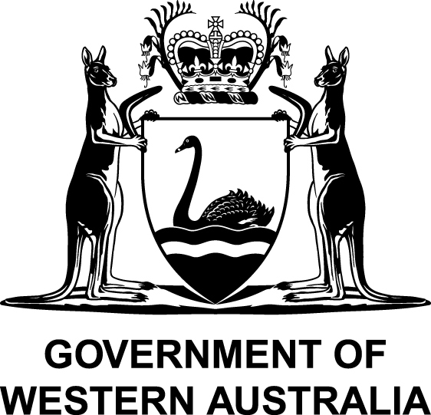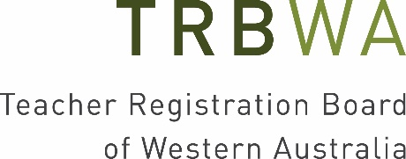

TEACHER REGISTRATION BOARD OF WESTERN AUSTRALIA ANNUAL REPORT 2018–19

This annual report reflects the operations of the Teacher Registration Board of Western Australia in regulating the registration of teachers and accrediting initial teacher education programs.

Letter of transmittal

Ms Lisa Rodgers
Director General
Department of Education

Dear Ms Rodgers

In accordance with section 114 of the Teacher Registration Act 2012, I am pleased to submit the annual report of the Teacher Registration Board of Western Australia for the period 1 July 2018 to 30 June 2019 for inclusion in the annual report of the Department of Education.

Yours sincerely
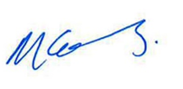
Margaret Collins
Chairperson
Teacher Registration Board of Western Australia

22 August 2019

CHAIRPERSON’S REPORT

On behalf of the Teacher Registration Board of Western Australia, I am pleased to present the Board’s 2018–19 annual report.

Over the last 12 months the Board has continued to focus on the delivery of its regulatory functions. In the administration of an effective and efficient teacher registration scheme and accreditation scheme, the ongoing challenge is to maintain the balance between rigour and proportionality, and at the same time ensure the best interests of children is the paramount consideration.

Following the Machinery of Government changes, the Board is supported in the performance of its functions by the Department of Education. A memorandum of understanding was signed to formalise these arrangements and confirm the independent status of the Board. On behalf of the Board, I would like to congratulate the Director General on her appointment and sincerely thank both her and her staff for their ongoing support.

In this period of transition, it was timely for the Board to review its strategic plan and following a period of stakeholder consultation, a new strategic direction was endorsed. In the current environment of reform, the Board strives to position itself as a quality and contemporary regulator that acts in the public interest.

In working to be a more effective regulator and to better meet the needs of our stakeholders, there have been a number of changes to the client interface through the Board’s online services. The result has been improved security, accessibility and functionality for applicants and registered teachers. In particular, for registered teachers, the online services environment provides a facility to view, update and manage most aspects of their teacher registration.

Of significant interest to the Board is the anticipated amendment to the Teacher Registration Act 2012, expected in the next reporting period. The Board will focus its work to amend policies and processes, as a result of these amendments, with a mind to continued improvement and efficiency in the delivery of its regulatory services. There will be opportunity to reflect on current practice, identify process improvement and reduce red tape.

The Board continues to contribute to the national reform agenda to work with its regulatory counterparts in each state and territory and the Australian Institute for Teaching and School Leadership on matters of shared concern.

There have been several changes to Board membership. We welcomed Ms Tracey Gray as a Board member in July and sadly farewelled her in December as she relocated to take up a Principal position in New South Wales. Following Ms Gray’s resignation, we were fortunate to have Mrs Nicole Brown, Deputy Associate Principal Primary School at Peter Moyes Anglican Community School, appointed in March by the Minister for Education and Training. Also, Mr Peter Collins and Mr Jeremy Bruse were both reappointed to the Board in December.

On behalf of the Board and secretariat, I would like to congratulate each on their appointments and especially thank Ms Gray for her valued contribution to the work of the Board.

Finally, I would like to thank my fellow Board members for their commitment and expertise, especially those members who chair or are members of the committees of the Board. I also thank the Director and staff of the secretariat for their great support and continued professionalism. In producing the Board’s new strategic direction, we identified our values as integrity, excellence, service, fairness and respect and I am looking forward to working with our stakeholders to embed these values in the coming years.

Mrs Margaret Collins
Chairperson

ABOUT THE BOARD

As the teacher regulatory authority in Western Australia, the Board is responsible for registering teachers, including renewing teacher registration, and administering the teacher disciplinary and impairment review processes. The Board is also responsible for the accreditation of initial teacher education programs delivered by Western Australian higher education providers.

In undertaking these functions, the Board maintains an up-to-date register of teachers, and has developed and published professional standards for teachers, accreditation standards for initial teacher education programs and a professional learning activities policy.

In performing its role, the Board’s paramount consideration is the best interests of children.

The relevant legislation

The Board was established in December 2012 under the Teacher Registration Act 2012.

The Board undertakes its duties in accordance with the Teacher Registration Act 2012 and its subsidiary legislation: the Teacher Registration (General) Regulations 2012 and the Teacher Registration (Accreditation of Initial Teacher Education Programmes) Regulations 2012.

The Board’s vision

A quality and contemporary regulator of the Western Australian teaching profession that operates in the best interests of children.

The Board’s purpose

Serving the public interest in Western Australia by ensuring that teachers are registered and initial teacher education programs are accredited in accordance with the Teacher Registration Act 2012.

The Board’s values

Integrity: We act with integrity, responsibility and transparency.

Excellence: We set standards of excellence and strive to achieve them.

Service: We are responsive, efficient and effective.

Fairness and Respect: We treat everyone fairly, with empathy and respect.

The Board’s members

The Board is appointed by the Minister for Education and Training and must include an Australian lawyer and at least three currently registered teachers.

At 30 June 2019 the Board members were:
- Margaret Collins (Chairperson) – former Regional Executive Director, South Metropolitan Education Region, Department of Education
- Ron Dullard (Deputy Chairperson) – former Director, Catholic Education Western Australia
- Peter Collins – Vice Principal, Holy Cross College, Ellenbrook
- Jeremy Bruse – Associate Principal, School and Community Statewide Services, Alternative Learning Settings
- Julie Woodhouse – Principal, Butler Primary School
- Nicole Brown – Deputy Associate Principal Primary School, Peter Moyes Anglican Community School
- Kate Offer – Assistant Professor, School of Law, The University of Western Australia.

During the reporting period:
- Peter Collins and Jeremy Bruse were reappointed to the Board.
- Tracey Gray was appointed to the Board on 2 July 2018 and resigned on 20 December 2018.
- Subsequently, Nicole Brown was appointed to the Board on 7 March 2019.

In 2018–19, the Board formally met 11 times and considered 13 items out-of-session.

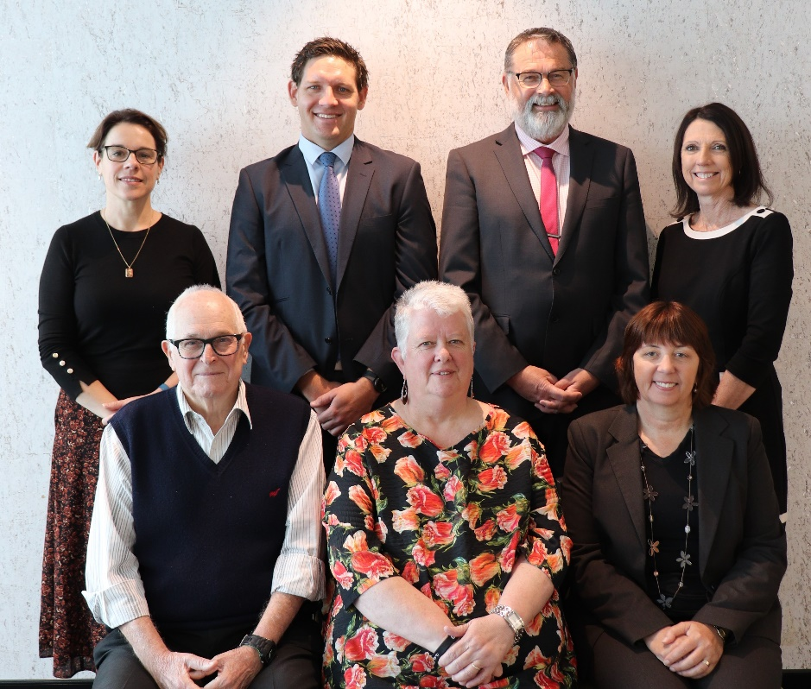
Back row (left to right): Kate Offer, Jeremy Bruse, Peter Collins, and Julie Woodhouse.
Front row (left to right): Ron Dullard, Margaret Collins and Nicole Brown.
Governance framework

The Teacher Registration Act 2012 requires the Board to establish at least one disciplinary committee and an impairment review committee. The Board may establish other committees to assist it to perform its functions.

In 2018–19, the Board was supported by the following committees:
- two disciplinary committees which consider complaints referred by the Board
- an impairment review committee which considers impairment matters referred by the Board
- an interim disciplinary order committee which has the authority to make an interim disciplinary order where
- there is the risk of imminent injury or harm to the physical or mental health of any person, or
- a registered teacher has been charged with a sexual offence involving a child.

See Disciplinary and impairment matters for further information about the activities of these committees in 2018–19.

The Department of Education’s Teacher Registration Directorate provides secretariat support to the Board which includes:
- processing teacher registration applications, and initial teacher education program accreditation applications for consideration by the Board
- assisting the Board to administer its disciplinary function
- supporting the work of the Board on policy matters.

The Board has delegated powers such as granting teacher registration to the Director, Teacher Registration, who refers matters that require further examination to the Board.

Financial statements and performance information related to the Teacher Registration Directorate and the Board’s remuneration are provided in the Department’s annual report.

The operations of the Board are funded by fees collected in accordance with the Teacher Registration Act 2012 and Costing and Pricing Government Services: Guidelines for Use by Agencies in the Western Australian Public Sector published by the Department of Treasury. The Board implemented a new fee schedule from 1 August 2018 to accommodate adjustments in the consumer price index.

Key achievements

Strategic direction
Following consultation with its stakeholders, the Board endorsed a new strategic direction which articulates its role as a regulatory authority and its strategic objectives and priorities.

The Board strives to be a quality and contemporary regulator of the Western Australian teaching profession that operates in the best interests of children. In undertaking its functions, the Board values integrity, excellence, service, fairness and respect.

Enhanced online services and improved processes
The Board continued to be responsive to the needs of its stakeholders and promote quality improvement and efficiency.

The Board improved online services for registered teachers, applicants and employers of teachers by implementing digital solutions with improved security, functionality and accessibility. This included a single sign-in process through which applicants and registered teachers can self-manage the registration process, streamlining the user experience. See Engagement with stakeholders for further information.

The Board introduced a digital third party identity verification system to streamline the process for meeting new requirements for national criminal record checks which mandate that the Board verify the identity of an applicant. This limited the increased administrative burden of the new requirement for applicants and the Board.

Revision and updating of Teacher-Student Professional Boundaries – A Resource for WA Teachers
The professional boundaries resource, first published by the Board in January 2017, was revised and updated to ensure its relevance in the current context.

The resource is designed to inform and guide teachers about professional boundaries they should maintain when dealing with students and prompt reflective behaviour.

The resource also provides useful information to employers of registered teachers, parents and the broader community and is intended to contribute to the continuing goal of making all schools in Western Australia as child safe as possible. Informal stakeholder feedback suggests the resource has been extremely useful for teachers in understanding their professional responsibilities.

Significant issues for the next financial year

Review of the Teacher Registration Act 2012
The Minister for Education and Training established a Strategic Implementation Group to advise on the recommendations from the review of the Teacher Registration Act 2012, which was tabled in Parliament in September 2018. It is anticipated that the review will be the subject of an amendment Bill in 2019–20. The Board will work to amend policies and processes in light of amendments to the Act with a view to improving delivery of its regulatory services.

National Review of Teacher Registration
The report from the national review of teacher registration led by an expert panel of state and territory representatives was submitted to the Council of Australian Governments (COAG) Education Council in September 2018. The review considered how the current national registration framework is operating across Australia.

Implementation of the review remains a matter of national consideration and the Board will continue to work with relevant authorities and regulatory counterparts to consider the review’s outcomes and potential impacts.

Royal Commission into Institutional Responses to Child Sexual Abuse
In December 2017, the Royal Commission presented its final report to the Governor-General, including its recommendations, detailing the culmination of its five-year inquiry into institutional responses to child sexual abuse and related matters. The Board will continue to work with relevant agencies as the Royal Commission’s recommendations relevant to the Board’s work as a teacher regulatory authority are considered and progressed.

Initial teacher education reform
The Board continues to engage with the Australian Institute for Teaching and School Leadership, state and territory teacher regulatory authorities and other stakeholders about proposed reforms to the initial teacher education accreditation scheme. The Board remains committed to the administration of an effective and efficient accreditation scheme for Western Australia that continues to balance regulatory rigour and reasonableness.

Digital business solutions
The Board has progressed developing and implementing digital solutions to replace legacy systems and to continue to assist applicants and registered teachers with meeting the requirements for gaining and maintaining teacher registration. In undertaking this work, the Board is balancing innovation with a robust risk-based approach to regulation.

The work includes converting analogue systems and information into the digital environment through the Board’s website and the Teacher Login portal. Preparations are also underway to replace the existing Customer Relationship Management System that holds approximately 55,000 current teacher registration records.

Planning for the next registration renewal application peak
The registration cycle for the renewal of Full Registration has cyclical peaks that arise approximately every three and a half years for an 18-month period.

The Board is expecting renewal applications to increase significantly from April 2020 and to continue to be relatively high until October 2021. Initial planning for the peak has commenced and the Board will undertake comprehensive preparation over the coming months to ensure effective registration processes and staffing arrangements are in place to manage the expected peak in applications.

ACTIVITIES OF THE BOARD

Regulatory activity

Teacher registration

All teachers teaching in schools and other educational venues in Western Australia (including centre-based education and care services such as long day care) are required to be registered with the Board.

At 30 June 2019, 54,736 teachers were registered with the Board across four registration categories (see Table 1). To meet registration requirements, applicants must be appropriately qualified, have the necessary English language skills, meet the required Professional Standards for Teachers for the relevant registration category, and be a fit and proper person. To renew registration, the Board must be satisfied that the teacher continues to meet the requirements for their category of registration.

Table 1: Teachers registered at June 30 by category 2015 to 2019
Category | 2015 | 2016 | 2017 | 2018 | 2019
Full Registration | 40,455 | 41,076 | 41,721 | 42,994 | 44,083
Provisional Registration | 8,046 | 5,701 | 5,710 | 5,913 | 5,721
Non-Practising Registration | 2,008 | 3,802 | 4,649 | 4,490 | 4,289
Limited Registration | 541 | 691 | 684 | 648 | 643
Total | 51,050 | 51,270 | 52,764 | 54,045 | 54,736

During 2018–19, the Board received 9,244 teacher registration applications and approved 9,601 applications (see Table 2). Where applicable, applicants had to provide criminal record checks from countries outside of Australia and 835 of these checks were conducted.

Table 2: Applications received and approved by type 2017–18 and 2018–19 (see note a)
Type of application | Received in 2017–18 | Approved in 2017–18 | Received in 2018–19 | Approved in 2018–19
New registration | 3,501 | 3,500 | 3,310 | 3,292
Renewal of registration | 2,542 | 2,240 | 3,218 | 3,587
Move registration category | 2,773 | 2,515 | 2,524 | 2,533
Extension of non-practising registration | 181 | 184 | 192 | 189
Total | 8,997 | 8,439 | 9,244 | 9,601
(a) Number of applications received in one year may not be the same as number approved that same year as applications may be processed in subsequent years.

In 2018–19, 1,643 applications for Full Registration from holders of Provisional Registration, including early career teachers, were approved. Five hundred and twenty-five holders of Non-Practising Registration successfully applied for Full Registration and 189 applications to extend the period of Non-Practising Registration were approved.

Based on the Mutual Recognition Principle, the Board registered 352 teachers with teacher registration in another Australian state or territory or in New Zealand.
Board determinations

The Board has delegated the granting of teacher registration to the Director, Teacher Registration. Applications considered by the Director to require further examination are referred to the Board.

During 2018–19, 24 of the 39 applications referred to the Board were refused as they did not meet one or more of the requirements for registration or the renewal of registration (see Table 3).

Table 3: Applications considered and refused by the Board by registration requirements 2017–18 and 2018–19
 | Considered in 2017–18 | Refused in 2017–18 | Considered in 2018–19 | Refused in 2018–19
One requirement considered:
Qualifications | 24 | 18 | 22 | 11
English Language | 19 | 15 | 12 | 10
Professional Standards | 0 | 0 | 1 | 0
Fit and Proper | 8 | 4 | 3 | 2
More than one requirement considered:
Qualifications and English Language | 4 | 4 | 1 | 1
Qualifications and Professional Standards | 1 | 1 | 0 | 0
Professional Standards and Professional Engagement | 0 | 0 | 0 | 0
Total | 56 | 42 | 39 | 24

The Board imposed conditions on the registration of seven teachers to ensure the professional, competent and safe practice of teaching by them.

Provision of advice

In 2018–19, the Board determined 95 requests for advice from people considering applying for registration on whether their qualifications would meet the requirements for teacher registration. Of these, the Director, Teacher Registration determined 68 met the qualification requirements. The Director referred 27 to the Board and 22 were determined not to meet qualifications requirements.

The Board received three requests for advice from people considering applying for registration as to whether they would meet the fit and proper person requirements of registration. The Board determined two did not meet the fit and proper requirements.

Annual teacher registration fee

In January 2019, the Board raised 52,752 invoices for the annual fee that registered teachers are required to pay by 31 March each year to maintain their registration.

A late payment processing fee was applied to 2,183 outstanding payments and 1,208 teachers who had not paid by 6 May 2019 had their registrations cancelled. By 30 June 2019, the Board had approved 18 requests for registration reinstatement from teachers whose non-payment was due to extenuating circumstances.

Unregistered teaching

One unregistered teaching matter referred for prosecution in the previous reporting period was concluded in the Magistrate’s Court and the individual was fined.

Review by the State Administrative Tribunal

Under section 124 of the Teacher Registration Act 2012, a person who is aggrieved by a reviewable decision of the Board may apply to the State Administrative Tribunal (SAT) for a review of that decision. In 2018–19, two matters were the subject of applications for review by the SAT. One matter was subsequently withdrawn by the applicant and one matter was settled by consent.

Disciplinary and impairment matters

The Board’s paramount consideration in dealing with disciplinary and impairment matters is the best interests of children. The Teacher Registration Act 2012 requires that only fit and proper people are registered as teachers, and places obligations on teachers, employers and certain other parties.

Notifications required by the Teacher Registration Act 2012 and complaints about teachers

Notifications are received about registered teachers from employers, teachers, the Commissioner of Police and Director of Public Prosecutions. More than one notification can be received per matter.

Complaints may also be made to the Board about registered teachers or a person who was a registered teacher at the time the alleged conduct occurred. More than one complaint can be received per matter.

In 2018–19, the Board received 48 notifications and nine complaints (see Table 4) relating to 53 matters.

Table 4: Notifications and complaints received by the Board 2017–18 and 2018–19 (see note a)
Notifications/complaints | 2017–18 | 2018–19
From Teachers
Legal actions (section 38) | 4 | 5
Loss of qualifications (section 39) | 0 | 0
Issued Working With Children Negative Notice (section 40) | 0 | 0
From Director of Public Prosecutions or Commissioner of Police (section 41) | 4 | 5
From Employers
Serious incompetence (section 42) | 6 | 6
Serious misconduct (section 42) | 41 | 32
Complaints from the public/other (section 51) | 14 | 9
Total | 69 | 57
(a) As per the specified section in the Teacher Registration Act 2012.

The Board continued to progress matters that were ongoing at the end of the previous reporting period. The status of these ongoing matters and the 53 new matters are reflected in Table 5.

Table 5: Status of matters as at 30 June 2019 (see note a)
Status of matters | 30 June 2019
Registration cancelled (section 27(2)(b)) | 4
Complaint not required (section 45(e)) | 14
Still to be decided (section 51(3)(a)) | 4
Investigations continuing (section 53(2)) | 25
Further action
Disciplinary Committee (section 53(1)(c)) | 4
Impairment Committee (section 53(1)(d)) | 0
State Administrative Tribunal (section 53(1)(e)) | 6
No further action
Other authority (section 57(1)(a)) | 6
Not within power (section 57(1)(b)) | 19
Without substance (section 57(1)(c)) | 4
Total | 86
(a) As per the specified section in the Teacher Registration Act 2012.

Of the four matters referred to a disciplinary committee, one was found to have contravened the Teacher Registration Act 2012 with the teacher receiving a reprimand and fine, and two matters remain ongoing. The fourth matter was referred back to the Board and subsequently to the State Administrative Tribunal (SAT) after the teacher failed to provide consent for a disciplinary committee to deal with the matter. This matter was ultimately discontinued.

Three ongoing matters from the previous reporting period were also dealt with by a disciplinary committee. One was referred back to the Board for further investigation and the two teachers in the other matters were found to be seriously incompetent. As a result, the disciplinary committee ordered that the full registration of one teacher be cancelled and substituted with provisional registration and that the other teacher be cautioned.

Of the six matters referred to the SAT, one matter was withdrawn, and five matters remain ongoing.

Five ongoing matters from the previous reporting period were also under consideration by the SAT. The Board withdrew one matter, the SAT ordered that one teacher be disqualified from applying for registration for two years and the three other matters remain ongoing.

Interim disciplinary orders

The interim disciplinary order committee has the authority to make interim disciplinary orders. The outcome of matters referred to the interim disciplinary order committee are reflected in Table 6.
Table 6: Matters referred to the interim disciplinary order committee 2018–19 (see note a)
Interim disciplinary orders | Referred | Made
An activity that involves a risk of imminent injury or harm  (section 59) | 5 | 1
Charged with child sexual offence (section 60) | 3 | 3
Total | 8 | 4
(a) As per the specified section in the Teacher Registration Act 2012.

The Board must refer all matters for which an interim disciplinary order has been made to the SAT within 14 days unless the order is revoked. Of the four orders made, only one matter was required to be referred to the SAT. The other three were revoked as the teachers concerned were no longer entitled to be registered.

Accreditation of initial teacher education programs

Accrediting initial teacher education (ITE) programs is directly linked to registering teachers. For a person to be eligible for Full, Provisional or Non-Practising Registration under the Teacher Registration Act 2012, they must have a teaching qualification from an accredited ITE program or one that the Board recognises as equivalent to such a qualification.

Applications from ITE providers for program accreditation or re-accreditation are assessed by a panel of education experts appointed by the Board against the Western Australian Standards for the Accreditation of Initial Teacher Education Programs. The standards are based on nationally agreed accreditation standards.

Approved programs are accredited for up to five years and recognised by other Australian state and territory teacher education regulatory bodies.

During 2018–19, the Board approved three ITE programs for initial accreditation and one for re-accreditation. As at 30 June 2019, the assessment of two applications for ITE re-accreditation, received during the reporting period, remain ongoing.

Table 7 shows the total number of accredited ITE programs in WA.

Table 7: WA accredited initial teacher education programs at 30 June, 2017–18 and
2018–19
ITE Programs | Undergraduate in 2017–18 | Undergraduate in 2018–19 | Postgraduate in 2017–18 | Postgraduate in 2018–19 | Total in 2017–18 | Total in 2018–19
Early Childhood | 4 | 3 | 1 | 1 | 5 | 4
Early Childhood/Primary | 0 | 1 | 1 | 2 | 1 | 3
Primary | 5 | 5 | 2 | 3 | 7 | 8
Primary/Secondary | 1 | 1 | 0 | 0 | 1 | 1
Secondary | 6 | 6 | 2 | 3 | 8 | 9
Early Childhood/  Primary/ Secondary | 0 | 0 | 1 | 1 | 1 | 1
Total | 16 | 16 | 7 | 10 | 23 | 26

Engagement with stakeholders

The Board continued to inform teachers and employers about their obligations by providing clear, consistent and timely information. This included educating the public about its role to ensure trust in the Board.

The Board’s Service Charter continued to provide a framework for customer service delivery standards. The customer service team assisted teachers, applicants and employers with enquiries via telephone, email and in-person. These enquiries predominantly related to applications for registration.

The Board’s website was refreshed during the reporting period with improved functionality including being made smartphone friendly with better security. It was the key resource for prospective and registered teachers, employers, universities and the public.

A single sign-in process was introduced to the Teacher Login portal which provided improved functionality and access to online forms and a facility for applicants to upload supporting evidence and registered teachers to view, update and self-manage most aspects of their teacher registration. This has reduced the number of paper applications submitted to the Board and the related administrative burden.

The Teacher Register Information (Professional) or TRIP, an online management tool for employers, was enhanced with a refreshed look, improved functionality and increased features including a single sign-in process. The TRIP continued to provide principals and employers with up-to-date information on the registration status of current and prospective teachers to assist them to meet their obligations under the Teacher Registration Act 2012.

The Board delivered presentations and provided professional development workshops about the Teacher Registration Act 2012, registration requirements and how teachers can maintain their registration. This included workshops specifically for new, early career and returning teachers and to employers of teachers within schools, and the education and care sectors. The Board also delivered presentations on how to become registered to final year pre-service teachers at each of Western Australia's universities.

The Board continued to be accountable by recording and assessing stakeholder feedback to identify ways to better meet the needs of the community through continuous improvement processes. Complaints and feedback during 2018–19 generally related to the legislative requirements underpinning teacher registration and service provision, including technical issues associated with accessing online forms and online payments during peak periods.

Finally, it is important to acknowledge two groups of key stakeholders with which the Board maintains strong links.

The first is other teacher regulatory authorities both in Australia and New Zealand. The Board continues to work with these other authorities on matters of common strategic interest including reform of processes to accredit initial teacher education programs and consideration of relevant recommendations arising from the recent National Review of Teacher Registration and the Royal Commission into Institutional Responses to Child Sexual Abuse.

The second is State Government departments and other authorities that have a focus on the interests of children. This includes the Department of Communities, Western Australia Police Force, the Commissioner for Children and Young People and of course the Department of Education, Catholic Education Western Australia and the Association of Independent Schools of Western Australia.

Feedback on our annual report can be sent to feedback@trb.wa.gov.au.

End of Teacher Registration Board of Western Australia Annual Report 2018–19.

KEY PERFORMANCE INDICATORS AND FINANCIAL STATEMENTS

Certification of key performance indicators

I hereby certify that the performance indicators are based on proper records, are relevant and appropriate for assisting users to assess the performance of the Department of Education, and fairly represent the performance of the Department for the year ended 30 June 2019.

Lisa Rodgers
Director General
(Accountable authority)

20 September 2019

Certification of financial statements

The accompanying financial statements of the Department of Education have been prepared in compliance with the provisions of the Financial Management Act 2006 from proper accounts and records to present fairly the financial transactions for the financial year ended 30 June 2019 and the financial position as at 30 June 2019.

At the date of signing, we are not aware of any circumstances which would render the particulars included in the financial statements misleading or inaccurate.
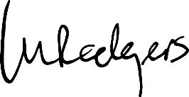
Lisa Rodgers
Director General
(Accountable authority)

20 September 2019

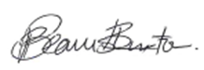
Philippa Beamish Burton
Acting Chief Finance Officer

20 September 2019

INDEPENDENT AUDITOR'S REPORT

To the Parliament of Western Australia
DEPARTMENT OF EDUCATION
Report on the Financial Statements

Opinion
I have audited the financial statements of the Department of Education which comprise the Statement of Financial Position as at 30 June 2019, the Statement of Comprehensive Income, Statement of Changes in Equity, Statement of Cash Flows and Summary of Consolidated Account Appropriations and Income Estimates for the year then ended, and Notes comprising a summary of significant accounting policies, Schedule of Income and Expenses by Service, Schedule of Assets and Liabilities by Service, and other explanatory information, including Administered transactions and balances.

In my opinion, the financial statements are based on proper accounts and present fairly, in all material respects, the operating results and cash flows of the Department of Education for the year ended 30 June 2019 and the financial position at the end of that period. They are in accordance with Australian Accounting Standards, the Financial Management Act 2006 and the Treasurer's Instructions.

Basis for Opinion
I conducted my audit in accordance with the Australian Auditing Standards. My responsibilities under those standards are further described in the Auditor's Responsibilities for the Audit of the Financial Statements section of my report. I am independent of the Department in accordance with the Auditor General Act 2006 and the relevant ethical requirements of the Accounting Professional and Ethical Standards Board's APES 110 Code of Ethics for Professional Accountants (the Code) that are relevant to my audit of the financial statements. I have also fulfilled my other ethical responsibilities in accordance with the Code. I believe that the audit evidence I have obtained is sufficient and appropriate to provide a basis for my opinion.

Responsibility of the Director General for the Financial Statements
The Director General is responsible for keeping proper accounts, and the preparation and fair presentation of the financial statements in accordance with Australian Accounting Standards, the Financial Management Act 2006 and the Treasurer's Instructions, and for such internal control as the Director General determines is necessary to enable the preparation of financial statements that are free from material misstatement, whether due to fraud or error.

In preparing the financial statements, the Director General is responsible for assessing the agency's ability to continue as a going concern, disclosing, as applicable, matters related to going concern and using the going concern basis of accounting unless the Western Australian Government has made policy or funding decisions affecting the continued existence of the Department.

Auditor's Responsibility for the Audit of the Financial Statements
As required by the Auditor General Act 2006, my responsibility is to express an opinion on the financial statements. The objectives of my audit are to obtain reasonable assurance about whether the financial statements as a whole are free from material misstatement, whether due to fraud or error, and to issue an auditor's report that includes my opinion. Reasonable assurance is a high level of assurance, but is not a guarantee that an audit conducted in accordance with Australian Auditing Standards will always detect a material misstatement when it exists. Misstatements can arise from fraud or error and are considered material if, individually or in the aggregate, they could reasonably be expected to influence the economic decisions of users taken on the basis of the financial statements.

As part of an audit in accordance with Australian Auditing Standards, I exercise professional judgment and maintain professional scepticism throughout the audit. I also:

- Identify and assess the risks of material misstatement of the financial statements, whether due to fraud or error, design and perform audit procedures responsive to those risks, and obtain audit evidence that is sufficient and appropriate to provide a basis for my opinion. The risk of not detecting a material misstatement resulting from fraud is higher than for one resulting from error, as fraud may involve collusion, forgery, intentional omissions, misrepresentations, or the override of internal control.

- Obtain an understanding of internal control relevant to the audit in order to design audit procedures that are appropriate in the circumstances, but not for the purpose of expressing an opinion on the effectiveness of the agency's internal control.

- Evaluate the appropriateness of accounting policies used and the reasonableness of accounting estimates and related disclosures made by the Director General.

- Conclude on the appropriateness of the Director General's use of the going concern basis of accounting and, based on the audit evidence obtained, whether a material uncertainty exists related to events or conditions that may cast significant doubt on the agency's ability to continue as a going concern. If I conclude that a material uncertainty exists, I am required to draw attention in my auditor's report to the related disclosures in the financial statements or, if such disclosures are inadequate, to modify my opinion. My conclusions are based on the audit evidence obtained up to the date of my auditor's report.

- Evaluate the overall presentation, structure and content of the financial statements, including the disclosures, and whether the financial statements represent the underlying transactions and events in a manner that achieves fair presentation.

I communicate with the Director General regarding, among other matters, the planned scope and timing of the audit and significant audit findings, including any significant deficiencies in internal control that I identify during my audit.

Report on Controls

Opinion
I have undertaken a reasonable assurance engagement on the design and implementation of controls exercised by the Department of Education. The controls exercised by the Department are those policies and procedures established by the Director General to ensure that the receipt, expenditure and investment of money, the acquisition and disposal of property, and the incurring of liabilities have been in accordance with legislative provisions (the overall control objectives).

My opinion has been formed on the basis of the matters outlined in this report.

In my opinion, in all material respects, the controls exercised by the Department of Education are sufficiently adequate to provide reasonable assurance that the receipt, expenditure and investment of money, the acquisition and disposal of property and the incurring of liabilities have been in accordance with legislative provisions during the year ended 30 June 2019.

The Director General's Responsibilities
The Director General is responsible for designing, implementing and maintaining controls to ensure that the receipt, expenditure and investment of money, the acquisition and disposal of property, and the incurring of liabilities are in accordance with the Financial Management Act 2006, the Treasurer's Instructions and other relevant written law.

Auditor General's Responsibilities
As required by the Auditor General Act 2006, my responsibility as an assurance practitioner is to express an opinion on the suitability of the design of the controls to achieve the overall control objectives and the implementation of the controls as designed.

I conducted my engagement in accordance with Standard on Assurance Engagements ASAE 3150 Assurance Engagements on Controls issued by the Australian Auditing and Assurance Standards Board. That standard requires that I comply with relevant ethical requirements and plan and perform my procedures to obtain reasonable assurance about whether, in all material respects, the controls are suitably designed to achieve the overall control objectives and the controls, necessary to achieve the overall control objectives, were implemented as designed.

An assurance engagement to report on the design and implementation of controls involves performing procedures to obtain evidence about the suitability of the design of controls to achieve the overall control objectives and the implementation of those controls. The procedures selected depend on my judgement, including the assessment of the risks that controls are not suitably designed or implemented as designed. My procedures included testing the implementation of those controls that I consider necessary to achieve the overall control objectives.

I believe that the evidence I have obtained is sufficient and appropriate to provide a basis for my opinion.

Limitations of Controls
Because of the inherent limitations of any internal control structure it is possible that, even if the controls are suitably designed and implemented as designed, once the controls are in operation, the overall control objectives may not be achieved so that fraud, error, or noncompliance with laws and regulations may occur and not be detected. Any projection of the outcome of the evaluation of the suitability of the design of controls to future periods is subject to the risk that the controls may become unsuitable because of changes in conditions.

Report on the Key Performance Indicators

Opinion
I have undertaken a reasonable assurance engagement on the key performance indicators of the Department of Education for the year ended 30 June 2019. The key performance indicators are the key effectiveness indicators and the key efficiency indicators that provide performance information about achieving outcomes and delivering services.

In my opinion, in all material respects, the key performance indicators of the Department of Education are relevant and appropriate to assist users to assess the Department's performance and fairly represent indicated performance for the year ended 30 June 2019.

The Director General's Responsibility for the Key Performance Indicators
The Director General is responsible for the preparation and fair presentation of the key performance indicators in accordance with the Financial Management Act 2006 and the Treasurer's Instructions and for such internal control as the Director General determines necessary to enable the preparation of key performance indicators that are free from material misstatement, whether due to fraud or error.

In preparing the key performance indicators, the Director General is responsible for identifying key performance indicators that are relevant and appropriate having regard to their purpose in accordance with Treasurer's Instruction 904 Key Performance Indicators.

Auditor General's Responsibility
As required by the Auditor General Act 2006, my responsibility as an assurance practitioner is to express an opinion on the key performance indicators. The objectives of my engagement are to obtain reasonable assurance about whether the key performance indicators are relevant and appropriate to assist users to assess the agency's performance and whether the key performance indicators are free from material misstatement, whether due to fraud or error, and to issue an auditor's report that includes my opinion. I conducted my engagement in accordance with Standard on Assurance Engagements ASAE 3000 Assurance Engagements Other than Audits or Reviews of Historical Financial Information issued by the Australian Auditing and Assurance Standards Board. That standard requires that I comply with relevant ethical requirements relating to assurance engagements.

An assurance engagement involves performing procedures to obtain evidence about the amounts and disclosures in the key performance indicators. It also involves evaluating the relevance and appropriateness of the key performance indicators against the criteria and guidance in Treasurer's Instruction 904 for measuring the extent of outcome achievement and the efficiency of service delivery. The procedures selected depend on my judgement, including the assessment of the risks of material misstatement of the key performance indicators. In making these risk assessments I obtain an understanding of internal control relevant to the engagement in order to design procedures that are appropriate in the circumstances.

I believe that the evidence I have obtained is sufficient and appropriate to provide a basis for my opinion.

My Independence and Quality Control Relating to the Reports on Controls and Key Performance Indicators
I have complied with the independence requirements of the Auditor General Act 2006 and the relevant ethical requirements relating to assurance engagements. In accordance with ASQC 1 Quality Control for Firms that Perform Audits and Reviews of Financial Reports and Other Financial Information, and Other Assurance Engagements, the Office of the Auditor General maintains a comprehensive system of quality control including documented policies and procedures regarding compliance with ethical requirements, professional standards and applicable legal and regulatory requirements.

Matters Relating to the Electronic Publication of the Audited Financial Statements and Key Performance Indicators
This auditor's report relates to the financial statements and key performance indicators of the Department of Education for the year ended 30 June 2019 included on the Department's website. The Department's management is responsible for the integrity of the Department's website. This audit does not provide assurance on the integrity of the Department's website. The auditor's report refers only to the financial statements and key performance indicators described above. It does not provide an opinion on any other information which may have been hyperlinked to/from these financial statements or key performance indicators. If users of the financial statements and key performance indicators are concerned with the inherent risks arising from publication on a website, they are advised to refer to the hard copy of the audited financial statements and key performance indicators to confirm the information contained in this website version of the financial statements and key performance indicators.
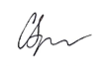

CAROLINE SPENCER
AUDITOR GENERAL
FOR WESTERN AUSTRALIA
Perth, Western Australia
23 September 2019

Key performance indicators

Key performance indicators enable senior management to assess and monitor the extent to which we achieve our Government desired outcome, and enhance our ability to account to the community for our performance.

Government Goal
Strong Communities: Safe communities and supported families

Desired Outcome
School students across Western Australia have access to high quality education

Services
- Public Primary Education
- Public Secondary Education
- Regulation and Non-Government Sector Assistance
- Support to the School Curriculum and Standards Authority

This section presents effectiveness indicators that show how well we met our desired outcome and efficiency indicators that show how efficiently we delivered our four services in 2018–19.

The indicators are as per our new Outcomes-Based Management (OBM) reporting structure, which was revised in 2018–19 to better reflect our current operations. Further information on the changes to our OBM reporting structure is in Appendix 5.

Results in 2018–19 for our former indicators are reported in Appendix 5 or in the relevant performance sections of this report.

Results in the appendices are not audited by the Office of the Auditor General.

Effectiveness indicators

Outcome: School students across Western Australia have access to high quality education

We aim to provide everyone aged four to 17 years (at 30 June) in Western Australia with access to education through the public school system, irrespective of their location, circumstances and whether that provision is taken up or not.

Two approaches are used to measure how well we achieve this aim.

The rate of participation in education gives an indication of the extent to which school-aged Western Australian residents are engaged in some form of education during the senior secondary years. The rate includes data spanning the main forms of education including public and non-government schools, vocational education and training, and university.

The apparent retention rate is the second measure of our success in providing access to education through the public system. It provides an indication of the proportion of students in Year 8 that completed Year 12 at public schools four years later.

Our other indicators provide measures of the extent to which students achieve high standards of learning.

The WACE achievement rate shows the percentage of Year 12 public school students who achieved the Western Australian Certificate of Education (WACE) qualification, the criterion for overall success in school in WA.

Student achievement prior to Year 12 is shown using indicators that measure the percentage of public school students in Years 3, 5, 7 and 9 who achieve proficiency standards in national reading and numeracy tests.

Rate of participation in education

This rate shows the proportion of the State’s estimated resident population of 15, 16 and 17 year olds who are participating in some form of education.

These ages of interest align to Years 10, 11 and 12. The rate includes young people of these ages who (i) were enrolled in public and non-government schools at the Semester 2 student census; (ii) attended vocational education and training during the year; or (iii) attended university during the year. To ensure students are only counted once, students attending both school and vocational education and training are only counted in the school data.

Participation rates for 2014 to 2018 are in Table 26 with rates by gender in Appendix 3.

The target in the 2018–19 Budget Papers is based on the higher of the preliminary actual for 2016 and the estimated actual for 2017, using the latest available data at the time of the 2018–19 State Budget.
Table 26: Participation rate (%) of persons aged 15 to 17 years engaged in some form of education 2014 to 2018 (see note a) (see note b)
2014 | 2015 | 2016 | 2017 (see note c) | 2018 | Target for 2018–19 (see note d)
93.9 | 96.7 | 96.8 | 96.2 | 98.0 | 97
Source: System and School Performance
(a) Based on Australian Bureau of Statistics preliminary estimates of resident population (age at 30 June) and data collected from public and non-government schools (Semester 2 student census, age at 1 July), universities (age at 30 June), and vocational education and training providers (age at 30 June).
(b) University enrolment data for 2018 is an estimate based on 2017 university enrolment data and an annual compound growth factor calculated from university enrolment data across the previous four years.
(c) Revised rate for 2017 due to updated data for 2017 university student enrolments and estimate of resident population. The 2017 rate published in our 2017–18 annual report was 96.3%.
(d) Target as per 2018–19 State Budget.

Retention in public schooling

The extent to which students continue to participate in public school education is indicated by the apparent Year 8 to 12 retention rate. This is the number of full-time students in Year 12, as a percentage of the number of full-time students who enrolled in Year 8 four years earlier (the start of secondary school at that time). Retention rates for 2014 to 2018 are in Table 27, with rates by subgroup in Appendix 3.

The apparent retention rate does not account for net changes to the school population caused by interstate and overseas migration, or students moving between school sectors.

As noted in previous reports, the 2014 rate was inflated by higher net overseas and interstate migration and more students moving to public schools from non-government schools and vocational education and training providers than in previous years.

The target in the 2018–19 Budget Papers was based on the higher of the two most recent years’ performance at that time (2016 and 2017).

Table 27: Apparent retention rate (%) of public school students from Year 8 to Year 12, 2014 to 2018 (see note a) (see note b)
2014 | 2015 | 2016 | 2017 | 2018 | Target for 2018–19 (see note c)
90.3 | 80.4 | 77.7 | 80.1 | 81.4 | 81
Source: System and School Performance
(a) Excludes Canning College and Tuart College students, part-time and international students, and mature-aged students at senior campuses.
(b) Semester 2 student census.
(c) Target as per 2018–19 State Budget.

WACE achievement by Year 12 public school students

To achieve the Western Australian Certificate of Education (WACE) qualification, students must meet criteria established by the School Curriculum and Standards Authority. For 2018, students had to:
- demonstrate the Authority’s minimum standards of literacy and numeracy
- complete at least 20 units (or equivalent) that met breadth and depth of study requirements
- complete at least four Year 12 Australian Tertiary Admission Rank (ATAR) courses or complete a certificate II (or higher) vocational education and training (VET) qualification
- achieve a grade of C or better in 14 course units (or equivalent) of which at least six must be completed in Year 12.

The WACE achievement rate is a new indicator which shows the percentage of Year 12 students enrolled in a public school in Semester 2 who achieved the WACE qualification that same year. The rates for 2015 to 2018 are in Table 28 with further breakdowns in Appendix 3.

The introduction of higher requirements for WACE achievement affected results for 2016, 2017 and 2018. From 2016, Year 12 students had to meet designated standards in reading, writing and numeracy through either the Year 9 National Assessment Program – Literacy and Numeracy (NAPLAN) or the School Curriculum and Standards Authority’s Online Literacy and Numeracy Assessment (OLNA) to achieve the WACE.

The target for 2018–19 was based on the higher of the two most recent years’ performance at that time (2016 and 2017).

Table 28: WACE achievement rate (%) of Year 12 public school students 2015 to 2018 (see note a) (see note b) (see note c)
2015 | 2016 | 2017 | 2018 (see note d) | Target for 2018–19 (see note e)
87.7 | 79.8 | 79.5 | 80.5 | 80
Source: System and School Performance
(a) Year 12 full-time students in the Semester 2 student census.
(b) Year 12 WACE achievement data from the School Curriculum and Standards Authority and taken at a point in time. Data may be updated after this time for a variety of reasons such as students successfully appealing their results.
(c) Data limitations do not allow for the calculation of this rate prior to 2015.
(d) A few registered training organisations did not complete VET certification for some public school students in time to be included in the 2018 data. This may have affected the data reported for 2018.
(e) As this is a new indicator, the target for 2018–19 is as reported in the 2019–20 State Budget.

Student proficiency in reading and numeracy

The National Assessment Program – Literacy and Numeracy (NAPLAN) is conducted annually across all states and territories by the Australian Curriculum, Assessment and Reporting Authority.

Full cohorts of Year 3, 5, 7 and 9 students across the country undertake common tests in May.

This program provides valuable information for parents on their children’s achievements as well as useful information at school-level and Australia-wide. The national and state/territory results are reported in 2018 NAPLAN national report.

The key performance indicators for reading and numeracy are defined as the proportion of public school students in Years 3, 5, 7 and 9 achieving proficiency standards in NAPLAN Reading and Numeracy.

The proficiency standards were set by the Department based on provisional work conducted nationally. They represent challenging but reasonable reading and numeracy achievement expectations for a typical student in Years 3, 5, 7 or 9. Proficiency indicates students are on track to meet the curriculum expectations for the year level and assessment area. Proficiency standards are more challenging to achieve than national minimum standards and we consider them to be better indicators of the quality of students’ reading and numeracy skills.

Results for WA public school students are in Table 29, including for 2014 to 2017 which have been recalculated using the proficiency standards.

The targets for 2018–19 were based on the higher of the two most recent years’ performance at that time (2016 and 2017).

WA public school students’ NAPLAN results are summarised online and in Appendix 2 of this report.

Table 29: Percentage of Western Australian public school Year 3, 5, 7 and 9 students achieving proficiency standards in NAPLAN Reading and Numeracy, 2014 to 2018 (see note a)
 | Assessment area | 2014 | 2015 | 2016 | 2017 | 2018 | Target for 2018–19 (see note b)
Year 3 | Reading | 61.5 | 63.8 | 64.6 | 67.3 | 70.0 | 68
Year 3 | Numeracy | 62.7 | 60.9 | 63.5 | 67.6 | 69.2 | 68
Year 5 | Reading | 61.0 | 58.1 | 62.8 | 65.0 | 68.4 | 66
Year 5 | Numeracy | 59.3 | 61.4 | 62.2 | 64.5 | 66.3 | 65
Year 7 (see note c) | Reading | 64.7 | 62.0 | 60.6 | 62.6 | 64.3 | 63
Year 7 (see note c) | Numeracy | 56.4 | 52.8 | 58.7 | 61.1 | 62.1 | 62
Year 9 | Reading | 64.1 | 63.2 | 65.1 | 64.3 | 71.1 | 66
Year 9 | Numeracy | 60.4 | 64.0 | 63.8 | 65.3 | 70.5 | 66
Source: System and School Performance
(a) From 2018 NAPLAN began transitioning from pen and paper to online assessments.
(b) As these are new indicators, the targets for 2018–19 are as reported in the 2019–20 State Budget.
(c) Year 7 became part of public school secondary education in Western Australia from 2015, having previously been part of primary education.

Efficiency indicators

Efficiency indicators show how efficiently we delivered our four services in 2018–19. The indicators have been calculated based on costs of services excluding the non-cash revaluation decrement.

The Department revised its Outcomes Based Management (OBM) structure in
2018–19 to reflect its current operations. The 2017–18 actuals have been recast for comparability purposes where the methodology for existing indicators has changed. The 2018–19 targets are as reported in the 2019–20 Budget Papers.

Service 1: Public Primary Education

This service provides access to education in public schools for persons aged generally from four years and six months to 11 years and six months.

Cost per student full-time equivalents of public primary education

This indicator is the total cost of services for primary education in public schools divided by the average full-time equivalent of public school primary students across the two semesters of the financial year.

Table 30: Cost ($) per full-time equivalent student of public primary education 2017–18 and 2018–19 (see note a) (see note b)
2017–18 | 2018–19 | Target for 2018–19 (see note c)
15,155 | 15,242 | 15,384
Source: Education Business Services
(a) Figures are not adjusted for inflation.
(b) The 2017–18 actual and 2018–19 target vary from those published in our 2017–18 annual report and the 2018–19 State Budget due to a change in the calculation methodology as a result of the Department’s revised OBM reporting structure.
(c) Target for 2018–19 as reported in the 2019–20 State Budget, prepared under the new OBM reporting structure.

Service 2: Public Secondary Education

This service provides access to education in public schools for persons aged generally from 11 years and six months. It includes the provision of accommodation, care and services for students from rural and remote areas who have to board away from home to attend a public school.

Cost per student full-time equivalents of public secondary education

This indicator is the total cost of services for secondary education in public schools divided by the average full-time equivalent of public school secondary students across the two semesters of the financial year.

Table 31: Cost ($) per full-time equivalent student of public secondary education 2017–18 and 2018–19 (see note a) (see note b)
2017–18 | 2018–19 | Target for 2018–19 (see note c)
18,383 | 18,488 | 18,870
Source: Education Business Services
(a) Figures are not adjusted for inflation.
(b) The 2017–18 actual and 2018–19 target vary from those published in our 2017–18 annual report and the 2018–19 State Budget due to a change in the calculation methodology as a result of the Department’s revised OBM reporting structure.
(c) Target for 2018–19 as reported in the 2019–20 State Budget, prepared under the new OBM reporting structure.

Service 3: Regulation and Non-Government Sector Assistance

This service provides regulatory and assistance services, as required by legislation or government policy, to support provision of quality services by non-government schools, universities and teachers across all Western Australian schools. It also includes the provision of accommodation, care and services for students from rural and remote areas who have to board away from home to attend a non-government school.

Cost of non-government school regulatory services per non-government school

This new indicator shows the cost to the Department of regulatory services provided for non-government schools divided by the number of Independent non-government schools.

The lower cost in 2018–19 compared to 2017–18 was primarily due to the transfer of the Training Accreditation Council secretariat function and staff to the Department of Training and Workforce Development. The result for 2018–19 was lower than the 2018–19 budget target due mainly to lower than expected expenditure.

Table 32: Cost ($) of non-government school regulatory services per non-government school 2017–18 and 2018–19 (see note a)
2017–18 | 2018–19 | Target for 2018–19 (see note b)
7,407 | 6,747 | 7,824
Source: Education Business Services
(a) Figures are not adjusted for inflation.
(b) As this is a new indicator, the target for 2018–19 is as reported in the 2019–20 State Budget.

Cost of teacher regulatory services per teacher

This indicator is the cost to the Department of providing secretariat support to the Teacher Registration Board of Western Australia divided by the number of registered teachers at 30 June.

Table 33: Cost ($) of teacher regulatory services per teacher 2017–18 and 2018–19 (see note a) (see note b)
2017–18 (see note c) | 2018–19 | Target for 2018–19 (see note d)
95 | 110 | 107
Source: Education Business Services
(a) Figures are not adjusted for inflation.
(b) The 2017–18 actual and 2018–19 target vary from those published in our 2017–18 annual report and the 2018–19 State Budget due to a change in the calculation methodology as a result of the Department’s revised OBM reporting structure.
(c) The 2017–18 result was lower due to the allocation of corporate overhead being less than anticipated. The methodology for applying corporate overhead has since been refined.
(d) Target for 2018–19 as reported in the 2019–20 State Budget, prepared under the new OBM reporting structure.

Service 4: Support to the School Curriculum and Standards Authority

This service provides resources to the School Curriculum and Standards Authority to assist it to perform its statutory functions under the School Curriculum and Standards Authority Act 1997.

Cost per student of support to the School Curriculum and Standards Authority

This new indicator shows the cost to the Department of providing secretariat services to the Authority divided by the average full-time equivalent of all students across the two semesters of the financial year.

Table 34: Cost ($) per student of support to the School Curriculum and Standards Authority 2017–18 and 2018–19 (see note a)
2017–18 | 2018–19 | Target for 2018–19 (see note b)
76 | 77 | 75
Source: Education Business Services
(a) Figures are not adjusted for inflation.
(b) As this is a new indicator, the target for 2018–19 is as reported in the 2019–20 State Budget.

Financial statements

For an alternative format of the Financial statements please telephone 9264 5802.

APPENDICES

‘Primary’ denotes Kindergarten to Year 6 and ‘Secondary’ spans Years 7 to 12 unless specified otherwise.

1. Student enrolment

Table A1: Students at Western Australian schools by sector 2005 to 2019 (see note a) (see note b)
Year | Public schools | Non-government schools | Total
2005 | 252,040 | 116,968 | 369,008
2006 | 252,061 | 119,896 | 371,957
2007 | 253,209 | 123,216 | 376,425
2008 | 253,838 | 127,248 | 381,086
2009 | 258,132 | 131,240 | 389,372
2010 | 258,115 | 134,335 | 392,450
2011 | 261,013 | 137,372 | 398,385
2012 | 268,129 | 140,006 | 408,135
2013 | 276,275 | 142,883 | 419,158
2014 | 283,739 | 144,877 | 428,616
2015 | 292,952 | 148,980 | 441,932
2016 | 296,377 | 148,545 | 444,922
2017 | 302,271 | 147,471 | 449,742
2018 | 307,520 | 147,813 | 455,333
2019 | 311,199 | 148,836 | 460,035
Source: System and School Performance
(a) Semester 1 student census. Primary and full-time secondary students. Public schools include community kindergartens and non-government schools include Independent pre-schools.
(b) Half cohort progressed through school from 2001 to 2014 inclusive, entering secondary education in 2010.

Table A2: Schools and students in Western Australia by sector and subgroup 2019 (see note a)
Sector | Schools | All students | Female students | Male students | Aboriginal students
Public | 812 | 311,199 | 150,497 | 160,702 | 26,002
Non-government | 309 | 148,836 | 74,311 | 74,525 | 5,005
Total | 1,121 | 460,035 | 224,808 | 235,227 | 31,007
Source: System and School Performance
(a) Semester 1 student census. Primary and full-time secondary students. Public schools include community kindergartens and non-government schools include Independent pre-schools.

Table A3: Students at Western Australian schools by year level and sector 2019 (see note a)
Year level | Public schools | Non-government schools | Total
Pre-kindergarten | – | 1,689 | 1,689
Kindergarten | 24,397 | 8,210 | 32,607
Pre-primary | 25,839 | 8,796 | 34,635
Year 1 | 26,075 | 8,800 | 34,875
Year 2 | 25,417 | 8,981 | 34,398
Year 3 | 25,344 | 9,204 | 34,548
Year 4 | 24,985 | 9,443 | 34,428
Year 5 | 24,351 | 9,734 | 34,085
Year 6 | 24,644 | 10,164 | 34,808
Year 7 | 20,824 | 13,219 | 34,043
Year 8 | 19,612 | 13,132 | 32,744
Year 9 | 18,702 | 12,380 | 31,082
Year 10 | 17,923 | 12,361 | 30,284
Year 11 | 17,839 | 11,817 | 29,656
Year 12 | 15,159 | 10,861 | 26,020
Primary total | 201,052 | 75,021 | 276,073
Secondary total | 110,147 | 73,815 | 183,962
Grand total | 311,199 | 148,836 | 460,035
Source: System and School Performance
(a) Semester 1 student census. Primary and full-time secondary students. Includes community kindergartens in public schools and Independent pre-schools in non-government schools. Totals include ungraded students.

Table A4: Students at Western Australian public schools by level of education and subgroup 2019 (see note a)
Level of education | All | Female | Male | Aboriginal
Primary | 201,052 | 97,171 | 103,881 | 16,887
Secondary | 110,147 | 53,326 | 56,821 | 9,115
Total | 311,199 | 150,497 | 160,702 | 26,002
Source: System and School Performance
(a) Semester 1 student census. Primary and full-time secondary students. Includes community kindergartens.

Table A5: Western Australian public schools and students by school type and level of education 2019 (see note a)
School type | Schools | Primary students | Secondary students | Total students
Community kindergarten | 18 | 456 | 0 | 456
Primary (see note b) | 560 | 187,723 | 559 | 188,282
District high | 53 | 7,604 | 3,774 | 11,378
Kindergarten–Year 12 (see note c) | 6 | 2,153 | 2,032 | 4,185
Secondary | 109 | 0 | 102,137 | 102,137
Education support (see note d) | 64 | 3,023 | 1,622 | 4,645
Specialist services (see note e) | 2 | 93 | 23 | 116
Total | 812 | 201,052 | 110,147 | 311,199
Source: System and School Performance
(a) Semester 1 student census. Primary and full-time secondary students.
(b) Includes schools of the air and remote community schools.
(c) Includes School of Isolated and Distance Education.
(d) Includes language development schools/centres.
(e) Comprises School of Special Educational Needs: Behaviour and Engagement and School of Special Educational Needs: Sensory.

Table A6: Students at Western Australian public schools by year level 2015 to 2019 (see note a) (see note b)
Year level | 2015 | 2016 | 2017 | 2018 | 2019
Kindergarten | 23,894 | 23,877 | 24,543 | 24,644 | 24,397
Pre-primary | 25,139 | 25,171 | 25,174 | 25,953 | 25,839
Year 1 | 24,918 | 25,171 | 25,465 | 25,444 | 26,075
Year 2 | 25,349 | 24,859 | 25,102 | 25,425 | 25,417
Year 3 | 24,816 | 25,261 | 24,853 | 25,064 | 25,344
Year 4 | 23,145 | 24,647 | 25,172 | 24,708 | 24,985
Year 5 | 21,784 | 22,797 | 24,301 | 24,775 | 24,351
Year 6 | 20,996 | 21,639 | 22,737 | 24,132 | 24,644
Year 7 | 17,394 | 17,783 | 18,673 | 19,679 | 20,824
Year 8 | 17,185 | 17,469 | 17,970 | 18,762 | 19,612
Year 9 | 17,460 | 17,326 | 17,582 | 18,057 | 18,702
Year 10 | 17,811 | 17,451 | 17,462 | 17,576 | 17,923
Year 11 | 18,419 | 18,187 | 18,088 | 17,954 | 17,839
Year 12 | 14,566 | 14,660 | 15,075 | 15,278 | 15,159
Primary total | 190,041 | 193,422 | 197,347 | 200,145 | 201,052
Secondary total | 102,911 | 102,955 | 104,924 | 107,375 | 110,147
Grand total | 292,952 | 296,377 | 302,271 | 307,520 | 311,199
Source: System and School Performance
(a) Semester 1 student census. Primary and full-time secondary students. Includes community kindergartens. Totals include ungraded students.
(b) Year 7 included in secondary from 2015. Prior to this Year 7 included in primary.

Table A7: Proportion (%) of students by public schools’ geolocation by level of education 2019 (see note a) (see note b)
Geolocation (see note c) | Primary | Secondary | All
Metropolitan | 76.1 | 75.1 | 75.8
Inner regional | 8.8 | 9.8 | 9.2
Outer regional | 7.3 | 8.4 | 7.7
Remote | 4.8 | 4.2 | 4.6
Very remote | 2.9 | 2.5 | 2.8
Source: System and School Performance
(a) Semester 1 student census. Primary and full-time secondary students. Includes community kindergartens.
(b) Percentages may not add to 100% due to rounding.
(c) Australian Bureau of Statistics Australian Statistical Geography Standard, based on location of students’ schools.

Table A8: Western Australian public schools and students by education region and level of education 2019 (see note a)
Education region | Schools | Students in Primary | Students in Secondary | Total students
Metropolitan
North Metropolitan | 245 | 73,419 | 39,104 | 112,523
South Metropolitan | 261 | 82,660 | 44,401 | 127,061
Total | 506 | 156,079 | 83,505 | 239,584
Country (see note b)
Goldfields | 38 | 5,327 | 2,660 | 7,987
Kimberley | 23 | 3,585 | 2,084 | 5,669
Midwest | 47 | 5,278 | 2,734 | 8,012
Pilbara | 29 | 6,651 | 2,842 | 9,493
Southwest | 100 | 18,387 | 12,942 | 31,329
Wheatbelt | 69 | 5,745 | 3,380 | 9,125
Total | 306 | 44,973 | 26,642 | 71,615
Grand total | 812 | 201,052 | 110,147 | 311,199
Source: System and School Performance
(a) Semester 1 student census. Primary and full-time secondary students. Includes community kindergartens.
(b) Defined as all non-metropolitan education regions.

Figure A1: Aboriginal students at Western Australian public schools by level of education 2005 to 2019 (see note a) (see note b) (see note c)

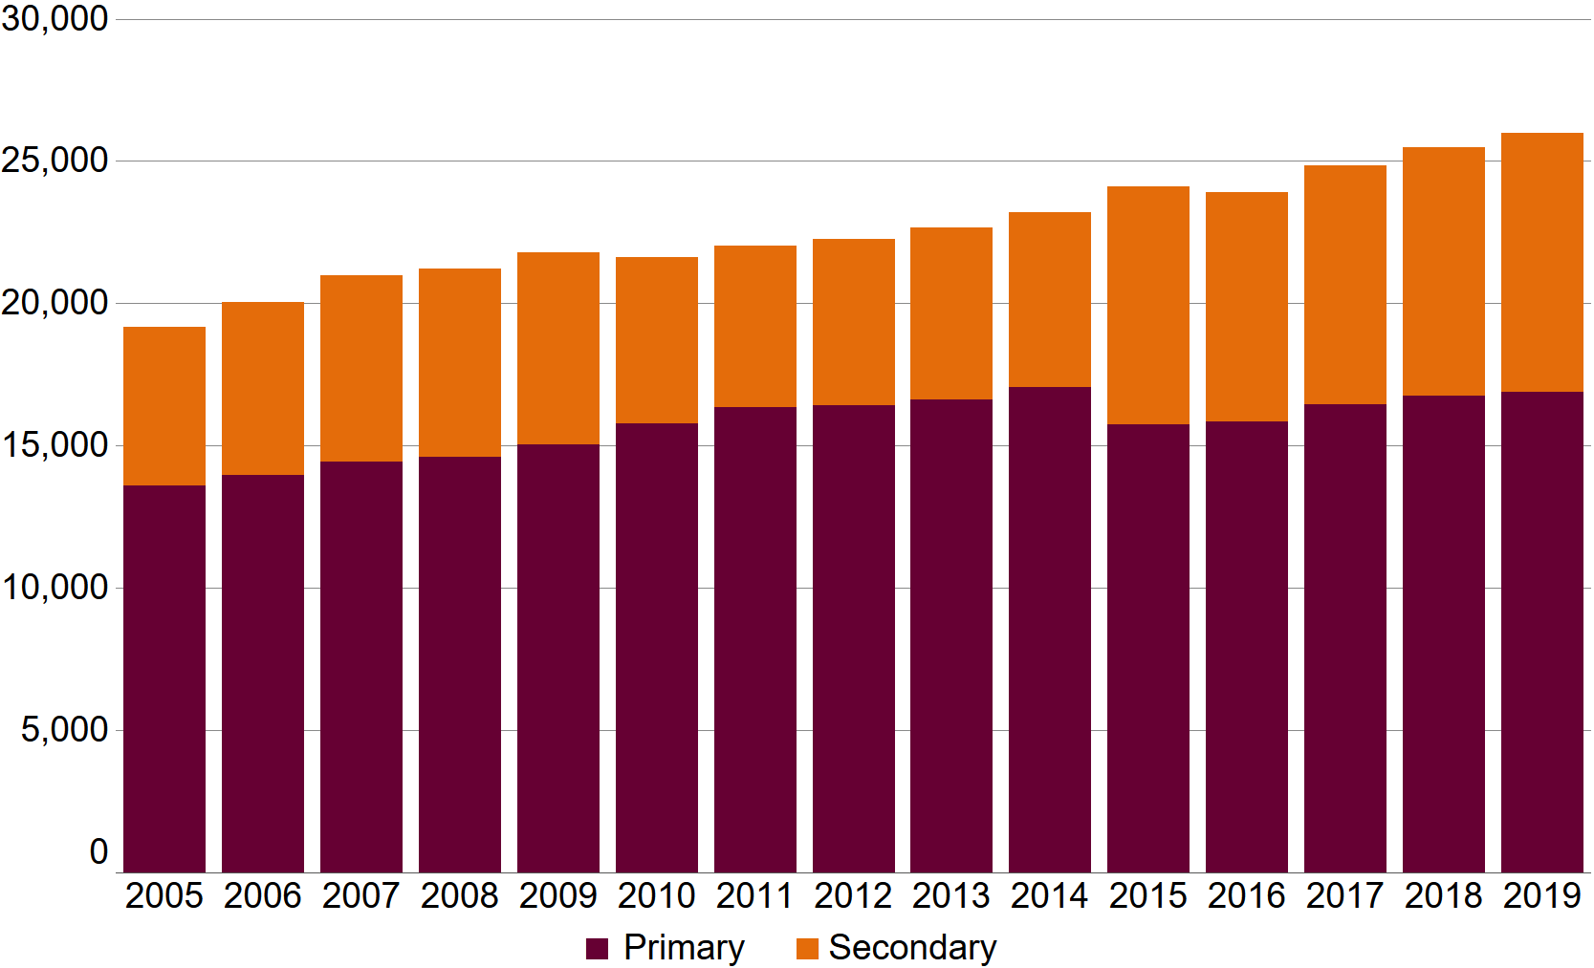
Source: System and School Performance
(a) Semester 1 student census. Primary and full-time secondary students. Includes community kindergartens.
(b) Year 7 included in secondary from 2015. Prior to this Year 7 included in primary.
(c) Half cohort progressed through school from 2001 to 2014 inclusive, entering secondary education in 2010.

Table A9: Aboriginal students at Western Australian public schools by year level 2015 to 2019 (see note a) (see note b)
Year level | 2015 | 2016 | 2017 | 2018 | 2019
Kindergarten | 1,812 | 1,714 | 1,854 | 1,860 | 1,800
Pre-primary | 1,997 | 2,027 | 2,020 | 2,115 | 2,137
Year 1 | 2,085 | 2,025 | 2,123 | 2,108 | 2,181
Year 2 | 2,060 | 2,076 | 2,073 | 2,160 | 2,139
Year 3 | 2,120 | 2,065 | 2,134 | 2,074 | 2,192
Year 4 | 1,999 | 2,089 | 2,095 | 2,141 | 2,125
Year 5 | 1,912 | 1,989 | 2,129 | 2,128 | 2,169
Year 6 | 1,754 | 1,872 | 2,032 | 2,156 | 2,144
Year 7 | 1,632 | 1,534 | 1,714 | 1,856 | 1,975
Year 8 | 1,633 | 1,619 | 1,584 | 1,726 | 1,858
Year 9 | 1,546 | 1,544 | 1,570 | 1,530 | 1,637
Year 10 | 1,474 | 1,375 | 1,457 | 1,464 | 1,390
Year 11 | 1,311 | 1,228 | 1,262 | 1,301 | 1,362
Year 12 | 783 | 736 | 816 | 852 | 893
Primary total | 15,739 | 15,857 | 16,460 | 16,742 | 16,887
Secondary total | 8,379 | 8,036 | 8,403 | 8,729 | 9,115
Grand total | 24,118 | 23,893 | 24,863 | 25,471 | 26,002
Source: System and School Performance
(a) Semester 1 student census. Primary and full-time secondary students. Includes community kindergartens. Totals include ungraded students.
(b) Year 7 included in secondary from 2015. Prior to this Year 7 included in primary.
Table A10: Aboriginal students at Western Australian public schools by education region 2019 (see note a)
Education region | Aboriginal | All | Aboriginal students as % of all public school students
Metropolitan
North Metropolitan | 4,793 | 112,523 | 4.3
South Metropolitan | 7,160 | 127,061 | 5.6
Total | 11,953 | 239,584 | 5.0
Country (see note b)
Goldfields | 1,807 | 7,987 | 22.6
Kimberley | 3,458 | 5,669 | 61.0
Midwest | 2,362 | 8,012 | 29.5
Pilbara | 2,700 | 9,493 | 28.4
Southwest | 2,259 | 31,329 | 7.2
Wheatbelt | 1,463 | 9,125 | 16.0
Total | 14,049 | 71,615 | 19.6
Grand total | 26,002 | 311,199 | 8.4
Source: System and School Performance
(a) Semester 1 student census. Primary and full-time secondary students. Includes community kindergartens.
(b) Defined as all non-metropolitan education regions.

Table A11: Students registered to receive home education 2015 to 2019 (see note a) (see note b)
2015 | 2016 | 2017 | 2018 | 2019
2,826 | 3,303 | 3,464 | 3,563 | 3,720
Source: Statewide Services
(a) Under the School Education Act 1999, the Department is responsible for regulation of home education, including evaluation of home education programs and educational progress of students.
(b) As at end of March.

Table A12: Western Australian non-government schools and students by school type and level of education 2019 (see note a) (see note b)
School type | Schools | Primary students | Secondary students | Total students
Independent pre-school | 1 | 58 | 0 | 58
Primary | 145 | 39,703 | 0 | 39,703
Primary–secondary | 121 | 35,260 | 47,406 | 82,666
Secondary | 42 | 0 | 26,409 | 26,409
Total | 309 | 75,021 | 73,815 | 148,836
Source: System and School Performance
(a) Semester 1 student census. Primary and full-time secondary students.
(b) Primary includes pre-kindergarten students at non-government schools.

Table A13: Non-government schools and students by religious affiliation of school 2018 and 2019 (see note a)
Religious affiliation | Schools in 2018 | Schools in 2019 | Students in 2018 | Students in 2019
No religious affiliation | 52 | 52 | 7,161 | 7,175
Total religious affiliation | 255 | 257 | 140,652 | 141,661
Anglican | 19 | 19 | 22,241 | 22,104
Baptist | 14 | 15 | 9,497 | 10,199
Catholic | 164 | 164 | 78,432 | 78,617
Seventh Day Adventist | 5 | 5 | 665 | 701
Uniting Church | 8 | 8 | 9,267 | 8,826
Various other | 45 | 46 | 20,550 | 21,214
Grand total | 307 | 309 | 147,813 | 148,836
Source: System and School Performance
(a) Semester 1 student census. Primary and full-time secondary students.

Table A14: Students at Western Australian residential colleges 2010 to 2019 (see note a)
College | 2010 | 2011 | 2012 | 2013 | 2014 | 2015 | 2016 | 2017 | 2018 | 2019
Albany | 127 | 95 | 97 | 80 | 81 | 86 | 94 | 82 | 69 | 66
Broome | 60 | 52 | 77 | 51 | 72 | 73 | 72 | 102 | 99 | 81
City Beach | 63 | 66 | 69 | 60 | 57 | 54 | 56 | 52 | 54 | 56
Esperance | 89 | 78 | 86 | 75 | 73 | 82 | 79 | 95 | 87 | 83
Geraldton | 109 | 100 | 89 | 89 | 62 | 60 | 80 | 68 | 55 | 62
Merredin | 34 | 24 | 44 | 47 | 48 | 59 | 60 | 41 | 37 | 37
Moora | 31 | 29 | 40 | 30 | 28 | 34 | 35 | 32 | 26 | 26
Narrogin | 163 | 156 | 142 | 133 | 124 | 125 | 113 | 102 | 92 | 93
Northam | 39 | 37 | 21 | 19 | 18 | 21 | 24 | 19 | 13 | 9
Total | 715 | 637 | 665 | 584 | 563 | 594 | 613 | 593 | 532 | 513
Source: Schools Division
(a) Semester 1 student census.

2. NAPLAN results

Figure A2: Percentage of Western Australian public school students achieving standards in NAPLAN Reading by year level, 2008 to 2018
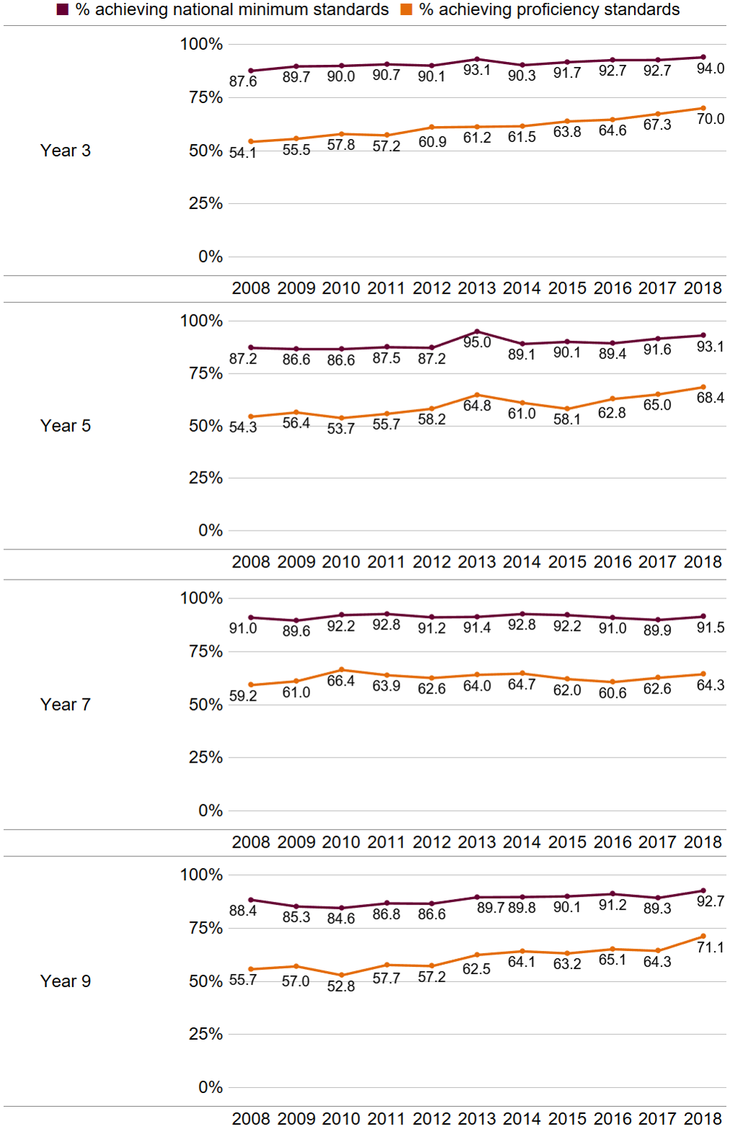
Source: System and School Performance
(a) Year 7 became part of public school secondary education in Western Australia from 2015, having previously been part of primary education.
Figure A3: Percentage of Western Australian public school students achieving standards in NAPLAN Numeracy by year level, 2008 to 2018
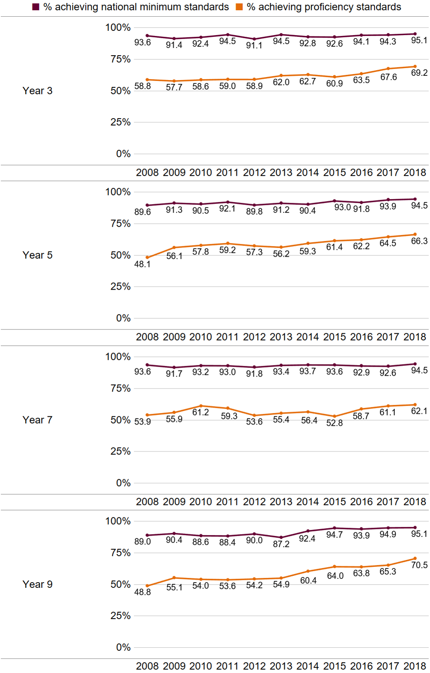
Source: System and School Performance
(a) Year 7 became part of public school secondary education in Western Australia from 2015, having previously been part of primary education.
Table A15: Percentage of Western Australian public school students achieving the national minimum standards in NAPLAN by year level 2018 (see note a)
Assessment area | Year 3 Target | Year 3 Result | Year 5 Target | Year 5 Result | Year 7 Target | Year 7 Result | Year 9 Target | Year 9 Result
Reading | 93 | 94.0 | 92 | 93.1 | 92 | 91.5 | 92 | 92.7
Writing | 96 | 92.0 | 92 | 86.5 | 86 | 82.4 | 81 | 77.2
Numeracy | 95 | 95.1 | 94 | 94.5 | 93 | 94.5 | 95 | 95.1
Source: System and School Performance
(a) The percentages of Western Australian public school students achieving national minimum standards in NAPLAN reading, writing and numeracy assessments were published as key performance indicators in the 2018–19 Budget Papers with targets as shown. The Department’s key performance indicators have since changed.

Figure A4: Mean NAPLAN Reading scores of Western Australian public school students by year level 2008 to 2018 (see note a)
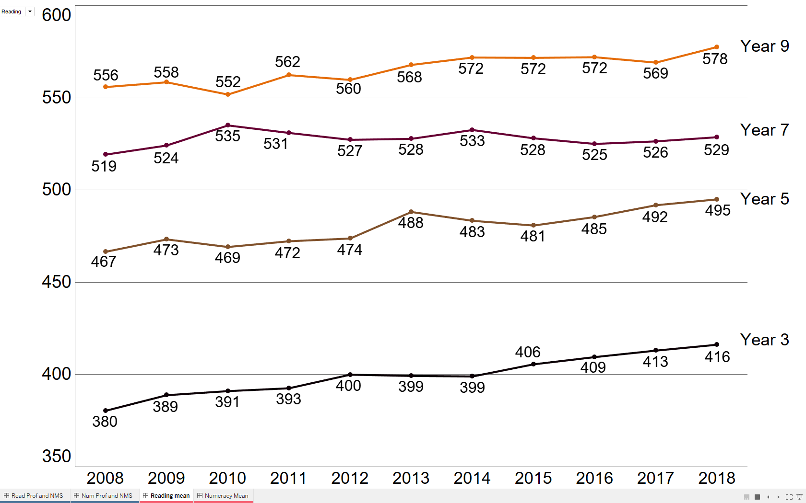
Source: System and School Performance
(a) Year 7 became part of public school secondary education in Western Australia from 2015, having previously been part of primary education.

Figure A5: Mean NAPLAN Numeracy scores of Western Australian public school students by year level 2008 to 2018 (see note a)
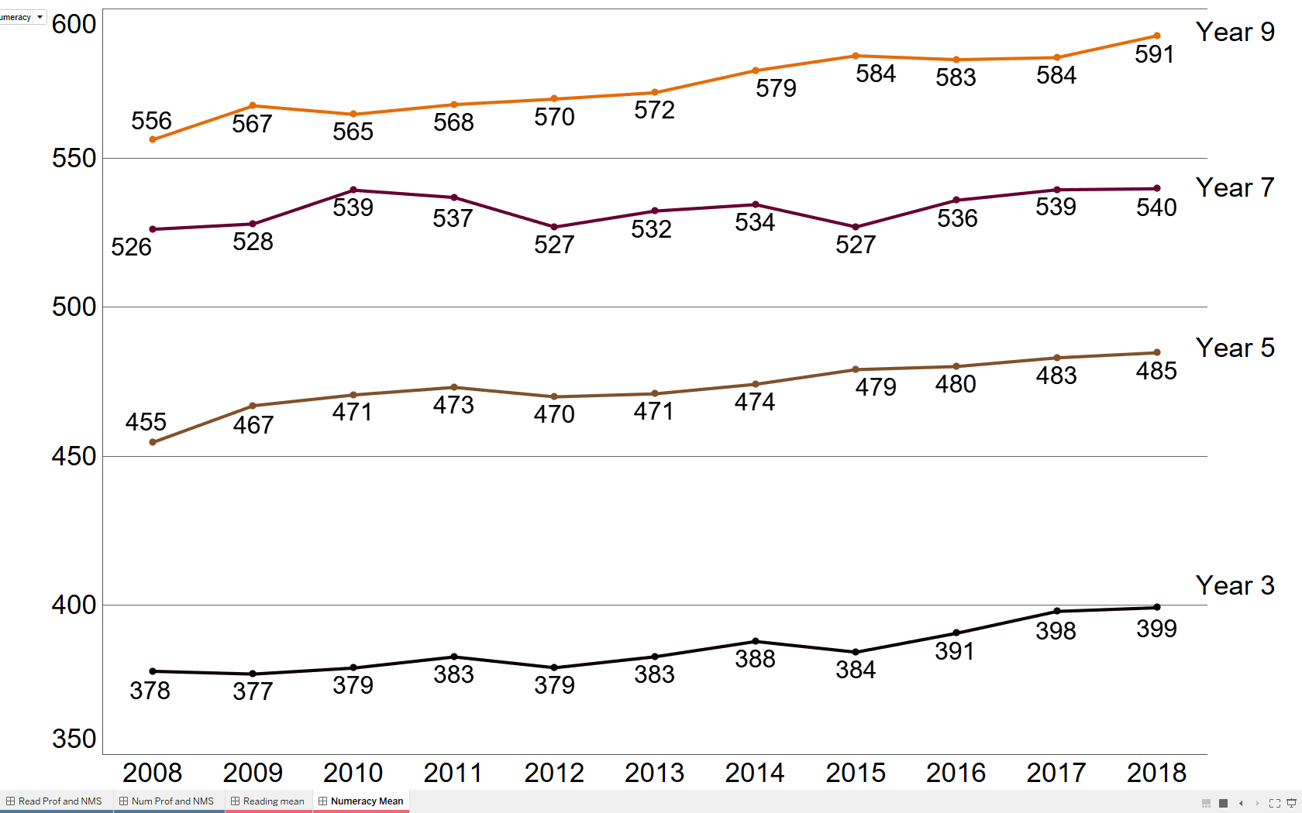
Source: System and School Performance
(a) Year 7 became part of public school secondary education in Western Australia from 2015, having previously been part of primary education.

Table A16: Percentage of children in care achieving the national minimum standards 2016 and 2018 (see note a)
Assessment area | Year level in 2016 | % in 2016 | Year level in 2018 | % in 2018
Reading | Year 3 | 84.9 | Year 5 | 73.9
Reading | Year 5 | 69.9 | Year 7 | 75.7
Reading | Year 7 | 76.4 | Year 9 | 73.6
Numeracy | Year 3 | 85.1 | Year 5 | 84.2
Numeracy | Year 5 | 76.0 | Year 7 | 86.9
Numeracy | Year 7 | 80.8 | Year 9 | 85.6
Source: System and School Performance
(a) Only includes students with results in 2016 and 2018.

3. Student participation, achievement and satisfaction

Figure A6: Participation rate (%) of persons aged 15 to 17 years engaged in some form of education by gender 2014 to 2018 (see note a) (see note b) (see note c)
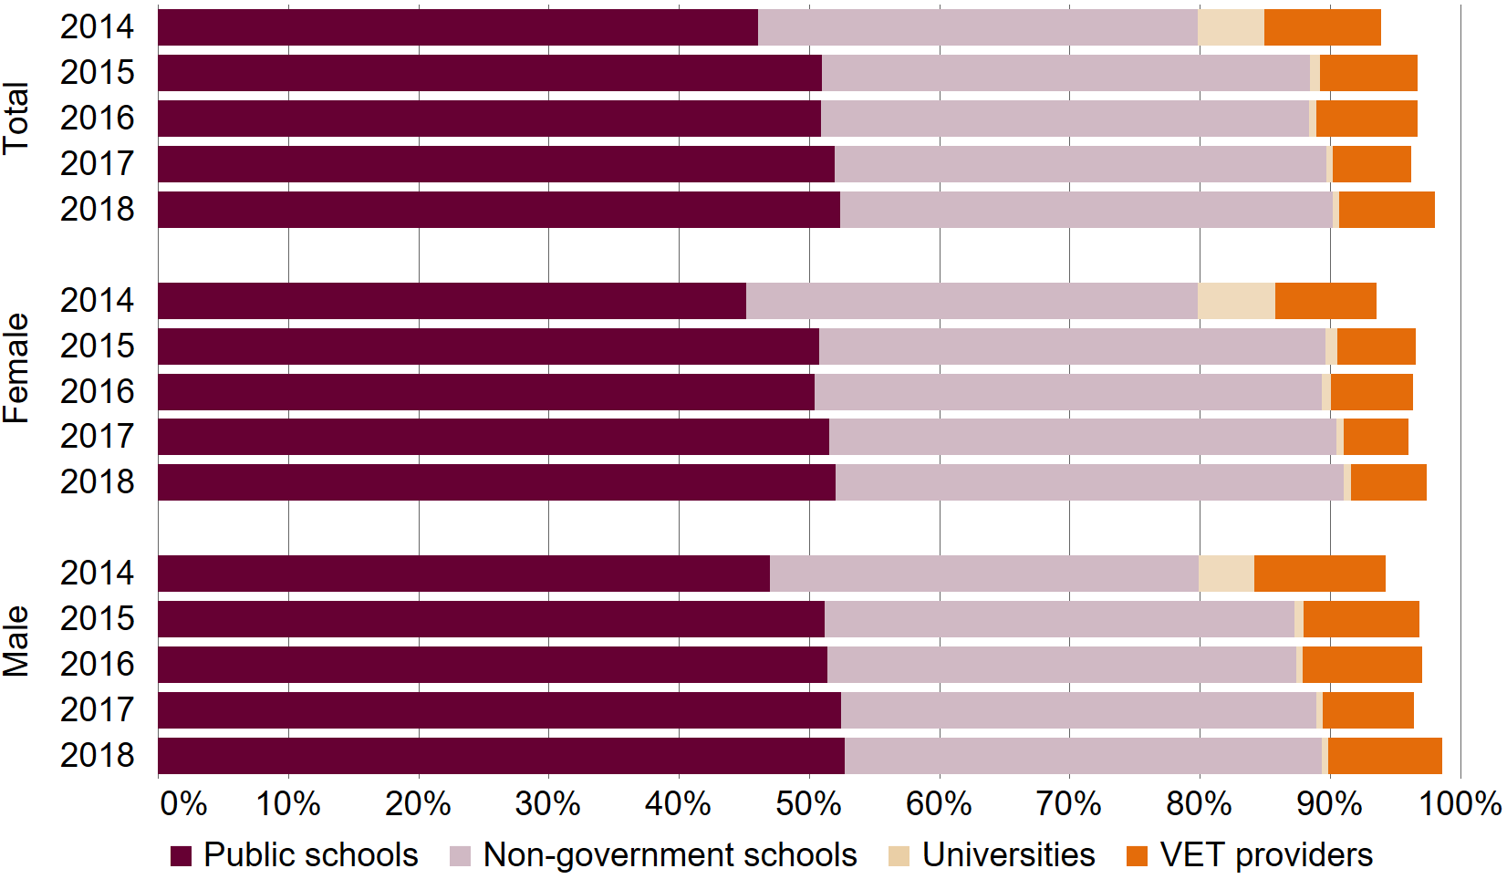
Source: System and School Performance
(a) Based on Australian Bureau of Statistics preliminary estimates of resident population (age at 30 June) and data collected from public and non-government schools (Semester 2 student census, age at 1 July), universities (age at 30 June), and vocational education and training providers (age at 30 June).
(b) University enrolment data for 2018 is an estimate based on 2017 university enrolment data and an annual compound growth factor calculated from university enrolment data across the previous four years.
(c) Revised figures for 2017 due to updated data for 2017 university student enrolments and estimate of resident population.

Table A17: Public school student attendance rate (%) by level of education and subgroup 2018 (see note a) (see note b)
Level of education | Aboriginal | Non-Aboriginal | All
All | 75.3 | 92.1 | 90.7
Primary (see note c) | 80.8 | 93.7 | 92.6
Secondary | 66.0 | 89.6 | 87.6
Source: System and School Performance
(a) Excludes Kindergarten students, Canning College and Tuart College, part-time and international students, and mature-aged students at senior campuses.
(b) As per National Standards for Student Attendance Data Reporting.
(c) Pre-primary to Year 6.

Table A18: Percentage of public school students by attendance category by subgroup 2018 (see note a) (see note b) (see note c)
Attendance category | Aboriginal | Non-Aboriginal | All
Regular attendance (90–100%) | 36.4 | 75.2 | 71.8
Indicated attendance risk (80–<90%) | 20.4 | 16.6 | 17.0
Moderate attendance risk (60–<80%) | 20.3 | 6.1 | 7.3
Severe attendance risk (<60%) | 22.8 | 2.1 | 3.9
Source: System and School Performance
(a) Excludes Kindergarten students, Canning College and Tuart College, part-time and international students, and mature-aged students at senior campuses.
(b) Percentages may not add to 100% due to rounding.
(c) As per National Standards for Student Attendance Data Reporting.

Figure A7: Percentage of public school students by subgroup by attendance category 2014 to 2018 (see note a) (see note b)
A stacked column chart of the attendance categories for all students and Aboriginal students. The percentage of students in each risk category (Regular attendance, indicated risk, moderate risk and severe risk) has remained consistent across years but shows substantially higher percentages of Aboriginal students to be in the severe and moderate risk categories with substantially lower percentages in the regular attendance category.
 | All students in 2014 | All students in 2015 | All students in 2016 | All students in 2017 | All students in 2018 | Aboriginal students in 2014 | Aboriginal students in 2015 | Aboriginal students in 2016 | Aboriginal students in 2017 | Aboriginal students in 2018
Regular | 70.0 | 71.9 | 71.4 | 71.8 | 71.8 | 35.2 | 36.1 | 36.1 | 36.5 | 36.4%
Indicated risk | 18.8 | 17.2 | 17.2 | 17.2 | 17.0 | 22.5 | 21.9 | 20.7 | 20.9 | 20.4%
Moderate risk | 7.5 | 7.2 | 7.4 | 7.1 | 7.3 | 21.0 | 21.0 | 20.8 | 20.1 | 20.3%
Severe risk | 3.7 | 3.7 | 3.9 | 3.9 | 3.9 | 21.3 | 21.1 | 22.4 | 22.4 | 22.8%

Source: System and School Performance
(a) Excludes Kindergarten students, Canning College and Tuart College, part-time and international students, and mature-aged students at senior campuses.
(b) As per National Standards for Student Attendance Data Reporting.

Table A19: Apparent retention rate (%) of public school students Years 8 to 12 by subgroup 2014 to 2018 (see note a) (see note b)
Subgroup | 2014 (see note c) | 2014 (see note c) | % in 2015 | Number in 2015 | % in 2016 | Number in 2016 | % in 2017 | Number in 2017 | % in 2018 | Number in 2018
All | 90.3 | 8,364 | 80.4 | 13,005 | 77.7 | 13,398 | 80.1 | 13,856 | 81.4 | 13,925
Female | 96.2 | 4,125 | 85.3 | 6,531 | 80.4 | 6,612 | 83.8 | 6,927 | 84.3 | 6,874
Male | 85.1 | 4,239 | 76.0 | 6,474 | 75.1 | 6,786 | 76.7 | 6,929 | 78.7 | 7,051
Aboriginal | 49.1 | 405 | 43.9 | 645 | 38.8 | 627 | 45.3 | 717 | 47.3 | 718
Female | 49.3 | 186 | 46.2 | 306 | 38.0 | 285 | 46.7 | 356 | 47.3 | 355
Male | 48.9 | 219 | 42.1 | 339 | 39.5 | 342 | 44.1 | 361 | 47.3 | 363
Source: System and School Performance
(a) Excludes Canning College and Tuart College, part-time and international students, and mature-aged students at senior campuses.
(b) ‘N’ is the number of Year 12 students. All data as at Semester 2 student census.
(c) Half cohort in Year 12.

Figure A8: Apparent retention rate (%) of public school students Years 8 to 12 by subgroup 1999 to 2018 (see note a) (see note b)

A line chart of apparent retention rates for each subgroup showing similar trends with one another over time. Females had the highest retention rates, followed by All, then males, and substantially lower retention rates for Aboriginal students. For all groups the apparent retention rate peaked in 2014 before decreasing in 2015 and 2016. The rates increase again in 2017 and 2018.
Year | Female | Male | Aboriginal | All
1999 | 66.1 | 54.2 | 19.2 | 60.0%
2000 | 66.6 | 54.9 | 22.3 | 60.4%
2001 | 65.5 | 55.2 | 18.0 | 60.1%
2002 | 67.5 | 58.0 | 20.4 | 62.6%
2003 | 66.6 | 59.4 | 21.6 | 62.9%
2004 | 67.1 | 58.4 | 23.7 | 62.6%
2005 | 68.6 | 58.5 | 24.3 | 63.4%
2006 | 68.8 | 57.9 | 28.5 | 63.1
2007 | 67.4 | 55.0 | 25.5 | 61.0
2008 | 71.4 | 60.3 | 40.2 | 65.6
2009 | 73.2 | 59.5 | 37.5 | 66.0
2010 | 75.7 | 65.4 | 39.3 | 70.3
2011 | 77.8 | 64.7 | 36.7 | 70.9
2012 | 78.5 | 69.2 | 34.4 | 73.6
2013 | 83.7 | 75.3 | 43.8 | 79.3
2014 | 96.2 | 85.1 | 49.1 | 90.3
2015 | 85.3 | 76.0 | 43.9 | 80.4
2016 | 80.4 | 75.1 | 38.8 | 77.7
2017 | 83.8 | 76.7 | 45.3 | 80.1%
2018 | 84.3 | 78.7 | 47.3 | 81.4

Source: System and School Performance
(a) Excludes Canning College and Tuart College students, part-time and international students, and mature-aged students at senior campuses.
(b) Semester 2 student census.

Table A20: Year 12 public school student WACE achievement rate and attainment rate by subgroup 2017 and 2018 (see note a)
 | Subgroup | % in 2017 | Number in 2017 | % in 2018 (see note b) | Number in 2018 (see note b)
WACE achievement rate (see note c) | All | 79.5 | 11,423 | 80.5 | 11,589
WACE achievement rate (see note c) | Aboriginal | 44.8 | 322 | 47.7 | 344
Attainment rate (see note d) | All | 96.2 | 12,510 | 95.6 | 12,483
Attainment rate (see note d) | Aboriginal | 89.4 | 428 | 89.9 | 443
Source: System and School Performance
(a) ‘N’ is the number of students who achieved the outcome.
(b) A few registered training organisations did not complete VET certification for some public school students in time to be included in the 2018 data. This may have affected the data reported for 2018 for WACE achievement, attainment and achievement of VET certificates.
(c) Percentage of Year 12 full-time students in the Semester 2 student census who achieved WACE. See our WACE achievement key performance indicator for details on criteria required to achieve WACE.
(d) Percentage of WACE eligible Year 12 students who achieved an ATAR of at least 55 and/or a certificate II or higher VET qualification.

Table A21: Year 12 public school student ATAR achievement by subgroup 2017 and 2018 (see note a)
 | Subgroup | % of students in 2017 | Number of students in 2017 | Median ATAR in 2017 | % of students in 2018 | Number of students in 2018 | Median ATAR in 2018
Students who achieved an ATAR (see note b) | All | 37.6 | 5,400 | 78.55 | 37.2 | 5,355 | 79.5
Students who achieved an ATAR (see note b) | Aboriginal | 8.9 | 64 | 64.525 | 8.3 | 60 | 62.7
ATAR students who achieved at least 55 | All | 84.8 | 4,580 | – | 85.2 | 4,563 | –
ATAR students who achieved at least 55 | Aboriginal | 67.2 | 43 | – | 61.7 | 37 | –
Source: System and School Performance
(a) ‘N’ is the number of students who achieved the outcome.
(b) Percentages use the number of Year 12 students at Semester 2 student census as the denominator.

Table A22: Year 12 public student VET certificate II or higher achievement by subgroup 2017 and 2018 (see note a)
Subgroup | % of students in 2017 (see note b) | Number of students in 2017 | Total VET certificates II or higher in 2017 | % of students in 2018 (see note b) (see note c) | Number of students in 2018 (see note c) | Total VET certificates II or higher in 2018 (see note c)
All | 75.8 | 10,889 | 16,789 | 74.5 | 10,732 | 16,183
Aboriginal | 65.6 | 471 | 671 | 67.8 | 489 | 716
Source: System and School Performance
(a) ‘N’ is the number of students who achieved a VET certificate II and higher.
(b) The number of Year 12 students at Semester 2 student census is the denominator.
(c) A few registered training organisations did not complete VET certification for some public school students in time to be included in the 2018 data. This may have affected the data reported for 2018 for WACE achievement, attainment and achievement of VET certificates.

Table A23: WACE achievement rate (%) of Year 12 public school students by subgroup 2015 to 2018 (see note a) (see note b) (see note c)
Subgroup | 2015 | 2016 | 2017 | 2018 (see note d)
All | 87.7 | 79.8 | 79.5 | 80.5
Male | 85.2 | 78.3 | 77.2 | 77.9
Female | 90.1 | 81.3 | 81.9 | 83.2
Aboriginal | 60.5 | 46.9 | 44.8 | 47.7
Source: System and School Performance
(a) Year 12 full-time students in the Semester 2 student census.
(b) Year 12 WACE achievement data from the School Curriculum and Standards Authority and taken at a point in time. Data may be updated after this time for a variety of reasons such as students successfully appealing their results.
(c) Data limitations do not allow for the calculation of this rate prior to 2015.
(d) A few registered training organisations did not complete VET certification for some public school students in time to be included in the 2018 data. This may have affected the data reported for 2018.

Table A24: Apparent secondary graduation rate (%) of public school students by subgroup 2014 to 2018 (see note a) (see note b) (see note c)
Subgroup | 2014 | 2015 | 2016 | 2017 | 2018 (see note d)
All (see note e) | 80.5 | 72.7 | 63.1 | 65.5 | 66.8
Male | 73.6 | 67.0 | 60.0 | 60.9 | 62.7
Female | 88.5 | 78.9 | 66.6 | 70.6 | 71.4
Aboriginal | 29.8 | 26.2 | 18.1 | 20.4 | 22.7
Source: System and School Performance
(a) Percentage of Year 8 cohort (which was the start of secondary school at that time) that satisfies the requirements for secondary graduation by Year 12. Year 8 cohort figure from Semester 2 student census four years earlier.
(b) Excludes Canning College and Tuart College students, international and non-government students. Repeating students included but only new instances of persons meeting requirements for secondary graduation are counted.
(c) Year 12 graduation data sourced from the School Curriculum and Standards Authority and taken at a point in time. Data may be updated after this time for a variety of reasons such as students successfully appealing their results.
(d) A few registered training organisations did not complete VET certification for some public school students in time to be included in the 2018 data. This may have affected the data reported for 2018.
(e) This was published as a key performance indicator in the 2018–19 Budget Papers with a target of 66% for 2018. The Department’s key performance indicators have since changed.

Table A25: Satisfaction of Year 12 public school students by subgroup 2014 to 2018 (see note a)
Subgroup | 2014 | 2015 | 2016 | 2017 | 2018
% of All students satisfied with quality of teaching | 89.6 | 88.4 | 87.3 | 88.0 | 87.7
% of Male students satisfied with quality of teaching | 88.7 | 87.8 | 87.0 | 87.5 | 87.1
% of Female students satisfied with quality of teaching | 90.4 | 88.9 | 87.6 | 88.6 | 88.3
% of Aboriginal students satisfied with quality of teaching | 94.4 | 92.3 | 91.0 | 88.2 | 89.9
% of All students satisfied with quality of education facilities | 85.7 | 84.8 | 83.3 | 83.4 | 84.8
% of Male satisfied with quality of education facilities | 85.4 | 84.2 | 83.2 | 83.2 | 84.7
% of Female satisfied with quality of education facilities | 85.8 | 85.4 | 83.5 | 83.7 | 84.9
% of Aboriginal satisfied with quality of education facilities | 87.3 | 88.1 | 84.6 | 82.6 | 88.2
Source: System and School Performance
(a) Post school intentions and satisfaction survey, conducted in Semester 2.

4. Staffing
Figure A9: Organisational chart at 30 June 2019
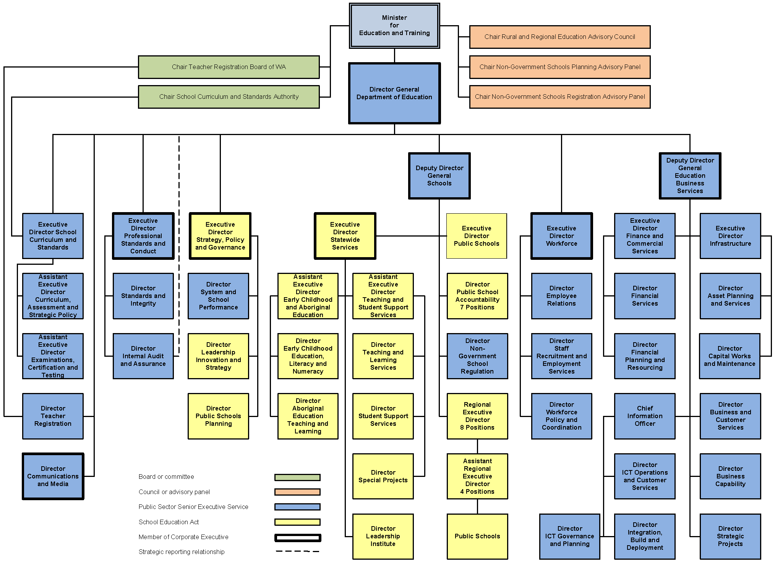
Table A26: School-based teaching staff (see note a) by education category (see note b) and gender 2019
Education category | Number of Female staff | % of Female staff | Number of Male staff | % of Male staff | Total numbers
Primary | 9,879 | 84.3 | 1,838 | 15.7 | 11,717
Secondary | 4,881 | 60.5 | 3,188 | 39.5 | 8,069
Education support | 704 | 83.3 | 141 | 16.7 | 845
Total | 15,464 | 75.0 | 5,167 | 25.0 | 20,631
Source: System and School Performance
(a) Full-time equivalents at Semester 1 student census including teachers at community kindergartens. Based on counting method used for National Schools Statistics Collection that does not include staff on extended leave.
(b) Staff apportioned to education category based on proportion of students in each education category, and apportioned and rounded to be consistent with figures presented in Table 23.

  - Table A27: Teacher retirements and resignations 2014 to 2018
 | 2014 | 2015 | 2016 | 2017 | 2018
Retirement | 549 | 539 | 542 | 566 | 550
Resignation | 577 | 582 | 622 | 597 | 586
Source: Workforce Policy and Coordination

5. Changes to our Outcomes Based Management reporting structure

Our new Outcomes Based Management (OBM) structure consolidates the four Desired Outcomes under our old OBM structure into a single, unified Desired Outcome that better reflects our current operations, purpose and the intent of the Machinery of Government and other changes since 1 July 2017.

The six services of our old OBM structure were consolidated into four services.
- The two services and two key efficiency indicators relating to public school education from our old OBM structure were retained.
- The service related to functions of the former Department of Education Services (DES) was renamed Regulation and Non-Government Sector Assistance to more accurately reflect its functions.
- The two services related to the School Curriculum and Standards Authority were replaced by a single service that better reflects our role in supporting the Authority.
- The service and expenditure for the residential colleges in our old OBM structure was incorporated into the services for Public Secondary Education, and Regulation and Non-Government Sector Assistance to reflect residential colleges’ services to secondary public and non-government school students.

Our new OBM structure also:
- addressed an imbalance in our old OBM structure which meant 10 (40%) of our 25 key effectiveness indicators and 12 (86%) of our key efficiency indicators represented less than two per cent of our annual budget and expenditure
- removed the key effectiveness and efficiency indicators that were also reported by the School Curriculum and Standards Authority, enacting a recommendation from the Office of the Auditor General
- uses better key effectiveness indicators for public school student achievement in literacy, numeracy and Year 12 achievement
- consolidated the six efficiency indicators related to the cost of non-government school and teacher regulatory services under our old OBM structure into two significant and meaningful efficiency indicators for these functions
- replaced the two efficiency indicators related to the School Curriculum and Standards Authority with a single efficiency indicator that more accurately reflects our role and costs in supporting the Authority
- reflects the change to our responsibilities arising from the transfer of secretariat support for the Training Accreditation Council to the Department of Training and Workforce Development on 1 January 2019.

Performance on our former Key Effectiveness Indicators

As part of the transition, the following tables show our performance on the Key Effectiveness Indicators that were ceased or replaced under our new OBM reporting structure and are not reported elsewhere in this annual report (see also Table A15 and Table A24). The results are not audited.

Results for our former Key Effectiveness Indicators that related to the School Curriculum and Standards Authority are not reported below. They are reported in the School Curriculum and Standards Authority’s 2018–19 Annual Report.
Further information about our former Key Effectiveness Indicators is available in our 2017–18 annual report.

Table A28: Percentage of Independent non-government schools complying with registration requirements of the School Education Act 1999, 2014–15 to 2018–19
2014–15 | 2015–16 | 2016–17 (see note a) | 2017–18 | 2018–19 (see note b)
91.0 | 95.0 | 88.0 | 90.3 | 87.1
Source: Schools Division
(a) Different methodology was used for 2016–17 to include any directions, conditions and/or quality improvement notices issued throughout the financial year.
(b) This was published as a key performance indicator in the 2018–19 Budget Papers with a target of 88%. The Department’s key performance indicators have since changed.

Table A29: Percentage of providers of education services to full fee international students complying with registration requirements of the Education Service Providers (Full Fee Overseas Students) Registration Act 1991 (WA) and Education Services for Overseas Students Act 2000 (Commonwealth) 2014–15 to 2018–19
2014–15 | 2015–16 | 2016–17 | 2017–18 | 2018–19 (see note a)
100 | 100 | 100 | 100 | 100
Source: Schools Division
(a) This was published as a key performance indicator in the 2018–19 Budget Papers with a target of 100%. The Department’s key performance indicators have since changed.

Table A30: Percentage of registered training organisations compliant with standards for registration 2014–15 to 2018–19
2014–15 | 2015–16 | 2016–17 | 2017–18 | 2018–19 (see note a)
99.7 | 99.3 | 100 | 98.7 | 99.5 (see note b)
Source: Department of Training and Workforce Development
(a) This was published as a key performance indicator in the 2018–19 Budget Papers with a target of 100%. The Department’s key performance indicators have since changed.
(b) For the period 1 July to 31 December 2018. The Training Accreditation Council secretariat function was transferred to the Department of Training and Workforce Development from 1 January 2019.

Table A31: Percentage of reviewed Independent Public Schools that met service and delivery requirements 2014–15 to 2018–19
2014–15 | 2015–16 | 2016–17 | 2017–18 | 2018–19 (see note a)
100 | 100 | 100 | 100 | –
Source: Schools Division
(a) This was published as a key performance indicator in the 2018–19 Budget Papers with a target of 100%. The Department’s key performance indicators have since changed. The Independent Public School reviews were replaced by a new review process in 2018 for all Western Australian public schools. These reviews are not comparable.

Table A32: Percentage of teachers compliant with the Teacher Registration Act 2012,
2014–15 to 2018–19
2014–15 | 2015–16 | 2016–17 | 2017–18 | 2018–19 (see note a)
100 | 100 | 100 | 100 | 100
Source: Teacher Registration
(a) This was published as a key performance indicator in the 2018–19 Budget Papers with a target of 100%. The Department’s key performance indicators have since changed.

Table A33: Number of students residing at residential colleges as a proportion of total student capacity across residential colleges (%) 2015 to 2019 (see note a) (see note b)
2015 | 2016 | 2017 | 2018 | 2019 (see note c)
68 | 68 | 62 | 56 | 54
Source: Schools Division
(a) Semester 1 student census.
(b) See Table A14 for WA residential colleges student information.
(c) This was published as a key performance indicator in the 2018–19 Budget Papers with a target of 62%. The Department’s key performance indicators have since changed.

Table A34: Percentage of parent survey respondents who rated residential college care and services as of good, high or very high quality 2010 to 2018 (see note a)
2010 | 2012 | 2014 | 2016 | 2018 (see note b)
92.1 | 90.1 | 92.2 | 91.9 | 93.6
Source: Schools Division
(a) The parent satisfaction survey is administered on a biennial basis.
(b) This was published as a key performance indicator in the 2018–19 Budget Papers with a target of 92%. The Department’s key performance indicators have since changed.

6. Annual estimates for 2019–20

In the 2019–20 Budget Statement, the estimates for the Department of Education and the School Curriculum and Standards Authority are consolidated within a single Division 23 of the Consolidated Account Expenditure Estimates.

These annual estimates represent the budget for the Department of Education excluding the School Curriculum and Standards Authority.

Estimate of Statement of Comprehensive Income
For the year ended 30 June 2020
2019–20
Estimate
$'000
COST OF SERVICES
Expenses
Employee benefits expense | 3,899,926
Supplies and services | 954,680
Depreciation and amortisation expense | 271,798
Grants and subsidies | 28,875
Finance costs | 78,804
Other expenses | 4,012
Total Cost of Services | 5,238,095
Income
Revenue
User contributions, charges and fees | 147,194
Interest revenue | 22,461
Other revenue | 81,452
Australian Government grants and contributions | 903,979
Total Revenue | 1,155,086
Total income other than income from State Government | 1,155,086
NET COST OF SERVICES | 4,083,009
Income from State Government
Service appropriation | 4,068,147
Grants from State Government Agencies | 6,246
Services received free of charge | 15,020
Royalties for Regions Fund | 28,658
Total income from State Government | 4,118,071
SURPLUS/(DEFICIT) FOR THE PERIOD | 35,062
OTHER COMPREHENSIVE INCOME
Items not reclassified subsequently to profit or loss
Changes in asset revaluation surplus | –
Total other comprehensive income | –
TOTAL COMPREHENSIVE INCOME FOR THE PERIOD | 35,062

Estimate of Statement of Financial Position
For the year ended 30 June 2020
2019–20
Estimate
$'000
ASSETS
Current Assets
Cash and cash equivalents | 491,566
Restricted cash and cash equivalents | 14,076
Amounts receivable for services | 19,673
Inventories | 6,084
Receivables | 97,228
Other current assets | 9,971
Non-current assets held for sale | 4,219
Total current assets | 642,817
Non-Current Assets
Restricted cash and cash equivalents | 53,598
Receivables | 311,800
Amounts receivable for services | 3,173,969
Property, plant and equipment | 12,708,311
Intangible assets | 16,958
Total non-current assets | 16,264,636
TOTAL ASSETS | 16,907,453
LIABILITIES
Current Liabilities
Payables | 128,544
Borrowings | 98,023
Provisions | 609,359
Other current liabilities | 14,135
Total current liabilities | 850,061
Non-Current Liabilities
Payables | 242
Borrowings and leases | 1,378,557
Provisions | 191,846
Total non-current liabilities | 1,570,645
TOTAL LIABILITIES | 2,420,706
NET ASSETS | 14,486,747
EQUITY
Contributed equity | 14,624,156
Reserves | –
Accumulated surplus/(deficit) | (137,409)
TOTAL EQUITY | 14,486,747

Estimate of Cash Flow Statement
For the year ended 30 June 2020
2019–20 Estimate
$'000
CASH FLOWS FROM STATE GOVERNMENT
Service appropriation | 3,796,427
Capital contribution | 365,494
Holding account draw downs | 19,673
Royalties for Regions | 75,708
Grants and subsidies income | 6,246
Net cash provided by State Government | 4,263,548
Utilised as follows:
CASH FLOWS FROM OPERATING ACTIVITIES
Payments
Employee benefits expense | (3,874,826)
Supplies and services | (939,580)
Grants and subsidies | (28,875)
Finance costs | (70,636)
GST payments on purchases | (107,920)
Loans advanced to non-government schools | (57,100)
Other payments | –
Receipts
User contributions, charges and fees | 147,154
Australian Government grants and contributions | 906,067
Interest received | 17,519
GST receipts on revenue | 6,805
GST receipts from taxation authority | 101,016
Repayments of loans by non-government schools | 34,101
Other receipts | 81,352
Net cash used in operating activities | (3,784,923)
CASH FLOW FROM INVESTING ACTIVITIES
Payments
Purchases of non-current physical assets | (452,810)
Receipts
Receipts from sale of non-current physical assets | –
Net cash provided by/(used in) investing activities | (452,810)

Estimate of Cash Flow Statement (continued)
2019–20 Estimate
$'000
CASH FLOW FROM FINANCING ACTIVITIES
Payments
Payment finance lease liabilities | (65,132)
Repayment of borrowings | (69,183)
Receipts
Proceeds from borrowings | 92,182
Net cash used in financing activities | (42,133)
Net increase/(decrease) in cash and cash equivalents | (16,318)
Cash and cash equivalents at the beginning of the period | 575,558
CASH AND CASH EQUIVALENTS AT THE END OF THE PERIOD | 559,240

