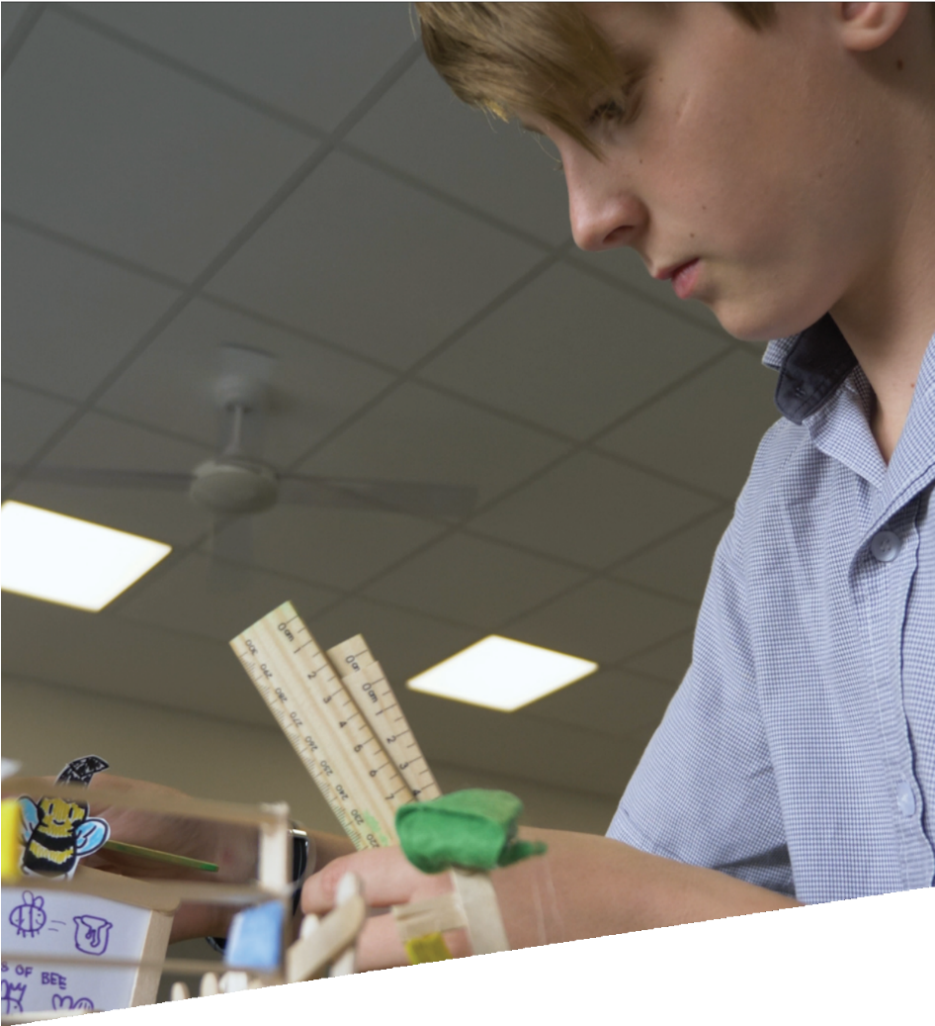

=

CURRICULUM RESOURCE MODULE
Template
YEAR 7 TO YEAR 10

Acknowledgements
The STEM Learning Project is funded by the Western Australian Department of Education and implemented by a consortium in STEM education comprising the Educational Computing Association of WA, the Mathematical Association of WA, the Science Teachers Association of WA and Scitech. We acknowledge and thank the teachers and schools who are creating and sharing good STEM teaching and learning.
This curriculum resource module has been produced using a template developed through the STEM Learning Project. The content of the module not been reviewed or recommended by the Department of Education or any members of the STEM education consortium.
Copyright and intellectual property
The copyright and intellectual property of this module remain the property of the Department.
Any Western Australian Curriculum content in this resource is used with the permission of the School Curriculum and Standards Authority; this permission does not constitute Authority endorsement of the resource. The Authority accepts no liability for any errors or damages arising from reliance on its content.
The Western Australian Curriculum content may be freely copied, or communicated on an intranet, for non-commercial purposes in educational institutions, provided that the Authority is acknowledged as the copyright owner. Copying or communication for any other purpose can be done only within the terms of the Copyright Act 1968 or with prior written permission of the Authority. Any Australian Curriculum content in the Western Australian Curriculum is used by the Authority under the terms of the Creative Commons Attribution-NonCommercial 3.0 Australia licence.
Any content on the www.scsa.wa.edu.au domain that has been derived from the Australian Curriculum may be used under the terms of Creative Commons Attribution-NonCommercial 3.0 Australia licence.
Appendix 2: General capabilities continuums is adapted from ACARA, © Australian Curriculum, Assessment and Reporting Authority (ACARA) 2009 to present, unless otherwise indicated. This material was downloaded from the ACARA website (www.acara.edu.au) (accessed December 2015) and was not modified. The material is licensed under CC BY 4.0 (https://creativecommons.org/licenses/by/4.0/). ACARA does not endorse any product that uses ACARA material or make any representations as to the quality of such products. Any product that uses material published on this website should not be taken to be affiliated with ACARA or have the sponsorship or approval of ACARA. It is up to each person to make their own assessment of the product.
Attributions: List in italics any trademarked products you refer to such as Google, Word etc
Kidblog, Weebly, Evernote (should be in all Yr 7 to 12 modules as part of Appendix 5.)
Autodesk, Tinkercad, SketchUp (if Appendix 4B is present)

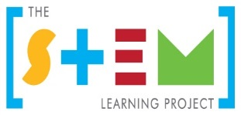
The table of contents will build itself. Simply right click and "update field".
Table of contents
The STEM Learning Project 2
Developing a STEM curriculum resource module 3
Instructions on using the CRM template 4
Overview 5
Activity sequence and purpose 8
Background 9
Activity 1: Title 11
Activity 2: Title 13
Activity 3: Title 15
Activity 4: Title 17
Appendix 1: Links to the Western Australian Curriculum 19
Appendix 1B: Mathematics proficiency strands 23
Appendix 2: General capabilities continuums 24
Appendix 3: Materials list 27
Appendix 4: Design process guide 28
Appendix 5: Reflective journal 29
Appendix 6: Student activity sheet 1.0: Journal checklist 30
Appendix 7: Teacher resource sheet 1.1: Cooperative learning – Roles 31
Appendix XX: Student activity sheet X.X: Prototype troubleshooting 32
Appendix XX: Teacher resource sheet XX: Evaluation 33
Appendix XX: Student activity sheet XX: Self-evaluation 34

The STEM Learning Project
The aim of the STEM Learning Project is to generate students’ interest, enjoyment and engagement with STEM (Science, Technology, Engineering and Mathematics) and to encourage their ongoing participation in STEM both at school and in subsequent careers. The curriculum resources will support teachers to implement and extend the Western Australian Curriculum and develop the general capabilities across Kindergarten to Year 12.
Why STEM?
A quality STEM education will develop the knowledge and intellectual skills to drive the innovation required to address global economic, social and environmental challenges.
STEM capability is the key to navigating the employment landscape changed by globalisation and digital disruption. Routine manual and cognitive jobs are in decline whilst non-routine cognitive jobs are growing strongly in Australia. Seventy-five per cent of the jobs in the emerging economy will require critical and creative thinking and problem solving, supported by skills of collaboration, teamwork and literacy in mathematics, science and technology. This is what we call STEM capability. The vision is to respond to the challenges of today and tomorrow by preparing students for a world that requires multidisciplinary STEM thinking and capability.
The approach
STEM capabilities are developed when students are challenged to solve open-ended, real-world problems that engage students in the processes of the STEM disciplines.
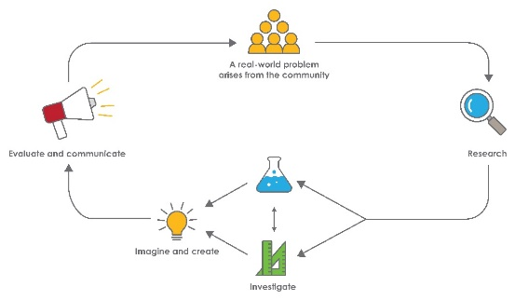
STEM Consortium

Developing a STEM curriculum resource module
A STEM learning module should encourage learning that is student-led and teacher-facilitated, and have an open-ended problem-solving approach. Problem solving involves an intellectual struggle that provides opportunities for higher-order thinking, reasoning and creativity.
Steps to designing an effective CRM
- Consider the elements and pedagogy the module should include, such as:
- A problem-based learning pedagogy
- A real-world problem in an authentic context
- STEM learning area content
- Suitability for learners
- The Design process
- Opportunities, where possible, to use and develop ICT skills
- Opportunities for developing higher order thinking, collaborative learning skills and reflective practice.
- Consider the Western Australian Curriculum
Review the year level curriculum content descriptions from each of the Science, Technology and Mathematics learning areas.
Identify opportunities for students to develop the general capabilities and cross-curriculum priorities.
- Develop a clear theme and the driving question you would like students to solve.
Consider current real-world problems both globally and locally. Review the United Nations Sustainable Development Goals for inspiration. Think about the big issues for Western Australia.
Consolidate the real-world problem down to the context of the students: How does this problem relate to important issues for the local community, students in your classroom or families at your school?
- Develop an outline for each of the Activities
- Activity 1 – Research
What and how will the students research to develop their understandings of the problem? How will their prior knowledge be drawn upon?
Students can research aspects of any or all of the learning areas.
- Activity 2 – Investigate
What investigations will students carry out to understand the variables that impact upon the problem?

- Activity 3 – Imagine and create
How will students enagae with the process strands of the learning areas and the design process to ideate their solutions?
- Activity 4 – Evaluate and communicate
How will students pitch their solutions? How could industry or other authentic audienes be involved?

Instructions on using the CRM template
When working with the template please not the following:
- The green text and the ### symbols are either instructions or examples and should be replaced as you develop your CRM.
- It may be useful to have a copy of an existing module as an example of how a module looks and what it contains.

Year X – Module title

Overview
A general overarching view of the module:

What is the context?
State the context in relation to the year level of the student.

What is the problem?
State the problem the students will be solving?

How does this module support integration of the STEM disciplines?
Science
Describe how the Western Australian Curriculum: Science is integrated into this module. How are the content descriptions related to the activtities in which the students will participate? What will the students learn?

Technology
Describe how the Western Australian Curriculum: Technologies is integrated into this module. How are the content descriptions related to the activtities in which the students will participate? What will the students learn?
The Design process guide is included as a resource to provide assistance to teachers in understanding the complete design process as developed in the Technologies syllabus.

Mathematics
Describe how the Western Australian Curriculum: Mathematics is integrated into this module. How are the content descriptions related to the activtities in which the students will participate? What will the students learn?

General capabilities
There are opportunities for the development of general capabilities and cross-curriculum priorities as students engage with module title. In this module, students:
- Develop critical and creative thinking skills as they research the problem and its context (Activity 1); investigate parameters impacting on the problem (Activity 2); imagine and develop solutions (Activity 3); and evaluate and communicate their solutions to an audience (Activity 4).
- Utilise creative thinking as they generate possible design solutions; and critical thinking, numeracy skills and ethical understanding as they choose between alternative approaches to solving the problem of …………...
- Utilise personal and social capability as they develop socially cohesive and effective working teams; collaborate in generating solutions; adopt group roles; and reflect on their group work capabilities through self and peer evaluation.
- Utilise a range of literacies and information and communication technology (ICT) capabilities as they collate records of work completed throughout the module in a journal; represent and communicate their solutions to an audience using digital technologies in Activity 4.
- Communicate and, using evidence, justify their group’s design to an authentic audience that might include………………………………………...
What are the pedagogical principles of the STEM learning modules?
The STEM Learning Project modules develop STEM capabilities by challenging students to solve real-world problems set in authentic contexts. The problems engage students in the STEM disciplines and provide opportunities for developing higher order thinking and reasoning, and the general capabilities of creativity, critical thinking, communication and collaboration.
The design of the modules is based on four pedagogical principles:
- Problem-based learning
All modules are designed around students solving an open-ended, real-world problem. Learning is supported through a four-phase instructional model: research the problem and its context; investigate the parameters impacting on the problem; design and develop solutions to the problem; and evaluate and communicate solutions to an authentic audience.
- Developing higher order thinking
Opportunities are created for higher order thinking and reasoning through questioning and discourse that elicits students' thinking, prompts and scaffolds explanations, and requires students to justify their claims. Opportunities for making reasoning visible through discourse are highlighted in the modules with the icon shown here.
- Collaborative learning
This provides opportunities for students to develop teamwork and leadership skills, challenge each other’s ideas, and co-construct explanations and solutions. Information that can support teachers with aspects of collaborative learning is included in the resource sheets.
- Reflective practice
Recording observations, ideas and one’s reflections on the learning experiences in some form of journal fosters deeper engagement and metacognitive awareness of what is being learnt. Information that can support teachers with journaling is included in the resource sheets.
These pedagogical principles can be explored further in the STEM Learning Project online professional learning modules located in Connect Resources.

Activity sequence and purpose
Activity title
Activity 1 focus. One or two sentences that summarise the main aspects of the Activity.
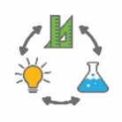  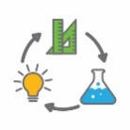 | Activity title  Activity 2 focus. One or two sentences that summarise the main aspects of the Activity.
Activity title
Activity 3 focus. One or two sentences that summarise the main aspects of the Activity.
Activity title
Activity 4 focus. One or two sentences that summarise the main aspects of the Activity.

Background
Expected learning | Summarise the curriculum content and expected learning. Write these as learning outcomes.  These should also be included in Appendix 1.  Students will be able to:
Vocabulary | The specific vocabulary of your module can be captured here or listed in a resource sheet in the appendices.  This module uses subject-specific terminology, some of which is shown in Teacher resource sheet #.#: title title.  The following vocabulary list contains other terms that need to be understood, either before the module commences or developed as they are used.
Timing | There is no prescribed duration for this module. The module is designed to be flexible enough for teachers to adapt. Activities do not equate to lessons; one activity may require more than one lesson to implement.
Consumable materials | The specific materials required for your module that are not ordinarily found in your classroom can be captured here or listed in a resource sheet in the appendices.  A Materials list is provided for this module. The list outlines materials outside of normal classroom equipment that will be needed to complete the activities.
Safety notes | There are potential hazards inherent in these activities and with the equipment being used, and a plan to mitigate any risks will be required.  Potential hazards specific to this module include but are not limited to:  - Possible exposure to cyber bullying, privacy violations and uninvited solicitations when using the internet
Enterprise skills | The ######### module focuses on higher order skills, with significant emphasis on outcomes from the general capabilities and enterprise skills.  Enterprise skills include problem solving, communication skills, digital literacy, teamwork, critical thinking and presentation skills.  Further background is available from the Foundation for Young Australians in the New Work Order six report series. A summary can be found at: www.fya.org.au/report/new-work-order-summary
Assessment | The STEM modules have been developed to provide students with learning experiences to solve authentic real-world problems using science, technology, engineering and mathematics capabilities. While working through the module, the following assessment opportunities will arise:  - List potential assessment opportunities here.  Appendix 1 indicates how the activities are linked to the Western Australian Curriculum.  Evidence of learning from journaling, presentations and anecdotal notes from this module can contribute towards the larger body of evidence gathered throughout a teaching period and can be used to make on-balance judgements about the quality of learning demonstrated by the students in the science, technologies and mathematics learning areas.  Students can further develop the general capabilities of Information and communication technology (ICT) capability, Critical and creative thinking, and Personal and social capability. Continuums for these are included in the General capabilities continuums but are not intended to be for assessment purposes.

Activity 1: Title
Activity focus | One or two sentences that summarise the main aspects of the Activity.
Background information | Information the teacher may find useful prior to implementing the lesson.  The purpose is to provide teachers with comprehensive information to reduce the need to research areas outside their subject area expertise.
Instructional procedures | Procedures to assist in the successful implementation of the activity. For example, visualisation strategies, cooperative learning strategies, inquiry based instructional strategies, differentiation, use of technology, higher order thinking and reasoning questions, modelling of classroom discourse and behaviour management strategies.
Expected learning | Summarise the curriculum content and expected learning. Write these as learning outcomes.  These should also be included in Appendix 1  Students will be able to:
Equipment required | For the class:
 | For the students:
Preparation | List any tasks or equipment that needs to be organised prior to the start of the Activity.
Activity parts | Decide on the individual tasks students will complete and describe them here.  Include some well considered, open questions.  Part 1: ###
 | Part 2: ###
 | Part 3: ###
 | Part 4: ###
 | Part 5: Reflection / journaling
Resource sheets | List resource sheets you develop here.
Digital resources | Provide links to websites with information to enhance learning.
Literary resources | Provide links to relevant literary resources.

Activity 2: Title
Activity focus | One or two sentences that summarise the main aspects of the Activity.
Background information | Information the teacher may find useful prior to implementing the lesson.  The purpose is to provide teachers with comprehensive information to reduce the need to research areas outside their subject area expertise.
Instructional procedures | Procedures to assist in the successful implementation of the activity. For example, visualisation strategies, cooperative learning strategies, inquiry based instructional strategies, differentiation, use of technology, higher order thinking and reasoning questions, modelling of classroom discourse and behaviour management strategies.
Expected learning | Summarise the curriculum content and expected learning. Write these as learning outcomes.  These should also be included in Appendix 1  Students will be able to:  1.  2.  3.
Equipment required | For the class:
 | For the students:
Preparation | List any tasks or equipment that needs to be organised prior to the start of the Activity.
Activity parts | Decide on the individual tasks students will complete and describe them here.  Include some well considered, open questions.  Part 1: ###
 | Part 2: ###
 | Part 3: ###
 | Part 4: ###
 | Part 5: ### Reflection / journaling
Resource sheets | List resource sheets you develop here.
Digital resources | Provide links to websites with information to enhance learning.
Literary resources | Provide links to relevant literary resources.

Activity 3: Title
Activity focus | One or two sentences that summarise the main aspects of the Activity.
Background information | Information the teacher may find useful prior to implementing the lesson.  The purpose is to provide teachers with comprehensive information to reduce the need to research areas outside their subject area expertise.
Instructional procedures | Procedures to assist in the successful implementation of the activity. For example, visualisation strategies, cooperative learning strategies, inquiry based instructional strategies, differentiation, use of technology, higher order thinking and reasoning questions, modelling of classroom discourse and behaviour management strategies.
Expected learning | Summarise the curriculum content and expected learning. Write these as learning outcomes.  These should also be included in Appendix 1  Students will be able to:  1.  2.  3.
Equipment required | For the class:
 | For the students:
Preparation | List any tasks or equipment that needs to be organised prior to the start of the Activity.
Activity parts | Decide on the individual tasks students will complete and describe them here.  Include some well considered, open questions.  Part 1: ###
 | Part 2: ###
 | Part 3: ###
 | Part 4: ###
 | Part 5: ### Reflection / journaling
Resource sheets | List resource sheets you develop here.
Digital resources | Provide links to websites with information to enhance learning.
Literary resources | Provide links to relevant literary resources.

Activity 4: Title
Activity focus | One or two sentences that summarise the main aspects of the Activity.
Background information | Information the teacher may find useful prior to implementing the lesson.  The purpose is to provide teachers with comprehensive information to reduce the need to research areas outside their subject area expertise.
Instructional procedures | Procedures to assist in the successful implementation of the activity. For example, visualisation strategies, cooperative learning strategies, inquiry based instructional strategies, differentiation, use of technology, higher order thinking and reasoning questions, modelling of classroom discourse and behaviour management strategies.
Expected learning | Summarise the curriculum content and expected learning. Write these as learning outcomes.  These should also be included in Appendix 1  Students will be able to:  1.  2.  3.
Equipment required | For the class:
 | For the students:
Preparation | List any tasks or equipment that needs to be organised prior to the start of the Activity.
Activity parts | Decide on the individual tasks students will complete and describe them here.  Include some well considered, open questions.  Part 1: ###
 | Part 2: ###
 | Part 3: ###
 | Part 4: ###
 | Part 5: ### Reflection / journaling
Resource sheets | List resource sheets you develop here.
Digital resources | Provide links to websites with information to enhance learning.
Literary resources | Provide links to relevant literary resources.

Appendix 1: Links to the Western Australian Curriculum
The XXXX module provides opportunities for developing students’ knowledge and understandings in science, technologies and mathematics. The table below shows how this module aligns to the content of the Western Australian Curriculum and can be used by teachers for planning and monitoring.
Delete sections and add content descriptions as required.
Module title  Links to the Western Australian Curriculum | ACTIVITY
 | 1 | 2 | 3 | 4
SCIENCE
SCIENCE UNDERSTANDING
Biological sciences: | ●
Chemical sciences: | ●
Earth and space sciences: | ●
Physical sciences: | ●
SCIENCE AS A HUMAN ENDEAVOUR
Nature and development of science: | ●
Use and influence of science: | ●
SCIENCE INQUIRY SKILLS
Questioning and predicting: | ●
Planning and conducting: | ●
Processing and alalysing data and information: | ●
Evaluating: | ●
Communicating: | ●

Module title  Links to the Western Australian Curriculum | ACTIVITY
 | 1 | 2 | 3 | 4
DESIGN AND TECHNOLOGIES
KNOWLEDGE AND UNDERSTANDING
Technologies and society: | ●
Technologies contexts: Engineering principles and systems | ●
Technologies contexts: Food and Fibre production | ●
Technologies contexts: Materials and technologies specialistaions | ●
PROCESSES AND PRODUCTION SKILLS
Creating solutions by: Investigating and defining: | ●
Creating solutions by: Designing | ●
Creating solutions by: Producing and implementing | ●
Creating solutions by: Evaluating | ●
Creating solutions by: Collaborating and managing | ●

Module title  Links to the Western Australian Curriculum | ACTIVITY
 | 1 | 2 | 3 | 4
DIGITAL TECHNOLOGIES
KNOWLEDGE AND UNDERSTANDING
Digital systems: | ●
Representation of data: | ●
PROCESSES AND PRODUCTION SKILLS
Collecting, managing and analysing data: | ●
Digital implementation: | ●
Creating solutions by: Investigating and defining | ●
Creating solutions by: Designing | ●
Creating solutions by: Producing and implementing | ●
Creating solutions by: Evaluating | ●
Creating solutions by: Collaborating and managing | ●

Module title  Links to the Western Australian Curriculum | ACTIVITY
 | 1 | 2 | 3 | 4
MATHEMATICS
NUMBER AND ALGEBRA
Number and place value: | ●
Fractions and decimals: | ●
Money and financial mathematics: | ●
Patterns and algebra: | ●
MEASUREMENT AND GEOMETRY
Using units of measurement: | ●
Shape: | ●
Location and transformation: | ●
STATISTICS AND PROBABILITY
Chance: | ●
Data representation and interpretation: | ●
Further information about assessment and reporting in the Western Australian Curriculum can be found at: k10outline.scsa.wa.edu.au/home.

Appendix 1B: Mathematics proficiency strands
Key ideas
In Mathematics, the key ideas are the proficiency strands of understanding, fluency, problem-solving and reasoning. The proficiency strands describe the actions in which students can engage when learning and using the content. While not all proficiency strands apply to every content description, they indicate the breadth of mathematical actions that teachers can emphasise.
Understanding
Students build a robust knowledge of adaptable and transferable mathematical concepts. They make connections between related concepts and progressively apply the familiar to develop new ideas. They develop an understanding of the relationship between the ‘why’ and the ‘how’ of mathematics. Students build understanding when they connect related ideas, when they represent concepts in different ways, when they identify commonalities and differences between aspects of content, when they describe their thinking mathematically and when they interpret mathematical information.
Fluency
Students develop skills in choosing appropriate procedures; carrying out procedures flexibly, accurately, efficiently and appropriately; and recalling factual knowledge and concepts readily. Students are fluent when they calculate answers efficiently, when they recognise robust ways of answering questions, when they choose appropriate methods and approximations, when they recall definitions and regularly use facts, and when they can manipulate expressions and equations to find solutions.
Problem-solving
Students develop the ability to make choices, interpret, formulate, model and investigate problem situations, and communicate solutions effectively. Students formulate and solve problems when they use mathematics to represent unfamiliar or meaningful situations, when they design investigations and plan their approaches, when they apply their existing strategies to seek solutions, and when they verify that their answers are reasonable.
Reasoning
Students develop an increasingly sophisticated capacity for logical thought and actions, such as analysing, proving, evaluating, explaining, inferring, justifying and generalising. Students are reasoning mathematically when they explain their thinking, when they deduce and justify strategies used and conclusions reached, when they adapt the known to the unknown, when they transfer learning from one context to another, when they prove that something is true or false, and when they compare and contrast related ideas and explain their choices.

Source:
www.australiancurriculum.edu.au/f-10-curriculum/mathematics/key-ideas/?searchTerm=key+ideas#dimension-content

Appendix 2: General capabilities continuums
The general capabilities continuums shown here are designed to enable teachers to understand the progression students should make with reference to each of the elements. There is no intention for them to be used for assessment.
Information and communication technology (ICT) capability learning continuum
Sub-element | Typically by the end of Foundation Year | Typically by the end of Year 2 | Typically by the end of Year 4
Create with ICT  Generate ideas, plans and processes | use ICT to follow or contribute to a simple plan for a solution | use ICT to prepare simple plans to find solutions or answers to questions | use ICT to generate ideas and plan solutions
Create with ICT  Generate solutions to challenges and learning area tasks | use ICT as a creative tool to generate simple solutions, modifications or data representations for personal or school purposes | experiment with ICT as a creative tool to generate simple solutions, modifications or data representations for particular audiences or purposes | create and modify simple digital solutions, creative outputs or data representation/ transformation for particular purposes
Communicating with ICT  Collaborate, share and exchange | use purposefully selected ICT tools safely to view information shared by trusted adults | use purposefully selected ICT tools safely to share and exchange information with appropriate local audiences | use appropriate ICT tools safely to share and exchange information with appropriate known audiences

Critical and creative thinking learning continuum
Sub-element | Typically by the end of Foundation Year | Typically by the end of Year 2 | Typically by the end of Year 4
Inquiring – identifying, exploring and organising information and ideas  Organise and process information | gather similar information or depictions from given sources | organise information based on similar or relevant ideas from several sources | collect, compare and categorise facts and opinions found in a widening range of sources
Generating ideas, possibilities and actions  Imagine possibilities and connect ideas | use imagination to view or create things in new ways and connect two things that seem different | build on what they know to create ideas and possibilities in ways that are new to them | expand on known ideas to create new and imaginative combinations
Generating ideas, possibilities and actions  Seek solutions and put ideas into action | predict what might happen in a given situation and when putting ideas into action | investigate options and predict possible outcomes when putting ideas into action | experiment with a range of options when seeking solutions and putting ideas into action
Reflecting on thinking and processes  Transfer knowledge into new contexts | connect information from one setting to another | use information from a previous experience to inform a new idea | transfer and apply information in one setting to enrich another

Personal and social capability learning continuum
Sub-element | Typically by the end of Foundation Year | Typically by the end of Year 2 | Typically by the end of Year 4
Social management  Work collaboratively | share experiences of cooperation in play and group activities | identify cooperative behaviours in a range of group activities | describe characteristics of cooperative behaviour and identify evidence of these in group activities
Social management  Negotiate and resolve conflict | listen to others’ ideas, and recognise that others may see things differently from them | practise solving simple interpersonal problems, recognising there are many ways to solve conflict | identify a range of conflict resolution strategies to negotiate positive outcomes to problems
Social management  Develop leadership skills | identify ways to take responsibility for familiar tasks at home and school | discuss ways in which they can take responsibility for their own actions | discuss the concept of leadership and identify situations where it is appropriate to adopt this role
Further information about general capabilities is available at:
k10outline.scsa.wa.edu.au/home/p-10-curriculum/general-capabilities-over/general-capabilities-overview/general-capabilities-in-the-australian-curriculum

Appendix 3: Materials list

The following materials are required to complete this module.

Materials for optional or extension parts are identified separately.

Appendix 4: Design process guide
Safe production of the final design or multiple copies of the final design.
Fine tuning the production process, such as division of labour for batch or mass production.
Use of intended materials and appropriate tools to safely make the solution to the design problem.
Reflection on the process taken and the success of the design.
Evaluation can lead to further development or improvement of the design and can be a final stage of the design process before a conclusion is reached.
Could be formal or informal and verbal or written.
Ideation
Development
Development of the design ideas. Improvements, refinements, adding detail, making it better.
Activities such as detailed drawings, modelling, prototyping, market research, gaining feedback from intended user, further research – if needed – to solve an issue with the design, testing different tools or equipment, trialling production processes, measuring or working out dimensions, testing of prototypes and further refinement.
Idea generation – turning ideas into tangible forms so they can be organised, ordered and communicated to others.
Activities such as brainstorming, mind mapping, sketching, drawing diagrams and plans, collecting colour samples and/or material samples and talking through these ideas can help to generate fu creative ideas.
Using the SCAMPER model can assist with this: www.mindtools.com/pages/article/newCT_02.htm
www.designorate.com/a-guide-to-the-scamper-technique-for- creative-thinking
Analysis
Finding useful and helpful information about the design problem.
Gathering information, conducting surveys, finding examples of existing solutions, testing properties of materials, practical testing.
Understanding the meaning of the research findings.
Analysing what the information means, summarising the surveys, judging the value of existing solutions, understanding test results.
Research
Production
Evaluation

Appendix 5: Reflective journal
When students reflect on learning and analyse their own ideas and feelings, they self-evaluate, thereby improving their metacognitive skills. When students self-monitor or reflect, the most powerful learning happens.
istockphoto.com
Journaling may take the form of a written or digital journal, a portfolio or a digital portfolio. Early childhood classrooms may use a class reflective floor book with pictures of the learning experience and scribed conversations.
Teachers can model the journaling process by thinking aloud and showing students how they can express learning and thoughts in a variety of ways including diagrams, pictures and writing.
A journal is a useful tool that gives teachers additional insight into how students value their own learning and progress, as well as demonstrating their individual achievements.
The following links provide background information and useful apps for journaling.
Kidblog – digital portfolios and blogging
kidblog.org/home
Edmodo – for consolidating and storing class notes and learning materials
www.edmodo.com/
Explain Everything™ – a screen casting, video and presentation tool all in one
explaineverything.com
Popplet – allows you to jot down your ideas and then sort them visually
Popplet.com
Seesaw – for capturing work completed by students in class, using a device’s camera function
web.seesaw.me
Connect – the Department of Education’s integrated, online environment
connect.det.wa.edu.au
Evernote (a digital portfolio app)
evernote.com
Digital portfolios for students (Cool tools for school)
cooltoolsforschool.wordpress.com/digital-student-portfolios

Appendix 6: Student activity sheet 1.0: Journal checklist
As an ongoing part of this module, you have been keeping a journal of your work.
Before submitting your journal to your teacher please ensure you have included the following information.
- Tick each box once complete and included.
- Write N/A for items that were not required in this module.
istockphoto.com

Your name and group member's names or photographs
An explanation of the problem you are solving
Your notes from Activity 1
Your notes from Activity 2
Your notes from Activity 3
Your notes from Activity 4
Student activity sheet #.#: #############
Student activity sheet #.#: #############
Student activity sheet #.#: #############
Student activity sheet 1.0: Journal checklist

Appendix 7: Teacher resource sheet 1.1: Cooperative learning – Roles
Cooperative learning frameworks create opportunities for groups of students to work together, generally to a single purpose.
istockphoto.com
As well as having the potential to increase learning for all students involved, using these frameworks can help students develop personal and social capability.
When students are working in groups, positive interdependence can be fostered by assigning roles to group members.
These roles could include:
- working roles such as Reader, Writer, Summariser, Timekeeper
- social roles such as Encourager, Observer, Noise monitor, Energiser.
Teachers using the Primary Connections roles of Director, Manager and Speaker for their science teaching may find it effective to also use these roles for STEM learning.
Further to this, specific roles can be delineated for specific activities that the group is completing.
It can help students if some background to the purpose of group roles is made clear to them before they start, but at no time should the roles get in the way of the learning. Teachers should decide when or where roles are appropriate to given tasks.
istockphoto.com

Appendix XX: Student activity sheet X.X: Prototype troubleshooting
Problem | Reason for the problem | Possible changes to your design to solve the problem

Appendix XX: Teacher resource sheet XX: Evaluation
Key:  - Sometimes  - Consistently  - Independently and consistently | Student name
Remains focused on tasks presented
Completes set tasks to best of their ability
Works independently without disrupting others
Manages time effectively
Cooperates effectively within the group
Contributes to group discussions
Shows respect and consideration for others
Uses appropriate conflict resolution skills
Actively seeks and uses feedback

Appendix XX: Student activity sheet XX: Self-evaluation
 | Always | Usually | Sometimes | Rarely
Remains focused on tasks presented
Completes set tasks to best of their ability
Works independently without disrupting others
Uses time well
Cooperates effectively within the group
Contributes to group discussions
Shows respect and consideration for others
Uses appropriate conflict resolution skills
Comes to class prepared for activities
Actively seeks and uses feedback

Comments: ________________________________________________________________________________________________________________________________________________________________________________________________________________________________________________________________________________________________________________________________________________

Notes
________________________________________________________________________________________________________________________________________________________________________________________________________________________________________________________________________________________________________________________________________________________________________________________________________________________________________________________________________________________________________________________________________________________________________________________________________________________________________________________________________________________________________________________________________________________________________________________________________________________________________________________________________________________________________________________________________________________________________________________________________________________________________________________________________________________________________________________________________________________________________________________________________________________________________________________________________________________________________________________________________________________________________________________________________________________________________________________________________________________________________________________________________________________________________________________________________________________________

Notes
________________________________________________________________________________________________________________________________________________________________________________________________________________________________________________________________________________________________________________________________________________________________________________________________________________________________________________________________________________________________________________________________________________________________________________________________________________________________________________________________________________________________________________________________________________________________________________________________________________________________________________________________________________________________________________________________________________________________________________________________________________________________________________________________________________________________________________________________________________________________________________________________________________________________________________________________________________________________________________________________________________________________________________________________________________________________________________________________________________________________________________________________________________________________________________________________________________________________

Notes
________________________________________________________________________________________________________________________________________________________________________________________________________________________________________________________________________________________________________________________________________________________________________________________________________________________________________________________________________________________________________________________________________________________________________________________________________________________________________________________________________________________________________________________________________________________________________________________________________________________________________________________________________________________________________________________________________________________________________________________________________________________________________________________________________________________________________________________________________________________________________________________________________________________________________________________________________________________________________________________________________________________________________________________________________________________________________________________________________________________________________________________________________________________________________________________________________________________________

