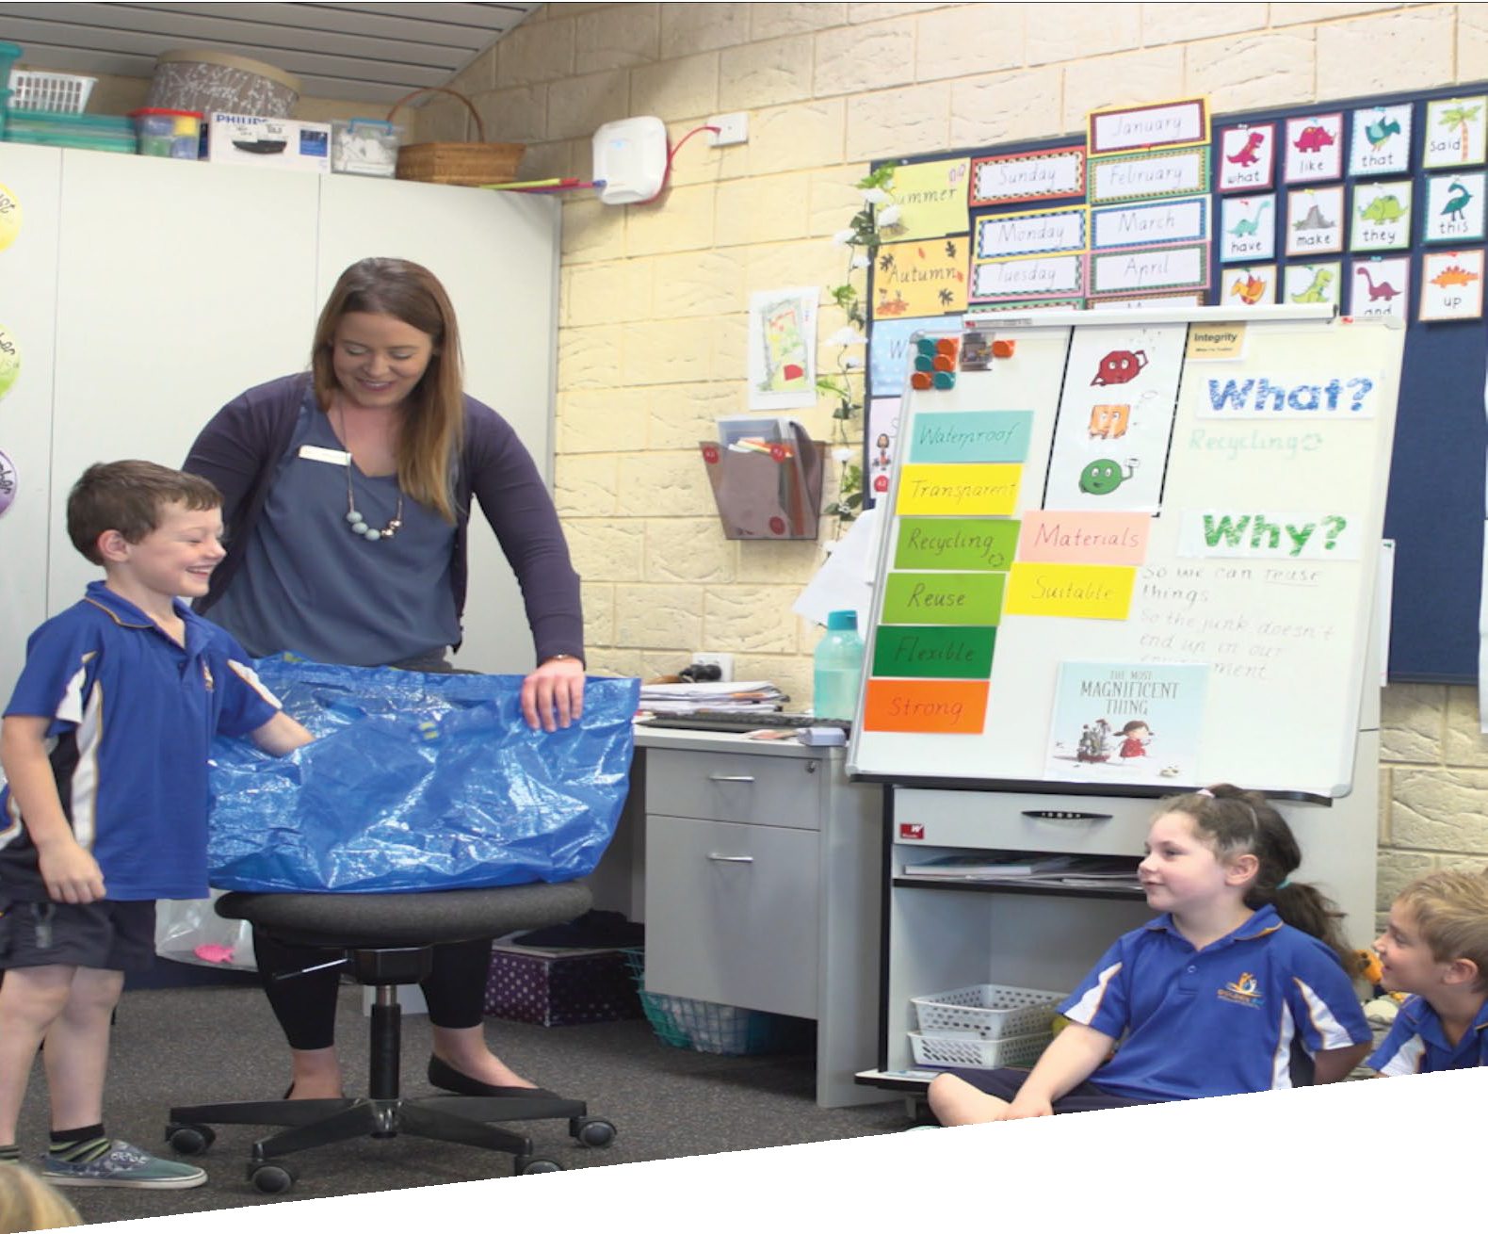

CURRICULUM RESOURCE MODULE

Our magnificent thing
YEAR 1

Acknowledgements
The STEM Learning Project respectfully acknowledges the Traditional Custodians of the lands upon which our students and teachers live, learn and educate.

The STEM Learning Project is funded by the Western Australian Department of Education (the Department) and implemented by a consortium in STEM education comprising the Educational Computing Association of Western Australia, the Mathematical Association of Western Australia, the Science Teachers Association of Western Australia and Scitech. We acknowledge and thank the teachers and schools who are the co-creators of these resources.

Copyright and intellectual property
The copyright and intellectual property of this module remain the property of the Department.

Any Western Australian Curriculum content in this resource is used with the permission of the School Curriculum and Standards Authority (the Authority); this permission does not constitute Authority endorsement of the resource. The Authority accepts no liability for any errors or damages arising from reliance on its content.

The Western Australian Curriculum content may be freely copied, or communicated on an intranet, for non-commercial purposes in educational institutions, provided that the Authority is acknowledged as the copyright owner. Copying or communication for any other purpose can be done only within the terms of the Copyright Act 1968 or with prior written permission of the Authority. Any Australian Curriculum content in the Western Australian Curriculum is used by the Authority under the terms of the Creative Commons Attribution NonCommercial
3.0 Australia licence. Any content on the www.scsa.wa.edu.au domain that has been derived from the Australian Curriculum may be used under the terms of Creative Commons Attribution-NonCommercial 3.0 Australia licence.

Appendix 2: General capabilities continuums are adapted from ACARA, © Australian Curriculum, Assessment and Reporting Authority (ACARA) 2009 to present, unless otherwise indicated. This material was downloaded from the ACARA website (www.acara.edu.au) (accessed December 2015) and was not modified. The material is licensed under CC BY
  - (https://creativecommons.org/licenses/by/4.0/). ACARA does not endorse any product that uses ACARA material or make any representations as to the quality of such products. Any product that uses material published on this website should not be taken to be affiliated with ACARA or have the sponsorship or approval of ACARA. It is up to each person to make their own assessment of the product.

This resource includes references and examples of iOS, Android and other apps. The Department does not endorse or recommend any commercial products and simply provides these as examples for teachers.

The Department is committed to providing quality information to its customers. Whilst every effort has been made to ensure accuracy, currency and reliability of the information within these documents, the Department accepts no responsibility for errors, omissions or amendments made since the time of publishing. Confirmation of information may be sought from the Department or the originating bodies providing the information. The Department has no control over the content of material published on websites to which users are referred in this resource. It is the responsibility of the internet user to make their own decision as to the relevancy, accuracy, currency and reliability of information found on those sites.

Attributions: iMovie, Doodle Buddy, Draw Free, Seesaw, Class Dojo, Explain everything

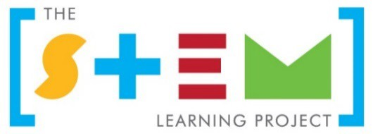

Table of contents
The STEM Learning Project 2
Overview 3
Activity sequence and purpose 6
Background 7
Activity 1: What a lot of rubbish 9
Activity 2: Explore properties and shapes 17
Activity 3: Design, draw and create 21
Activity 4: Present and explain 28
Appendix 1A: Links to the Western Australian Curriculum 32
Appendix 1B: Mathematics proficiency strands 34
Appendix 2: General capabilities continuums 35
Appendix 3: Materials list 38
Appendix 4: Design process guide 39
Appendix 5: Reflective journal 40
Appendix 6: Teacher resource sheet 1.0: Sample parent letter 41
Appendix 7: Teacher resource sheet 1.1: Cooperative learning – Roles 42
Appendix 8: Teacher resource sheet 1.2: Cooperative learning – Think, Pair, Share 43
Appendix 9: Student activity sheet 1.3: I see, I think, I wonder 44
Appendix 10: Student resource sheet 1.4: Materials in our recyclable items 45
Appendix 11: Student activity sheet 2.1: Material properties – Strength 46
Appendix 12: Student activity sheet 2.2: Material properties – Transparency 47
Appendix 13: Student activity sheet 2.3: Material properties – Water-resistance 48
Appendix 14: Student activity sheet 3.1: Materials used 49
Appendix 15: Student activity sheet 3.2: Shapes or objects 50
Appendix 16: Teacher resource sheet 3.3: Construction skills 51
Appendix 17: Student activity sheet 4.1: Analysis 55
Appendix 17B: Student activity sheet 4.1B: Analysis 56

The STEM Learning Project
The aim of the STEM Learning Project is to generate students’ interest, enjoyment and engagement with STEM (Science, Technology, Engineering and Mathematics) and to encourage their ongoing participation in STEM both at school and in subsequent careers. The curriculum resources will support teachers to implement and extend the Western Australian Curriculum and develop the general capabilities across Kindergarten to Year 12.

Why STEM?
A quality STEM education will develop the knowledge and intellectual skills to drive the innovation required to address global economic, social and environmental challenges.
STEM capability is the key to navigating the employment landscape changed by globalisation and digital disruption. Routine manual and cognitive jobs are in decline whilst non-routine cognitive jobs are growing strongly in Australia. Seventy-five per cent of the jobs in the emerging economy will require critical and creative thinking and problem solving, supported by skills of collaboration, teamwork and literacy in mathematics, science and technology. This is what we call STEM capability. The vision is to respond to the challenges of today and tomorrow by preparing students for a world that requires multidisciplinary STEM thinking and capability.

The approach
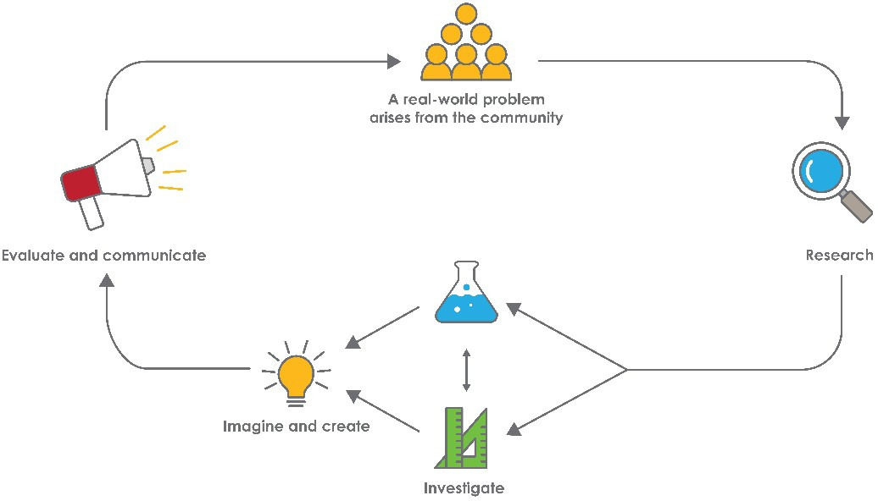
STEM capabilities are developed when students are challenged to solve open-ended, real-world problems that engage students in the processes of the STEM disciplines.

Year 1 – Our magnificent thing Overview
This module focuses on repurposing rubbish, giving students the opportunity to consider sustainability and the impact of their lifestyle choices on the environment. Based on the fiction picture book, The Most Magnificent Thing by Ashley Spires, students are encouraged to repurpose recyclable items to create their own most magnificent thing (something of value to them). Students develop their ability to design, create and problem-solve.

What is the context?
The majority of items we buy are packaged in paper, cardboard, plastic, aluminium or glass. Although packaging comprises valuable resources, it is often thrown away. This waste of natural resources and energy is a threat to sustainability.

What is the problem?
What problem in your life could you solve by building something with reused materials?
How does this module support the integration of the STEM disciplines? Science
Students explore the properties of familiar materials and make decisions about which will be most useful for constructing their magnificent thing. They consider ways of changing the available materials to suit their needs (ACSSU018 – Everyday materials can be physically changed in a variety of ways). Students will explain why they chose to use particular materials and how and why they physically changed the materials.

Students will follow simple procedures to test the properties of the materials available to make their magnificent thing and record their observations. They consider ways or organising their observations and begin to infer cause-and-effect relationships from their observations (ACSIS025 – Participate in guided investigations to explore and answer questions).
Technologies
Students explore the properties of familiar materials and make decisions about which will be most useful for constructing their magnificent thing. They also justify their choice of materials in constructing their magnificent thing (ACTDEK004 – Characteristics and behaviours of individual materials used in products).
Students produce a design that meets their specific needs (ACTDEK001 - People produce familiar products and services to meet personal and community needs). They create a diagram of their magnificent thing and can describes their design ideas
(WATPPS07 – Develop and communicate design ideas through describing, drawing,

modelling and/or a sequence of written or spoken steps).

Students document their design process and use digital technologies to share their work (ACTDIP006 – Share and publish information with known people in an online environment, modelling strategies to stay safe online).

The Design process guide is included as a resource to provide assistance to teachers in understanding the complete design process as developed in the technologies curriculum.
Mathematics

Students recognise and classify familiar shapes and objects as they sort and select materials for their magnificent thing construction (ACMMG022 – Recognise and classify familiar two-dimensional shapes and three-dimensional objects using obvious features).

During sorting and classifying activities, students directly and indirectly compare mass, length, and capacity, practising previously learned skills (ACMMG006: Use direct and indirect comparisons to decide which is longer, heavier or holds more, and explain reasoning in everyday language) leading to using informal uniform units (ACMMG019: Measure and compare the lengths and capacities of pairs of objects using uniform informal units). Students count the number of shapes or objects and record their observations as a tally or a simple data display with one-to-one correspondence. They describe the data in simple terms. (ACMSP263 - Represent data with objects and drawings where one object or drawing represents one data value. Describe the displays).
General capabilities
There are opportunities for the development of general capabilities and cross- curriculum priorities as students engage with Our magnificent thing. In this module, students:
- Develop problem solving skills as they research the problem and its context (Activity1); investigate parameters impacting on the problem (Activity 2); imagine and develop solutions (Activity 3); and evaluate and communicate their solutions to an audience (Activity 4).
- Utilise creative thinking as they generate possible design solutions; and critical thinking, numeracy skills and ethical understanding as they choose between alternative approaches to solving the problem of reusing materials to make something of use.
- Utilise personal and social capability as they develop socially cohesive and effective working teams; collaborate in generating solutions; adopt group roles; and reflect on their group work capabilities.

    - Utilise a range of literacies and information and communication technology (ICT) capability as they collate records of work completed throughout the module in a class journal and represent and communicate their solutions to an audience using digital technologies in Activity 4.

- Communicate and, using evidence, justify their design to an authentic audience.
What are the pedagogical principles of the STEM learning modules?
The STEM Learning Project modules develop STEM capabilities by challenging students to solve real-world problems set in authentic contexts. The problems engage students in the STEM disciplines, provide opportunities for developing higher order thinking and reasoning and the general capabilities of creativity, critical thinking, communication and collaboration.
The design of the modules is based on four pedagogical principles:
- Problem-based learning
This is an underlying part of all modules with every module based around solving an initial problem. It is supported through a four-phase instructional model: research the problem and its context; investigate the parameters impacting on the problem; design and develop solutions to the problem; and evaluate and communicate solutions to an authentic audience.
- Developing higher order thinking
Opportunities are created for higher order thinking and reasoning through questioning and discourse that elicits students' thinking, prompts and scaffolds explanations and requires students to justify their claims. Opportunities for making reasoning visible through discourse are highlighted in the modules with the icon shown here.
- Collaborative learning
This provides opportunities for students to develop teamwork and leadership skills, challenge each other’s ideas, and co-construct explanations and solutions.
Information that can support teachers with aspects of collaborative learning is included in the resource sheets.
- Reflective practice
Recording observations, ideas and one’s reflections on the learning experiences in some form of journal fosters deeper engagement and metacognitive awareness of what is being learned. Information that can support teachers with journaling is included in the resource sheets.
These pedagogical principles can be explored further in the STEM Learning Project online professional learning modules located in Connect Resources.

Activity sequence and purpose

What a lot of rubbish
Activity 1
RESEARCH
The text The Most Magnificent Thing is shared with students, encouraging them to think creatively about how they can repurpose items to create something of value.
Students sort, count and tally collected items, and represent data using graphs.

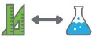
Explore properties and shapes
Activity 2
INVESTIGATE
Students investigate the properties and shapes of the items and decide which materials will be useful for building their own most magnificent thing.

Design, draw and create
Activity 3
IMAGINE & CREATE
Students draw an annotated design of their own most magnificent thing and explain its role or purpose. They use this design to build their most magnificent thing from reused materials.

Present and explain

Activity 4

COMMUNICATE & EVALUATE
Students reflect on the design process and analyse their most magnificent thing. They communicate their designs to an authentic audience through a chosen form of digital media.

Background

Expected learning | Students will be able to:  - Identify types of materials, sort objects by material type and explain why some objects are made of particular materials.  - Follow simple procedures to test the properties of materials, recording observations in a provided table.  - Explain how objects can be changed physically and justify why certain materials were used in their construction.  - Count numbers of objects, record numbers as a tally and represent tallies as a pictograph.  - Compare the length, capacity and mass of objects and containers.  - Recognise and classify familiar two-dimensional figures and three-dimensional objects.  - Imagine, design and construct an object for a purpose.  - Create a labelled drawing and a digital representation of their object.
Vocabulary | The following vocabulary list contains terms that need to be understood, either before the module commences or developed as they are used.  aluminium foil, cans, cardboard, classify, construct, glass, paper, plastic, purposeful, recyclable, recycle, repurpose, reuse, rubbish, sort, strength, sustainability, transparency, useful, water-resistant
Timing | There is no prescribed duration for this module. The module is designed to be flexible enough for teachers to adapt.  Activities do not equate to lessons; one activity may require more than one lesson to implement.
Consumable materials | A Materials list is provided for this module.  This list outlines materials outside of normal classroom equipment that will be needed to complete the activities.
Safety notes | There are potential hazards inherent in these activities and with the equipment being used, and a plan to mitigate any risks will be required.  Potential hazards specific to this module include but are not limited to:

 | - Using construction tools
Assessment | The STEM modules have been developed to provide students with learning experiences to solve authentic real- world problems using science, technology, engineering and mathematics capabilities. While working through the module, the following assessment opportunities will arise:  - Student presentations in Activity 4 provide an opportunity for assessment with cross curricular links to English – Literacy; Speaking and listening.  Appendix 1 indicates how the activities are linked to the Western Australian Curriculum.  Evidence of learning from journaling, presentations and anecdotal notes from this module can contribute towards the larger body of evidence gathered throughout a teaching period and can be used to make on-balance judgements about the quality of learning demonstrated by the students in the Science, Technologies and Mathematics learning areas.  Students can further develop the general capabilities of Information and communication technology capability, Critical and creative thinking and Personal and social capability. Continuums for these are included in the General capabilities continuums but are not intended to be for assessment purposes.

Activity 1: What a lot of rubbish

Activity focus | This activity is designed to encourage students to think creatively about how they can repurpose items to create something of value.  Students read the text The Most Magnificent Thing by Ashley Spires; sort, count and tally collected recyclable items; and represent data using graphs.
Background information | Sustainability refers to conserving resources to support long- term ecological balance. In developed countries, marketing has convinced consumers that the things they purchase should be packaged in an attractive manner.  Packaging often goes beyond keeping the product hygienic or safe and focuses on making the product attractive. The manufacture of packaging materials consumes resources and energy. When packaging is discarded, the resources are wasted. Sustainability is enhanced when packaging is reduced, reused, repurposed or recycled.
Instructional procedures | Student thinking from the lesson should be recorded as annotations in the class reflective journal, along with copies of photos that have been taken. This could also be recorded through a digital platform, see Reflective journal for elaboration.  It is recommended that students work in small groups of three to four for the activities. Mixed ability groups encourage peer tutoring and collaboration in problem solving. Collaboration is an important STEM capability. There are many solutions to this problem and negotiation is encouraged. See Teacher resource sheet 1.1: Cooperative learning – Roles.  Throughout these activities, it is important students are involved in creating the tables and graphs used to collect and represent data. When guided to generate their own tables and graphs, opportunities are presented for students to build mathematical reasoning. Whilst this will typically require more time than using a prepared template, it will enable students to wrestle with the concepts, and in doing so, develop a deeper understanding.

Expected learning | Students will be able to:  - Identify types of materials, sort objects by material type and explain why some objects are made of particular materials (Technologies).  - Count numbers of objects, record numbers as a tally (Mathematics).  - Contribute to creating and describing a picture graph display of collected objects (Mathematics)  - Compare objects according to of mass, length and capacity using direct comparison and uniform informal units (Mathematics)
Equipment required | For the class:  Whiteboard or interactive whiteboard  The Most Magnificent Thing book by Ashley Spires (or access to a video reading of the book).
For the students:
Recyclable items, labels for sorting items, hoops or boxes to sort items into.
Preparation | Organise for recyclable items to be collected prior to starting the module. Students could collect recyclable items at school or bring in clean recyclable waste from home.  Allow sufficient time for enough items to be collected.  Teacher resource sheet 1.0: Sample parent letter provides a sample parent letter explaining the STEM activity in which students will be involved and the resources requested for donation.  Have labels, hoops or boxes for sorting items ready before starting. Alternatively, chalk or tape can be used to create section areas on the floor.
Activity parts | Part 1: Story time  Show the cover of the story The Most Magnificent Thing by Ashley Spires (or a similar book) to the class. As a class discuss what the story could be about. When questioning students, practice wait time and use “because” as a prompt to encourage deeper thinking and reasoning. A cooperative strategy such as Think-pair-share provides  opportunity for all students to share thoughts. See Teacher

resource sheet 1.1: Cooperative learning – Roles and Teacher resource sheet 1.2: Cooperative learning – Think, Pair, Share. A template suggestion to record class thinking is provided Student activity sheet 1.3: I see, I think, I wonder. I see, I think, I wonder is a visible thinking routine that encourages students to make careful observations and thoughtful interpretations, stimulating curiosity and inquiry.
Read The Most Magnificent Thing by Ashley Spires (or a similar book) to the class. Discuss the text and consider questions such as:
- What was the girl’s wonderful idea?
- Why did she want to make this?
- What did the girl do before she started building her most magnificent thing? (ie she drew a plan, got an assistant and gathered supplies)
- Where do you think the girl got the supplies to build her most magnificent thing? Could she use different supplies if these weren’t available? Such as?
- What if the girl was on a farm? In the bush? At the beach?
- Did the most magnificent thing work out the way the girl planned? Was she happy with it?
- How could the girl make her most magnificent thing bigger or smaller? Stronger? Waterproof? Change colour?
- Was the final product the same as her plan?
- What most magnificent thing could you make?
Record ideas for students to reference in the following activities. Explain to the students they will be designing and building their own magnificent thing as they work through this module.
Part 2: Examine
After reading and discussing the book, look at the collected recyclable items. Ask students to sit in a circle and show them the types of items. List the range of items on the board (eg boxes, bottles, containers and newspapers). Identify the original purpose of the items.
- Do we have more of some items than others?
- Why do you think we have so many or so few of certain items? Because…
- Are some items harder to find than others? Which ones? Why?

      - What is recycling?
      - How can recycling help our environment?
      - How does your family recycle?
Practice wait time and use because and why to encourage higher order thinking and reasoning.

Part 3: Sort and measure
Work together as a class to sort items into groups of the same material. Encourage students to think about why items are made from different materials.
      - Why do you think water bottles are made of plastic?
      - Why do you think cereal boxes are made of cardboard?
      - Would glass be a good choice for a meat tray? Because…
Once sorted into groups, students determine their own criteria to resort items. Use the following prompts:
      - Describe the types of items in the collection.
      - Which group of items are nearly all the same size?
      - What items in the collection have very different sizes?
      - What can you tell me about the collection?
Have students sort the same collection into half or double the amount of groups (ie two groups instead of four groups or four groups instead of two). Ask students:
      - What would you call each group?
      - How have you organised your information compared to other students?
Have students sort their collections of plastic bottles, jars and cardboard boxes according to measurement attributes of mass, length and capacity (e.g. heaviest to lightest, biggest to smallest, tallest to shortest, holds the most to the least). Assist students to refine their understanding of size comparisons and associated language. Encourage the use of informal units as appropriate. Ask students, for example:
      - How did you decide this box is larger than that one? What can you measure to check?
- Is the biggest box also the heaviest? How can you tell?

      - You told me this bottle is ‘tall’ and that one is ‘short’, but the ‘short’ one is ‘tall’ when I put it next to that little one. How can it be ‘short’ and ‘tall’ at the same time?
      - Which bottle holds the most? How could you show me that the bottle holds more than the jar.
      - What else could you do to compare the lengths and heights of those two boxes (use pop sticks, straws etc).
Demonstrate and model comparative language to help students understand the meaning of words like taller, shorter, bigger, smaller, longer, shorter, heavier, lighter, holds more. Typically, students at this level think of size in absolute terms, i.e. they categorize objects as either ‘big’ or ‘small’ and don’t yet understand that the same object can be bigger or smaller when compared to other objects.
They also tend to use ‘big’ and ‘small’ to cover a range of attributes. For example, they may use ‘big’ to refer to a long straw (length), a large ball (volume), a large tumbler (capacity), a heavy brick (mass) or a large mat (area).
You can also clarify misconceptions regarding early number comparisons. When asked which has ‘more’ they can confuse the size of collections with the size of the objects in a collection. For example, if there were five large bottles and five small bottles, and the student was asked “Are there more large bottles than small bottles?” they may think that there ‘more’ large bottles, because there is a larger amount of ‘bottle’ overall in the group of five large bottles.
Students also confuse size and mass. When objects are made of the same material, the larger object will often be the heavier. Students need to experience conflicting situations where the largest object is the lightest. This is more difficult to model when comparing recyclable materials, but can be planned by pairing, for example, a large, very light plastic bottle with a small, very heavy cardboard box with extra packaging left inside. Ask:
      - Which do you think is heavier?
      - Can you tell by just looking? Why not?
      - What will you need to do to work out which is heavier? Students will need to use hefting, i.e. pick up both, one in each hand and judge which feels heavier.

Note that students in year one will not yet understand the

use of balance scales, but this could be modelled by the teacher along with hefting. They will likely learn to use balance scales in Year Two. They should have experienced all the attributes listed above using direct and indirect comparison in Pre-primary and so should be able to use the comparison strategies in this task.

Part 4: Tally
Working in groups, students count and tally items in a selected classification (ie material, shape or size). If there are a large number of items, it is suggested to tally a small collection so that numbers are more appropriate for the following graphing activity.
Students record their results in a table such as the one provided in Student resource sheet 1.4: Materials in our recyclable items.
In modelling the use of the table, ask:
      - Where would you write the different types of items?
      - What will you write in the second column?
      - How do you know which number refers to each type of item?
      - What headings should be on each column.
Note: don’t assume Year One students know how to read a table. Ask:
      - Can you see anything interesting in your table?

Part 5: I do, we do
This part creates an opportunity for students to begin to see, in a concrete way, how information can be displayed graphically to make comparisons easier.
Distribute all the items that have been tallied to the students and ask them to draw a picture of each of their items on separate sticky notes. Have students place their squares on the white board in groups that go together (initially the squares should be in clusters, not rows).
Ask, which group has more and discuss counting how many. Ask “How could we arrange the squares so that we could see, without counting, which group has more?” Elicit that aligning the squares in rows would help.
With assistance from students, arrange the squares in rows, or columns. Much later students will learn how to construct

a bar graph with horizontal rows and a column graph with vertical columns, however, at this stage, focus on the importance of placing the squares equal distance apart and starting from the same line.
To develop students’ awareness of this, model uneven spacing and different starting points, and ask students to comment.
- What’s wrong with this row?
It is unevenly spaced and it looks more but there are less plastic bottles than icecream containers.
- Does it matter where the rows start?
You can’t see which is more by looking at the end of the top.
When satisfied, the squares could be transferred and glued to a sheet of card in even rows or columns, with a line drawn as the ‘base line’ and the types of items labelled to become a wall display of the picture graph.
Draw attention to the use the display for showing which items we have the most of without counting each picture.
Invite students to make statements about the display using the words ‘more’, ‘less’, or the ‘same number of’ and introduce and model the terms ‘greater’ and ‘fewer’ to describe the data. For example:
“There is a greater number of boxes than plastic bottles.”
“There are fewer plastic bottles than boxes.”
Part 6: Reflection
Students record responses to the following questions in the class reflective journal:
- Describe some different materials and shapes you investigated today.
- Are there properties that make some materials more suitable for building?
- Which materials would be best for making your most magnificent thing? Why?
Properties of materials will be investigated in Activity 2.
Ideas can be represented through drawings, photos, mind maps or structured sentences.
Resource sheets | Teacher resource sheet 1.0: Sample parent letter

Teacher resource sheet 1.1: Cooperative learning – Roles
Teacher resource sheet 1.2: Cooperative learning – Think, Pair, Share.
Student activity sheet 1.3: I see, I think, I wonder
Student resource sheet 1.4: Materials in our recyclable items
Digital resources | The Most Magnificent Thing Stop Motion animated by Elmwood School in Ottawa (Mr Mattperreaut, 2015) www.youtube.com/watch?v=GgECc3gKuTo
 | The Most Magnificent Thing by Ashley Spires (read aloud) (Stories that build character and more…,2017) www.youtube.com/watch?v=SzVB7JzQMzs
Material labels are available from www.twinkl.co.uk/resource/t-t-17590-materials-word-wall- pack (Twinkl, 2017)
This is a free download but requires an account.
Literary resources | Alternative book options along similar lines to The Most Magnificent Thing include:  - Iggy Peck Architect by Andrea Beaty  - Rosie Revere, Engineer by Andrea Beaty  - Anything Is Possible by Giulia Belloni and Marco Trevisan  - Going Places by Peter and Paul Reynolds  - Coppernicker The Invention by Wouter van Reek  - What Do You Do With An Idea? by Kobi Yamada  - The Magnificent tree by Nick Bland

Activity 2: Explore properties and shapes

Activity focus  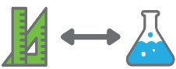 | In this activity, students explore the properties and shapes of collected items and decide what will be useful in creating their own most magnificent thing.
Background information | Objects and materials have properties such as strength, transparency and water resistance. Strength refers to the ability of an object to not change shape when exposed to compression (squashing) or stretching forces. Transparency refers to the extent to which materials allow light to pass through them. Transparent materials such as flat glass allow light to pass through without diffusion, textured glass diffuses light as it passes through and is considered translucent, while opaque objects such as a wooden plank will not allow any light to pass through. Water resistance refers to the extent to which an object will allow water to permeate (eg water resistant materials such as plastic sheeting).  The properties of objects are largely determined by the material from which they are made.  However, the shape of an object may also contribute to its properties. For example, a flat sheet of glass is less strong than glass formed into the shape of a bottle. Some recyclable items have regular shapes, for example cylindrical cans. Others, such as crumpled newspaper, have irregular shapes. Objects can be categorised as either two- dimensional (eg squares) or three-dimensional (eg prisms).
Instructional procedures | Student thinking from the lesson should be recorded as annotations in the class reflective journal, along with photos that have been taken.  During testing, encourage students to consider the materials they will use for their designs:  - Would this new information be important when you are choosing materials for your most magnificent thing?
Expected learning | Students will be able to:  1. Follow simple procedures to test the properties of materials, and make and record observations in a provided table (Science).

- Recognise and classify familiar two-dimensional figures and three-dimensional objects (Mathematics).

Equipment required | For the class:  Collected recyclable items, and a list of material properties and shapes to investigate.  A torch to test transparency (one per group)
For the students:
Books or other masses such as large blocks
Water and an eye dropper to test if materials are water- resistant.
Preparation | Using the previously collected items from Activity 1, decide what shapes and properties students will investigate prior to beginning the activity.
Activity parts | Part 1: Classify  Working in small groups of three or four, students sort collected recyclable items by shape.  Questioning can be used to guide students through the process.  - What are the items shaped like?  - What shapes can you see in the items?  - What is the same and what is different in the shapes?  - What shapes could go together?  - How can you sort them into groups by their shapes?  - Are there unfamiliar shapes or objects? How could we group these?  - How could we group the items in a different way?  - Which kinds of shapes will be good for building a most magnificent thing? Why?
Part 2: Test - strength
Students test the material properties of the items. Each group may test a different type of material (eg metal, plastic, cardboard, fabric, rubber or foam).

Students test the strength of the recyclable items by placing blocks or books on top of them to determine how much weight they can support. Care needs to be taken when choosing materials to test.
Note: The testing may not be fair from a scientific

perspective, however the purpose is for students to see which materials will be best for different parts of their design.
  - Which items were the strongest? How many books/blocks did they hold?
  - Which items were the weakest? How many books/blocks did they hold?
  - Which items would be useful in your most magnificent thing? Why?
Note: When a material is formed into different shapes its properties change. For example cardboard folded into a triangular prism or rolled into a tube is much stronger than a flat sheet of cardboard. The strength testing can be used to compare the same material when formed into different shapes.
Students can record their results using Student activity sheet 2.1: Material properties – Strength.

Part 3: Test – transparency
Students investigate materials to see if they are transparent by holding them up to the light and seeing if they can see through them.
- Which materials were transparent? How do you know?
- Which materials were not transparent? How do you know?
- How could you use transparent materials? Why?
Students can record their results using Student activity sheet 2.2: Material properties – Transparency.
Part 4: Test - water-resistance
Students investigate materials to see if they are water- resistant by adding drops of water to samples of the materials (eg paper, plastic, cardboard) placed flat on the table.
- What happens to the water when dropped on …?
- Do the drops stay on the surface, soak in or drip through the material onto the table? Why?
- Which of the materials was most water-resistant? How do you know this?
- Which material was least water-resistant? How do you know this?
- What happens to the materials when they get wet?
- How could you use water-resistant materials? Why?

- Are materials that soak up water useful? How would you use them? Why?
Students can record their results using Student activity sheet 2.3: Material properties – Water-resistance.
Part 4: Journaling
Students record what they have learnt in the class reflective journal and begin to brainstorm the types of materials they might use to build their most magnificent thing. Prompt student responses using a focus question:
- Which materials will you use to build your most magnificent thing? Why?
Resource sheets | Student activity sheet 2.1: Material properties – Strength  Student activity sheet 2.2: Material properties – Transparency  Student activity sheet 2.3: Material properties – Water- resistance
Digital resources | 2D Shape Word Mat – available from  www.twinkl.co.uk/resource/t-n-105-2d-shape-word-mat
3D Shape Word Mat – available from
www.twinkl.co.uk/resource/t-n-106-3d-shape-word-mat
 | BBC Science Clips – Characteristics of materials (BBC, 2014) www.bbc.co.uk/schools/scienceclips/ages/7_8/characterist ics_materials_fs.shtml
BBC Science Clips – Grouping and changing materials (BBC, 2014)
www.bbc.co.uk/schools/scienceclips/ages/6_7/grouping_ materials.shtml
 | BBC Science Clips – Sorting and using materials (BBC, 2014) www.bbc.co.uk/schools/scienceclips/ages/5_6/sorting_usin g_mate.shtml
Everyday Materials Property Word Cards – available from
www.twinkl.co.uk/resource/t-sc-094-ks1-everyday-materials- property-word-cards (Twinkl, 2017)

Activity 3: Design, draw and create

Activity focus | In this activity, students draw an annotated design of their own most magnificent thing, explaining its role or purpose. They use this design to build their most magnificent thing from recycled materials and reflect on the design process.
Instructional procedures | Designing typically progresses from understanding a need to imagining what might be developed to address that need.  The Design process guide is included as a resource to provide assistance to teachers in understanding the complete design process as developed in the technologies syllabus.  Students may find it difficult to imagine a need for their design to fulfill. Scaffold this part of the design process giving specific design criteria. For instance, the most magnificent thing could fulfill a need for a teddy such as a chair, or create something to fulfill a need at home, a design solution for storing objects or collections of growing plants, or something useful for pets or cooking. Students could also create a toy.  To further link to the science curriculum, the students could be directed to create an instrument (Physical Science) or a habitat for animals (Biological Science).  Once imagined, planning is required to identify the materials required and tools needed for construction.  A labelled diagram can clarify how each component relates to others and the specifications of the materials. The labelled diagram guides the design process.  During construction, new insights may emerge which initiate revisions. Further improvements are often made to the design following feedback on the prototype.  Refer to Teacher resource sheet 3.3: Construction skills for tips on joining and binding items. Photographs or videos of the construction processes can be taken for digital presentations in Activity 4. The teacher guides students through the design process as they participate in this activity, see Design process guide.

Student thinking from the lesson should be recorded as annotations in the class reflective journal, along with photos that have been taken.

Expected learning | Students will be able to:  - Imagine, design and construct an object for a purpose (Technologies).  - Explain how objects can be changed physically for construction purposes (Science).  - Create a detailed, labelled diagram (Technologies).
Equipment required | For the class:  Collected items from Activity 1 and supplies for construction including: tape, scissors, cutting mats, glue sticks, PVA glue, paintbrushes, hot glue (to be used by an adult) etc.
For the students:
Design worksheets:
Student activity sheet 3.1: Materials used Student activity sheet 3.2: Shapes or objects
Preparation | Adult help for construction.  Teacher resource sheet 3.3: Construction skills
Activity parts | Part 1: Class discussion  Discuss the process the girl in The Most Magnificent Thing  book underwent to build her creation.  - What steps did the girl follow between having an idea and building her most magnificent thing?  - When she had her idea, did she start building straight away?  - What did she do first?  - If you could make anything what would you make?  - Why would you make your most magnificent thing? What purpose would your thing have? How would it be useful to you?  - What materials will be useful for your most magnificent thing?  - What shapes will be useful for your most magnificent thing?  - What type of items are most plentiful?

Part 2: Ideation
As a class discuss what useful things could be made from recycled materials. To enable students to share ideas about how to meet these needs use a think-pair-share activity (Teacher resource sheet 1.2: Cooperative learning – Think, Pair, Share). The ideas from this discussion are to inspire students in their design.
Decide if students will work individually or in groups; this will depend on whether the focus is on individual work and design skills, or on personal capability skills of collaborating and managing.

Part 3: Development
Students name and describe the purpose of their most magnificent thing. Students should identify:
- Our/my magnificent thing is a (name).
- Our/my magnificent thing will be useful for ……….
(what it will do), because (the need it will
meet).
Students draw their designs and use labels to identify the items they will use to build their most magnificent thing.
Drawing apps (such as Doodle Buddy or Draw Free) could be used during the design process. Students could create a movie or voice memo to explain their plan and the purpose of their most magnificent thing.
Students list the materials and shapes in their design (Student activity sheet 3.1: Materials used and Student activity sheet 3.2: Shapes or objects).
Part 4: Gallery walk
Students participate in a gallery walk to offer feedback on others designs. Feedback may include something they like about a design and something they suggest improving.
Part 5: Production
Students follow their design plan to build their most magnificent thing. Adult assistance may be required throughout this process.
Question students about the process
- What are you making?
- What is its purpose?

- How are you joining pieces? Why did you choose that method?
- Are you able to follow your plan or did you have to make changes? Why did you need to change your plan?
- What problems have you had with your construction?
- Is that how you hoped it would be? Because…
- What could you do to make it stronger?
Support students in documenting the design process by capturing digital images.
Teacher resource sheet 3.3: Construction skills is a useful resource for this activity.
Part 6: Evaluation
Conduct a review of the construction process. Ask students if they needed to alter materials to make their most magnificent thing.
- What objects or materials did you change when making your most magnificent thing?
- How did you change them? Did you change the shape of the objects? Did you change the size?
Record student reflections of the design process in the class reflective journal.
Resource sheets | Teacher resource sheet 1.2: Cooperative learning – Think, Pair, Share  Student activity sheet 3.1: Materials used Student activity sheet 3.2: Shapes or objects Teacher resource sheet 3.3: Construction skills
Digital resources | Doodle Buddy  itunes.apple.com/au/app/doodle-buddy-paint-draw- scribble/id313232441?mt=8
 | Draw Free itunes.apple.com/au/app/draw-free-for- ipad/id366755447?mt=8

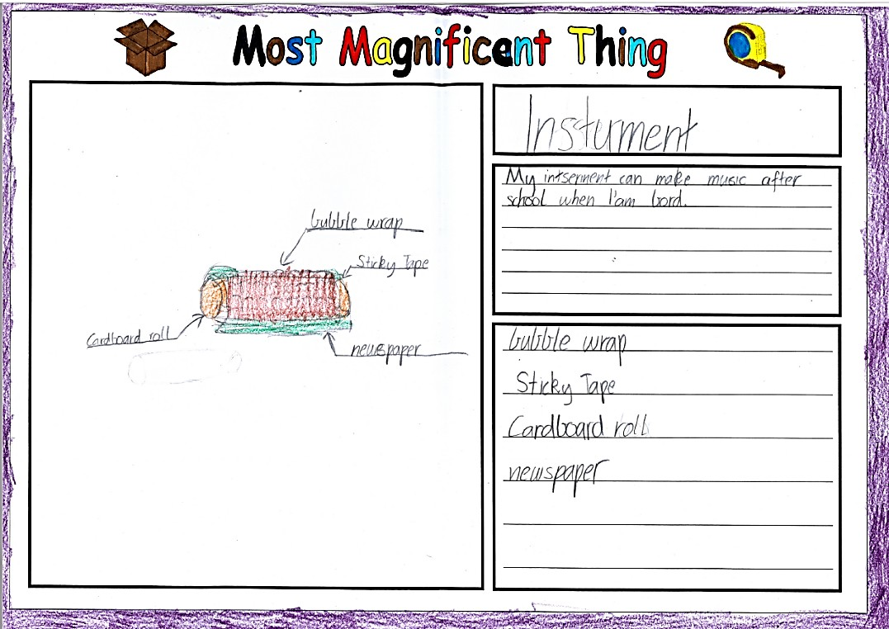

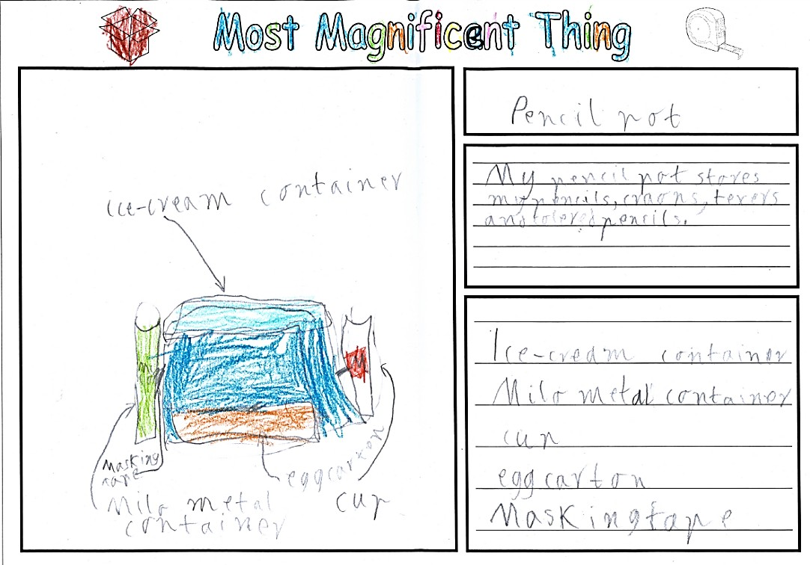

Student work samples showing design plans for their most magnificent things

After completing their most magnificent things, the students reflected on the design process, the changes they made and how their creations met their needs.

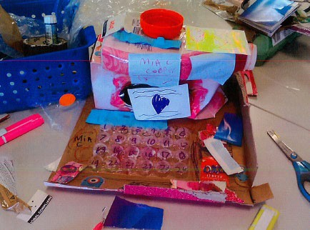

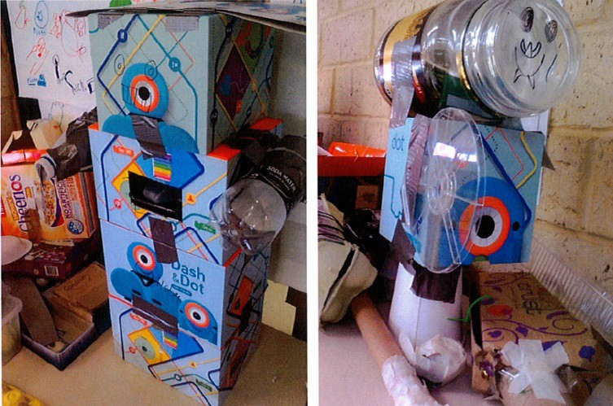

These images show a student’s most magnificent thing, an automatic pet feeder. They illustrate the design process where the student sought feedback and improved on the original design idea

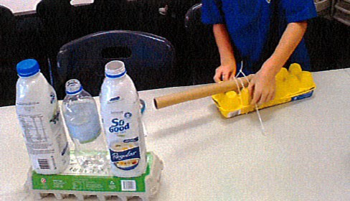

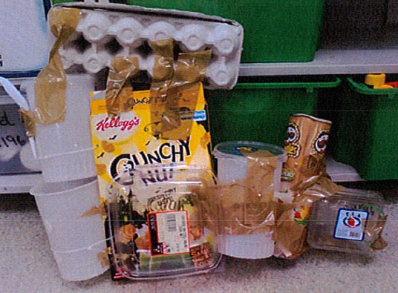

Activity 4: Present and explain

Activity focus | In this activity, students reflect on their completed most magnificent thing and justify changes to the design plan.  Students communicate the design process through a chosen form of digital media. Presentations are shared with the class and an external audience where possible.
Instructional procedures | Students will need support and scaffolding to help them both prepare for their presentation and to present. Group- based presentations could be prepared in groups of three or four students and, to scaffold cooperative group work, each member of the group could have a role and responsibilities. For further information on possible roles and how they can work within a group refer to Teacher resource sheet 1.1: Cooperative learning – Roles. All students contribute in three phases: deciding on the content, preparing the media and presenting. Each student could have overall responsibility for managing a phase of the task.  It is assumed that presentations will be made by groups. Presentations will last 3-5 minutes and may have to be scheduled over two separate lessons.  The presentations provide a rich opportunity for assessing the students' understanding of the science and technology principles and processes, as well as the literacies associated with speaking and listening  Students can be given a choice of creating a presentation with a range of presentation types (eg iMovie or Explain everything). Presentations can then be shared through Connect, Seesaw or Class Dojo, or shared on the interactive whiteboard. Students may require explicit instruction in using apps.  If digital technology is not accessible, students could share their project using a traditional poster, recount or book.  Student thinking from the lesson should be recorded as annotations in the class reflective journal, along with photos  from the activities.

Expected learning | Students will be able to:  - Explain what their object is, how it will be useful, how it was constructed and why particular materials were used (Technologies).  - Compare their initial design with the constructed object and justify differences (Technologies).  - Create a digital representation of their creation and design process using a digital platform to share thinking (Technologies).
Equipment required | For the class:  Class reflective journal
For the students:
A device with an appropriate app for creating a digital presentation (see Digital resources for suggestions).
Preparation | Devices will need to be charged and loaded with appropriate apps.  Presentations may have to be scheduled for two separate sessions.  Consider the length of the presentations. Two minutes is a good length for speaking, with two minutes for questions and two minutes swap over between groups.  Invite members of the community to join the audience for the presentations.
Activity parts | Part 1: Analysing  Students analyse their most magnificent thing, count the materials used, and compare this to their initial design plan.  - What materials were used most? Why?  - What wasn’t used? Why?  - What shapes were used most? Why?  Students compare their finished product to their planned design using Student activity sheet 4.1: Analysis.  Comparisons can also be recorded in the class reflective journal.

Part 2: Presentation content
Students decide on and write the content of the presentation.
Presentations should focus on the objects the students have made, the purpose of their most magnificent thing and their choice of materials as outlined in their design plan. Students should also share what they have learnt as they have worked through the activities. Students should justify any changes made during the construction process.
Part 3: Choosing media
With teacher guidance, students choose a form of digital media to communicate their design process. See Digital resources for suggestions.
Part 4: Creating presentation
Planning questions can include:
- How long will the presentations be?
- Who will speak? One person may introduce the presentation, another give the presentation and a third answer any questions.
Students may require explicit instruction or help from a buddy class to use technology.
If digital technology is not accessible, students could share their project using a traditional poster, recount or book.
Part 5: Sharing
Students share their presentations with their peers and, where possible, an audience beyond the classroom. The work may be shared with parents via Connect, a portal, class blog or other digital platform.
Part 6: Reflecting
Students reflect on the STEM module and their learning journey. They could represent their learning as a timeline using a combination of words and pictures.

Resource sheets | Teacher resource sheet 1.1: Cooperative learning – Roles Student activity sheet 4.1: Analysis
Digital resources | Comic Life  itunes.apple.com/us/app/comic- life/id432537882?mt=8&ign-mpt=uo%3D4 ($4.99)
 | Pixton Comic Maker itunes.apple.com/au/app/pixton-comic- maker/id1000914010?mt=8
iBooks Author
www.apple.com/au/ibooks-author/
Book Creator
itunes.apple.com/au/app/book-creator-for-ipad- create/id442378070?mt=8 ($7.99)
iMovie
itunes.apple.com/au/app/imovie/id377298193?mt=8
Pages
itunes.apple.com/au/app/pages/id361309726?mt=8
Keynote
itunes.apple.com/au/app/keynote/id361285480?mt=8
Connect – the Department of Education’s integrated, online environment
connect.det.wa.edu.au
Seesaw Digital Portfolio
web.seesaw.me
Class Dojo
www.classdojo.com

Appendix 1A: Links to the Western Australian Curriculum
The Our magnificent thing module provides opportunities for developing students’ knowledge and understandings in science, technologies and mathematics. The table below shows how this module aligns to the content of the Western Australian Curriculum and can be used by teachers for planning and monitoring.

OUR MAGNIFICENT THING  Links to the Western Australian Curriculum | ACTIVITY
 | 1 | 2 | 3 | 4
SCIENCE
SCIENCE UNDERSTANDING
Chemical sciences: Everyday materials can be physically changed in a variety of ways (ACSSU018) |  | ● | ●
SCIENCE INQUIRY SKILLS
Planning and conduction: Participate in guided investigations to explore and answer  questions (ACSIS025) | ● | ●
DIGITAL TECHNOLOGIES
PROCESS AND PRODUCTION SKILLS
Digital Implementation: Share and publish information with known people in an online environment, modelling strategies to stay safe online (ACTDIP006) |  |  |  | ●
DESIGN AND TECHNOLOGIES
KNOWLEDGE AND UNDERSTANDING
Technologies and society: People produce familiar products and services to meet personal and community needs (ACTDEK001) | ● |  | ●
Technologies contexts: Characteristics and behaviours of individual materials used in products (ACTDEK004) |  | ●
PROCESS AND PRODUCTION SKILLS
Creating solutions by: Designing: Develop and communicate design ideas through describing, drawing, modelling and/or a sequence of written or spoken steps (WATPPS07) |  |  | ● | ●

OUR MAGNIFICENT THING | ACTIVITY
Links to the Western Australian Curriculum | 1 | 2 | 3 | 4
MATHEMATICS
MEASUREMENT AND GEOMETRY
Using units of measurement: Use direct and indirect comparisons to decide which is longer, heavier or holds more, and explain reasoning in everyday language (ACMMG006) (Pre-primary) | ●
Using units of measurement: Measure and compare the lengths and capacities of pairs of objects using uniform informal units (ACMMG019) | ●
Shape: Recognise and classify familiar two- dimensional shapes and three-dimensional objects using obvious features (ACMMG022) |  | ●
PROBABILITY AND STATISTICS
Data representation and interpretation: Represent data with objects and drawings where one object or drawing represents one data value. Describe the displays (ACMSP263) | ●

Further information about assessment and reporting in the Western Australian Curriculum can be found at: https://k10outline.scsa.wa.edu.au/home curriculum-browser/technologies/technologies-overview/ways-of-assessing

Appendix 1B: Mathematics proficiency strands
Source:
www.australiancurriculum.edu.au/f-10-curriculum/mathematics/key- ideas/?searchTerm=key+ideas#dimension-content

Key ideas
In Mathematics, the key ideas are the proficiency strands of understanding, fluency, problem-solving and reasoning. The proficiency strands describe the actions in which students can engage when learning and using the content. While not all proficiency strands apply to every content description, they indicate the breadth of mathematical actions that teachers can emphasise.

Understanding
Students build a robust knowledge of adaptable and transferable mathematical concepts. They make connections between related concepts and progressively apply the familiar to develop new ideas. They develop an understanding of the relationship between the ‘why’ and the ‘how’ of mathematics. Students build understanding when they connect related ideas, when they represent concepts in different ways, when they identify commonalities and differences between aspects of content, when they describe their thinking mathematically and when they interpret mathematical information.

Fluency
Students develop skills in choosing appropriate procedures; carrying out procedures flexibly, accurately, efficiently and appropriately; and recalling factual knowledge and concepts readily. Students are fluent when they calculate answers efficiently, when they recognise robust ways of answering questions, when they choose appropriate methods and approximations, when they recall definitions and regularly use facts, and when they can manipulate expressions and equations to find solutions.

Problem-solving
Students develop the ability to make choices, interpret, formulate, model and investigate problem situations, and communicate solutions effectively. Students formulate and solve problems when they use mathematics to represent unfamiliar or meaningful situations, when they design investigations and plan their approaches, when they apply their existing strategies to seek solutions, and when they verify that their answers are reasonable.

Reasoning
Students develop an increasingly sophisticated capacity for logical thought and actions, such as analysing, proving, evaluating, explaining, inferring, justifying and generalising.
Students are reasoning mathematically when they explain their thinking, when they deduce and justify strategies used and conclusions reached, when they adapt the known to the unknown, when they transfer learning from one context to another, when they prove that something is true or false, and when they compare and contrast related ideas and explain their choices.

Appendix 2: General capabilities continuums
The general capabilities continuums shown here are designed to enable teachers to understand the progression students should make with reference to each of the elements. There is no intention for them to be used for assessment.

Information and communication technology (ICT) capability learning continuum

Sub-element | Typically by the end of Foundation Year | Typically by the end of Year 2 | Typically by the end of Year 4
Create with ICT  Generate ideas, plans and processes | use ICT to follow or contribute to a simple plan for a solution | use ICT to prepare simple plans to find solutions or answers to questions | use ICT to generate ideas and plan solutions
Create with ICT  Generate solutions to challenges and learning area tasks | use ICT as a creative tool to generate simple solutions, modifications or data representations for personal or school purposes | experiment with ICT as a creative tool to generate simple solutions, modifications or data representations for particular audiences or purposes | create and modify simple digital solutions, creative outputs or data representation/transformation for particular purposes
Communicating with ICT  Collaborate, share and exchange | use purposefully selected ICT tools safely to view information shared by trusted adults | use purposefully selected ICT tools safely to share and exchange information with appropriate local audiences | use appropriate ICT tools safely to share and exchange information with appropriate known audiences

Critical and creative thinking learning continuum

Sub-element | Typically by the end of Foundation Year | Typically by the end of Year 2 | Typically by the end of Year 4
Inquiring – identifying, exploring and organising information and ideas  Organise and process information | gather similar information or depictions from given sources | organise information based on similar or relevant ideas from several sources | collect, compare and categorise facts and opinions found in a widening range of sources
Generating ideas, possibilities and actions  Imagine possibilities and connect ideas | use imagination to view or create things in new ways and connect two things that seem different | build on what they know to create ideas and possibilities in ways that are new to them | expand on known ideas to create new and imaginative combinations
Generating ideas, possibilities and actions  Seek solutions and put ideas into action | predict what might happen in a given situation and when putting ideas into action | investigate options and predict possible outcomes when putting ideas into action | experiment with a range of options when seeking solutions and putting ideas into action
Reflecting on thinking and processes  Transfer knowledge into new contexts | connect information from one setting to another | use information from a previous experience to inform a new idea | transfer and apply information in one setting to enrich another

Personal and social capability learning continuum

Sub-element | Typically by the end of Foundation Year | Typically by the end of Year 2 | Typically by the end of Year 4
Social management Work collaboratively | share experiences of cooperation in play and group activities | identify cooperative behaviours in a range of group activities | describe characteristics of cooperative behaviour and identify evidence of these in group activities
Social management Negotiate and resolve conflict | listen to others’ ideas, and recognise that others may see things differently from them | practise solving simple interpersonal problems, recognising there are many ways to solve conflict | identify a range of conflict resolution strategies to negotiate positive outcomes to problems
Social management Develop leadership skills | identify ways to take responsibility for familiar tasks at home and school | discuss ways in which they can take responsibility for their own actions | discuss the concept of leadership and identify situations where it is appropriate to adopt this role
Further information about general capabilities is available at:
k10outline.scsa.wa.edu.au/home/p-10-curriculum/general-capabilities-over/general-capabilities-overview/general-capabilities-in- the-australian-curriculum

Appendix 3: Materials list

The following materials are required to complete this module. A range of recyclable items, including:
- newspaper
- cans
- plastic bottles
- ice-cream containers
- yoghurt containers
- shoe boxes
- plastic wrapping
- boxes
- foil
- fabric scraps
- egg cartons
- bottle caps.

A selection of cutting and construction tools such as:
- tape
- scissors
- cutting mats
- glue sticks
- PVA glue
- paint brushes
- hot glue guns (used by adults)
- tacks
- cable ties
- string.

Appendix 4: Design process guide
Evaluation
Production
Development
Ideation
Analysis
Research
Reflection on the process taken and the success of the design.
Evaluation can lead to further development or improvement of the design and can be a final stage of the design process before a conclusion is reached.
Could be formal or informal and verbal or written.
Safe production of the final design or multiple copies of the final design.
Fine tuning the production process, such as division of labour for batch or mass production.
Use of intended materials and appropriate tools to safely make the solution to the design problem.
Development of the design ideas. Improvements, refinements, adding detail, making it better.
Activities such as detailed drawings, modelling, prototyping, market research, gaining feedback from intended user, further research – if needed – to solve an issue with the design, testing different tools or equipment, trialling production processes, measuring or working out dimensions, testing of prototypes and further refinement.
Idea generation – turning ideas into tangible forms so they can be organised, ordered and communicated to others.
Activities such as brainstorming, mind mapping, sketching, drawing diagrams and plans, collecting colour samples and/or material samples and talking through these ideas can help to generate more creative ideas.
Using the SCAMPER model can assist with this:
www.mindtools.com/pages/article/newCT_02.htm
www.designorate.com/a-guide-to-the-scamper-technique-for-
creative-thinking
Understanding the meaning of the research findings.
Analysing what the information means, summarising the surveys, judging the value of existing solutions, understanding test results.
Finding useful and helpful information about the design problem.
Gathering information, conducting surveys, finding examples of existing solutions, testing properties of materials, practical testing.

Appendix 5: Reflective journal
When students reflect on learning and analyse their own ideas and feelings, they self-evaluate, thereby improving their metacognitive skills. When students self-monitor or reflect, the most powerful learning happens.
Journaling may take the form of a written or digital journal, a portfolio or a digital portfolio. Early
childhood classrooms may use a class reflective floor book with pictures of the learning experience and scribed conversations.
Teachers can model the journaling process by thinking aloud and showing students how they can express learning and thoughts in a variety of ways including diagrams, pictures and writing.
Journals are a useful tool that gives teachers additional insight into how students value their own learning and progress, as well as demonstrating their individual achievements.
The following links provide background information and useful apps for journaling.

Kidblog – digital portfolios and blogging
kidblog.org/home
Edmodo – for consolidating and storing class notes and learning materials
www.edmodo.com/
Explain Everything™ – a screen casting, video and presentation tool all in one
explaineverything.com
Popplet – allows you to jot down your ideas and then sort them visually
Popplet.com
Seesaw – for capturing work completed by students in class, using a device’s camera function
web.seesaw.me
Connect – the Department of Education’s integrated, online environment
connect.det.wa.edu.au
Evernote (a digital portfolio app)
evernote.com
Digital portfolios for students (Cool tools for school)
cooltoolsforschool.wordpress.com/digital-student-portfolios

Appendix 6: Teacher resource sheet 1.0: Sample parent letter
(School details and letterhead) (Date)

Dear parents/caregivers,

RE: COLLECTING ITEMS FOR OUR MAGNIFICENT THING STEM PROJECT

Our class is undertaking a STEM (Science, Technology, Engineering and Mathematics) project called Our magnificent thing. Based on the picture book The Most Magnificent Thing by Ashley Spires, this project will involve students in our class repurposing recyclable items to create their own most magnificent thing (something of value to them).
This project focuses on repurposing recyclable items to give students opportunities to consider sustainability and the impact of our lifestyles on our environment, while developing their ability to design, create and problem-solve. To enable students to create their most magnificent things, we would appreciate if you could please collect clean recyclable items from your house (over a one-week period). Please do not include any alcoholic containers or toilet rolls.
We would like the recyclable items to be delivered to the classroom before (date).
We will be collecting data on the shape and material properties of the items before using them to create something magnificent. We may require adult assistance during the construction phase so please let me know if you are available to help.

Thank you in advance,

(Classroom teacher)

Appendix 7: Teacher resource sheet 1.1: Cooperative learning – Roles
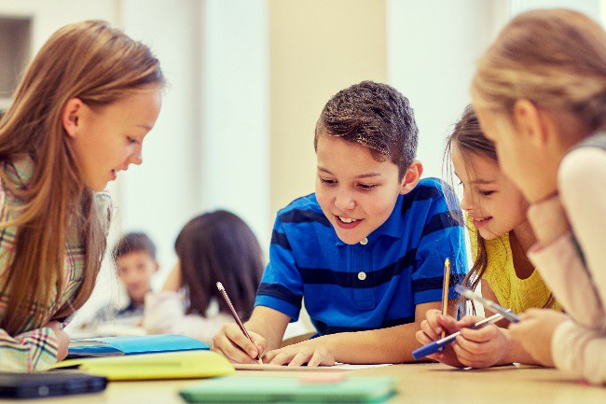
Cooperative learning frameworks create opportunities for groups of students to work together, generally to a single purpose.
As well as having the potential to increase learning for all students involved, using these frameworks can help students develop personal and social capability.
When students are working in groups, positive interdependence can be fostered by assigning roles to group members.
These roles could include:
- working roles such as Reader, Writer, Summariser, Time-keeper.
- social roles such as Encourager, Observer, Noise monitor, Energiser.
Teachers using the Primary Connections roles of Director, Manager and Speaker for their science teaching may find it effective to also use these roles for STEM learning.
Further to this, specific roles can be delineated for specific activities that the group is completing.
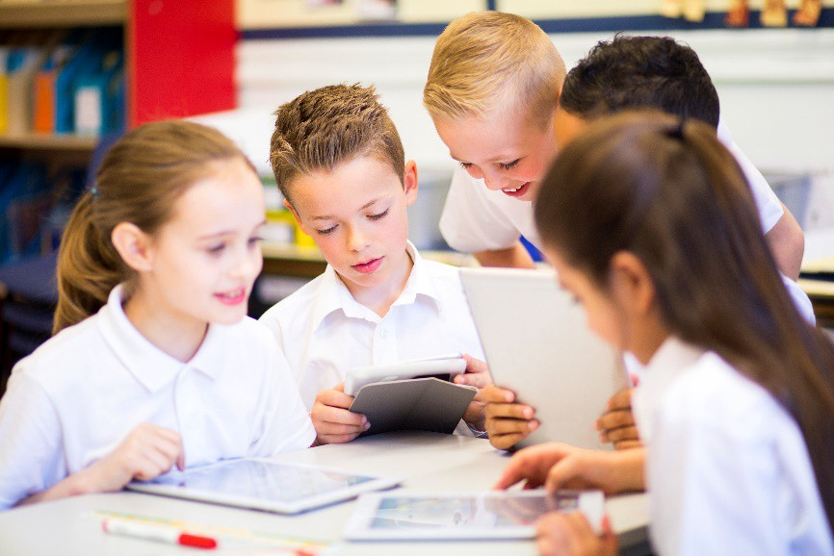
It can help students if some background to the purpose of group roles is made clear to them before they start, but at no time should the roles get in the way of the learning. Teachers should decide when or where roles are appropriate to given tasks.

Appendix 8: Teacher resource sheet 1.2: Cooperative learning – Think, Pair, Share
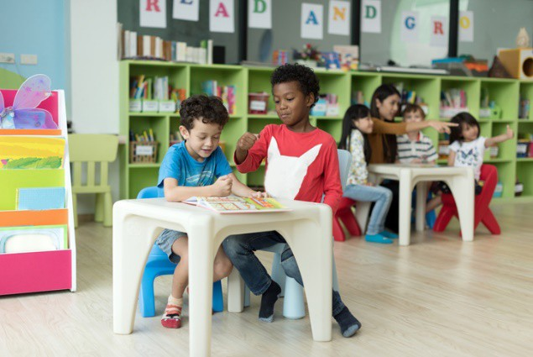
This resource sheet provides a brief outline of a cooperative learning strategy known as 'think – pair – share'.
Cooperative learning frameworks create opportunities for groups of students to work together, generally to a single purpose.
As well as having the potential to increase learning for all students involved, using these frameworks can help students develop personal and social capability.
In the 'think' stage, each student thinks silently about a question asked by the teacher.
In the 'pair' stage, students discuss their thoughts and answers to the question in pairs.
In the 'share' stage, the students share their answer, their partners answer or what they decided together. This sharing may be with other pairs or with the whole class. It is important also to let students 'pass'. This is a key element of making the strategy safe for students.
Think – pair – share increases student participation and provides an environment for higher levels of thinking and questioning.

Appendix 9: Student activity sheet 1.3: I see, I think, I wonder

What do you see when you look at this image?
What are you thinking about as you look at this image?
What are your wonderings (questions)?

Appendix 10: Student resource sheet 1.4: Materials in our recyclable items
What recyclable materials were collected by the class?

Table of results:

Material | How many?
1.
2.
3.
4.
5.
6.
7.
8.

Appendix 11: Student activity sheet 2.1: Material properties – Strength

If something is strong, it can hold a lot of blocks.
It is recommended glass or plastic are not used for strength tests.

Object | Number of blocks held | Did the object change shape?
1.
2.
3.
4.
5.
6.

The strongest object was The weakest object was

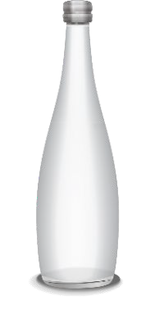
Appendix 12: Student activity sheet 2.2: Material properties – Transparency

If something is transparent you can see clearly through it.

Object tested | Was it transparent?  Yes or No?
1.
2.
3.
4.
5.
6.

The most transparent object was The least transparent object was

Appendix 13: Student activity sheet 2.3: Material properties – Water-resistance

If something is water-resistant, very little to no water will soak into it or drip through it.

Object tested | Was it water-resistant?  Yes or No?
1.
2.
3.
4.
5.
6.

The most water-resistant object was The least water-resistant object was

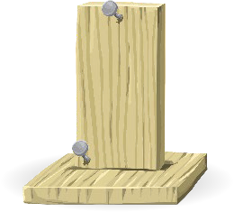
Appendix 14: Student activity sheet 3.1: Materials used
Materials we used to make our most magnificent thing

Material | Why we used this material

Appendix 15: Student activity sheet 3.2: Shapes or objects

Shapes or objects we used in our most magnificent thing

Shape or object | How many can we count in our most magnificent thing?

Appendix 16: Teacher resource sheet 3.3: Construction skills
Construction skills help students to generate and produce solutions for real-world problems.
This resource can be used as a visual stimulus to prompt students to develop solutions to design problems. The cards can be printed to create stations.
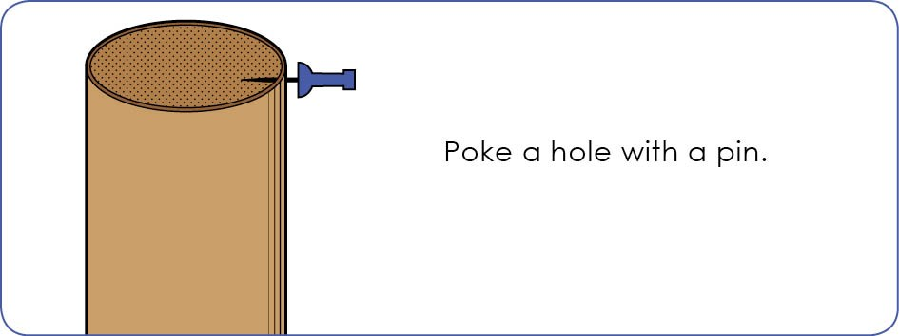

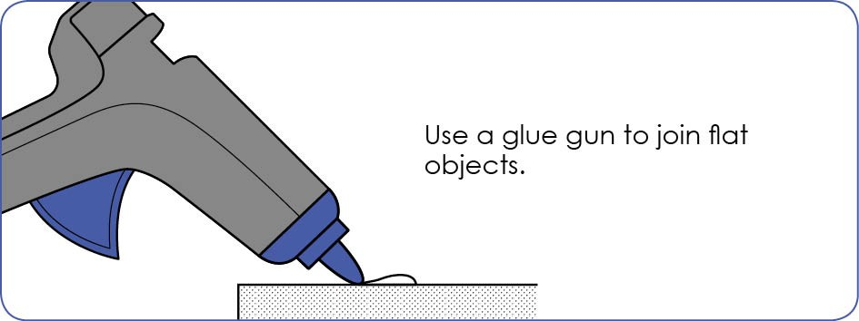

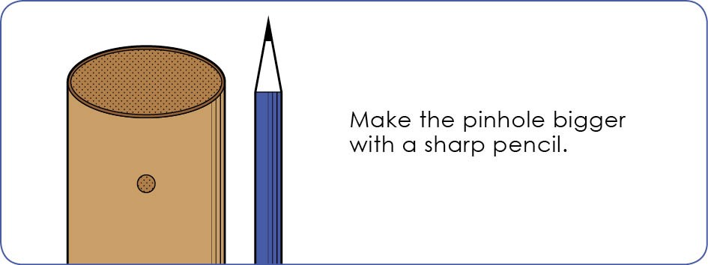

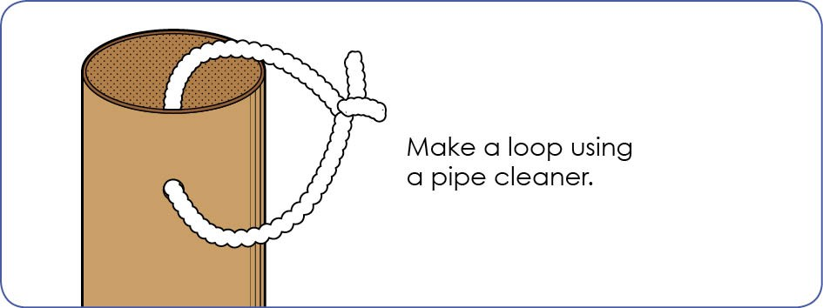

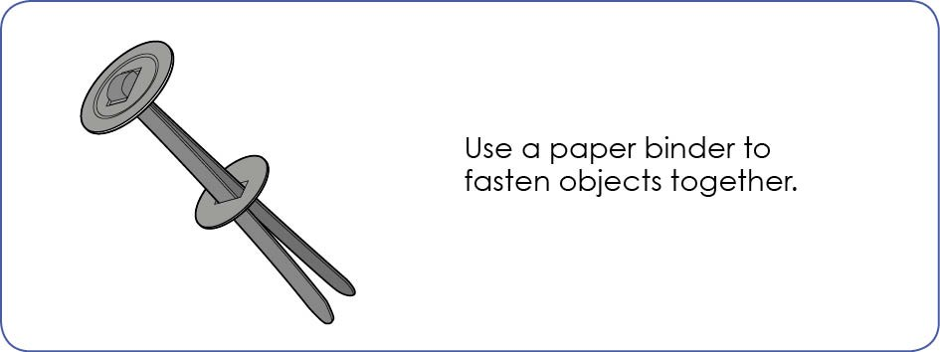

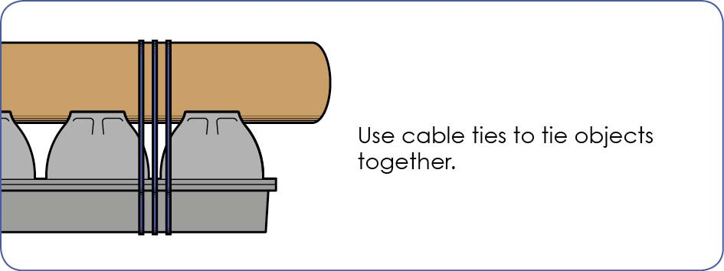

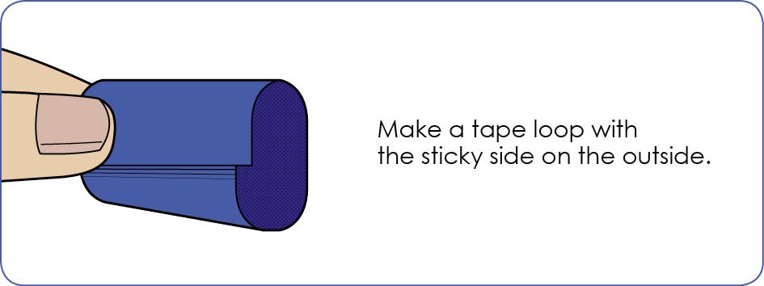

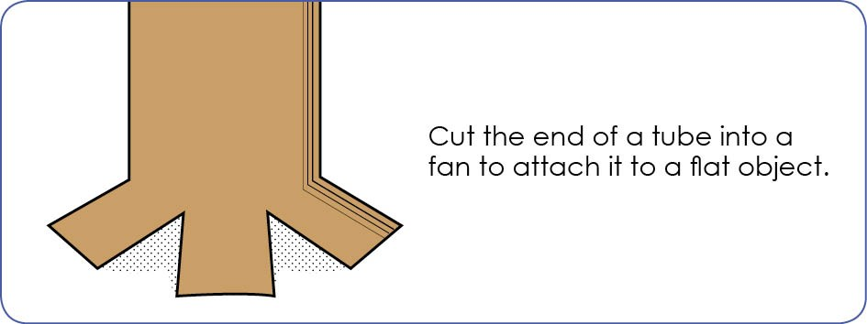

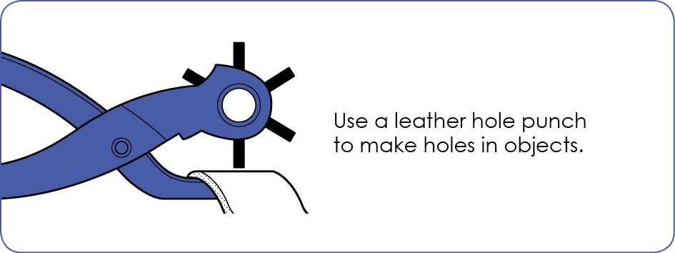

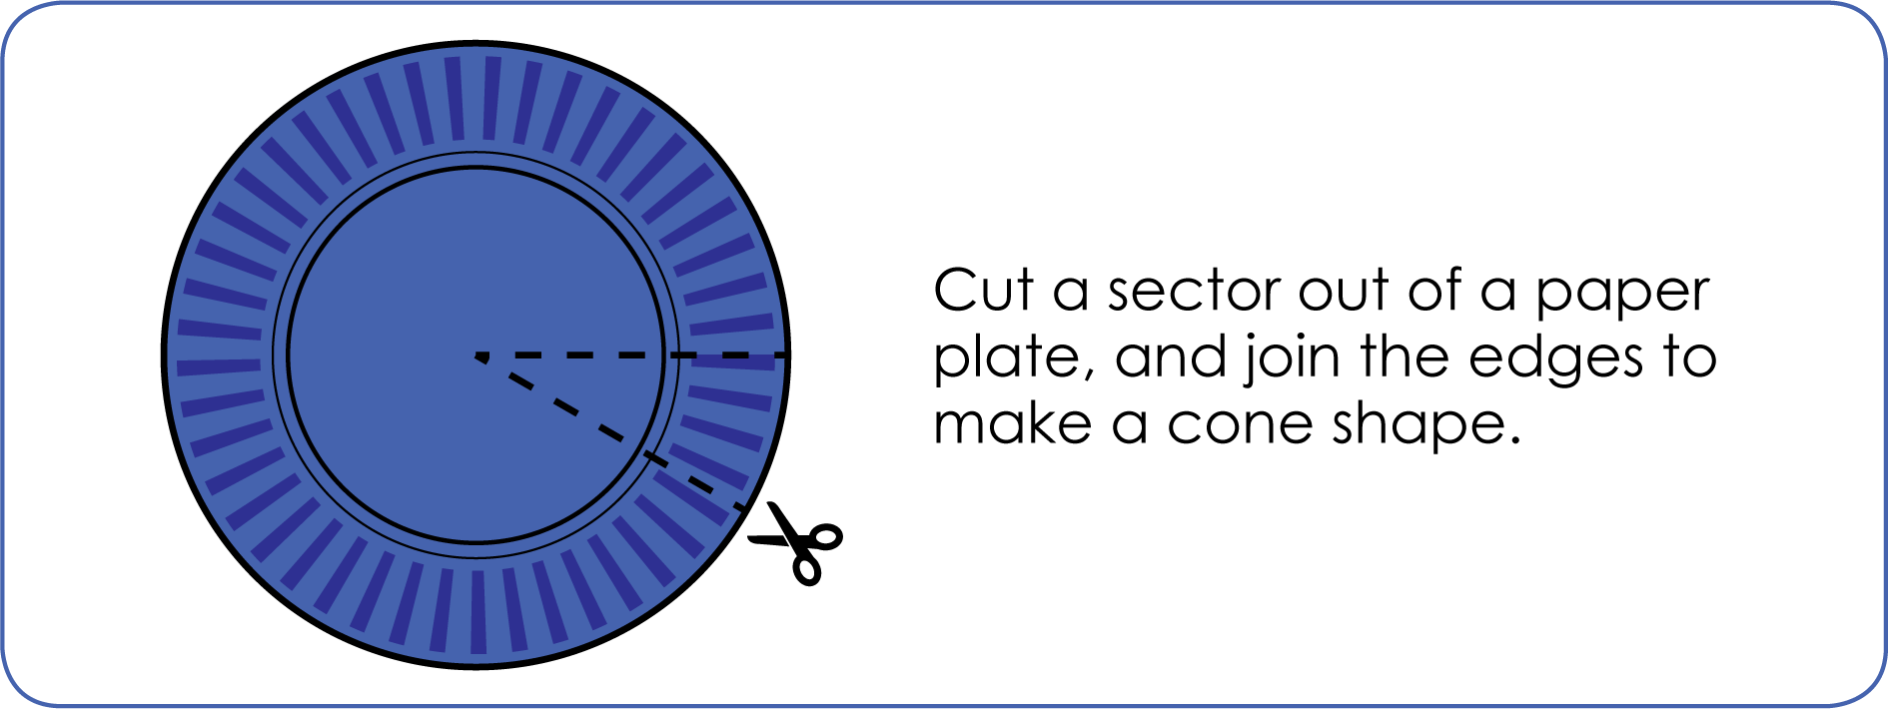

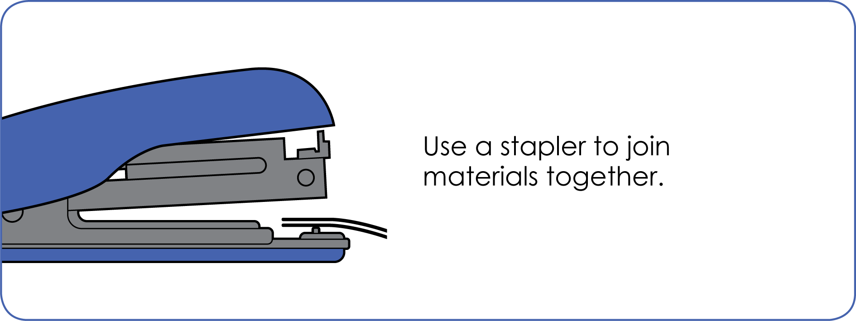

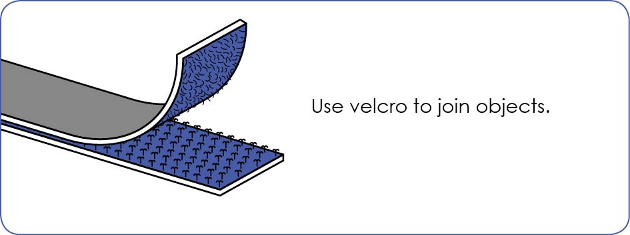

Is it different to your plan?
What does it do?

Appendix 17: Student activity sheet 4.1: Analysis
Write the steps you took to make your most magnificent thing.
What is it made from?
What is it?

Appendix 17B: Student activity sheet 4.1B: Analysis

Draw or glue a picture of your most magnificent thing

Notes

