Submit school preferences in WAIVS help card
- Log into WAIVS using your employee ID and password.

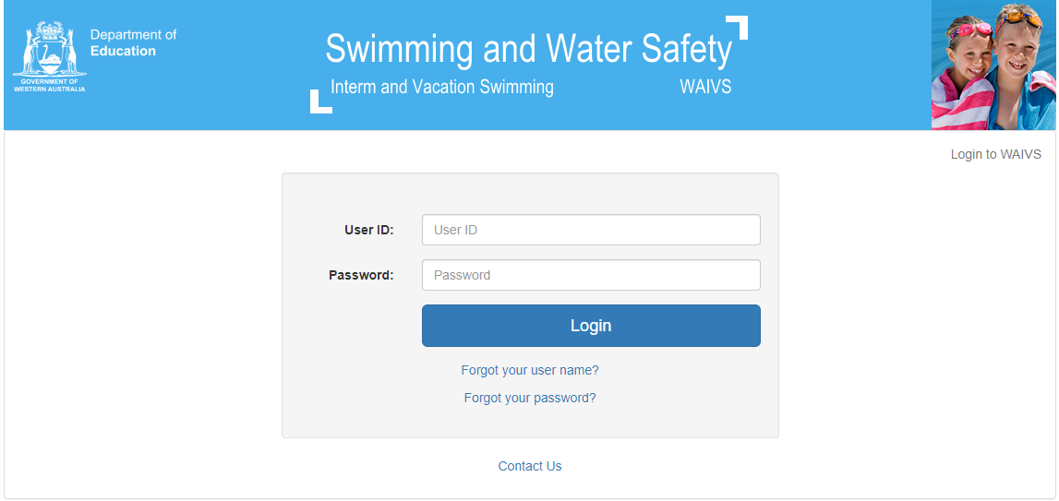

- Click on ‘School Preferences’ on the left hand side

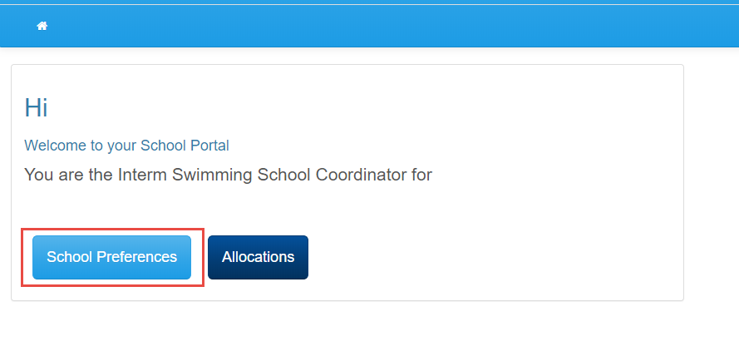

- Complete/update your school details

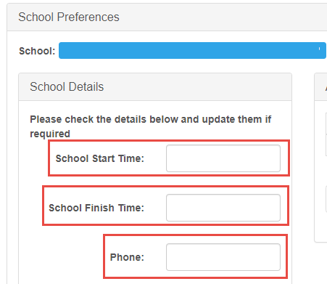
Please note: Completing/updating these details allows Swimming and Water Safety to effectively allocate your lesson times.

- Select the year groups you would like to submit preferences for

Please note: A school can have preferences for the whole school (P – 7) to attend at one time or select to attend at different dates and venues for individual year groups (e.g. P – 4) at a pool and Yr 5 – 7 at a beach).

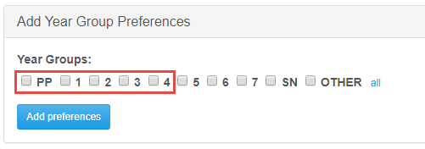

- Click ‘Add preferences’

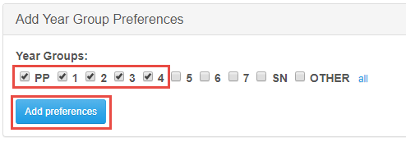

- Add the ‘number of students’ (this needs to be an accurate projected estimate of the number of students)

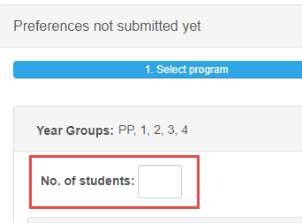

You will need to submit a minimum of two date preferences per term for all four terms.
- This includes schools that prefer lessons at a beach venue in Term 1 or 4, submitting Term 2 and 3 preferences for their local indoor swimming pool.

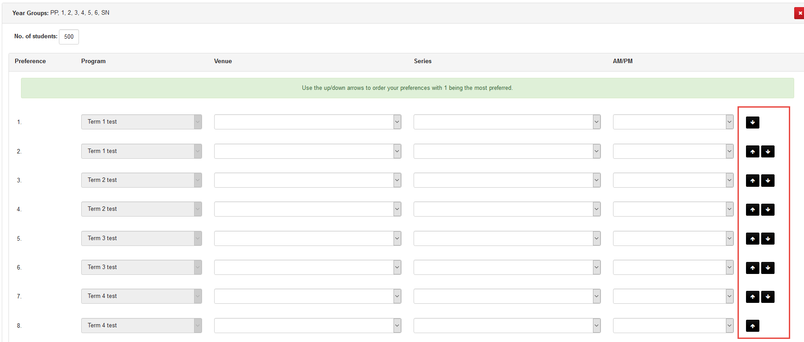

You can use the arrows on the right hand side to move your preferences up or down so they are in your preferred order.

Please note:
This does not include schools in locations where venues are only accessible for part of the year.
- To enable us to facilitate this through WAIVS, schools in these locations have these been classified as a “Country school”

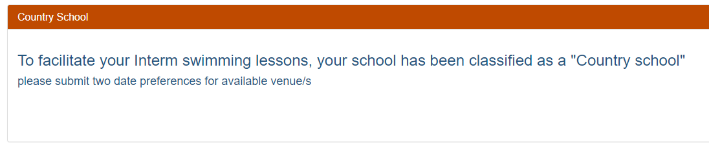

“Country school’s” will need to submit a minimum of two date preferences for available venue/s.

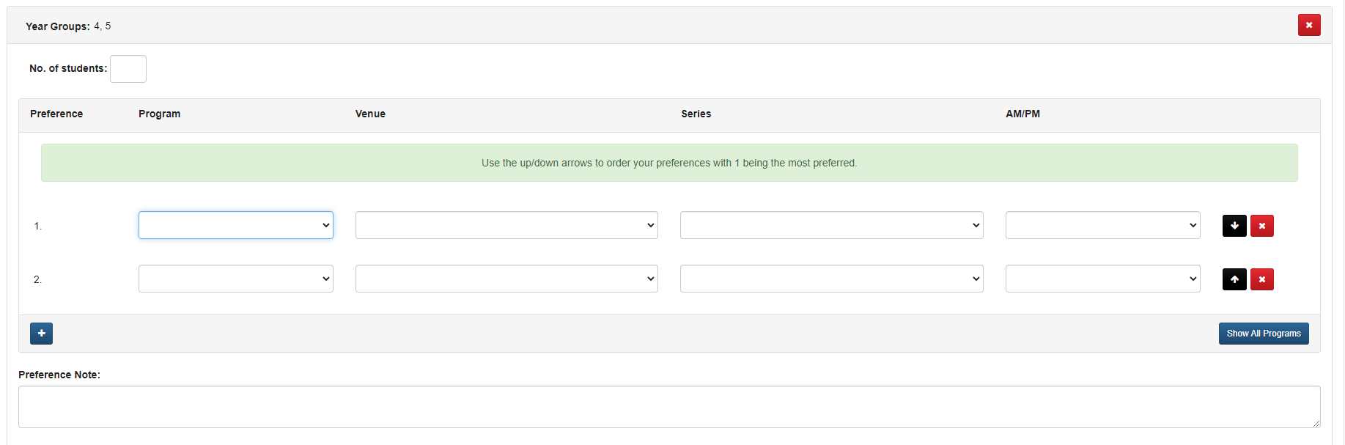
- Click the ‘drop down arrow’ under venue to select the preferred ‘venue’

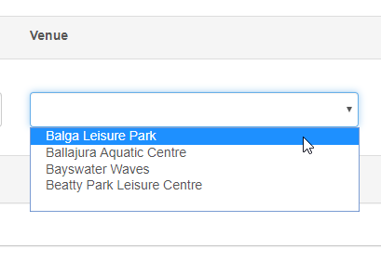

- Click on the ‘drop down arrow’ under series to select the preferred ‘series’

Please note: alternative series dates are not available

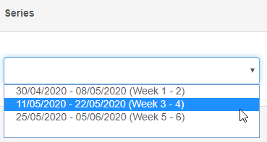

- Click the ‘drop down arrow’ under AM/PM to select the preferred ‘time’

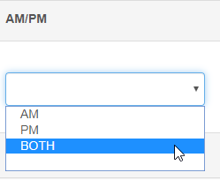

Any necessary adjustments made to school preferences will be discussed with the school before an allocation is made

To assist Swimming and Water Safety with your schools’ allocation please include relevant information in the school preference notes.
- early close day and time
- school development days
- request for support and adjustments required to assist students with special needs in the aquatic environment.

- click ‘submit’

